

CE1003/CZ1003: Introduction to Computational Thinking

Assignment 2 Program Testing

**Python Hangman Game**

**Azmira Tania (U1221168B)**

**Group FsP4**

SESSION 2012/2013

SEMESTER 1

SCHOOL OF COMPUTER ENGINEERING

NANYANG TECHNOLOGICAL UNIVERSITY

**Test case #1**

1. Allow player to choose a category between 1 to 4
2. Display which category the player has chosen
3. Tell the player the length of the random word they have to guess
4. Prompt the player to guess a character or guess the whole word

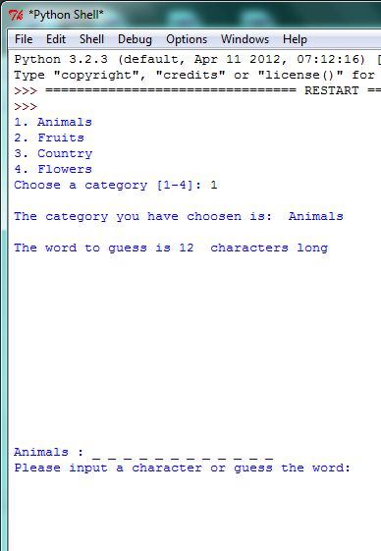

**Test case #2**

1. If the character guess is correct, the blanks get updated with the character.
2. Program shows what characters have already been guessed.

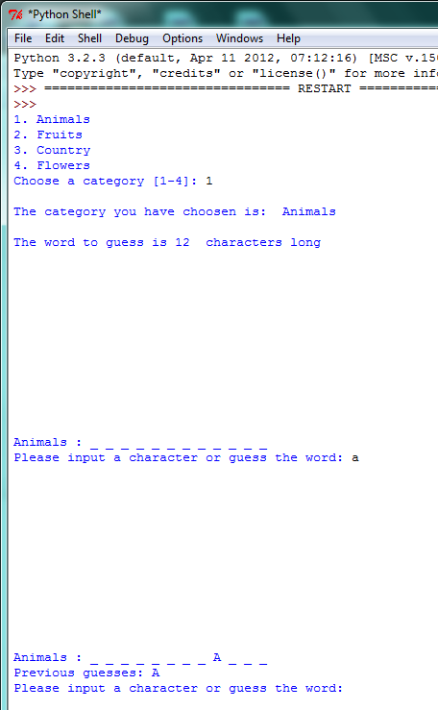

**Test case #3**

1. If the character guess is wrong, a message saying ***“Character not in the word”*** is displayed and the corresponding ASCII art for the Hangman appears. The following if the program screen capture showing what happens when the player cannot guess the word even 9 wrong inputs.

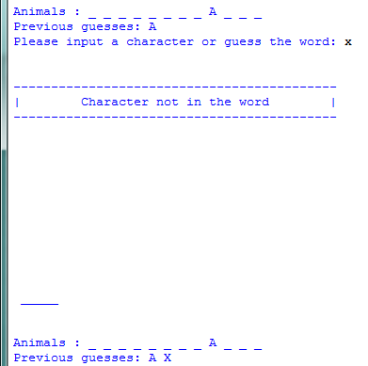

**1st wrong guess**

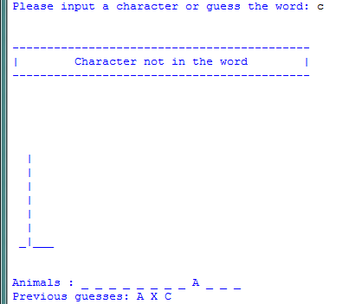

**2nd wrong guess**

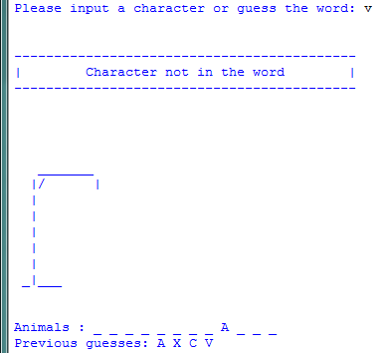

**3rd wrong guess**

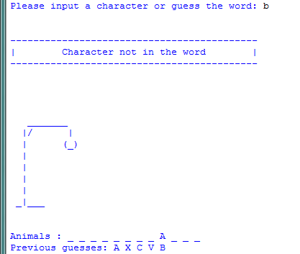

**4th wrong guess**

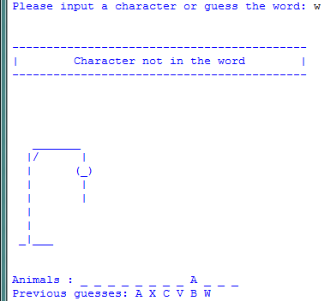

**5th wrong guess**

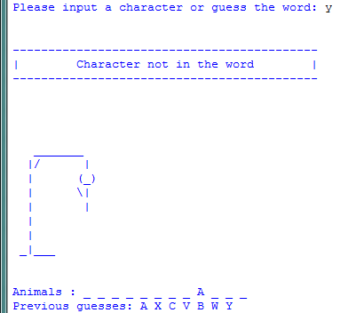

**6th wrong guess**

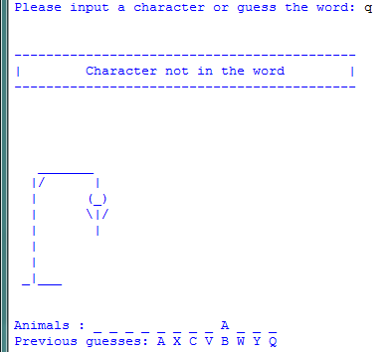

**7th wrong guess**

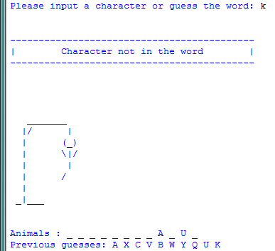

**8th wrong guess**

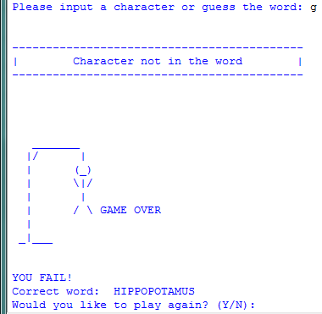

**9th wrong guess 🡪 GAME OVER**

**Test case #4**

1. Program testing showing what happens when player is able to guess the word.

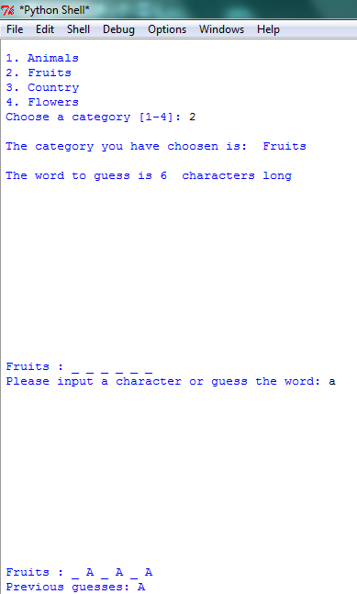

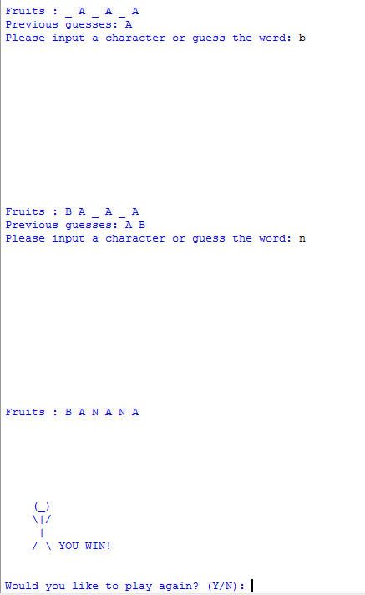

**Test case #5**

1. Player is allowed to guess the whole word.

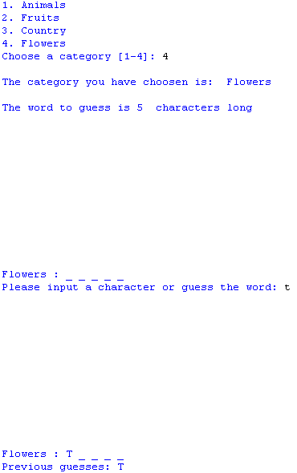

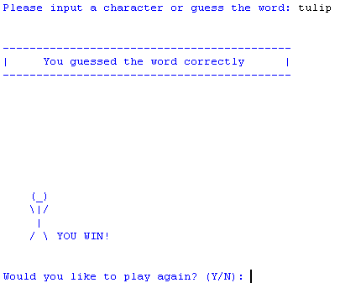

**Test case #6 (Validations & Corresponding Alert messages)**

|  |  |  |
| --- | --- | --- |
| **#** | **Validations & Alert messages** | |
| 1 | Check that the player input  character is not in the word and alert player |  |
| 2 | Check if player has already guessed the character. | **The player has already guessed the alphabet “T” previously, therefore the program will prompt player that “T” has already been guessed.** |
| 3 | Check that the player only inputs alphabets |  |
| 4 | Check that the player has used the whole word correctly, if not alert player. |  |
| 5 | Check that player inputs only a single character or the whole word. Prompt error if otherwise. |  |
| 6 | Player is only able to choose the category between 1 to 4 and nothing else | C:\Users\c120056\Desktop\assign2\7.png |