WEEK 01

**1# Write a program to find product of two usersupplied integers and if the product is equal to or lower than 5000 then return sum of the two numbers.**

**Code:**

*num1=int(input("Enter the first number : "))*

*num2=int(input("Enter the second number : "))*

*product=num1*num2*

*if(product<=5000):*

*sum=num1+num2*

*print(f"Sum : {sum}")*

*else :*

*print(f"Product : {product}")*

*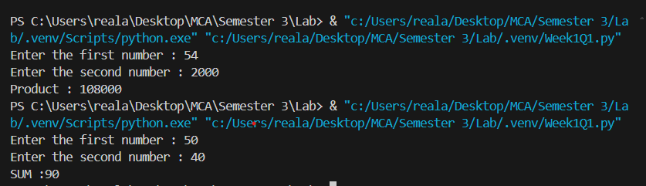***Output:**

**2# Write a program to print sum of first 10 numbers.**

**Code:**

*sum=0*

*for i in range(10) :*

*sum+=i*

*print("Sum : " +str(sum))*

**Output:***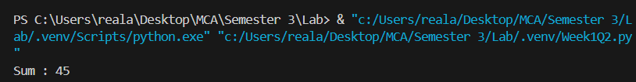*

**3# Write a program to Iterate the supplied list of 20 numbers by the user and print only those numbers which are divisible by 5.**

**Code:**

*def divisibleBy5(numbers):*

*result=[]*

*for n in numbers:*

*if n%5==0:*

*result.append(n)*

*return result*

*numbers=[]*

*for i in range(20):*

*n=int(input(f"Enter number {i+1} : "))*

*numbers.append(n)*

*result=divisibleBy5(numbers)*

*print()*

*print(f"The numbers which are divisible by 5 are : {result}")*

**Output:**

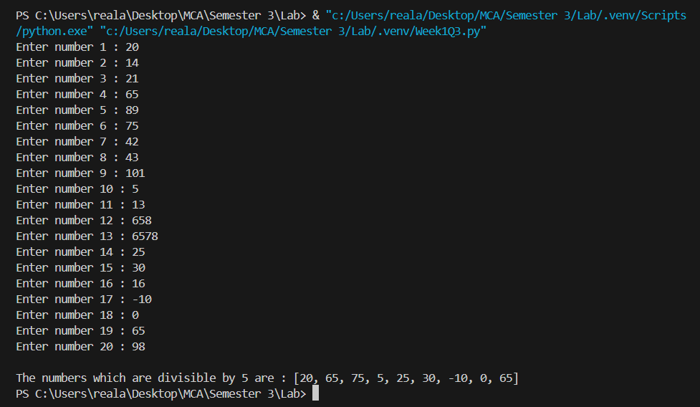

**4# Write a program to check if the given number is a palindrome number or not.**

**Code:**

*def isPalindrome(number):*

*original=number*

*reverse=0*

*while original>0:*

*remainder=original%10*

*reverse=reverse*10+remainder*

*original=original//10*

*return number==reverse*

*def isPalindrome2(number):*

*return str(number) == str(number)[::-1]*

*number=int(input("Enter the number : "))*

*if(isPalindrome2(number)) :*

*print("Palindrome number")*

*else :*

*print("Not a palindrome number")*

**Output:**

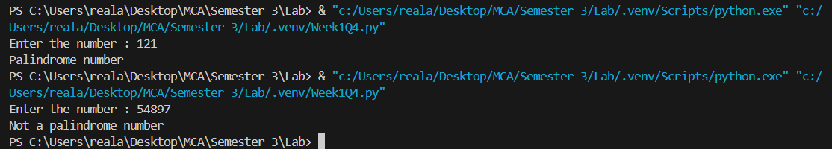

**5# Write a program to calculate the cube of all numbers from 1 to a given number.**

**Code:**

*n=int(input("Enter the number upto which you want the cube : "))*

*print()*

*cubes=[]*

*for i in range(1,n+1) :*

*cube = i ** 3*

*cubes.append(cube)*

*print(cubes)*

**Output:**

