WEEK 02

**1# Write a Program to extract each digit from an integer in the reverse order**

**Code:**

*def digitsReverse(number):*

*original=number*

*print()*

*print("The digits in reverse order are : ")*

*while original>0:*

*print(original%10)*

*original=original//10*

*number=int(input("Enter a number : "))*

*digitsReverse(number)*

**Output:**

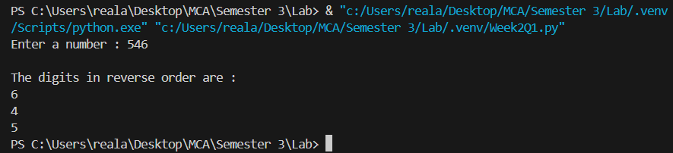

**2# Write a program to count the total number of digits in a number using a while loop.**

**Code:**

*def countDigits(number):*

*count=0*

*original=number*

*while original>0 :*

*original=original//10*

*count+=1*

*return count*

*number=int(input("Enter a number : "))*

*print(f"Total digits in {number} are {countDigits(number)}")*

**Output:**

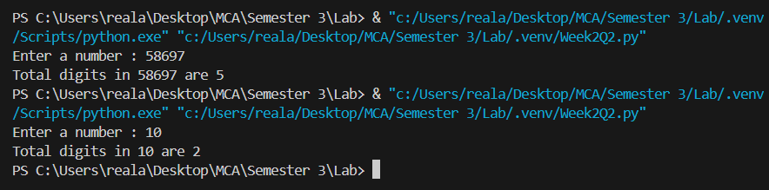

**3# Write a program to display all prime numbers within a range.**

**Code:**

*def isPrime(n):*

*if n<=1:*

*return False*

*if n<=3:*

*return True*

*if n%2==0 or n%3==0:*

*return False*

*i=5*

*while i*i<=n:*

*if n%i==0 or n%(i+2)==0:*

*return False*

*i+=6*

*return True*

*start=int(input("Enter start : "))*

*end=int(input("Enter end : "))*

*primes=[]*

*for num in range(start,end+1):*

*if(isPrime(num)):*

*primes.append(num)*

*print(f"Primes b/w {start} and {end} are {primes}")*

**Output:**

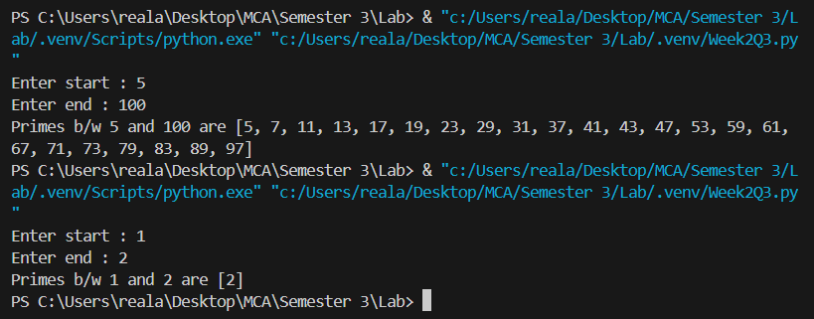

**4# Write a program to use the loop to find the factorial of a given number.**

**Code:**

*def findFactorial(number):*

*if number<0:*

*return -1*

*if number == 0:*

*return 1*

*result=1*

*for num in range(1,number+1):*

*result=result*num*

*return result*

*number=int(input("Enter the number : "))*

*factorial=findFactorial(number)*

*if factorial==-1:*

*print("Factorial of a negative number is not possible")*

*else:*

*print(f"Factorial of {number} is {factorial}")*

**Output:**

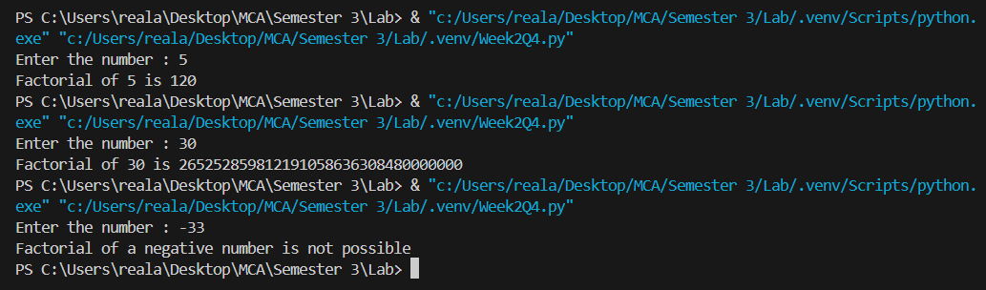

**5# Write a program to find the sum of digits of a supplied integer.**

**Code:**

*def sumOfDigits(number):*

*sum=0*

*while number>0 :*

*sum+=number%10*

*number=number//10*

*return sum*

*number=int(input("Enter the number : "))*

*sum=sumOfDigits(number)*

*print(f"Sum of digits of {number} is {sum}")*

**Output:**

