WEEK 03

**1# Write a program to print the following pattern using the for loop:**

**5 4 3 2 1**

**4 3 2 1**

**3 2 1**

**2 1**

**1**

**Code:**

*for i in range(5,0,-1):*

*for j in range(i,0,-1):*

*print(j, end=' ')*

*print()*

**Output:**

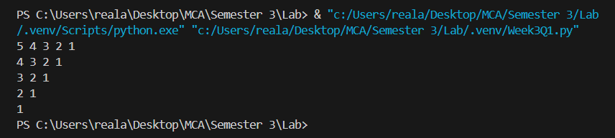

**2# Write a program to print the following pattern using for loop:**

**\***

**\* \***

**\* * \***

**\* * * \***

**\* * * * \***

**\* * * \***

**\* * \***

**\* \***

**\***

**Code:**

*for i in range(6):*

*for j in range(i):*

*print('*', end=' ')*

*print()*

*for i in range(4,0,-1):*

*for j in range(i):*

*print('*', end=' ')*

*print()*

**Output:**

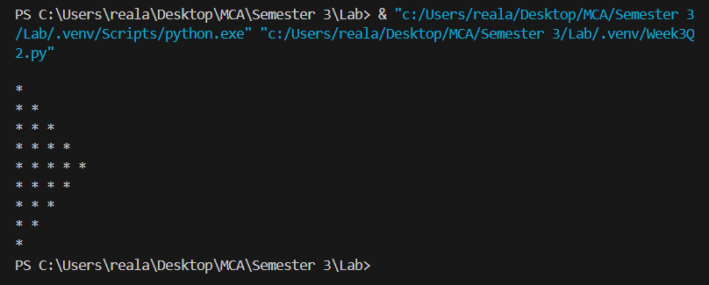

**3# Write a program to print characters from a string which are present at an even index numbers.**

**Code:**

*string=input("Enter the string : ")*

*print("The characters at even indexes are : ")*

*for index, char in enumerate(string):*

*if index%2==0:*

*print(char)*

**Output:**

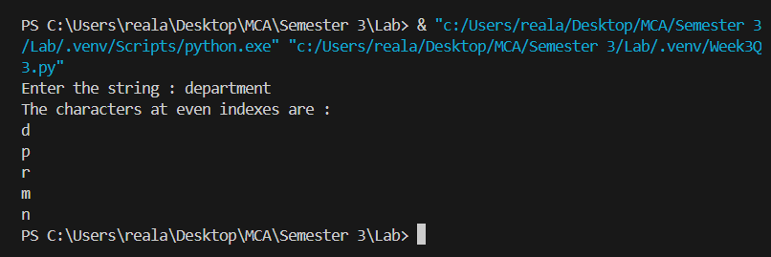

**4# Write a program to accept a string from the user and display characters that are present at an even index number.**

**Code:**

*string=input("Enter the string : ")*

*print("The characters at even indexes are : ")*

*for index, char in enumerate(string):*

*if index%2==0:*

*print(char)*

**Output:**



**5# Write a program to remove characters from a string starting from n to last and return a new string. Example: remove_chars("aligarh", 3) so output must be al.**

**Code:**

*def removeCharacter(str,n):*

*if n>len(str):*

*return ""*

*result=""*

*for index,char in enumerate(str):*

*if index<n-1 :*

*result+=char*

*if index>=n-1 :*

*break*

*return result*

*# using an inbuilt method*

*def removeCharacters2(str,n):*

*if n>len(str):*

*return ""*

*return str[:n-1]*

*str=input("Enter the string : ")*

*n=int(input("Enter the number of characters to remove : "))*

*result=removeCharacter(str,n)*

*print(f"After removing characters : {result}")*

**Output:**

