WEEK 04

**1# Write a program to create function cal_sum_sub() such that it can accept two variables and calculate addition and subtraction. Also, it must return both addition and subtraction in a single return call.**

**Code:**

*def cal_sum_sub(num1,num2):*

*sum=num1+num2*

*sub=num1-num2*

*return sum,sub*

*num1=int(input("Enter first number : "))*

*num2=int(input("Enter second number : "))*

*sum, sub=cal_sum_sub(num1,num2)*

*print(f"SUM : {sum}\nDIFFERENCE : {sub}")*

**Output:**

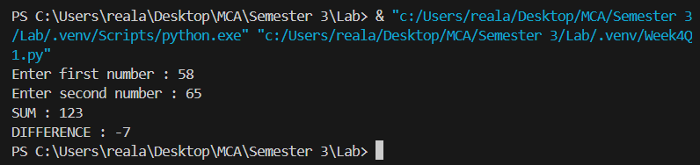

**2# Write a function to return True if the first and last number of a given list is same. If numbers are different then return False**

**Code:**

*def checkFirstLast(list):*

*if not list:*

*return False*

*return list[0]==list[-1]*

*# list[0]==list[len(list)-1]*

*list=[]*

*print("Enter the numbers in the list (enter -1 as last element): ")*

*i=1*

*while True:*

*num = int(input(f"Enter number {i} : "))*

*if num==-1:*

*break*

*list.append(num)*

*i+=1*

*print()*

*if(checkFirstLast(list)):*

*print("The first and last element are the same.")*

*else:*

*print("The first and last element are not same.")*

**Output:**

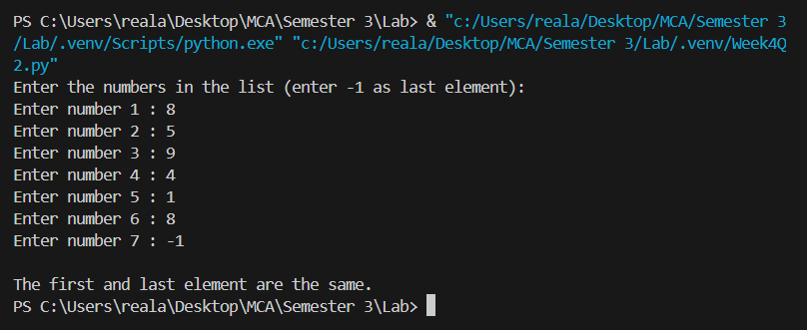

**3# Given a list of numbers. Write a program to turn every item of a list into its square.**

**Code:**

*list=[1,4,6,8,11,33,44]*

*print(f"List : {list}")*

*for i in range(len(list)):*

*list[i]=list[i]**2*

*print(f"Squared List : {list}")*

**Output:**

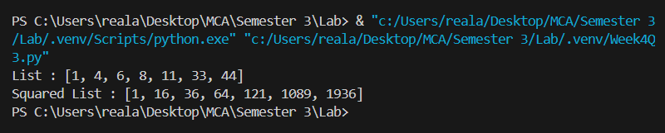

**4# Given a two Python list. Write a program to iterate both lists simultaneously and display items from list 1 in original order and items from list 2 in reverse order.**

**Code:**

*list1=[1,2,3,4,5,6,7,8,9,10]*

*list2=[10,9,8,7,6,5,4,3,2,1]*

*size=len(list1)*

*for i in range(size):*

*print(f"List 1 : {list1[i]} , List 2 : {list2[size-i-1]}")*

*print()*

*list3=["Saud", "Aisha", "Sana", "Zaki", "Moaz"]*

*list4=[1,2,3,4,5]*

*size2=len(list3)*

*for i in range(size2):*

*print(f"List 1 : {list3[i]} , List 2 : {list4[size2-i-1]}")*

**Output:**

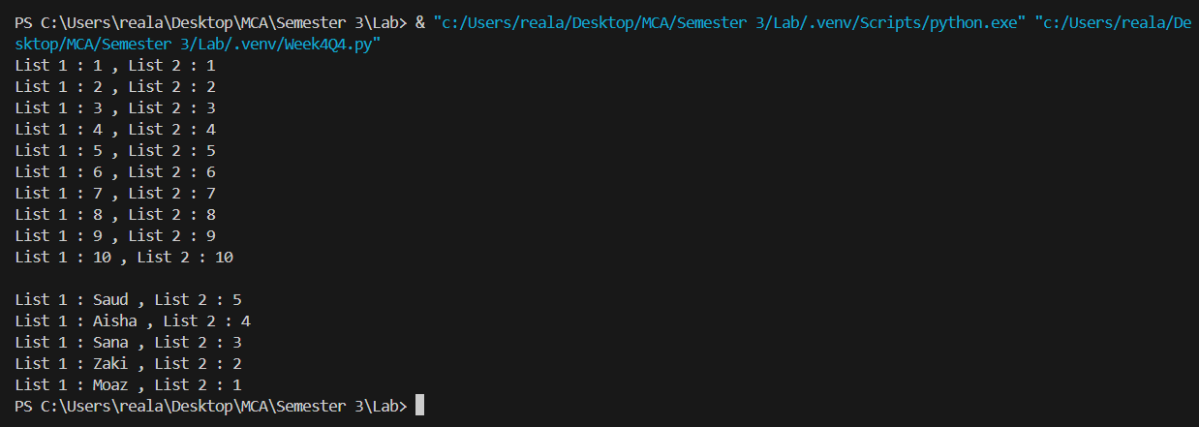

**5# Write a program to count the number of occurrences of item 50 from below tuple tp1: tp1= (50, 10, 60, 70, 50)**

**Code:**

*def countOccurence(tuple,number):*

*count = 0*

*for x in tuple:*

*if(x==number):*

*count+=1*

*return count*

*tuple=(50,10,60,70,50)*

*number=50*

*count=countOccurence(tuple,number)*

*print(f"{number} occurs {count} times in the {tuple}")*

**Output:**

