WEEK 06

**1# Write a Python program that inputs two tuples and creates a third that contains all elements of the first followed by all elements of the second. (You may use other data types such as lists etc. to make your program work)**

**Code:**

*def combine(tuple1,tuple2):*

*list1=list(tuple1)*

*list2=list(tuple2)*

*list3=list1+list2*

*tuple3=tuple(list3)*

*return tuple3*

*tuple1=tuple(map(int,input("Enter elements of first tuple : ").split()))*

*tuple2=tuple(map(int,input("Enter elements of second tuple : ").split()))*

*print()*

*print("COMBINED TUPLE : ")*

*tuple=combine(tuple1,tuple2)*

*print(tuple)*

**Output:**

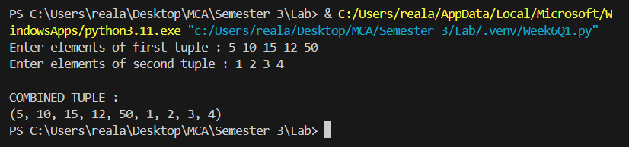

**2# Write a Python program to create a Python dictionary (the dictionary type). Add three names and their phone numbers in the dictionary. The names should act as a keys and phones as their values. Then ask the user a name and print its corresponding phone number.**

**Code:**

*phoneDictionary={}*

*phoneDictionary['Saud']='7770099911'*

*phoneDictionary['Aisha']='1222333344'*

*phoneDictionary['Sana']='44444444444'*

*name=input("Enter a name to get the phone number : ")*

*print()*

*if name in phoneDictionary:*

*print(f"The phone number of {name} is {phoneDictionary[name]}")*

*else :*

*print(f"The data for {name} is not available")*

**Output:**

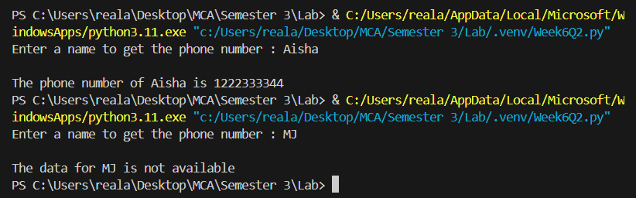

**3# Write a Python program having a void function that receives a 4-digit number and calculates the sum of squares of first 2 digits’ number and last two digits’ number, e.g. if 1233 is passed as argument then function should calculate 12^2 + 33^2 .**

**Code:**

*def calcSum(number):*

*if 1000<=number<=9999:*

*num=str(number)*

*firstTwo=int(num[:2])*

*lastTwo=int(num[2:])*

*squareFirst=firstTwo ** 2*

*squareLast=lastTwo ** 2*

*result=squareFirst+squareLast*

*print(f"The sum of squares of {firstTwo} and {lastTwo} is {result}")*

*else:*

*print("Enter a 4 digit number")*

*number=int(input("Enter a 4 digit number : "))*

*print()*

*calcSum(number)*

**Output:**

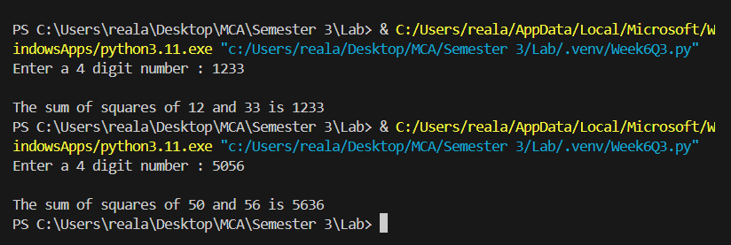

**4# Write a program that inputs a main string and then creates an encrypted string by embedding a short symbol-based string after each character. The program should also be able to produce the decrypted string from encrypted string.**

**Code:**

*import random*

*import string*

*def generateRandomSymbol(length):*

*symbol=string.punctuation*

*return ''.join(random.choice(symbol) for _ in range(length))*

*def encryption(mainString):*

*encryptedString=""*

*for char in mainString:*

*randomSymbol=generateRandomSymbol(2)*

*encryptedString+=char+randomSymbol*

*return encryptedString*

*def decryption(encryptedString):*

*decryptedString = ""*

*i=0*

*while i<len(encryptedString):*

*decryptedString+=encryptedString[i]*

*i+=3*

*return decryptedString*

*mainString=input("Enter the main string : ")*

*print()*

*encryptedString=encryption(mainString)*

*print("Encrypted String : ", encryptedString)*

*print()*

*decryptedString=decryption(encryptedString)*

*print("Decrypted String : ", decryptedString)*

**Output:**

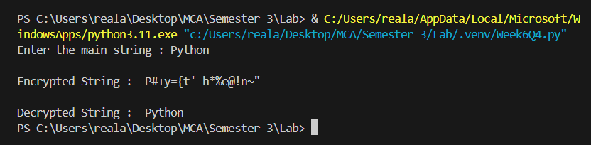

**5# Write a program to get roll numbers, names and marks of the students of a class (get from user) and store these details in a file called “Marks.data”**

**Code:**

*students=[]*

*while True:*

*roll=input("Enter roll number (or 'Complete' to finish) : ")*

*if roll.lower()=='complete':*

*break*

*name=input("Enter name : ")*

*marks=input("Enter marks : ")*

*student = {*

*'roll' : roll,*

*'name' : name,*

*'marks' : marks*

*}*

*students.append(student)*

*print()*

*with open("Marks.data", 'w') as file:*

*for student in students:*

*file.write(f"{student['roll']},{student['name']},{student['marks']}\n")*

*print()*

*print("Records saved.")*

**Output:**

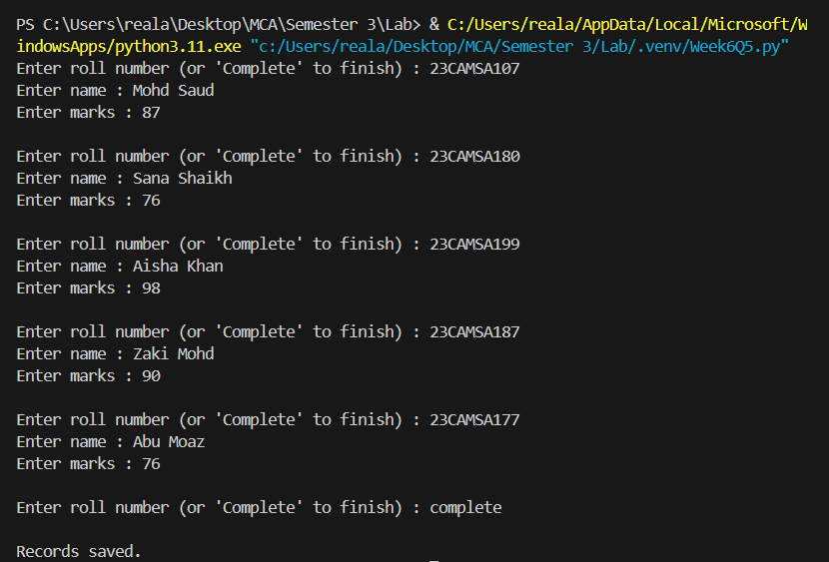

**File Generated:**

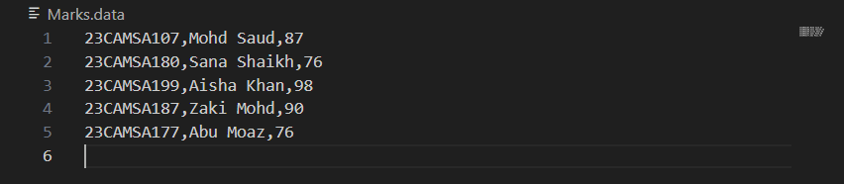

**6# Write a program to accept a string and display the following:**

**a) Number of uppercase characters**

**b) Numbers of lowercase characters**

**c) Total number of alphabets**

**d) Number of digits**

**Code:**

*def find(inputString):*

*uCount=0*

*lCount=0*

*aCount=0*

*dCount=0*

*for char in inputString:*

*if char.isupper():*

*uCount+=1*

*if char.islower():*

*lCount+=1*

*if char.isalpha():*

*aCount+=1*

*if char.isdigit():*

*dCount+=1*

*return uCount,lCount,aCount,dCount*

*inputString=input("Enter a string : ")*

*uCount,lCount,aCount,dCount=find(inputString)*

*print()*

*print(f"Number of uppercase characters : {uCount}")*

*print(f"Number of lowercase characters : {lCount}")*

*print(f"Number of alphabets : {aCount}")*

*print(f"Number of digits : {dCount}")*

**Output:**

