Name: Omid Azodi

Due Date: 03/10/2016

Professor: Dr. Hadaegh

Class: CS443

**Assignment # 1**

**Question #1**

**Consider the following data. Arrows show the functional dependency.**

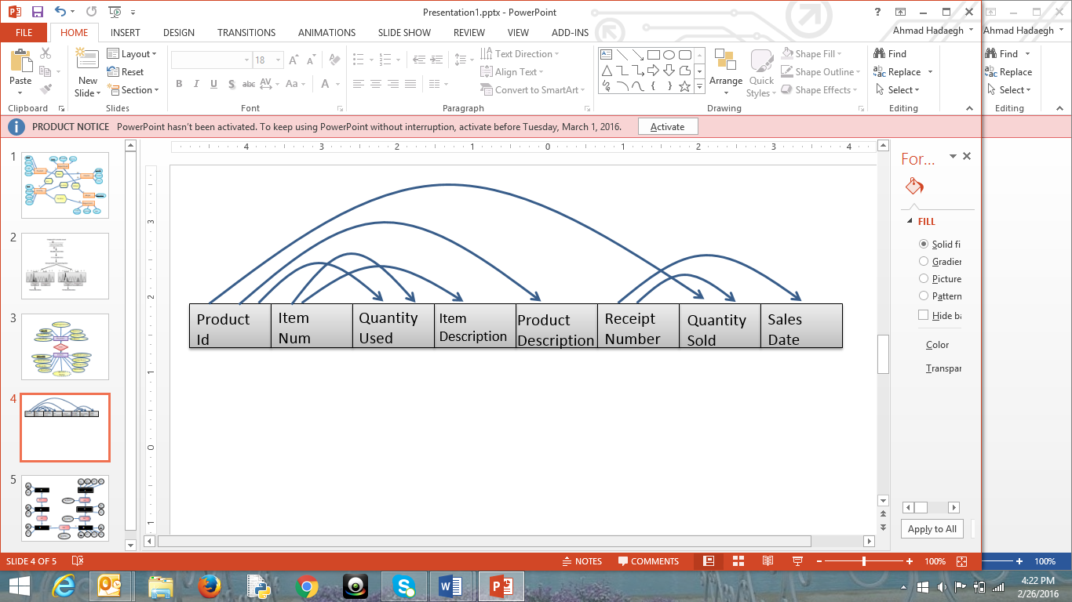

1. **Write the tables**

Sales(ReceiptNumber, SalesDate)

Quantity(ProductID, ReceiptNumber, QuantitySold)

Product(ProductID, ProductDescription)

Item(ItemNum, ItemDescription)

Quantity2(ProductID, ItemNum, QuantityUsed)

1. **Place the tables in 3rd normal form (if necessary)**

The tables are already in 3rd normal form. I knew this, because I checked for the ones that only had a composite primary key. However for the tables that had a composite primary key there was no transitive or derived dependency.

1. **Create ERD based on the normalized tables**

Quantity

N N

Sales

Item

QuanSec

Product

1. **Write a script to create a database. Your script should create the tables and ensures that all constraints are set properly.**

CREATE TABLE Sales

(

ReceiptNumber INTEGER,

SalesDate DATE,

CONSTRAINT pk_SalesTable PRIMARY KEY(ReceiptNumber)

);

CREATE TABLE Quantity

(

ProductID INTEGER,

ReceiptNumber INTEGER,

QuantitySold INTEGER,

CONSTRAINT pk_QuantityTable PRIMARY KEY (ProductID,ReceiptNumber),

CONSTRAINT fk_ProductSecond FOREIGN KEY(ProductID) REFERENCES Product(ProductID),

CONSTRAINT fk_SalesForeign FOREIGN KEY (ProductID) REFERENCES Sales(ReceiptNumber),

CONSTRAINT checkQuanSold CHECK(QuantitySold >= 0)

);

CREATE TABLE Product

(

ProductID INTEGER,

ProductDescription VARCHAR(200),

CONSTRAINT pk_ProductPrimary PRIMARY KEY (ProductID)

);

CREATE TABLE Item

(

ItemNum INTEGER,

ItemDescription VARCHAR(200),

CONSTRAINT pk_ItemPrimary PRIMARY KEY (ItemNum)

);

CREATE TABLE QuantitySecond

(

ProductID INTEGER,

ItemNum INTEGER,

QuantityUsed INTEGER,

CONSTRAINT pk_ProductAndItem PRIMARY KEY (ProductID, ItemNum),

CONSTRAINT fk_ItemForeign FOREIGN KEY (ItemNum) REFERENCES Item(ItemNum),

CONSTRAINT fk_ProductForeign FOREIGN KEY (ProductID) REFERENCES Product(ProductID),

CONSTRAINT checkQuanUsed CHECK (QuantityUsed >= 0)

);

**Question #2**

**Consider the following ERD**

**PATIENT**

# PHYSICIAN

IS-TREATED

1

N

**Note**: The arrows are drawn on HARD COPY. The tables are NOT separate they are supposed to be combined into one big long table, however since it would not fit I had to make them separate, however they should be merged from Room Rate and PhysID.

1. **Using arrows draw the dependencies that exist in the data.**

|  |  |  |  |  |  |  |  |  |
| --- | --- | --- | --- | --- | --- | --- | --- | --- |
| Patient Id | Patient Name | Patient Addr | AdminDate | AmoutnOwning | RoomNo | RoomPhone | Hosp. Stay Day | Room Rate |

|  |  |  |  |  |  |  |
| --- | --- | --- | --- | --- | --- | --- |
| PhysID | PhysName | PhysDept | DeptSupervisorId | TreatId | TreatDesc | TreatCost |

1. **Write the initial tables**

Patient(PatientID, PatientName, PatientAddr., OwingAmt., RoomPhone, Hosp.DaySpent, RoomRate, RoomNo, AdminDate)

Physician(PhysID, PhysName, PhysDept., Dept.SupervisorId, TreatId, TreatDesc, TreatCost)

1. **Place the tables in 3rd normal form (if necessary)**

Patient(PatientID, PatientName, PatientAddr., AdmitDate, Hosp.DayStay, RoomNo, PhysID)

Physician(PhysID, PhysName, PhysDept., TreatId)

Department(PhysDeptID, Dept.SupervisorID)

Room(roomNO., roomPhone, roomRate)

Treatment(treatID, treatDesc., treatCost)

1. **Revise the given ERD based on the normalized tables**

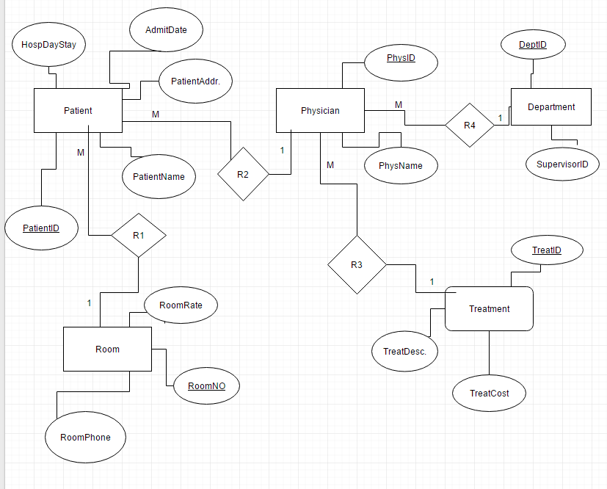

1. **Write a script to create a database. Your script should create the tables and ensures that all constraints are set properly. **Note**: There is attached SQL File to RUN.**

CREATE TABLE Patient

(

PatientID INTEGER,

PatientName VARCHAR2(50)

CONSTRAINT PatientNameNotEmpty NOT NULL,

PatientAddress VARCHAR2(200)

CONSTRAINT PatientAddressNotEmpty NOT NULL,

AdmitDate DATE,

HospitalStayDays INTEGER,

RoomNo INTEGER,

PhysID INTEGER,

CONSTRAINT pk_PrimaryPatientIDs PRIMARY KEY (PatientID),

CONSTRAINT fk_RoomNoForeigns FOREIGN KEY (RoomNo) REFERENCES Room(RoomNo),

CONSTRAINT fk_PhysIDForeigns FOREIGN KEY (PhysID) REFERENCES Physician(PhysID),

CONSTRAINT checkRoomNos CHECK ((RoomNo >=100) AND (RoomNo <=999)),

CONSTRAINT checkHospitalStayDays CHECK (HospitalStayDays >=0)

);

CREATE TABLE Physician

(

PhysID INTEGER,

PhysName VARCHAR2(50)

CONSTRAINT PhysNameNotEmpty NOT NULL,

PhysDept INTEGER,

TreatID INTEGER,

CONSTRAINT pk_PhysIDPrimary PRIMARY KEY (PhysID),

CONSTRAINT fk_TreatIDForeign FOREIGN KEY (TreatID) REFERENCES Treatment(TreatID),

CONSTRAINT fk_PhysIDForeign FOREIGN KEY (PhysDept) REFERENCES Department(PhysDeptId)

);

CREATE TABLE Department

(

PhysDeptId INTEGER,

DeptSupervisorId INTEGER,

CONSTRAINT pk_PhysDeptIDPrimary PRIMARY KEY (PhysDeptId)

);

CREATE TABLE Room

(

RoomNo INTEGER,

RoomPhone VARCHAR2(8),

RoomRate NUMBER(10,2),

CONSTRAINT pk_RoomNoPrimarys PRIMARY KEY (RoomNo),

CONSTRAINT checkRoomNo CHECK ((RoomNo >=100) AND (RoomNo <=999)),

CONSTRAINT RoomRateRange CHECK ((RoomRate >=30.00) AND (RoomRate <=100.00))

);

CREATE TABLE Treatment

(

TreatID INTEGER,

TreatDescription VARCHAR2(200),

TreatCost NUMBER(10,2),

CONSTRAINT pk_TreatIDPrimarys PRIMARY KEY (TreatID),

CONSTRAINT TreatCostChecking CHECK (TreatCost >=50.00)

);

ALTER TABLE DEPARTMENT ADD CONSTRAINT fk_PhysDeptIDForeign FOREIGN KEY (DeptSupervisorId) REFERENCES Physician(PhysID)

**Question #3**

Create the tables related to the following ERD

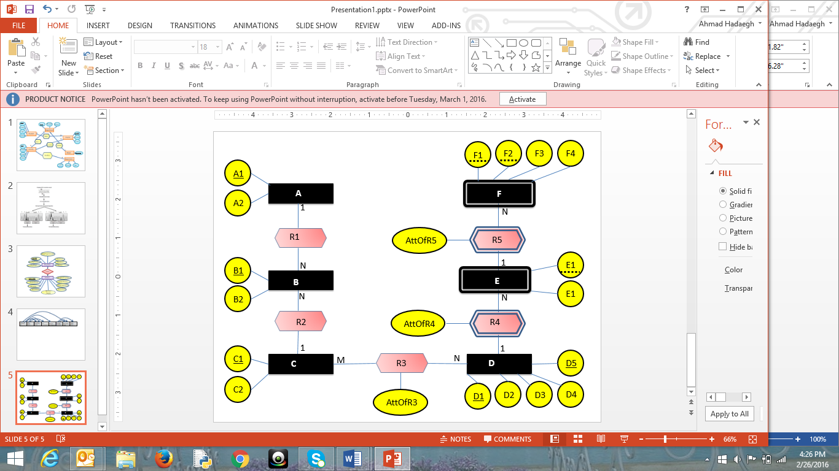

First Table: A(A1, A2)

Second Table: B(B1, B2, A1, C1)

Third Table: C(C1,C2)

Fourth Table: R3(C1, D1,D5, AttOfR3)

Fifth Table: D(D1,D5,D2,D3,D4)

Sixth Table: E(E1,D1,D5,E2, AttOfR4)

Seventh Table: F(F1,F2,E1,D1,D5,F3,F4,AttOfR5)

**Question # 4**

Create the tables related to the following ERD.

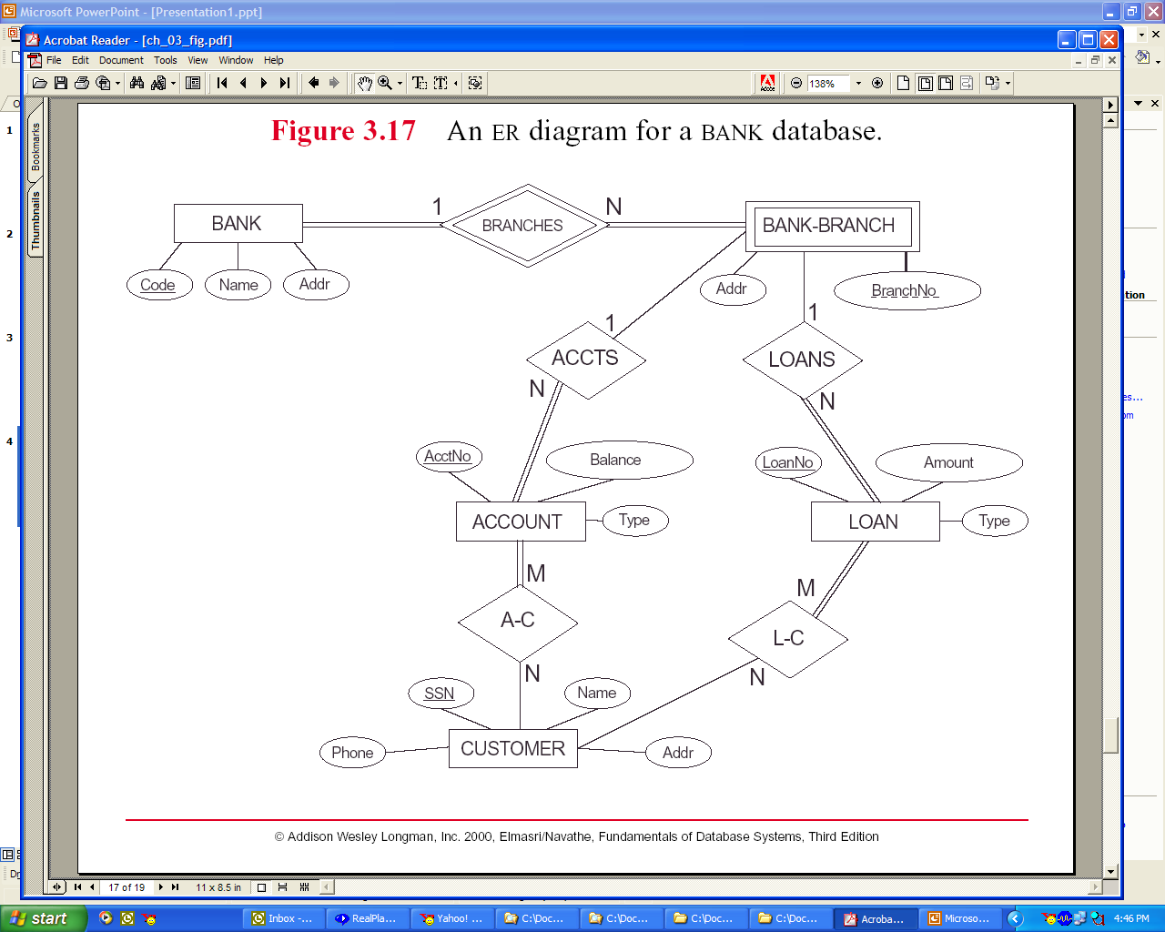

First Table: Bank(Code, Name, Addr)

Second Table: Bank-Branch(BranchNo,Code,Addr)

Third Table: Loan(LoanNo, Amount, Type, BranchNo,Code)

Fourth Table: Account( AcctNo, Balance, Type, BranchNo, Code)

Fifth Table: Customer(SSN, Name, Addr, Phone)

Sixth Table: A-C(SSN,AcctNo)

Seventh Table: L-C(SSN, LoanNo)

**Question #5**

**Create ERD based on the following tables. The underlines attributes are primary keys. The links are connection between primary keys and foreign keys.**

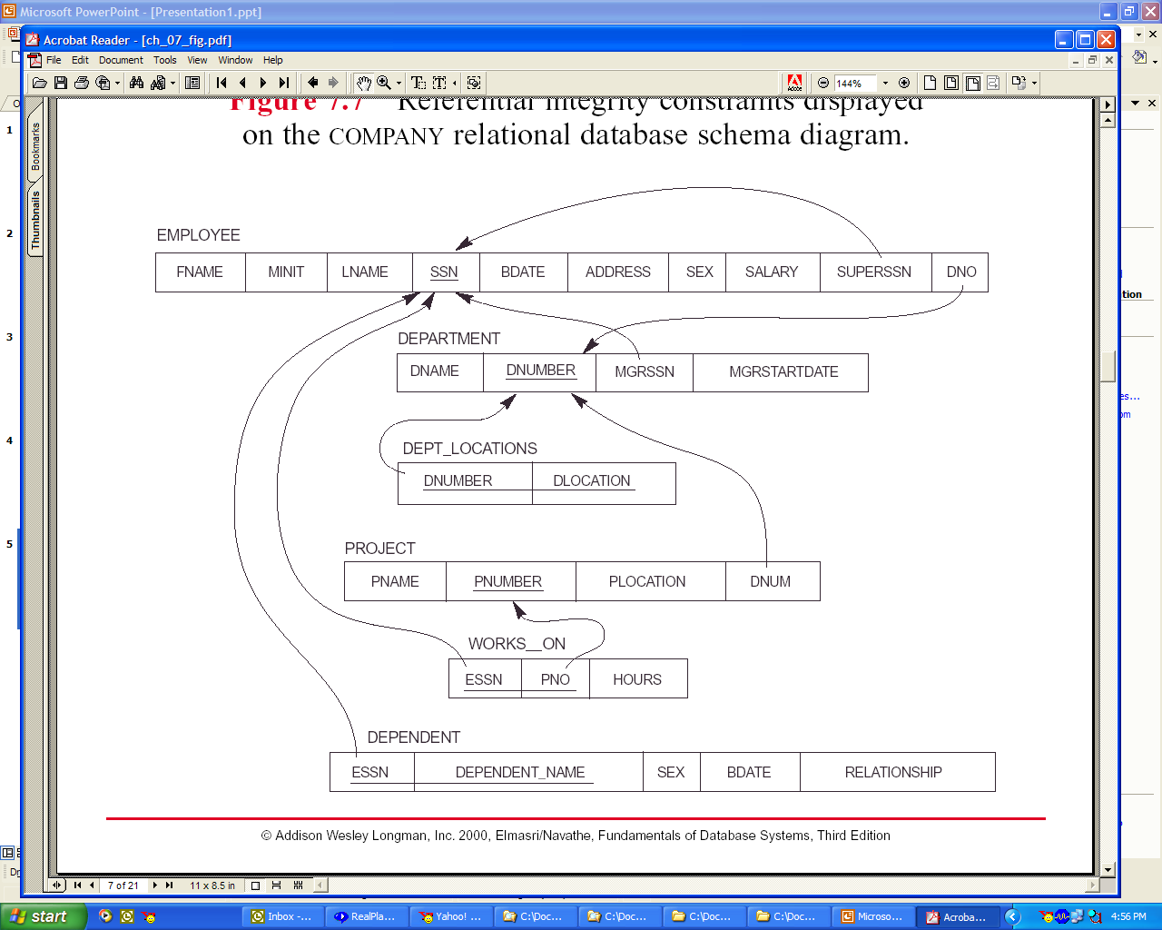

**\*\*Note**:** The Relationships (1-M, M-1, M-N, and R6, and R7) are filled in on the HARD COPY. (I had trouble with this one on Microsoft Word), However I did my other ERD on draw.io. (From now on I will use draw.io, much easier) Sorry if this one is a bit messy!

Dept_Loca De

R5

R4

R3

R2

R1

Project

Department

Employee

Dependent