CERTIFICATE OF CALIBRATION
Antikernel Labs
PO Box 4665
10355 NE Valley Rd
Rollingbay, WA 98061-0665
https://www.antikernel.net/
sales@antikernel.net

This document certifies that the instrument described has been verified to comply with all published datasheet specifications using traceably calibrated equipment.

Instrument Description 2 GHz Transmission Line Probe
Model AKL-PT1
Serial Number 0014

Calibration Performed By A. Zonenberg Date 2020-08-06 00:20
Test Conditions 21ºC, 44% R H Cal Due 2021-08-06

Calibration Standards
Type | Manufacturer | Model | Serial | Cal due date
Multimeter | Rohde & Schwarz | HMC8012 | 36174847 | 2021-04-15
Vector Network Analyzer | Pico Technology | PicoVNA 106 | 09335 | 2021-04-17
SOLT Standard | Pico Technology | TA345 | SF:296 | 2021-04-17
Oscilloscope | Teledyne LeCroy | WaveRunner 8404M-MS | LCRY4254N20447 | 2021-07-16
Pulse Generator* | Leo Bodnar | SMA Pulse Generator | P00718 | 2021-08-01
* Used as signal source only, not as measurement standard

Test Results
Unless otherwise specified measurements are of probe body only, with cable and fixture de-embedded.
Test | Minimum | Measured | Maximum | Unit | Result
DC resistance | 449.75 | 450.27 | 450.75 | Ω | PASS
S₂₁ (1 MHz) | -20.48 | -20.45 | -20.42 | dB | PASS
S₂₁ (500 MHz) | -20.85 | -20.60 | -20.35 | dB | PASS
S₂₁ (1.0 GHz) | -21.10 | -20.88 | -20.35 | dB | PASS
S₂₁ (1.5 GHz) | -21.45 | -21.27 | -20.75 | dB | PASS
S₂₁ (2.0 GHz) | -21.60 | -22.10 | -22.45 | dB | PASS
Bandwidth (-23.5 dB) | 2.25 | 2.52 | 2.60 | GHz | PASS
Rise time (20-80%) w/ cable | 118 | 122 | 129 | ps | PASS

Typical Waveform

Nominal 40 ps risetime pulse including the provided cable if applicable
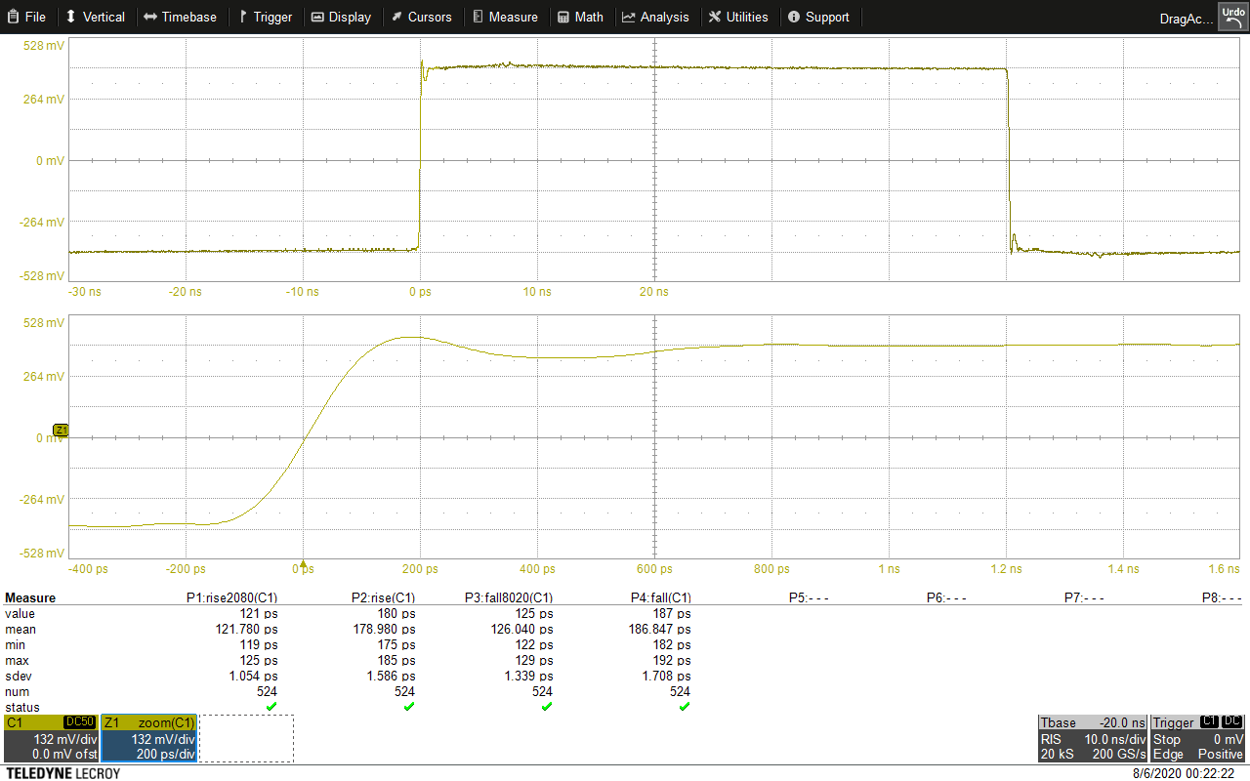

S-Parameter Data
Machine readable S2P files for de-embedding may be downloaded at:
https://www.antikernel.net/downloads/AKL-PT1/caldata/0014/

Insertion Loss (tip ground, across 50Ω termination)
tipground.s2p S₂₁
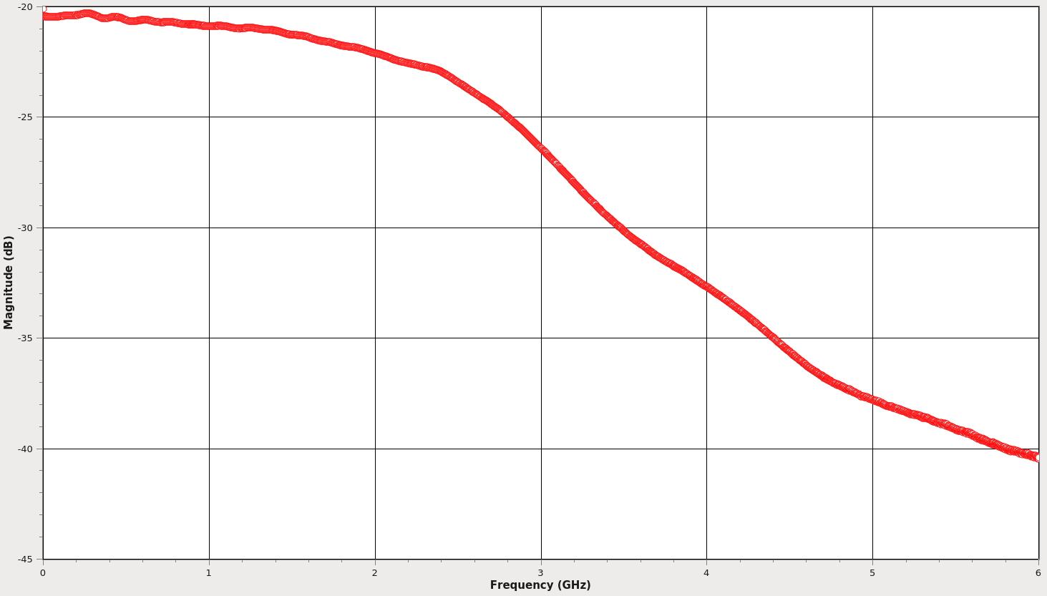

Insertion Loss (leaf ground, across 50Ω termination)
leafground.s2p S₂₁
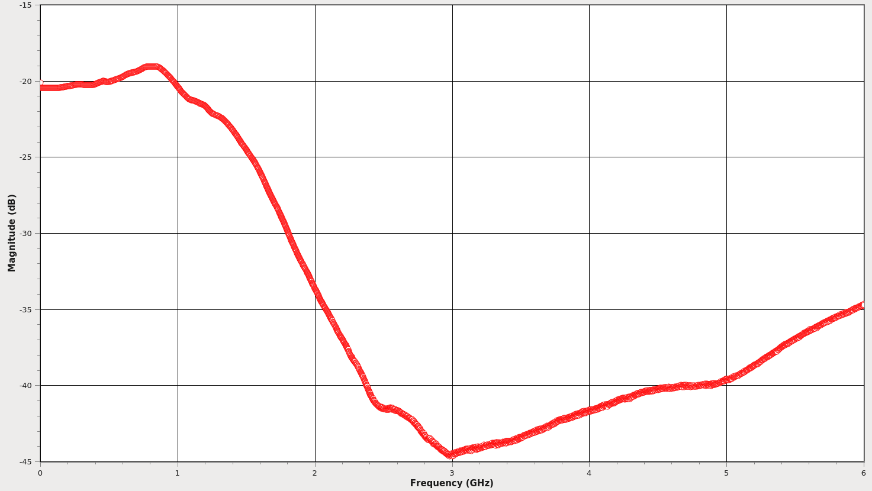

Insertion Loss (Z-ground, across 50Ω termination)
zground.s2p S₂₁
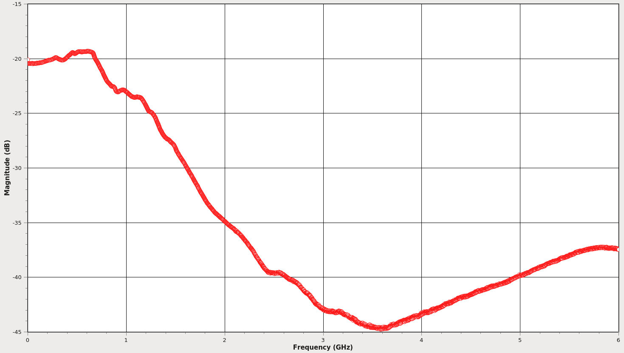

Insertion Loss (flex ground, across 50Ω termination)
flexground.s2p S₂₁
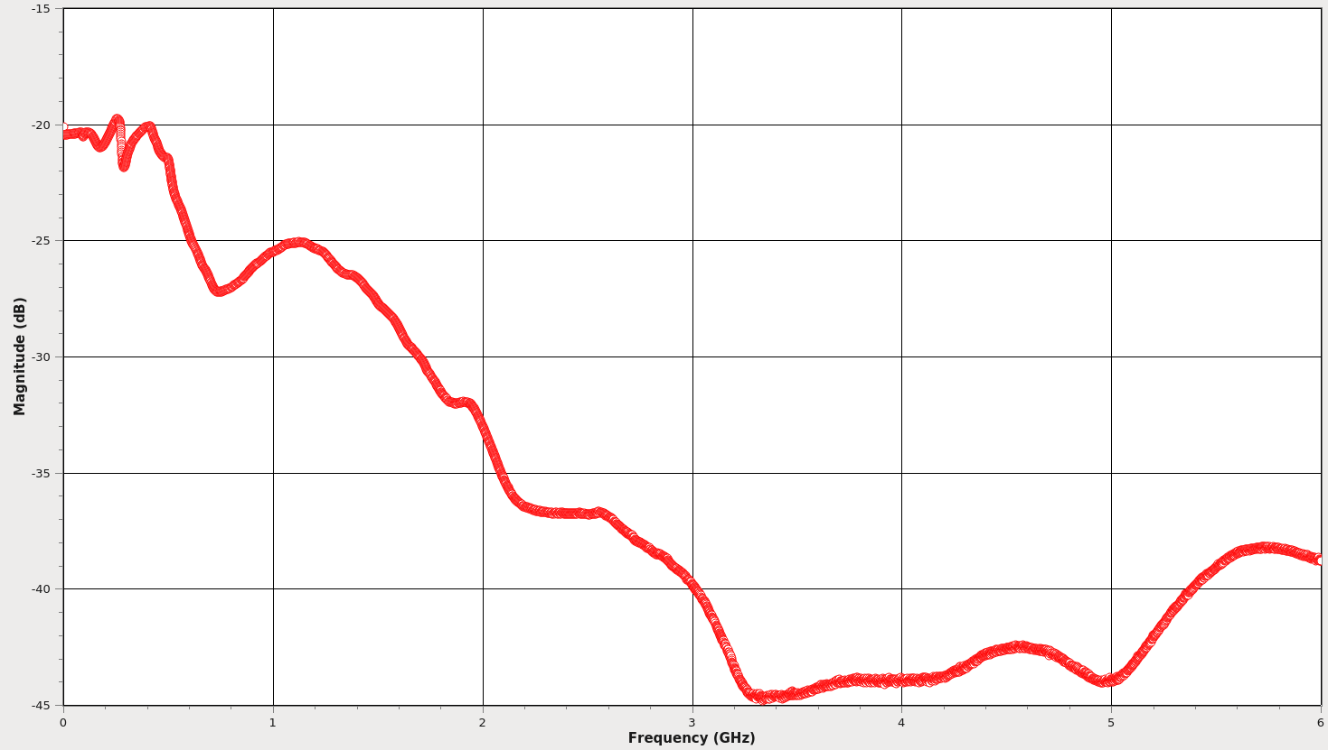

Return Loss (tip ground, across open circuit)
zin.s2p S₁₁

