CERTIFICATE OF CALIBRATION
Antikernel Labs
PO Box 4665
10355 NE Valley Rd
Rollingbay, WA 98061-0665
https://www.antikernel.net/
sales@antikernel.net

This document certifies that the instrument described has been verified to comply with all published datasheet specifications using traceably calibrated equipment.

Instrument Description 2 GHz Transmission Line Probe
Model AKL-PT1
Serial Number 0007

Calibration Performed By A. Zonenberg Date 2020-07-30 15:50
Test Conditions 21ºC, 46% R H Cal Due 2021-07-30

Calibration Standards
Type | Manufacturer | Model | Serial | Cal due date
Multimeter | Rohde & Schwarz | HMC8012 | 36174847 | 2021-04-15
Vector Network Analyzer | Pico Technology | PicoVNA 106 | 09335 | 2021-04-17
Oscilloscope | Teledyne LeCroy | WaveRunner 8404M-MS | LCRY4254N20447 | 2021-07-16
Pulse Generator | Leo Bodnar | SMA Pulse Generator | N/A | N/A

Test Results
All measurements are of probe body only, with cable and fixture de-embedded.
Test | Minimum | Actual | Maximum | Result
DC resistance | 448.87 Ω | 450.35 Ω | 452.25 Ω | PASS
S₂₁ (1 MHz) | -23.0 dB | -20.46 dB | -20 dB | PASS
S₂₁ (500 MHz) | -23.0 dB | -20.72 dB | -20 dB | PASS
S₂₁ (1.0 GHz) | -23.0 dB | -21.25 dB | -20 dB | PASS
S₂₁ (1.5 GHz) | -23.0 dB | -21.56 dB | -20 dB | PASS
S₂₁ (2.0 GHz) | -23.0 dB | -22.73 dB | -20 dB | PASS
Bandwidth (-23.5 dB) | 2.0 GHz | 2.23 GHz | N/A | PASS
Rise time (20-80%) | N/A | 117 ps | 175 ps | PASS

Typical Waveform

Nominal 40 ps risetime pulse. Top waveform includes cable effects, bottom is de-embedded.
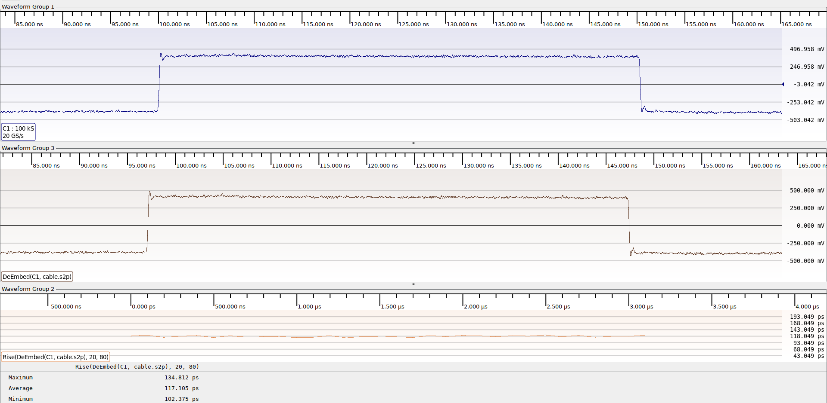

S-Parameter Data
Machine readable S2P files for de-embedding may be downloaded at:
https://github.com/azonenberg/starshipraider-caldata/tree/master/handheld-resistive-probe/007/

Insertion Loss (tip ground, across 50Ω termination)
tipground.s2p S₂₁
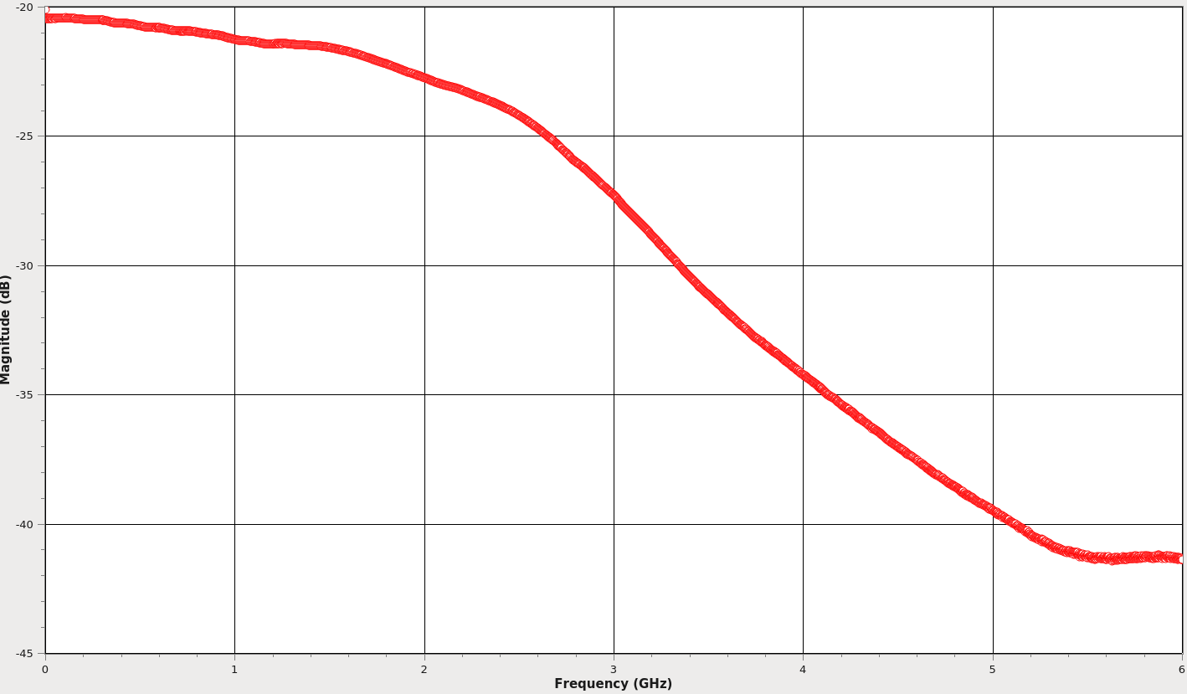

Insertion Loss (leaf ground, across 50Ω termination)
leafground.s2p S₂₁
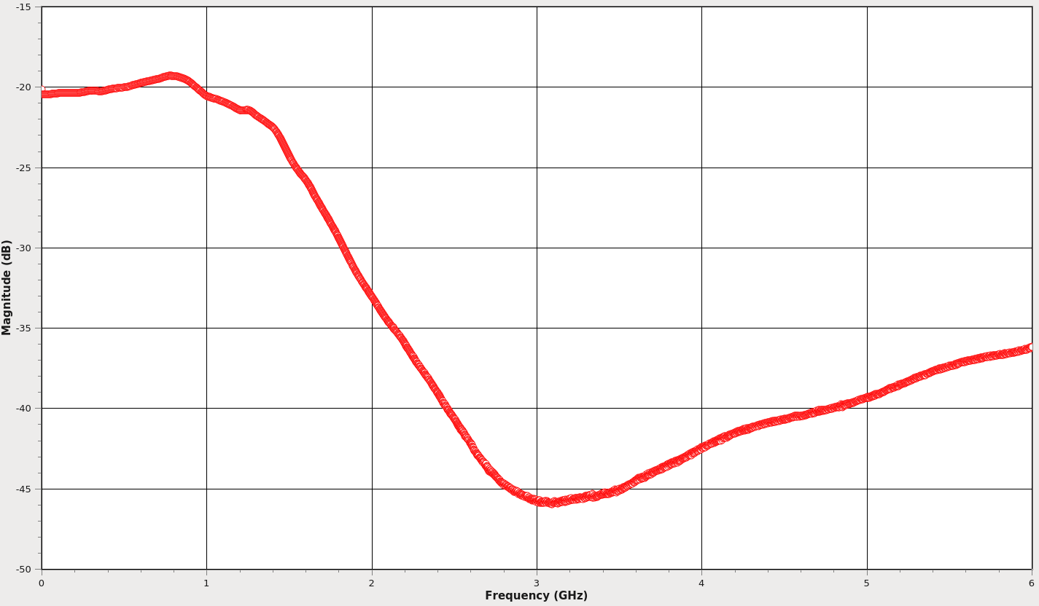

Insertion Loss (Z-ground, across 50Ω termination)
zground.s2p S₂₁
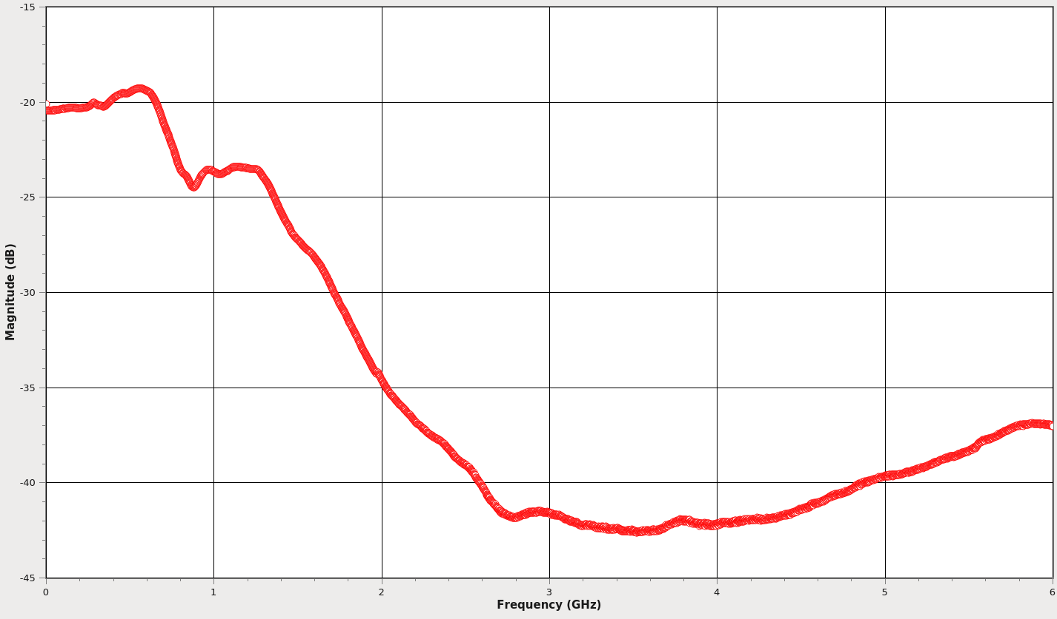

Insertion Loss (flex ground, across 50Ω termination)
flexground.s2p S₂₁
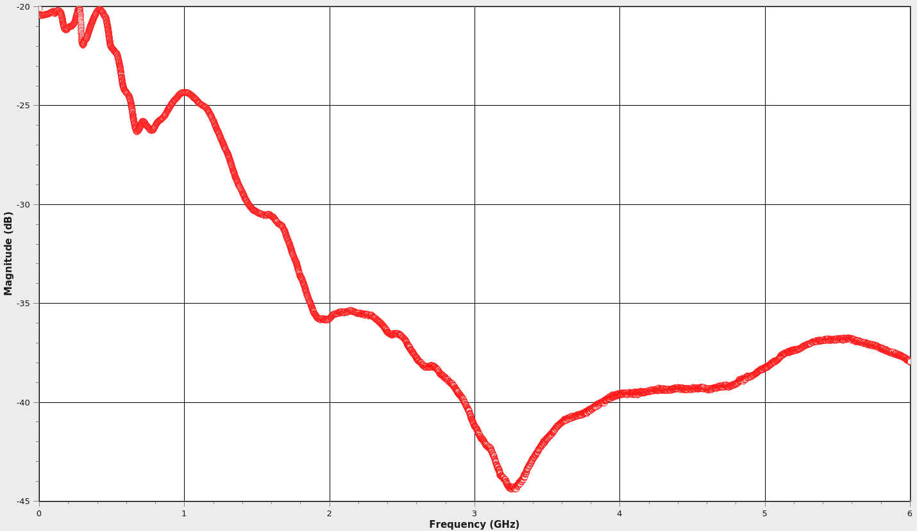

Return Loss (tip ground, across open circuit)
zin.s2p S₁₁
