AKL-PT2 Test Procedure

Background information
- Record probe serial number, date, time, temperature, and relative humidity

DC Resistance
- Equipment needed:
  - 5 ¾ digit multimeter (example: Rohde & Schwarz HMC8012)
- Set multimeter to resistance mode.
- Touch tips of probes together and press “NULL” button to remove lead resistance.
- Place one probe on tip-side ground contact and the other on the top flat of the SMA as shown. Wait for meter reading to stabilize and record R_gnd value.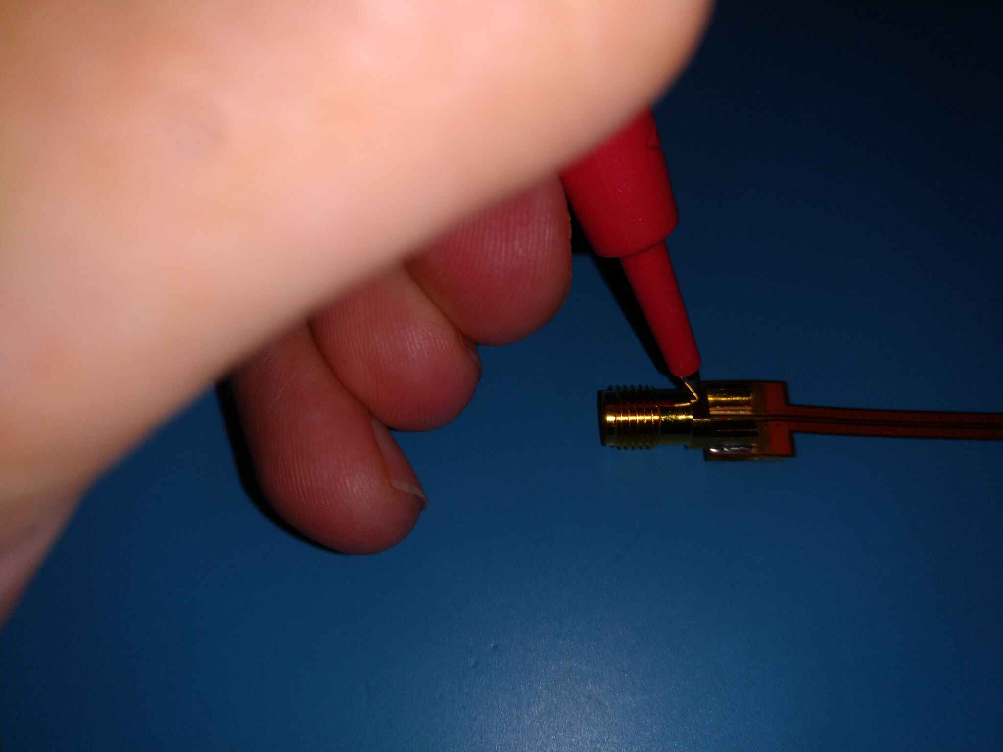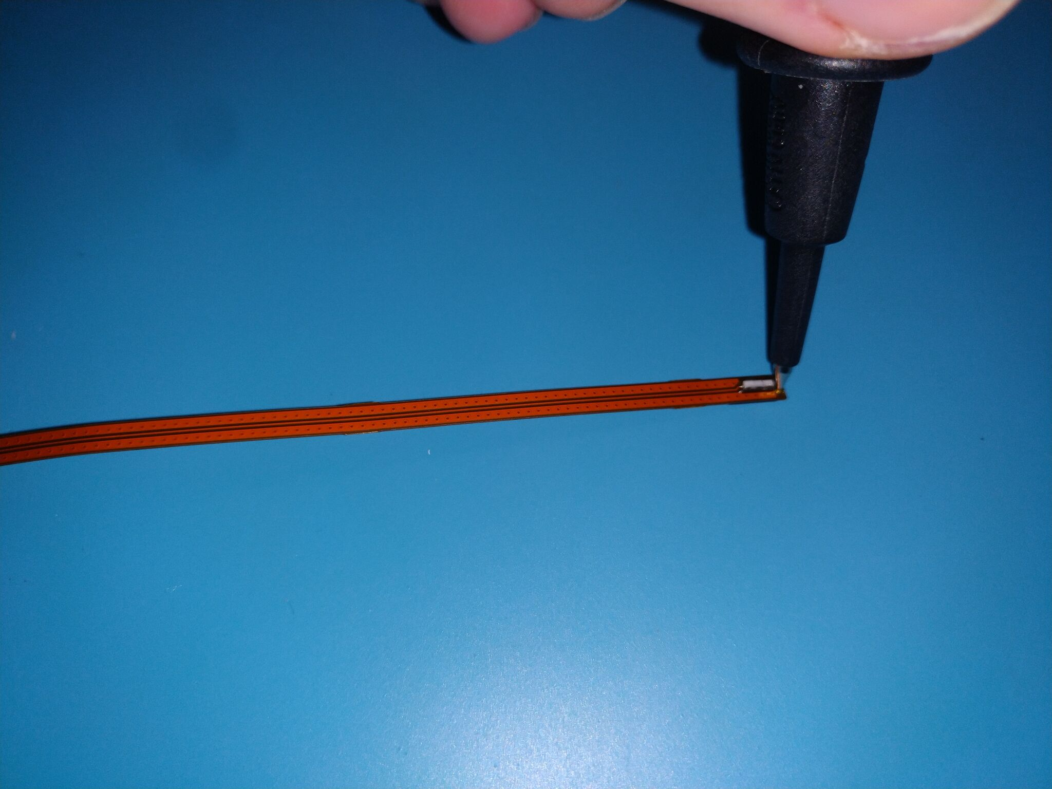
- Place one probe on tip-side signal contact and one on SMA center pin as shown. Wait for meter reading to stabilize and record R_sig value.
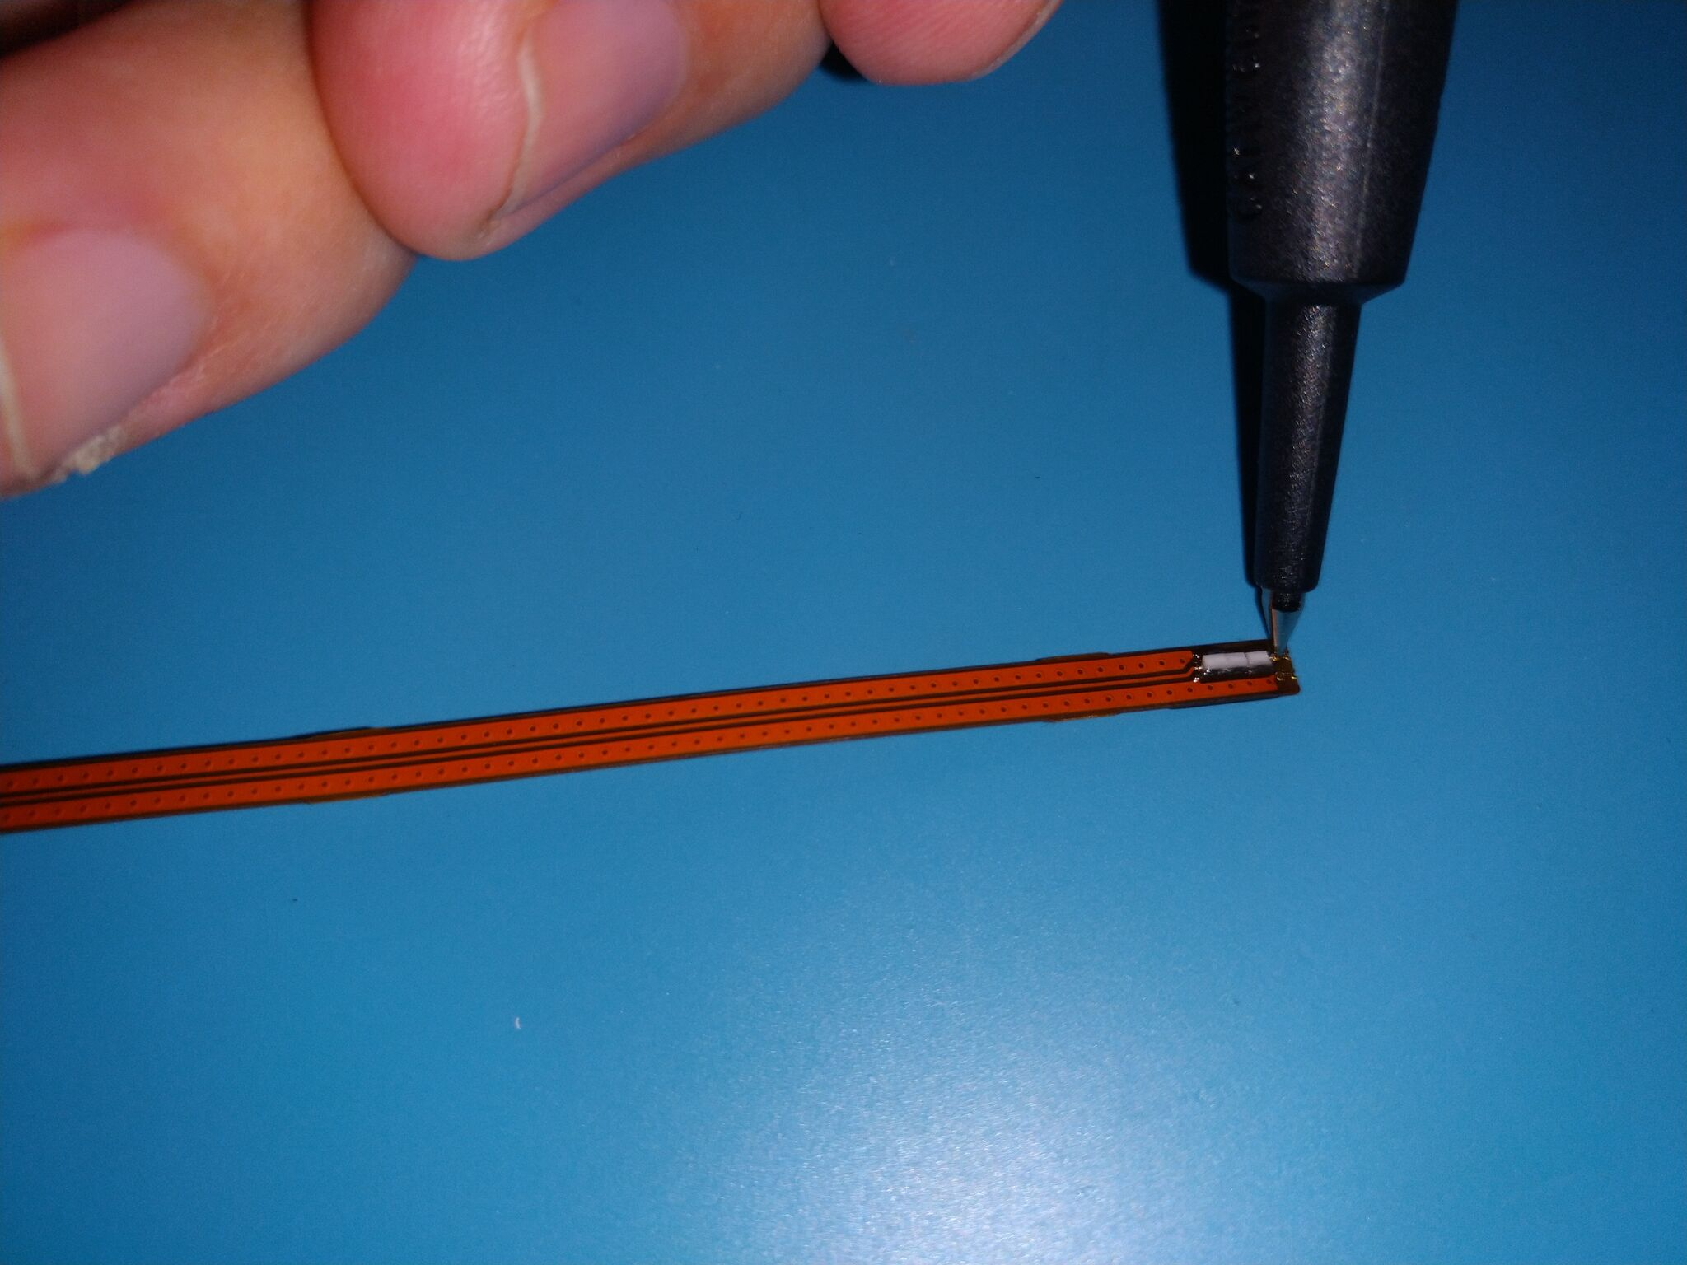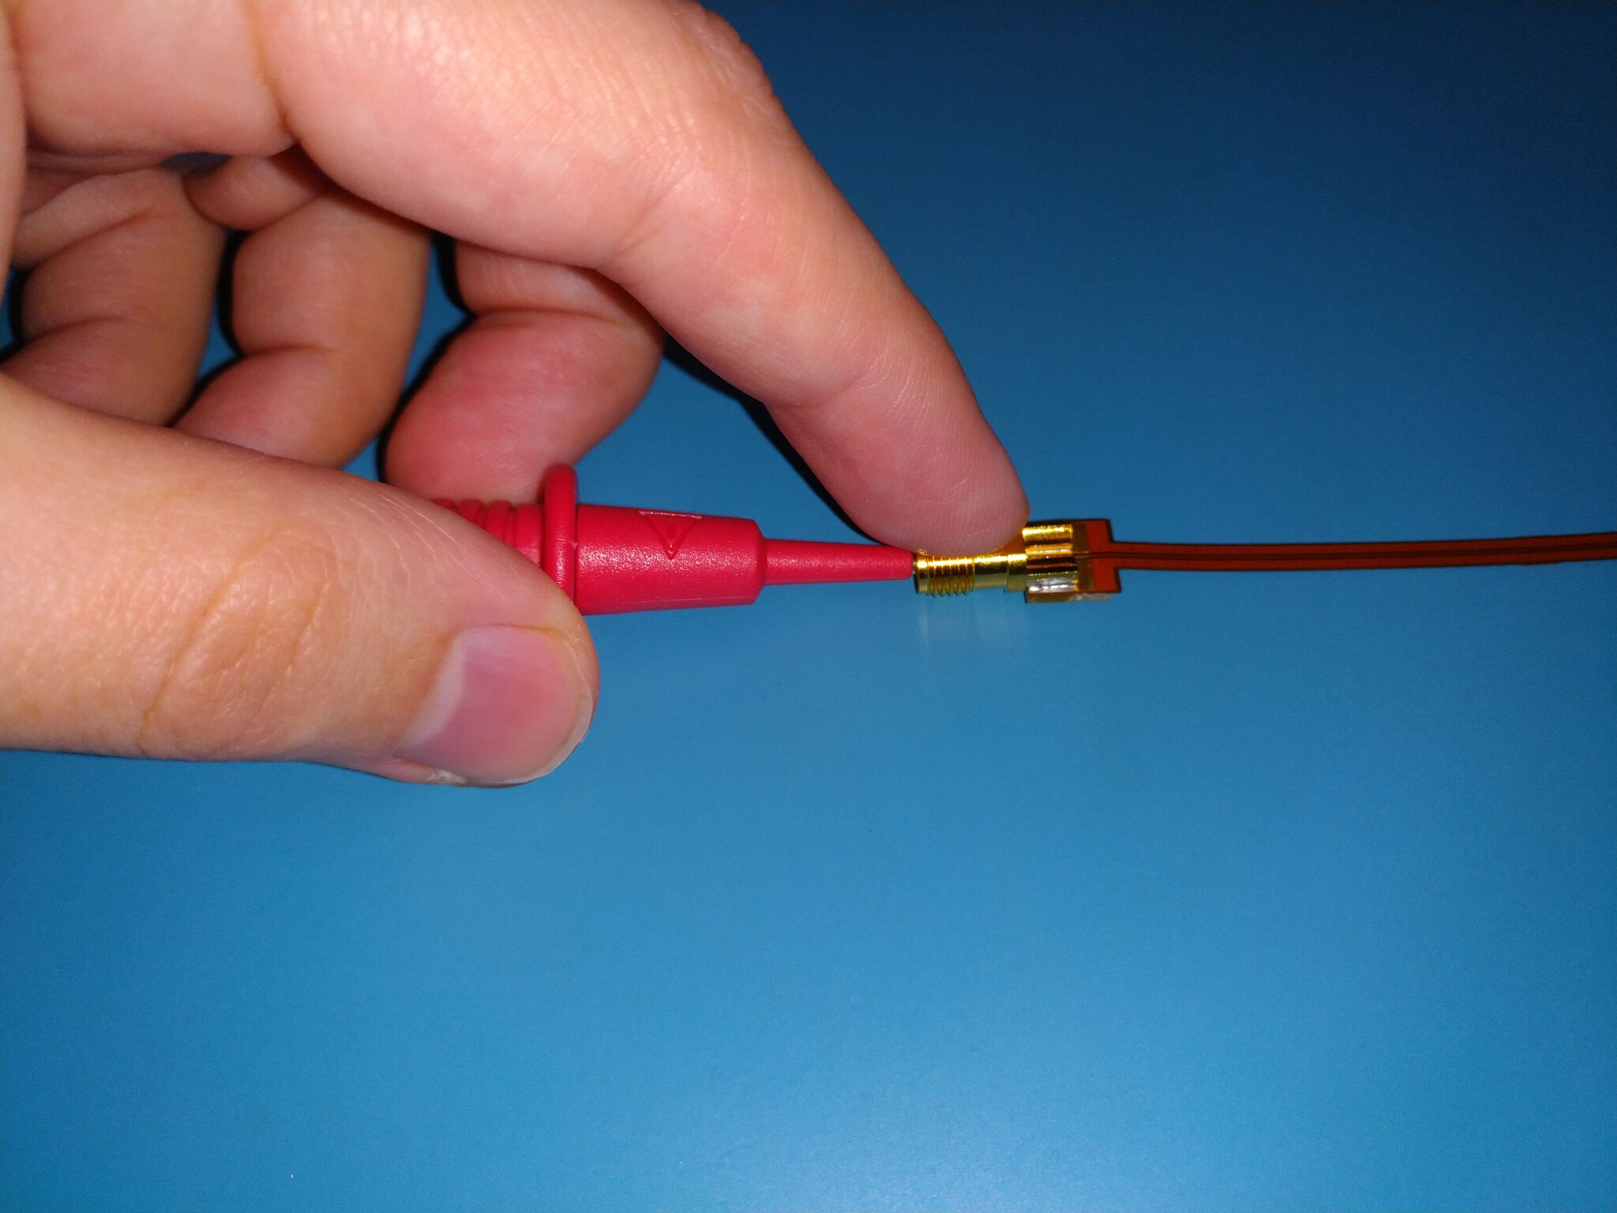

Connector Gaging
- Equipment needed:
  - SMA gage set (ex: Mini-Circuits ACUDIAL-SMA)
- Zero female pin gage against the gage master.
- Measure female pin position and record FP value to nearest .0005” (12.7 μm).
- Repeat for female dielectric.

Open Circuit Return Loss / Impedance
- Equipment needed:
  - Soldering gear
  - Test fixture
  - 2-port 6 GHz VNA (ex: PicoVNA 106) and SOLT standard set
  - Precision SMA male terminator (ex: Rosenberger 32S15R-1.0E3)
  - 5 lbf-in (0.57 Nm) torque wrench
- Perform single port SOLT calibration on VNA port 1 per manufacturer procedure.
- Apply 23.99 mm reference plane extension to VNA port 1 to shift reference plane to tip of probe.
- Secure bottom side of probe to Stickvise with double-sided tape and solder tip of probe to 6mm open on fixture as shown.
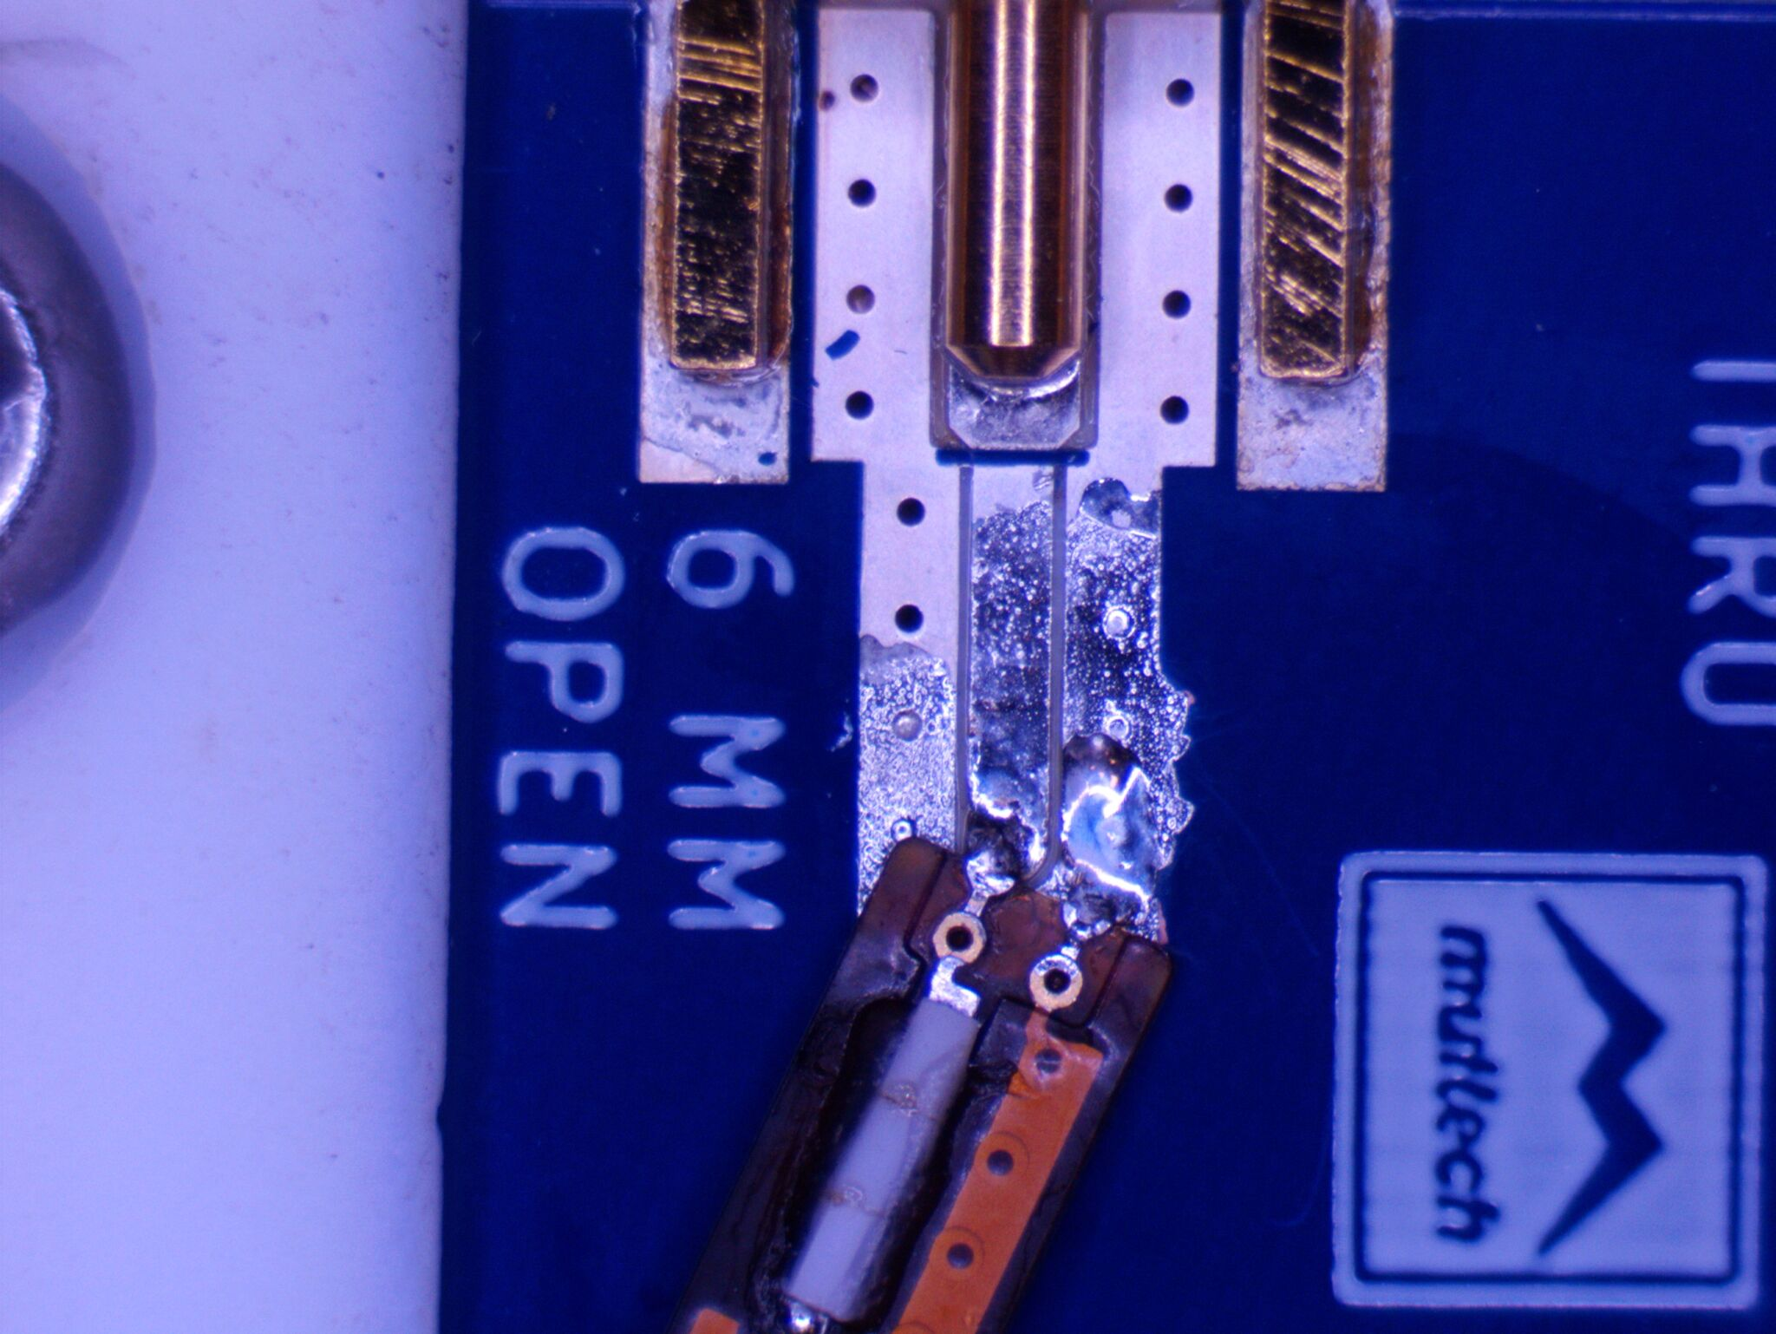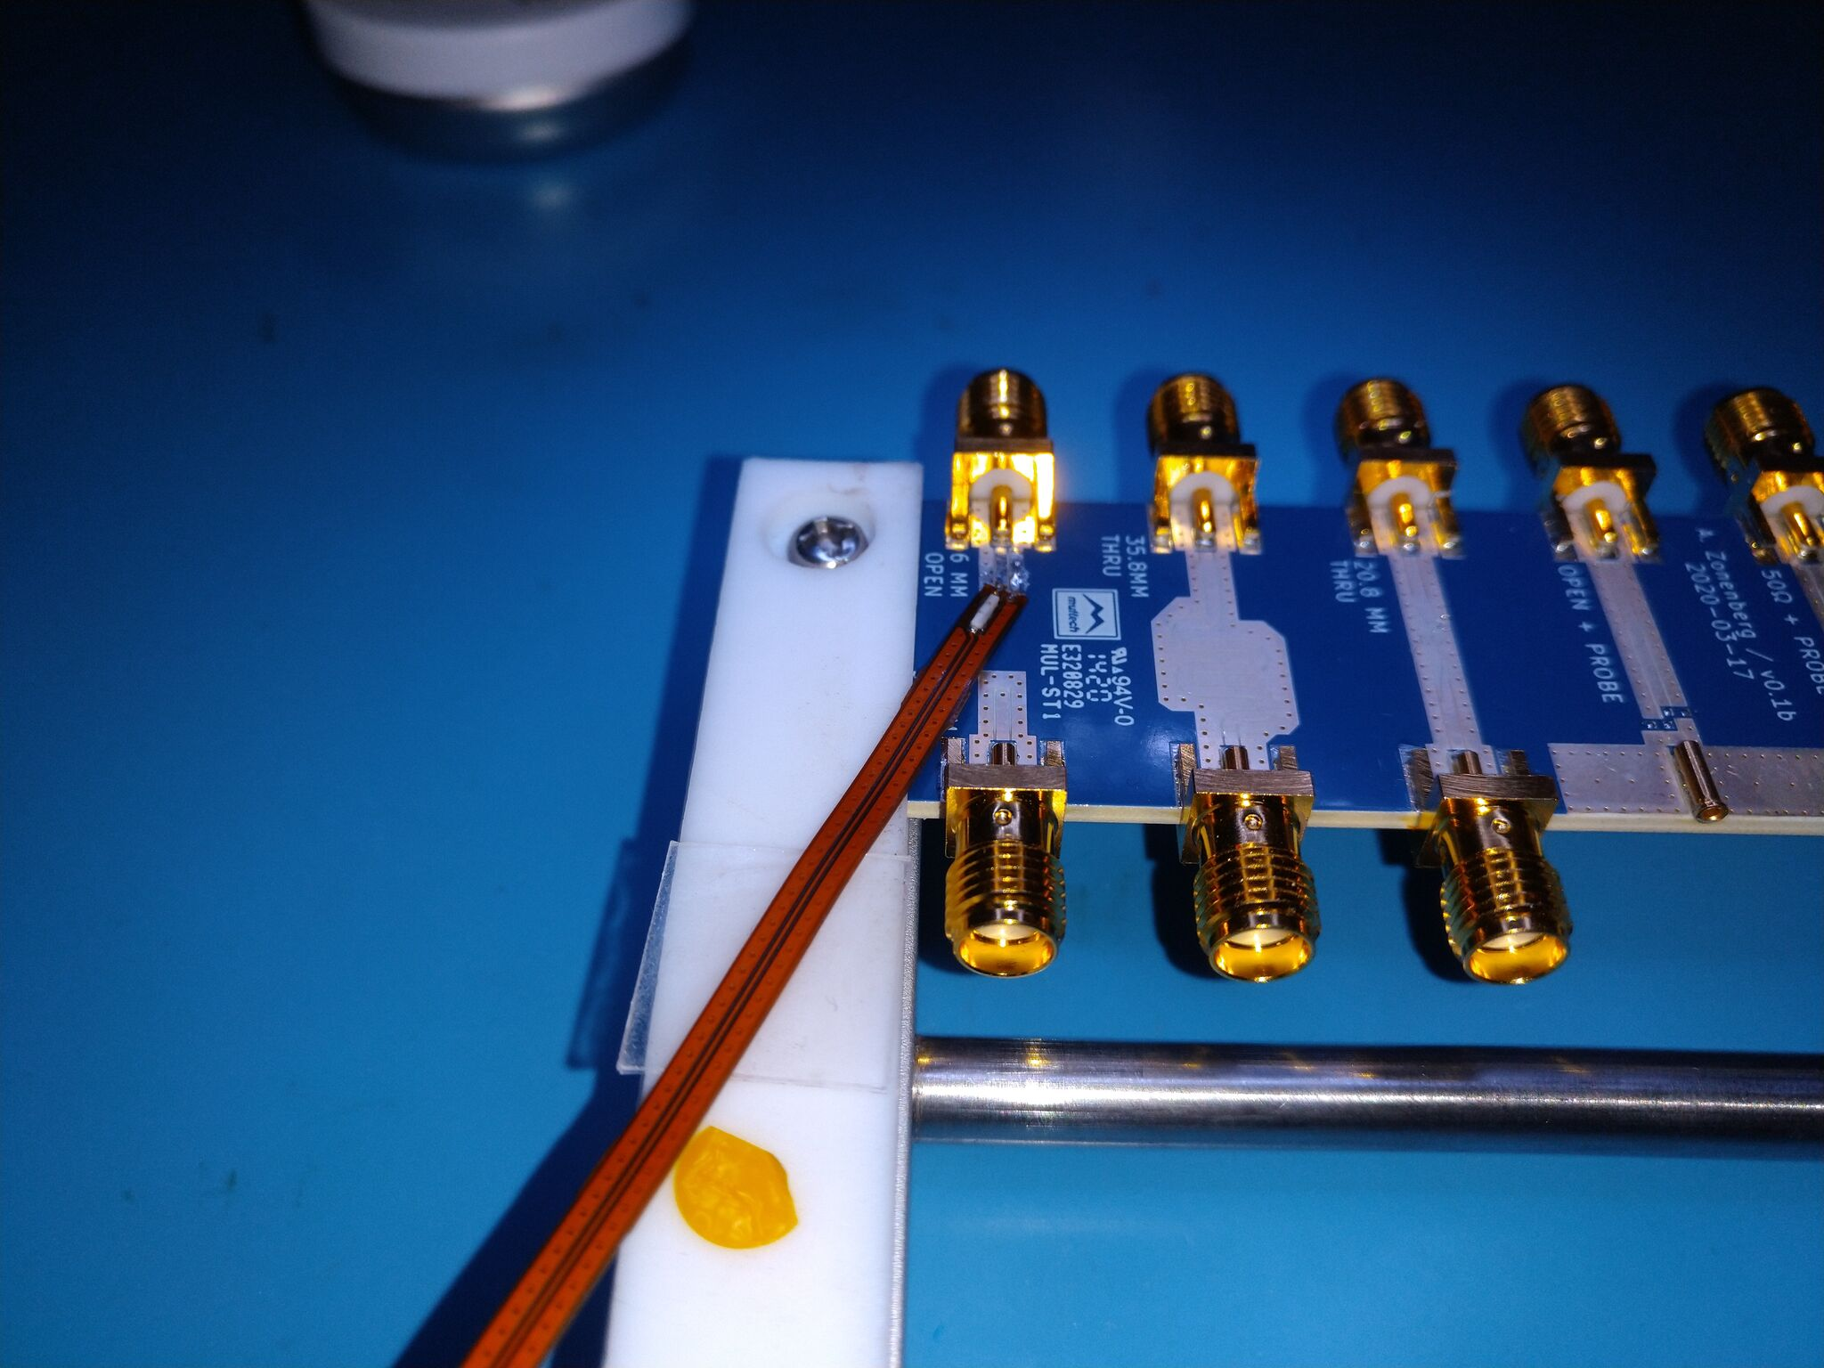
- Connect terminator to SMA on probe and VNA port 1 to SMA on fixture. Torque both connections to 5 lbf-in (0.57 Nm).
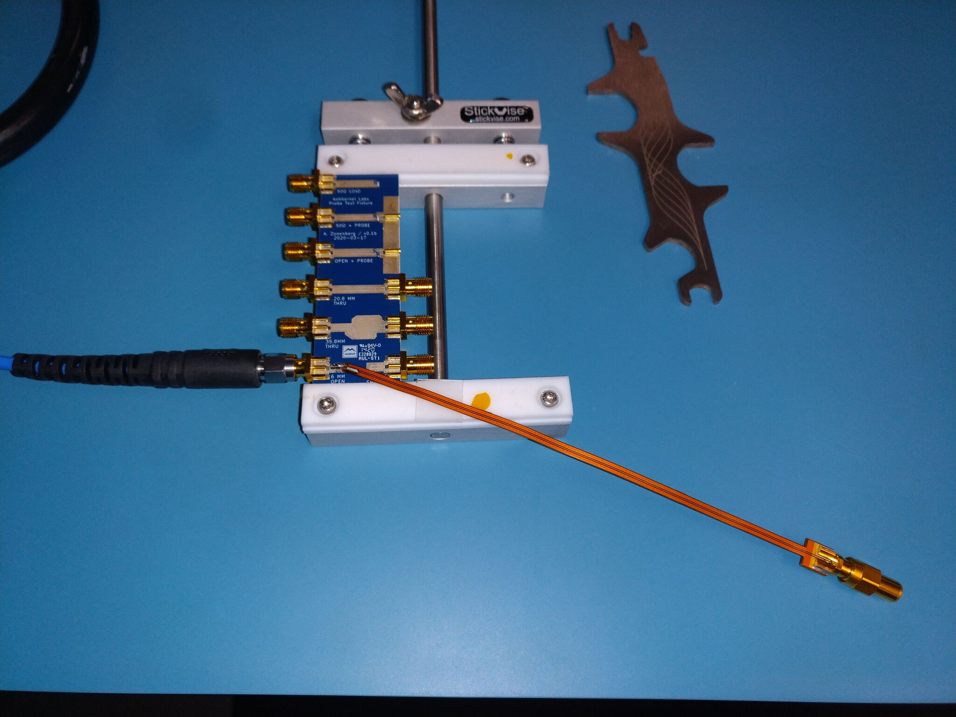
- Record 1-port S-parameters as {probe serial}-zin.s1p.

Insertion Loss
- Equipment needed:
  - Soldering gear
  - Test fixture
  - 2-port 6 GHz VNA (ex: PicoVNA 106) and SOLT standard set
  - 5 lbf-in (0.57 Nm) torque wrench
- 13.29 mm refext

