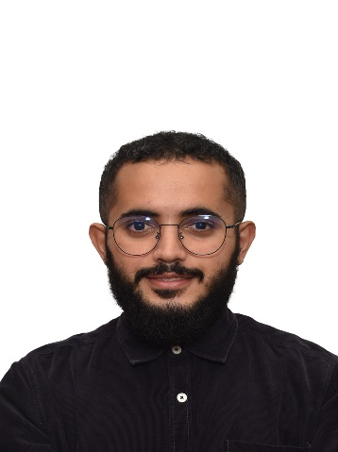

B.ENG(HONS.) Mechatronics Engineering, Faculty Of Manufacturing Engineering, with **3.76 CGPA out of 4**

* **Computer Numerical Control Machine(CNC)**
* **Computer Aided Manufacturing**
* CATIA:

Building a machining simulation, and generating G code.

* **Vibration Testing Design**
* CATIA , ANSYS:

Designing a part by Catia and testing the effect of vibration.

* **Microsoft Office**
* Word, PowerPoint, Excel
* **Mobile Development**
* Flutter:

Building an Android and IOS app system with firestore as a backend.

* **Programming Languages**
* C, Python, Matlab , JavaScript
* **Web Development**
* HTML, CSS, SQL, Python :

Building a responsive webpage using HTML and CSS and control it by flask as a backend

* **Computer Aided Design**
* AutoCAD , CATIA, SolidWorks:

Designing Mechanical parts

* **Circuit Design**
* NI Multisim:

Designing electric circuits for various purposes

TECHNICAL SKILLS

As a student, learning and getting experience is the main goal in this stage .So, I pursue to learn anything that is related to engineering, with the ability to learn in no time and under high pressure .Also, I am glad to give all I have to improve the community to better future.

2018

2018

2017

2016

2017-2020

2011-2014

2018

2017 - 2020

Applying thermodynamic knowledge for Building a steam car

**CONTACT**

**SOFT SKILLS**

**Phone**

+601124547686

**Email**

[aziz.alhaj25@gmail.com](mailto:aziz.alhaj25@gmail.com)

TEAMWORK

SKILLS

PROBLEM SOLVING

SKILLS

LEADERSHIP

SKILLS

COMMUNICATION

**LANGUAGES**

ARABIC

SKILLS

ENGLISH

SKILLS

**HOBBIES**

* Arabic Calligraphy
* Reading
* Jogging

**AFFILIATION &MEMBERSHIPS**

* The Institution Of Engineers, Malaysia (Student Member)

**REFERENCE**

**DR. MOHD YAZID BIN ABU**

ACADEIMIC ADVISOR

**Phone:** +60 9-4245815

**Email:** myazid@ump.edu.my

Participated on an Matlbab workshop

**Institution Of Engineers, Malaysia**

Participated on an Dasylab workshop

**University Malaysia Pahang**

Participated on an Arduino workshop

**University Malaysia Pahang**

Had four English levels and IELTS certificates with band **5.00**

**Erican College**

COURSES

Building an AC-DC converter

Creating GUI systems to simulate lathe machine

**Fundamental Of Electric Engineering Lab**

[**Computer**](https://kalam.ump.edu.my/course/view.php?id=1423) **Simulation**

Creating an IOT system

[**Programming For Engineers**](https://kalam.ump.edu.my/course/view.php?id=1423)

**Thermodynamic**

PROJECTS

HONORS & AWARDS

EXPERIENCE

Worked In Publicity Department of Engineering Week

**Institution Of Engineers,** **Malaysia**

Received **5** Dean’s List certificates in Mechatronics Engineering

**University Malaysia Pahang**

**University Malaysia Pahang , Pekan , Pahang , Malaysia**

**UUniversity**

Receiving a certificate with **98.24%**

**Alimama Abdullah Bin Saud High School , Jeddah , KSA**

EDUCATION

**MECHATRONICS ENGINEER**

**Abdulaziz Salman**