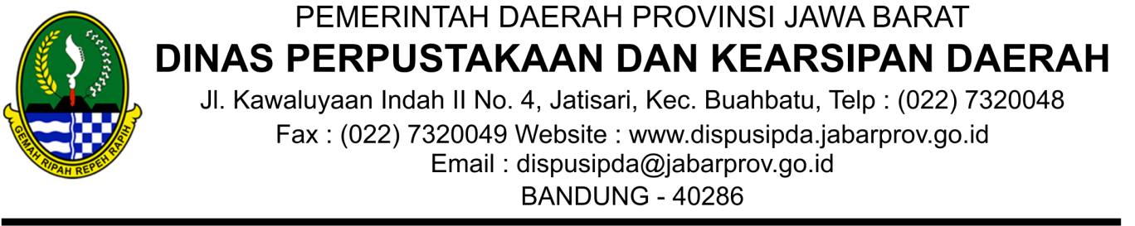

Nomor : 1212/KUKM.01.02/PAD

Kepada

Bandung, 29 Maret 2023

Sifat : Penting Lampiran : -

Hal : Undangan

Yth. Dr. IKA MARDIAH, M.Si.

di

Bandung

Lorem Ipsum is simply dummy text of the printing and typesetting industry. Lorem Ipsum has been the industry's standard dummy text ever since the 1500s, when an unknown printer took a galley of type and scrambled it to make a type specimen book. It has survived not only ﬁve centuries, but also the leap into electronic typesetting, remaining essentially unchanged. It was popularised in the 1960s with the release of Letraset sheets containing Lorem Ipsum passages, and more recently with desktop publishing software like Aldus PageMaker including versions of Lorem Ipsum.

KEPALA DINAS PERPUSTAKAAN DAN KEARSIPAN DAERAH

Ditandatangani secara elektronik oleh:

KEPALA DINAS PERPUSTAKAAN DAN KEARSIPAN DAERAH

Dr. HENING WIDIATMOKO, M.A.

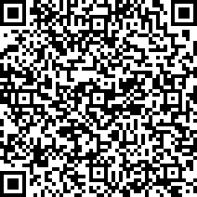

3D8C630084

Dokumen ini telah ditandatangani secara elektronik menggunakan sertifikat elektronik yang diterbitkan oleh Balai Sertifikasi Elektronik (BSrE) Badan Siber dan Sandi Negara. Dokumen digital yang asli dapat diperoleh dengan memindai QR Code, memasukkan kode pada Aplikasi NDE Pemerintah Daerah Provinsi Jawa Barat, atau mengakses tautan berikut

https://devsidebar.digitalservice.id/v/3D8C630084