Connect E28-2G4M12S module to Wemos S2

E28-2G4M12S module:
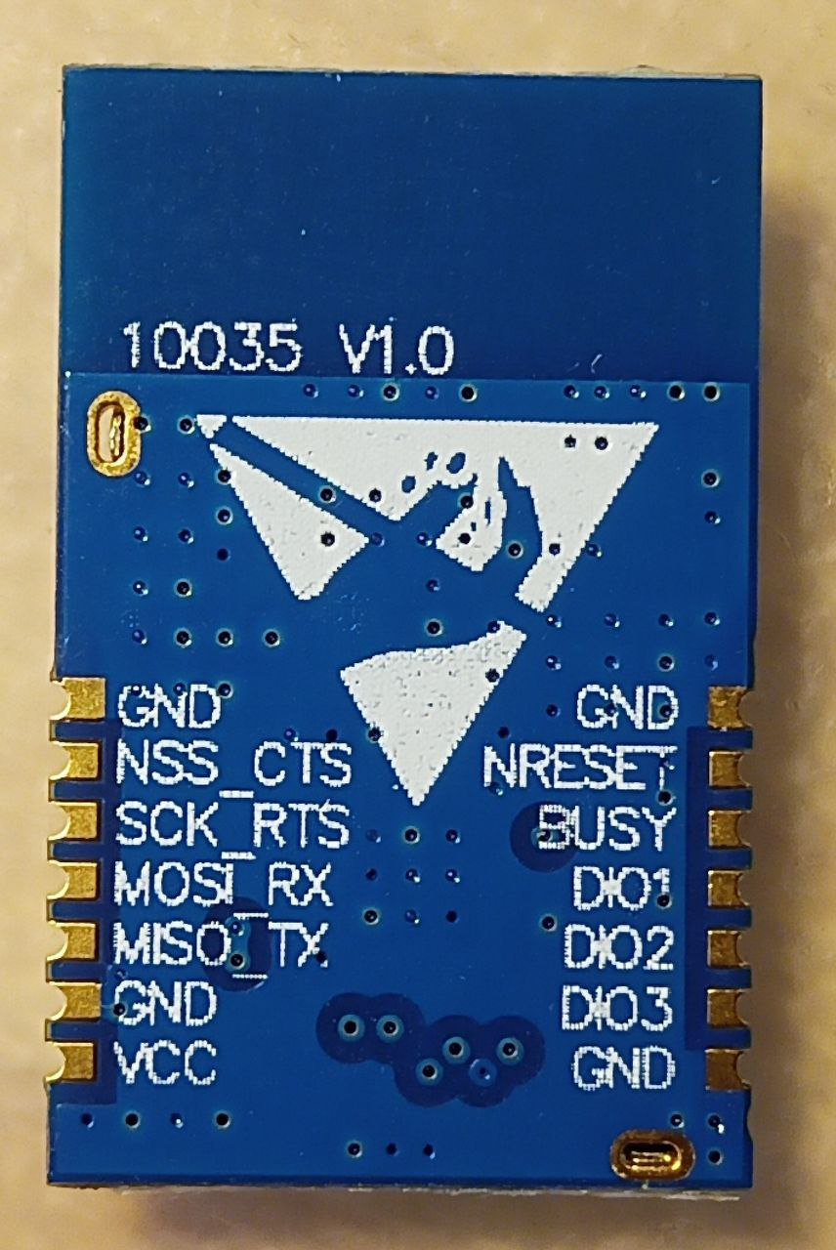

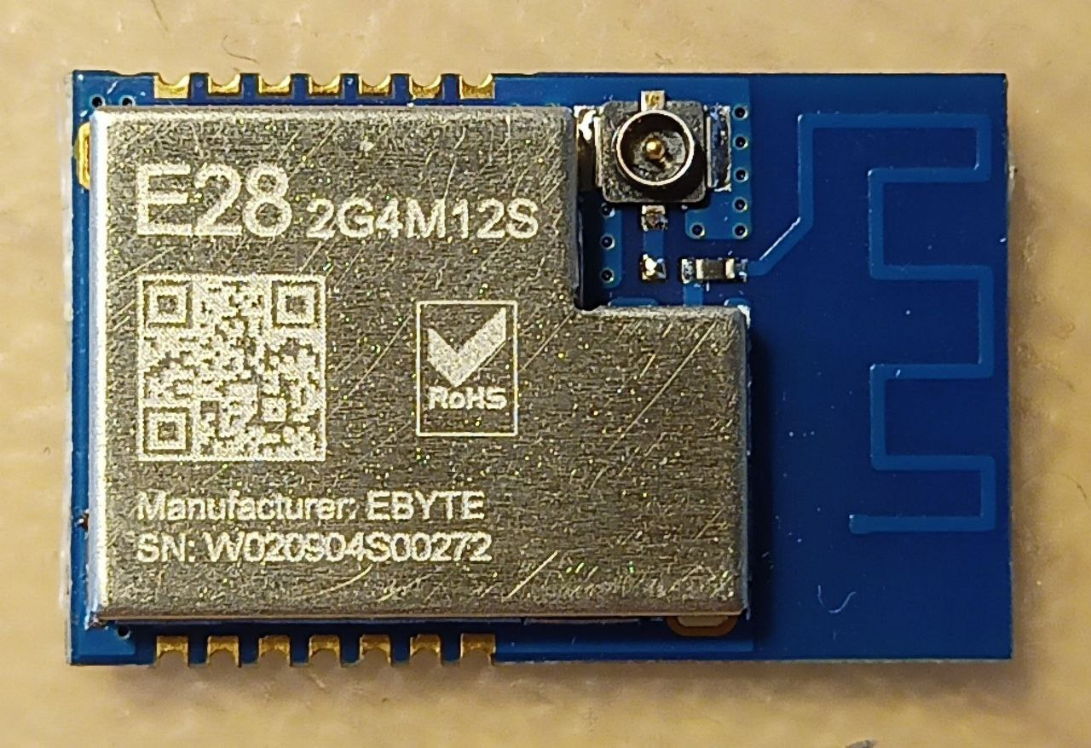

Wemos S2 mini ESP32 module:
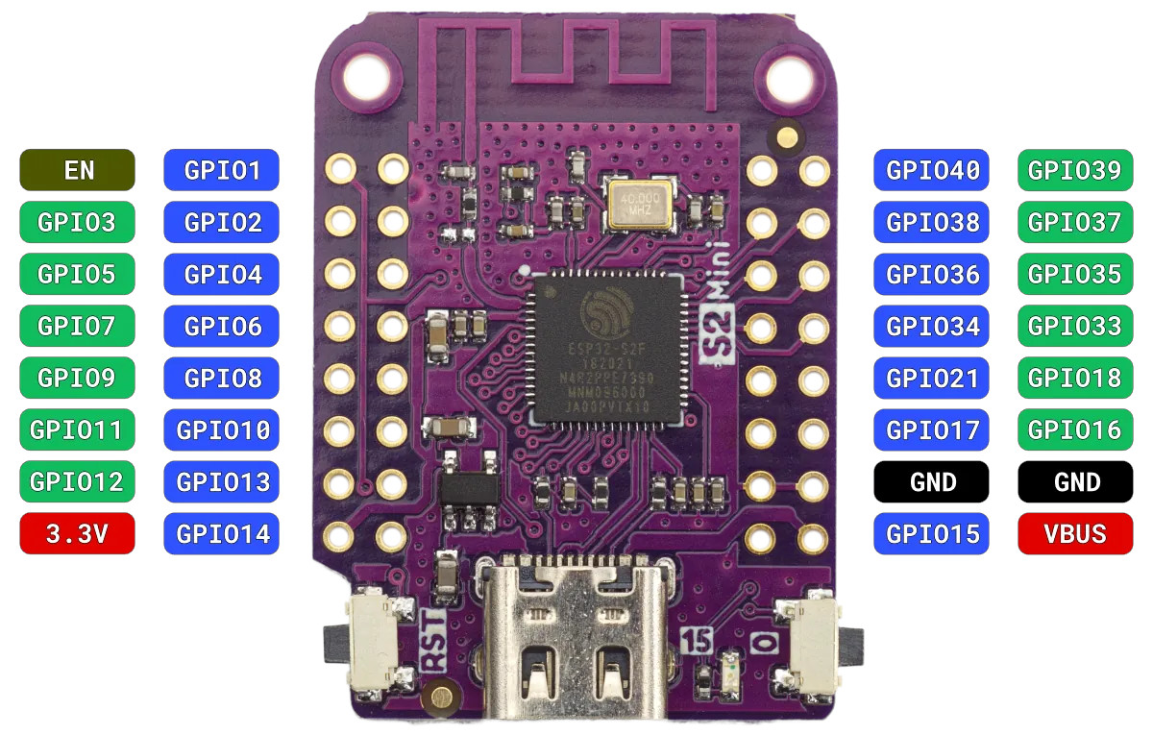

Connect table:

ESP32 | S2 mini | E28 | Comment | Pin name | Other
3V3 | 3.3V | VCC | +3.3V power | -
GND | GND | GND | ground | -
GPIO14 | 14 | MISO_TX | SPI MISO (in) | MISO
GPIO13 | 13 | MOSI_RX | SPI MOSI (out) | MOSY
GPIO12 | 12 | SCK_RTS | SPI SCK (out) | SCK
GPIO | 10 | NSS_CTS | SPI NSS (out) | NSS
GND | GND | GND | ground | -
GPIO11 | 11 | DIO1 | SX interrupt (in) | DIO1
GPIO8 | 8 | BUSY | SX Busy (in) | BUSY
GPIO9 | 9 | NRESET | SX neg. reset (out) | NRST

