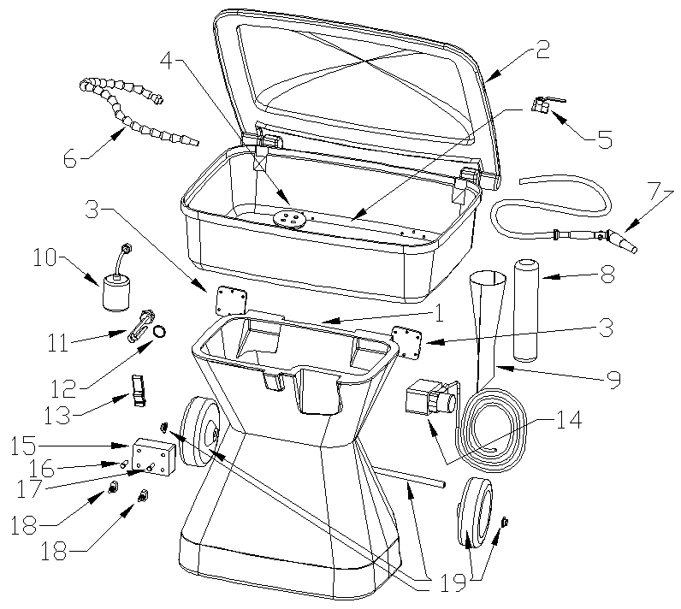

ITEM DESCRIPTION PART NO.

1 Parts Washer Bottom-Molded PW-2001

2 Parts Washer Sink w/ Lid PW-2002
3 Parts Washer Hinge ( 1 Supplied) PW-2003
4 Sink Drain Assy. PW-2004
5 Valve PW-2005
6 Articulated Hose Assy. PW-2006
7 Brush Hose Assy. PW-2007
8 Sink Sock Filter PW-2008
9 Sink Sock Sleeve PW-2009
10 Shut-Off Switch PW-2010
11 Heater Element PW-2011
12 Heater Element Washer PW-2012
13 Sink Latch PW-2013
14 Pump PW-2014
15 Switch Box Enclosure PW-2015
16 LED Green Indicator PW-2016
17 LED Red Indicator PW-2017
18 Covered Switch ( 1 Supplied) PW-2018
19 Wheel/Shaft Assy. ( 2 Wheels, Axle, PW-2019
2 Wheel Nuts)
20 Thermostat PW-2020

