EE/CSE 469 Computer Architecture I

HW 3

1. With the single-cycle CPU shown in lecture, highlight the paths used by the following instructions. Also, fill out the corresponding control signal table:

# a. AND R10, R9, #3

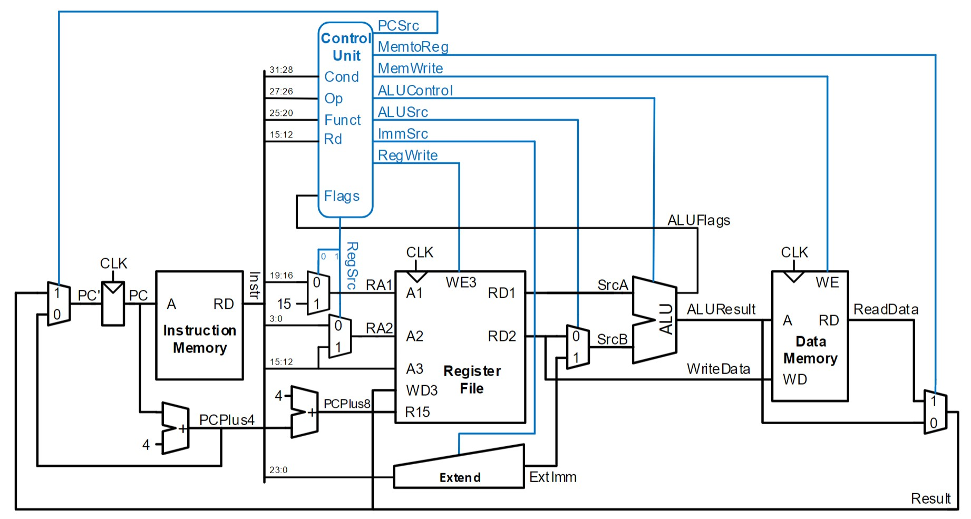

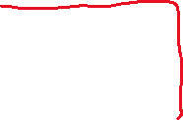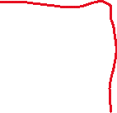

|  |  |  |  |  |  |  |  |
| --- | --- | --- | --- | --- | --- | --- | --- |
| **PCSrc** | **MemtoReg** | **MemWrite** | **ALUControl** | **ALUSrc** | **ImmSrc** | **RegWrite** | **RegSrc** |
| 0 | 0 | 0 | 10 | 1 | 00 | 1 | 00 |

# b. ADD R1, R3, R4

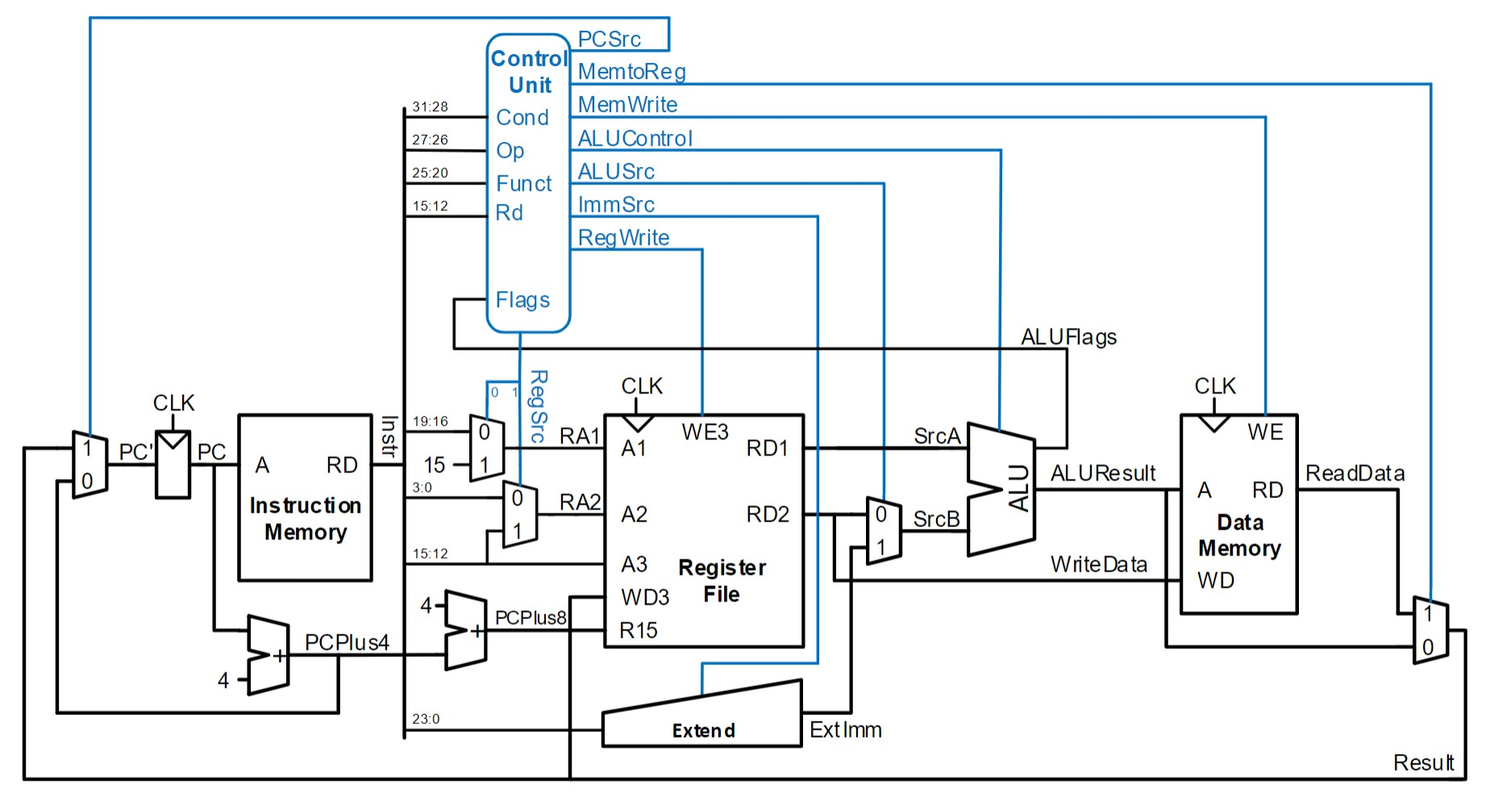



|  |  |  |  |  |  |  |  |
| --- | --- | --- | --- | --- | --- | --- | --- |
| **PCSrc** | **MemtoReg** | **MemWrite** | **ALUControl** | **ALUSrc** | **ImmSrc** | **RegWrite** | **RegSrc** |
| 0 | 0 | 0 | 00 | 0 | 00 | 1 | 00 |

# STR R4, [R11, #0]



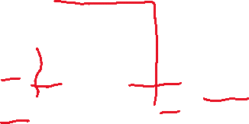

|  |  |  |  |  |  |  |  |
| --- | --- | --- | --- | --- | --- | --- | --- |
| **PCSrc** | **MemtoReg** | **MemWrite** | **ALUControl** | **ALUSrc** | **ImmSrc** | **RegWrite** | **RegSrc** |
| 0 | 0 | 1 | 00 | 1 | 01 | 0 | 10 |

2. We would like to implement a new custom ARM instruction, SOIRIP Rd, Rn, Rm (Subtract Only If Result Is Positive). This is like a normal subtract instruction, except if the result of the subtraction is negative, write a 0 back into the destination register. If the result is positive, write the computed result back into the destination register. The bit encodings for Rd, Rn, and Rm are the same as SUB with I=0, and Instruction[4] = 0. Your custom instruction may overwrite SUB (and SUBS).

a. Examples: Let R1 = 4, R2 = 5, R3 = 6

1. SOIRIP R5, R1, R2

This would result in R5 = R1 - R2, which comes out to be -1, so the value 0 would be stored in R5.

1. SOIRIP R6, R3, R2

This would result in R6 = R3 - R2, which comes out to be 1, so the value 1 would be stored in R6.

Modify the datapath shown in class (provided below), adding additional control signals and hardware as necessary.

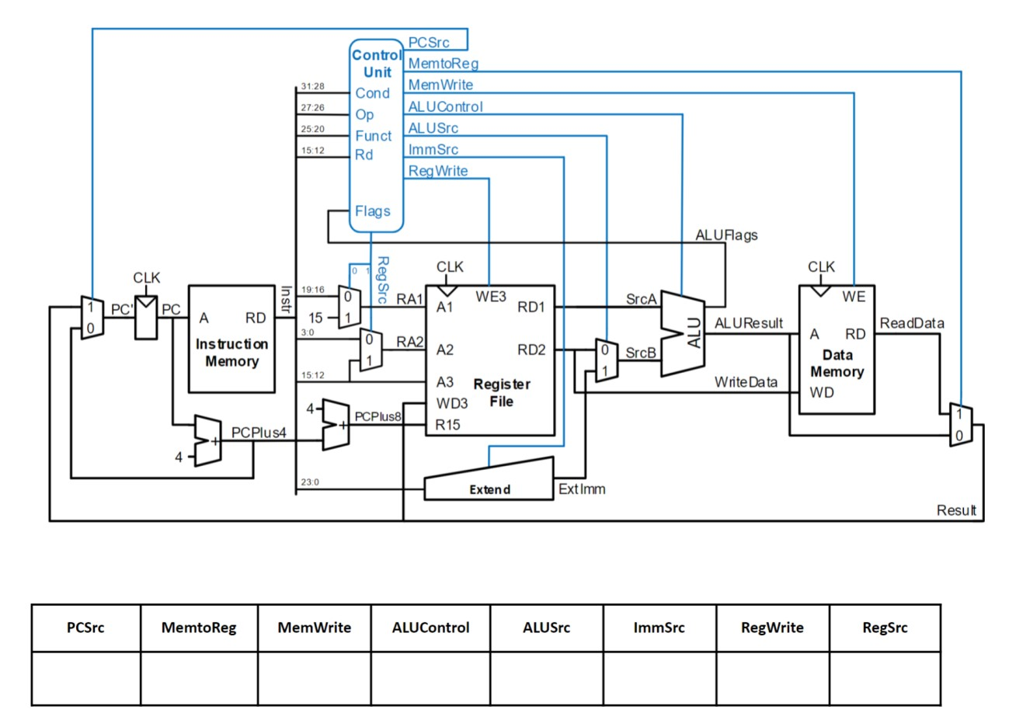

ALUFlags[3]

00

01

10

11

0

1

0

|  |  |  |  |  |  |  |  |
| --- | --- | --- | --- | --- | --- | --- | --- |
| **PCSrc** | **MemtoReg** | **MemWrite** | **ALUControl** | **ALUSrc** | **ImmSrc** | **RegWrite** | **RegSrc** |
| 0 | 0 | 0 | 01 | 0 | 00 | 1 | 00 |

