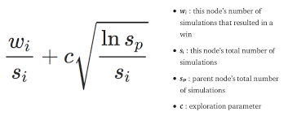
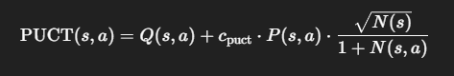
- Q(s,a):
The mean value of actionaa from state s, based on simulations so far (i.e., average reward of child node).
- P(s,a):
The prior probability of selecting action a from state s, given by the policy network.
- cpuct​:
The exploration constant. It balances exploration (trying new moves) and exploitation (favoring high-value moves). Higher values encourage more exploration.
- N(s):
The total number of visits to node s, summed over all its children.
- N(s,a):
The number of times action a has been selected from state s.

