GRACE: A Narrative-Centered Socio-Technical Ecosystem for Elder Wellbeing
First Author
Second Author
2023-06-23
Abstract
Population aging is increasing demand for digital systems that support older adults’ wellbeing. Most existing systems emphasize safety, monitoring, and service coordination, but underrepresent identity, meaning, contribution, and relationship quality. This paper proposes GRACE (Growing, Resourceful, Active, and Enriched Life), a narrative-centered socio-technical ecosystem for elder wellbeing. GRACE is designed as an intelligent multiagent community computing framework that supports older adults in maintaining relationships with the spiritual self, family and friends, working colleagues, communities, and the wider world, including markets and public services. The paper makes four contributions. First, it introduces a narrative-centered theory of elder wellbeing grounded in relationship quality and contribution exchange. Second, it proposes the GRACE Index, a daily measure of whether a person remains “in the zone” of narrative selfhood during ordinary and difficult periods. Third, it extends the framework with three innovations: daily hero’s-journey story creation, an AI-based fast state predictor, and a smart stimulus agent for anticipatory support. Fourth, it presents an agent-based simulation design to evaluate these innovations. We argue that elder-oriented AI should move beyond deficit-oriented monitoring toward socio-technical ecosystems that preserve dignity, agency, reciprocity, and life authorship.
.

I. Introduction
Population aging is reshaping healthcare, labor, family structures, and public services. In response, digital systems for older adults have grown rapidly, especially in telehealth, remote monitoring, medication support, and care coordination. These systems are valuable, but many are built around narrow assumptions: that old age is primarily a condition of decline, risk, and dependency.
That assumption is socially and technically limiting. Older adults are not only patients or service users. They are also storytellers, mentors, workers, caregivers, citizens, spiritual beings, and bearers of memory and legacy. Their wellbeing depends not only on safety and functional support, but also on continuity of identity, meaningful relationships, opportunities to contribute, and the capacity to interpret life events within a coherent story.
This paper proposes GRACE—Growing, Resourceful, Active, and Enriched Life—as a socio-technical ecosystem for elder wellbeing. GRACE is an intelligent community computing framework organized around five relational domains: 1) spiritual self, 2) family and friends, 3) working colleagues, 4) communities, and 5) the wider world, including markets and public services. GRACE is grounded in the premise that elder wellbeing is relational and that the quality of relationships shapes the exchange of care, recognition, participation, and contribution.
The central design claim of GRACE is that narrative identity should be treated as a core systems concept. Older adults should not be modeled merely through static profiles, health states, or risk scores. They should be understood as persons living through unfolding stories. GRACE therefore acts as a live autobiographical ecosystem, helping elders remain connected to selfhood across daily life, transitions, and adversity. A high-level overview is shown in Figure 1, with the multiagent architecture shown in Figure 5 and the dynamic closed-loop logic in Figure 4.
To operationalize this vision, the paper introduces the GRACE Index, a daily measure of whether a person remains “in the zone” of narrative selfhood. The paper further adds three innovations: 1) a Daily Story Creation Engine that frames lived experience through the hero’s journey, 2) an AI-based Fast State Predictor that forecasts near-future wellbeing state, and 3) a Smart Stimulus Agent that initiates timely, personalized prompts to preserve wellbeing and authorship. Finally, the paper proposes an agent-based simulation design to demonstrate these innovations.

Contributions
- A socio-technical framework for elder wellbeing centered on narrative identity, relationship quality, and contribution exchange.
- The GRACE Index, a daily metric of narrative selfhood and adaptive continuity.
- Three AI-enabled innovations—daily story creation, fast state prediction, and smart stimuli—for anticipatory wellbeing support.
- An agent-based simulation design for evaluating these mechanisms before real-world deployment.

II. Related Work

A. Aging Technologies and Deficit-Oriented Design
Technologies for older adults have often focused on safety, surveillance, and functional support (Sixsmith & Gutman, 2013; Czaja et al., 2006; Mitzner et al., 2010). While these systems can improve independence and care delivery, they may also reproduce deficit-oriented assumptions about aging. HCI scholarship has argued that such framings narrow the design space and underplay agency, participation, and dignity (Vines et al., 2015).

B. Social Connectedness and Wellbeing
Social relationships are strongly associated with wellbeing, resilience, and mortality outcomes (Holt-Lunstad et al., 2010). Social isolation and perceived loneliness can negatively affect cognition and health (Cacioppo & Hawkley, 2009). In later life, relationship quality matters as much as contact frequency, including dimensions such as reciprocity, belonging, and social integration (Cornwell & Waite, 2009; Berkman et al., 2000).

C. Narrative Identity and Later Life
Narrative identity theory suggests that individuals construct a sense of self through evolving life stories (McAdams, 2001; Habermas & Bluck, 2000; Singer, 2004). In later life, autobiographical continuity and life review become especially important for meaning-making, legacy, and coping with transition (Butler, 1963; Bohlmeijer et al., 2007). Yet most digital systems do not operationalize narrative identity as a core computational construct.

D. Generativity and Productive Aging
Older adults continue to contribute through mentoring, caregiving, volunteering, advising, and cultural transmission. Generativity is a major source of meaning and self-worth (McAdams & de St. Aubin, 1992; Erikson, 1982). Productive aging research likewise emphasizes the value of creating roles and systems that support continued contribution (Morrow-Howell et al., 2017).

E. Community Computing, Multiagent Systems, and Human-Centered AI
Community informatics has shown how digital infrastructures can support participation, local engagement, and social inclusion (Gurstein, 2007; Carroll, 2014). Multiagent systems offer a framework for distributed intelligence, coordination, and adaptive decision-making (Jennings et al., 1998; Wooldridge, 2009). Human-centered AI emphasizes reliability, safety, and alignment with human values (Shneiderman, 2020). GRACE integrates these strands into a single socio-technical architecture.

F. Research Gap
Existing work rarely integrates all of the following in one coherent framework: narrative identity, relationship quality, contribution exchange, community participation, institutional and market access, predictive wellbeing support. GRACE addresses this gap by proposing a narrative-centered, socially grounded AI ecosystem for elder wellbeing.

III. GRACE as a Socio-Technical Ecosystem
The overall socio-technical structure of GRACE is illustrated in Figure 1. The five relational domains, their functions, and example system supports are summarized in Table 1.
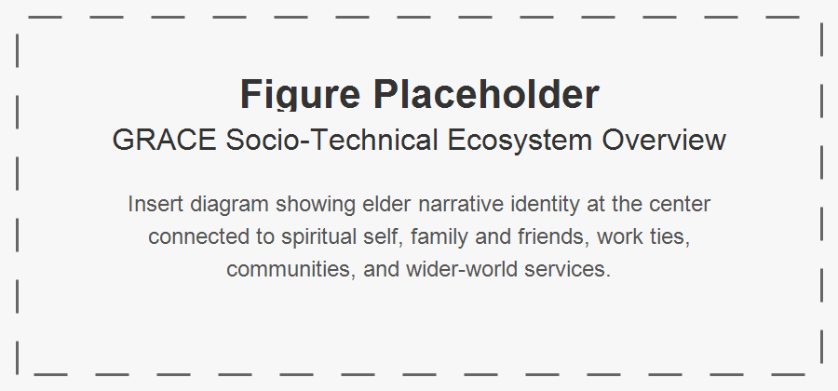
Figure 1: Placeholder for the GRACE socio-technical ecosystem overview.

A. Core Premise
GRACE is based on a simple claim: elder wellbeing emerges from the interaction of identity, relationships, contribution, and access. A person flourishes when they remain connected to who they are, to people who matter, to ways of contributing, and to the broader systems that structure everyday life.

B. Five Relational Domains
GRACE supports the elder’s relationship with: 1. Spiritual self 2. Family and friends 3. Working colleagues 4. Communities 5. Wider world, including markets and public services. As shown in Table 1, each domain supports different functions that contribute to wellbeing. The system provides tailored supports to help maintain these relationships and their associated benefits.
options(knitr.table.format = function() {if (knitr::is_latex_output()) 'latex' else 'pandoc'})
dt <- read.csv("assets/tables/tbl-domains.csv", check.names = FALSE, fileEncoding = "UTF-8")
knitr::kable(dt, booktabs = TRUE)
Table 1: GRACE relational domains and example system supports.
Domain | Description | Wellbeing Functions | Example System Supports
Spiritual Self | Inner life, values, faith, reflection, existential orientation | peace, meaning, hope, acceptance, moral continuity | reflection prompts, prayer/meditation support, ritual reminders, grief-sensitive dialogue
Family and Friends | Intimate and enduring personal relationships | belonging, affection, care continuity, emotional security, shared memory | family coordination, message prompts, memory sharing, visit planning
Working Colleagues | Ongoing or legacy vocational and professional ties | role continuity, usefulness, recognition, mentoring, productive identity | mentoring matching, advisory opportunities, skill-sharing, encore work prompts
Communities | Local groups, associations, faith communities, neighborhoods, civic groups | participation, recognition, mutual aid, collective belonging | event discovery, volunteering prompts, group participation support, community connectors
Wider World | Markets, institutions, services, transport, civic systems, public services | inclusion, access, autonomy, service reach, economic and civic participation | service navigation, benefits support, transport coordination, marketplace access

C. Narrative Identity as System Core
Rather than using a conventional user profile, GRACE maintains a Living Autobiography Model. Its principal constructs are summarized in Table 2, which shows how life chapters, relationships, roles, values, places, rituals, memories, concerns, and hopes become computational resources for narrative continuity.
options(knitr.table.format = function() {if (knitr::is_latex_output()) 'latex' else 'pandoc'})
dt <- read.csv("assets/tables/tbl-autobiography.csv", check.names = FALSE, fileEncoding = "UTF-8")
knitr::kable(dt, booktabs = TRUE)
Table 2: Core constructs in the GRACE Living Autobiography Model.
Construct | Description | Examples | Function
Life Chapters | Major periods or phases of life | childhood, career phase, retirement, caregiving years | supports contextual interpretation of current events
Major Transitions | Turning points and disruptions | bereavement, migration, illness onset, retirement | supports sensitivity to recurring vulnerabilities and resilience patterns
Key Relationships | Important persons and social ties | spouse, children, friends, mentor, colleague | informs relational prompts and support priorities
Roles and Identities | Enduring self-definitions | parent, teacher, engineer, volunteer, believer | supports role continuity and contribution opportunities
Values and Beliefs | Moral, spiritual, and existential commitments | faith, service, independence, compassion | aligns prompts and interventions with personal meaning
Strengths and Skills | Capabilities and resources | mentoring, storytelling, teaching, organizing | supports contribution matching
Meaningful Places | Places of emotional or narrative significance | family home, workplace, temple, neighborhood park | supports memory prompts and place-based engagement
Rituals and Traditions | Recurrent meaningful practices | weekly worship, family dinners, anniversaries | supports temporal and spiritual grounding
Significant Memories | Events with autobiographical weight | marriage, awards, losses, milestones | supports story creation and identity continuity
Present Concerns | Current needs and stresses | loneliness, mobility limits, family conflict | supports adaptive intervention
Future Hopes | Forward-looking aims | legacy project, reconnecting with family, community service | supports future-oriented narrative continuity

D. Theater-of-Life Perspective
GRACE may be understood as a theater of life: the elder is the lead performer and author, life settings are stages, daily events are scenes, human and AI participants form the cast, and narrative identity is the script in progress. This metaphor is not decorative; it is a design principle. It emphasizes authorship, visibility, and continuity.

IV. The GRACE Index
The GRACE Index model is summarized visually in Figure 2, with dimensions and data sources in Table 3 and scoring interpretation in Table 5.
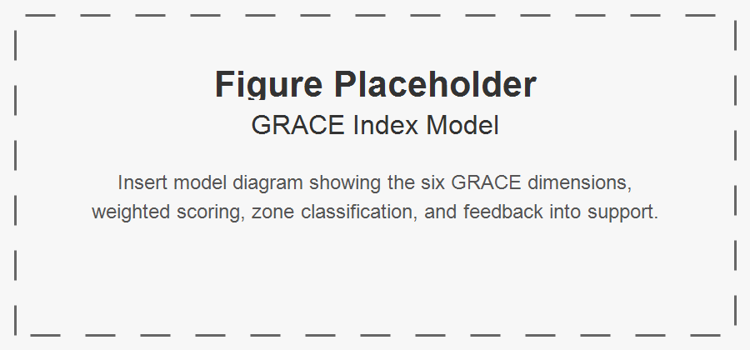
Figure 2: Placeholder for the GRACE Index model.

A. Purpose
The GRACE Index is a daily composite indicator designed to assess whether a person remains “in the zone” of narrative selfhood. This means the person still experiences life as meaningfully their own, even when facing difficulty, grief, illness, or uncertainty. The index is intended to measure narrative integrity, not merely mood or symptom burden.

B. Dimensions
The GRACE Index is a daily composite indicator designed to assess whether a person remains “in the zone” of narrative selfhood. This means the person still experiences life as meaningfully their own, even when facing difficulty, grief, illness, or uncertainty. The index is intended to measure narrative integrity, not merely mood or symptom burden. The six dimensions, their indicators, and example data sources are summarized in Table 3.
options(knitr.table.format = function() {if (knitr::is_latex_output()) 'latex' else 'pandoc'})
dt <- read.csv("assets/tables/tbl-grace-index.csv", check.names = FALSE, fileEncoding = "UTF-8")
knitr::kable(dt, booktabs = TRUE)
Table 3: GRACE Index dimensions, indicators, and example data sources.
Dimension | Description | Indicators | Example Data Sources
Narrative Continuity | Sense of remaining connected to one’s life story and selfhood | felt like self, could make sense of the day, role continuity, future orientation | self-report, voice reflections, story engine outputs
Spiritual Grounding | Degree of inner peace, reflection, faith, or value alignment | prayer/reflection, gratitude, acceptance, values-based action | self-report, ritual logs, spiritual prompts
Relational Vitality | Quality of meaningful connection and belonging | meaningful contact, warmth of interaction, reciprocity, felt belonging | interaction logs, visit records, self-report
Contribution and Usefulness | Sense of helping, guiding, teaching, or being needed | mentoring, helping, advice-giving, feeling useful | contribution logs, task records, self-report
Community and World Engagement | Participation beyond the immediate self or household | event attendance, service access, neighborhood interaction, civic participation | activity logs, appointments, community records
Adaptive Resilience | Capacity to remain centered and recover during stress | coping, help-seeking, recovery after setbacks, staying grounded | self-report, predictor features, behavior trends

C. Scoring Model
Let N = Narrative Continuity; S = Spiritual Grounding; R = Relational Vitality; C = Contribution and Usefulness; E = Community and World Engagement; A = Adaptive Resilience.
$$G_{t}=0.22N_{t}+0.14S_{t}+0.20R_{t}+0.16C_{t}+0.13E_{t}+0.15A_{t}$$
with scores normalized to 0–100. The component weights in Table 4 reflect the relative importance of each dimension to narrative selfhood.
options(knitr.table.format = function() {if (knitr::is_latex_output()) 'latex' else 'pandoc'})
dt <- read.csv("assets/tables/tbl-grace-index-weights.csv", check.names = FALSE, fileEncoding = "UTF-8")
knitr::kable(dt, booktabs = TRUE)
Table 4: Weights used to calculate the GRACE Index.
Component | Weight
Narrative Continuity N | 0.22
Spiritual Grounding S | 0.14
Relational Vitality R | 0.20
Contribution and Usefulness C | 0.16
Community and World Engagement E | 0.13
Adaptive Resilience A | 0.15

options(knitr.table.format = function() {if (knitr::is_latex_output()) 'latex' else 'pandoc'})
dt <- read.csv("assets/tables/tbl-grace-index-zones.csv", check.names = FALSE, fileEncoding = "UTF-8")
knitr::kable(dt, booktabs = TRUE)
Table 5: GRACE Index score zones and interpretations.
Zone | Range | Interpretation
Flourishing Zone | 85–100 | strong continuity, connection, contribution, and resilience; reinforce growth and legacy opportunities
Stable Narrative Zone | 70–84 | stable selfhood and functioning despite ordinary challenges; maintain routines and meaningful engagement
Vulnerability Zone | 50–69 | early signs of drift, withdrawal, or reduced engagement; initiate gentle, targeted support
Disruption Zone | 30–49 | significant weakening of narrative continuity or relational vitality; escalate coordinated intervention
Fragmentation Risk Zone | 0–29 | severe disconnection, overwhelm, or loss of self-authorship; urgent, high-touch support with human oversight

D. Zone Interpretation
A person may remain in a stable narrative zone even during distress if selfhood, belonging, and meaning remain intact. As shown in Table 5, the zones distinguish flourishing and stable narrative continuity from vulnerability, disruption, and fragmentation risk.

V. Three AI-Enabled Innovations
These innovations are summarized in Table 6. The hero’s-journey structure is shown in Figure 3, while the predictive-intervention loop is shown in Figure 4.
options(knitr.table.format = function() {if (knitr::is_latex_output()) 'latex' else 'pandoc'})
dt <- read.csv("assets/tables/tbl-innovations.csv", check.names = FALSE, fileEncoding = "UTF-8")
knitr::kable(dt, booktabs = TRUE)
Table 6: Three AI-enabled innovations in GRACE.
Innovation | Inputs | Mechanism | Outputs | Intended Effect
Daily Story Creation Engine | daily events, emotional signals, interactions, reflections | converts daily life into hero’s-journey narrative structure | daily story, heroic integration score, narrative tags | improved meaning-making and narrative continuity
Fast State Predictor | GRACE Index history, trends, event context, story features | forecasts near-future wellbeing state and risk | predicted score, predicted zone, intervention urgency | earlier detection of decline
Smart Stimulus Agent | predicted state, preferences, consent rules, intervention history | selects personalized prompt or support action | narrative/relational/spiritual/contribution/community/practical stimulus | reduced time in vulnerable or disrupted states

A. Daily Story Creation Through the Hero’s Journey
GRACE includes a Daily Story Creation Engine that interprets everyday life through the hero’s journey. Instead of storing events as isolated entries, it reframes them through elements such as ordinary world, call to adventure, trial, guide, courage, insight, and return.

Figure 3: Placeholder for the daily hero’s-journey story structure.
$$H_{t}=α_{1}T_{t}+α_{2}Gd_{t}+α_{3}Co_{t}+α_{4}In_{t}$$
This mechanism is intended to buffer narrative fragmentation by preserving meaning under adversity.

B. AI-Based Fast State Predictor
GRACE includes a Fast State Predictor that forecasts near-future wellbeing state using recent GRACE Index trajectories, event patterns, and story features.
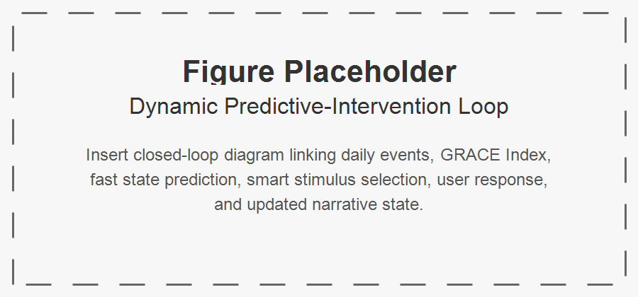
Figure 4: Placeholder for the predictive-intervention loop.
$${\hat{G}}_{t+τ}=P(G_{t−ℓ:t},X_{t−ℓ:t},H_{t−ℓ:t},U_{t−ℓ:t})$$
This predictor enables the system to shift from reactive monitoring to anticipatory support.

C. Smart Stimulus Agent
GRACE also includes a Smart Stimulus Agent that selects a personalized prompt or support action based on predicted state.
$$a_{t}∈A=\{a^{nar},a^{rel},a^{spi},a^{con},a^{com},a^{prac},a^{none}\}$$
$$a_{t}=π({\hat{Z}}_{t+1},X_{t},p)$$
The aim is not behavior control, but supportive intervention that helps preserve dignity, continuity, and agency.

VI. Multiagent Architecture and Governance
The architecture is shown in Figure 5. Agent responsibilities are summarized in Table 7. Governance risks and safeguards are summarized in Table 8 and visually in Figure 6.

Figure 5: Placeholder for the GRACE multiagent architecture.

options(knitr.table.format = function() {if (knitr::is_latex_output()) 'latex' else 'pandoc'})
dt <- read.csv("assets/tables/tbl-agents.csv", check.names = FALSE, fileEncoding = "UTF-8")
knitr::kable(dt, booktabs = TRUE)
Table 7: Agent responsibilities in the GRACE ecosystem.
Agent | Role | Inputs | Outputs | Domains
Narrative Agent | maintain autobiographical continuity | reflections, memories, daily events | stories, narrative summaries, continuity signals | all domains
Relationship Agent | track and strengthen social ties | interaction logs, visit patterns | tie-strength estimates, reconnection suggestions | family, colleagues, communities
Wellbeing Agent | synthesize cross-domain wellbeing | GRACE dimensions, trends, events | state summaries, risk signals | all domains
Spiritual Companion Agent | support reflection and spiritual grounding | rituals, reflections, values | spiritual prompts, grounding support | spiritual self
Family Coordination Agent | coordinate communication and care continuity | family contacts, calendars, events | visit plans, updates, reminders | family and friends
Work and Contribution Agent | identify contribution opportunities | skills, roles, requests | mentoring matches, contribution prompts | colleagues, communities
Community Connector Agent | support participation and local belonging | local events, memberships, opportunities | engagement recommendations | communities
Service Access Agent | connect to services and institutions | appointments, transport, benefits needs | service guidance, access support | wider world
Memory and Legacy Agent | preserve long-term story and artifacts | stories, photos, milestones | archives, legacy packages | family, communities
Ethics and Safety Agent | enforce safeguards and accountability | consent rules, system actions, risk states | approvals, constraints, audit records | all domains

options(knitr.table.format = function() {if (knitr::is_latex_output()) 'latex' else 'pandoc'})
dt <- read.csv("assets/tables/tbl-governance.csv", check.names = FALSE, fileEncoding = "UTF-8")
knitr::kable(dt, booktabs = TRUE)
Table 8: Governance risks and safeguards for GRACE.
Risk | Concern | Safeguard
Paternalism | system over-directs behavior; erosion of autonomy | adjustable autonomy, opt-out controls, human override
Narrative Imposition | system interprets life story too forcefully; distortion of selfhood | user-editable stories, narrative sovereignty, transparency
Privacy Breach | sensitive autobiographical data exposed; loss of trust, harm to dignity | access controls, encryption, consent-based sharing
Over-Intervention | too many prompts or alerts; fatigue, frustration, disengagement | rate limits, preference learning, intervention thresholds
Family Misuse | relatives use system to pressure elder; coercion or conflict | granular permissions, elder-first governance
Prediction Opacity | unclear reason for risk prediction; mistrust, confusion | explainable prediction summaries
Bias in Prediction | model underperforms for some groups; inequitable support | fairness auditing, subgroup validation
Emotional Harm | prompts surface painful memories badly; distress or retraumatization | sensitivity rules, contextual timing, human escalation
Dependency on System | overreliance on AI mediation; reduced direct human engagement | human-in-the-loop design, connection-first policies

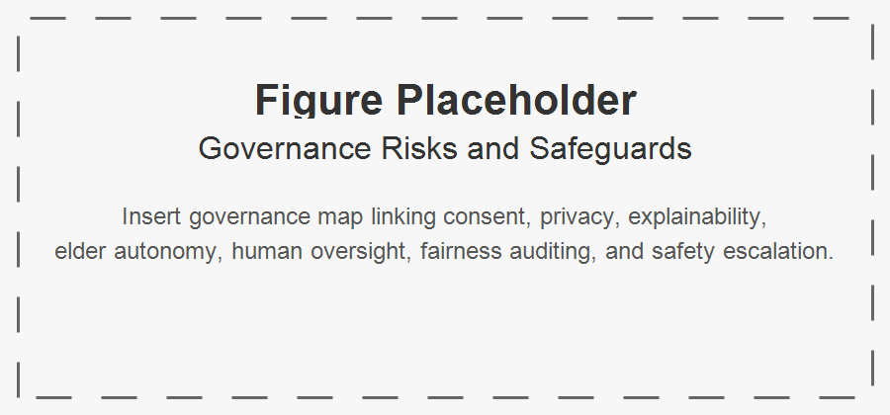
Figure 6: Placeholder for governance risks and safeguards.
Because GRACE handles intimate autobiographical and relational data, governance is central. The risks and safeguards in Table 8 address paternalism, narrative imposition, privacy breaches, over-intervention, family misuse, prediction opacity, bias, emotional harm, and dependency. The system should include consent-based data access, explainable interventions, adjustable autonomy, human override, privacy protection, and safeguards against manipulative prompting.

VII. Agent-Based Simulation Design
The simulation structure is shown in Figure 7, with conditions in Table 9, hypotheses in Table 10, variables in Table 11, and outcome metrics in Table 12.

A. Objective
Before real-world deployment, the three innovations should be evaluated in simulation.
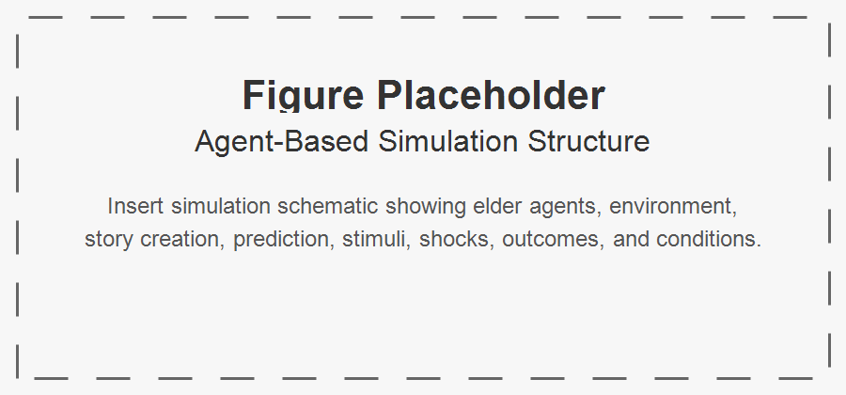
Figure 7: Placeholder for the agent-based simulation structure.

B. Agents
Elder Agent; Narrative Agent; Predictor Agent; Stimulus Agent; Social Tie Agents; Environment Agent.

C. State Representation
$$X_{i,t}=[N_{i,t},S_{i,t},R_{i,t},C_{i,t},E_{i,t},A_{i,t}]$$
$$G_{i,t}=0.22N_{i,t}+0.14S_{i,t}+0.20R_{i,t}+0.16C_{i,t}+0.13E_{i,t}+0.15A_{i,t}$$
$$X_{i,t+1}=f(X_{i,t},U_{i,t},H_{i,t},A_{i,t}^{stim},ε_{i,t})$$
options(knitr.table.format = function() {if (knitr::is_latex_output()) 'latex' else 'pandoc'})
dt <- read.csv("assets/tables/tbl-simulation-conditions.csv", check.names = FALSE, fileEncoding = "UTF-8")
knitr::kable(dt, booktabs = TRUE)
Table 9: Simulation conditions for evaluating GRACE innovations.
Condition | Story | Prediction | Stimulus | Expectation
Baseline | No | No | No | monitoring only
Story Only | Yes | No | No | improved narrative continuity
Story + Prediction | Yes | Yes | No | improved early risk detection
Full GRACE | Yes | Yes | Yes | highest stability and fastest recovery

options(knitr.table.format = function() {if (knitr::is_latex_output()) 'latex' else 'pandoc'})
dt <- read.csv("assets/tables/tbl-simulation-hypotheses.csv", check.names = FALSE, fileEncoding = "UTF-8")
knitr::kable(dt, booktabs = TRUE)
Table 10: Simulation hypotheses for GRACE.
Hypothesis | Expectation
H1 | Story creation increases Narrative Continuity relative to baseline
H2 | Fast prediction improves early detection of decline
H3 | Smart stimuli reduce time spent in low GRACE zones
H4 | Full GRACE yields highest average GRACE Index
H5 | Full GRACE reduces recovery time after adverse shocks

options(knitr.table.format = function() {if (knitr::is_latex_output()) 'latex' else 'pandoc'})
dt <- read.csv("assets/tables/tbl-simulation-variables.csv", check.names = FALSE, fileEncoding = "UTF-8")
knitr::kable(dt, booktabs = TRUE)
Table 11: State and derived variables tracked in the simulation.
Variable | Name | Type | Function
N | Narrative Continuity | state variable | tracks self-story coherence
S | Spiritual Grounding | state variable | tracks inner steadiness
R | Relational Vitality | state variable | tracks connection quality
C | Contribution and Usefulness | state variable | tracks perceived usefulness
E | Community and World Engagement | state variable | tracks external participation
A | Adaptive Resilience | state variable | tracks coping and recovery
G | GRACE Index | composite metric | primary wellbeing outcome
H | Heroic Integration Score | derived metric | measures successful narrative reframing

options(knitr.table.format = function() {if (knitr::is_latex_output()) 'latex' else 'pandoc'})
dt <- read.csv("assets/tables/tbl-simulation-outcomes.csv", check.names = FALSE, fileEncoding = "UTF-8")
knitr::kable(dt, booktabs = TRUE)
Table 12: Outcome metrics used to evaluate the simulation.
Variable | Type | Function
Stable-Zone Days | outcome metric | proportion of days with G ≥ 70; assesses sustained wellbeing
Vulnerable/Disrupted Days | outcome metric | proportion of days with G < 70; assesses instability
Recovery Time | outcome metric | days to return to stable zone after shock; assesses resilience
Reframing Success | outcome metric | proportion of adverse days with high H; assesses story engine effect
Intervention Efficiency | outcome metric | gain in G per stimulus action; assesses stimulus value

VIII. Technology and Society Implications

A. From Monitoring to Meaning
Many existing systems for older adults are designed around surveillance, compliance, and risk reduction. Although these functions are often necessary, they can narrow the social meaning of technology to observation and behavioral management. GRACE suggests a different orientation: intelligent systems should also support meaning-making, narrative continuity, and relationship quality. This matters because technologies do not merely assist users; they also shape how users are socially perceived. A system that frames older adults mainly as vulnerable subjects of monitoring may reinforce dependency narratives. By contrast, a system that recognizes them as authors, contributors, and relational beings may support dignity and public visibility.

B. The Social Construction of Aging Through Technology
Technologies embody assumptions about the populations they serve. In aging contexts, these assumptions often center decline, burden, and incapacity. Such framings can indirectly reproduce ageism by embedding deficit-oriented views of later life into interfaces, workflows, and service logics. GRACE instead frames later life as a stage of ongoing identity development, contribution, and relational growth. This shift has implications beyond design. It suggests that socio-technical systems should not merely adapt to older adults as they are socially classified, but should also challenge reductive classifications that limit participation and agency.

C. Narrative Data as a New Category of Sensitive Data
GRACE relies on autobiographical, relational, and interpretive data in addition to behavioral and service data. This class of information is especially sensitive because it concerns identity, memory, grief, values, and social bonds. Conventional privacy models may be insufficient for such data because the issue is not only exposure, but interpretation and authorship. Questions arise regarding who owns a life story representation, who may correct or extend it, and how conflicting interpretations should be handled when family members or institutions are involved. The use of narrative data therefore requires governance structures that protect not only privacy, but also identity integrity.

D. Prediction, Intervention, and the Risk of Paternalism
The Fast State Predictor and Smart Stimulus Agent introduce anticipatory action into elder-oriented systems. While this can improve support, it also creates the risk of paternalism. Predictions may be used to steer behavior in ways that are insufficiently transparent or insufficiently aligned with the elder’s own intentions. In contexts where older adults are already socially positioned as dependent, such interventions may amplify rather than reduce power asymmetries. GRACE therefore implies that predictive systems should be explainable, consent-aware, adjustable in intensity, and always open to refusal or override. The goal is not to optimize the person, but to support the person’s own authorship.

E. Human-Centered AI in Socially Embedded Contexts
GRACE contributes to human-centered AI by expanding what counts as success in intelligent systems. Reliability, safety, and performance remain necessary, but they are not sufficient in socially embedded domains such as aging. Systems should also be evaluated according to whether they preserve agency, dignity, self-interpretation, reciprocity, and belonging. In this sense, GRACE argues for a broader evaluative framework for AI in society: one that includes effects on identity and relational life alongside traditional technical metrics.

F. Social Infrastructure and Inclusion
Older adult wellbeing depends not only on internal state or family support, but also on access to social infrastructure, including transportation, public services, community groups, and marketplaces. GRACE highlights that intelligent support systems should therefore function not merely as private assistants, but as bridges to institutional and civic participation. This has policy implications. Public-interest technologies for aging should be designed to support inclusion, not just care; participation, not just monitoring; and contribution, not just dependency management.

G. Implications for Technology Governance
From a technology-and-society perspective, GRACE suggests five governance principles for elder-oriented AI. First, narrative sovereignty: the elder retains primary authority over their life story representation. Second, consentful prediction: predictive analytics must be understandable, optional, and bounded in use. Third, non-manipulative intervention: prompts and actions should support rather than coerce. Fourth, relational accountability: system actions should be evaluated for their effects on family, community, and institutional relationships. Fifth, dignity-centered evaluation: success should include preservation of selfhood, not only efficiency or compliance.

H. Broader Relevance
Although GRACE is developed for older adults, its implications extend to other domains in which wellbeing depends on identity continuity and social participation, including disability support, chronic illness, rehabilitation, and mental health recovery. More broadly, the framework suggests that intelligent socio-technical systems should be designed not only to predict and intervene, but also to help persons remain present in their own lives.

IX. Discussion
Taken together, Figure 1, Figure 5, Figure 4, Figure 3, Figure 2, Figure 7, Figure 6, and the referenced tables show that GRACE is not merely a collection of tools, but an integrated socio-technical ecosystem.
GRACE reframes elder-oriented AI away from narrow models of surveillance and deficit management. Its central contribution is to treat older adults as ongoing authors of life rather than passive subjects of care. This reframing changes the role of intelligent systems. Instead of merely detecting problems or enforcing routines, such systems can support meaning, relationship quality, contribution, and continuity of self.
The GRACE Index is important in this regard because it shifts measurement away from symptom burden alone and toward narrative integrity. A person may be grieving, ill, or facing uncertainty while still remaining deeply connected to selfhood, belonging, and purpose. Conventional metrics may not capture this distinction. By contrast, the GRACE Index is intended to identify whether the person remains “in the zone” of narrative selfhood, thereby enabling support that is more humane and context-sensitive.
The three added innovations extend this contribution. The Daily Story Creation Engine offers a computational mechanism for narrative reframing. The Fast State Predictor moves the system from reactive to anticipatory operation. The Smart Stimulus Agent transforms prediction into practical support. In combination, these mechanisms suggest a new class of elder-oriented intelligent systems: systems that are reflective, predictive, and supportive, while remaining grounded in dignity and agency.
For IEEE audiences, the broader implication is that intelligent systems in socially sensitive settings should be evaluated not only by technical performance, but also by their effects on identity, autonomy, and social life. GRACE therefore contributes to ongoing conversations about human-centered AI, algorithmic governance, and the social responsibilities of digital infrastructure.
The proposed agent-based simulation design provides a useful intermediate step before real-world deployment. It allows key questions to be examined under controlled conditions: whether narrative reframing buffers decline, whether predictive models can identify vulnerability early, and whether stimulus policies improve recovery without becoming intrusive. It also enables examination of governance concerns such as intervention thresholds, uncertainty handling, and the trade-off between support and paternalism.
At the same time, GRACE should be understood as a framework rather than a finished system. Its value lies in offering a coherent socio-technical direction for future work at the intersection of aging, AI, and community computing.

X. Limitations and Future Work
This paper is conceptual and simulation-oriented. Several limitations should therefore be acknowledged.
First, the GRACE Index is proposed as a theoretically grounded composite measure, but its weighting scheme and dimensional structure have not yet been empirically validated. The model should be treated as provisional until psychometric testing, longitudinal analysis, and user-centered validation are conducted.
Second, the Daily Story Creation Engine, Fast State Predictor, and Smart Stimulus Agent are presented as design innovations, not as fully implemented and tested modules. Their actual effectiveness will depend on interface quality, data quality, personalization logic, and the degree to which users perceive them as supportive rather than intrusive.
Third, the proposed simulation is an abstraction of real life. Although simulation can help evaluate mechanisms and explore policy behavior, it cannot fully represent the emotional, cultural, and relational complexity of lived aging. Real-world evaluation with older adults, families, and community organizations remains essential.
Fourth, the framework may require substantial cultural adaptation. Narrative identity, spirituality, family expectations, contribution norms, and attitudes toward AI vary across settings. A system designed around autobiographical continuity and relational support must therefore be locally interpretable and culturally responsive.
Fifth, governance challenges remain significant. The use of autobiographical and predictive data introduces risks related to privacy, bias, paternalism, narrative imposition, and over-intervention. Future work should address these issues through fairness testing, explainability design, participatory governance, and careful consent models.
Future research should proceed along at least six directions: 1. participatory co-design with older adults, caregivers, and community stakeholders; 2. prototype implementation of the GRACE ecosystem and GRACE Index interfaces; 3. simulation execution and reporting to evaluate the three innovations under controlled scenarios; 4. psychometric validation of the GRACE Index across diverse elder populations; 5. pilot deployment studies to assess usability, acceptability, and perceived dignity impact; and 6. governance and fairness analysis focused on predictive intervention, consent, and relational accountability.
These steps are necessary to move GRACE from a conceptual socio-technical framework toward a validated and ethically robust intelligent ecosystem.

XI. Conclusion
GRACE proposes a narrative-centered socio-technical ecosystem for elder wellbeing. By integrating relationship quality, autobiographical continuity, predictive modeling, and anticipatory intervention, it offers an alternative to deficit-oriented aging technologies. Rather than viewing older adults primarily through decline, risk, and service dependency, GRACE understands them as persons who continue to live, interpret, and contribute within unfolding life stories.
The framework contributes four main ideas: a relational and narrative model of elder wellbeing; the GRACE Index as a daily measure of narrative selfhood; three AI-enabled mechanisms for story creation, prediction, and supportive intervention; and an agent-based simulation design for structured evaluation. Together, these elements suggest that intelligent systems for older adults should be designed not only to manage risk, but also to sustain dignity, reciprocity, participation, and the ongoing authorship of life.
More broadly, GRACE argues that the future of elder-oriented AI should be socio-technical rather than merely technical, and human-centered in a deep sense: not simply usable, but respectful of identity, meaning, and relationship. If developed responsibly, systems like GRACE may help ensure that digital innovation in aging supports not only longer life, but more connected, authored, and enriched life.

References
Baltes, P. B., & Smith, J. (2008). The fascination of wisdom: Its nature, ontogeny, and function. Perspectives on Psychological Science, 3(1), 56–64.
Berkman, L. F., Glass, T., Brissette, I., & Seeman, T. E. (2000). From social integration to health: Durkheim in the new millennium. Social Science & Medicine, 51(6), 843–857.
Bohlmeijer, E., Roemer, M., Cuijpers, P., & Smit, F. (2007). The effects of reminiscence on psychological well-being in older adults: A meta-analysis. Aging & Mental Health, 11(3), 291–300.
Butler, R. N. (1963). The life review: An interpretation of reminiscence in the aged. Psychiatry, 26(1), 65–76.
Carroll, J. M. (2014). Human-computer interaction in the new millennium. Addison-Wesley.
Carstensen, L. L., Isaacowitz, D. M., & Charles, S. T. (1999). Taking time seriously: A theory of socioemotional selectivity. American Psychologist, 54(3), 165–181.
Cacioppo, J. T., & Hawkley, L. C. (2009). Perceived social isolation and cognition. Trends in Cognitive Sciences, 13(10), 447–454.
Cornwell, E. Y., & Waite, L. J. (2009). Social disconnectedness, perceived isolation, and health among older adults. Journal of Health and Social Behavior, 50(1), 31–48.
Czaja, S. J., Charness, N., Fisk, A. D., Hertzog, C., Nair, S. N., Rogers, W. A., & Sharit, J. (2006). Factors predicting the use of technology: Findings from the Center for Research and Education on Aging and Technology Enhancement (CREATE). Psychology and Aging, 21(2), 333–352.
Erikson, E. H. (1982). The life cycle completed. W. W. Norton.
Gurstein, M. (2007). What is community informatics (and why does it matter)? Polimetrica.
Habermas, T., & Bluck, S. (2000). Getting a life: The emergence of the life story in adolescence. Psychological Bulletin, 126(5), 748–769.
Holt-Lunstad, J., Smith, T. B., & Layton, J. B. (2010). Social relationships and mortality risk: A meta-analytic review. PLoS Medicine, 7(7), e1000316.
Jennings, N. R., Sycara, K., & Wooldridge, M. (1998). A roadmap of agent research and development. Autonomous Agents and Multi-Agent Systems, 1(1), 7–38.
McAdams, D. P. (2001). The psychology of life stories. Review of General Psychology, 5(2), 100–122.
McAdams, D. P., & de St. Aubin, E. (1992). A theory of generativity and its assessment through self-report, behavioral acts, and narrative themes in autobiography. Journal of Personality and Social Psychology, 62(6), 1003–1015.
Mitzner, T. L., Boron, J. B., Fausset, C. B., Adams, A. E., Charness, N., Czaja, S. J., Dijkstra, K., Fisk, A. D., Rogers, W. A., & Sharit, J. (2010). Older adults talk technology: Technology usage and attitudes. Computers in Human Behavior, 26(6), 1710–1721.
Morrow-Howell, N., Gonzales, E., Harootyan, R., Lee, Y., & Lindberg, B. (2017). Approaches, policies, and practices to support the productive engagement of older adults. Journal of Gerontological Social Work, 60(3), 193–200.
Shneiderman, B. (2020). Human-centered artificial intelligence: Reliable, safe & trustworthy. International Journal of Human-Computer Interaction, 36(6), 495–504.
Singer, J. A. (2004). Narrative identity and meaning making across the adult lifespan: An introduction. Journal of Personality, 72(3), 437–460.
Sixsmith, A., & Gutman, G. M. (Eds.). (2013). Technologies for active aging. Springer.
Vines, J., Pritchard, G., Wright, P., Olivier, P., & Brittain, K. (2015). An age-old problem: Examining the discourses of ageing in HCI and strategies for future research. ACM Transactions on Computer-Human Interaction, 22(1), Article 2.
Wooldridge, M. (2009). An introduction to multiagent systems (2nd ed.). Wiley.

