T­his is the lab for creating a development environment on your laptop. Basically, follow the steps in the presentation.

1. Copy the project onto your laptop using “git clone <url>”
2. Change the network timeouts by editing ‘/config/development.json’ as shown in the presentation and below.

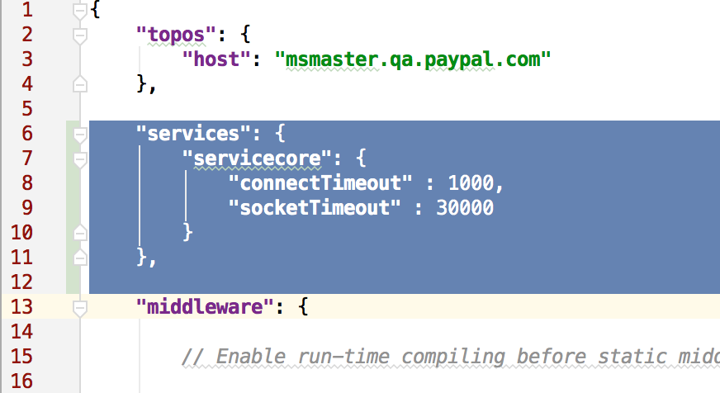

npm config list

1. Change the npm registry with npm config set registry http://npm.paypal.com
2. Compile the application using “npm install” in the main directory.
3. Start the application using “npm start” in the main directory.
4. Test the application using the browser at [http://localhost.paypal.com:8000/sampleapp](http://localhost:8000/sampleapp)

If you have a Windows machine, the “npm install” might find many issues. Npm searches for a C++ compiler to compile several modules. There is a page on Confluence that describes the issues and how to resolve them. It is a multi-hour process. I suggest installing VMWare with a Linux distribution on the local machine for development.