|  |  |
| --- | --- |
| Nama : Firman Syariffudin |  |
| NBI : 1461800019 |
| Kelas Praktikum : D2 |
| Praktikum : Dasar Pemrograman |
| Tugas Akhir Ke- 4 | ACC ASLAB |

1. **@Code Source**

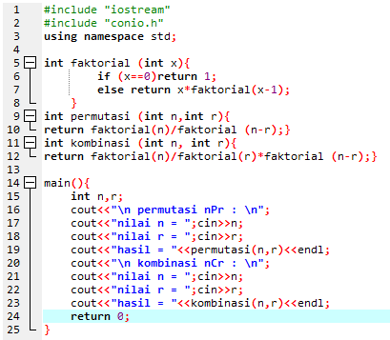

**@Output**

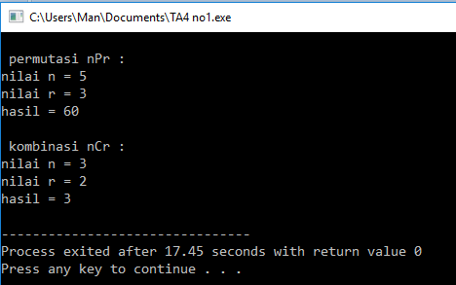

1. **@Code Source**

**#include "iostream"**

**#include "time.h"**

**#include "stdlib.h"**

**using namespace std;**

**int main() {**

**int x[3][3], y[3][3],z[3][3];**

**srand(time(NULL));**

**printf("Matriks A : \n");**

**for (int k=0; k<3; k++)**

**for (int l=0; l<3; l++) {**

**x[k][l]=rand()%5;**

**printf("[%d][%d] = %d \n", k, l, x[k][l]);**

**}**

**srand(time(NULL));**

**printf("Matriks B : \n");**

**for (int g=0; g<3; g++)**

**for (int h=0; h<3; h++) {**

**y[g][h]=rand()%8;**

**printf("[%d][%d] = %d \n", g, h, y[g][h]);**

**}**

**printf("Matriks A x Matriks B : \n");**

**for (int r=0; r<3; r++)**

**for (int u=0; u<3; u++) {**

**z[r][u]=0;**

**for (int v=0; v<3; v++) {**

**z[r][u] += x[r][v] * y[v][u];**

**}**

**}**

**for (int r=0; r<3; r++)**

**for (int u=0; u<3; u++) {**

**printf("[%d][%d] = %d \n", r, u, z[r][u]);**

**}**

**return 0;**

**}**

**@Output**

