**PART I**

For each question from 1 to 10, four options are given. One of them is the correct answer. Make your choice (1, 2, 3 or 4). Shade the correct oval (1, 2, 3 or 4) on the Optical Answer Sheet. (24 x 2 marks)

________________________________________________________________

1. The leaves of a mimosa plant will fold inward and droop when touched.   
     
   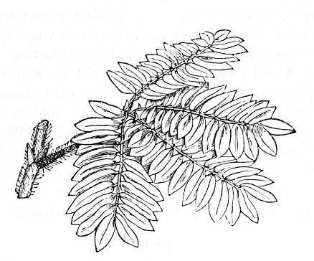  
     
   This shows that a mimosa plant is a living thing because it can _____________.  
     
   (1) grow  
     
   (2) breathe  
     
   (3) reproduce  
     
   (4) respond to changes

( )

1. Study the flowchart below carefully.  
     
   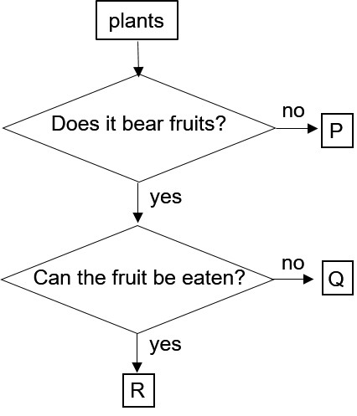  
     
   Based on the flowchart above, which one of the following statements is definitely correct?  
     
   P cannot make food.  
   Q and R bear flowers.  
   P reproduces from seeds.  
   R reproduces from spores.  
     
   (1) P cannot make food.  
   (2) Q and R bear flowers.  
   (3) P reproduces from seeds.  
   (4) R reproduces from spores.

( )

1. Linda tested three objects to find out which of them are living things. She recorded her findings in the table below.   
     
    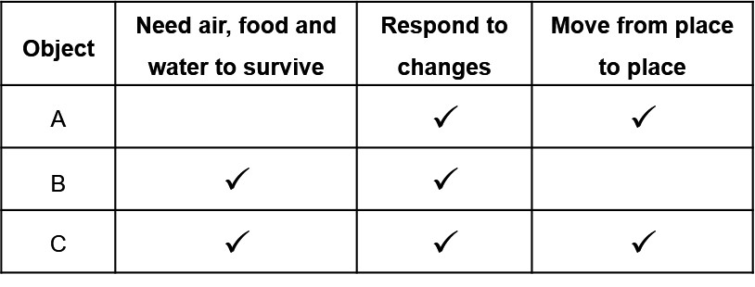   
     
   Which of the object(s) is/are likely to be living things?   
   (1) A only   
   (2) A and B only   
   (3) B and C only   
   (4) A, B and C only

( )

1. Aileen classified some animals into three groups as shown.  
     
   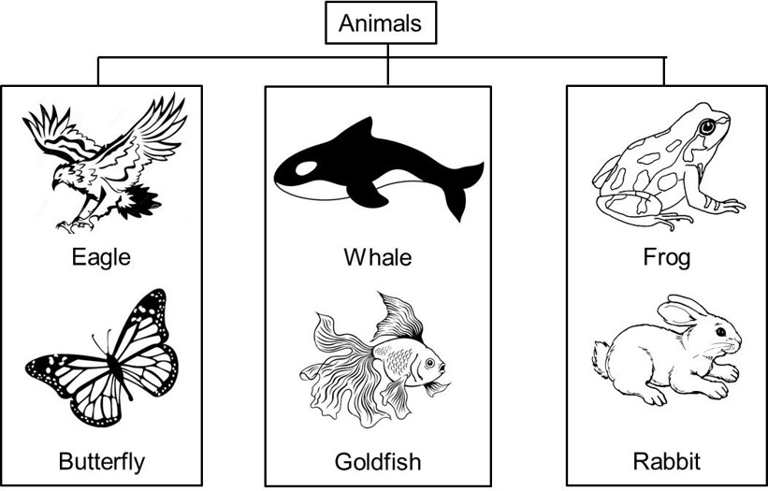  
     
   She classified the animals according to __________.  
     
   (1) how they move  
   (2) the way they reproduce   
   (3) their outer body covering   
   (4) their number of body parts

( )

1. Which one of the following objects allows light to pass through?   
     
   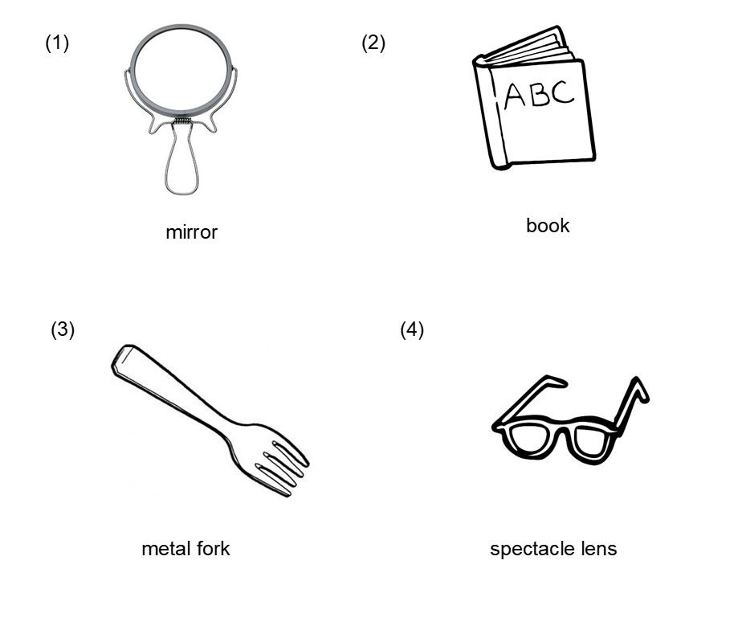

( )

1. Which one of the following is a living thing?  
     
   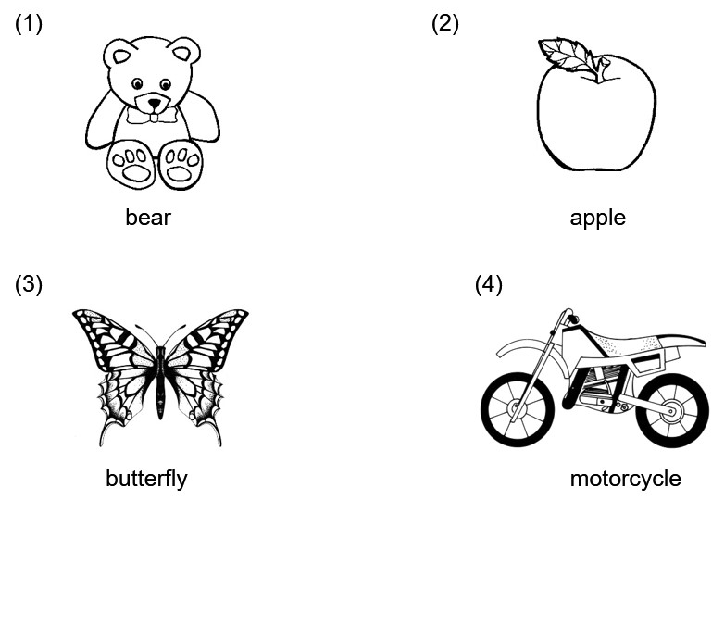

( )

1. Which one of the following objects allows all light to pass through?  
     
   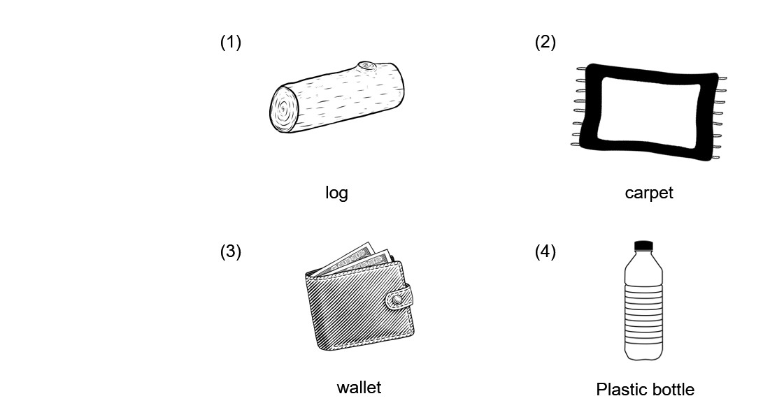

( )

1. Ailing touched the leaves of plant M and they closed.  
     
   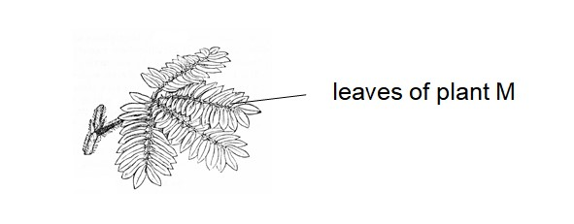  
     
   This shows that plant M is a living thing because it can ________________________.  
     
     
   (1) breathe  
   (2) grow  
   (3) respond  
   (4) reproduce

( )

1. The graph below shows the height of Animal Q over 5 months.  
     
   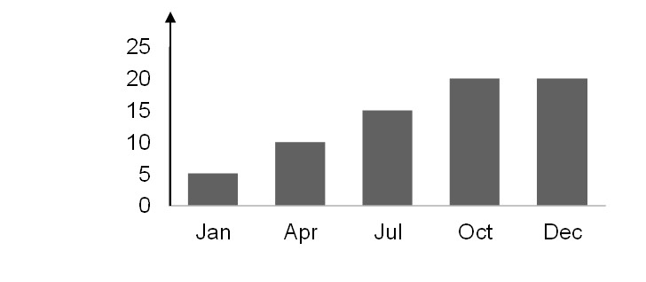  
     
   Based only on the graph, what can we conclude about Animal Q from January to May?  
     
   (1) Animal Q grew taller.  
     
   (2) Animal Q reproduced.  
      
   (3) Animal Q increased in size.  
     
   (4) Animal Q increased in mass.

( )

1. Bala placed 50g of food in three containers, X, Y and Z. He recorded the amount of food and water left after three days.  
     
   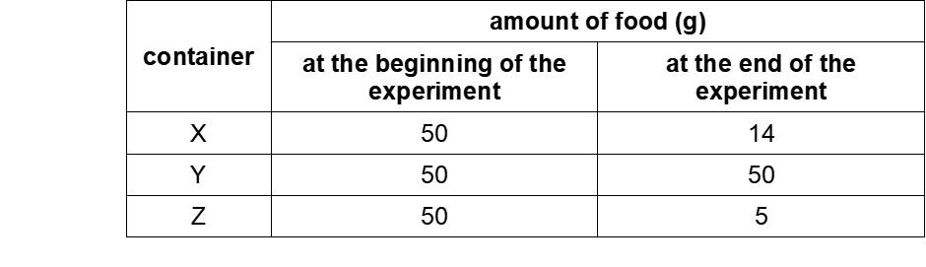  
     
   Based on the information above, which containers, X, Y and/or Z, have living things in them?   
     
   (1) X and Y only  
     
   (2) X and Z only  
     
   (3) Y and Z only  
     
   (4) X, Y and Z

( )

**END OF BOOKLET ABLANK PAGE**