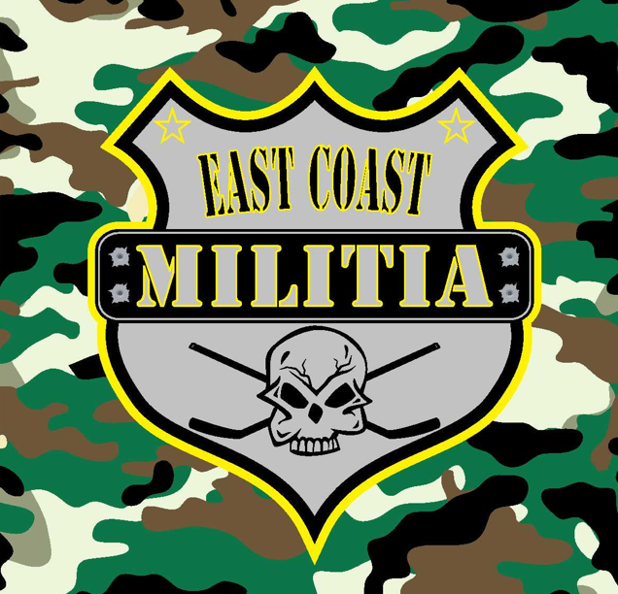 **Waiver of Liability, Release**

**Assumption of Risk & Indemnity Agreement**

It is the purpose of this agreement to exempt, waive and relieve releasees from liability for personal injury, property damage, and wrongful death, including if caused by negligence, including the negligence, if any, of releasees. “Releasees” include Nik Tasiopoulos, East Coast Militia Hockey, its affiliate associations, local associations, member teams, event hosts, other participants, coaches, and officials. For and in consideration of the undersigned participant’s registration with East Coast Militia, its affiliates, local associations and member and being allowed to participate in tournaments and member team activities, participant (and the parent(s) or legal guardian(s) of participant, if applicable) waive, release and relinquish any and all claims for liability and cause(s) of action, including for personal injury, property damage or wrongful death occurring to participant, arising out of participation in tournaments as a member of team activities, the sport of ice hockey, Militia workouts/exercises, and/or activities incidental thereto, whenever or however they occur and for such period said activities may continue, and by this agreement any such claims, rights, and causes of action that participant (and participant’s parent(s) or legal guardian(s), if applicable) may have are hereby waived, released and relinquished, and participant (and parent(s)/guardian(s), if applicable) does(do) so on behalf of my/our and participant’s heirs. Participants acknowledge, understand and assume all risks relating to ice hockey and any team activities/workouts and during travels, and understand that ice hockey involves risks to participant’s person including bodily injury, partial or total disability, paralysis and death, and damages which may arise therefrom and that I/we have full knowledge of said risks. These risks and dangers may be caused by the negligence of the participant or the negligence of others. These risks and dangers include, but are not limited to, those arising from participating with bigger, faster and stronger participants. I/We further acknowledge that there may be risks and dangers not known to us or not reasonably foreseeable at this time. This waiver does not expire and is valid through infinite years or participation with our program. Thank you for your cooperation and your participation with the East Coast Militia

______________________________________________ PARTICIPANT SIGNATURE

______________________________________________ PARTICIPANT NAME (PRINT)

______________________________________________

PARENT OR GUARDIAN SIGNATURE (if Participant is 17 years of age or younger)

Age ________

Date Signed _______________________