**COSC 4353: *Software Design***

**Group 22**

*Hussein Alfartosy, Annabella Tao, Loveleen Thomas*

**ASSIGNMENT 1**

**1. Discuss your initial thoughts in detail on how you will design this application? (2 points)**

We are planning to make a website using HTML/CSS/JavaScript as our frontend and MongoDB as our backend. We think that using HTML to give a structure to our website, CSS to make the website more appealing and JavaScript to create functions for the calculations necessary to make the website usable.

The website will predict the rate of fuel based on the location of the client and determine whether the client is in-state or out-of-state. The purchase history of the client, the gallons of fuel requested and the company’s profit margin percent are also required in order to calculate the rate of fuel. This means that we need to create a form for new logins if the client is new, a form for existing clients which will look up to the database for their information to verify if they are an existing client for the company. We will also need a fuel quote form to find the rate and total cost as well as use the backend to check client history.

**2. Discuss what development methodology you will use and why? (2 points)**

The best technique for this undertaking is to adopt an Agile method strategy. The reasoning behind taking a steady and iterative strategy is to a great extent because of the way that the construction of the task is compartmentalized, this will implement new thoughts and ideas in this complex application.

During this semester we are going to divide the semester assignments into different segments to work on. As we can see in the different assignments, throwing out the semester will be focusing on different aspects of this whole project. An example of this is assignment 2 which will be focusing on the frontend. And looking at assignment 3 which will be focusing on the backend. From this, we are creating subcomponents of the program one at time at a productive rate. If there are any changes or unexpected changes that happen randomly it will happen during the development phase and it would be easy to change it around.

We have decided to use the Agile method for our project because it allows us to be flexible in our development process. Moreover, Agile is the most popular SDLC model used today in the industry and focuses on adaptability. Using Agile, we will be able to plan our actions for the project systematically and looking forward to our future assignments in this course, we think using Agile would be a perfect choice.

**3. Provide a high level design / architecture of your solution that you are proposing? (6 points)**

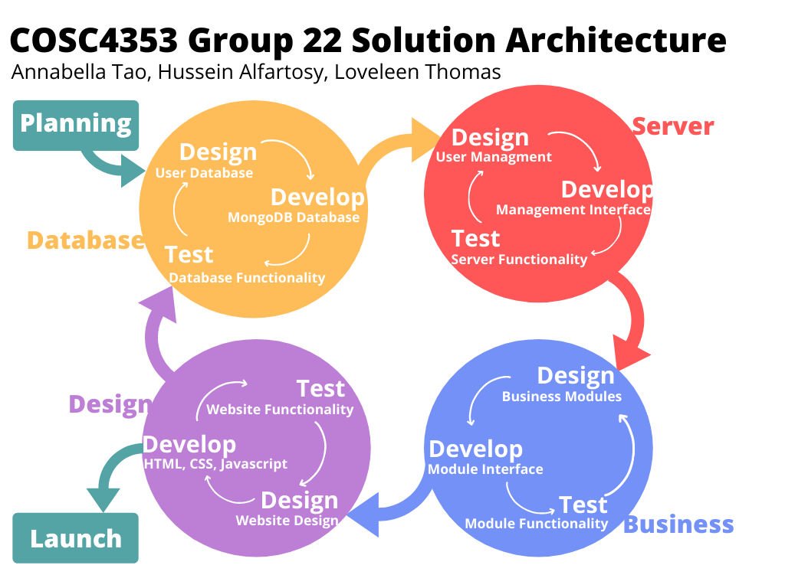

As we already mentioned in Question 3, we are going to use the Agile process first to create a homepage with both login and a registration page. Both login and registration will have a backend in both HTML and CSS. This will insure the user is logged in or need to register for a new user if the client doesn’t have a username. The registration page will include creating a username, Email, and creating a password for the login, which will be all stored in the database(MongoDB). We begin with Planning and then move on to design, develop and test the Database, Server, Business and Design sections of the project, followed by the launch of the website. In short, we would like to work on the backend first, giving it the highest priority in order to save all the information from the clients.

**4. List who did what within the group.**

Because this assignment is mostly planning, we have created a GitHub for our project but since we haven’t started coding, work did not reflect on the GitHub repository. The way we split up the work for the first assignment is Loveleen on Question 1, Hussein on Question 2, and Annabella on Question 3(Design) and both Loveleen and Hussein on the explanation.

GitHub Link: <https://github.com/aztao/COSC4353-Group-22>