UNIVERSITI MALAYSIA SARAWAK
Faculty of Computer Science and Information Technology
TMA3084 Software Engineering Laboratory | Semester 1, 2026/2027
PROJECT PROPOSAL
(Product Requirements Document)
Jejari Halus Bakery App
Group Number / Name | Group 26
Lab Group / Demonstrator | Group 2 – Raynold Kabai
Client / Organisation | Abdul Rahman bin Haji Jawawi, Owner, Jejari Halus Bakery
Lecturer | Mdm. Nurfauza Jali
GitHub Repository | https://github.com/azuah12/Jejari_Halus_Bakery_App.git
Version / Date | v1.0 (original)

Team Members
No. | Name | Matric No. | TSPi Role | Signature
1 | Amira Asniesha Binti Mohamad Zulkhairi | 102424 | Planning Manager & Client Liaison | 
2 | Nur Ainin Sofiya binti Jeffery | 102810 | Team Leader | 
3 | Nurul Syahmina binti Busra | 102904 | Developer Management | 
4 | Noor Azuah binti Sawal | 105404 | Quality/Process & Support Manager | 

Declaration
By signing above, we certify that this proposal is our own work, that all external sources, libraries, APIs and AI-assisted content are acknowledged, and that we have not engaged in plagiarism or unauthorised collusion (Peraturan Akademik UNIMAS, Etika Akademik). AI tool usage is recorded in LOGAI.

Table of Contents
Abstract 4
1. Introduction 4
1.1 Client Background 4
1.2 Team Background 5
2. Problem Statement 6
3. Project Objectives & Success Metrics 7
4. Project Perspective 8
4.1 Target Users 8
4.2 System Context and Architecture 9
5. Project Scope 10
5.1 In Scope / Out of Scope 10
5.2 Features and User Stories 12
5.3 AI Feature 14
5.4 Non-Functional Requirements and Constraints 15
5.5 System Environment 16
6. Task Allocation & Team Contribution 17
7. Team Goals 18
8. Expected Results 18
8.1 Working System 18
8.2 Documentation and Artefacts 19
9. Project Planning 20
9.1 Methodology 20
9.2 Submission Schedule 20
9.3 Development Milestones (GitHub) 21
9.4 Risks and Assumptions 22
10. References 23
Appendix A: Client Meeting Evidence 24
A.1 Meeting 1: Target Client Selection and Project Planning 24
A.2 Meeting 2: Client Requirements Gathering 24
Appendix B: Revision History 26

List of Tables
Table 1:Summary of client problems 7
Table 2:Project objectives and success metrics 8
Table 3:Target users 9
Table 4:Scope boundary 11
Table 5:Features and user stories 13
Table 6:AI feature summary 15
Table 7:Non-functional requirements and constraints 16
Table 8:System environment 17
Table 9:Task allocation and contribution 18
Table 10:Team goals 18
Table 11:Deliverables 19
Table 12:Submission schedule 21
Table 13:Development milestones 21
Table 14:Risks and assumptions 22

Abstract
This project proposes the development of a cross-platform mobile application for Jejari Halus Bakery, a local bakery owned by Abdul Rahman bin Haji Jawawi. Currently, the bakery relies on manual and paper-based ordering and record-keeping processes, which lead to delayed communication and occasional lost orders. To solve these challenges, CrumbTech proposes a Flutter-based mobile application equipped with broad product catalogues, advance preordering, seamless customer ordering, and reliable owner dashboard controls. Furthermore, the system integrates a Generative AI recommendation feature to help customers discover suitable bakery products based on their specific preferences, occasion, and budget. The application applies Flutter and Dart for frontend development, Provider for state management, Firebase Authentication for secure owner access control, and also Cloud Firestore for storing product, order, payment verification records, and order statuses. The project targets thorough verification through at least 50 test cases, minimum of 60% code coverage, and formal User Acceptance Testing (UAT) sign-off. The main expected outcome is a fully functional, tested, and client-approved mobile platform that optimizes daily tasks and transforms the bakery’s traditional order workflows completely while extending customer engagement.

1. Introduction

1.1 Client Background
Jejari Halus Bakery is a locally owned bakery established in 2019 in Miri, Sarawak, Malaysia. The business was founded by a Muslim couple, Haji Abdul Rahman and his wife, Hajah Khairunnisa. Initially operating as a small home-based business, the bakery gradually expanded its operations to Medan Saberkas, Miri, before opening its first dedicated shop in Desa Pujut, Miri. The nature of Jejari Halus Bakery's business involves the preparation, production, and sale of bakery products to customers. Through its growth from a home-based business to a physical retail establishment, the bakery continues to serve customers in the local community by providing convenient access to its products.
To further improve its business operations and customer experience, the proposed mobile application aims to provide a convenient platform for customers to browse available bakery products and place pre-orders. The application is intended for existing and potential customers of Jejari Halus Bakery, particularly those who wish to order products in advance without having to visit the physical shop. Customers will be able to submit their orders, select their preferred payment method, upload payment receipts for verification when paying via QR payment, and receive in-app notifications regarding their order status. The bakery owners will manage the application, including reviewing and accepting or rejecting incoming orders. This application is expected to streamline the ordering process, improve communication between the bakery and its customers, and support the continued growth of the business.
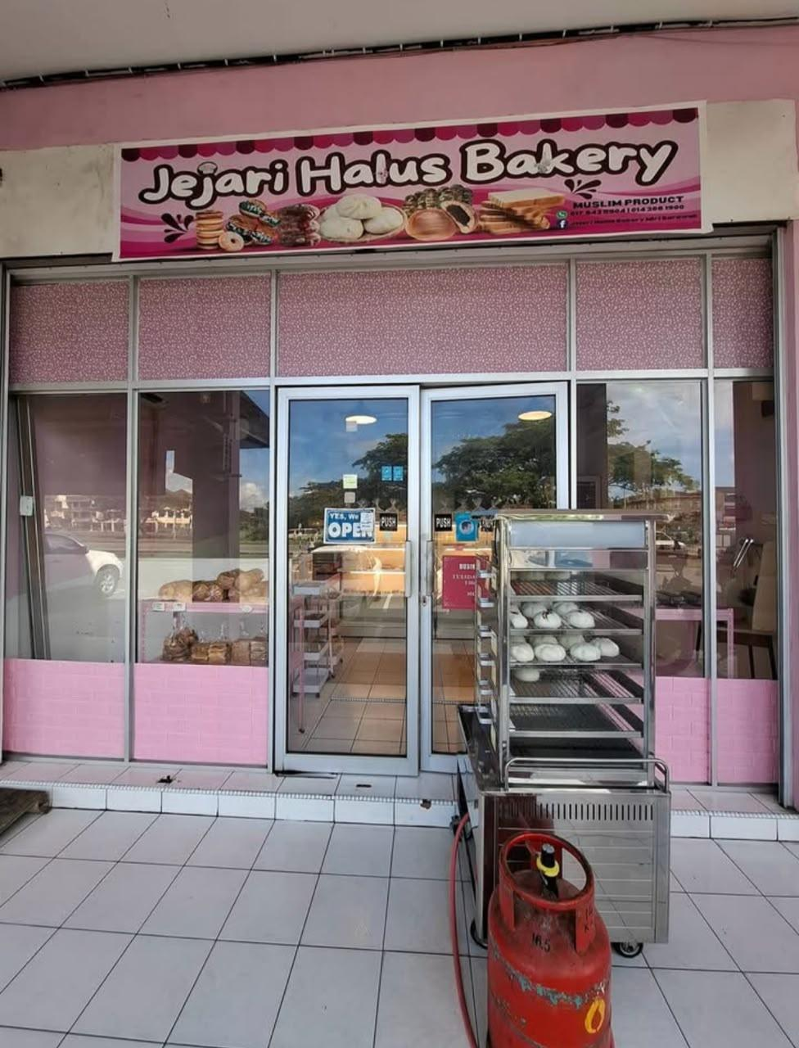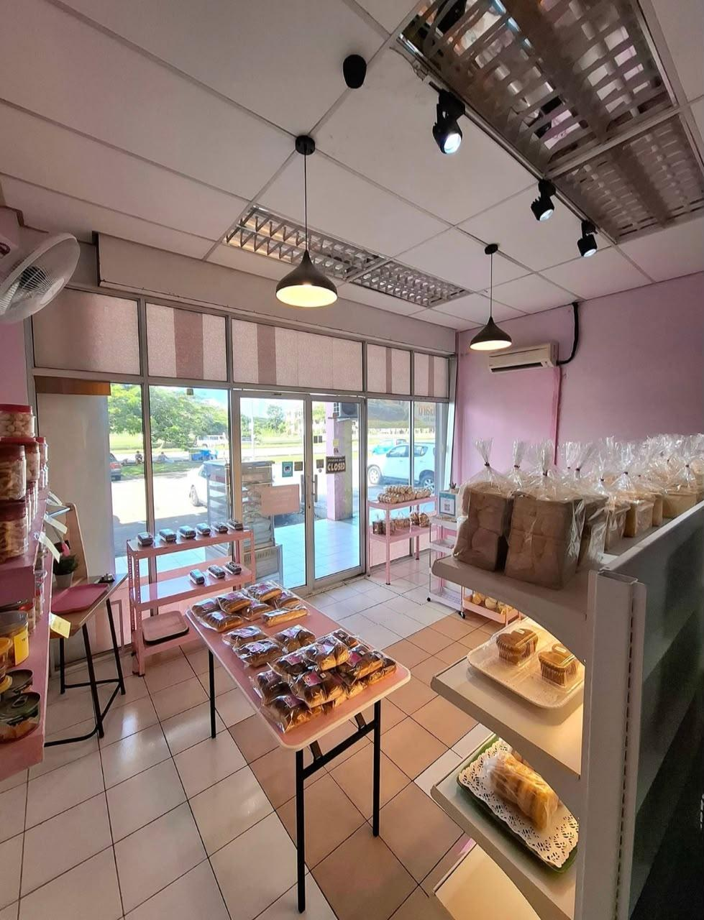

1.2 Team Background
Team Name: CrumbTech
Team Logo:

Team Motto: A little Crumb, A lot of Tech
Team Summary: CrumbTech is an enthusiastic and hard-working team of software engineering students specializing in agile mobile development, robust backend integration and committed to deliver high-quality software solutions tailored to real-world business challenges.

2. Problem Statement
ID | Current process / problem | Impact on client | Evidence (source)
P1 | Managing incoming orders and advance preorders may require the owner to coordinate order details, fulfilment dates, and order statuses manually or across separate channels. | Orders may be overlooked, order details may become disorganized, and it may be difficult to track pending orders and preorders efficiently. | Client interview, 12/10/2026
P2 | Product information, prices, and daily availability need to be kept up to date. Without a centralised management system, customers may not have clear information about which products are available. | Customers may request unavailable products, while the owner may need to spend additional time checking stock and informing customers about availability. | Client interview, 12/10/2026
P3 | Payment verification and order confirmation require the owner to review submitted QR payment receipts, manage cash-on-delivery orders, and accept or reject incoming orders. | Payment confirmation and order processing may take additional time, particularly when the owner must coordinate payment information with individual orders. | Client interview, 12/10/2026
P4 | Customers need to receive updates when their orders are accepted, rejected, or progress through different fulfilment stages. Without a dedicated notification system, updates may require separate communication with customers. | Customers may be uncertain about their order status, increasing the need for follow-up enquiries and additional communication from the owner. | Client interview. 12/10/2026
Table 1:Summary of client problems

Proposed Solution: A Flutter mobile application that centralises bakery product management, customer ordering, advance preorders, payment receipt verification, and order tracking for Jejari Halus Bakery. The application will use a user-friendly, pink-themed interface and in-app notifications to streamline order management and improve the customer experience.

3. Project Objectives & Success Metrics
No. | Objective | Solves | Success metric (how we measure) | Priority
O1 | To study and analyse the bakery's order handling and manual tracking processes to centralize incoming orders and advance preorders. | P1 | Client formal sign-off on the SRS document by Milestone 1 | High
O2 | To design and develop a centralised Flutter app and availability management module that maintain up-to-date pricing and stock status. | P2 | All Must-have FRs successfully pass acceptance testing | High
O3 | To integrate an AI feature powered bakery product recommendation feature that assists customers with tailored suggestions based on their preferences and budget. | P3 | Recommendation model achieves ≥80% correct classification results on the test set | High
O4 | To test and evaluate the mobile application, automated notifications, and payment verification workflows with the client | All | Completed ≥50 test cases, reached ≥60% coverage, obtained UAT sign-off | Medium
Table 2:Project objectives and success metrics

4. Project Perspective

4.1 Target Users
User type | Description | Main needs / goals | Device / tech level
Customer | Existing or potential customers who wish to purchase bakery products through the application. | Browse products, view prices and availability, place immediate orders or preorders at least two days in advance, choose pickup or delivery where applicable, submit QR payment receipts, select cash on delivery, and receive order notifications without creating an account. | Android or iOS smartphone; basic to intermediate technology skills.
Bakery Owner / Admin | Haji Abdul Rahman and Hajah Khairunnisa, who own and manage Jejari Halus Bakery. | Add, edit, and remove products; update prices and availability; review and accept or reject orders; verify payment receipts; manage order statuses; monitor upcoming preorders; and keep customers informed through in-app notifications. | Android or iOS smartphone; basic to intermediate technology skills.
Table 3:Target users

4.2 System Context and Architecture
The Jejari Halus Bakery App is proposed as a new Flutter-based mobile application to support the bakery’s customer ordering and owner management processes. The application provides a customer interface for browsing products, placing immediate orders or advance preorders, selecting eligible fulfilment methods, submitting QR payment receipts, and receiving order updates. The owner dashboard allows authorised users to manage product information and availability, review incoming orders, verify payment receipts, and update order statuses. Provider will manage application state, while Firebase Authentication will support owner access control and Cloud Firestore will store product, order, payment record, and status information. Payment receipts will be reviewed manually by the owner; the system will not directly process online payments. An AI recommendation service, which will be selected later, will suggest products based on customer preferences, budget, occasion, and the bakery’s catalogue. The application will verify product availability before order submission, and the AI API key will be protected on the server side rather than embedded in the mobile application.
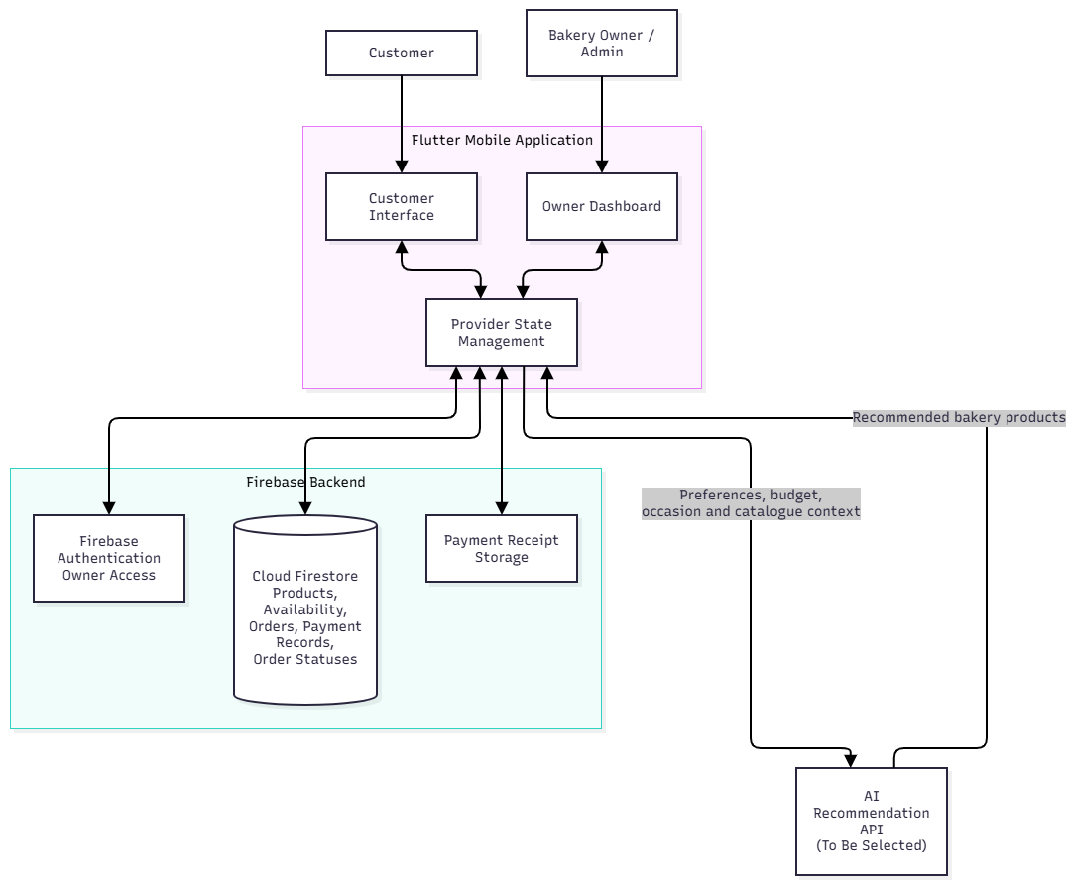
Figure 1: High-level System Architecture

5. Project Scope

5.1 In Scope / Out of Scope
In scope (will deliver this semester) | Out of scope (will not deliver)
Customer interface: Browse bakery products, view product images, prices, and availability. | Online payment gateway integration: Direct payment processing through banks, credit cards, or e-wallets.
Guest ordering: Customers can place orders without creating an account. | Customer registration and login: Customer accounts, profiles, and password management.
Order management: Place immediate orders and advance preorders at least two days before the required date. | Order cancellation and modification: Customers cannot cancel or modify submitted orders through the application.
Order fulfilment: Allow shop pickup and bakery delivery for eligible preorders. | Third-party delivery integration: Integration with external delivery platforms or courier services.
Payment options: Display a QR payment code, allow customers to submit payment receipts, and support cash on delivery. | Automated payment verification: Direct verification of transactions through banking systems; the owner reviews submitted receipts manually.
Owner administration: Add, edit, and remove products; update prices and availability; and manage incoming orders. | External notification services: SMS notifications, email notifications, or WhatsApp integration.
Order approval: Allow the owner to accept or reject incoming orders. | Advanced business analytics: Sales forecasting, customer behaviour analysis, and AI-powered recommendations.
Order status tracking: Allow the owner to update order statuses and notify customers through in-app notifications.
User interface design: Develop a consistent, user-friendly pink-themed interface for customers and the bakery owners.
Table 4:Scope boundary

5.2 Features and User Stories
FR-ID | Module | User story (As a … I want … so that …) | Priority
FR-01 | Product Catalogue | As a customer, I want to view product names, images, prices, and availability so that I can choose products to order. | Must
FR-02 | Product and Availability Management | As the owner, I want to add, edit and remove products and update product prices and daily availability so that customers see current product information. | Must
FR-03 | Guest Ordering | As a customer, I want to place orders without registering an account so that I can order conveniently. | Must
FR-04 | Immediate Orders | As a customer, I want to order currently available products for shop pickup so that I can purchase products immediately. | Must
FR-05 | Advance Preorders | As a customer, I want to preorder larger quantities at least two days in advance so that the bakery can prepare for events. | Must
FR-06 | Pickup and Bakery Delivery | As a customer, I want to choose shop pickup or eligible bakery delivery so that I can receive my order through a suitable method. | Must
FR-07 | Payment Methods | As a customer, I want to choose QR payment or cash on delivery and submit my QR payment receipt when applicable so that my payment can be processed. | Must
FR-08 | Order Acceptance and Rejection | As the owner, I want to accept or reject incoming orders so that I can manage orders according to stock and scheduling. | Must
FR-09 | Order Management Dashboard | As the owner, I want to view current orders and advance preorders in one dashboard so that I can monitor bakery operations. | Must
FR-10 | Order Status Management | As the owner, I want to update order statuses, including Order Received, Awaiting Payment Confirmation (where applicable), Order Confirmed, Preparing Order, Ready for Pickup, Out for Delivery, Completed, and Rejected, so that customers can follow their order progress. | Must
FR-11 | In-App Notifications | As a customer, I want to receive in-app notifications when my order is accepted, rejected, or updated so that I stay informed. | Must
FR-12 | Cancellation and Modification Policy | As a customer, I want to see the cancellation and modification policy before submitting an order so that I understand the conditions. | Must
FR-13 | Owner Administration | As the owner, I want to manage product information, product availability, order acceptance or rejection, payment verification, and order status updates through an authorised interface so that I can control bakery operations. | Must
FR-AI-01 | AI Product Recommendations | As a customer, I want to receive AI-assisted bakery product recommendations based on my preferences and occasions so that I can find suitable products. | Must
Table 5:Features and user stories

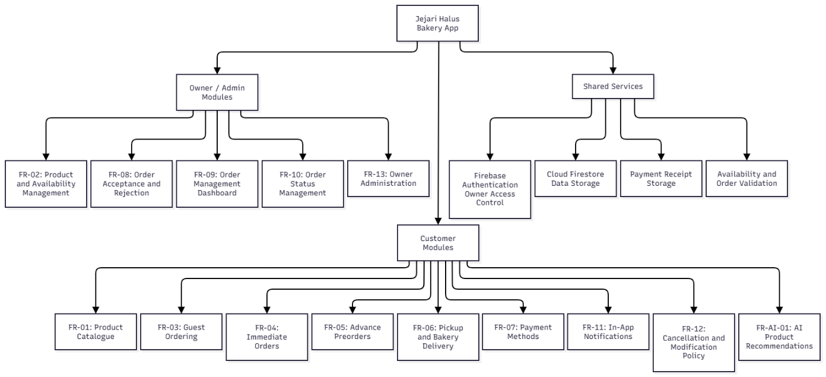
Figure 2: System modules diagram

5.3 AI Feature
The proposed application will include an AI-powered bakery product recommendation feature to help customers identify suitable bakery products based on their preferences, budget, and occasion. Customers may provide information such as the type of occasion, preferred product category, and budget. The AI service will use this information together with the bakery's available product catalogue to suggest relevant products.
The feature aims to improve product discovery and help customers make ordering decisions. Recommendations will be limited to products listed in the bakery's catalogue. Before an order is submitted, the application must verify the selected product's current availability to ensure that customers do not order unavailable items.

Item | Description
AI capability | AI-powered bakery product recommendation
User value | Helps customers discover suitable bakery products based on their needs and budget.
Input → Output | Occasion, budget, and product preferences → Relevant product recommendations from the bakery's catalogue
AI service / API | To be selected by the team after evaluating suitability, cost, availability, and integration requirements.
Constraints | API usage limits and response time may affect availability and performance. Customer input must be handled with appropriate privacy safeguards. Recommendations may not always be accurate or relevant, so users should be able to review suggested products. API keys must be protected and must not be embedded directly in the mobile application. Product availability must be verified by the application before order submission.
Table 6:AI feature summary

5.4 Non-Functional Requirements and Constraints
NFR-ID | Category | Requirement / constraint | Target
NFR-01 | Performance | Catalogue and owner order dashboard load quickly | < 2 s on mid-range phone
NFR-02 | Security | API keys and secrets never stored in source code or the APK | 0 secrets in repo
NFR-03 | Security | Only the authenticated owner can edit products and order statuses and view payment receipts. | 100% of owner-only writes rejected for guests (Firestore rules tested)
NFR-04 | Usability | A first-time customer can place an order unaided | ≤ 3 min per order; SUS score ≥ 70 in UAT with ≥ 5 users
NFR-05 | Reliability | App stays usable if the AI service or network fails | AI timeout 10 s, then fall back to the full catalogue; 0 crashes in UAT
NFR-06 | Compatibility | Runs on the client’s and customers’ phones | Android 8.0+ and iOS-capable Flutter codebase (confirm minimum version with the client)
Table 7:Non-functional requirements and constraints

5.5 System Environment
Layer | Technology / tool | Justification
Mobile app | Flutter and Dart | Supports mobile application development using a single codebase and is the required course technology.
UI framework | Material 3 | Provides reusable interface components and consistent styling, which can be customised to match the bakery's branding.
State management | Provider | Supports sharing and managing application state, including cart information and order details, across screens.
Backend/Database | Firebase Authentication and Cloud Firestore | Provides owner authentication and cloud storage for product information, orders, payment verification records, and order statuses.
Version control | Git and GitHub | Supports collaborative development, version tracking, and management of source code changes.
Continuous Integration | GitHub Actions | Can automate configured build and test checks to identify problems during development.
Target devices | Android smartphones (initial target) | Provides a focused initial platform for development, testing, and demonstration. The minimum supported Android version remains to be confirmed.
AI Service | To be determined | The AI service will be selected based on the agreed AI feature, integration requirements, security, and feasibility.
Table 8:System environment

6. Task Allocation & Team Contribution
Member | TSPi role | Owned features (FR-IDs) | Other responsibilities / contribution
Nur Ainin Sofiya binti Jeffery (102810) | Team Leader | FR-9, FR-10, FR-13 | Weekly team meetings, week progress report, proposal compilation, overall coordination, task/schedule management, milestone tracking
Noor Azuah binti Sawal (105404) | Quality/Process Manager & Support Manager | FR-3, FR-4, FR-6, FR-12 | LOGAI & AI tool monitoring, LOGTEST tracking, defect tracking, repository setup & tools configuration
Amira Asniesha Binti Mohamad Zulkhairi (102424) | Client Liaison, Planning Manager | FR-1, FR-2, FR-5 | Task/Schedule forms GitHub board tracking, client meeting minutes, requirements gathering & UAT coordination
Nurul Syahmina binti Busra (102904) | Development Manager | FR-7, FR-8, FR-11, FR-AI-01 | System architecture design, state management setup, code review supervision, GitHub Actions CI/CD setup, code coverage tracking
Table 9:Task allocation and contribution

7. Team Goals
No. | Team goal | Measure
G1 | Produce a high quality and reliable product | All Must-have FRs pass verification; CI pipeline remains green on.
G2 | Maintain communication and engagement with the client | Formal or informal client meetings at least once every two weeks.
G3 | Run a disciplined, productive and well-managed project lifecycle | Every milestone and deliverable is submitted on or ahead of schedule.
G4 | Ensure fair contribution across all team members | Each member successfully merges more or equal to 1 pull request per sprint.
Table 10:Team goals

8. Expected Results

8.1 Working System
The final app will be a fully functional mobile application developed using Flutter and Dart, supported by Firebase Authentication and Cloud Firestore for secure cloud data storage. From the user's point of view, customers can effortlessly browse the bakery's product catalogue, view item prices and daily availability. Guest can immediately order or purchase for advance preorders or shop pickup that placed at least two days in advance. Furthermore, customers can select convenient payment methods, including QR payment with ability to upload the receipt and also cash on delivery, while using the cloud AI-powered recommendation feature to receive tailored product suggestions based on their specific preferences, budget and occasion. For the bakery owner, the system provides a centralized dashboard to manage product information, accept or reject incoming orders, verify payment receipts, and update statuses across different stages, which automatically triggers in-app notifications to keep customers informed. The release criteria for the final working system include a stable, signed release APK (v1.0.0), successful execution of at least 50 comprehensive test cases with a minimum of 60% code coverage, and formal sign-off through client user acceptance testing (UAT).

8.2 Documentation and Artefacts
Deliverable | Submitted with
Project Proposal (original) | Proposal Submission (Week 4)
Revised Proposal and Software Requirements Specification (SRS) | Initial Report (Week 9)
Runnable prototype (4–5 screens), tagged release | Demo 1 (Week 9)
Software Design Specification (SDS), test plan and results (LOGTEST), user manual, maintenance plan, client acceptance form | Final Report (Week 13)
Release APK, demo video (5–10 min), presentation slides | Final Demo 2 (Week 14)
GitHub repository and complete project file | e-Archive (Week 15)
TSPi forms (LOGT, LOGD, LOGAI, SCHEDULE, SUMP, SUMQ, SUMS, SUMTASK, WEEK, PEER) and meeting minutes | Ongoing; compiled in Final Report
Table 11:Deliverables

9. Project Planning

9.1 Methodology
The team uses Scrum with two-week sprints (Rising & Janoff, 2000), together with the roles from the Team Software Process Initiative (TSPi) (Humphrey, 2000). This method is suitable for Jejari Halus Bakery because the owner's needs, such as order handling, payment verification, and preorders, may change or become clearer during development. By showing prototypes at the end of each sprint, the team can get feedback from the owner and make improvements based on their comments. Each team member has a different role. The Team Leader acts as the Scrum Master and leads weekly meetings. The Planning Manager gathers and manages the client's requirements, while the Development Manager handles system design and coding. The Quality/Process and Support Manager is responsible for testing, continuous integration (CI), and keeping records of the development process (Humphrey, 2000). The team records each task as a GitHub Issue and links it to the relevant functional requirement (e.g., FR-xx). Developers work on separate branches and submit their changes through Pull Requests. Before merging changes into the main branch, at least one team member must review and approve the Pull Request (Bacchelli & Bird, 2013). The code must also pass the automated build through GitHub Actions (Hilton et al., 2016). Any significant use of AI tools is recorded in the LOGAI register, while test activities and results are recorded in LOGTEST.

9.2 Submission Schedule
Phase | Deliverable | Week | Due
Phase 1: Planning & Development | Proposal Submission | 4 | 16 Oct 2026
 | Proposal Presentation | 5 | 19 – 23 Oct 2026
 | Initial Report | 9 | 16 Nov 2026
 | Demo 1 | 9 | 16 – 20 Nov 2026
Phase 2: Finalisation & Closure | Final Report | 13 | 24 Dec 2026
 | Final Demo 2 | 14 | 28 – 31 Dec 2026
 | e-Archive | 15 | Before 10 Jan 2027
Table 12:Submission schedule

9.3 Development Milestones (GitHub)
Milestone | Week | Key output | Status
M1 – Scope & Requirements | 4 – 5 | GitHub repo, issue board, CI file; proposal and initial SRS in /docs
M2 – Design & Prototype | 9 | SDS draft, 4–5 screen prototype, green CI, v0.2.0 tag
M3 – Product & Verification | 13 | ≥50 tests, ≥60% coverage, AI feature working
M4 – Final Release & Acceptance | 15 | Release APK v1.0.0, client sign-off, e-Archive
Table 13:Development milestones
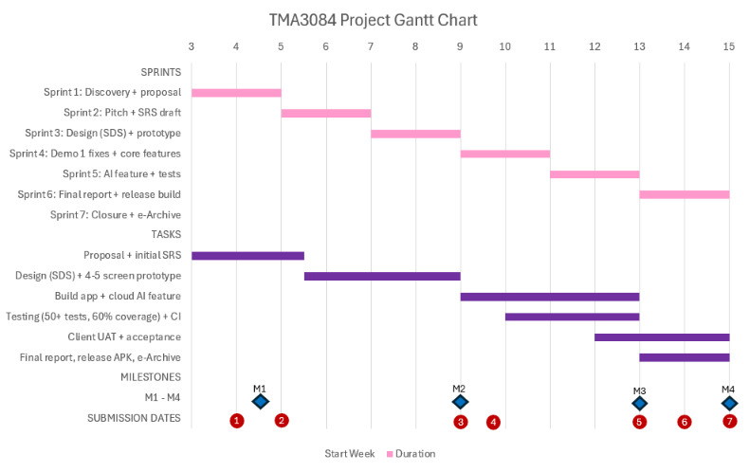
Submission dates: 1 Proposal (W4, 16 Oct) | 2 Proposal Presentation (W5, 19–23 Oct) | 3 Initial Report (W9, 16 Nov) | 4 Demo 1 (W9, 16–20 Nov) | 5 Final Report (W13, 24 Dec) | 6 Final Demo 2 (W14, 28–31 Dec) | 7 e-Archive (W15, before 10 Jan 2027)
Figure 3: Gantt chart

9.4 Risks and Assumptions
ID | Risk / assumption | Likelihood | Impact | Mitigation
R1 | Client unavailable for meetings | Medium | High | Agree a fixed fortnightly slot; WhatsApp/online fallback; minutes signed each time
R2 | AI API free tier limits exceeded | High | Medium | Cap output tokens and requests per user; cache common recommendations; catalogue fallback; RM0 budget
R3 | API key leaked | Low | High | Key kept off the app (see section 5); secret scanning; rotate immediately if exposed
R4 | Skill gaps (Flutter, Firebase, testing) | Medium | Medium | Learning spike in Sprint 1; pair work; assign FRs by skill; peer PR review
R5 | Schedule slip (other courses, double-role members) | Medium | High | MoSCoW; build the AI feature after the core order flow; buffer in every sprint; weekly WEEK check
Table 14:Risks and assumptions

10. References
Bacchelli, A., & Bird, C. (2013). Expectations, outcomes, and challenges of modern code review. Proceedings of the 35th International Conference on Software Engineering (ICSE), 712–721. https://doi.org/10.1109/ICSE.2013.6606617

Hilton, M., Tunnell, T., Huang, K., Marinov, D., & Dig, D. (2016). Usage, costs, and benefits of continuous integration in open-source projects. Proceedings of the 31st IEEE/ACM International Conference on Automated Software Engineering (ASE), 426–437. https://doi.org/10.1145/2970276.2970358

Humphrey, W. S. (2000). Introduction to the team software process. Addison-Wesley.
Rising, L., & Janoff, N. S. (2000). The Scrum software development process for small teams. IEEE Software, 17(4), 26–. https://doi.org/10.1109/52.854065

Appendix A: Client Meeting Evidence

A.1 Meeting 1: Target Client Selection and Project Planning
Date: 9 October 2026
Time: 8:00 PM – 10:00 PM
Mode: Online via Google Teams
Project: Jejari Halus Bakery App
Meeting Type: Team Meeting
Attendees: Amira Asniesha, Nur Ainin Sofiya, Noor Azuah, Nurul Syahmina.
Meeting Objective: To select the target client and assign roles and responsibilities to team members.
Key Discussion Points and Decisions:
- The group discussed potential clients and agreed to select Jejari Halus Bakery in Miri, Sarawak.
- Amira was appointed as the Planning Manager and Client Liaison, responsible for contacting the bakery owner.
- The group agreed on the distribution of roles: Amira as Planning Manager and Client Liaison, Syahmina as Developer Manager, Noor Azuah as Quality, Process and Support Manager, and Ainin as Team Leader.
- The group agreed to arrange a face-to-face meeting with the bakery owner to introduce the project and gather information about the bakery's needs.
Outcome: Jejari Halus Bakery was selected as the target client, and Amira was assigned to arrange the initial client meeting.

A.2 Meeting 2: Client Requirements Gathering
Date: 12 October 2026
Time: 8:00 AM – 10:30 AM
Location: Online via Google Meet
Meeting Type: Client Meeting
Attendees: Amira Asniesha and Abdul Rahman bin Haji Jawawi, Nur Ainin Sofiya, Nurul Syahmina, Noor Azuah.
Meeting Objective: To understand the bakery's business operations, gather information about the client's expectations, and identify potential functional requirements for the proposed bakery application.
Key Discussion Points and Decisions:
- Product Catalogue and Availability: The proposed application would allow customers to browse bakery products, with the client requesting the ability to update product availability daily.
- Customer Ordering: The group discussed immediate orders for available products and advance orders for larger quantities or special events, including collection and delivery arrangements.
- Order Management: The proposed system would provide an interface for the bakery owner to monitor current orders and event preorders.
- Order Status Notifications: Customer notifications for statuses such as order received, order confirmed, and out for delivery were discussed for further requirements review.
- Requirements Documentation: Amira was assigned to document the client's feedback and prepare the functional requirements for review by the group.
Outcome: The meeting provided initial information about the bakery's operational needs and established a basis for drafting the application's functional requirements. The final features and order management workflow remain subject to further group review and clarification.

Appendix B: Revision History
Version | Date | Changes (e.g. after proposal presentation feedback) | By
1.0 | 16/10/2026 | Original submission | CrumbTech

