(W54A01) XOR Gate

encrypt/decrypt – LAB

1. Application screnshots
The application has a menu with 3 options: encrypt, decrypt and exit. The user select the desired option and give the string to encrypt:

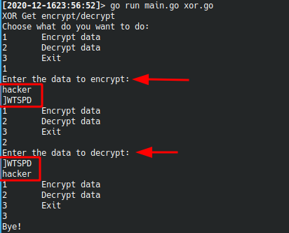

The key to encrypt is stored in a constant in the code (xor.go), which is not a good practice, but for the sake of simplicity, it was saved in this way.

2. Source code

main.go
package main
import "fmt"
const menu string = `1 Encrypt data
2 Decrypt data
3 Exit`

func main() {
fmt.Println("XOR Get encrypt/decrypt")
fmt.Println("Choose what do you want to do:")
var opt int
for opt != 3 {
fmt.Println(menu)
fmt.Scanf("%d", &opt)
switch opt {
case 1:
fmt.Println("Enter the data to encrypt:")
var data string
if _, e := fmt.Scanln(&data); e != nil {
fmt.Println("There was an error with your input")
break
}
fmt.Println(Encrypt(data))
case 2:
fmt.Println("Enter the data to decrypt:")
var encData string
if _, e := fmt.Scanln(&encData); e != nil {
fmt.Println("There was an error with your input")
break
}
fmt.Println(Decrypt(encData))
}
}
fmt.Println("Bye!")
}

xor.go
package main

// not so secure to have it on code!
const key = "5678"

// Encrypt XOR encryption
func Encrypt(s string) string {
var encSlice []int
sASCII := toASCII(s)
keyASCII := toASCII(key)
for i, e := range sASCII {
encSlice = append(encSlice, e^keyASCII[i%len(keyASCII)])
}
return toString(encSlice)
}

// Decrypt XOR decryption
func Decrypt(s string) string {
var decSlice []int
sASCII := toASCII(s)
keyASCII := toASCII(key)
for i, e := range sASCII {
decSlice = append(decSlice, e^keyASCII[i%len(keyASCII)])
}
return toString(decSlice)
}

func toASCII(s string) []int {
var asciiVals []int
for _, e := range s {
asciiVals = append(asciiVals, int(e))
}
return asciiVals
}

func toString(is []int) string {
var st string
for _, s := range is {
st += string(byte(s))
}
return st
}

