
Azriel V. Atara
Address : Guibang, Gamu, Isabela 3300
Mobile : +639536730304
Email : azrielv.atara@gmail.com

OBJECTIVE
A self-motivated individual and contribute meaninfully while enhancing my skills and knowledge. I aim to support the organization’s sucess and foster my personal growth.
EDUCATION
Tertiary
Bachelor of Science in Information Technology (BSIT)
Isabela State University – Ilagan Campus
Calamagui 2nd, City of Ilagan, Isabel, Philippines
2026 – Ongoing

Secondary
Saint Ferdinand College
Senior Highschool Graduate – STEM
Sta. Ana St, Ilagan City, 3300 Isabela
2020 – 2022

Elementary
Guibang Elementary School
Elementary Graduate
Guibang, Gamu, Isabela 3300
2009 – 2015

CERTIFICATES AND ORGANIZATIONS

- Information Technology Specialist in Databases
- Philippine Information Technology of the North (PITON) – Member (SY2023-2025)

SKILLS
- Adaptable, detail-oriented, and Microsoft Office literate, with strong problem-solving abilities, time management skills, and a willingness to learn and grow professionally.
- Skilled in computer and smartphone troubleshooting, assembly and disassembly, software installation, reformatting, and system configuration.
- Proficient in programming, web development, database management, and data analysis using
technologies such as C#, Python, MySQL, HTML, CSS, JavaScript, PHP, and Microsoft
Excel.

REFERENCES

JAYDWIN T. LABIANO
Instructor
College of Engineering, Architecture and Technology
Isabela State University – City of Ilagan, Isabela
09552016529

ROMAN ALEX F. LUSTRO, DIT
Associate Professor
Information and Communication Technology
Isabela State University – Ilagan Campus
City of Ilagan, Isabela
09354000214
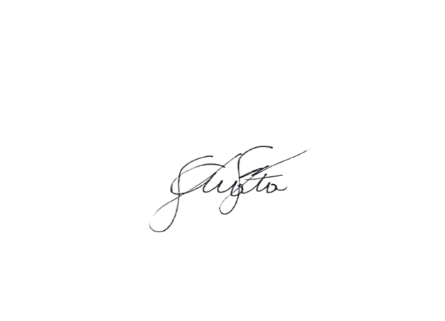

I hereby certify that the above information is true and correct with the best of my knowledge and ability.

Signature of Applicant

