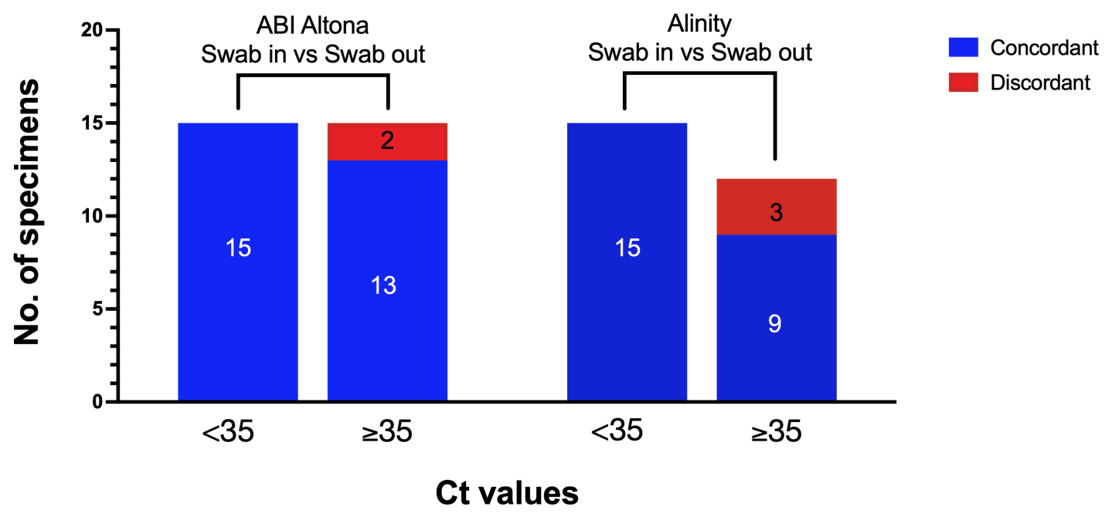 *Figure 1: Agreement between swab-in and swab-out methods. Comparison of concordant (true positives, in blue) and discordant (false negatives, in red) results observed after swab removal for the <32 and ≥32 groups for the ABI (left) and Alinity (right) Real-Time PCR Platforms. Inside the bar charts are the number of samples in each group.*