**Name: Raphael Hideki Azuma**

**Email:** [**raphael.azuma@outlook.com**](mailto:raphael.azuma@outlook.com)

**Contact number: + 55 11 975801768**

**São Paulo, São Paulo - Brazil**

**LinkedIn: www.linkedin.com/in/raphaelazuma-2a05b5198**

**\*Curriculum\***

**About -**

**Working as a WorkForce Software AMS and project Consultant.**

**Knowledge in Big Data processes, Machine Learning, Employee Central (SuccessFactors),**

**WorkForce Software, Service now, SAP CAS and livestream softwares such as OBS studio and**

**streamlabs OBS.**

**Experience in providing services to large companies such as: Votorantim, Nexa, Fibria, CBA,**

**Cesp, Softys, Elgin, Steel, José Alves Group, Tigre, Gerdau, SASOL, NTT data, UnitedHealth**

**Group, Lear, Rede Sarah, Embraer and Cielo.**

**Always in search of knowledge and improvement.**

**Experience -**

**Intelligenza (1 year 8 months) - WFS consultant**

**▪️Project implementation for Sasol, Cielo and Embraer.**

**▪️AMS consultant for UnitedHealth Group, Rede Sarah, Lear corporation and NTT DATA.**

**▪️EC-WFS-ECP integration process.**

**Evox Solutions ( 2 years 1 month) - SAP Functional Analyst**

**▪️Service Now, Topdesk and Voixtel data extraction, organization and analysis for better service**

**rates and schedules improvement.**

**▪️Analysis and resolution in SAP SD, LES, MM, HCM modules.**

**▪️Creation and management of SAP knowledge base in order to increase FCR (First Call**

**Resolution) and improve analysts knowledge.**

**▪️ Tickets reprocessing (NF-e's and MDF-e's), freight cost, transport, and SEFAZ access key**

**analysis, helping to stabilize logistics processes**

**▪️Service for Votorantim, Nexa, Fibria, CBA, Cesp, Softys, Elgin, Steel and Grupo José Alves.**

**▪️Advisor for new N1 analysts.**

**Juntos Somos Mais (5 months) - IT Functional Analyst**

**▪️Project implementation of a B2B commercial transaction tool for construction material.**

**▪️Customer support (navigation and shopping difficulties) on the VC Online and Virtual Store**

**portals (Juntos Somos Mais).**

**▪️Analysis of availability and price of materials in order to instruct the customer the best**

**possible purchase.**

**▪️Service for Votorantim Cimentos, Gerdau and Tigre companies**

**▪️Product and Online Store Marketing.**

**▪️Creation of shortcuts for service via chat.**

**▪️Customer data updates.**

## **Licenses & certifications -**

**Functional Implementation: Partner Certification (WFS)**

**Configuration Specialist: Partner Certification (WFS)**

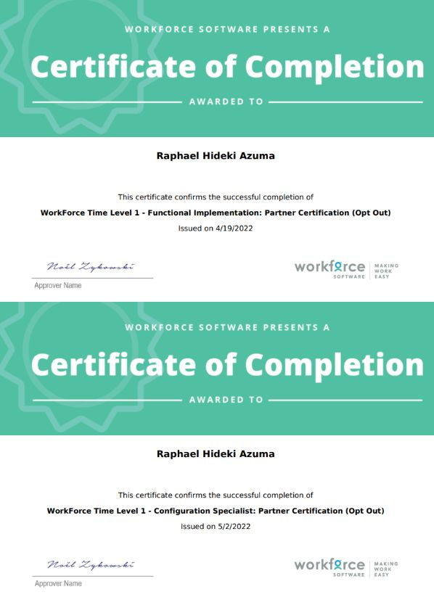

**Big Data Integration and Processing (UC San Diego)**

[**https://www.coursera.org/account/accomplishments/certificate/WCAEW9ANFY9V**](https://www.coursera.org/account/accomplishments/certificate/WCAEW9ANFY9V)

**Machine Learning With Big Data (UC San Diego)**

[**https://www.coursera.org/account/accomplishments/certificate/BB7FXG5VSBEY**](https://www.coursera.org/account/accomplishments/certificate/BB7FXG5VSBEY)

**Big Data modeling and Management Systems (UC San Diego)**

[**https://www.coursera.org/account/accomplishments/certificate/557LHQJ7YC5V**](https://www.coursera.org/account/accomplishments/certificate/557LHQJ7YC5V)

**Introduction to Big Data (UC San Diego)**

[**https://www.coursera.org/account/accomplishments/certificate/R8W8P2VD7EUK**](https://www.coursera.org/account/accomplishments/certificate/R8W8P2VD7EUK)

**Languages -**

**English (Full Professional)**

**Spanish (Basic)**

**Portuguese (Native)**