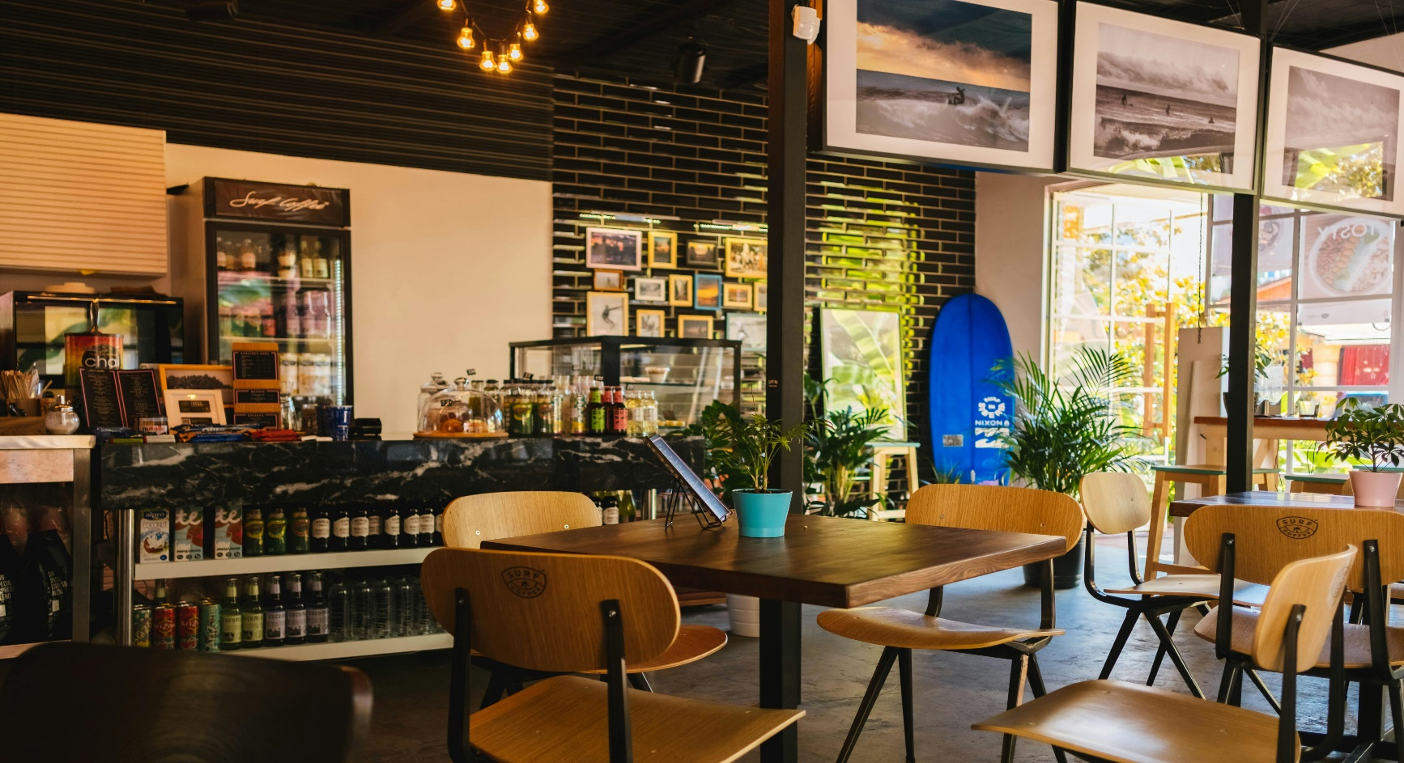

BUSINESS PROPOSAL FOR DIGITAL MARKETING SERVIICES
BY: FLAVOUR MARKETING AGENCY
FOR: TASTE OF ITALY RESTAURANT

ADDRESS: 123 CULINARY AVE.
FOODTOWN, FT 45678
info@tastofitaly.com
(123) 456-7890
OCTOBER 14, 2024

MR. JOHN SMITH
OWNER, TASTE OF ITATLY
456 BISTRO LANE
FOODTOWN, FT 45678

INTRODUCTION
About Us:
FLAVOUR MARKETING AGENCY is a digital marketing agency specializing in the food and beverage industry. We help restaurants like TASTE OF ITALTY enhance their online presence and engage with customers effectively.
Understanding Your Needs:
We recognize that TASTE OF ITALY seeks to attract more patrons, increase online orders, and build a loyal community around your brand.

OBJECTIVES
Increase Brand Awareness:
Goal: Establish a strong online presence to attract new customers.
Strategies:
- Create engaging content across social media platforms to showcase the restaurant's unique offerings.
- Implement targeted online advertising to reach local audiences.
- Optimize the restaurant's website for search engines to improve visibility.
Drive Foot Traffic:
Goal: Encourage more diners to visit the restaurant through targeted campaigns.
Strategies:
- Promote special events, happy hours, and seasonal menus through social media and local advertising.
- Utilize geo-targeted ads to reach potential customers in the vicinity.
- Collaborate with local influencers to create buzz and attract their followers to the restaurant.
Boost Online Orders:
Goal: Increase online reservations and takeout through effective digital strategies.
Strategies:
- Enhance the restaurant's website with an easy-to-use online ordering system.
- Launch email marketing campaigns featuring exclusive offers for online orders.
- Promote partnerships with delivery platforms to widen reach.

MARKET ANALYSIS
Target Audience
Customer Segments:
Young Professionals (Ages 25-40)
Demographics: Typically, single or married, with disposable income, seeking convenient dining options.
Dining Preferences: Favor trendy, Instagram-worthy dishes and experiences; often look for online ordering options.

Families (Ages 30-50)
Demographics: Parents with children looking for family-friendly dining experiences.
Dining Preferences: Prefer casual dining with a diverse menu; appreciate promotions and special deals for families.

PROPOSED DIGITAL MARKETING
Website optimization
Enhance User Experience and Mobile Responsiveness:
- Revamp the website design to ensure intuitive navigation and a visually appealing layout.
- Optimize the site for mobile devices, ensuring quick load times and accessible features, such as online ordering and reservations.
Implement SEO Best Practices:
- Conduct keyword research to identify relevant terms that potential customers are searching for, such as "Italian restaurant near me" or "best pasta in [City]."
- Optimize on-page elements, including meta tags, headers, and image alt texts, to improve search rankings.
- Create high-quality, keyword-rich content, such as blog posts or articles about Italian cuisine, to drive organic traffic.

BUGDET
Items | Cost
Salads | E200
Chicken Wings | E400
Spring Rolls | E500
French Fries | E700
Mashed Potatoes | E900
Garlic Bread | E1000

TIMELINE
Phase | Task | Start Date | End Date
Phase 1: Strategy Development | Conduct market research, finalize strategy | 3rd, oct | 4th, oct
Phase 2: Setup | Create social media profiles, set up email tools | 6th, oct | 7th, oct
Phase 3: Content Creation | Develop initial content pieces (blogs, graphics) | 9th, oct | 10^{th,} oct
Phase 4: Launch Campaign | Begin social media ads, email campaigns | 13th, oct | 14th, oct
Phase 5: Monitor & optimize | Analyze performance metrics, adjust strategy | 20th, oct | 22nd oct
Phase 6: Final Review | Present final report and recommendations | 29th, oct | 30th, oct

CONCLUSION
We believe that our proposed digital marketing strategies will significantly enhance TASTE OF ITATLY’s online presence, attract new customers, and strengthen loyalty among existing patrons. We look forward to the opportunity to work together.

CALL TO ACTION
Let’s schedule a meeting to discuss this proposal in detail and explore how we can achieve your marketing goals together.

