spring整合Mybatis详细过程

整合思路
- 数据源信息交给spring管理
- SqlSessionFactory交给spring进行单例管理
- 由spring来管理原始dao的实现类或者mapper代理的代理类。

需求
使用原始dao方式和mapper代理方式实现以下功能：
根据用户ID查询用户信息

工程搭建
- Mysql的驱动包
- Mybatis的核心包和依赖包
- Mybatis和spring的整合包
- Spring的包
- druid数据库连接池包
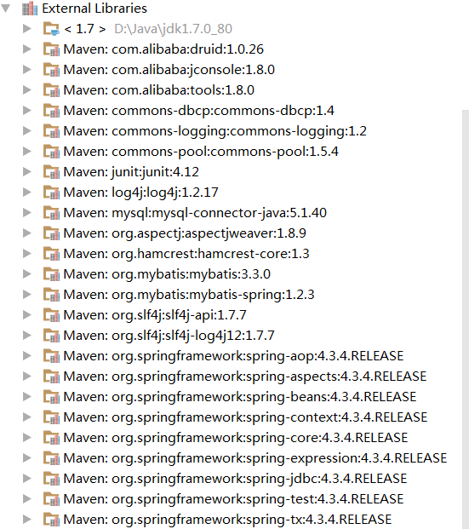

<!-- junit -->
<dependency>
<groupId>junit</groupId>
<artifactId>junit</artifactId>
<version>4.12</version>
</dependency>
<!-- SLF4J -->
<dependency>
<groupId>org.slf4j</groupId>
<artifactId>slf4j-log4j12</artifactId>
<version>1.7.7</version>
</dependency>
<!--spring -->
<dependency>
<groupId>org.springframework</groupId>
<artifactId>spring-test</artifactId>
<version>4.3.4.RELEASE</version>
</dependency>
<dependency>
<groupId>org.springframework</groupId>
<artifactId>spring-context</artifactId>
<version>4.3.4.RELEASE</version>
</dependency>
<dependency>
<groupId>org.springframework</groupId>
<artifactId>spring-aspects</artifactId>
<version>4.3.4.RELEASE</version>
</dependency>
<dependency>
<groupId>org.springframework</groupId>
<artifactId>spring-jdbc</artifactId>
<version>4.3.4.RELEASE</version>
</dependency>
<!-- mysql -->
<dependency>
<groupId>mysql</groupId>
<artifactId>mysql-connector-java</artifactId>
<version>5.1.40</version>
<scope>runtime</scope>
</dependency>
<!-- druid -->
<dependency>
<groupId>com.alibaba</groupId>
<artifactId>druid</artifactId>
<version>1.0.26</version>
</dependency>
<dependency>
<groupId>commons-dbcp</groupId>
<artifactId>commons-dbcp</artifactId>
<version>1.4</version>
</dependency>
<dependency>
<groupId>org.mybatis</groupId>
<artifactId>mybatis</artifactId>
<version>3.3.0</version>
</dependency>
<dependency>
<groupId>org.mybatis</groupId>
<artifactId>mybatis-spring</artifactId>
<version>1.2.3</version>
</dependency>

具体整合

整合配置文件

Mybatis
在src/main/resources下创建SqlMapConfig.xml
<?xml version="1.0" encoding="UTF-8" ?>
<!DOCTYPE configuration PUBLIC "-//mybatis.org//DTD Config 3.0//EN"
"http://mybatis.org/dtd/mybatis-3-config.dtd">
<configuration>
<!-- mybatis默认是没有开启延迟加载的 需要手动开启 -->
<settings>
<!-- 延迟加载 默认false -->
<setting name="lazyLoadingEnabled" value="true" />
<!-- 积极加载 默认true -->
<setting name="aggressiveLazyLoading" value="false" />
<!--开启缓存-->
<setting name="cacheEnabled" value="true"/>
</settings>
<!-- 加载映射文件 -->
<mappers>
<mapper resource="User.xml"/>
</mappers>
</configuration>

将jdbcperties和log4j.properties拷贝到src/main/resources目录下。

Spring
在src/main/resources创建applicationContext.xml
<!--扫描包路径-->
<context:component-scan base-package="com.zhiyou100"/>
<!--加载配置文件-->
<context:property-placeholder location="classpath:jdbc.properties"/>
<!--数据源配置-->
<bean id="dataSource" class="com.alibaba.druid.pool.DruidDataSource" init-method="init" destroy-method="close">
<property name="driverClassName" value="${jdbc.driverClassName}"/>
<property name="url" value="${jdbc.url}"/>
<property name="username" value="${jdbc.username}"/>
<property name="password" value="${jdbc.password}"/>
<property name="filters" value="stat"/>
<property name="maxActive" value="20"/>
<property name="initialSize" value="1"/>
<property name="maxWait" value="60000"/>
<property name="minIdle" value="1"/>
<property name="timeBetweenEvictionRunsMillis" value="60000"/>
<property name="minEvictableIdleTimeMillis" value="300000"/>
<property name="validationQuery" value="SELECT 'x'"/>
<property name="testWhileIdle" value="true"/>
<property name="testOnBorrow" value="false"/>
<property name="testOnReturn" value="false"/>
</bean>
<!--让spring管理mybatis的sqlSessionFactory-->
<bean id="sqlSessionFactory" class="org.mybatis.spring.SqlSessionFactoryBean">
<property name="dataSource" ref="dataSource"/>
<!--spring管理mybatis的配置文件-->
<property name="configLocation" value="sqlMapConfig.xml"/>
</bean>
<!--向sqlSessionTemplate注入sqlSessionFactory工厂 sqlSessionTemplate实现了sqlSession接口
因为sqlSession是多例的 所以需要设置scope="prototype"
-->
<bean id="sqlSession" class="org.mybatis.spring.SqlSessionTemplate" scope="prototype">
<constructor-arg name="sqlSessionFactory" ref="sqlSessionFactory"/>
</bean>

整合代码

原始dao开发方式

映射文件
在src/main/resources下创建User.xml
<?xml version="1.0" encoding="UTF-8" ?>
<!DOCTYPE mapper PUBLIC "-//mybatis.org//DTD Mapper 3.0//EN"
"http://mybatis.org/dtd/mybatis-3-mapper.dtd">
<mapper namespace="user">
<select id="findUserById" parameterType="java.lang.Integer" resultType="com.zhiyou100.model.User">
SELECT * FROM t_user WHERE id = #{id}
</select>
</mapper>

Dao代码
Dao接口
public interface UserDao {
User getUserById(Integer id);
}
Dao实现类
@Repository
public class UserDaoImpl implements UserDao {
@Autowired
private SqlSession sqlSession;//必须定义成多例
@Override
public User getUserById(Integer id) {
System.out.println("查询用户");
User user = sqlSession.selectOne("user.findUserById",1);
return user;
}
}

测试代码
@RunWith(SpringJUnit4ClassRunner.class)
@ContextConfiguration(locations = "classpath:applicationContext.xml")
public class UserServiceTest {
@Autowired
UserService userService;
@Test
public void getUserById() throws Exception {
User user = userService.getUserById(1);
System.out.println(user);
}
}

Mapper代理

映射文件
编写映射文件UserMapper.xml

Mapper接口
public interface UserMapper {
long countByExample(UserExample example);
int deleteByExample(UserExample example);
int deleteByPrimaryKey(Integer id);
int insert(User record);
int insertSelective(User record);
List<User> selectByExample(UserExample example);
}

配置mapper代理类
- 单个mapper代理类配置
<!--配置userMapper的代理类-->
<bean id="userMapper" class="org.mybatis.spring.mapper.MapperFactoryBean">
<!--设置代理类的接口-->
<property name="mapperInterface" value="com.zhiyou100.mapper.UserMapper"/>
<!--给代理类注入sqlSessionFactory-->
<property name="sqlSessionFactory" ref="sqlSessionFactory"/>
</bean>

- 批量设置mapper代理类
<!--配置userMapper的代理类默认生成的mapper代理类的bean id 是mapper接口名称的首字母小写-->
<bean class="org.mybatis.spring.mapper.MapperScannerConfigurer">
<property name="basePackage" value="com.zhiyou100"/>
<property name="sqlSessionFactoryBeanName" value="sqlSessionFactory"/>
</bean>

测试代码
@RunWith(SpringJUnit4ClassRunner.class)
@ContextConfiguration(locations = "classpath:applicationContext.xml")
public class UserServiceTest {
@Autowired
private UserService userService;
@Test
public void getUserById() throws Exception {
User user = userService.getUserById(1);
System.out.println(user);
}
}

spring整合Mybatis项目实战

工程结构图
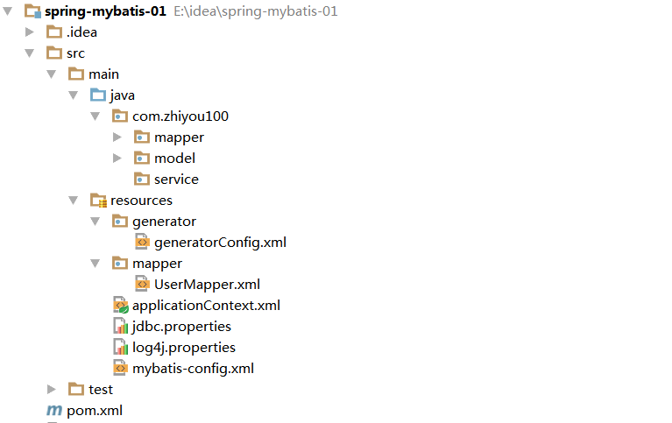

pom.xml配置
<?xml version="1.0" encoding="UTF-8"?>
<project xmlns="http://maven.apache.org/POM/4.0.0"
xmlns:xsi="http://www.w3.org/2001/XMLSchema-instance"
xsi:schemaLocation="http://maven.apache.org/POM/4.0.0 http://maven.apache.org/xsd/maven-4.0.0.xsd">
<modelVersion>4.0.0</modelVersion>
<groupId>com.zhiyou100</groupId>
<version>1.0-SNAPSHOT</version>
<artifactId>spring-mybatis-01</artifactId>
<dependencies>
<!-- junit start-->
<dependency>
<groupId>junit</groupId>
<artifactId>junit</artifactId>
<version>4.12</version>
<scope>test</scope>
</dependency>
<!-- junit end-->
<!--spring start-->
<dependency>
<groupId>org.springframework</groupId>
<artifactId>spring-context</artifactId>
<version>4.3.4.RELEASE</version>
</dependency>
<dependency>
<groupId>org.springframework</groupId>
<artifactId>spring-aspects</artifactId>
<version>4.3.4.RELEASE</version>
</dependency>
<dependency>
<groupId>org.springframework</groupId>
<artifactId>spring-jdbc</artifactId>
<version>4.3.4.RELEASE</version>
</dependency>
<dependency>
<groupId>org.springframework</groupId>
<artifactId>spring-test</artifactId>
<version>4.3.4.RELEASE</version>
<scope>test</scope>
</dependency>
<!--spring end-->
<!-- database begin -->
<dependency>
<groupId>mysql</groupId>
<artifactId>mysql-connector-java</artifactId>
<version>5.1.40</version>
<scope>runtime</scope>
</dependency>
<dependency>
<groupId>com.alibaba</groupId>
<artifactId>druid</artifactId>
<version>1.0.26</version>
</dependency>
<dependency>
<groupId>org.mybatis</groupId>
<artifactId>mybatis</artifactId>
<version>3.3.0</version>
</dependency>
<dependency>
<groupId>org.mybatis</groupId>
<artifactId>mybatis-spring</artifactId>
<version>1.2.3</version>
</dependency>
<!-- database end -->
<!-- loging begin-->
<dependency>
<groupId>org.slf4j</groupId>
<artifactId>slf4j-log4j12</artifactId>
<version>1.7.7</version>
</dependency>
<!-- loging end -->
<!-- Mybatis Generator -->
<dependency>
<groupId>org.mybatis.generator</groupId>
<artifactId>mybatis-generator-core</artifactId>
<version>1.3.5</version>
<scope>compile</scope>
<optional>true</optional>
</dependency>
</dependencies>
<build>
<plugins>
<plugin>
<groupId>org.mybatis.generator</groupId>
<artifactId>mybatis-generator-maven-plugin</artifactId>
<version>1.3.2</version>
<configuration>
<configurationFile>${basedir}/src/main/resources/generator/generatorConfig.xml</configurationFile>
<overwrite>true</overwrite>
<verbose>true</verbose>
</configuration>
<dependencies>
<dependency>
<groupId>mysql</groupId>
<artifactId>mysql-connector-java</artifactId>
<version>5.1.40</version>
</dependency>
</dependencies>
</plugin>
</plugins>
</build>
</project>

lib包
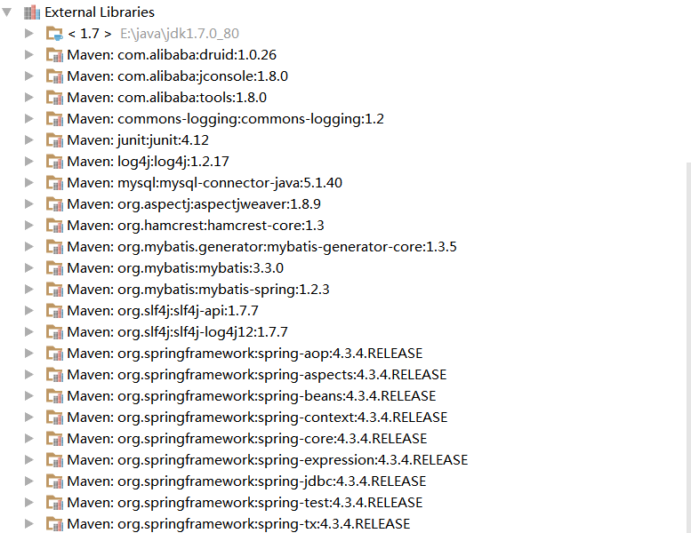

log4j.properties配置

log4j.rootLogger=DEBUG, Console
#Console
log4j.appender.Console=org.apache.log4j.ConsoleAppender
log4j.appender.Console.layout=org.apache.log4j.PatternLayout
log4j.appender.Console.layout.ConversionPattern=%d [%t] %-5p [%c] - %m%n
log4j.logger.com.github.pagehelper=DEBUG
log4j.logger.org.apache.ibatis=DEBUG
log4j.logger.com.github.pagehelper.mapper = TRACE

jdbc.properties配置
#数据库连接信息
jdbc.driverClassName=com.mysql.jdbc.Driver
jdbc.url=jdbc:mysql://localhost:3306/spring_mybatis
jdbc.username=root
jdbc.password=123456

applicationContext.xml配置
<?xml version="1.0" encoding="UTF-8"?>
<beans xmlns:xsi="http://www.w3.org/2001/XMLSchema-instance"
xmlns:tx="http://www.springframework.org/schema/tx"
xmlns:aop="http://www.springframework.org/schema/aop"
xmlns:context="http://www.springframework.org/schema/context"
xmlns="http://www.springframework.org/schema/beans"
xsi:schemaLocation="http://www.springframework.org/schema/beans
http://www.springframework.org/schema/beans/spring-beans.xsd
http://www.springframework.org/schema/tx
http://www.springframework.org/schema/tx/spring-tx.xsd
http://www.springframework.org/schema/aop
http://www.springframework.org/schema/aop/spring-aop.xsd
http://www.springframework.org/schema/context
http://www.springframework.org/schema/context/spring-context.xsd">
<!--扫描包路径-->
<context:component-scan base-package="com.zhiyou100"/>
<!--加载配置文件-->
<context:property-placeholder location="classpath:jdbc.properties"/>
<!--数据源配置-->
<bean id="dataSource" class="com.alibaba.druid.pool.DruidDataSource" init-method="init" destroy-method="close">
<property name="driverClassName" value="${jdbc.driverClassName}"/>
<property name="url" value="${jdbc.url}"/>
<property name="username" value="${jdbc.username}"/>
<property name="password" value="${jdbc.password}"/>
<property name="filters" value="stat"/>
<property name="maxActive" value="20"/>
<property name="initialSize" value="1"/>
<property name="maxWait" value="60000"/>
<property name="minIdle" value="1"/>
<property name="timeBetweenEvictionRunsMillis" value="60000"/>
<property name="minEvictableIdleTimeMillis" value="300000"/>
<property name="validationQuery" value="SELECT 'x'"/>
<property name="testWhileIdle" value="true"/>
<property name="testOnBorrow" value="false"/>
<property name="testOnReturn" value="false"/>
</bean>
<!-- 注入sqlSessionFactory -->
<bean id="sqlSessionFactory" class="org.mybatis.spring.SqlSessionFactoryBean">
<!-- 注入数据源-->
<property name="dataSource" ref="dataSource"/>
<!-- 自动扫描mapping.xml文件，**表示迭代查找 -->
<property name="mapperLocations" value="classpath:mapper/*Mapper.xml"/>
<!--mybatis配置文件位置-->
<property name="configLocation" value="mybatis-config.xml"/>
</bean>
<!--扫描com.zhiyou100下的mapper接口-->
<bean class="org.mybatis.spring.mapper.MapperScannerConfigurer">
<property name="basePackage" value="com.zhiyou100"/>
</bean>
<!-- 事务管理器 -->
<bean id="transactionManager" class="org.springframework.jdbc.datasource.DataSourceTransactionManager">
<property name="dataSource" ref="dataSource"/>
</bean>
<!--事务详情(事务通知/增强)， 在aop筛选基础上，确定使用什么样的事务。例如：读写、只读等
<tx:attributes> 用于配置事务详情（属性属性）
<tx:method name=""/> 详情具体配置
propagation 传播行为 ， REQUIRED：必须；REQUIRES_NEW:必须是新的 read-only 是否是只读事物
isolation 隔离级别 read-only 只读事物
-->
<tx:advice id="txAdvice" transaction-manager="transactionManager">
<tx:attributes>
<tx:method name="select*" read-only="true"/>
<tx:method name="find*" read-only="true"/>
<tx:method name="get*" read-only="true"/>
<tx:method name="*"/>
</tx:attributes>
</tx:advice>
<!--支持基于注解的aspectj-->
<aop:aspectj-autoproxy/>
<!--AOP编程，切入点表达式 确定增强的连接器，从而获得切入点-->
<aop:config>
<aop:advisor advice-ref="txAdvice" pointcut="execution(* com.zhiyou100.service..*.*(..)))"/>
</aop:config>
</beans>

mybatis-config.xml配置
<?xml version="1.0" encoding="UTF-8" ?>
<!DOCTYPE configuration PUBLIC "-//mybatis.org//DTD Config 3.0//EN"
"http://mybatis.org/dtd/mybatis-3-config.dtd">
<configuration>
<!-- mybatis默认是没有开启延迟加载的 需要手动开启 -->
<settings>
<!-- 延迟加载 默认false -->
<setting name="lazyLoadingEnabled" value="true" />
<!-- 积极加载 默认true -->
<setting name="aggressiveLazyLoading" value="false" />
<!--开启缓存-->
<setting name="cacheEnabled" value="true"/>
</settings>
</configuration>

generatorConfig.xml配置
<?xml version="1.0" encoding="UTF-8"?>
<!DOCTYPE generatorConfiguration
PUBLIC "-//mybatis.org//DTD MyBatis Generator Configuration 1.0//EN"
"http://mybatis.org/dtd/mybatis-generator-config_1_0.dtd">
<generatorConfiguration>
<properties resource="jdbc.properties"/>
<context id="mysql" targetRuntime="MyBatis3">
<commentGenerator>
<!-- 是否去除自动生成的注释 true：是 ： false:否 -->
<property name="suppressAllComments" value="true"/>
</commentGenerator>
<!--数据库连接的信息：驱动类、连接地址、用户名、密码 -->
<jdbcConnection driverClass="${jdbc.driverClassName}"
connectionURL="${jdbc.url}"
userId="${jdbc.username}"
password="${jdbc.password}">
</jdbcConnection>
<javaTypeResolver>
<property name="forceBigDecimals" value="false"/>
</javaTypeResolver>
<!-- targetProject:生成model类的位置 -->
<javaModelGenerator targetPackage="com.zhiyou100.model" targetProject=".\src\main\java">
<!-- enableSubPackages:是否让schema作为包的后缀 -->
<property name="enableSubPackages" value="false"/>
<!-- 从数据库返回的值被清理前后的空格 -->
<property name="trimStrings" value="true"/>
</javaModelGenerator>
<!-- targetProject:mapper映射文件生成的位置 -->
<sqlMapGenerator targetPackage="mapper" targetProject=".\src\main\resources">
<!-- enableSubPackages:是否让schema作为包的后缀 -->
<property name="enableSubPackages" value="false"/>
</sqlMapGenerator>
<!-- targetPackage：mapper接口生成的位置 -->
<javaClientGenerator type="XMLMAPPER"
targetPackage="com.zhiyou100.mapper" targetProject=".\src\main\java">
<!-- enableSubPackages:是否让schema作为包的后缀 -->
<property name="enableSubPackages" value="false"/>
</javaClientGenerator>
<!-- 指定数据库表 -->
<table tableName="t_user" domainObjectName="User"/>
</context>
</generatorConfiguration>

运行mvn插件
在pom.xml这一级目录的命令行窗口执行mvn mybatis-generator:generate即可 或者在idea/eclipse中执行该命令
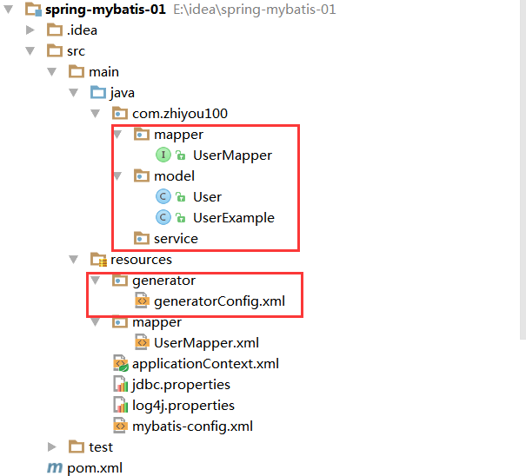

编写service类
@Service
public class UserService {
@Autowired
private UserMapper userMapper;
public User getUserById(Integer id){
return userMapper.selectByPrimaryKey(id);
}
}

测试
@RunWith(SpringJUnit4ClassRunner.class)
@ContextConfiguration(locations = "classpath:applicationContext.xml")
public class UserServiceTest {
@Autowired
private UserService userService;
@Test
public void getUserById() throws Exception {
User user = userService.getUserById(1);
System.out.println(user);
}
}

引入mybatis通用mapper插件

在pom中添加通用mapper的jar包依赖
<dependency>
<groupId>tk.mybatis</groupId>
<artifactId>mapper</artifactId>
<version>3.3.9</version>
</dependency>
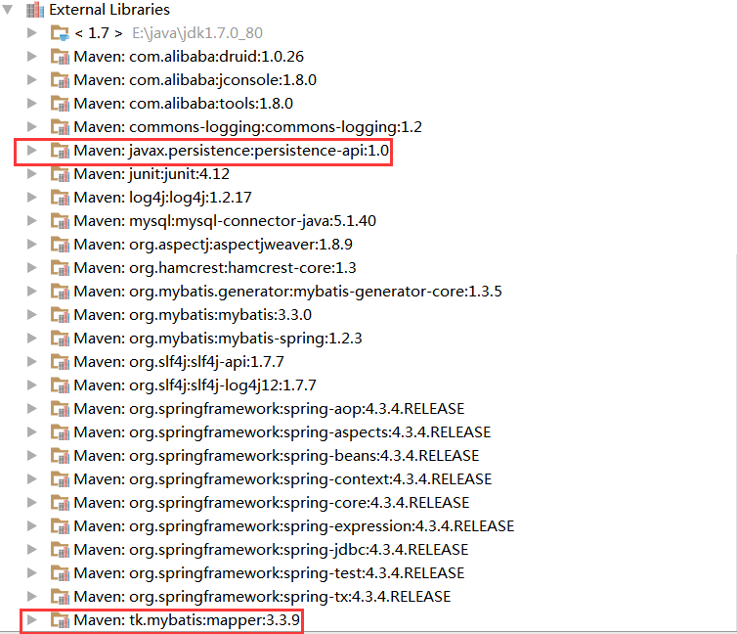

替换pom.xml中mybatisgenerator插件
将
<plugin>
<groupId>org.mybatis.generator</groupId>
<artifactId>mybatis-generator-maven-plugin</artifactId>
<version>1.3.2</version>
<configuration>
<configurationFile>${basedir}/src/main/resources/generator/generatorConfig.xml</configurationFile>
<overwrite>true</overwrite>
<verbose>true</verbose>
</configuration>
<dependencies>
<dependency>
<groupId>mysql</groupId>
<artifactId>mysql-connector-java</artifactId>
<version>5.1.40</version>
</dependency>
</dependencies>
</plugin>
替换为
<plugin>
<groupId>org.mybatis.generator</groupId>
<artifactId>mybatis-generator-maven-plugin</artifactId>
<version>1.3.2</version>
<configuration>
<configurationFile>${basedir}/src/main/resources/generator/generatorConfig.xml</configurationFile>
<overwrite>true</overwrite>
<verbose>true</verbose>
</configuration>
<dependencies>
<dependency>
<groupId>mysql</groupId>
<artifactId>mysql-connector-java</artifactId>
<version>5.1.40</version>
</dependency>
<dependency>
<groupId>tk.mybatis</groupId>
<artifactId>mapper</artifactId>
<version>3.3.9</version>
</dependency>
</dependencies>
</plugin>

修改jdbc.properties文件
#数据库连接信息
jdbc.driverClassName=com.mysql.jdbc.Driver
jdbc.url=jdbc:mysql://localhost:3306/spring_mybatis
jdbc.username=root
jdbc.password=123456
mapper.plugin=tk.mybatis.mapper.generator.MapperPlugin
mapper.Mapper=tk.mybatis.mapper.common.Mapper

修改applicationContext.xml文件
将
<bean class="org.mybatis.spring.mapper.MapperScannerConfigurer">
<property name="basePackage" value="com.zhiyou100"/>
</bean>
替换为
<!--扫描com.zhiyou100下的mapper接口-->
<bean class="tk.mybatis.spring.mapper.MapperScannerConfigurer">
<property name="basePackage" value="com.zhiyou100"/>
<!-- 通用Mapper通过属性注入进行配置，默认不配置时会注册Mapper<T>接口-->
<property name="properties">
<value>
mappers=tk.mybatis.mapper.common.Mapper
</value>
</property>
</bean>

修改generatorConfig.xml文件
在<context>标签中添加
<plugin type="${mapper.plugin}">
<property name="mappers" value="${mapper.Mapper}"/>
</plugin>
将
<!-- 指定数据库表 -->
<table tableName="t_user" domainObjectName="User"/>
修改为
<table tableName="t_user" domainObjectName="User">
<generatedKey column="id" sqlStatement="Mysql" identity="true"/>
</table>

运行mybatis-generator:generate

测试
@RunWith(SpringJUnit4ClassRunner.class)
@ContextConfiguration(locations = "classpath:applicationContext.xml")
public class UserServiceTest {
@Autowired
private UserService userService;
@Test
public void getUserById() throws Exception {
User user = userService.getUserById(1);
System.out.println(user);
}
}

引入mybatis分页插件

引入jar包
<!-- 分页插件 -->
<dependency>
<groupId>com.github.pagehelper</groupId>
<artifactId>pagehelper</artifactId>
<version>4.1.6</version>
</dependency>
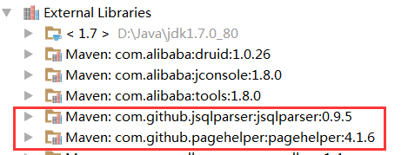

在Mybatis配置mybatis-config.xml中配置拦截器插件
<?xml version="1.0" encoding="UTF-8" ?>
<!DOCTYPE configuration PUBLIC "-//mybatis.org//DTD Config 3.0//EN"
"http://mybatis.org/dtd/mybatis-3-config.dtd">
<configuration>
<!-- mybatis默认是没有开启延迟加载的 需要手动开启 -->
<settings>
<!-- 延迟加载 默认false -->
<setting name="lazyLoadingEnabled" value="true" />
<!-- 积极加载 默认true -->
<setting name="aggressiveLazyLoading" value="false" />
<!--开启缓存 -->
<setting name="cacheEnabled" value="true" />
</settings>
<plugins>
<!-- com.github.pagehelper为PageHelper类所在包名 -->
<plugin interceptor="com.github.pagehelper.PageHelper">
<!-- 4.0.0以后版本可以不设置该参数 -->
<property name="dialect" value="mysql" />
<!-- 该参数默认为false -->
<!-- 设置为true时，会将RowBounds第一个参数offset当成pageNum页码使用 -->
<!-- 和startPage中的pageNum效果一样 -->
<property name="offsetAsPageNum" value="true" />
<!-- 该参数默认为false -->
<!-- 设置为true时，使用RowBounds分页会进行count查询 -->
<property name="rowBoundsWithCount" value="false" />
<!-- 设置为true时，如果pageSize=0或者RowBounds.limit = 0就会查询出全部的结果 -->
<!-- （相当于没有执行分页查询，但是返回结果仍然是Page类型） -->
<property name="pageSizeZero" value="true" />
<!-- 3.3.0版本可用 - 分页参数合理化，默认false禁用 -->
<!-- 启用合理化时，如果pageNum<1会查询第一页，如果pageNum>pages会查询最后一页 -->
<!-- 禁用合理化时，如果pageNum<1或pageNum>pages会返回空数据 -->
<property name="reasonable" value="false" />
<!-- 3.5.0版本可用 - 为了支持startPage(Object params)方法 -->
<!-- 增加了一个`params`参数来配置参数映射，用于从Map或ServletRequest中取值 -->
<!-- 可以配置pageNum,pageSize,count,pageSizeZero,reasonable,orderBy,不配置映射的用默认值 -->
<!-- 不理解该含义的前提下，不要随便复制该配置 -->
<property name="params"
value="pageNum=pageHelperStart;pageSize=pageHelperRows;" />
<!-- 支持通过Mapper接口参数来传递分页参数 -->
<property name="supportMethodsArguments" value="false" />
<!-- always总是返回PageInfo类型,check检查返回类型是否为PageInfo,none返回Page -->
<property name="returnPageInfo" value="none" />
</plugin>
</plugins>
</configuration>

参数说明
1.dialect属性，使用时可以指定该属性（不指定的情况下，分页插件会自动判断）
可选值为oracle,mysql,mariadb,sqlite,hsqldb,postgresql,db2,sqlserver,informix,h2,sqlserver2012。
2.offsetAsPageNum属性，默认值为false，使用默认值时不需要增加该配置，需要设为true时，需要配置该参数。当该参数设置为true时，3.RowBounds分页时，会将offset参数当成pageNum使用，可以用页码和页面大小两个参数进行分页。
增加rowBoundsWithCount属性，默认值为false，使用默认值时不需要增加该配置，需要设为true时，需要配置该参数。
当该参数设置为true时，使用RowBounds分页会进行count查询。
4.pageSizeZero属性，默认值为false，使用默认值时不需要增加该配置，需要设为true时，需要配置该参数。当该参数设置为true时，
如果pageSize=0或者RowBounds.limit = 0就会查询出全部的结果（相当于没有执行分页查询，但是返回结果仍然是Page类型）。
5.reasonable属性，默认值为false，使用默认值时不需要增加该配置，需要设为true时，需要配置该参数。
具体作用请看上面配置文件中的注释内容。
- 为了支持startPage(Object params)方法，增加了一个params参数来配置参数映射，用于从Map或ServletRequest中取值，可以配置 pageNum,pageSize,count,pageSizeZero,reasonable,orderBy,不配置映射的用默认值。
7.supportMethodsArguments支持通过Mapper接口参数来传递分页参数，默认值false，具体用法参考com.github.pagehelper.test.basic包下的ArgumentsMapTest和ArgumentsObjTest测试类。
8.returnPageInfo用来支持直接返回PageInfo类型，默认值none，可选参数always总是返回PageInfo类型,check检查返回类型是否为9.PageInfo,none返回Page(List)类型。用法和配置参考com.github.pagehelper.test.basic包下的PageInfoTest，
特别要注意接口的返回值和xml中的resultType类型。
10.closeConn属性，当使用动态数据源或没有设置dialect属性自动获取数据库类型时，会自动获取一个数据库连接，通过该属性来设置是否关闭获取的这个连接，默认true关闭。
11.当offsetAsPageNum=false的时候，由于PageNum问题，RowBounds查询的时候reasonable会强制为false。使用PageHelper.startPage方法不受影响。
另外使用RowBounds在这种情况下返回的Page对象由于没有正确的pageNum属性，所以也不能使用PageInfo处理。
如果你不理解为什么，可以看这样一个例子：查询offset=7,limit=10，这个时候pageNum=?，这种情况没法计算pageNum，没法判断当前是第几页。

如何选择分页参数
单独看每个参数的说明可能是一件让人不爽的事情，这里列举一些可能会用到某些参数的情况。
首先dialect属性是必须的，不需要解释。其他的参数一般情况下我们都不必去管，如果想了解何时使用合适，你可以参考以下场景：

场景一
如果你仍然在用类似ibatis式的命名空间调用方式，你也许会用到rowBoundsWithCount，分页插件对RowBounds支持和Mybatis默认的方式是一致，默认情况下不会进行count查询，如果你想在分页查询时进行count查询，以及使用更强大的PageInfo类，你需要设置该参数为true。

场景二
如果你仍然在用类似ibatis式的命名空间调用方式，你觉得RowBounds中的两个参数offset,limit不如pageNum,pageSize容易理解，你可以使用offsetAsPageNum参数，将该参数设置为true后，offset会当成pageNum使用，limit和pageSize含义相同。

场景三
如果觉得某个地方使用分页后，你仍然想通过控制参数查询全部的结果，你可以配置pageSizeZero为true，配置后，如可以通过设置pageSize=0或者RowBounds.limit = 0就会查询出全部的结果。

场景四
如果你分页插件使用于类似分页查看列表式的数据，如新闻列表，软件列表，你希望用户输入的页数不在合法范围（第一页到最后一页之外）时能够正确的响应到正确的结果页面，那么你可以配置reasonable为true，这时如果pageNum<1会查询第一页，如果pageNum>总页数会查询最后一页。

如何在代码中使用
首先该分页插件支持以下两种调用方式：
//第一种，RowBounds方式的调用
List<Country> list = sqlSession.selectList("x.y.selectIf", null, new RowBounds(1, 10));
//第二种，Mapper接口方式的调用，推荐这种使用方式。
PageHelper.startPage(1, 10);
List<Country> list = countryMapper.selectIf(1);
下面分别对这两种方式进行详细介绍

1). RowBounds方式的调用
List<Country> list = sqlSession.selectList("x.y.selectIf", null, new RowBounds(1, 10));
使用这种调用方式时，你可以使用RowBounds参数进行分页，这种方式侵入性最小，我们可以看到，通过RowBounds方式调用只是使用了这个参数，并没有增加其他任何内容。
分页插件检测到使用了RowBounds参数时，就会对该查询进行物理分页。
关于这种方式的调用，有两个特殊的参数是针对RowBounds的，你可以参看上面的场景一和场景二
注：不只有命名空间方式可以用RowBounds，使用接口的时候也可以增加RowBounds参数，例如：
//这种情况下也会进行物理分页查询
List<Country> selectAll(RowBounds rowBounds);

2). PageHelper.startPage静态方法调用
在你需要进行分页的Mybatis方法前调用PageHelper.startPage静态方法即可，紧跟在这个方法后的第一个Mybatis查询方法会被进行分页。

例一：
SqlSession sqlSession = MybatisHelper.getSqlSession();
CountryMapper countryMapper = sqlSession.getMapper(CountryMapper.class);
try {
//获取第1页，10条内容，默认查询总数count
PageHelper.startPage(1, 10);
//紧跟着的第一个select方法会被分页
List<Country> list = countryMapper.selectIf(1);
assertEquals(2, list.get(0).getId());
assertEquals(10, list.size());
//分页时，实际返回的结果list类型是Page<E>，如果想取出分页信息，需要强制转换为Page<E>，
//或者使用PageInfo类（下面的例子有介绍）
assertEquals(182, ((Page) list).getTotal());
} finally {
sqlSession.close();
}

例二：
SqlSession sqlSession = MybatisHelper.getSqlSession();
CountryMapper countryMapper = sqlSession.getMapper(CountryMapper.class);
try {
//获取第1页，10条内容，默认查询总数count
PageHelper.startPage(1, 10);
//紧跟着的第一个select方法会被分页
List<Country> list = countryMapper.selectIf(1);
//后面的不会被分页，除非再次调用PageHelper.startPage
List<Country> list2 = countryMapper.selectIf(null);
assertEquals(2, list.get(0).getId());
assertEquals(10, list.size());
//分页时，实际返回的结果list类型是Page<E>，如果想取出分页信息，需要强制转换为Page<E>，
//或者使用PageInfo类（下面的例子有介绍）
assertEquals(182, ((Page) list).getTotal());
assertEquals(1, list2.get(0).getId());
assertEquals(182, list2.size());
} finally {
sqlSession.close();
}

例三，使用PageInfo的用法：
//获取第1页，10条内容，默认查询总数count
PageHelper.startPage(1, 10);
List<Country> list = countryMapper.selectAll();
//用PageInfo对结果进行包装
PageInfo page = new PageInfo(list);
//测试PageInfo全部属性
//PageInfo包含了非常全面的分页属性
assertEquals(1, page.getPageNum());
assertEquals(10, page.getPageSize());
assertEquals(1, page.getStartRow());
assertEquals(10, page.getEndRow());
assertEquals(183, page.getTotal());
assertEquals(19, page.getPages());
assertEquals(1, page.getFirstPage());
assertEquals(8, page.getLastPage());
assertEquals(true, page.isFirstPage());
assertEquals(false, page.isLastPage());
assertEquals(false, page.isHasPreviousPage());
assertEquals(true, page.isHasNextPage());

@RunWith(SpringJUnit4ClassRunner.class)
@ContextConfiguration(locations = "classpath:applicationContext.xml")
public class UserServiceTest {
@Autowired
private UserService userService;
@Test
public void findUser() throws Exception {
User user = new User();
user.setUsername("rose");
List<User> list = userService.find(user, 1, 5);
// System.out.println(list);
for (User u : list) {
System.out.println(u.getUsername());
}
}
}

编写AbstractService
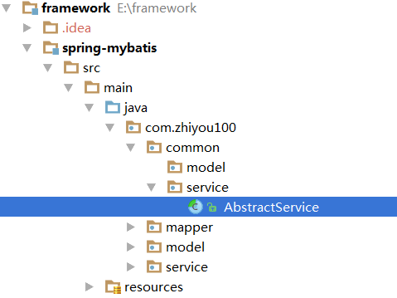

模板方法模式实现
package com.zhiyou100.common.service;
import java.util.List;
import org.apache.ibatis.session.RowBounds;
import com.github.pagehelper.PageHelper;
import com.github.pagehelper.PageInfo;
import tk.mybatis.mapper.common.Mapper;
public abstract class AbstractService<T> {
public abstract Mapper<T> getMapper();
/**
* 保存一个实体，null的属性也会保存，不会使用数据库默认值
*
* @param entity 实体对象
* @return 返回结果
*/
public int save(T entity) throws Exception {
return getMapper().insert(entity);
}
/**
* 保存一个实体，null的属性不会保存，会使用数据库默认值
*
* @param entity 实体对象
* @return 返回结果
*/
public int saveNotNull(T entity) throws Exception {
return getMapper().insertSelective(entity);
}
/**
* 根据主键更新实体全部字段，null值会被更新
*
* @param entity 实体对象
* @return 返回结果
*/
public int update(T entity) throws Exception {
return getMapper().updateByPrimaryKey(entity);
}
/**
* 根据主键更新属性不为null的值
*
* @param entity 实体对象
* @return 返回结果
*/
public int updateNotNull(T entity) throws Exception {
return getMapper().updateByPrimaryKeySelective(entity);
}
/**
* 根据主键字段进行删除，方法参数必须包含完整的主键属性
*
* @param key 主键
* @return 返回结果
*/
public int deleteByPrimaryKey(Object key) throws Exception {
return getMapper().deleteByPrimaryKey(key);
}
/**
* 根据实体属性作为条件进行删除，查询条件使用等号
*
* @param entity 实体对象
* @return 返回结果
*/
public int delete(T entity) throws Exception {
return getMapper().delete(entity);
}
/**
* 根据主键字段进行查询，方法参数必须包含完整的主键属性，查询条件使用等号
*
* @param key 主键
* @return 返回结果
*/
public T get(Object key) {
return getMapper().selectByPrimaryKey(key);
}
/**
* 查询全部结果
*
* @return 返回结果
*/
public List<T> findAll() {
return getMapper().selectAll();
}
/**
* 根据实体中的属性进行查询，只能有一个返回值，有多个结果是抛出异常，查询条件使用等号
*
* @param entity 实体对象
* @return 返回结果
*/
public T findOne(T entity) {
return getMapper().selectOne(entity);
}
/**
* 根据实体中的属性值进行查询
*
* @param entity 实体对象
* @return 返回结果
*/
public List<T> find(T entity) {
return getMapper().select(entity);
}
/**
* 根据实体中的属性值进行查询带分页
*
* @param entity 实体对象
* @return 返回结果
*/
public List<T> find(T entity, Integer pageNum, Integer pageSize) {
return getMapper().selectByRowBounds(entity, new RowBounds(pageNum, pageSize));
}
/**
* 查询条数
*
* @param entity 实体对象
* @return 返回结果
*/
public int findCount(T entity) {
return getMapper().selectCount(entity);
}
/**
* 根据实体中的属性值进行分页查询，返回PageInfo对象
*
* @param entity 实体对象
* @param pageNum 页码
* @param pageSize 每页显示的条数
* @return 返回结果
*/
public PageInfo<T> findPageInfo(T entity, Integer pageNum, Integer pageSize) {
if (pageNum == null) {
pageNum = 0;
}
if (pageSize == null) {
pageSize = 0;
}
PageHelper.startPage(pageNum, pageSize);
List<T> list = find(entity);
return new PageInfo<T>(list);
}
/**
* 根据Example条件进行查询
*
* @param example 查询条件
* @return 返回结果
*/
public List<T> findByExample(Object example) {
return getMapper().selectByExample(example);
}
/**
* 根据example条件进行分页查询
*
* @param example 查询条件
* @param pageNum 页码
* @param pageSize 每页显示的条数
* @return 返回结果
*/
public List<T> findByExample(Object example, int pageNum, int pageSize) {
return getMapper().selectByExampleAndRowBounds(example, new RowBounds(pageNum, pageSize));
}
/**
* 根据Example条件进行查询总数
*
* @param example 查询条件
* @return 返回结果
*/
public int findCountByExample(Object example) {
return getMapper().selectCountByExample(example);
}
/**
* 根据Example条件进行分页查询，查询条件使用等号，返回PageInfo对象
*
* @param example 查询条件
* @param pageNum 页码
* @param pageSize 每页显示的条数
* @return 返回结果
*/
public PageInfo<T> findPageInfoByExample(Object example, Integer pageNum, Integer pageSize) {
if (pageNum == null) {
pageNum = 0;
}
if (pageSize == null) {
pageSize = 0;
}
PageHelper.startPage(pageNum, pageSize);
List<T> list = findByExample(example);
return new PageInfo<T>(list);
}
}

Service层使用
@Service
public class UserService extends AbstractService<User> {
@Autowired
private UserMapper mapper;
@Override
public Mapper<User> getMapper() {
return mapper;
}
}

Spring4泛型注入实现
package com.zhiyou100.common.service;
import com.github.pagehelper.PageHelper;
import com.github.pagehelper.PageInfo;
import org.apache.ibatis.session.RowBounds;
import org.springframework.beans.factory.annotation.Autowired;
import tk.mybatis.mapper.common.Mapper;
import java.util.List;
public abstract class AbstractService<T> {
@Autowired
public Mapper<T> mapper;
/**
* 保存一个实体，null的属性也会保存，不会使用数据库默认值
*
* @param entity
* 实体对象
* @return 返回结果
*/
public int save(T entity) throws Exception {
return mapper.insert(entity);
}
/**
* 保存一个实体，null的属性不会保存，会使用数据库默认值
*
* @param entity
* 实体对象
* @return 返回结果
*/
public int saveNotNull(T entity) throws Exception {
return mapper.insertSelective(entity);
}
/**
* 根据主键更新实体全部字段，null值会被更新
*
* @param entity
* 实体对象
* @return 返回结果
*/
public int update(T entity) throws Exception {
return mapper.updateByPrimaryKey(entity);
}
/**
* 根据主键更新属性不为null的值
*
* @param entity
* 实体对象
* @return 返回结果
*/
public int updateNotNull(T entity) throws Exception {
return mapper.updateByPrimaryKeySelective(entity);
}
/**
* 根据主键字段进行删除，方法参数必须包含完整的主键属性
*
* @param key
* 主键
* @return 返回结果
*/
public int deleteByPrimaryKey(Object key) throws Exception {
return mapper.deleteByPrimaryKey(key);
}
/**
* 根据实体属性作为条件进行删除，查询条件使用等号
*
* @param entity
* 实体对象
* @return 返回结果
*/
public int delete(T entity) throws Exception {
return mapper.delete(entity);
}
/**
* 根据主键字段进行查询，方法参数必须包含完整的主键属性，查询条件使用等号
*
* @param key
* 主键
* @return 返回结果
*/
public T get(Object key) {
return mapper.selectByPrimaryKey(key);
}
/**
* 查询全部结果
*
* @return 返回结果
*/
public List<T> findAll() {
return mapper.selectAll();
}
/**
* 根据实体中的属性进行查询，只能有一个返回值，有多个结果是抛出异常，查询条件使用等号
*
* @param entity
* 实体对象
* @return 返回结果
*/
public T findOne(T entity) {
return mapper.selectOne(entity);
}
/**
* 根据实体中的属性值进行查询
*
* @param entity
* 实体对象
* @return 返回结果
*/
public List<T> find(T entity) {
return mapper.select(entity);
}
/**
* 根据实体中的属性值进行查询带分页
*
* @param entity
* 实体对象
* @return 返回结果
*/
public List<T> find(T entity, Integer pageNum, Integer pageSize) {
return mapper.selectByRowBounds(entity, new RowBounds(pageNum, pageSize));
}
/**
* 查询条数
*
* @param entity
* 实体对象
* @return 返回结果
*/
public int findCount(T entity) {
return mapper.selectCount(entity);
}
/**
* 根据实体中的属性值进行分页查询，返回PageInfo对象
*
* @param entity
* 实体对象
* @param pageNum
* 页码
* @param pageSize
* 每页显示的条数
* @return 返回结果
*/
public PageInfo<T> findPageInfo(T entity, Integer pageNum, Integer pageSize) {
if (pageNum == null) {
pageNum = 0;
}
if (pageSize == null) {
pageSize = 0;
}
PageHelper.startPage(pageNum, pageSize);
List<T> list = find(entity);
return new PageInfo<T>(list);
}
/**
* 根据Example条件进行查询
*
* @param example
* 查询条件
* @return 返回结果
*/
public List<T> findByExample(Object example) {
return mapper.selectByExample(example);
}
/**
* 根据example条件进行分页查询
*
* @param example
* 查询条件
* @param pageNum
* 页码
* @param pageSize
* 每页显示的条数
* @return 返回结果
*/
public List<T> findByExample(Object example, int pageNum, int pageSize) {
return mapper.selectByExampleAndRowBounds(example, new RowBounds(pageNum, pageSize));
}
/**
* 根据Example条件进行查询总数
*
* @param example
* 查询条件
* @return 返回结果
*/
public int findCountByExample(Object example) {
return mapper.selectCountByExample(example);
}
/**
* 根据Example条件进行分页查询，查询条件使用等号，返回PageInfo对象
*
* @param example
* 查询条件
* @param pageNum
* 页码
* @param pageSize
* 每页显示的条数
* @return 返回结果
*/
public PageInfo<T> findPageInfoByExample(Object example, Integer pageNum, Integer pageSize) {
if (pageNum == null) {
pageNum = 0;
}
if (pageSize == null) {
pageSize = 0;
}
PageHelper.startPage(pageNum, pageSize);
List<T> list = findByExample(example);
return new PageInfo<T>(list);
}
}

Service层使用
@Service
public class UserService extends AbstractService<User> {
}

spring整合web开发

导入jar包
<dependency>
<groupId>org.springframework</groupId>
<artifactId>spring-web</artifactId>
<version>4.3.4.RELEASE</version>
</dependency>

tomcat启动加载配置文件
servlet --> init(ServletConfig) --> <load-on-startup>2
filter --> init(FilterConfig) --> web.xml注册过滤器自动调用初始化
listener --> ServletContextListener --> servletContext对象监听【】
spring提供监听器 ContextLoaderListener --> web.xml <listener><listener-class>....
如果只配置监听器，默认加载xml位置：/WEB-INF/applicationContext.xml

web.xml配置
<!-- 确定配置文件位置 -->
<context-param>
<param-name>contextConfigLocation</param-name>
<param-value>classpath:applicationContext.xml</param-value>
</context-param>
<!-- 配置spring 监听器，加载xml配置文件 -->
<listener>
<listener-class>org.springframework.web.context.ContextLoaderListener</listener-class>
</listener>

从servletContext作用域获得spring容器 （了解）
// 从application作用域（ServletContext）获得spring容器
//方式1： 手动从作用域获取
ApplicationContext applicationContext =
(ApplicationContext) this.getServletContext().getAttribute(WebApplicationContext.ROOT_WEB_APPLICATION_CONTEXT_ATTRIBUTE);
//方式2：通过工具获取
ApplicationContext apppApplicationContext2 = WebApplicationContextUtils.getWebApplicationContext(this.getServletContext());

spring整合springmvc

