AZ-204 Scribe

Lab Repo: <https://github.com/MicrosoftLearning/AZ-204-DevelopingSolutionsforMicrosoftAzure>

Instructions of Labs: <https://github.com/MicrosoftLearning/AZ-204-DevelopingSolutionsforMicrosoftAzure/tree/master/Instructions/Labs>

Advanced real world use cases: <https://github.com/search?q=MCW&type=repositories>



**____select from dropdown____ cosmosClient = new ____select from dropdown____ (____select from dropdown____, __________, new CosmosClientOptions() { AllowBulkExecution = true });**

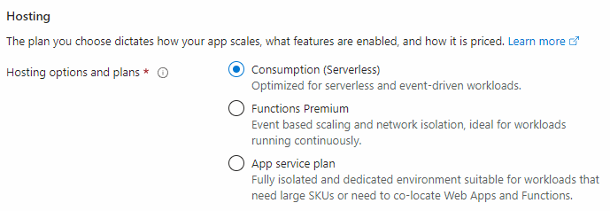

**Stateless -> State of execution is not maintained or stored. Every time function logic executes it has no information about what happened in previous execution.**

**Programmers can make it stateful by writing its output to a storage queue making output durable.**

**This output written to the storage queue can act as a trigger or an input data binding for next execution. Hence, developers can make sequential stateful workflows cascading functions logic using this approach.**

**Default time out of function logic is 10 minutes. By default, short running synchronous process. Meaning you cannot develop long running asynchronous process using functions.**

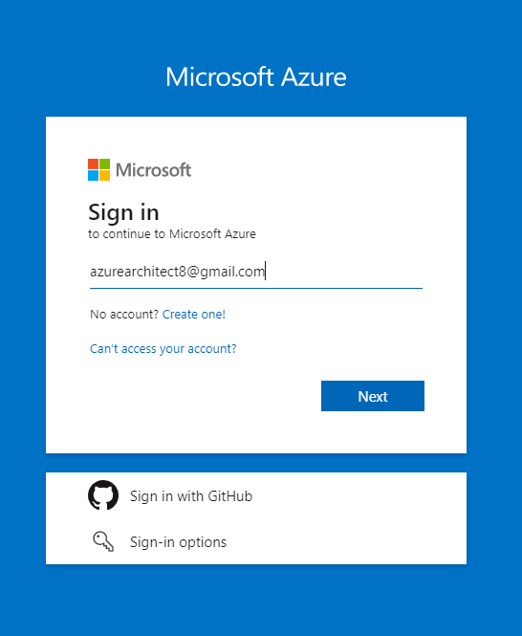





**Cross Platform AZ Cli cmdlets**

**Az.Powershell Module cmdlets**

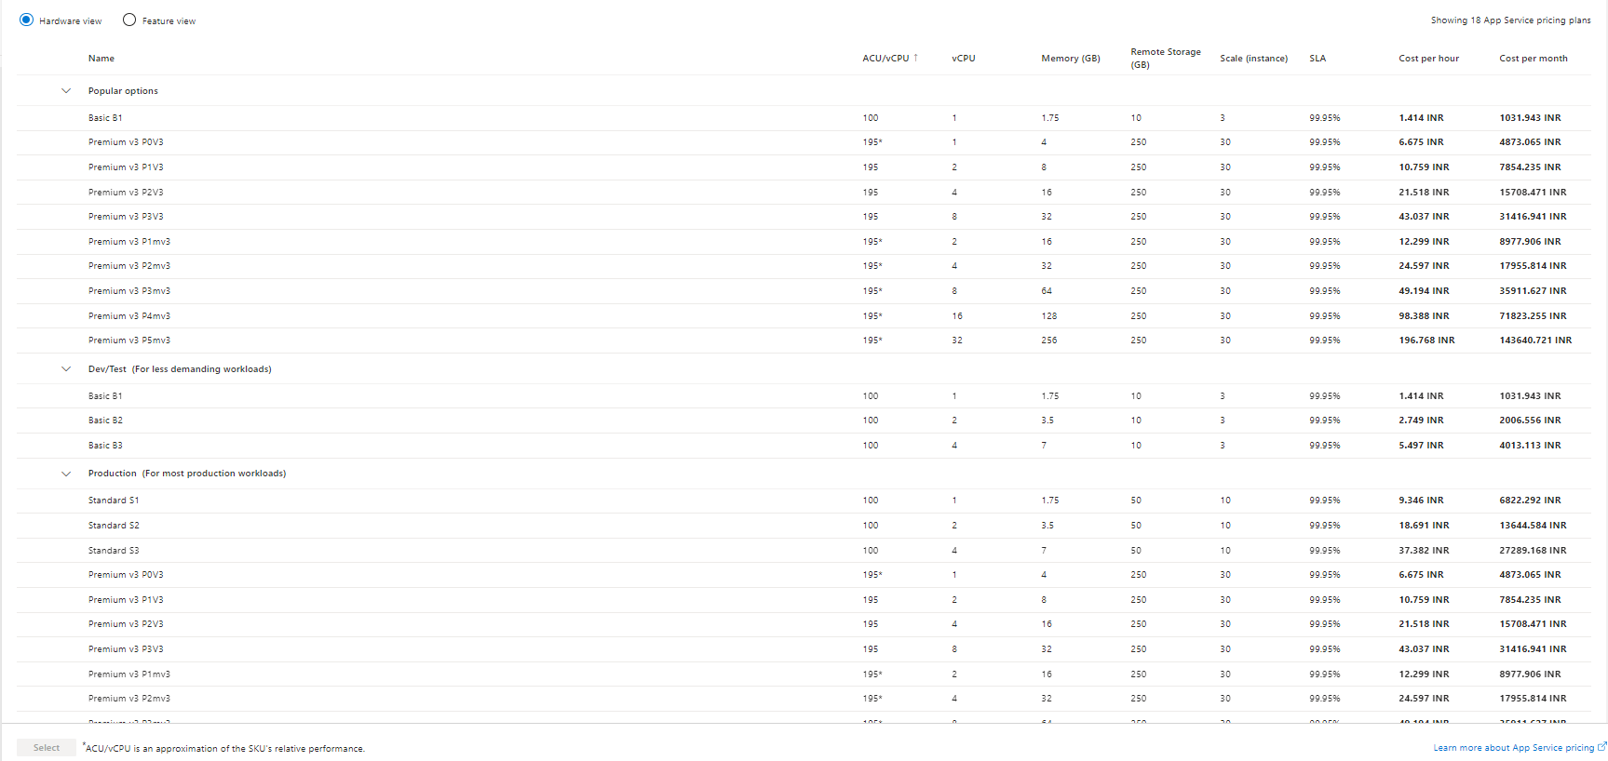

**Default domain name :- webappname.azurewebsites.net**

**Custom domain name :- myboutique.in**

[**https://learn.microsoft.com/en-us/azure/azure-functions/durable/durable-functions-overview?tabs=in-process%2Cv3-model%2Cv1-model&pivots=csharp**](https://learn.microsoft.com/en-us/azure/azure-functions/durable/durable-functions-overview?tabs=in-process%2Cv3-model%2Cv1-model&pivots=csharp)

**Admin Access**

**nsimgstorage**

**8oP83a9P3sWB7oqf2ED/C1n8KDngDNsEtPkNFTYMofP8OobLleTupw9/SQQiY40XxnBBq3SPuawk+AStCLewlA==**

**Admin key**

**DefaultEndpointsProtocol=https;AccountName=nsimgstorage;AccountKey=8oP83a9P3sWB7oqf2ED/C1n8KDngDNsEtPkNFTYMofP8OobLleTupw9/SQQiY40XxnBBq3SPuawk+AStCLewlA==;EndpointSuffix=core.windows.net**

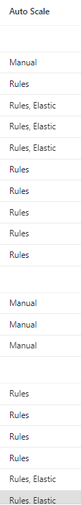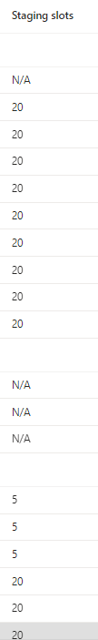

{

    "location": "UK West",

    "tags": {},

    "properties": {

        "name": "DeloitteASP-Autoscale-479",

        "enabled": true,

        "targetResourceUri": "/subscriptions/06cb8659-f29a-4c66-a432-03817fc40482/resourcegroups/DevTestRG/providers/Microsoft.Web/serverFarms/DeloitteASP",

        "profiles": [

            {

                "name": "CPU",

                "capacity": {

                    "minimum": "2",

                    "maximum": "30",

                    "default": "2"

                },

                "rules": [

                    {

                        "scaleAction": {

                            "direction": "Increase",

                            "type": "ChangeCount",

                            "value": "1",

                            "cooldown": "PT5M"

                        },

                        "metricTrigger": {

                            "metricName": "CpuPercentage",

                            "metricNamespace": "microsoft.web/serverfarms",

                            "metricResourceUri": "/subscriptions/06cb8659-f29a-4c66-a432-03817fc40482/resourceGroups/DevTestRG/providers/Microsoft.Web/serverFarms/DeloitteASP",

                            "operator": "GreaterThan",

                            "statistic": "Average",

                            "threshold": 70,

                            "timeAggregation": "Average",

                            "timeGrain": "PT1M",

                            "timeWindow": "PT10M",

                            "Dimensions": [],

                            "dividePerInstance": false

                        }

                    },

                    {

                        "scaleAction": {

                            "direction": "Decrease",

                            "type": "ChangeCount",

                            "value": "1",

                            "cooldown": "PT5M"

                        },

                        "metricTrigger": {

                            "metricName": "CpuPercentage",

                            "metricNamespace": "microsoft.web/serverfarms",

                            "metricResourceUri": "/subscriptions/06cb8659-f29a-4c66-a432-03817fc40482/resourceGroups/DevTestRG/providers/Microsoft.Web/serverFarms/DeloitteASP",

                            "operator": "LessThanOrEqual",

                            "statistic": "Average",

                            "threshold": 45,

                            "timeAggregation": "Average",

                            "timeGrain": "PT1M",

                            "timeWindow": "PT10M",

                            "Dimensions": [],

                            "dividePerInstance": false

                        }

                    }

                ],

                "fixedDate": {

                    "timeZone": "UTC",

                    "start": "2023-09-05T00:00:00.000Z",

                    "end": "2023-09-05T23:59:00.000Z"

                }

            },

            {

                "name": "Holiday",

                "capacity": {

                    "minimum": "20",

                    "maximum": "20",

                    "default": "20"

                },

                "rules": [],

                "recurrence": {

                    "frequency": "Week",

                    "schedule": {

                        "timeZone": "UTC",

                        "days": [

                            "Saturday",

                            "Sunday"

                        ],

                        "hours": [

                            6

                        ],

                        "minutes": [

                            0

                        ]

                    }

                }

            },

            {

                "name": "{\"name\":\"Auto created default scale condition\",\"for\":\"Holiday\"}",

                "capacity": {

                    "minimum": "1",

                    "maximum": "1",

                    "default": "1"

                },

                "rules": [],

                "recurrence": {

                    "frequency": "Week",

                    "schedule": {

                        "timeZone": "UTC",

                        "days": [

                            "Saturday",

                            "Sunday"

                        ],

                        "hours": [

                            18

                        ],

                        "minutes": [

                            0

                        ]

                    }

                }

            }

        ],

        "notifications": [],

        "targetResourceLocation": "UK West"

    },

    "id": "/subscriptions/06cb8659-f29a-4c66-a432-03817fc40482/resourceGroups/DevTestRG/providers/microsoft.insights/autoscalesettings/DeloitteASP-Autoscale-479",

    "name": "DeloitteASP-Autoscale-479",

    "type": "Microsoft.Insights/autoscaleSettings"

}

[**https://azure.microsoft.com/en-us/pricing/details/app-service/linux/**](https://azure.microsoft.com/en-us/pricing/details/app-service/linux/)

**https://learn.microsoft.com/en-us/azure/azure-resource-manager/management/azure-subscription-service-limits#app-service-limits**