This Document will walk you through connecting to SSAS Multidimensional Model and Tabular Model from Power BI Desktop. First we will design both solutions then when connect to it from power query.

SSAS Multidimensional Model:

1. Open your visual studio.
2. 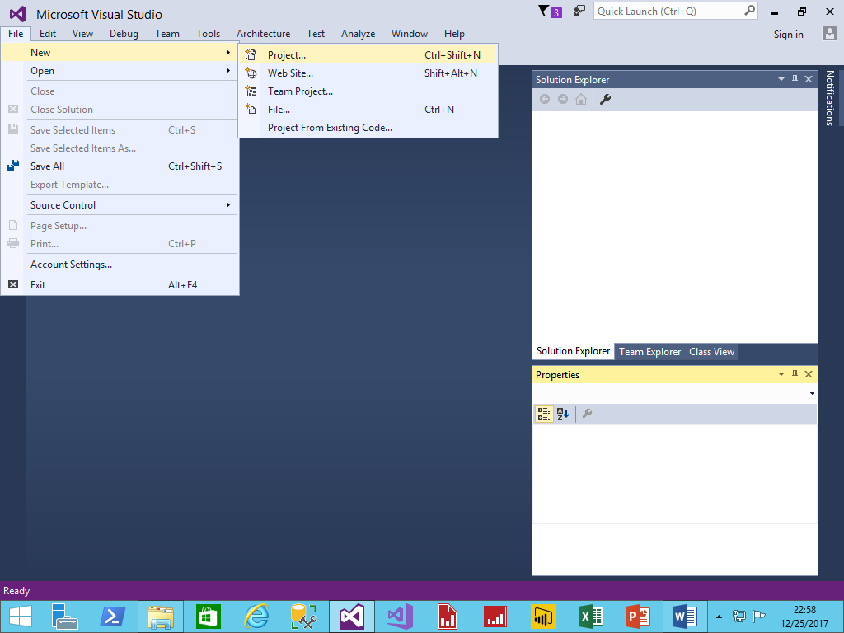

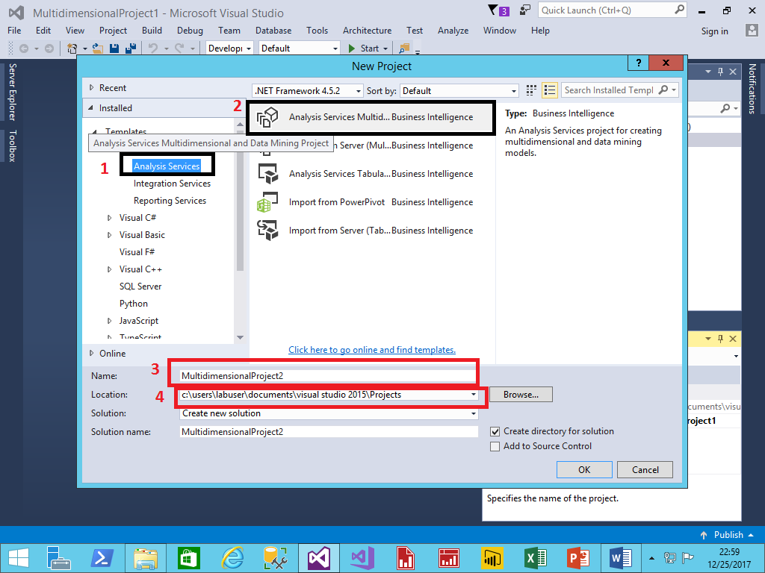

You see the following the folder structure.

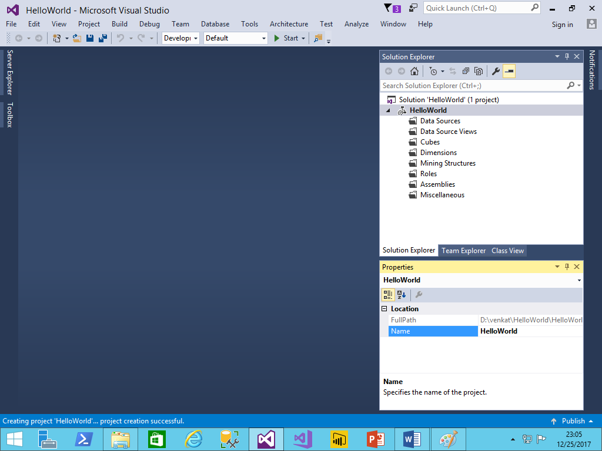

Connect to data source and load the tables.

Right Click on data sources.

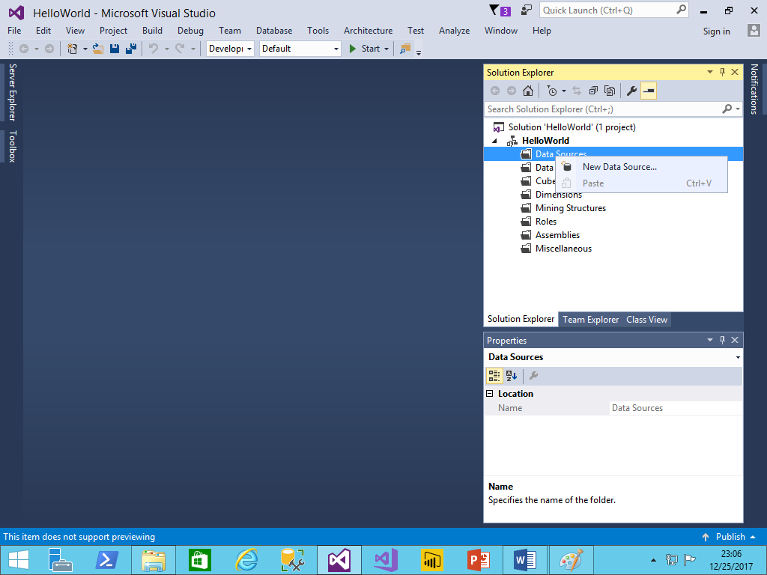

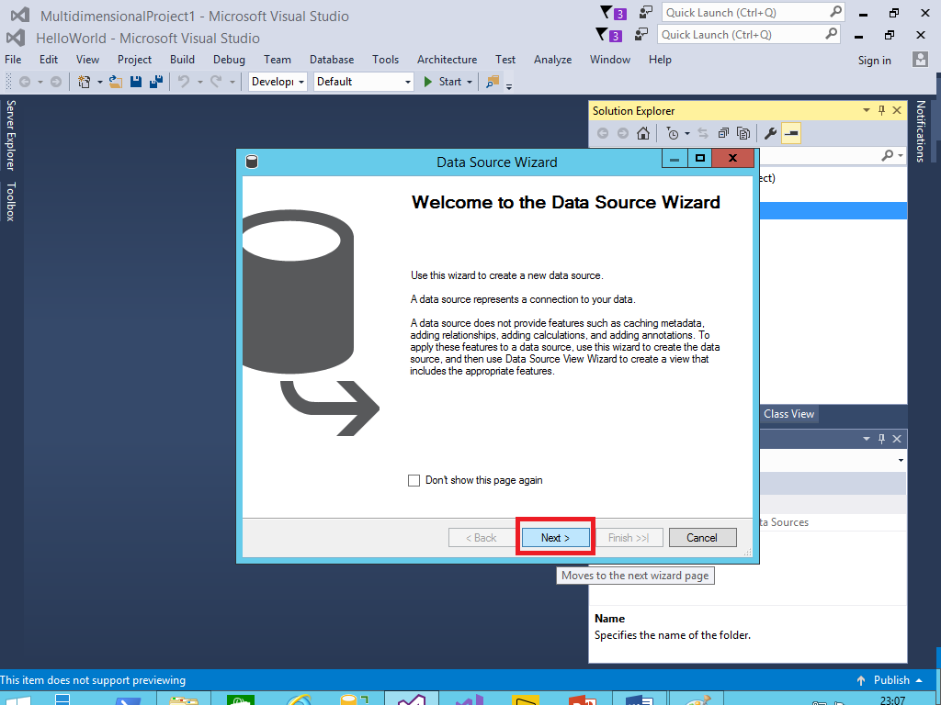

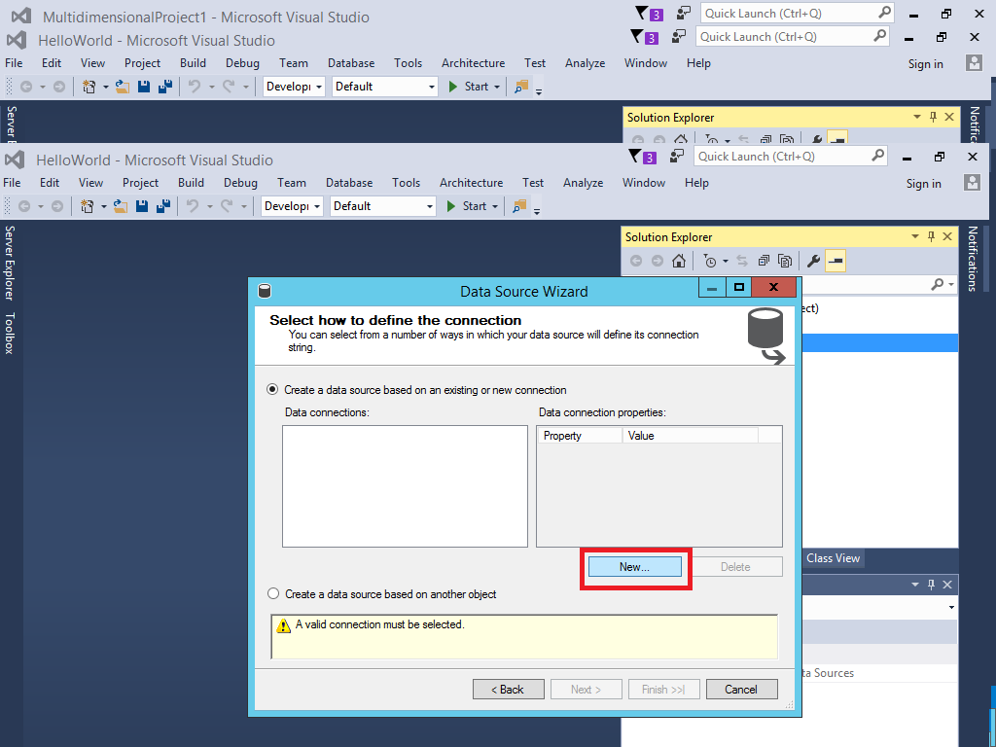

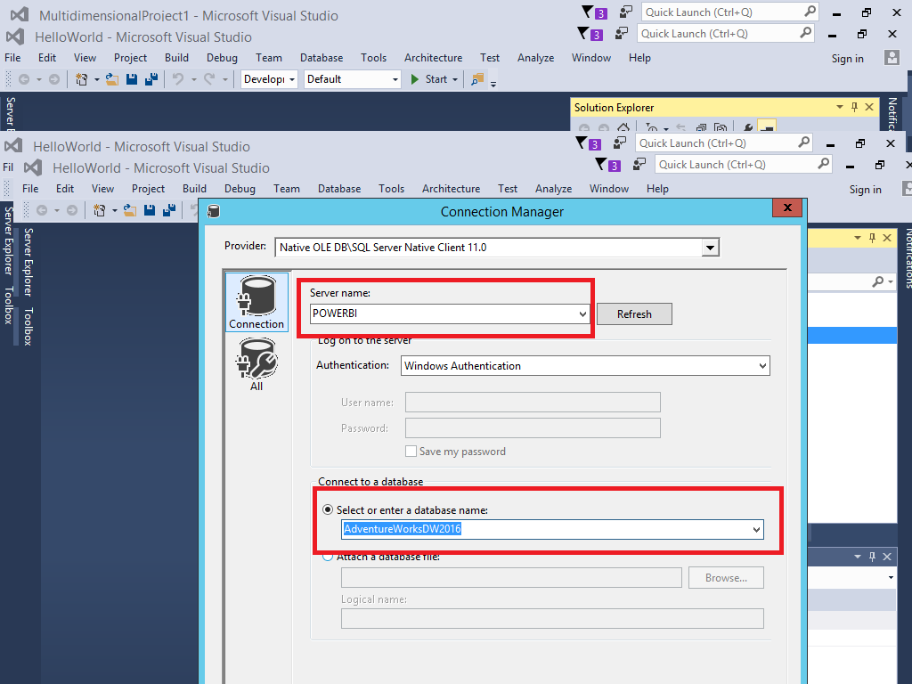

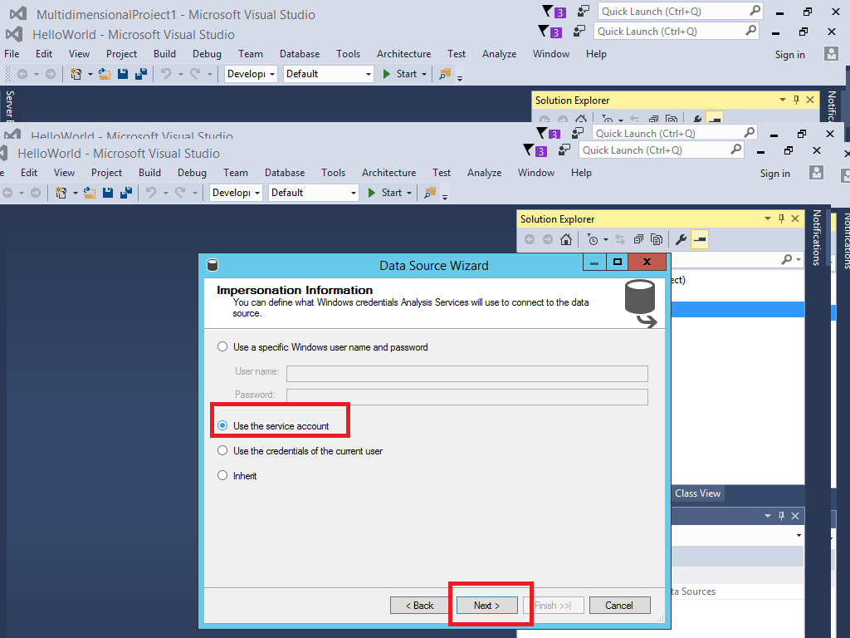

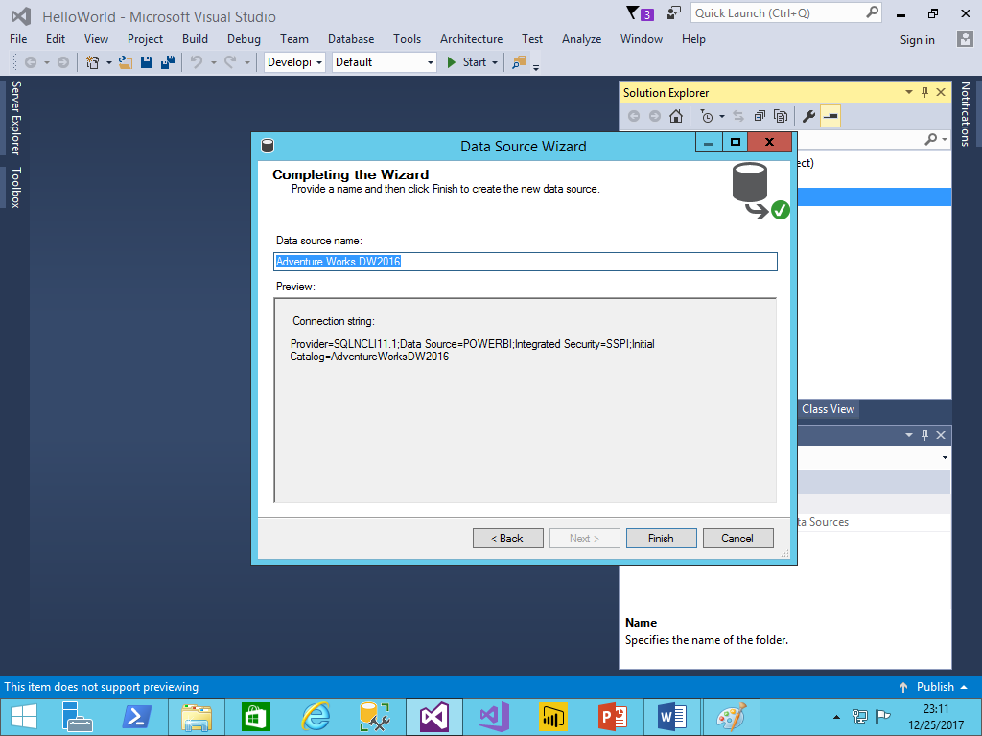

Now select the tables from the data source.

Right click on data source view

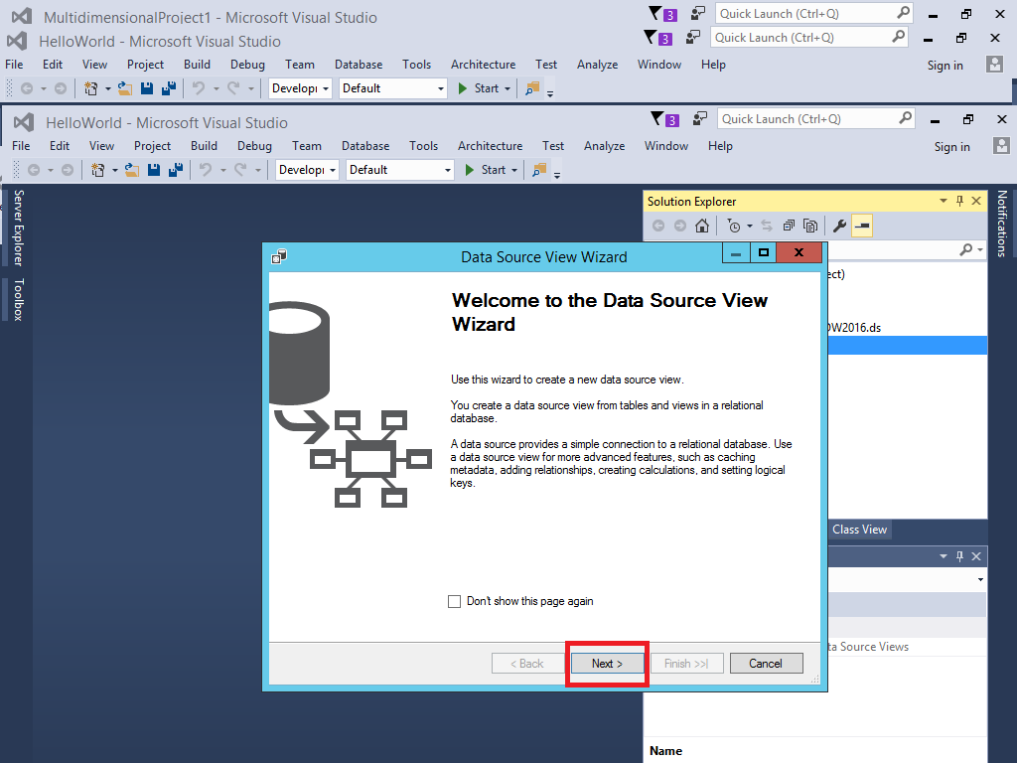

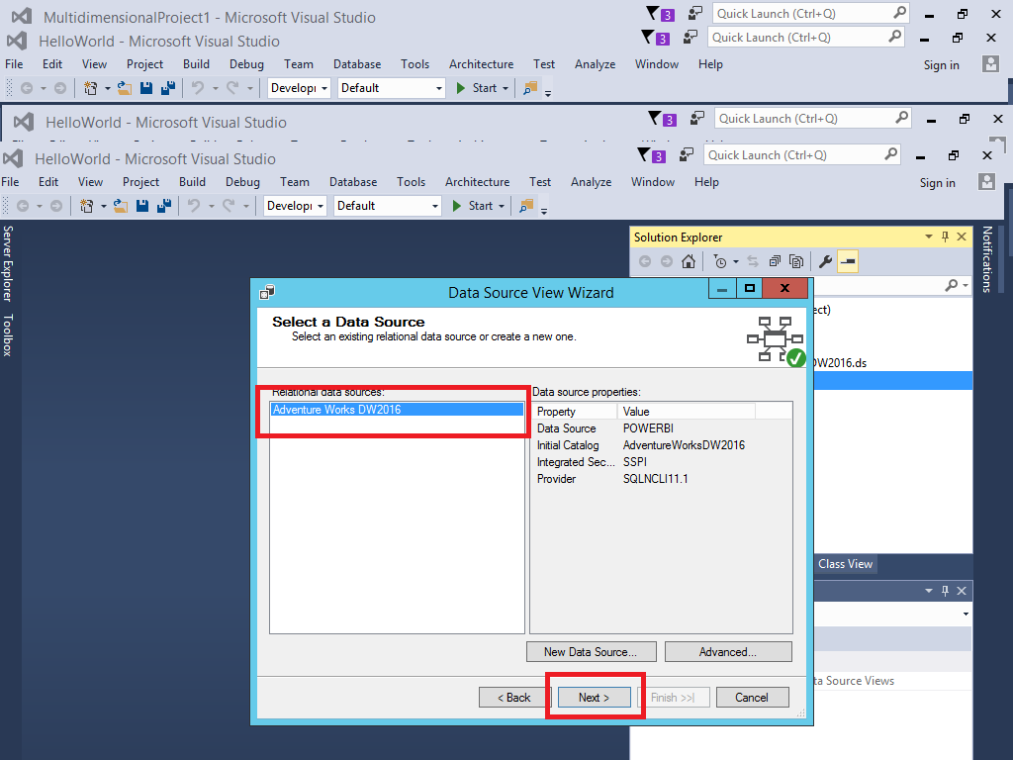

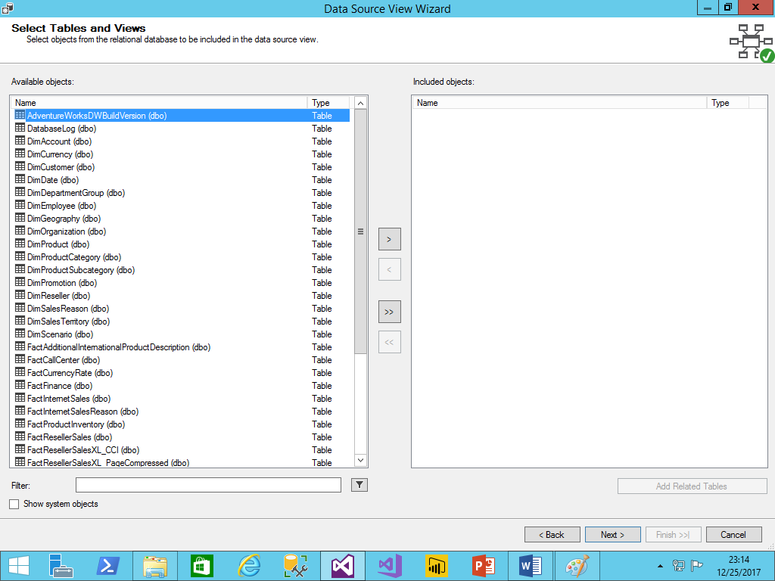

Select the table and click (>) symbol.

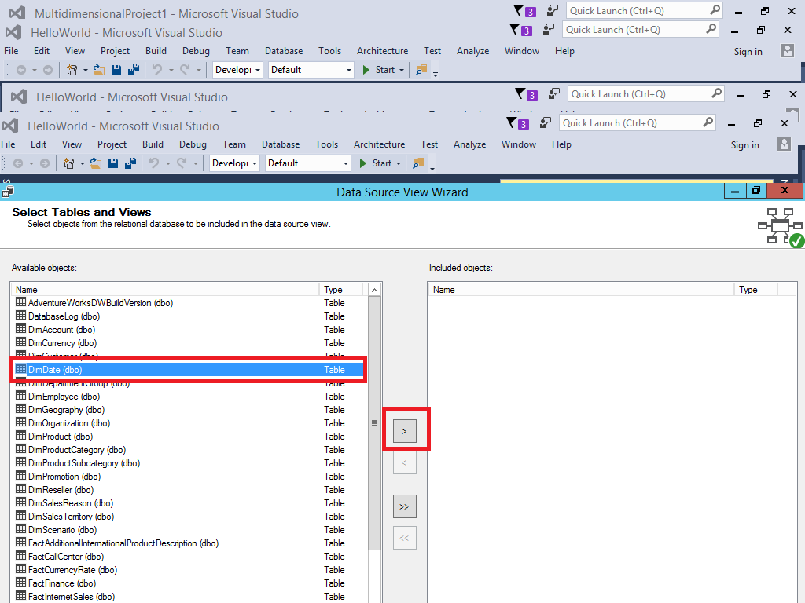

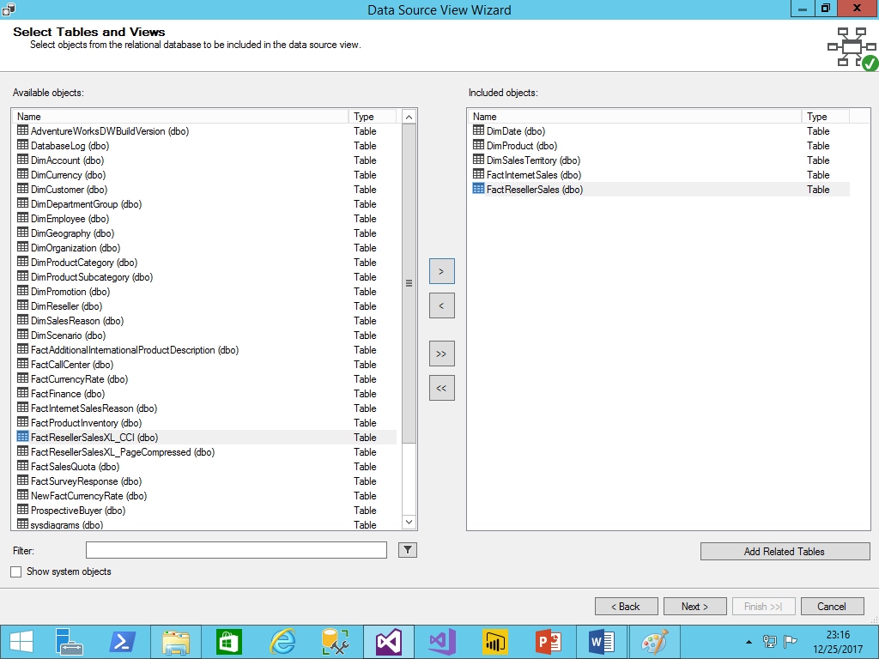

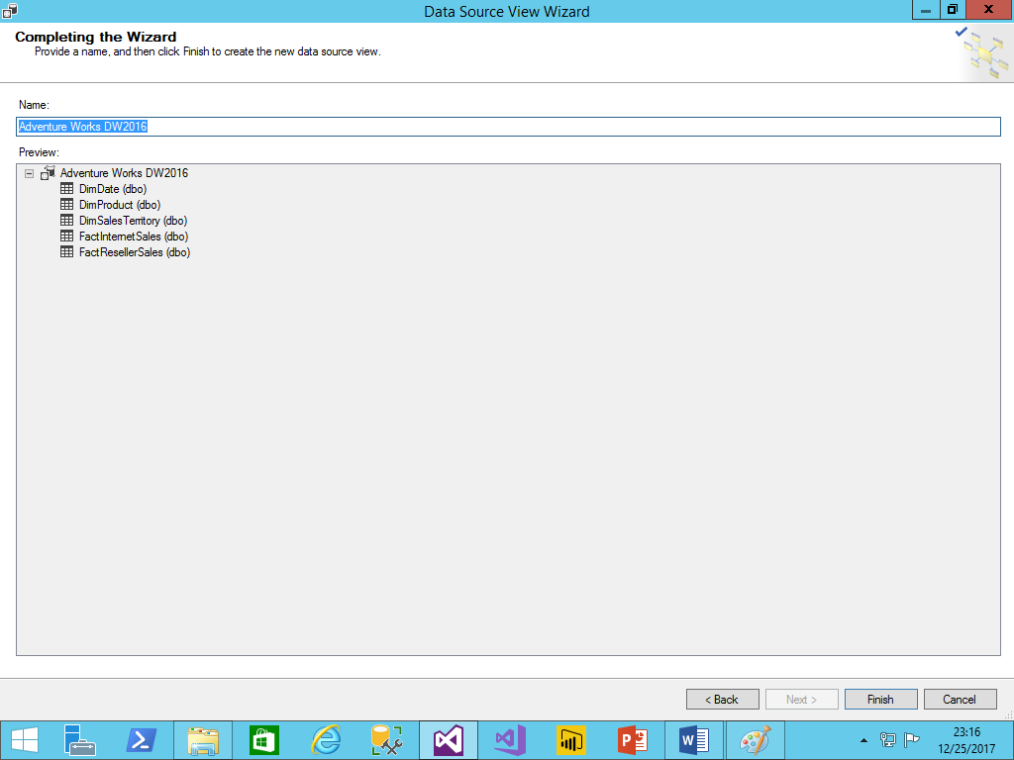

Finish

Right click on Dimensions

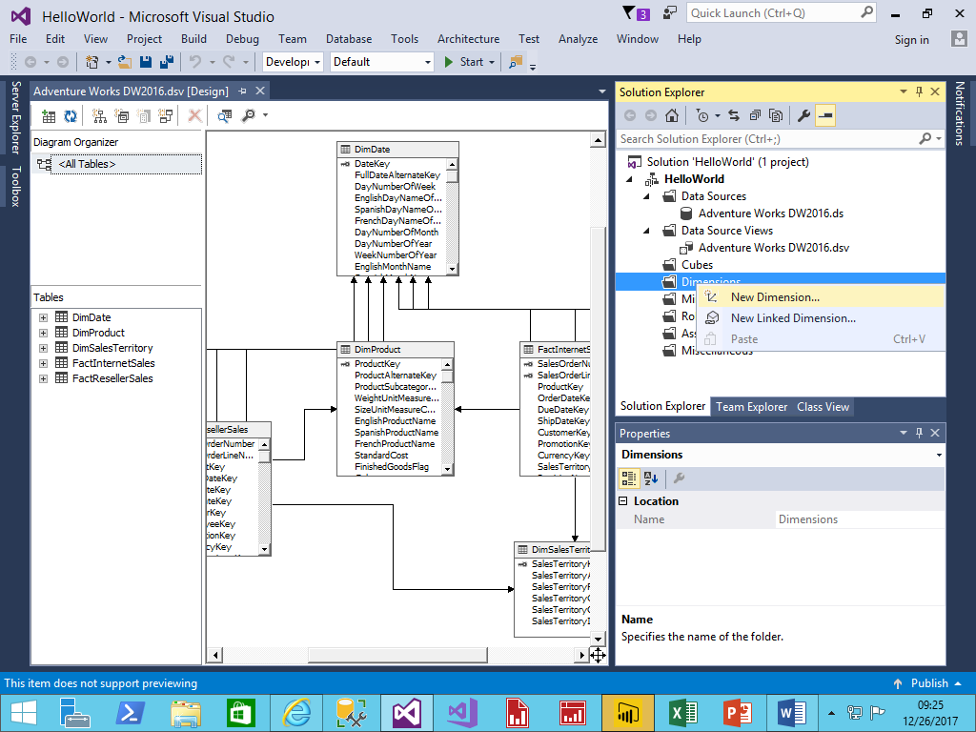

Select New Dimension

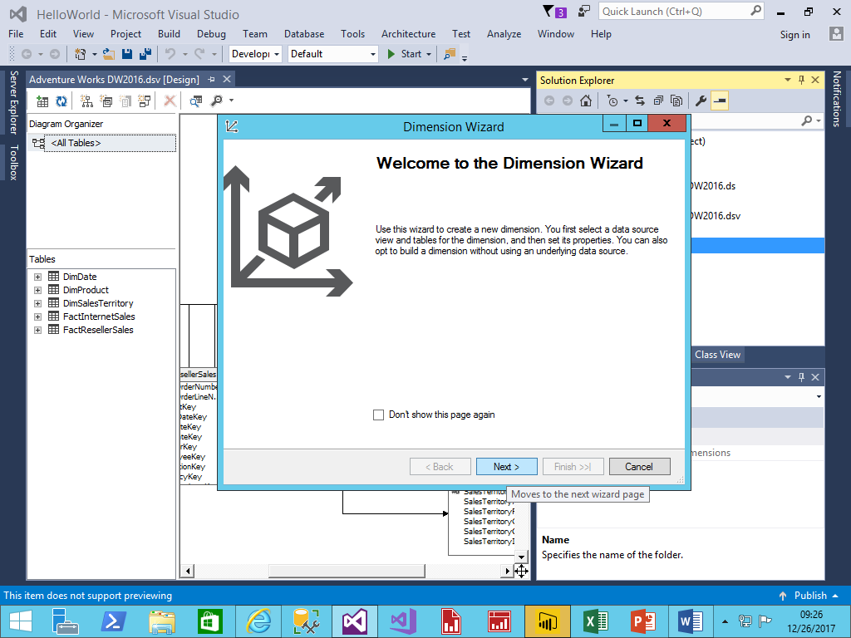

Click Next

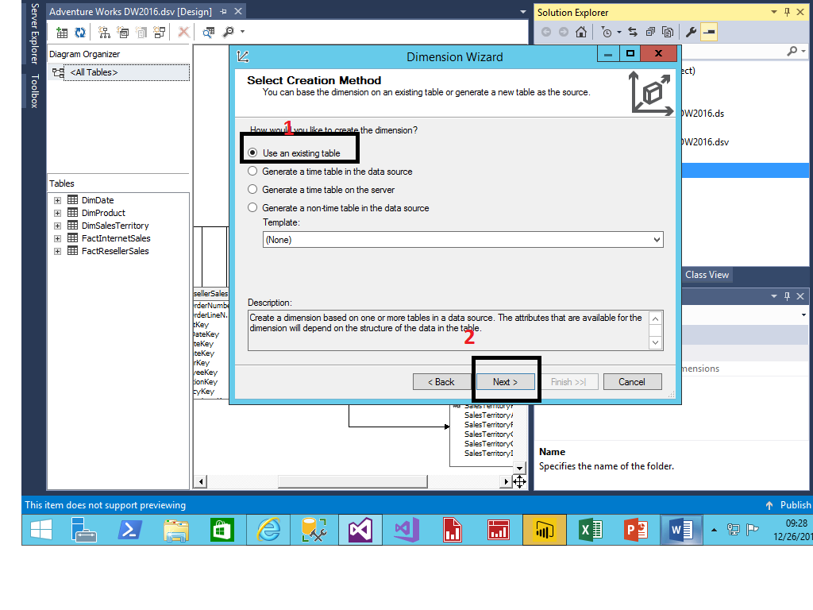

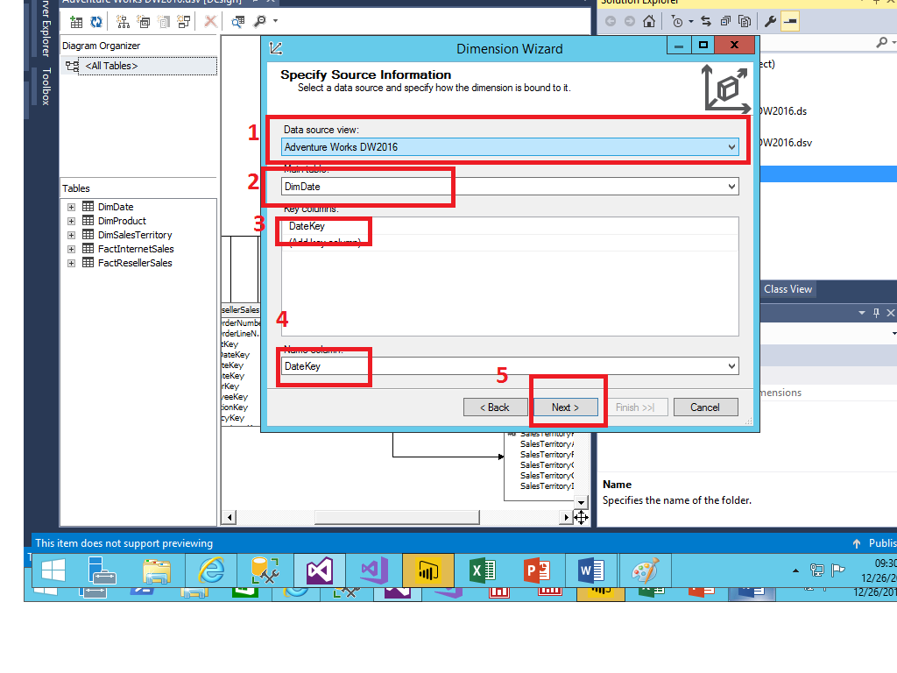

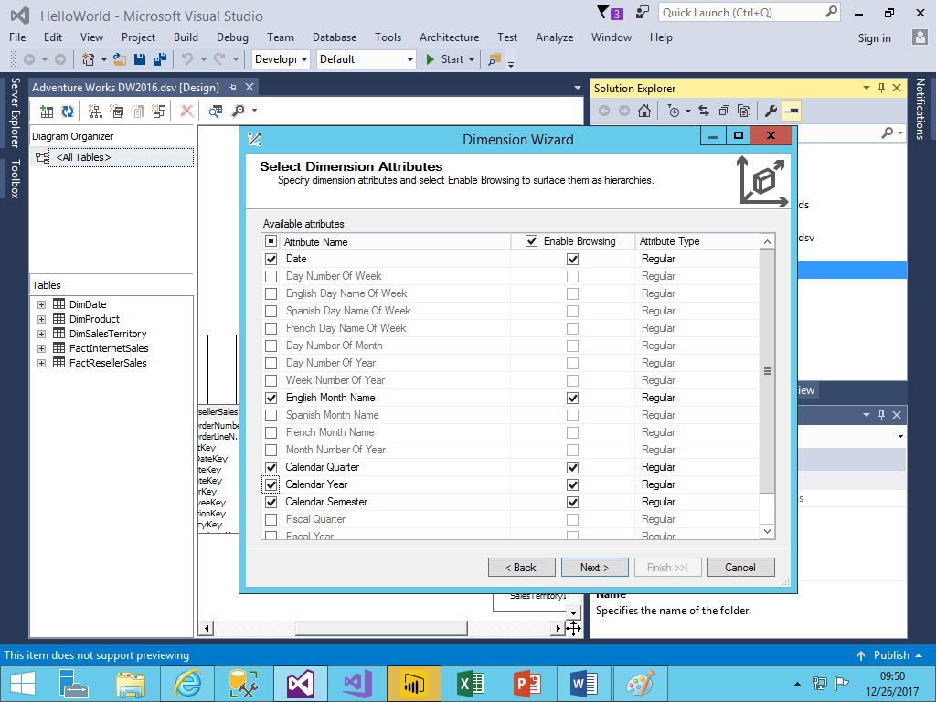

Select the attribute members. Click next button.

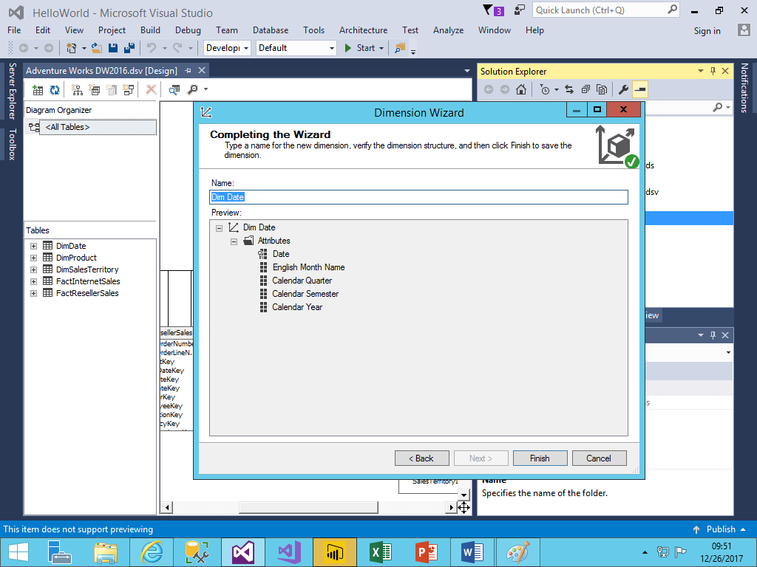

Click finish button.

Similarly add the other dimensions(DimProduct and DimSalesTerritory) too.

Now we are going for creating Cubes.

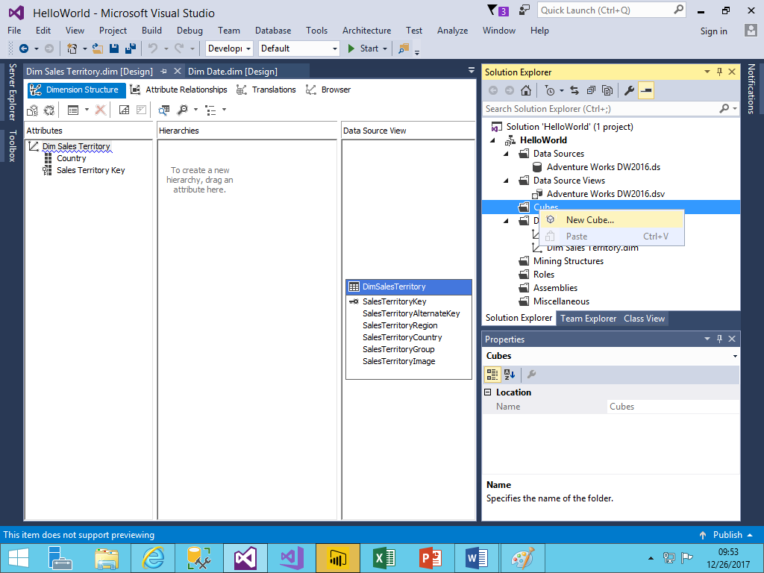

Right click on cube

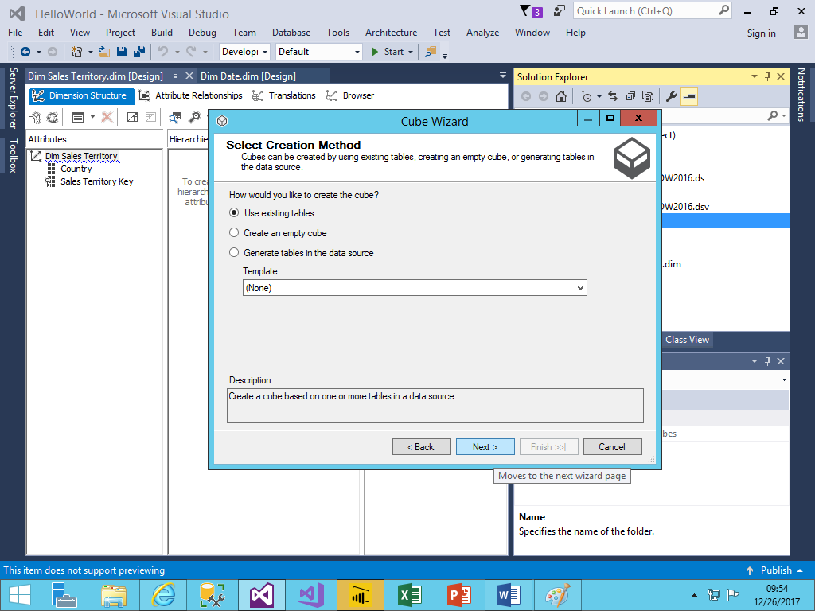

Click next

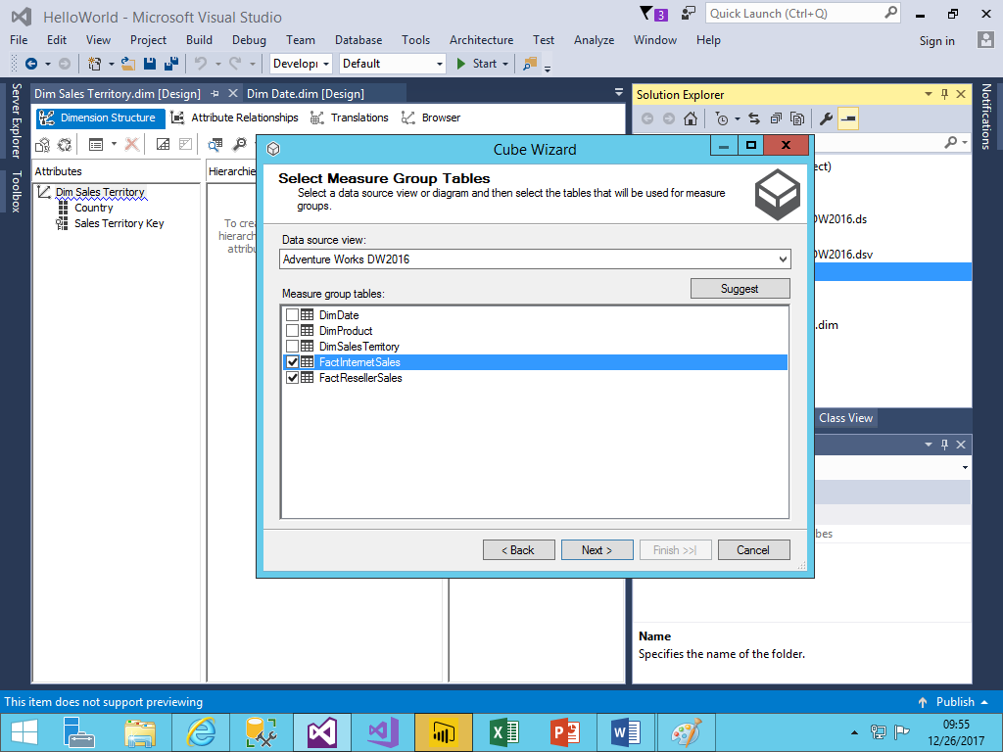

Select measure group tables and click next button.

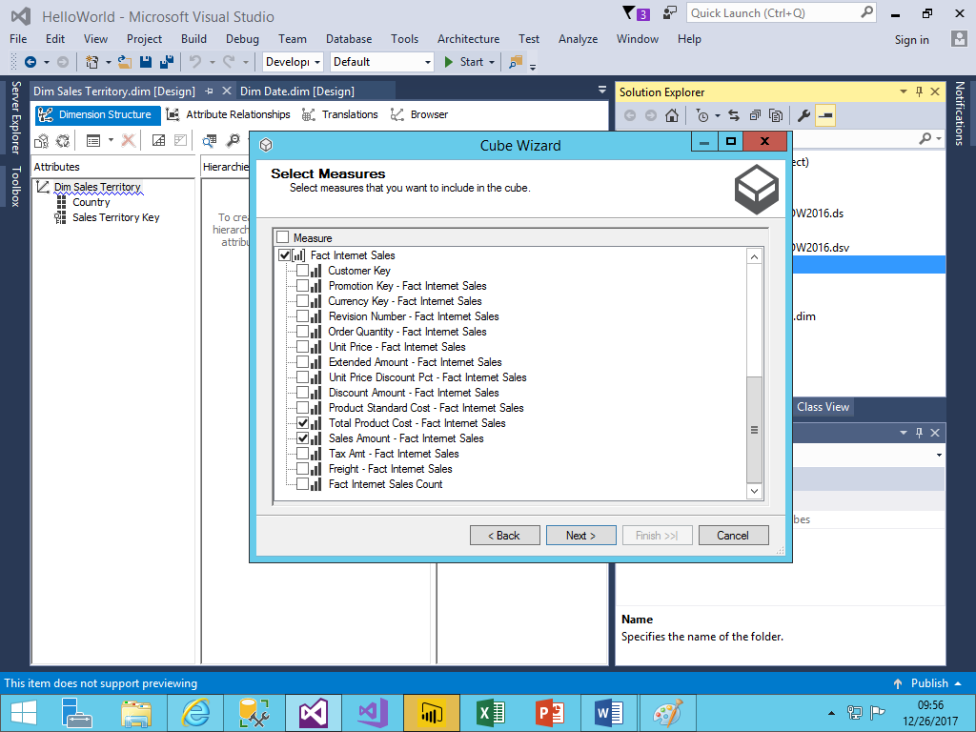

Click next and select existing dimesions(created in dimensions folder)

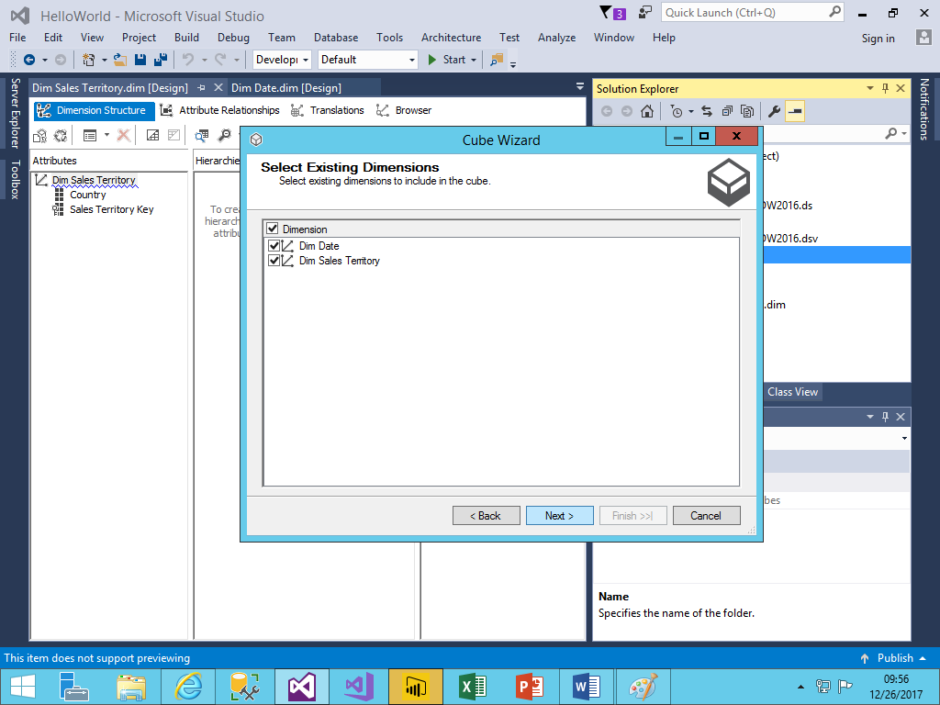

Click next

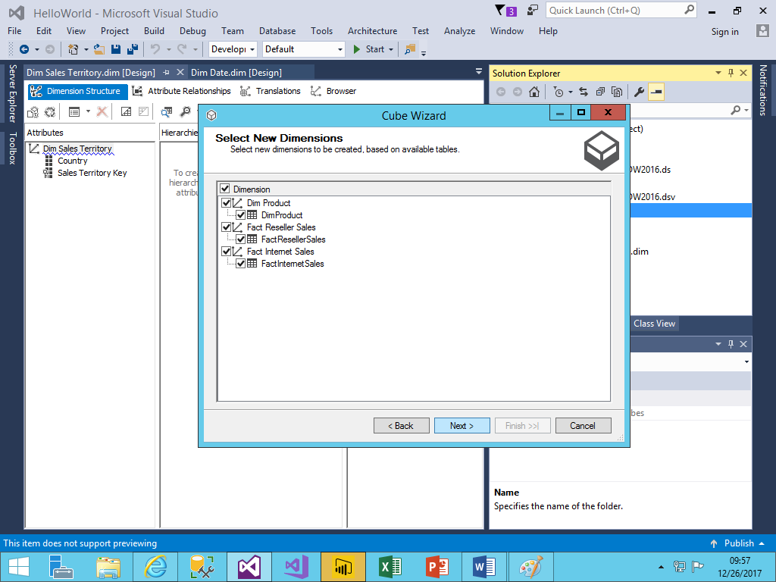

You can deselect all these new dimensions and click next.

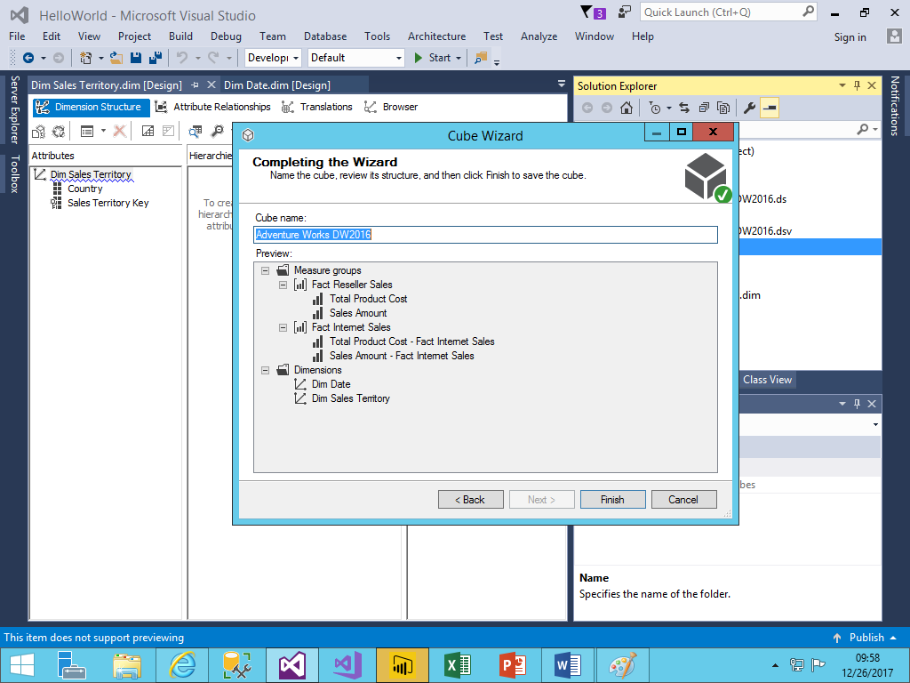

Now lets deploy and process solution by right click on project and deploy

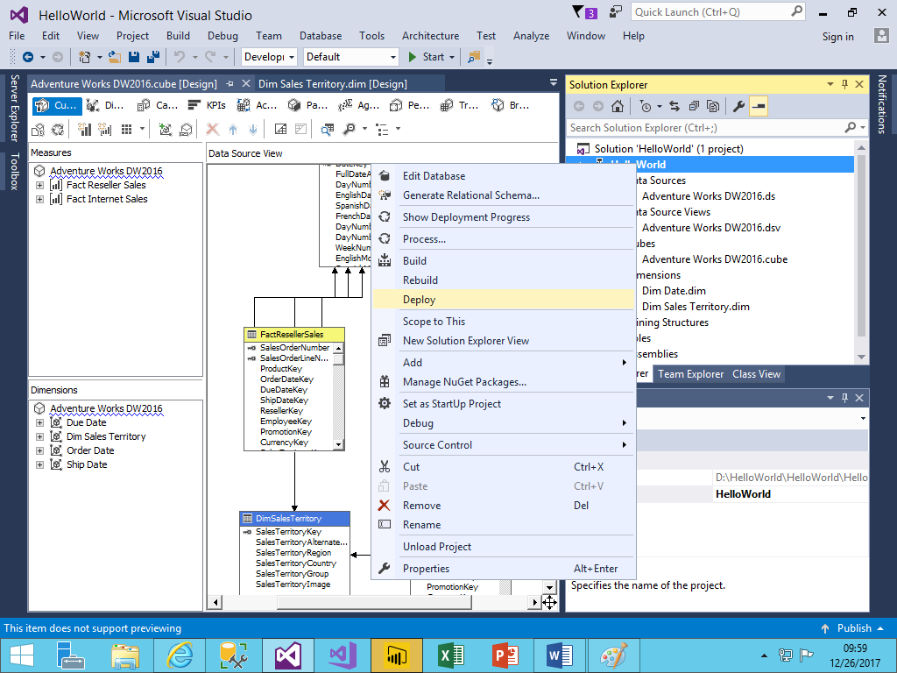

After processing is completed, now try connecting to SSAS cube and browse the data.

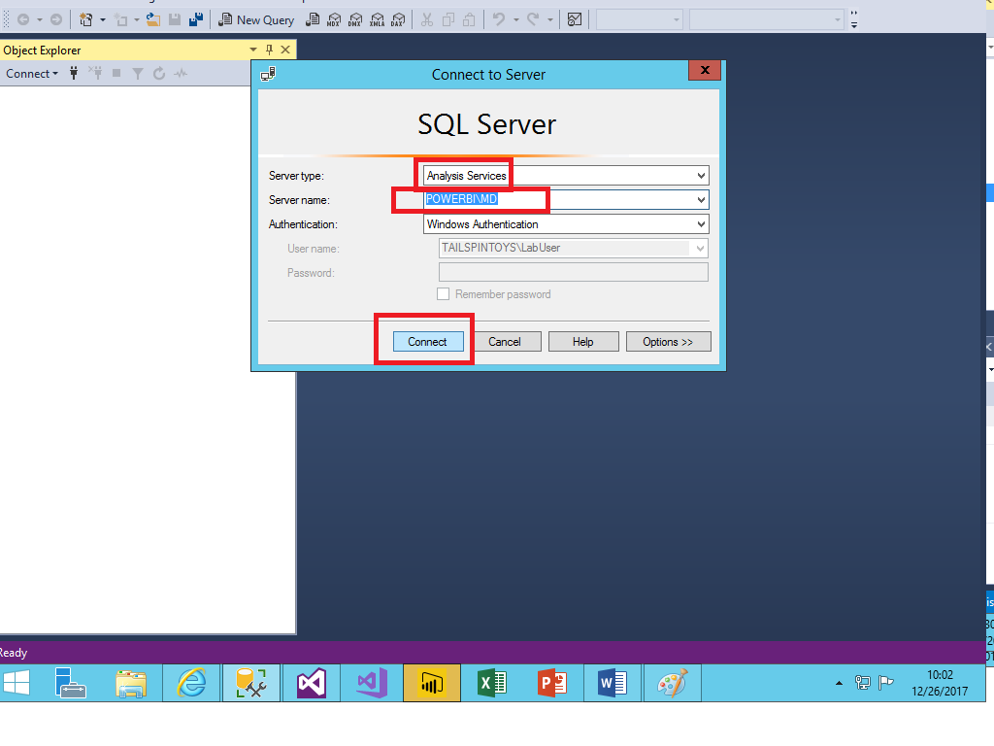

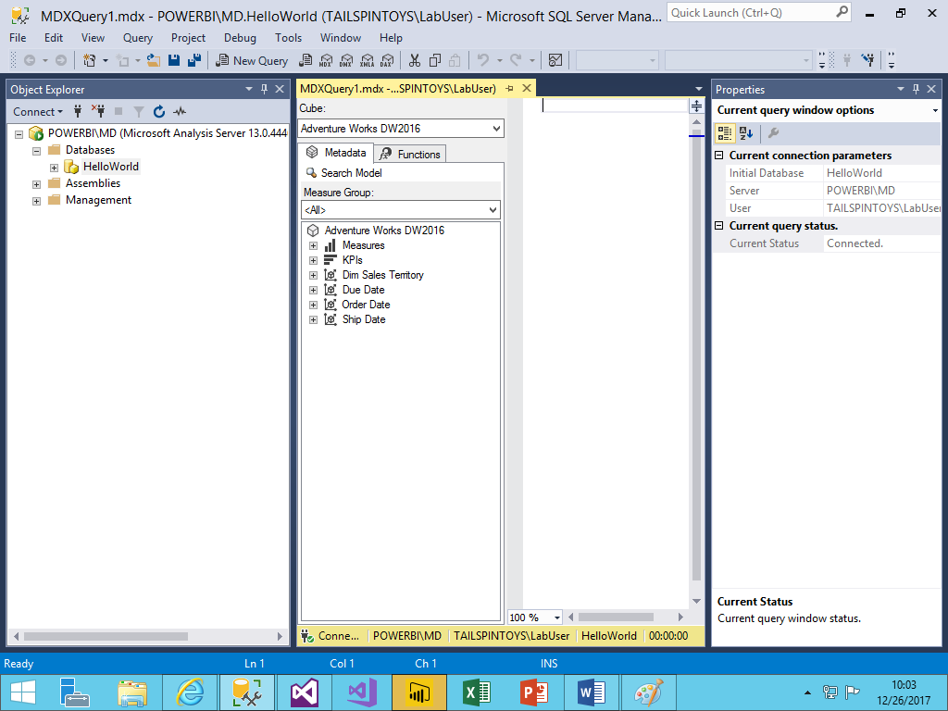

Now go for connecting to SSAS Cube from Power BI Desktop

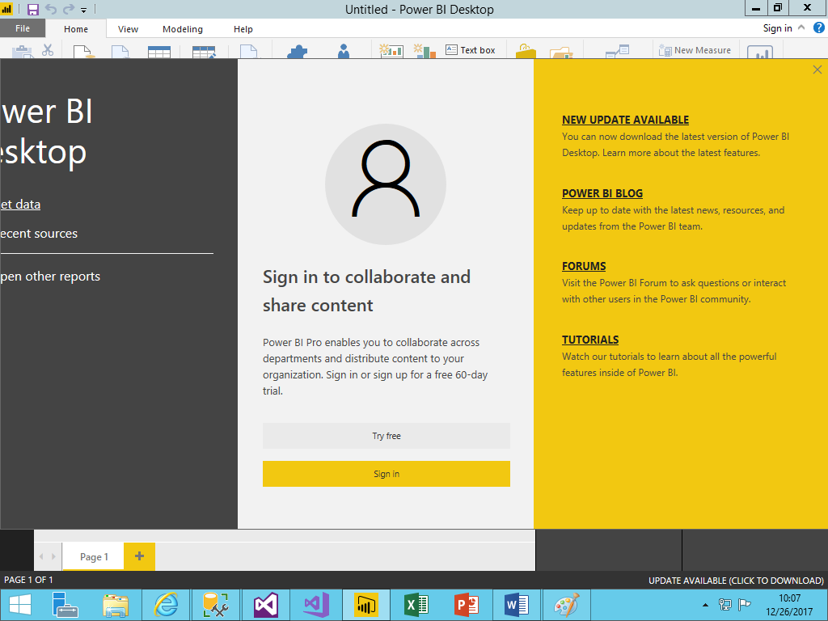

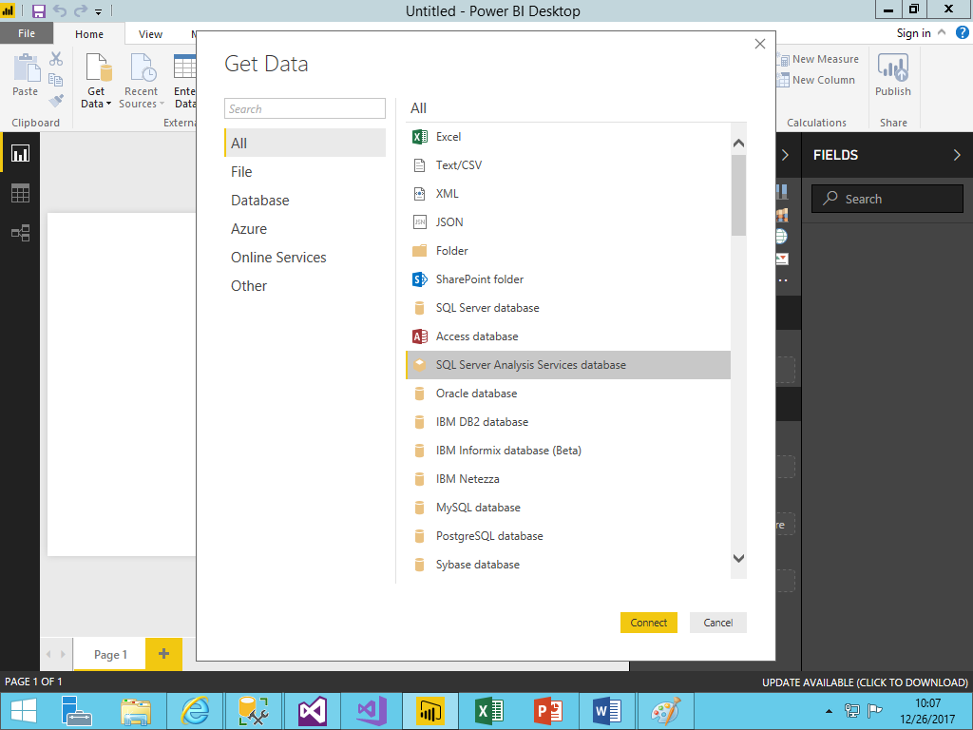

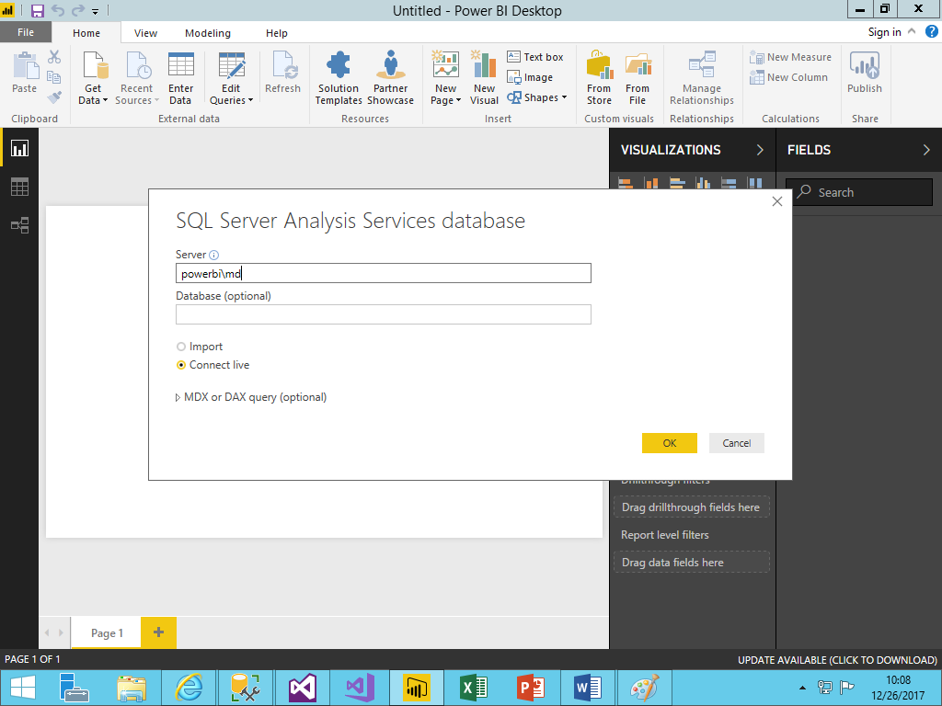

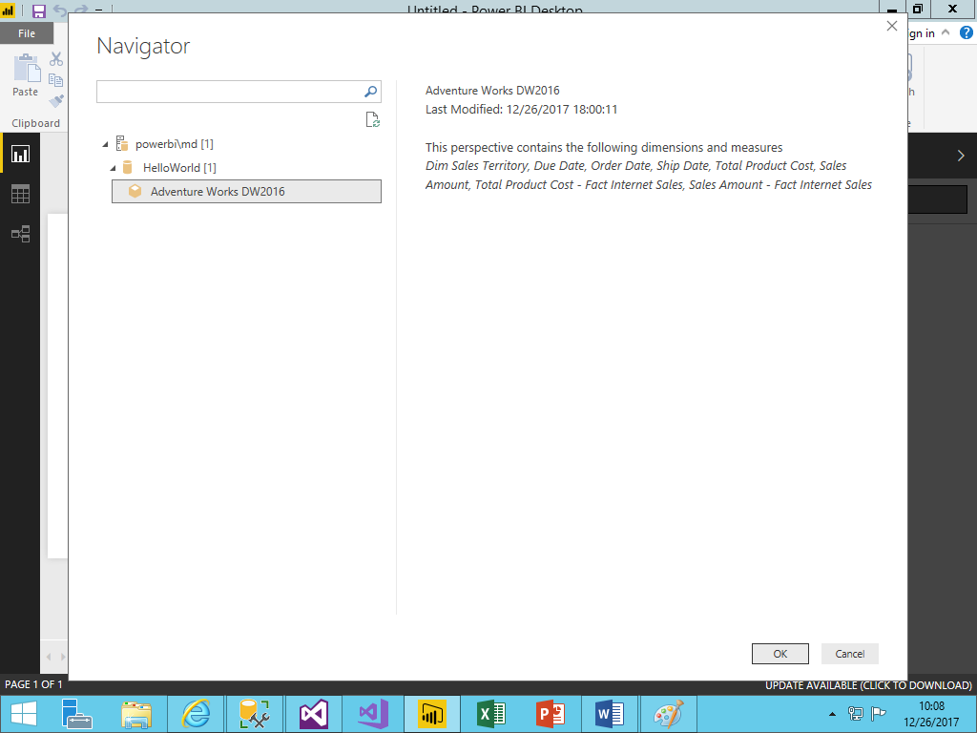

Now you have all your tables in your model.

Connecting to Tabular Model from Power BI Desktop:

First create Tabular Solution

1. Open Visual studio >> File >> New >> Project >> Business Intelligence >> Analysis Services >> Analysis Services Tabular Project.
2. Please specify your project location and Solution Name.
3. You will see the following folder structure.

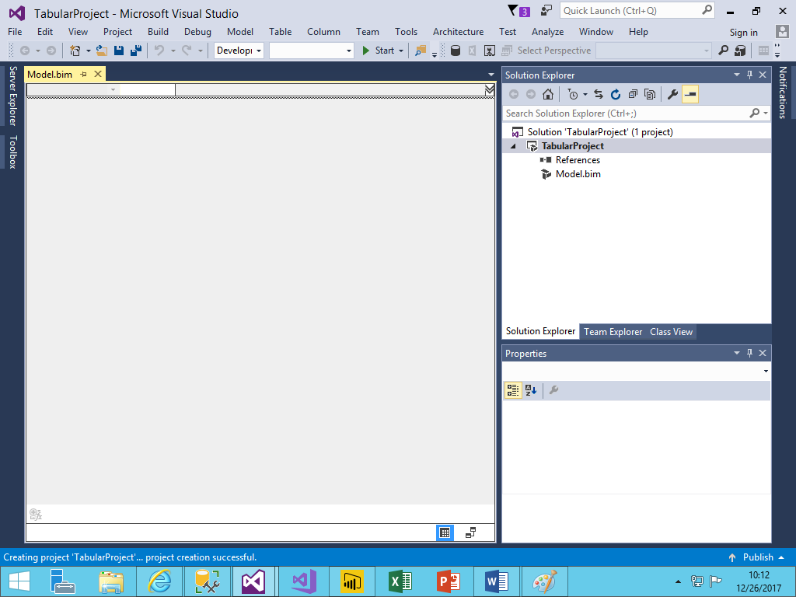

1. Go Model Menu, select Import Data from DataSource.

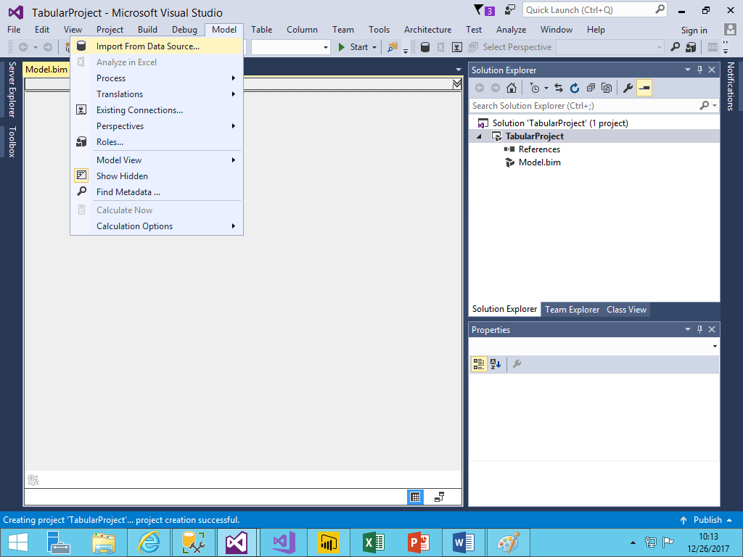

1. Select the data source type.

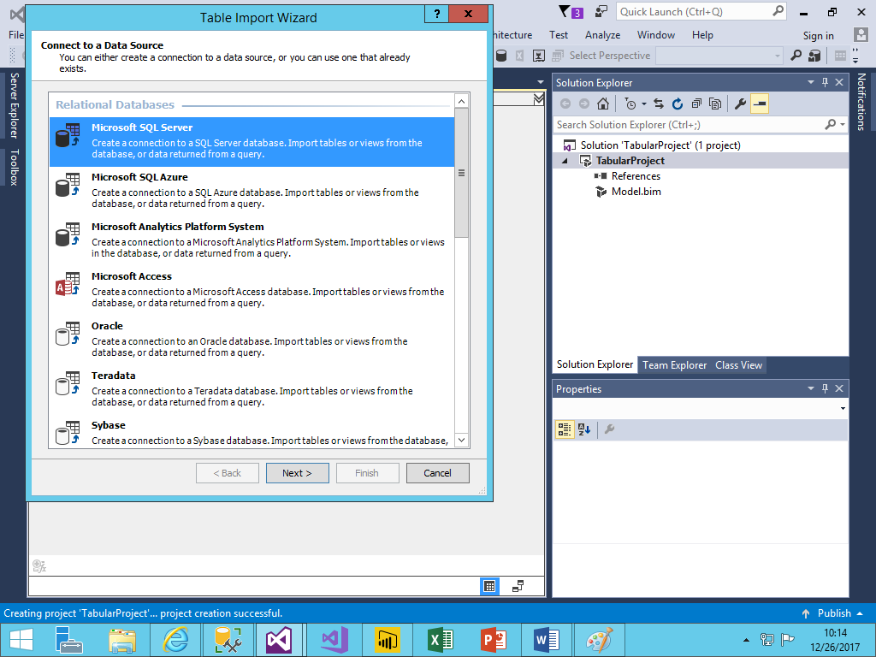

1. Enter server name and database name click next button.
2. 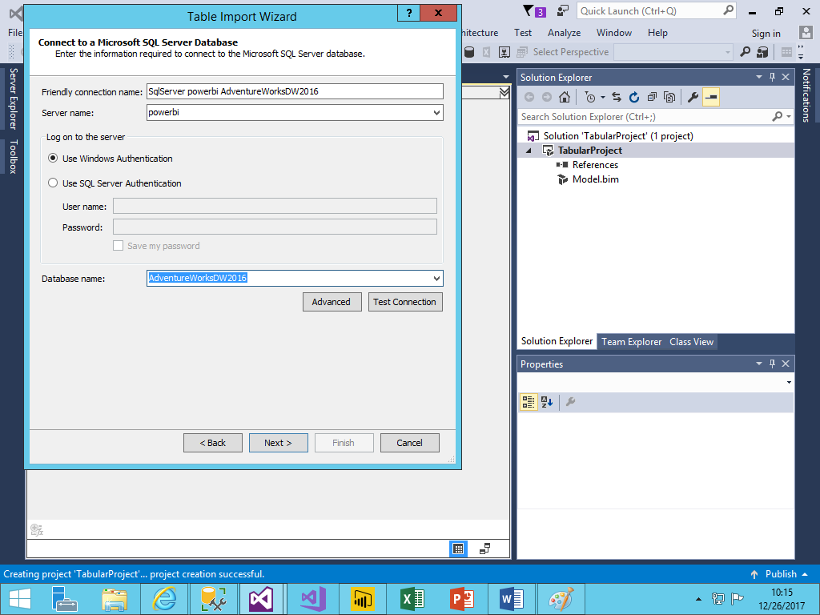
3. Select Service account in next screen.
4. 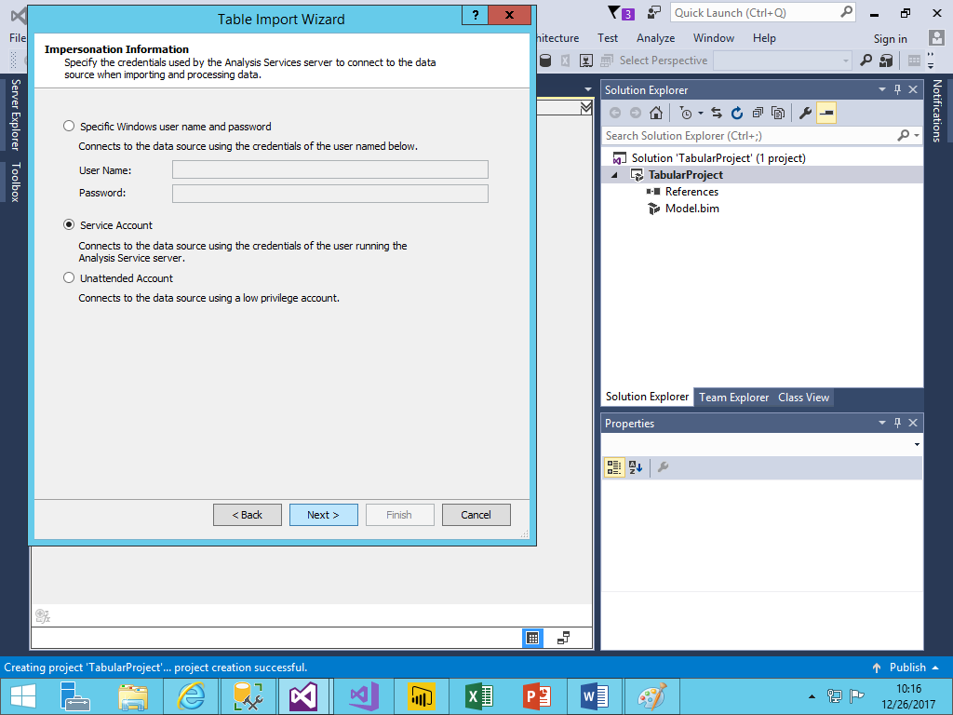
5. 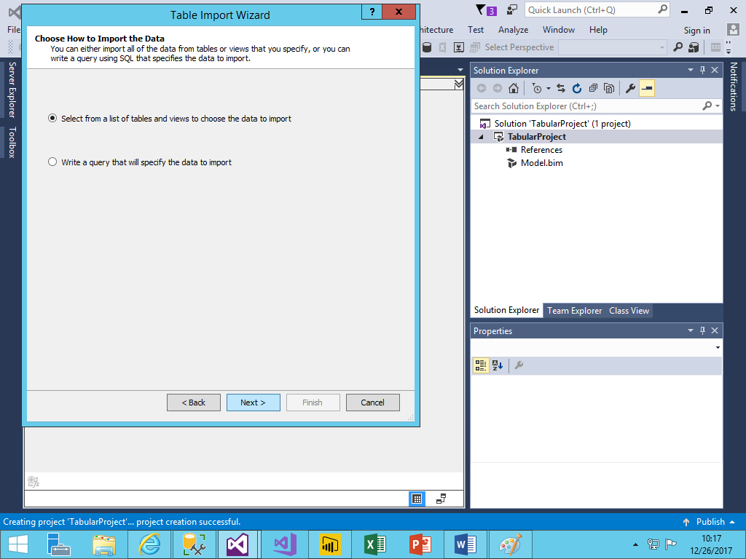
6. Select tables and click finish.
7. 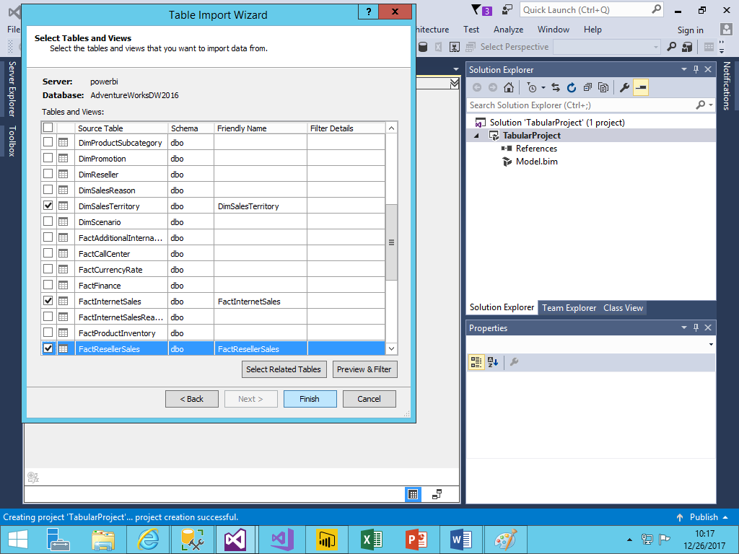
8. Right click on project and deploy.
9. 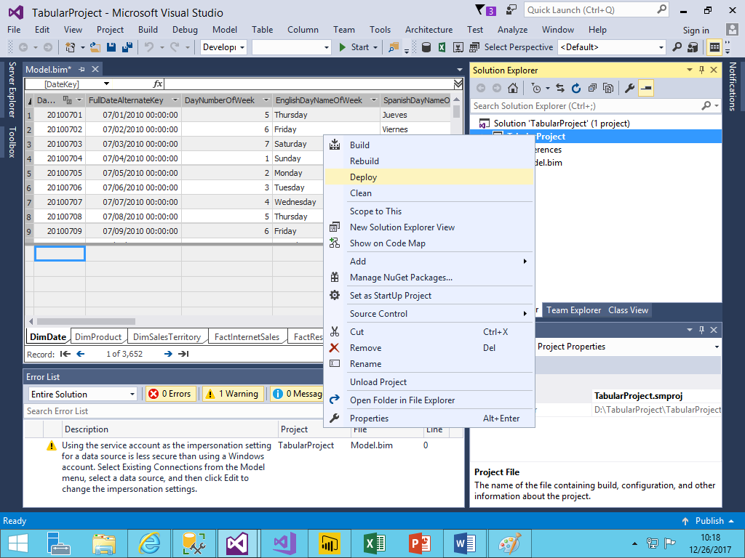
10. You will see the following screen.
11. 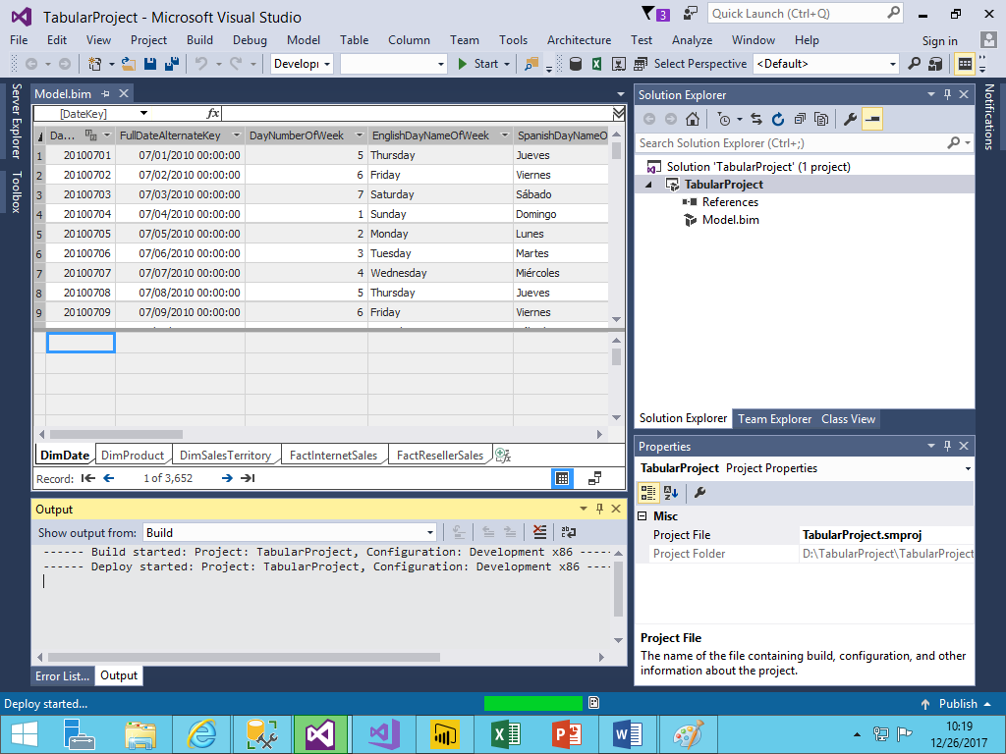

Now you can check the same tabular cube connecting server using SSMS.

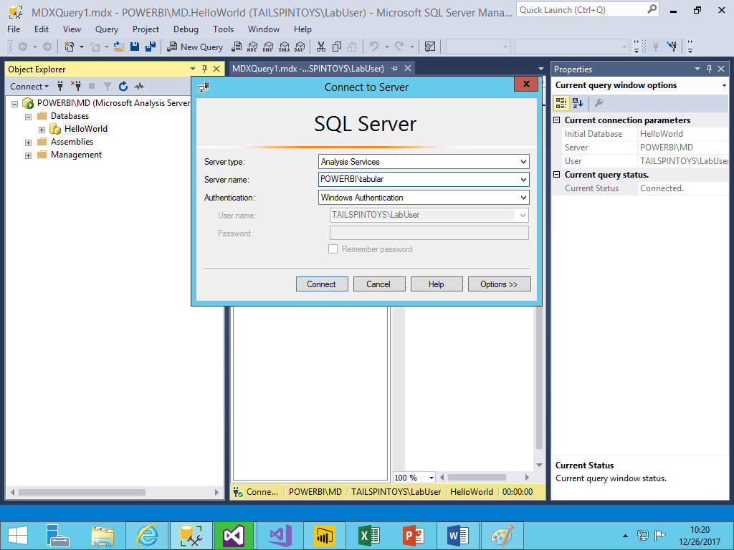

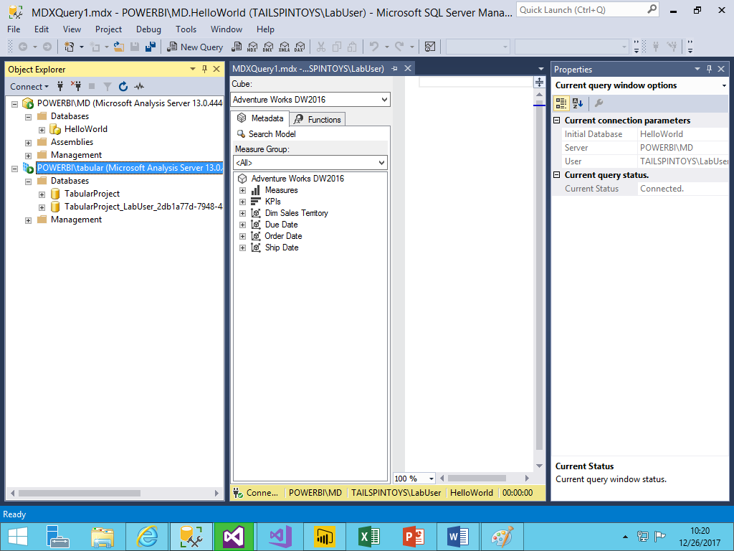

Now go for connecting to tabular data source from Power BI Desktop.

1. Get Data >> Database >> SQL Server Analysis Services Database
2. Enter Server name and database name.
3. 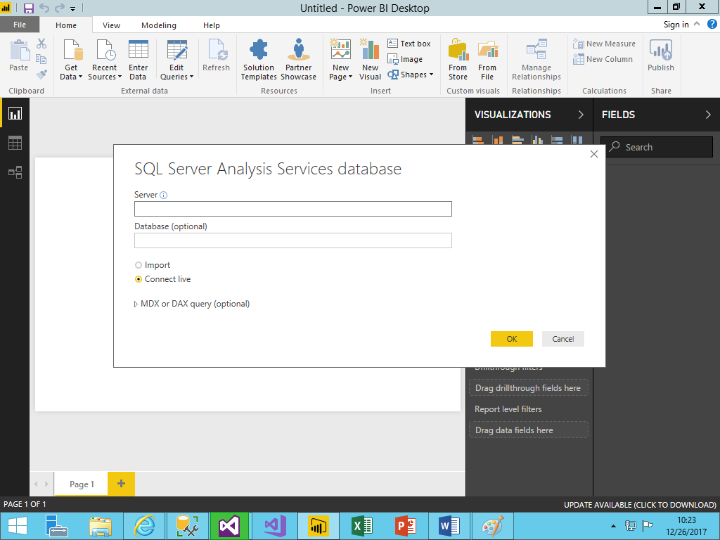

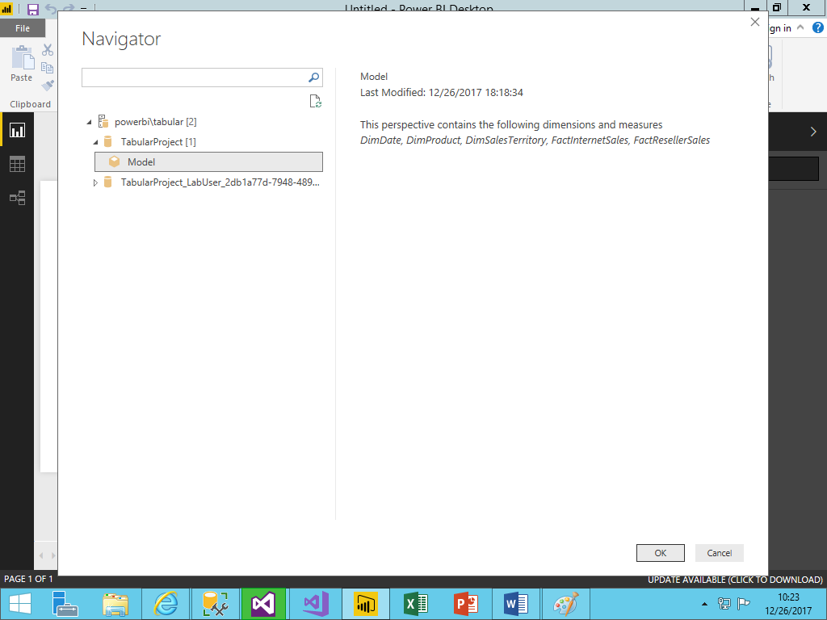

You will see all the tables loaded to Model. For import do the same, change the data connectivity Mode.