This document will walk you through the process of setting up the data gateway to keep your on-premises SSAS tabular and Power BI dataset in sync using live connection.

First we will create the SSAS tabular solution and deploy it on a server.

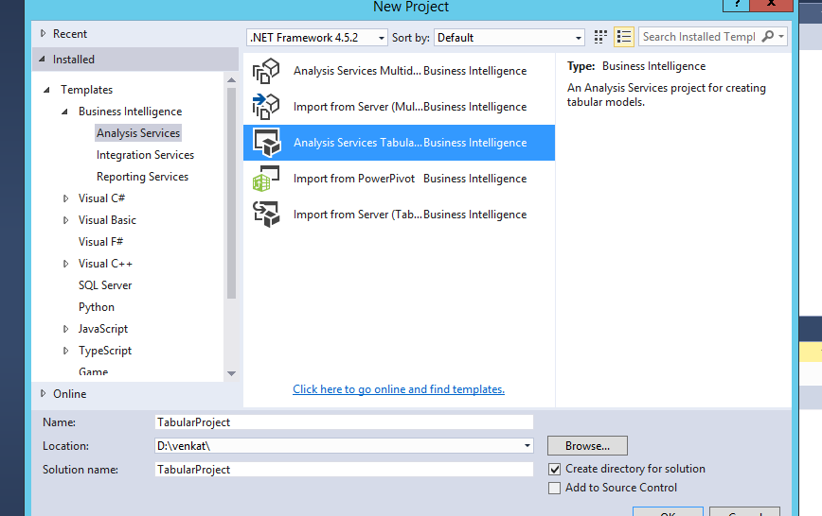

Load the tables to model.

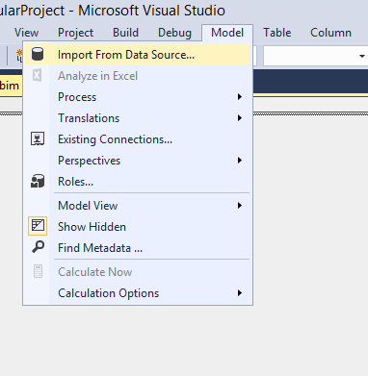

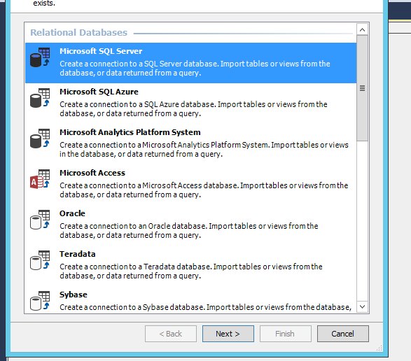

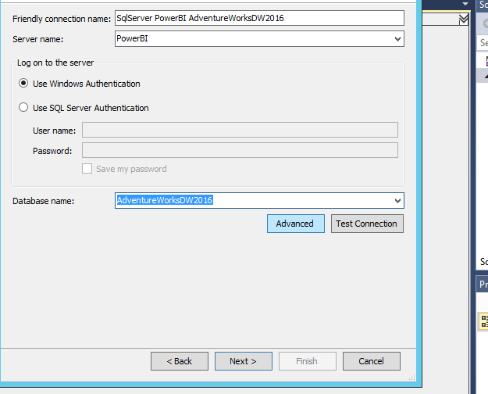

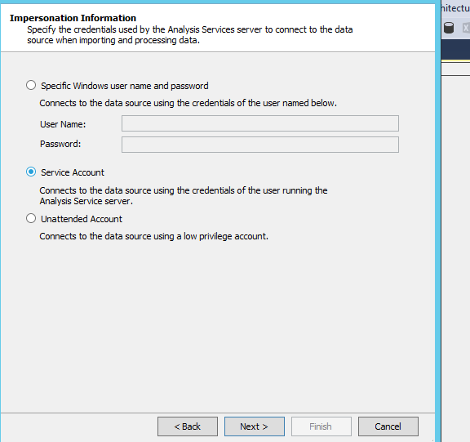

Select the tables.

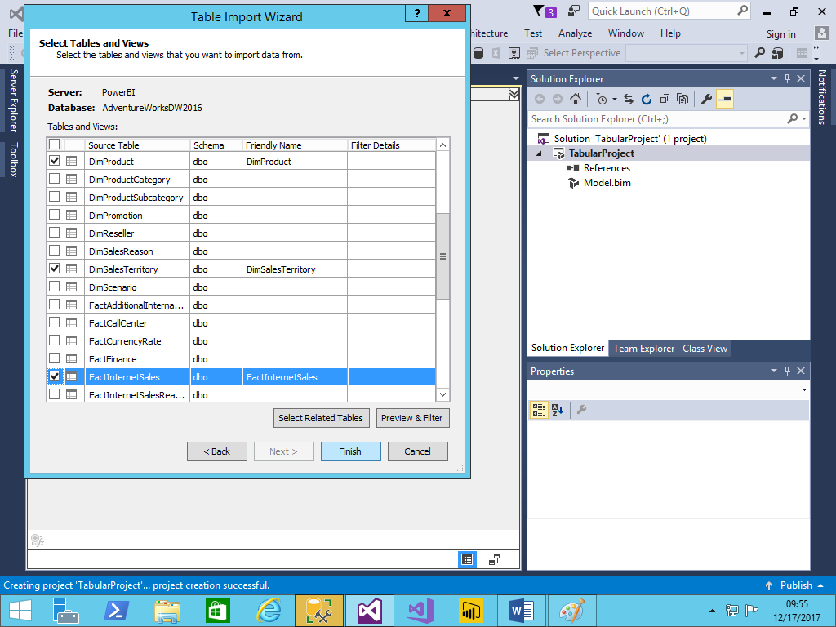

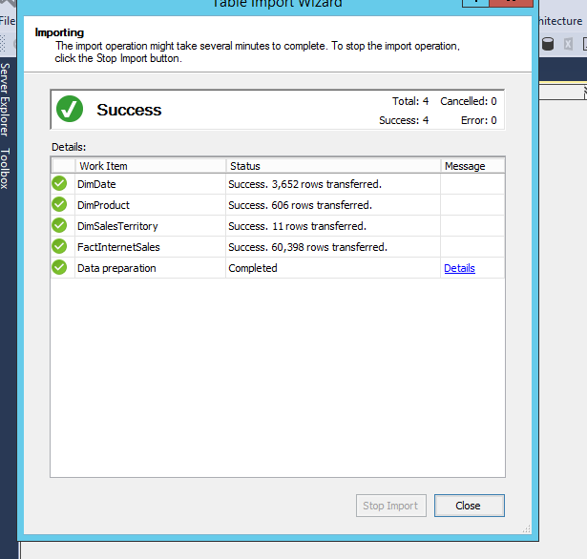

Now you will all the tables in the model

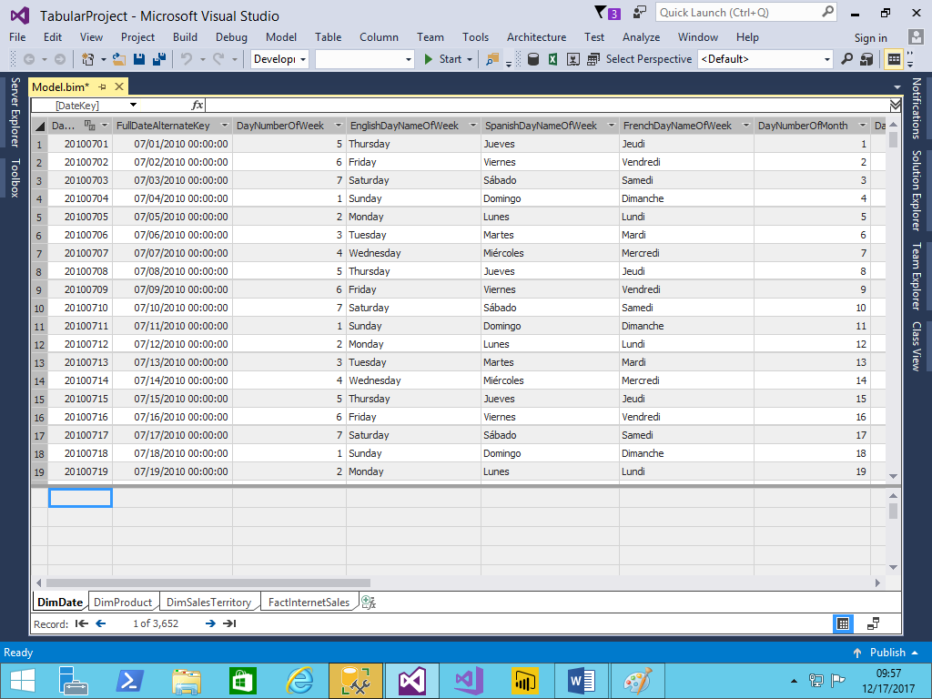

Now deploy the solution.

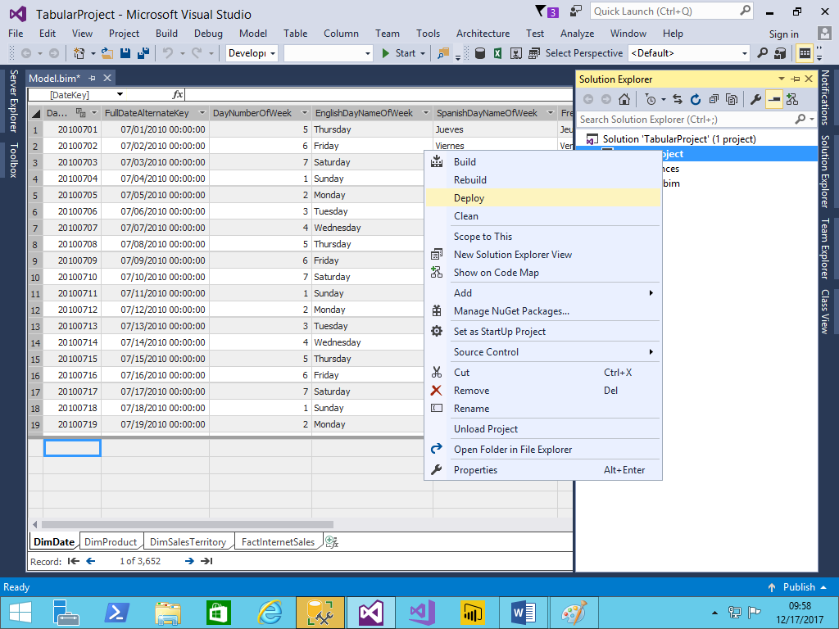

Deployment has been completed, now you can see the database in SSAS tabular server.

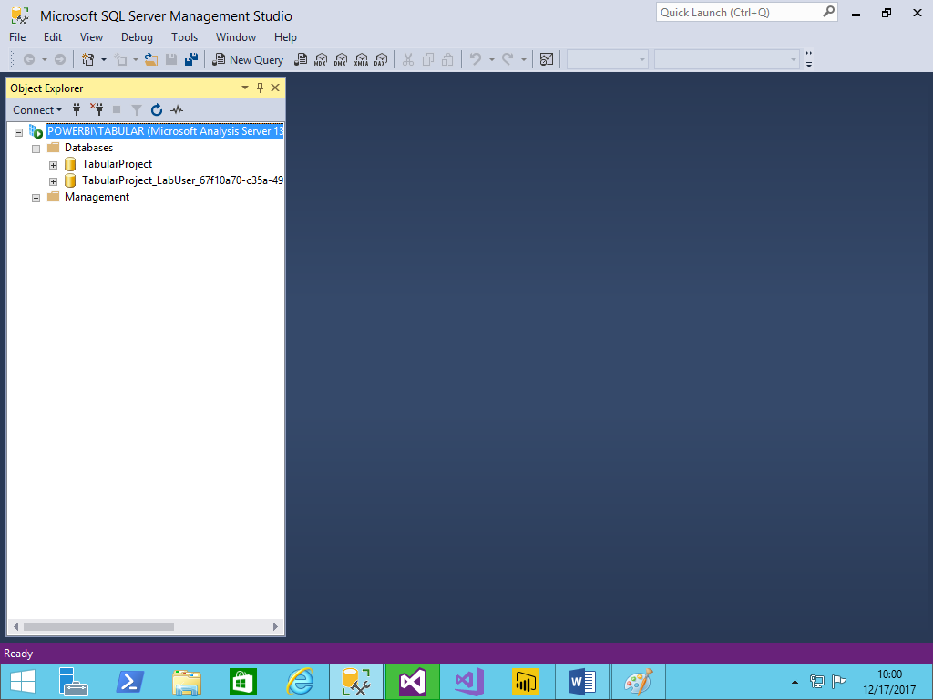

Now we will design the Power BI report.

Select analysis services connection

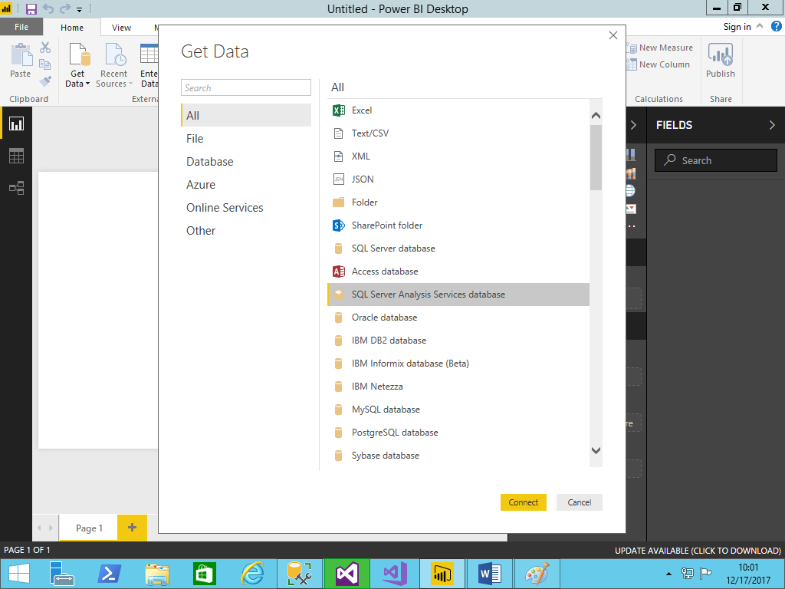

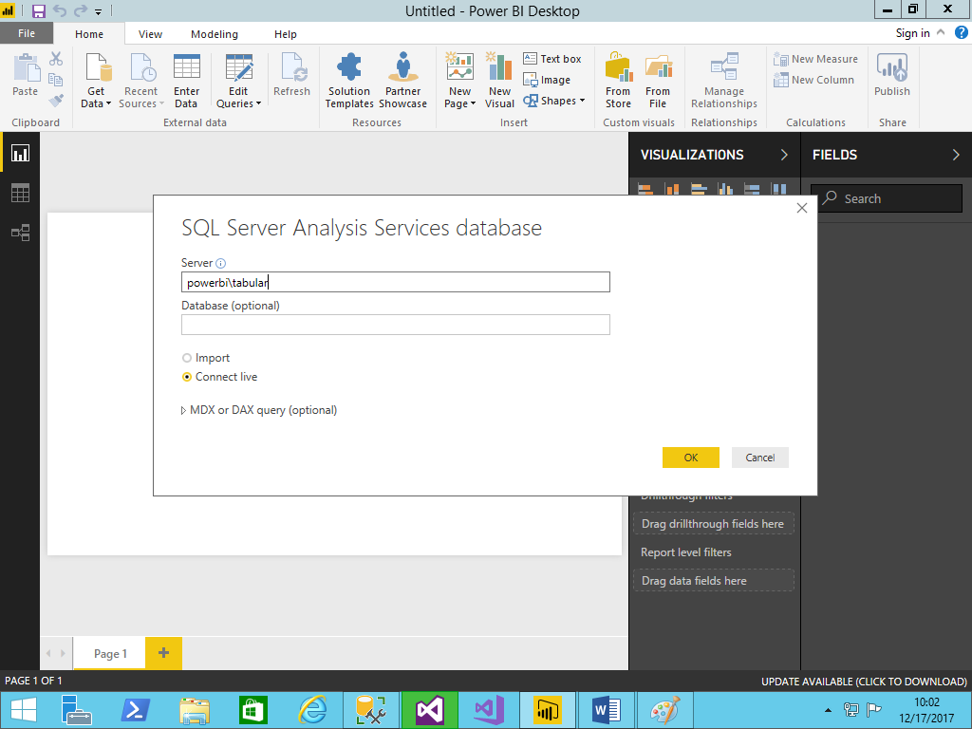

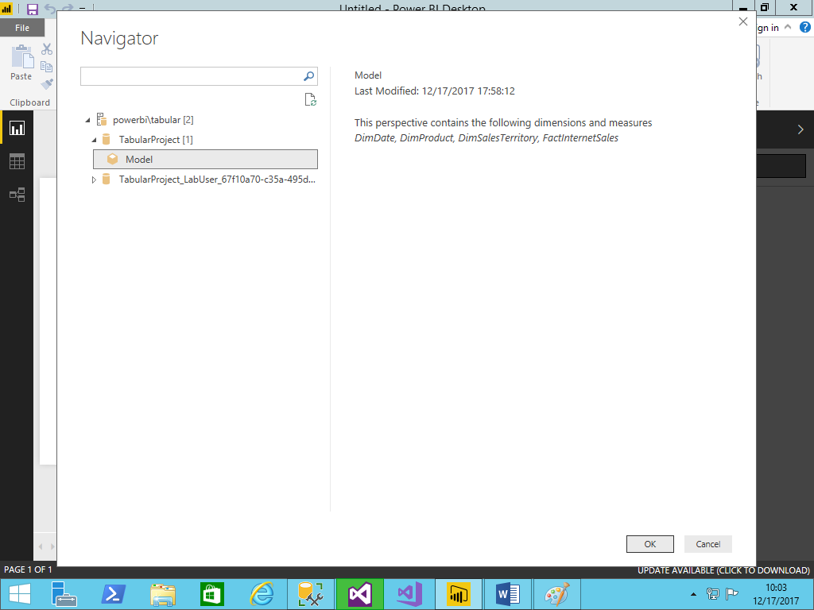

Now see the power bi model.

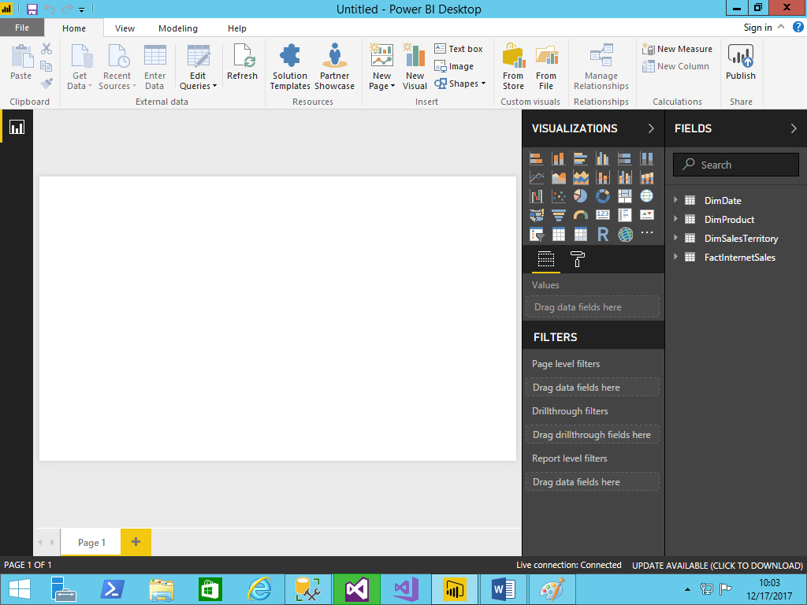

The final report would be

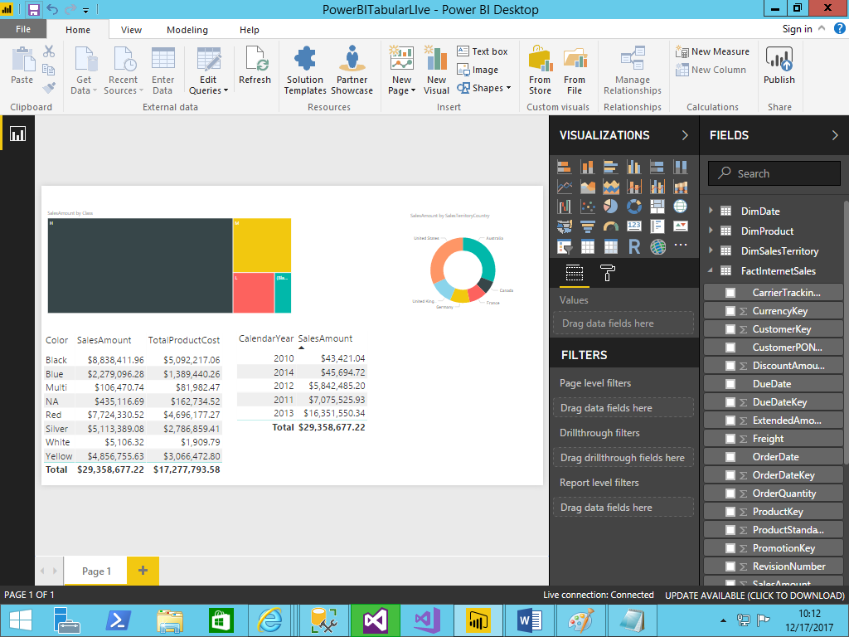

Now download the data gate way and install in premises server. After installation you will see the following image.

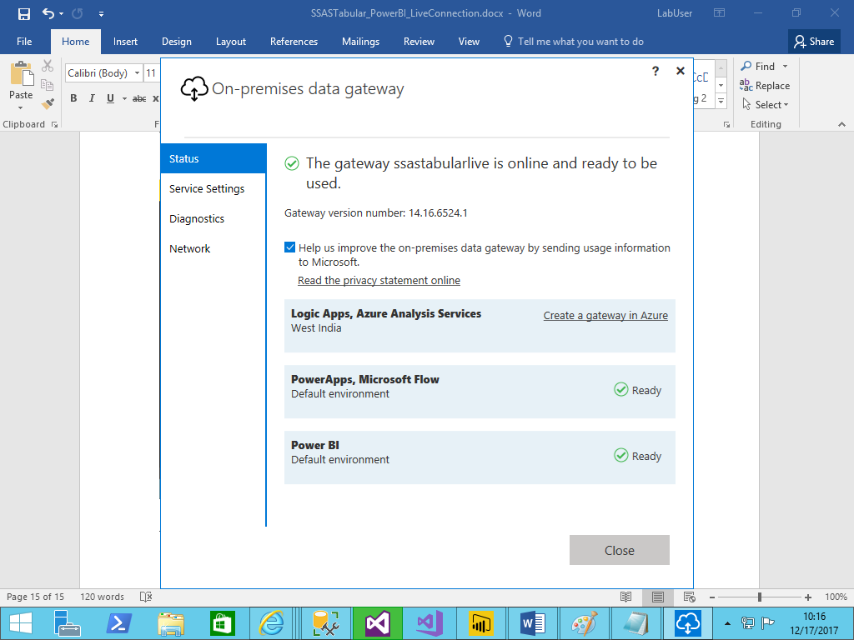

Now we will go to Power BI service and we will register ssas tabular database with data gateway.

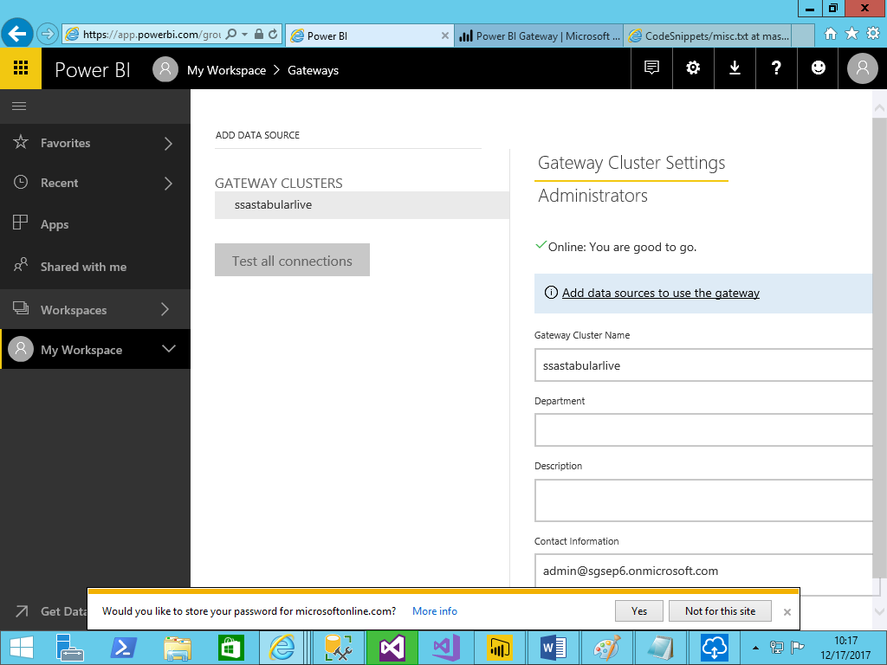

Add datasource to data gateway.

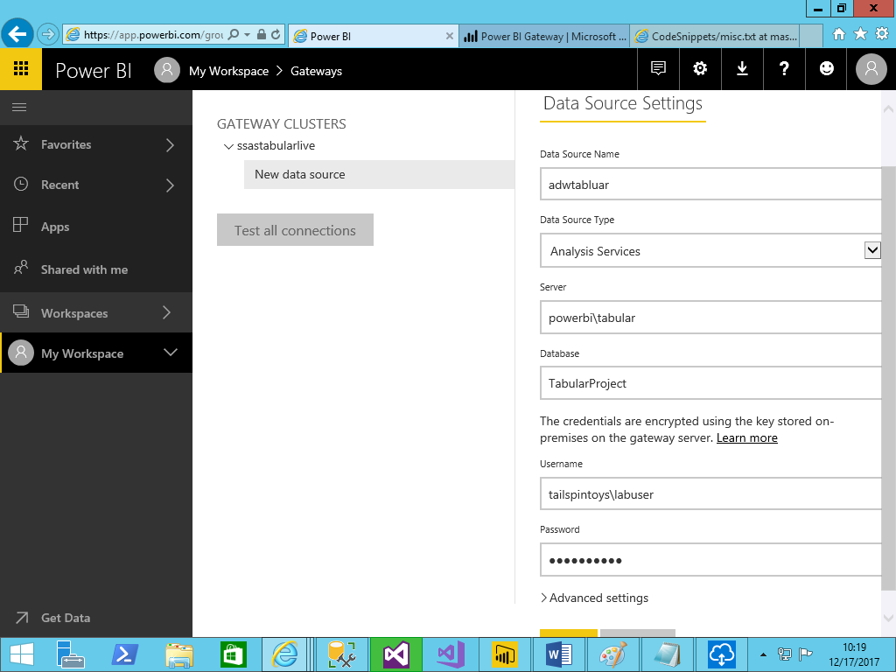

After datasource registration you will see the following.

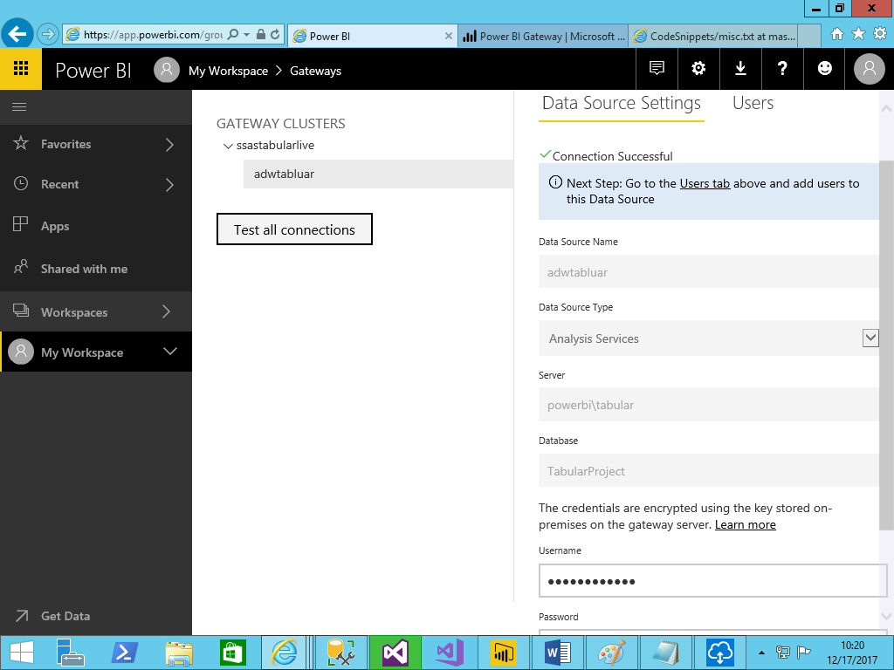

Here we have to make sure one thing, that is the credentials provided here must have administrator level permissions on tabular server.

You can check that by right click on tabular server to security

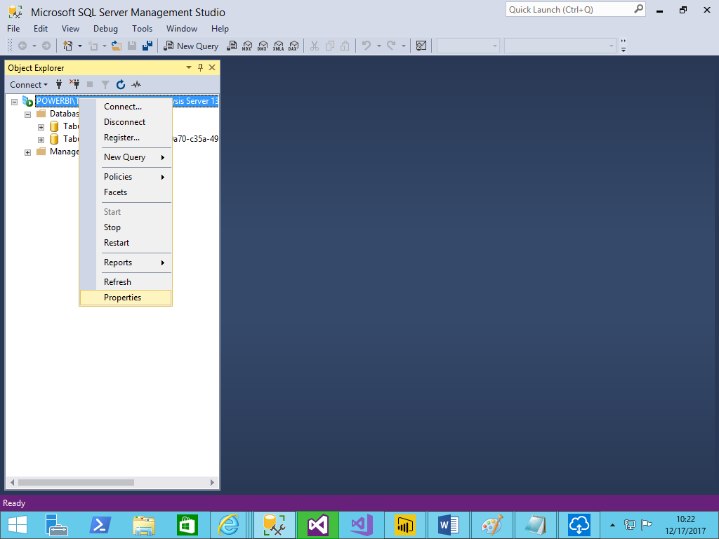

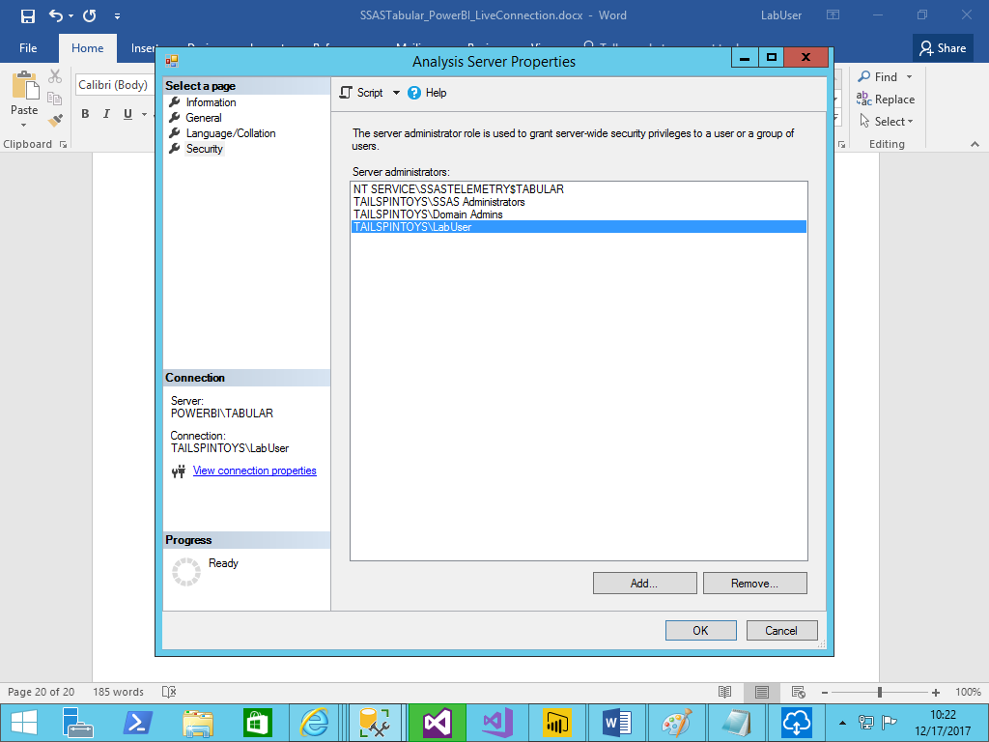

Now publish the report to power bi service.

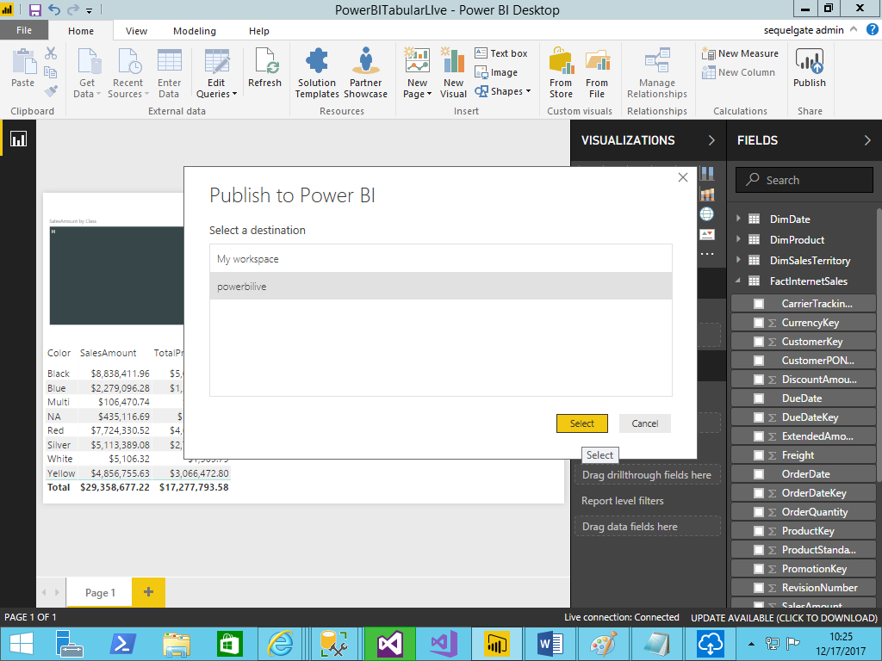

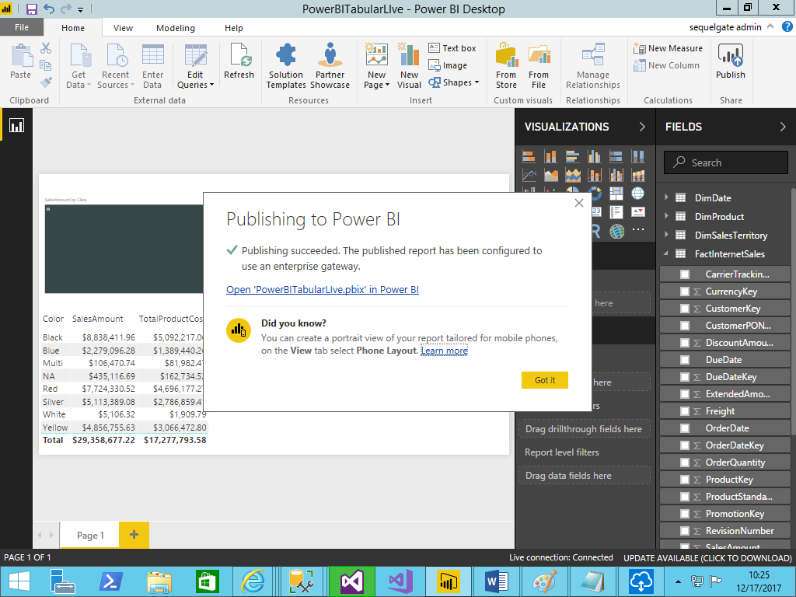

Report has been successfully published to Power BI Service.

Now go to Power BI service and open the report for verification.

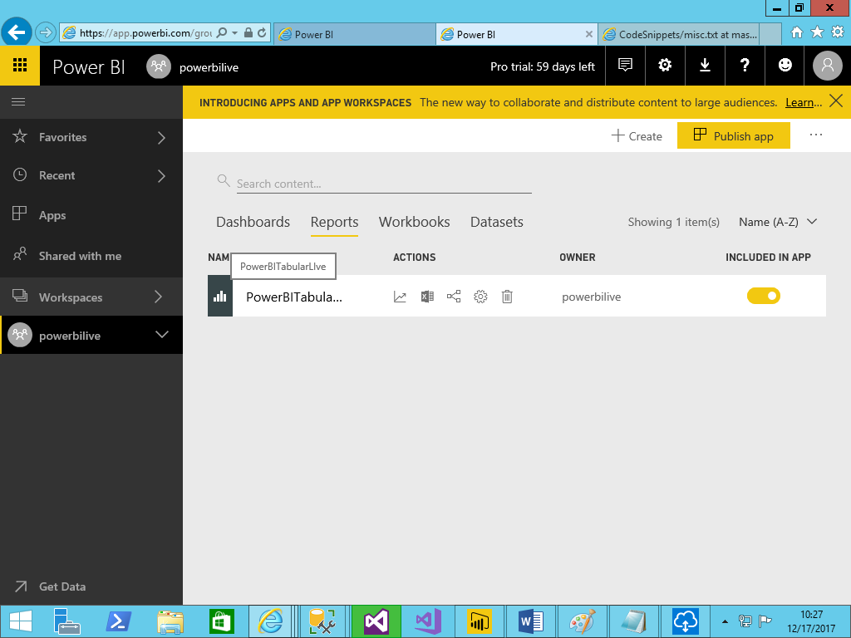

Once you open the report, you will see the following error, how can we fix that.

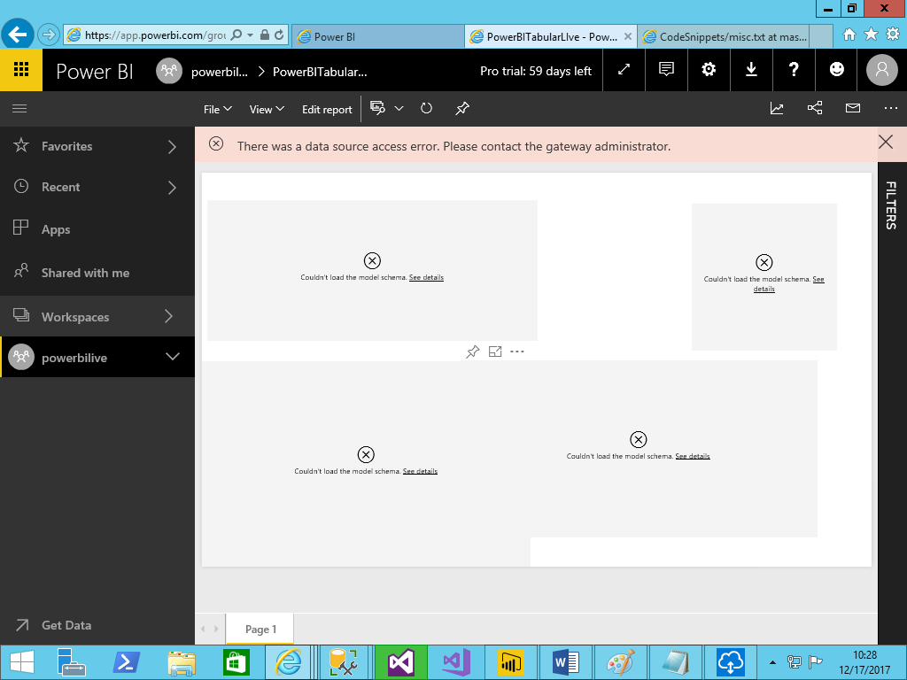now go data gate way, select your datasource and goto map usernames.

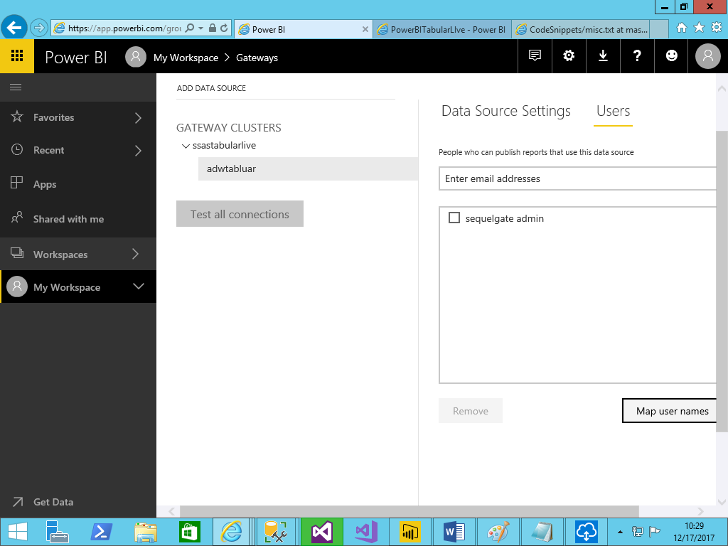

You will see the following image.

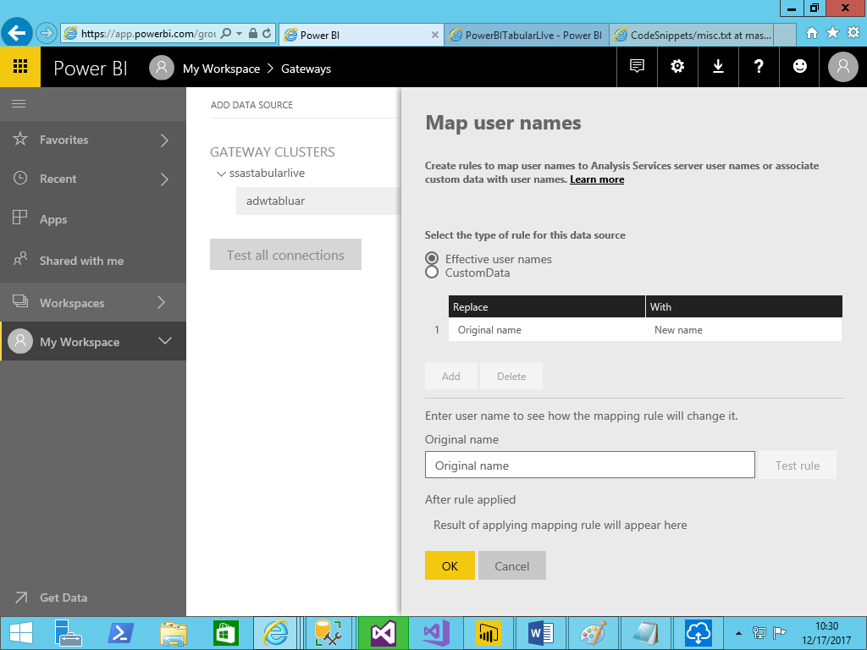

Here add your users with new user(your on premise active directory domain account). How can you find that.

Go start button, search

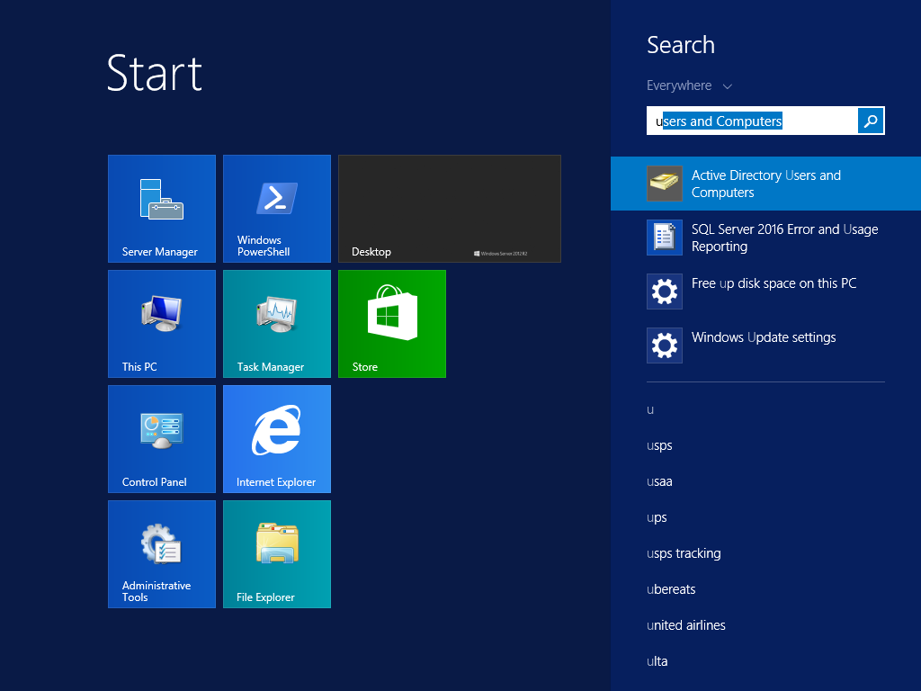

You will see the following screen.

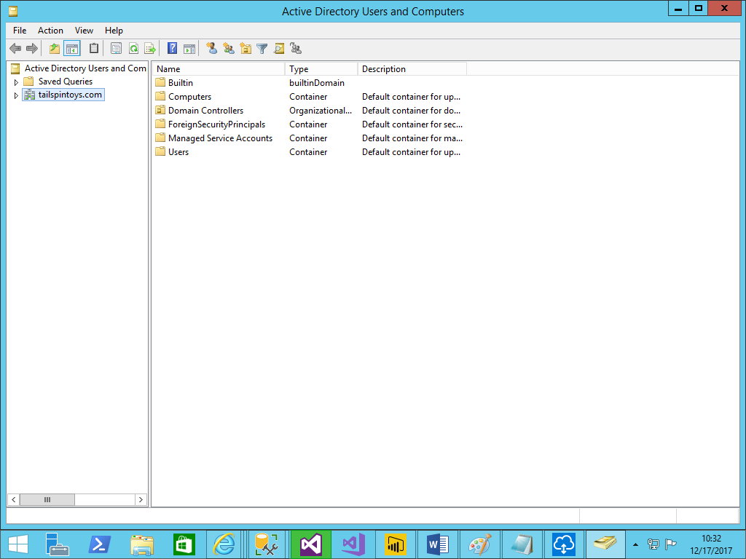

Goto users and select user which is having administrator rights on tabular server.(In our case tailspintoys\labuser)

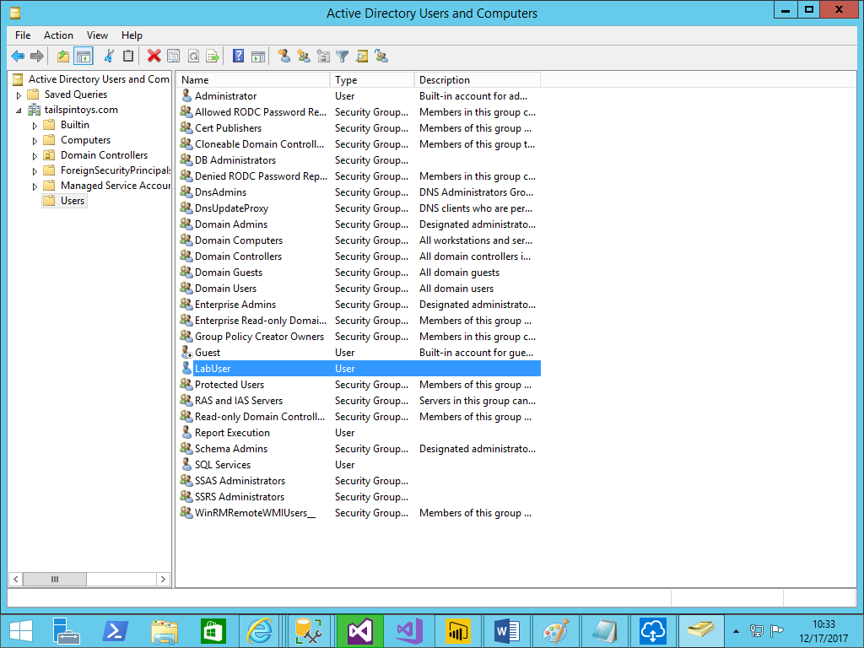double click that user and goto to account tab, you will see that following screen and take the domain name from the following screen

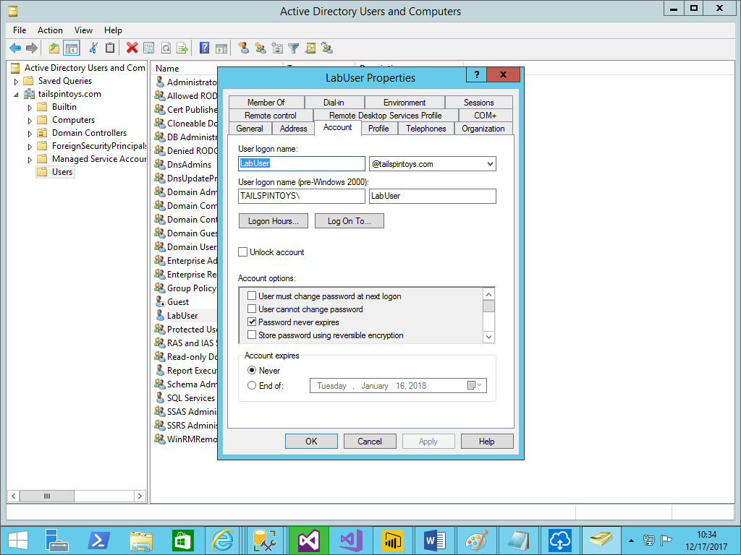

Now the domain name is – [labuser@tailspintoys.com](mailto:labuser@tailspintoys.com). No go for mapping your users with this domain account in power bi service.

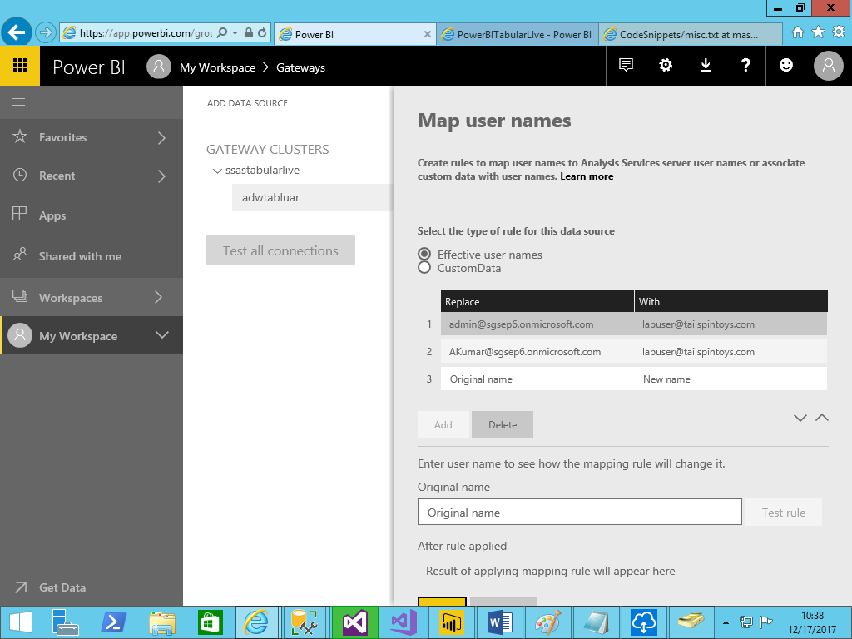

Now try opening the report.

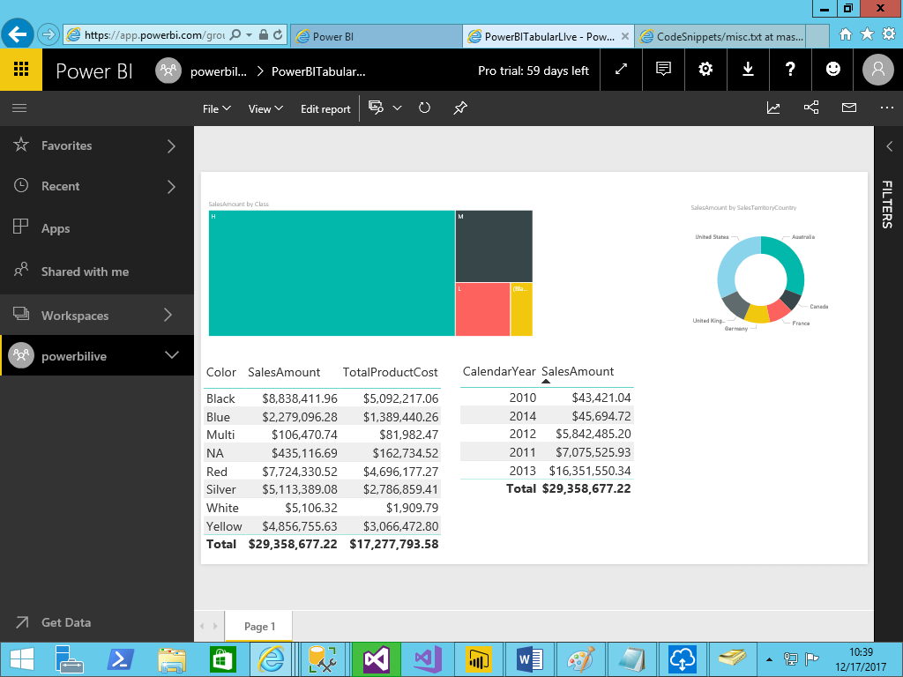

We are able to see the report. Now try logging as another user and open the report.

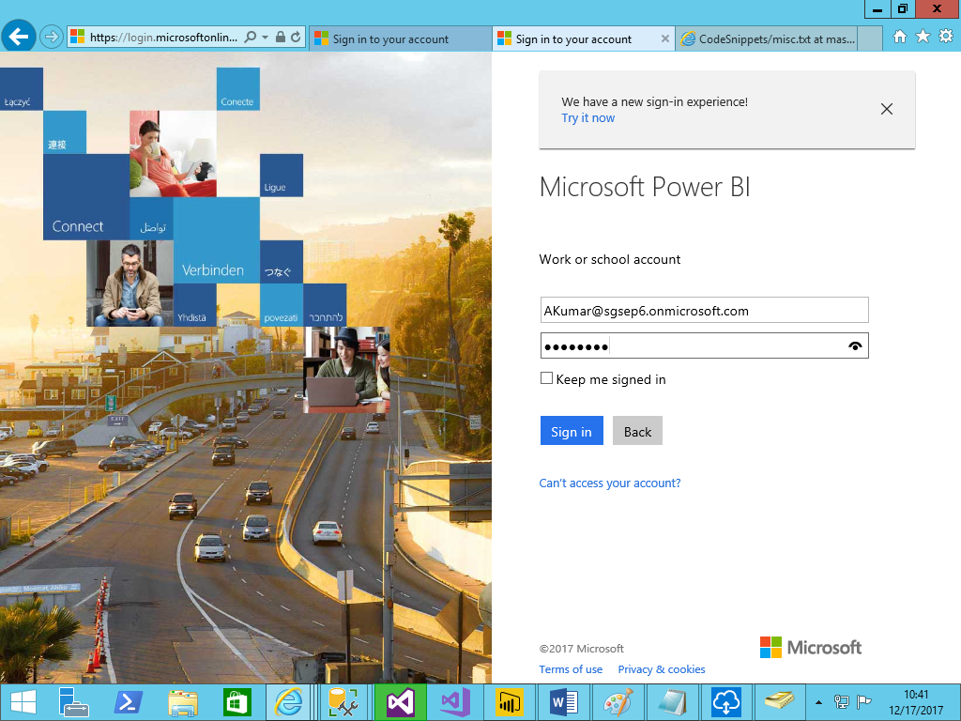

Make sure to check the logged in user.

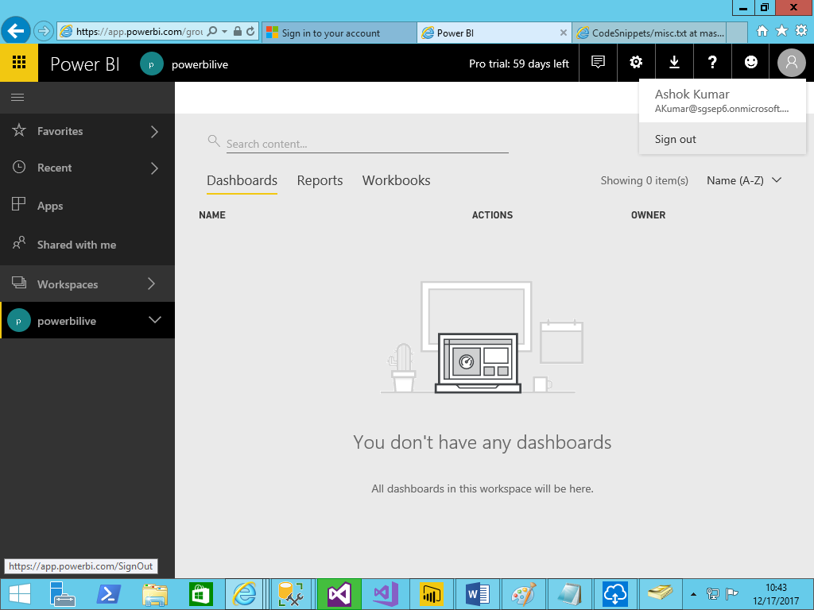

Open the report.

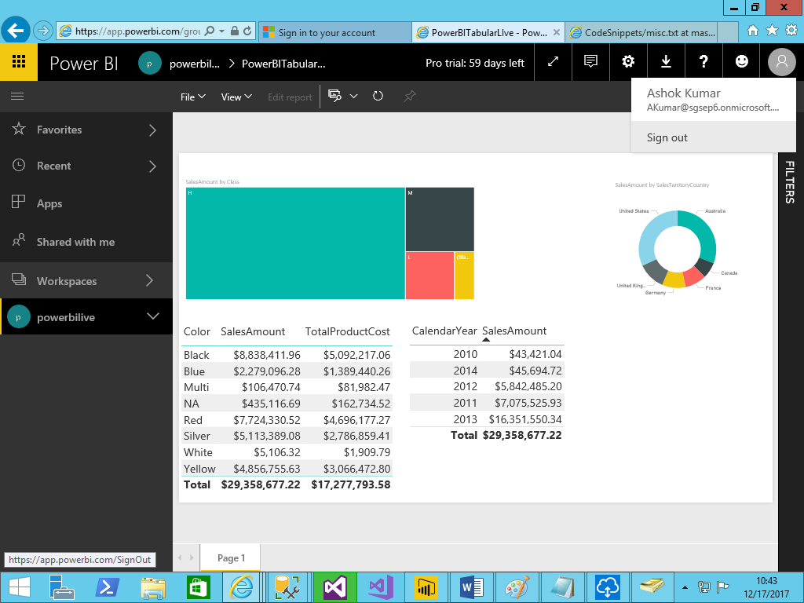

Users also able to see the report.