1)The size of 10 sec 720p video clip without uncompressed:

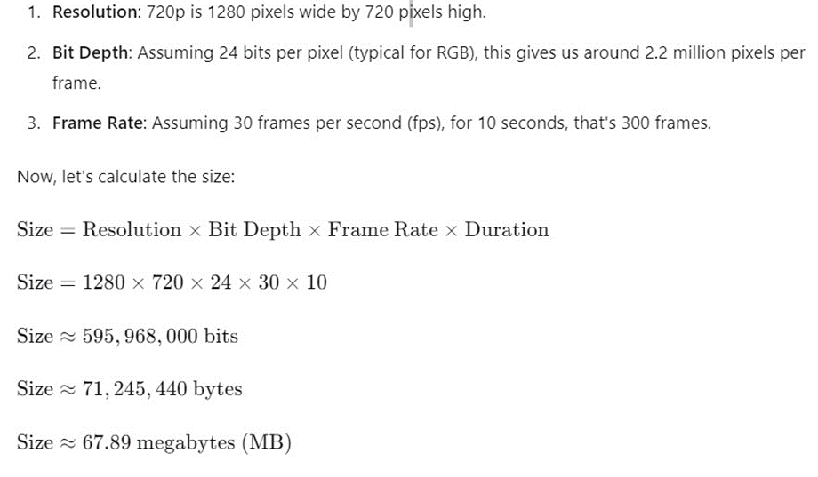

2)We also have 1 MB photo.

Both 1) and 2) together, the total size would be approximately ~ 70 MB.

Since we will have 6000 repairs per month:

|  |  |  |  |  |  |
| --- | --- | --- | --- | --- | --- |
| **Data storage prices pay-as-you-go** | **Premium** | **Hot** | **Cool** | **Cold** | **Archive** |
| **First 50 terabyte (TB) / month** | **$0.15** per GB | **$0.021** per GB | **$0.015** per GB | **$0.0036** per GB | **$0.00099** per GB |
| **Next 450 TB / month** | **$0.15** per GB | **$0.02** per GB | **$0.015** per GB | **$0.0036** per GB | **$0.00099** per GB |
| **Over 500 TB / month** | **$0.15** per GB | **$0.0191** per GB | **$0.015** per GB | **$0.0036** per GB | **$0.00099** per GB |