Azure Portal go to Azure Migrate

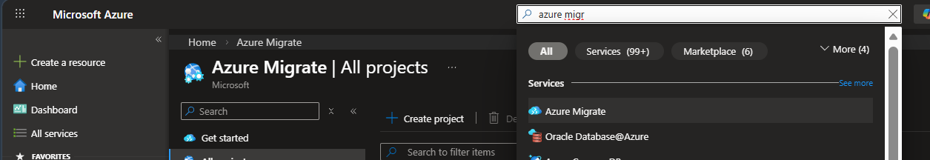
Goto All project
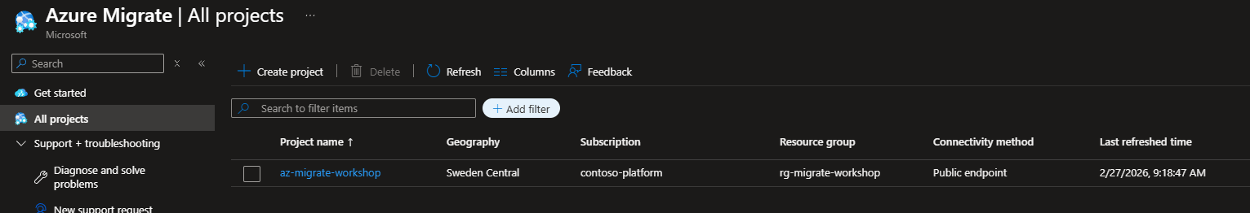
Open az-migrate-workshop and choose Start Discovery -> Using Appliance -> For Azure
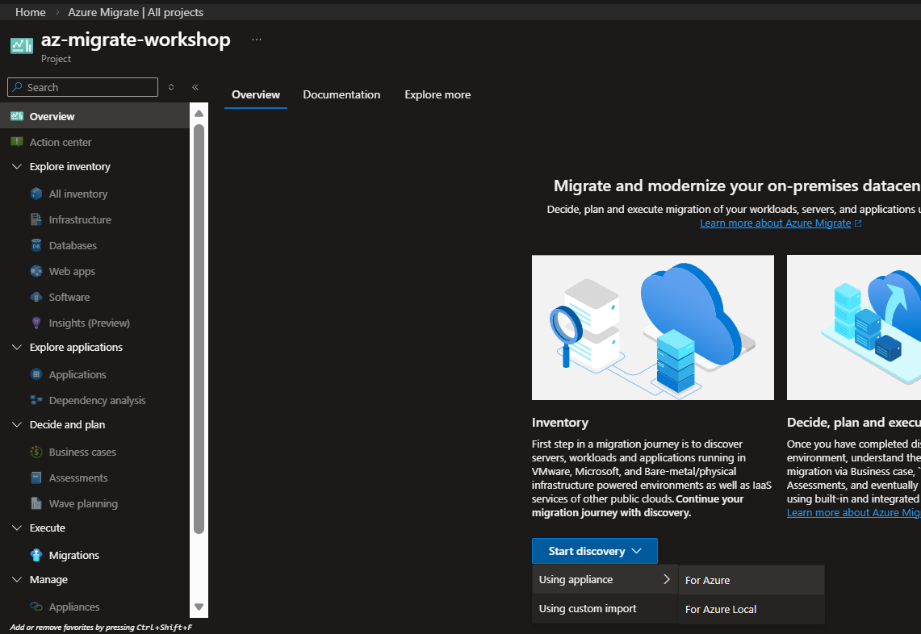

Are you servers virtualized: Yes, with Hyper=V
Name your appliance and generate key
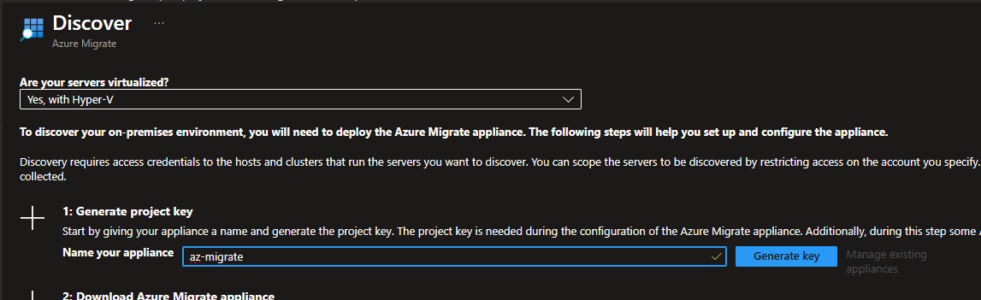

Copy the key and go to your Azure Migrate Appliance (RDP Session with tunnel)
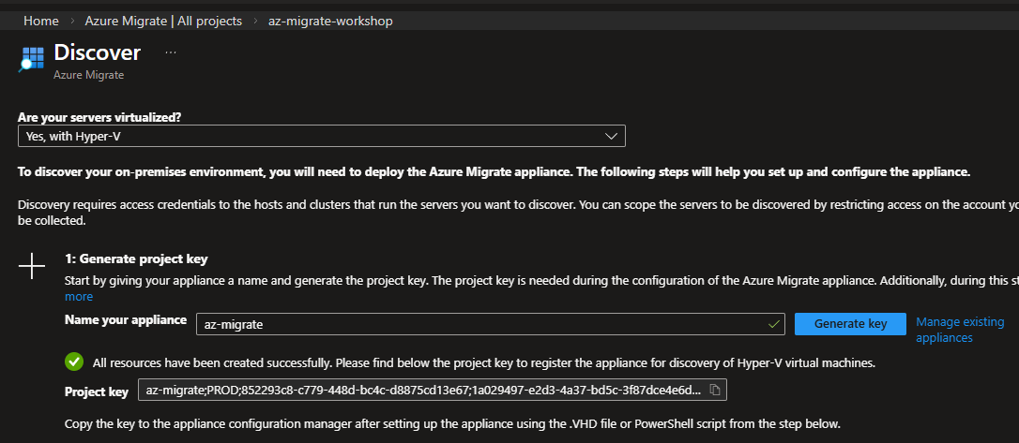

In the appliance
Paste the project key and hit verify
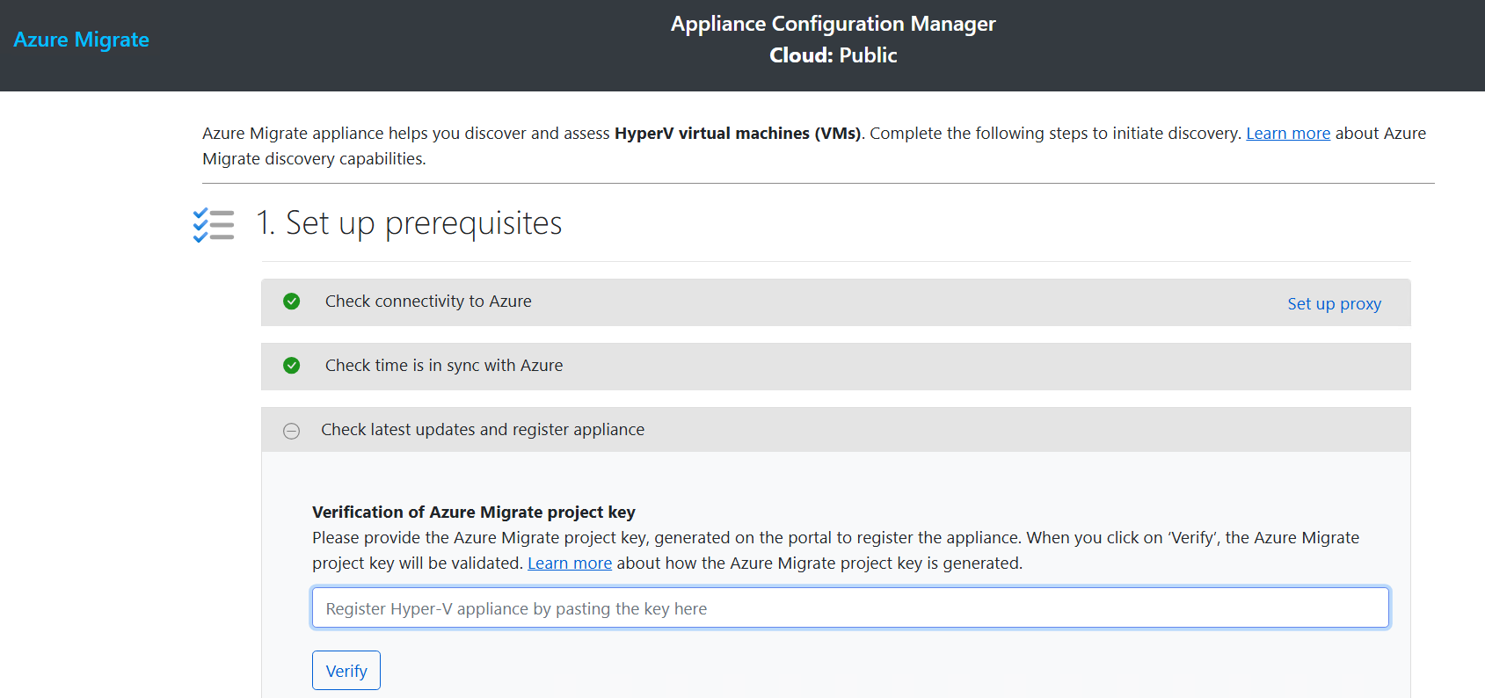
Key is verified: Auto-Update will run
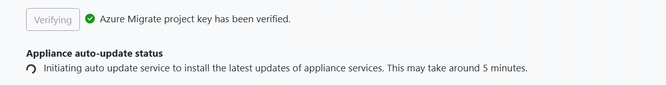

Refresh the browser when update completed
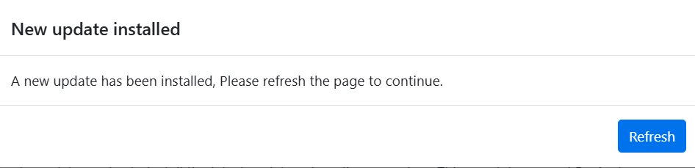

Hit Verify your Azure Migrate project key again
Auto update will check for updates again (will not find but can take a couple of minutes)
Nest Step: Login to your Azure Account (Copy Device Code)
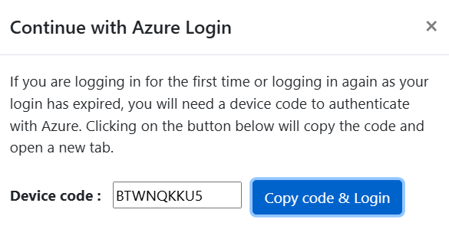
After successfully logging in, wait for appliance to register

Part 2: Manage Credentials and discovery sources

Credentials for the Hyper-V host
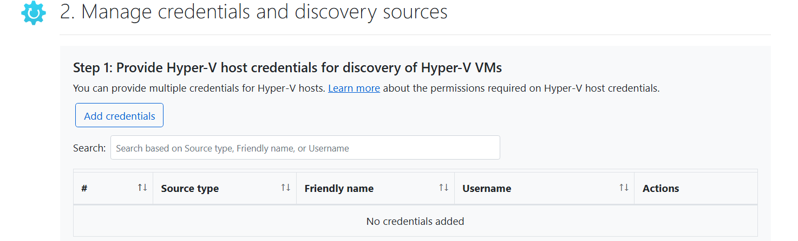


Add discovery source
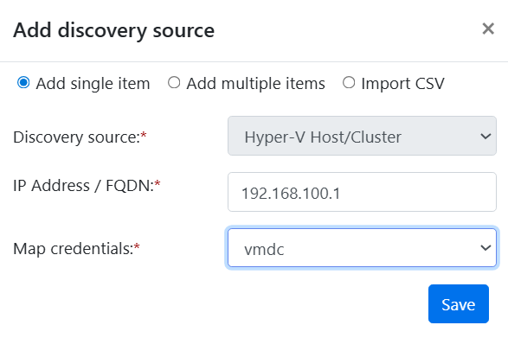

Migrate – Azure Portal
Hit “Migrations” and “Replication Summary (first tile)

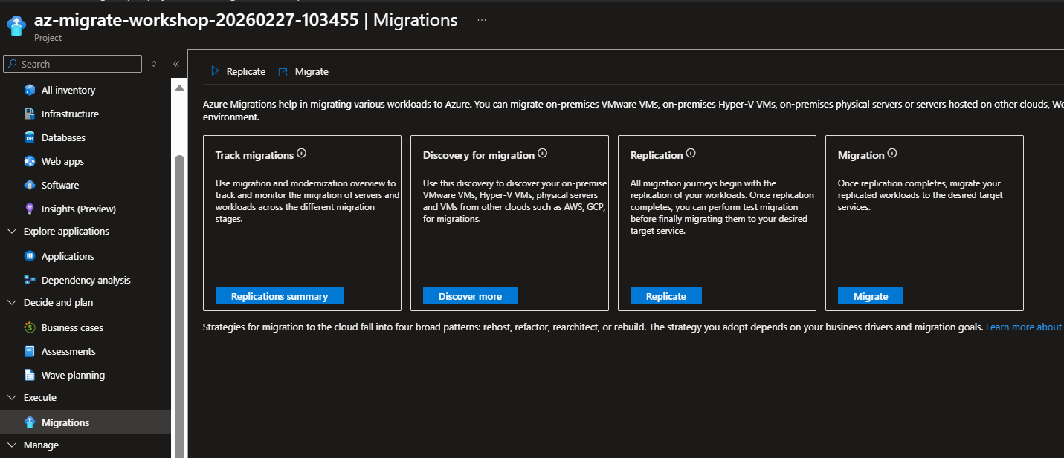
Hit “Discovered Servers” -> Disvoer
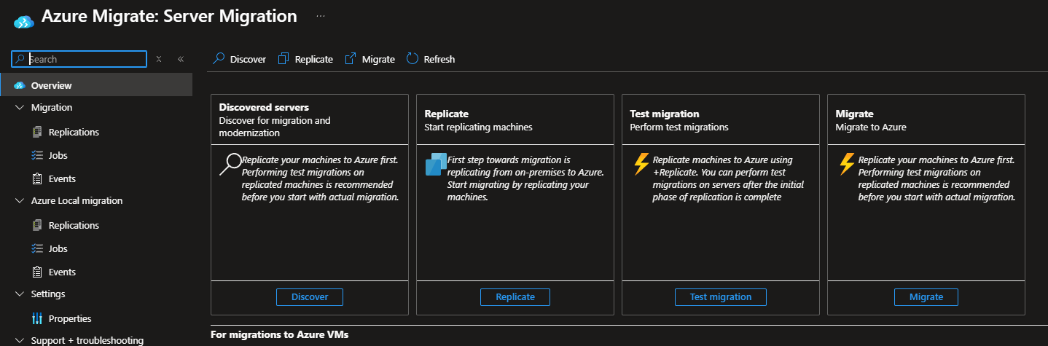

Migrate to Azure VM – Create Resources
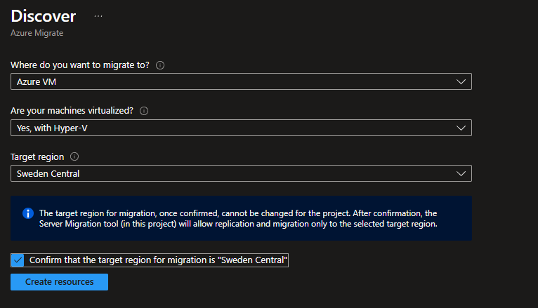

Install The AzureSiteRecovery tooling on the VM-DC (Via Bastion)
Download Keyfile and Finalize registration in the portal

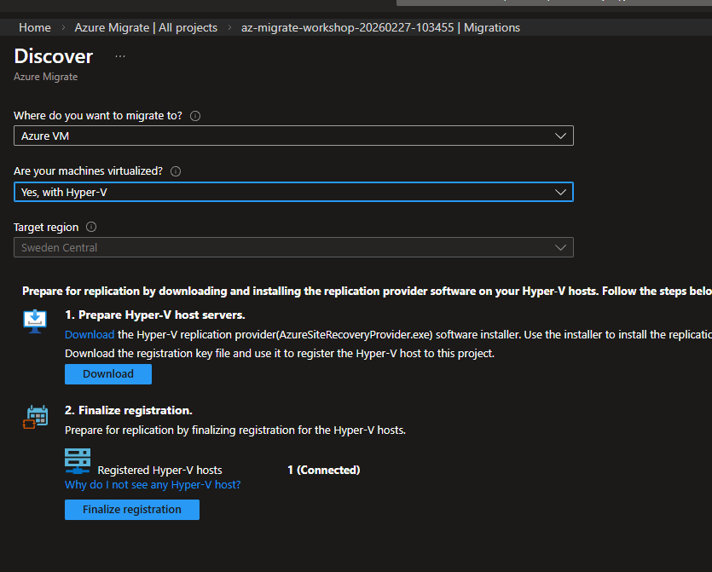

Update Azure Connected Machine Agent
https://aka.ms/AzureConnectedMachineAgent

