Raspberry Pi Compute Module Flash Instructions

- Download and run the [Windows installer](https://github.com/raspberrypi/usbboot/raw/master/win32/rpiboot_setup.exe) to install the drivers and boot tool.

- Plug your host PC USB into the CMIO USB SLAVE port, making sure J4 is set to the EN position.

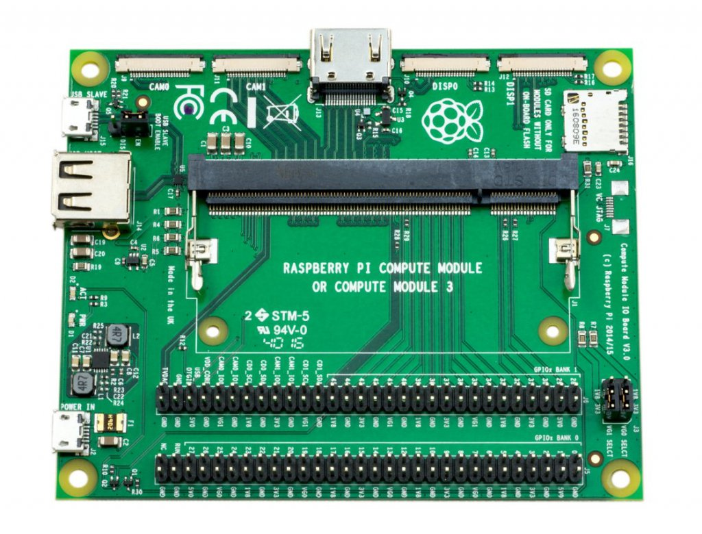

The image above shows a Compute Module IO Board v3.0 – the IO boards seem to be cross compatible with newer/older versions of the Compute Module’s (I am using a v1.2 board with both 1.1 and 3+ Modules).

- Apply power to the CMIO board, Windows should now find the hardware and install the driver.

- Once the driver installation is complete, run the RPiBoot.exe tool that was previously installed.

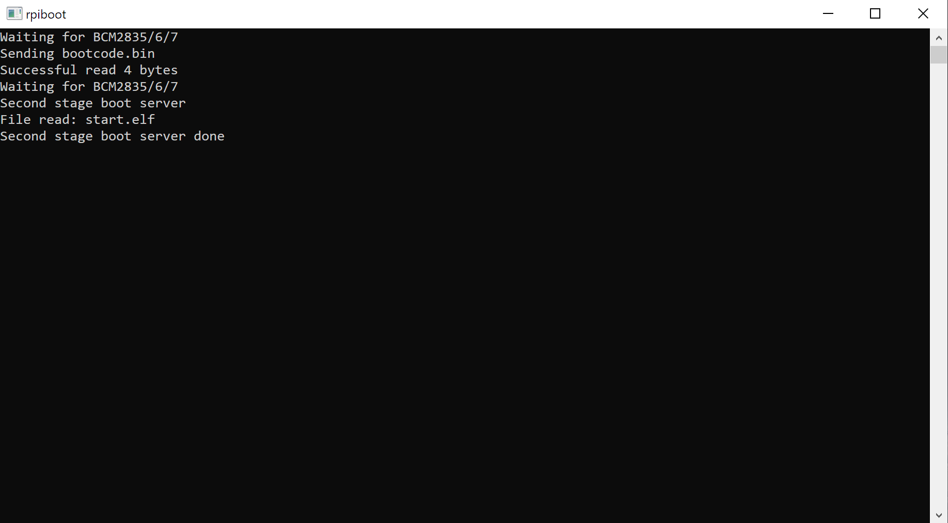

- After a few seconds, the Compute Module eMMC will pop up under Windows as a disk (USB mass storage device).

Flash the Linux image File

Flash the device using [Balena Etcher](https://www.balena.io/etcher/) – download the install or portable version. Run the Balena Etcher program.

Select the installation image by clicking on the 'Select image' button;

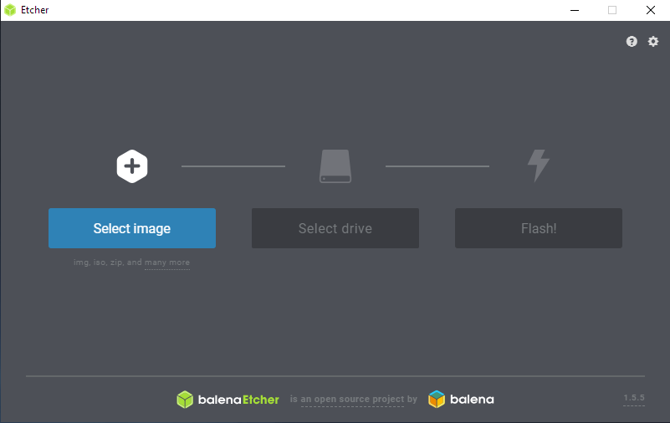

Select the image file – in this case use Raspbian Stretch image file;

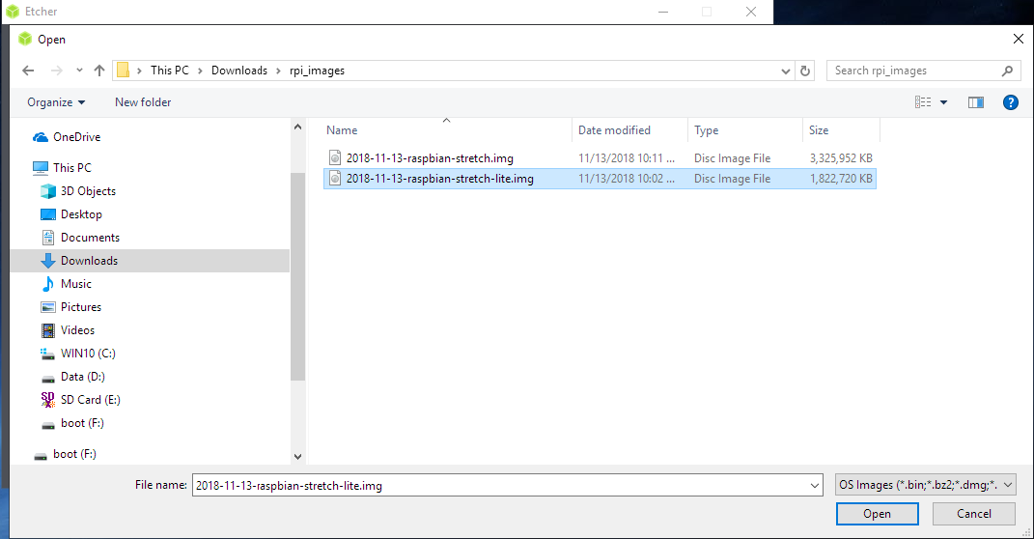

Select the drive to write to by clicking on the 'Select Drive' button;

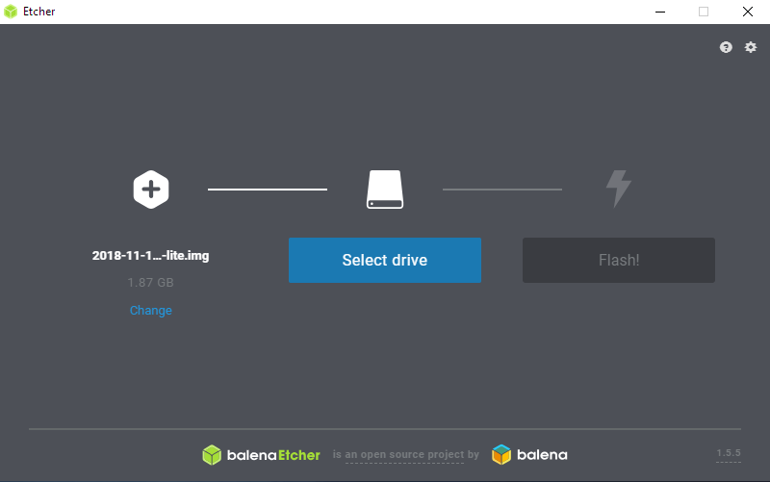

Select the Compute Module in the list of drives;

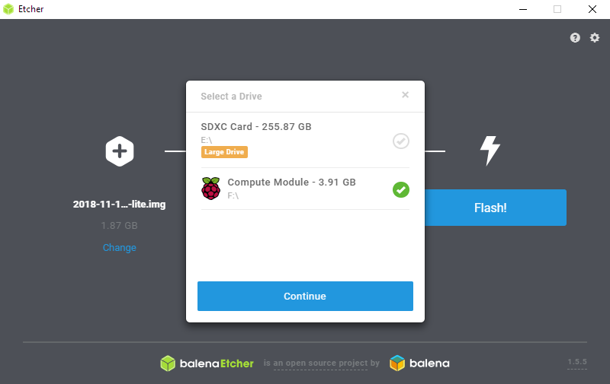

Start the flash process by clicking on the 'Flash' button;

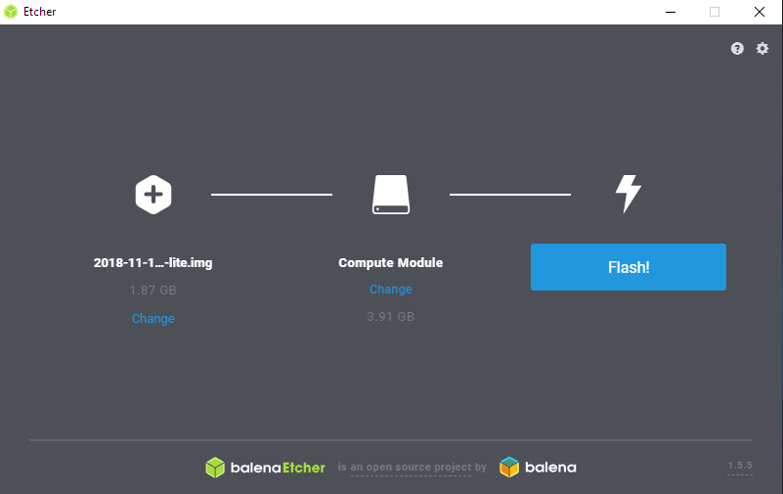

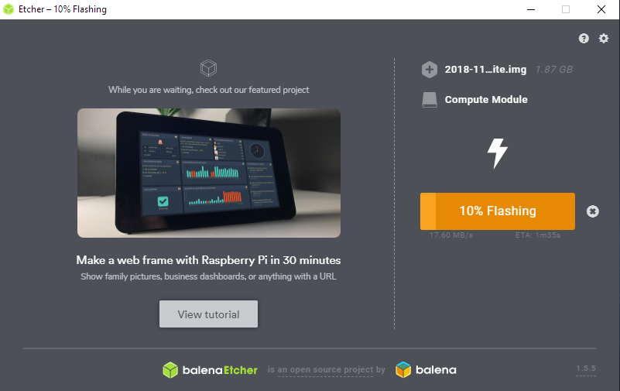

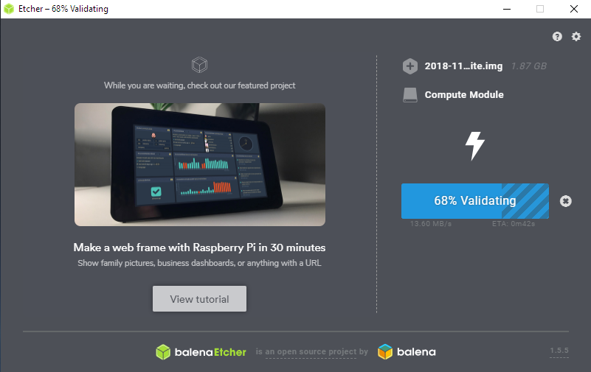

After validation completes close Etcher and follow the Install Procedure.