Raspberry Pi Compute Module Flash Instructions

- Download and run the [Windows installer](https://github.com/raspberrypi/usbboot/raw/master/win32/rpiboot_setup.exe) to install the drivers and boot tool.

- Insert your Compute Module into the SODIMM connector of the Compute Module IO Board (CMIO).

- Plug your host PC USB into the CMIO USB SLAVE port, making sure J4 is set to the ‘USB Slave’ position.

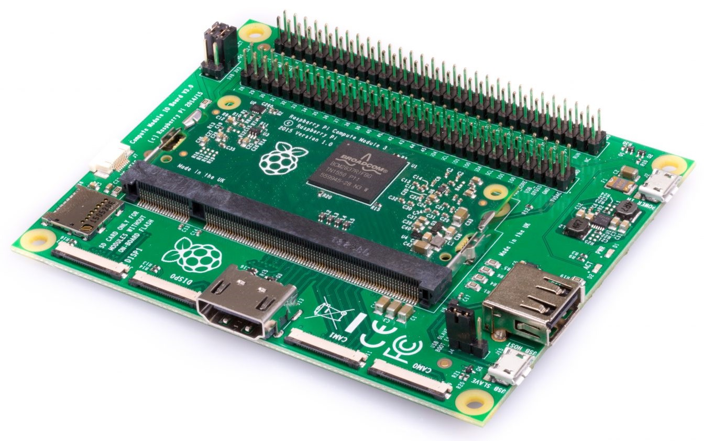

The image shows a Compute Module IO Board v3.0 – the IO boards seem to be cross compatible with newer/older versions of the Compute Module’s (I am using a v1.2 board with both 1.1 and 3+ Modules).

- Apply power to the CMIO board, Windows should now find the hardware and install the driver.

- Once the driver installation is complete, run the RPiBoot.exe tool that was previously installed.

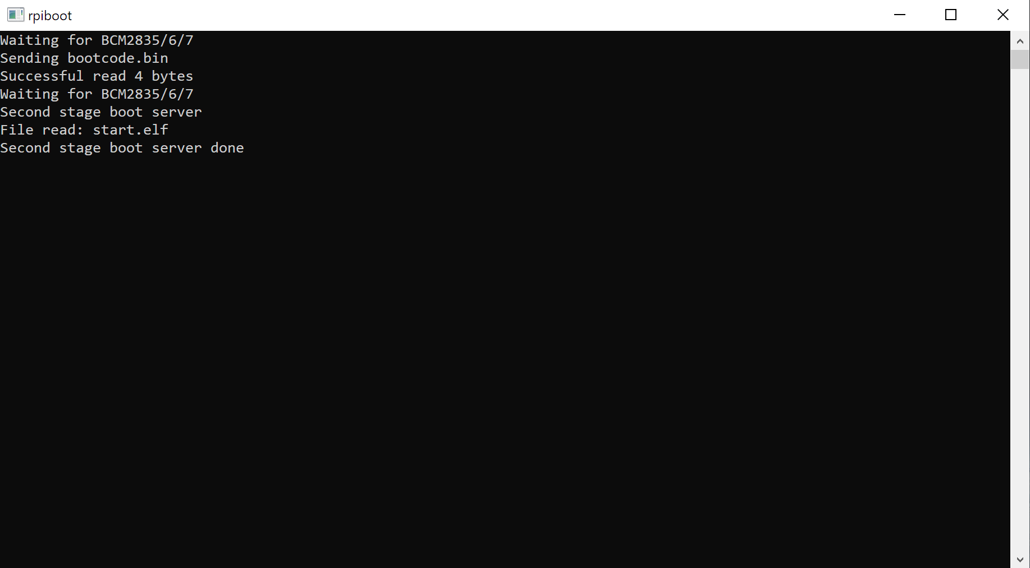

- After a few seconds, the Compute Module eMMC will pop up under Windows as a disk (USB mass storage device).

Flash the Linux image File

Flash the device using [Balena Etcher](https://www.balena.io/etcher/) – download the install or portable version. Run the Balena Etcher program.

Select the installation image by clicking on the 'Select image' button;

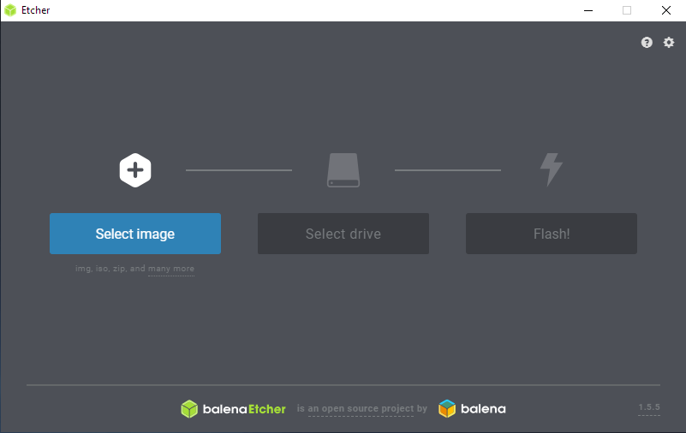

Select the image file – in this case use the most recent Raspbian Stretch lite image file;

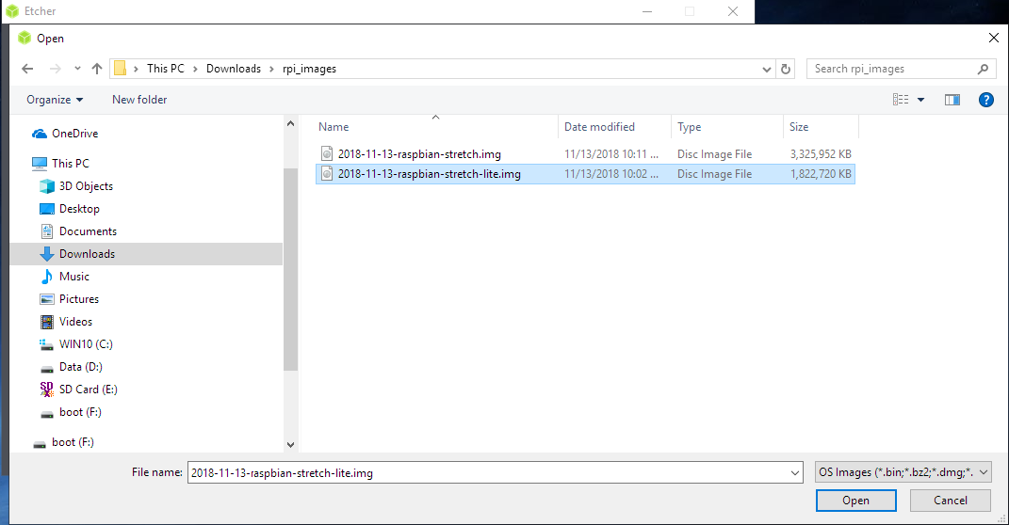

Select the drive to write to by clicking on the 'Select Drive' button;

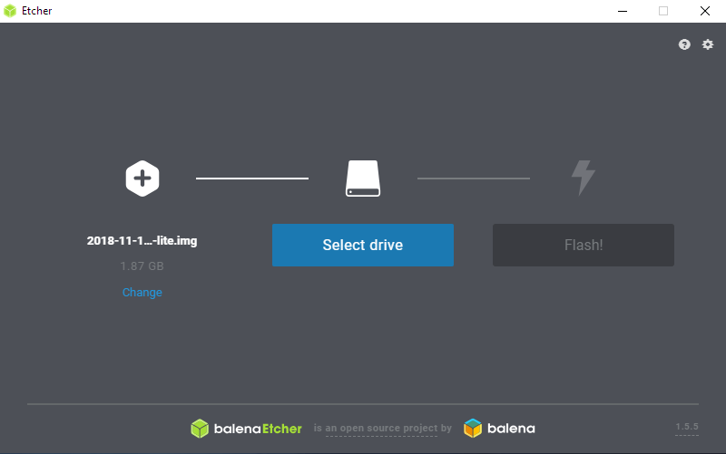

Select the Compute Module in the list of drives;

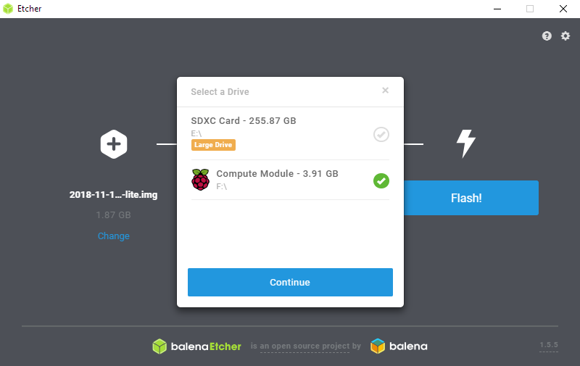

Start the flash process by clicking on the 'Flash' button;

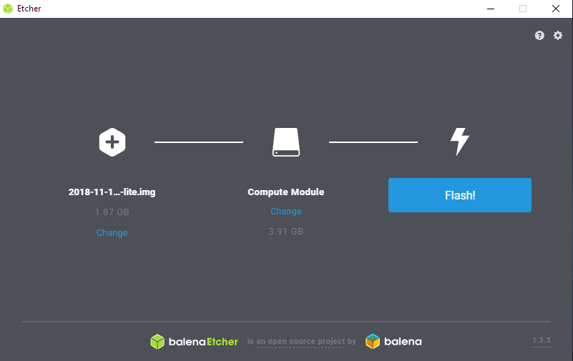

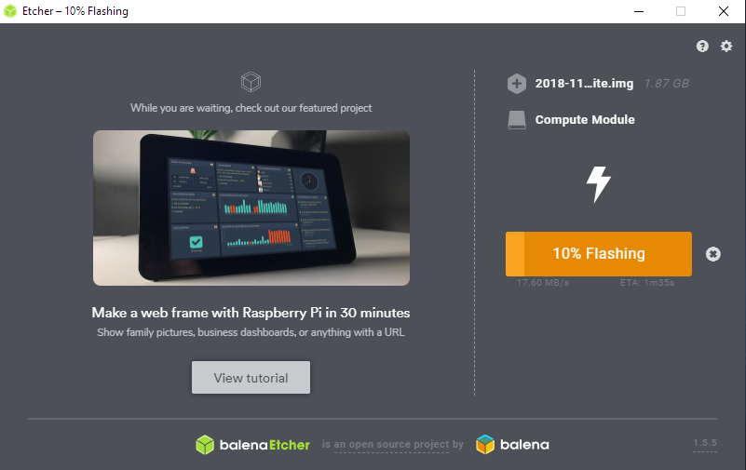

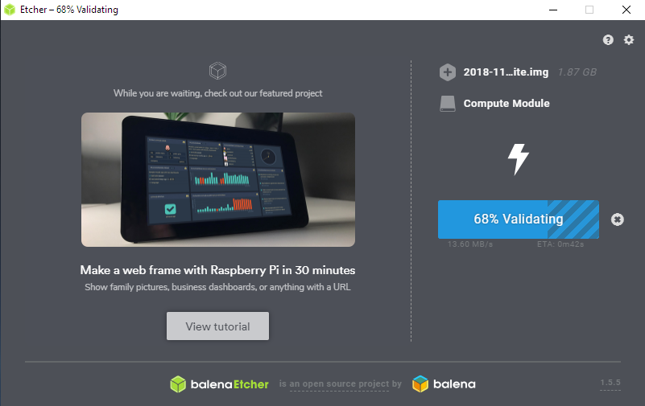

After validation completes close Etcher and follow the Install Procedure.

Unplug the Compute Module from the computer and proceed to the Raspbian install Procedure in the next section.

Raspbian Install Procedure

This install procedure is a guide on how to install the minimum necessary to run a basic Raspberry Pi Lite install with everything needed to run Desktop and command line, without all the extra software that gets installed with a standard desktop install. This is mainly for use with Raspberry Pi (RPi) Compute Modules, but will also work on a standard Raspberry Pi.

If you want to work with the Compute Module connected to the Compute Module IO Board (CMIO), or a Temco Controls T3 Router as a standalone system, a HDMI display must be connected to the HDMI output on either board. For the CMIO board use a USB Hub to connect either a Wi-fi dongle or USB > Lan adapter, and to connect a keyboard and mouse. The T3 Router provides 3 USB ports so a USB hub is usually not needed. After the system has booted and you are logged in (default user name for RPi is ‘pi’ and password is ‘raspberry’) access the RPi Software configuration tool by typing;

sudo raspi-config

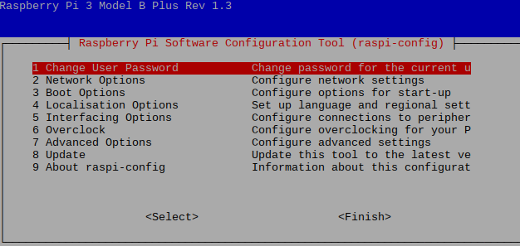

The Raspi-config GUI appears. Select ‘Network Options’ from the list, then Wi-Fi from the options list.

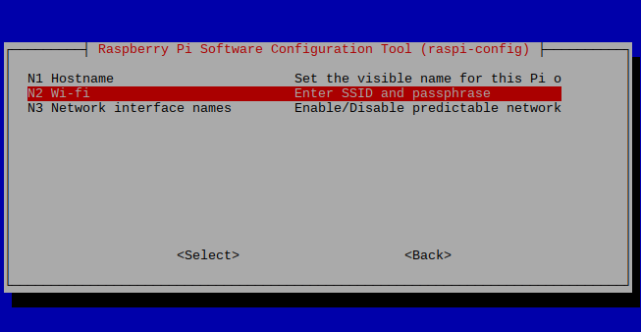

The first time this is run on a new installation it will ask for Country to set the available Wi-fi channels according to your Country.

Then it will prompt for Wi-fi SSID and Password.

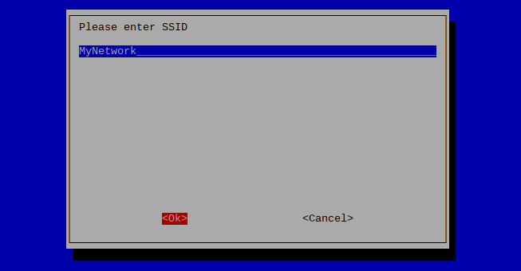

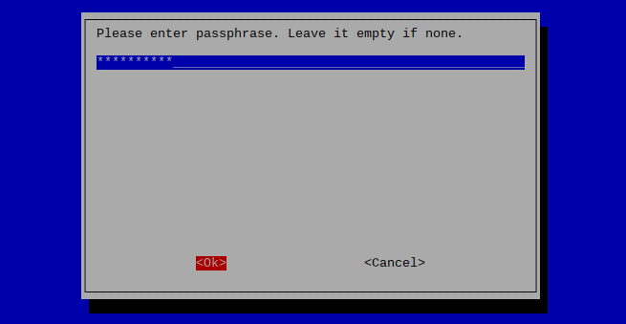

If you want to use the system ‘headless’ (without a display/keyboard/mouse) and SSH into the Compute Module then all you need is to connect a Wi-fi or USB>Lan adapter. If Wi-fi is used then it’s necessary to configure the Wi-fi first by editing a file on the rootfs partition of the Compute Module. You will need to connect the IO board in slave mode to a computer and edit the Wi-fi configuration file;

sudo nano /etc/wpa_supplicant/wpa_supplicant.conf

Using either a Linux or Windows System - add (or edit) the following;

network={

ssid="testing"

psk="testingPassword"

}

Replace “testing” with the SSID of your Wifi router, and “testingPassword” with your Wi-fi password. Save the file and disconnect the IO Board from the computer.

Set the J4 jumper into the USB Slave position. Ensure that your Compute Module IO board is connected to HDMI, Keyboard and Mouse, and to a network either using USB >Lan adapter or a compatible USB WiFi adapter. Boot the Compute IO board by connecting a micro USB cable to only the power input.

Enable SSH

sudo raspi-config

Select Interfacing Options.

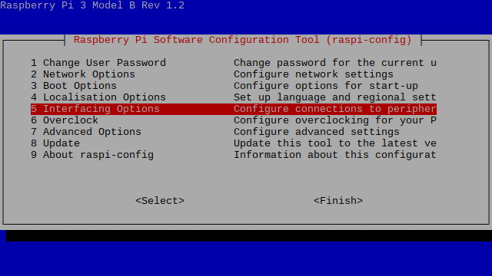

Enable SSH (and SPI for use with the T3 Router).

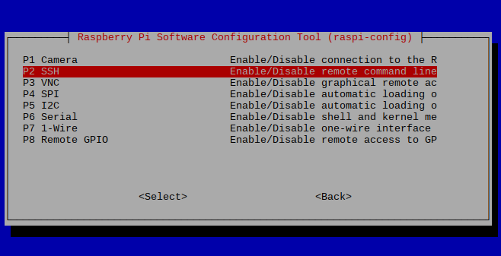

To enable SSH on a ‘headless’ system you need to create a file named ssh on the boot partition of the Compute Module using a Linux/Windows computer.

Setup Localization options for Locale, Time Zone, and Keyboard Layout using raspi-config

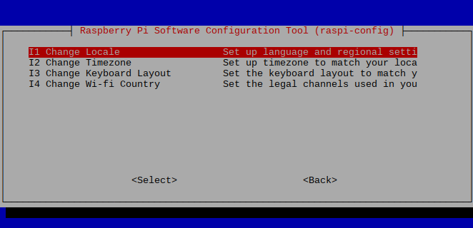

Once all of the settings have been configured exit the Raspberry Pi configuration Tool (use the Tab key to navigate to ‘Finish’). Then enter the following commands to update the system.

sudo apt update

sudo apt upgrade

sudo apt dist-upgrade

Then clean the installed packages to free up space, and reboot before installing the Desktop Environment.

sudo apt clean

sudo reboot

Now install the necessary packages for LXDE Desktop Environment.

sudo apt install --no-install-recommends xserver-xorg

sudo apt install --no-install-recommends xinit

sudo apt install lxde-core lxappearance

sudo apt install lightdm

sudo reboot

The System will boot into the Desktop Environment.

After logging in again in order to disable the Desktop Environment from starting on boot;

sudo raspi-config

Select Boot Options

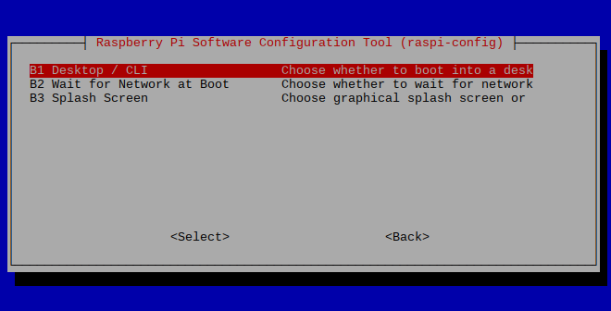

You can configure whether the system will boot to Desktop or command line mode.

To install Chromium Browser

sudo apt-get install -y rpi-chromium-mods

sudo apt-get install -y python-sense-emu python3-sense-emu

Install Mono to compile and run the T3000 GUI

Import [Mono](https://en.wikipedia.org/wiki/Mono_(software)) repository following official distro instructions from [Mono Project](https://www.mono-project.com/download/stable/#download-lin) website.

sudo apt install apt-transport-https dirmngr gnupg ca-certificates

sudo apt-key adv --keyserver hkp://keyserver.ubuntu.com:80 --recv-keys 3FA7E0328081BFF6A14DA29AA6A19B38D3D831EF

echo "deb https://download.mono-project.com/repo/debian stable-raspbianstretch main" | sudo tee /etc/apt/sources.list.d/mono-official-stable.list

sudo apt update

sudo apt install mono-devel

Then install the mono-complete, git and curl packages using the following command.

sudo apt install mono-complete git curl

Install nuget

sudo apt install nuget

Check nuget

sudo nuget update -self

Execute the following commands to clone the repo

rm -r -f T3000_CrossPlatform

git clone https://github.com/temcocontrols/T3000_CrossPlatform

nuget restore T3000_CrossPlatform/T3000_CrossPlatform.sln

And to build from command line

msbuild T3000_CrossPlatform/T3000_CrossPlatform.sln /p:Configuration=Release

chmod +x T3000_CrossPlatform/T3000/bin/Release/T3000.exe

Run the application

mono ./T3000_CrossPlatform/T3000/bin/Release/T3000.exe