Advanced Software Engineering (ASE) Assignment 2018

Assignment 2

|  |  |  |  |  |  |  |
| --- | --- | --- | --- | --- | --- | --- |
| **Module name and CRN** | | | Advanced Software Engineering10542 | | | |
| **Module Leader** | | | Duncan Mullier | | | |
| **Semester** | A | **Level** | | 6 | **Approx No of Students** |  |

**COMPONENT TITLE: Bug Tracking Software**

**COMPONENT WEIGHTING: 40% of Module Marks**

**HAND-OUT DATE: 24th September 2018 (Week 1)**

**SUGGESTED STUDENT EFFORT: 20 hours**

**DETAILS OF THE ASSESSMENT**

A Software Engineering Bug Tracking Application.

**Student Information**

Avinash Mishra

C7181324

BSc. (Hons) Computing Level 6

Version Control System

**Home Page**

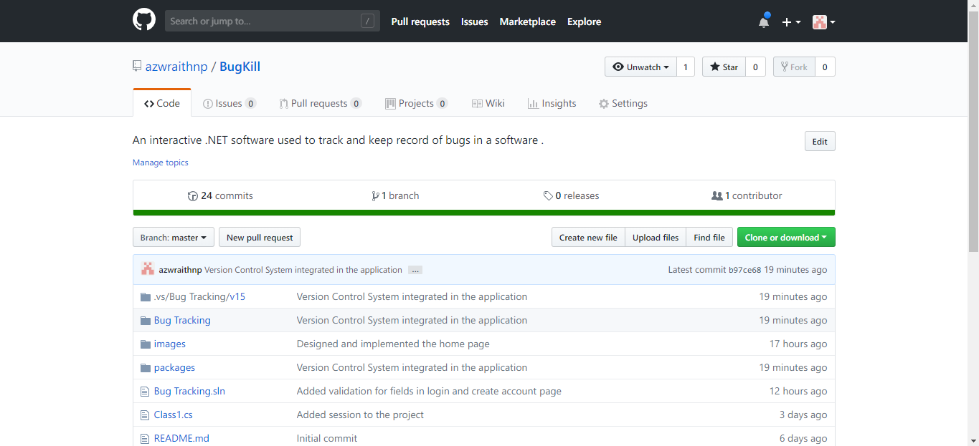

**Commits**

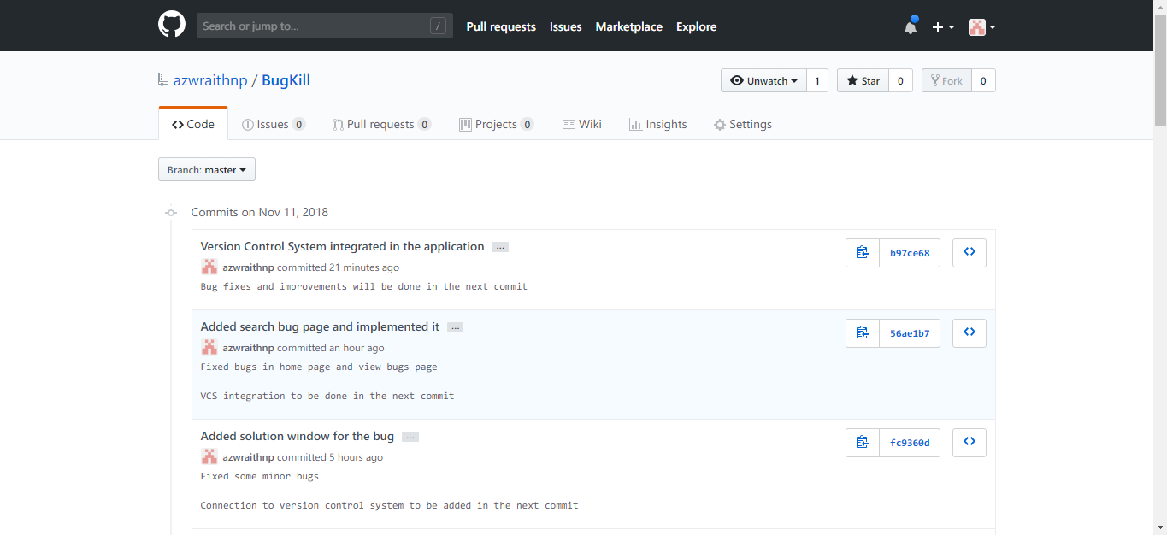

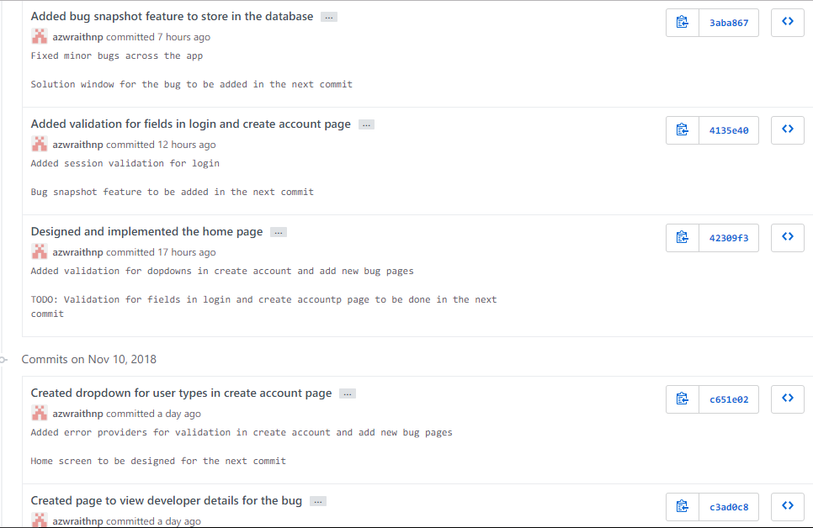

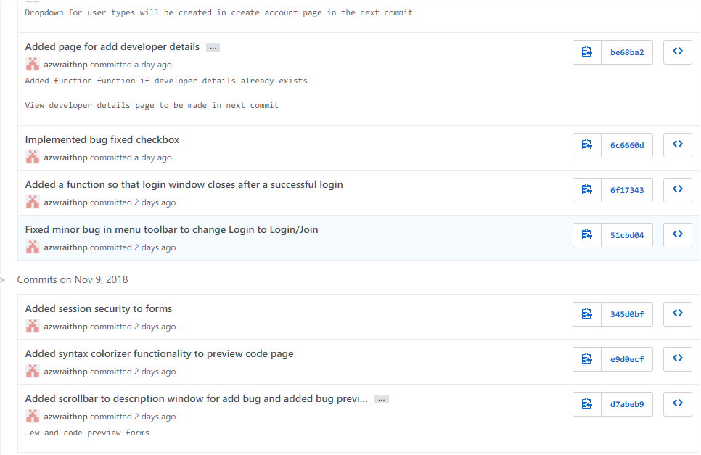

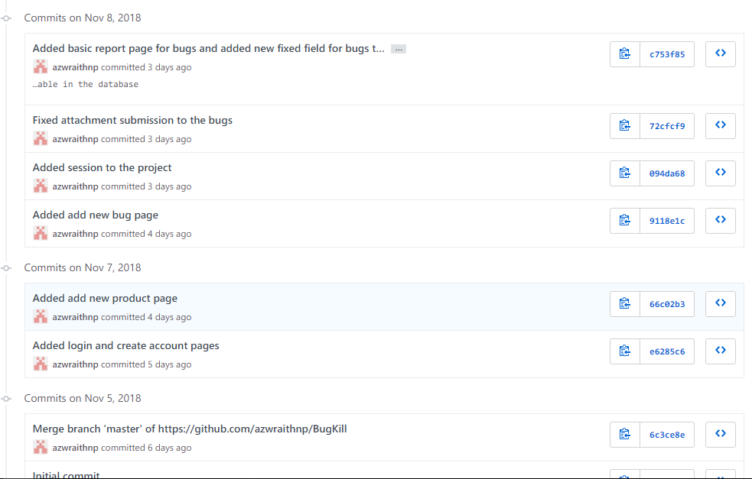 

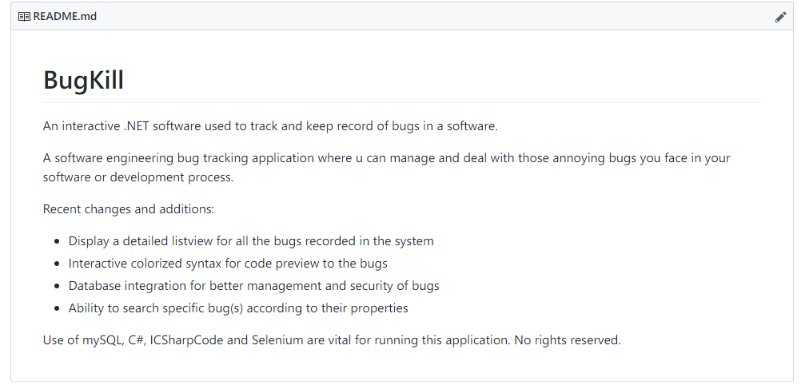

**Application Output**

Home page:

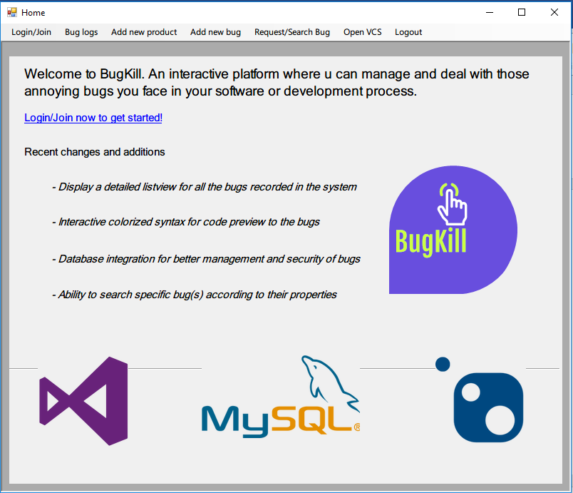

Home screen is the beginning page of the app from where the user can navigate to different parts of the application. It also displays general information on what is the software about, its recent changes and a hyperlink to login or create an account.

Login:

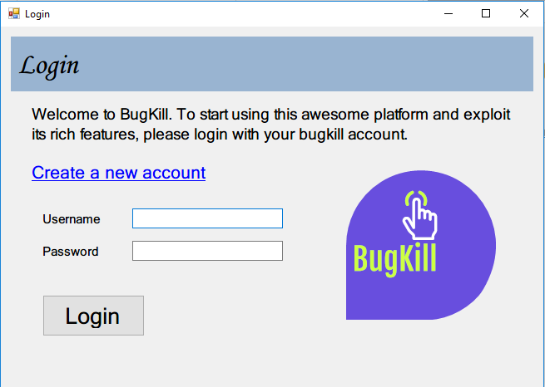

Login page helps the user enter the system to use its different features. Login session validation is applied in every crucial and sensitive part of the application to increase its security; therefore, any normal user needs to login or create an account then login to properly start using the application to its maximum potential.

Create account:

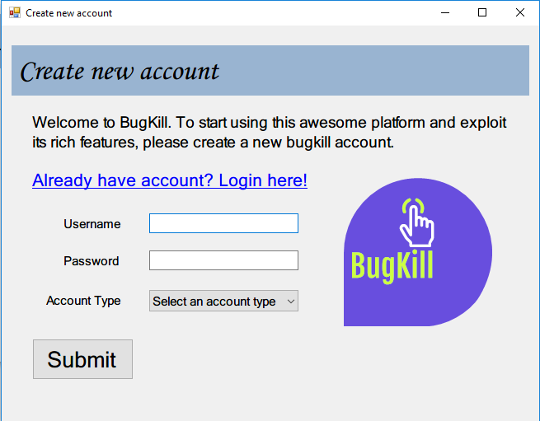

If the user is not logged in, s/he has an option to create an account for Bugkill. This way the user can ensure that they are enrolled in the system and use its feature like any other ordinary consumer. Account type should be included which helps with the bug management process in the future.

View bugs:

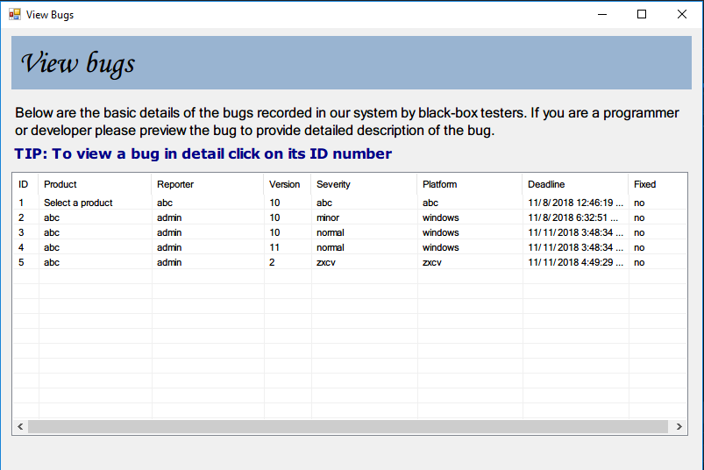

This is a crucial screen where the user logged in can view all the bugs recorded in a system. It has all the basic information about the bug that the user would like to see in a glance. For detailed information, the user can click on any bug’s id number to the left which shows another form for additional data.

Preview bug:

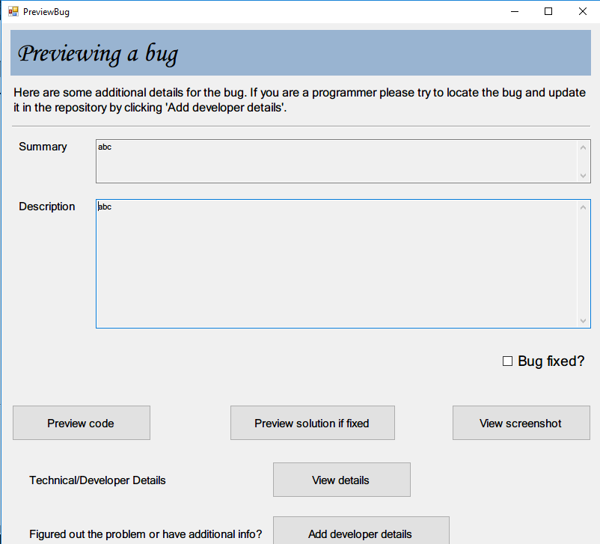

This form is shown from the view bugs window when the user decides to view more information about a particular bug. In this window, the consumer level details are shown for the bug like summary and description. The user can check to update if the bug is fixed, preview the code, preview the solution if the bug is fixed, view screenshot provided with the bug as well as view technical details and if the user logged in is a programmer, he can add developer details.

View screenshot:

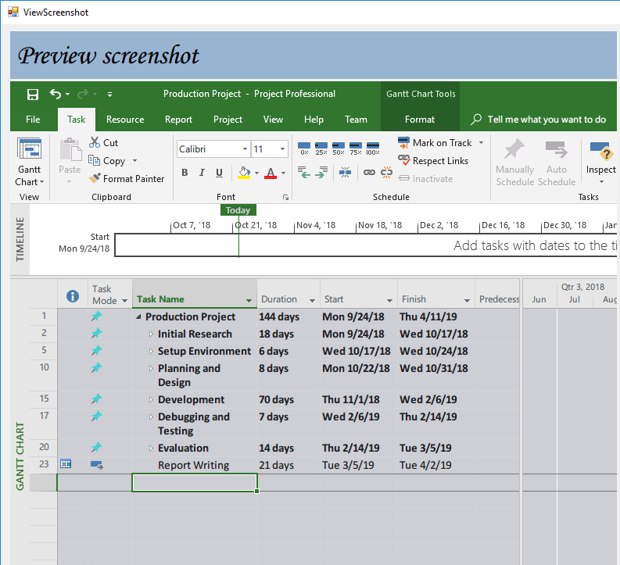

This window helps users or programmers view the screenshot provided along with the bug description. This helps narrow down the problem and provide solution faster than going through the code line by line. This window is mostly used by consumers, testers and front-end developers.

View code:

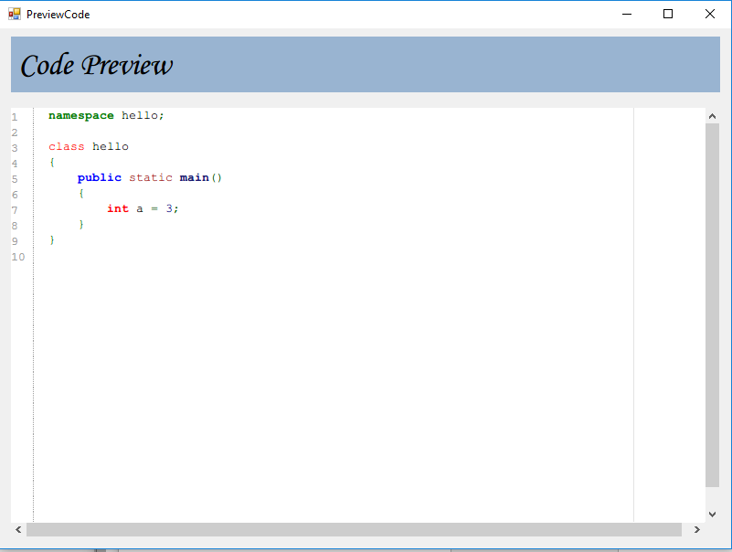

This window helps users or programmers preview the source code that was entered during the bug submission. This window is syntax-colorized which helps looking and examining the code much easier. This also often helps finding the solution much faster if the error resides in the syntax level of the code. This is mostly used by system testers and programmers concerned with the back-end of the software.

View developer details:

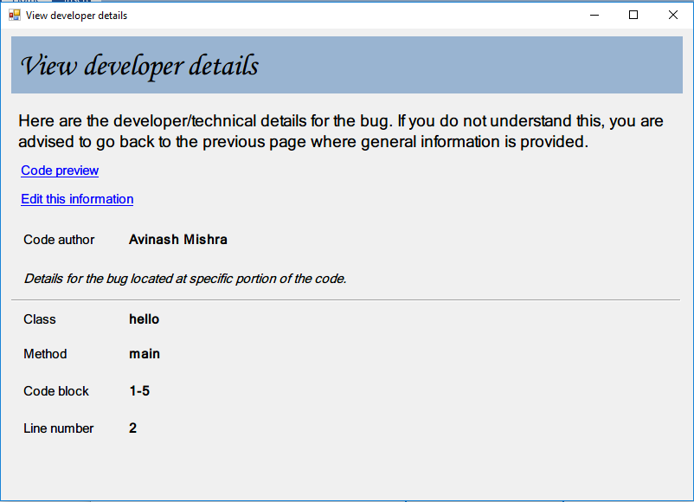

Just like the preview bug window, this form also allows user to display information about the bug but in this case, the information is much more technical and related to a programmer or developer examining the bug. It contains the data like the code author and in the code context, details such as class, method, code-block and line number are shown where the bug might have been located.

Add developer details:

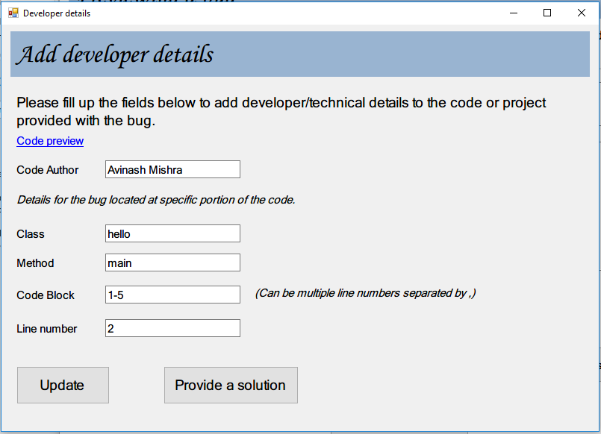

This window is where the technical details are added by an active user or programmer. Details related to the bug and the error lines are kept here. It can be also updated if information is already provided before as shown in the above screenshot of example. Solution for the bug can also be provided right from here by the user or programmer examining the bug.

Add product:

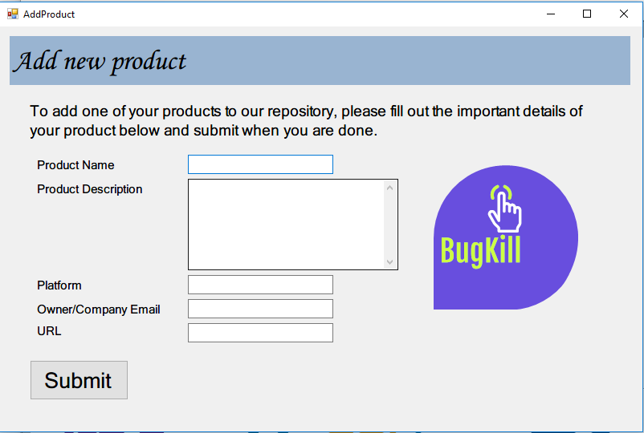

Since this application supports recording bugs of multiple products and software, a user can register more than one product to the bugfix repository. Information such as product name, description, platform, company email and URL are provided and when done, they are saved to the database.

Add new bug:

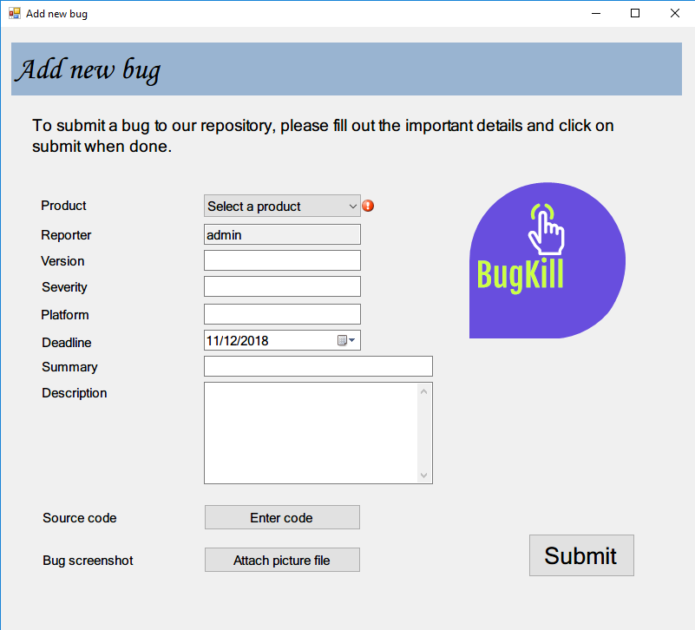

This is one of the most important forms in this application. This is where the user submits a bug to the system. Details such as product name, bug reporter name, version, severity of the bug, platform of the software, deadline, summary and description are provided. Source code and bug screenshot can also be provided if the user has it available with them.

View solution:

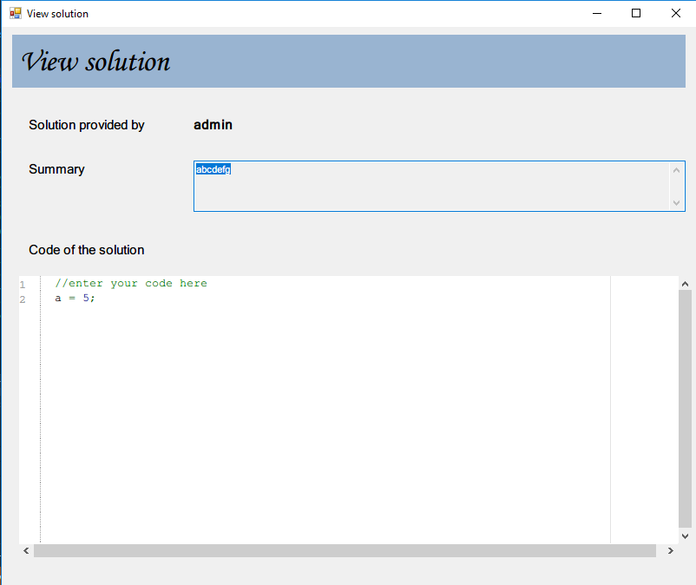

If a solution is provided by one of the users, testers or programmers, it can be shown here. It contains information like the name of the user who provided the solution, the summary of the solution for the bug and the solution code, which again is colorized for better reading and entry.

Provide solution:

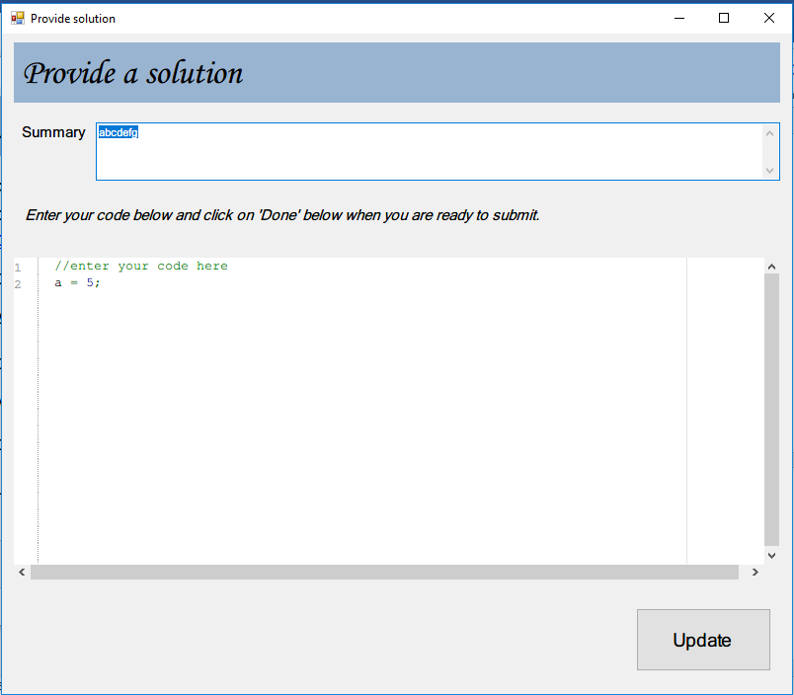

In this window, solution for the bug can be provided by the user or programmer currently active on the system. The code editor is colorized so that the programmer feels right at home and it makes the process easier. In the above example, solution was already recorded for this particular bug. In this case, the solution for the bug can be updated.

Search for a bug:

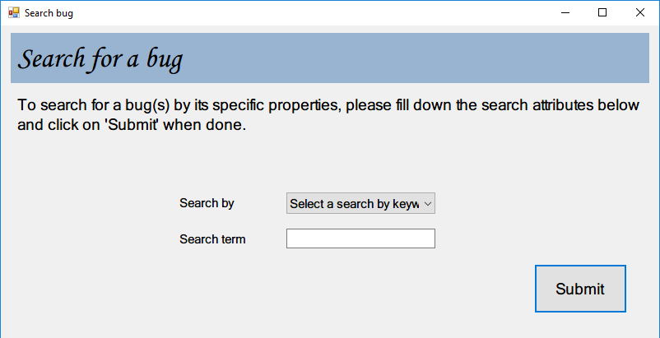

One of the features of the application where the user can search for a bug providing its specific attribute such as bugid, version, etc. It comes really in handy when there is a large collection of bugs in the database system and the user needs to locate a specific bug in the fastest way possible.

Browse VCS:

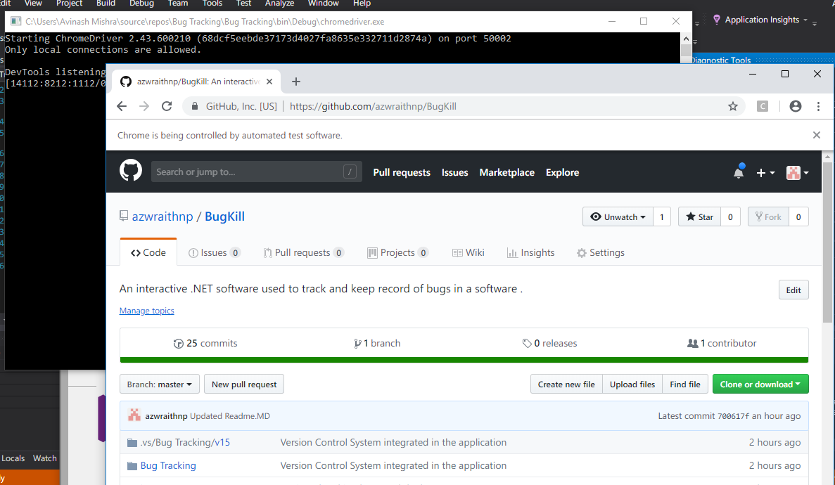

VCS can be browsed from within the application itself. On clicking the menu bar item open VCS, it opens up a browser, signs in itself using authentication methods from Selenium making it twice as easier for the user or programmer.