School of Computing, Creative Technologies and Engineering

Assessment Brief

**COURSEWORK**

|  |  |  |  |  |  |  |
| --- | --- | --- | --- | --- | --- | --- |
| **Module name and CRN** | | | Advanced Software Engineering A 16108 | | | |
| **Module Leader** | | | Dr Duncan Mullier | | | |
| **Semester** | A | **Level** | | 6 | **Approx No of Students** | 40 |

6

**COMPONENT TITLE: Graphical Programming Language Application**

**COMPONENT WEIGHTING: 60% of Module Marks**

**HAND-OUT DATE: 24th September 2018 (Week 1)**

**SUGGESTED STUDENT EFFORT: 30 hours**

**SUBMISSION DATE: 7/1/2018 9 am (Monday week 13)**

**DETAILS OF THE ASSESSMENT**

A Software Engineering Graphic Programming Language Application.

**Student Information**

Avinash Mishra

C7181324

BSc. (Hons) Computing Level 6

**Version Control System**

<https://github.com/azwraithnp/Draw.GUI>

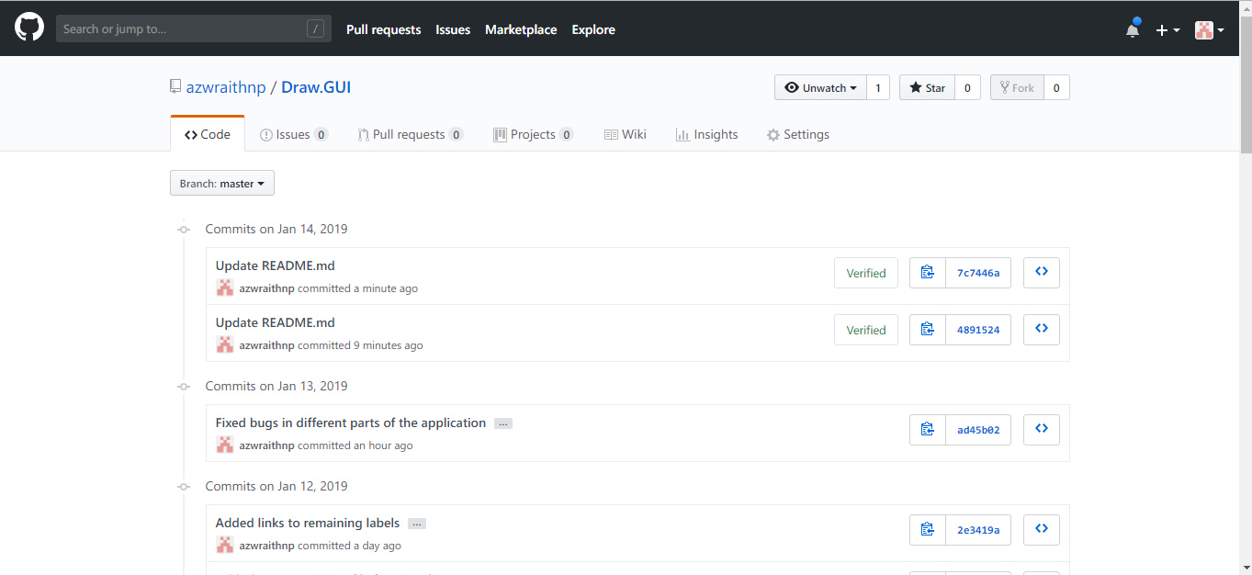

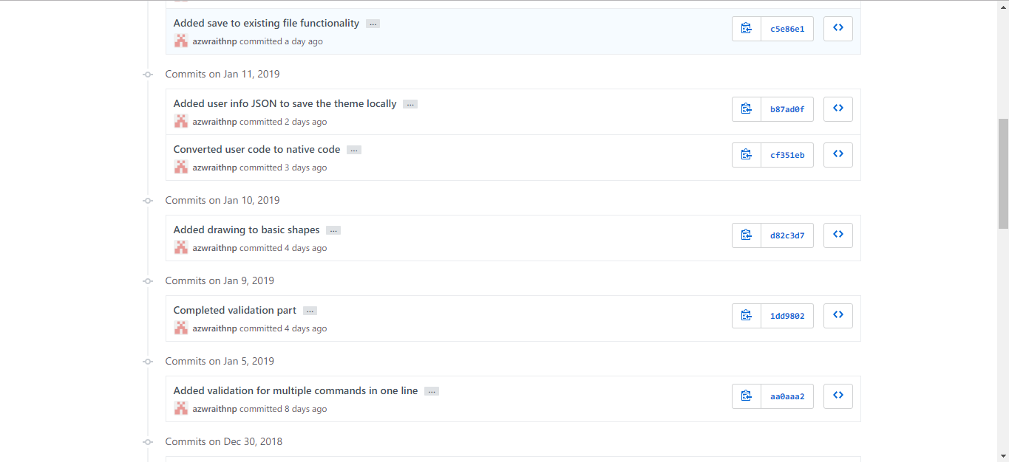

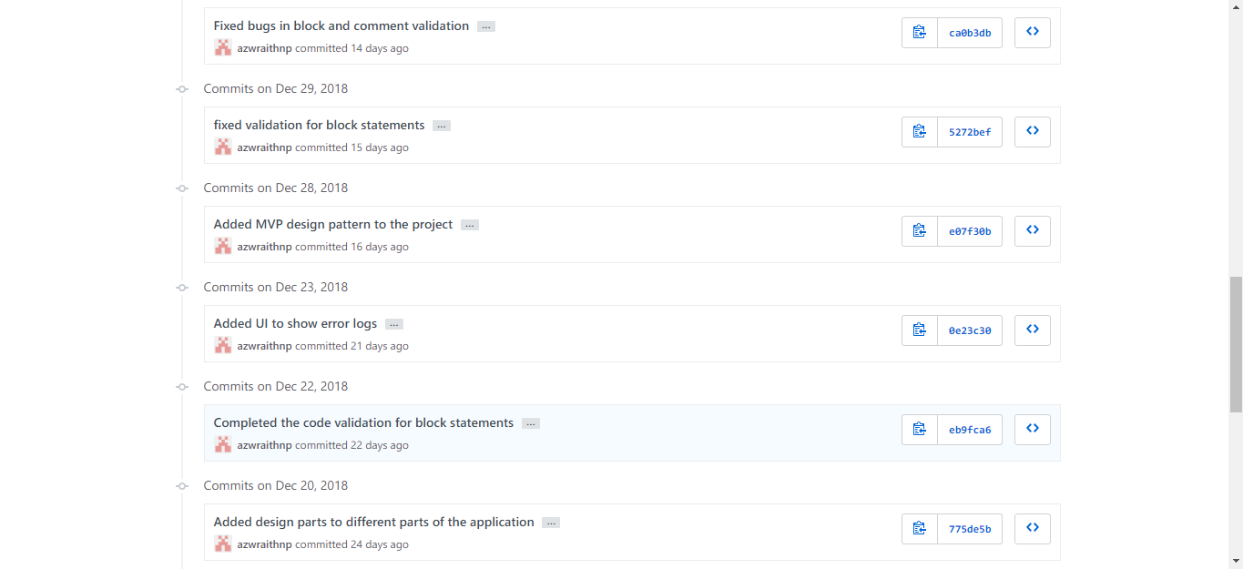

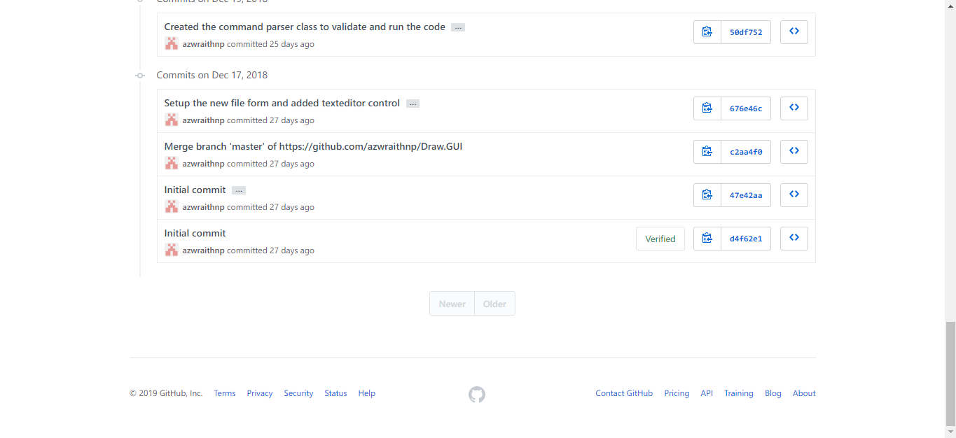

**XML Documentation**

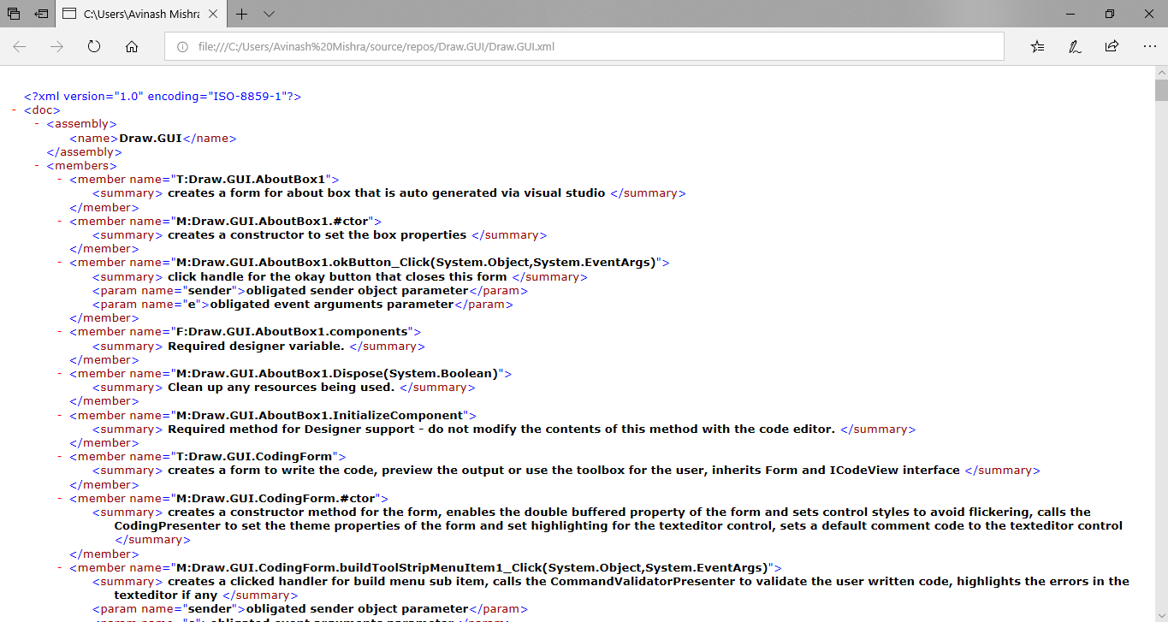

**Unit tests**

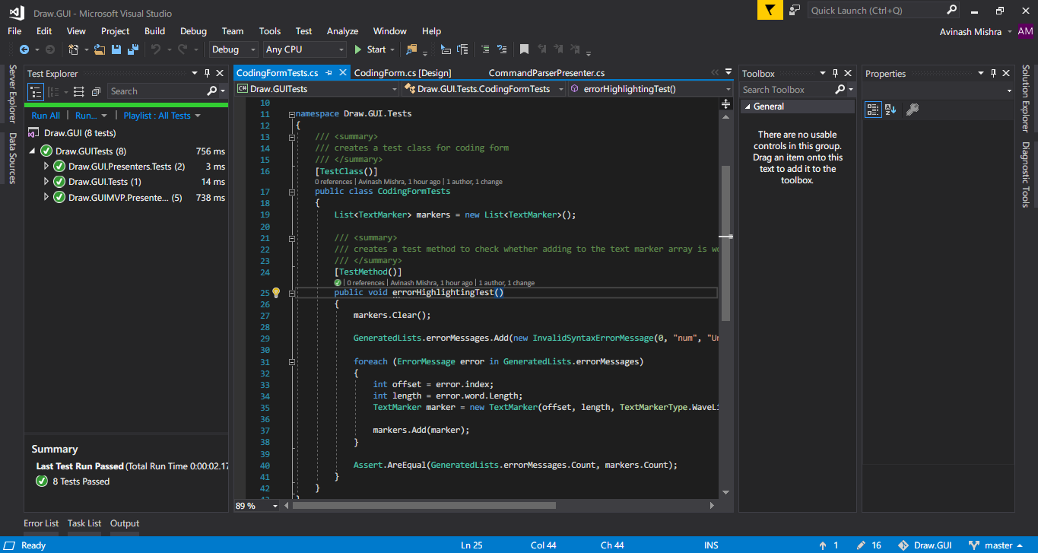

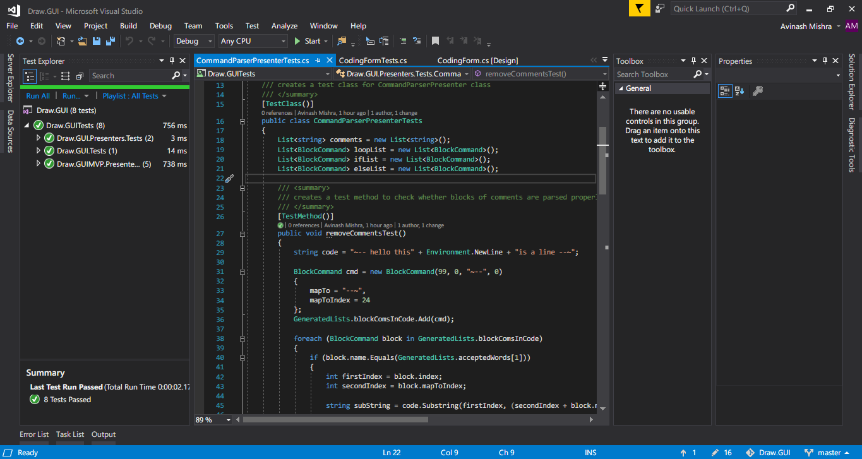

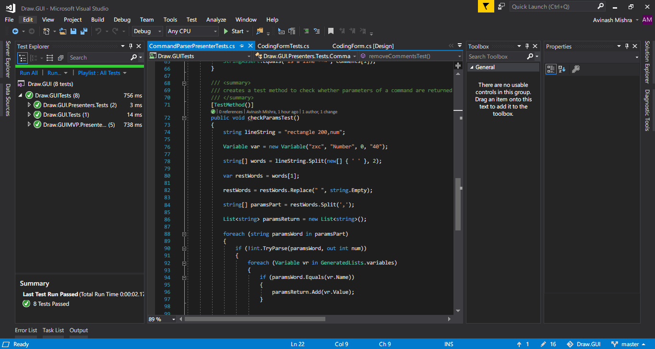

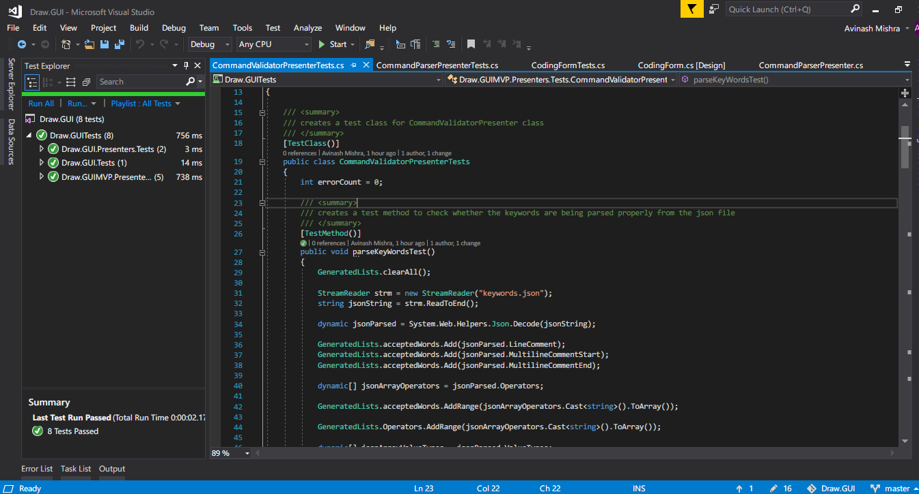

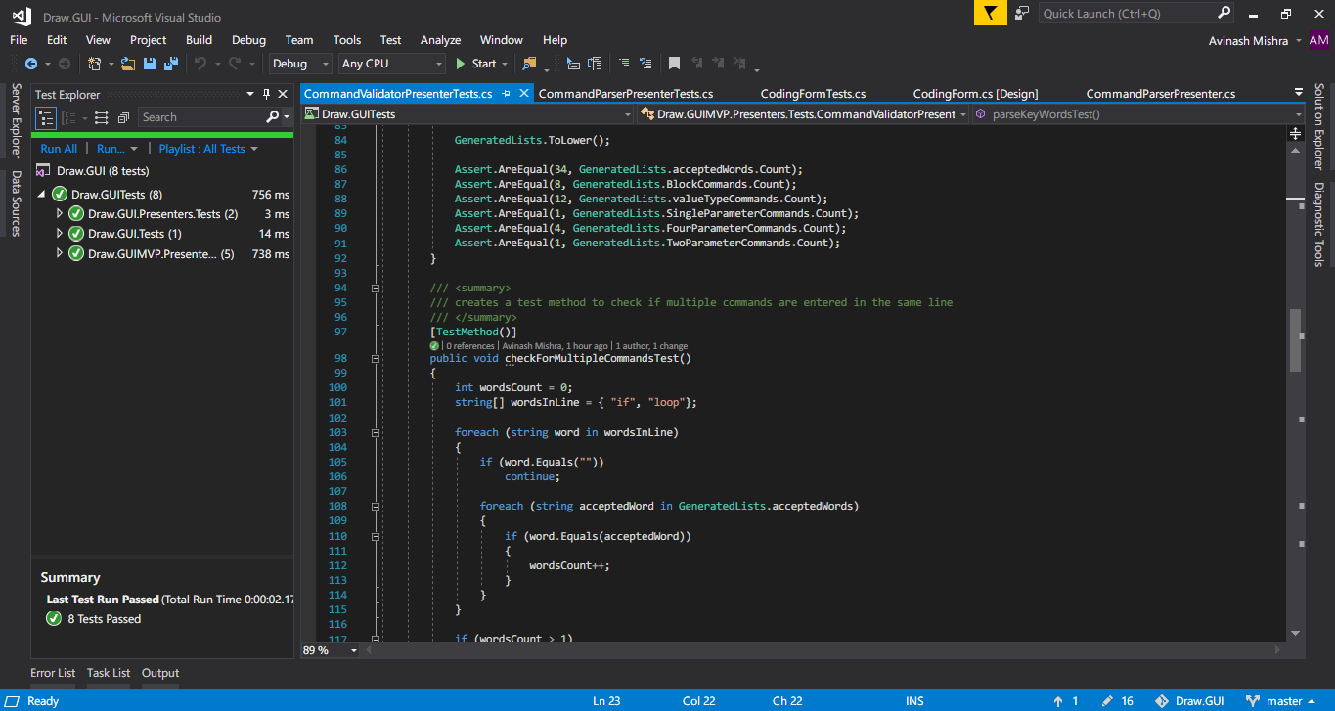

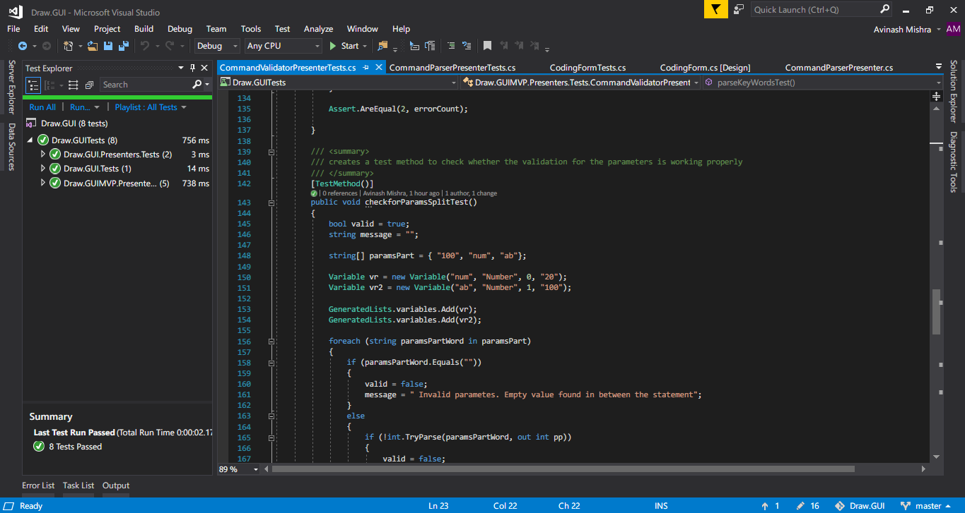

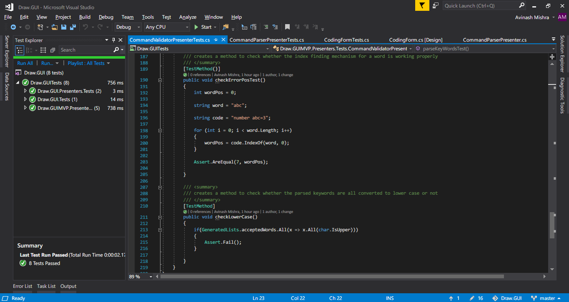

Test case scenarios:

|  |  |
| --- | --- |
| Testcase ID | 01CodingFormTests |
| Testcase Description | Check if adding to the text marker array is working properly |
| Testcase scenario | Add a dummy data to GeneratedLists.errorMessages  Add a textmarker for every iteration of count of GeneratedLists.errorMessages  Compare the length of text marker array and GeneratedLists.errorMessages |
| Expected Result | Length of both arrays should be the same |
| Actual Result | As expected |
| Testcase Pass/Fail/Not tested | Pass |

|  |  |
| --- | --- |
| Testcase ID | 02CommandParserPresenterTests |
| Testcase Description | Check whether blocks of comments are parsed properly |
| Testcase scenario | Make a dummy code string and a dummy block command  Check if block command is a comment command  Generate a substring by extracting the string between the starting of the block comment and ending of block comment  Compare the extracted substring with expected values |
| Expected Result | Substring should match the expected value |
| Actual Result | As expected |
| Testcase Pass/Fail/Not tested | Pass |

|  |  |
| --- | --- |
| Testcase ID | 03CommandParserPresenterTests |
| Testcase Description | Check whether parameters of a command are returned properly |
| Testcase scenario | Make a dummy line string and a dummy variable  Split the line string by spaces and then by commas  If parameter is integer or a variable its value should be returned |
| Expected Result | Parameters are returned from the dummy string |
| Actual Result | As expected |
| Testcase Pass/Fail/Not tested | Pass |

|  |  |
| --- | --- |
| Testcase ID | 04CommandValidatorPresenterTests |
| Testcase Description | Check whether the keywords are being parsed properly from the json file |
| Testcase scenario | Parse json from the keywords.json file  Store the specific keywords in respective arrays in GeneratedLists class  Check the length of each array |
| Expected Result | Length of each array corresponds to the actual number of commands declared in the json file |
| Actual Result | As expected |
| Testcase Pass/Fail/Not tested | Pass |

|  |  |
| --- | --- |
| Testcase ID | 05CommandValidatorPresenterTests |
| Testcase Description | Check if multiple commands are entered in the same line |
| Testcase scenario | Create a dummy wordsinline array with random but syntax compatible keywords  If a line contains more than one command, increase the error count  Check the error count after iterations |
| Expected Result | Error count should be as much as the number of commands in the dummy array |
| Actual Result | As expected |
| Testcase Pass/Fail/Not tested | Pass |

|  |  |
| --- | --- |
| Testcase ID | 06CommandValidatorPresenterTests |
| Testcase Description | Check whether the validation for the parameters is working properly |
| Testcase scenario | Create a dummy params array consisting of three valid parameters  Create two dummy variables containing valid numeric values  Check the parameters for every iteration in the params array  Check whether the Boolean value is true or not at the end |
| Expected Result | Parameters are valid so the Boolean value should be true |
| Actual Result | As expected |
| Testcase Pass/Fail/Not tested | Pass |

|  |  |
| --- | --- |
| Testcase ID | 07CommandValidatorPresenterTests |
| Testcase Description | Check whether the index finding mechanism for a word is working properly |
| Testcase scenario | Create a dummy word and string containing the dummy word  Calculate the index of the dummy word in the string |
| Expected Result | Index of the dummy word should be expected to be the real value |
| Actual Result | As expected |
| Testcase Pass/Fail/Not tested | Pass |

|  |  |
| --- | --- |
| Testcase ID | 08CommandValidatorPresenterTests |
| Testcase Description | Check whether the parsed keywords are all converted to lower case or not |
| Testcase scenario | Use linq to find if all the words in the GeneratedLists.acceptedWords array is lowercase |
| Expected Result | All words are in lowercase |
| Actual Result | As expected |
| Testcase Pass/Fail/Not tested | Pass |

**Kanbanflow: Project management tool for agile development**

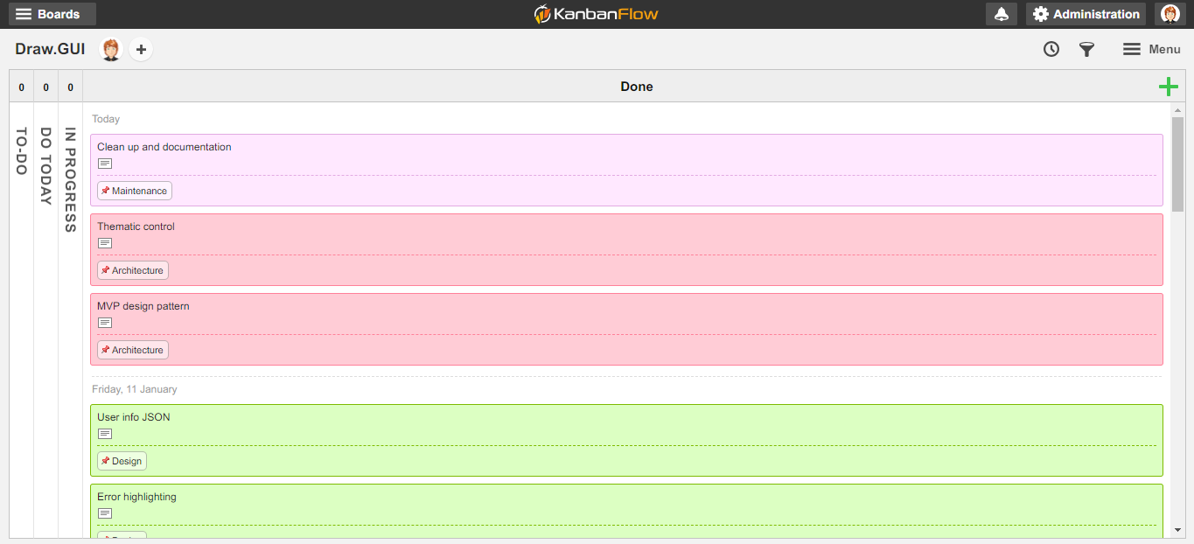

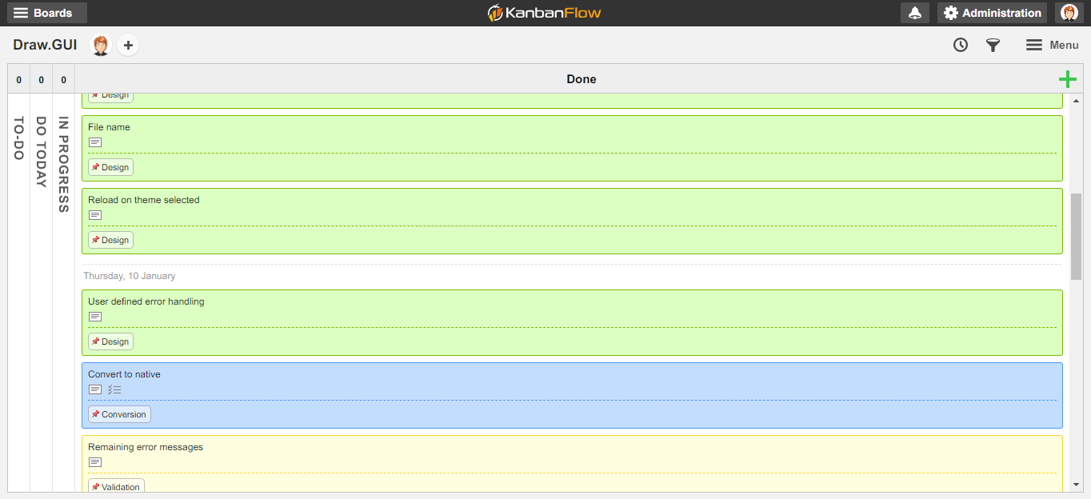

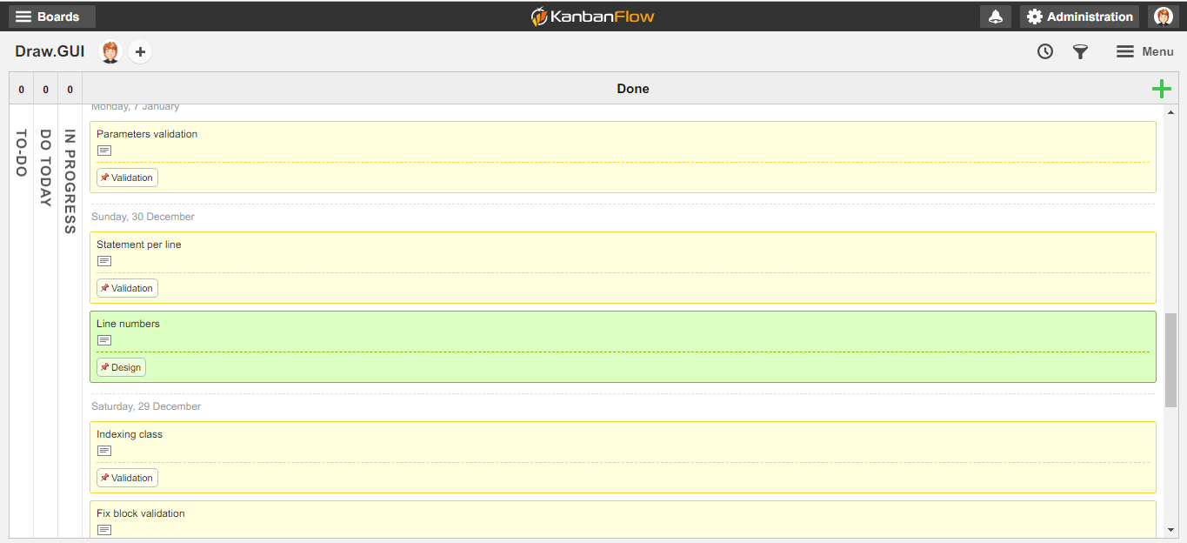

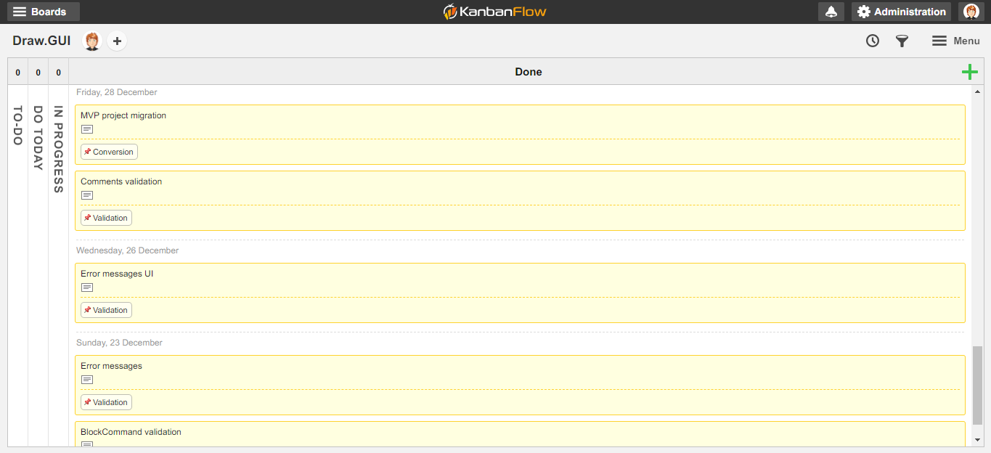

**Additional features and architecture used in this application**

Use of MVP (Model, View, Presenter) design pattern used throughout the application

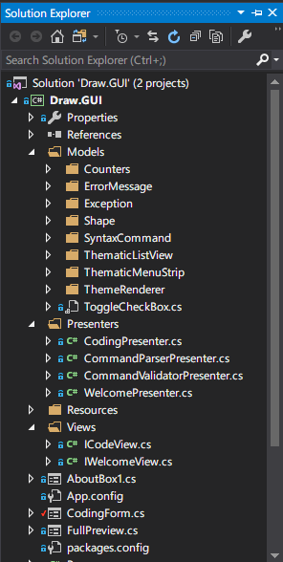

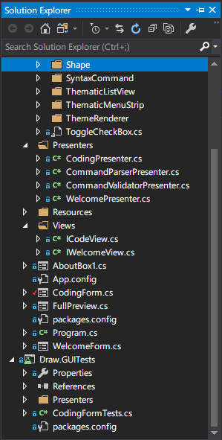

User can select a theme for the application (Dark or Light)

Dark Theme

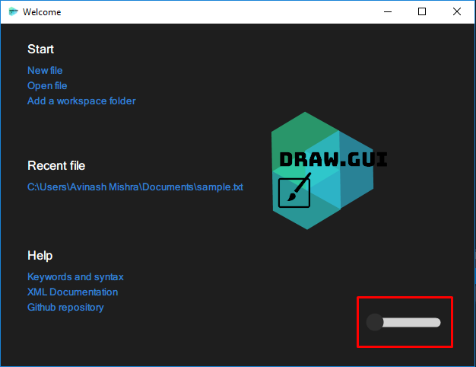

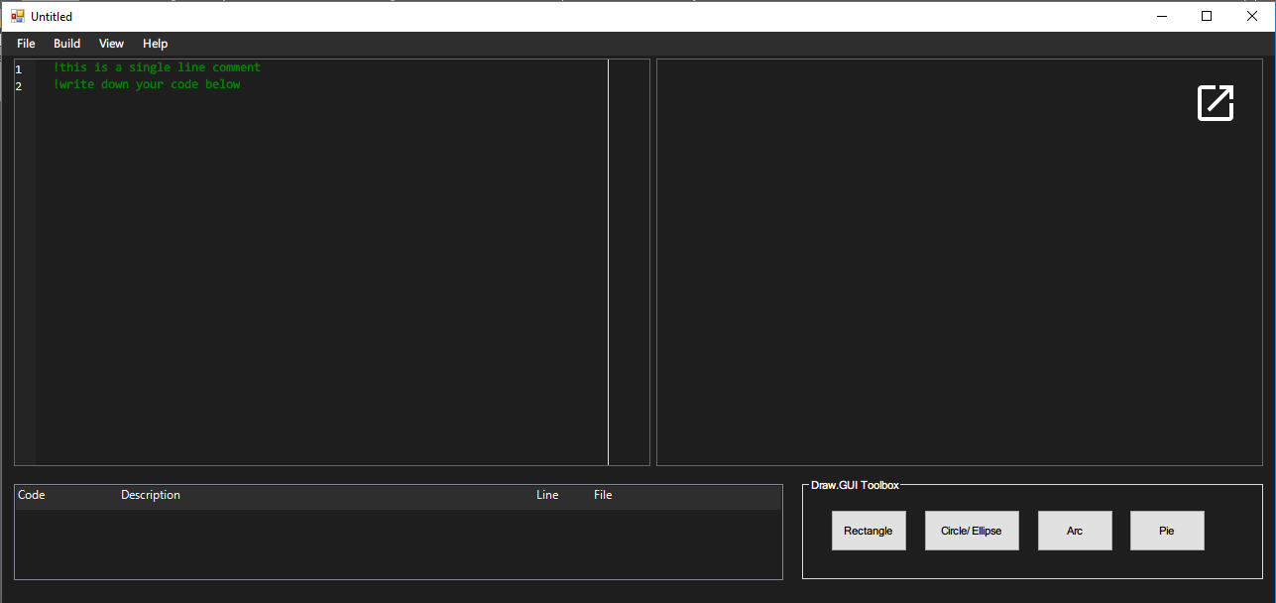

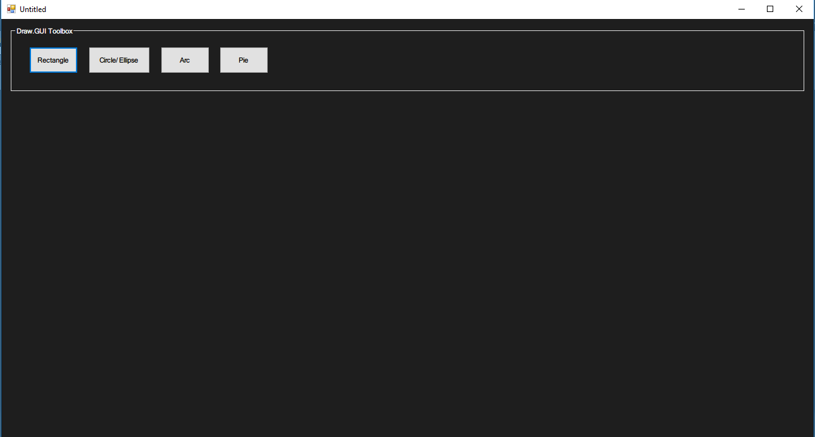

Light theme

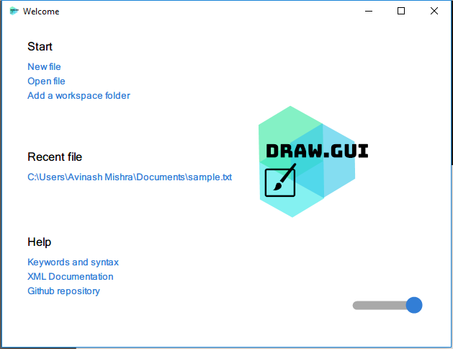

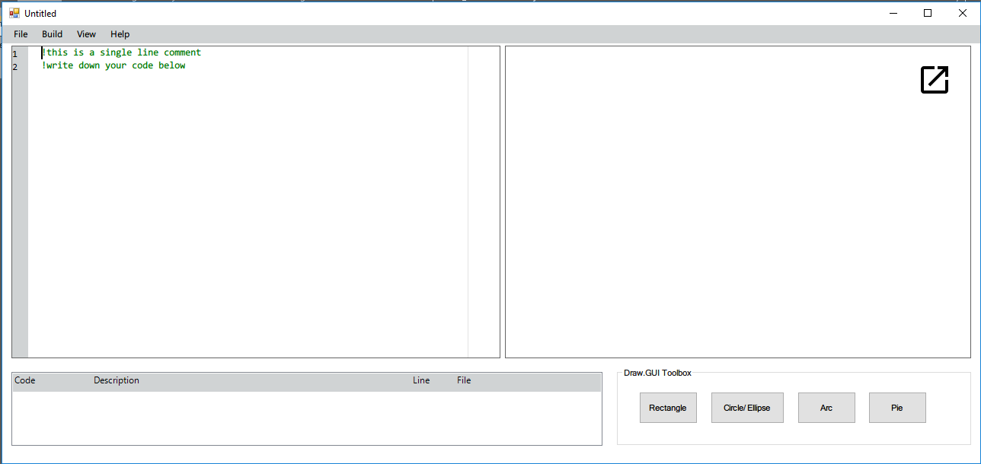

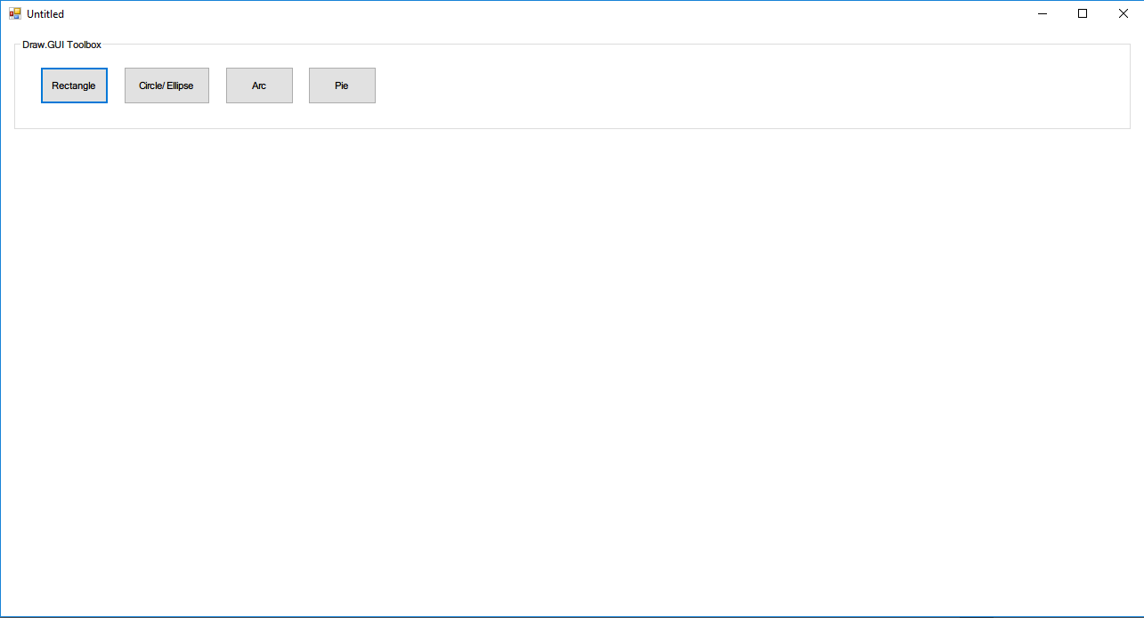

Drawing of advanced shapes

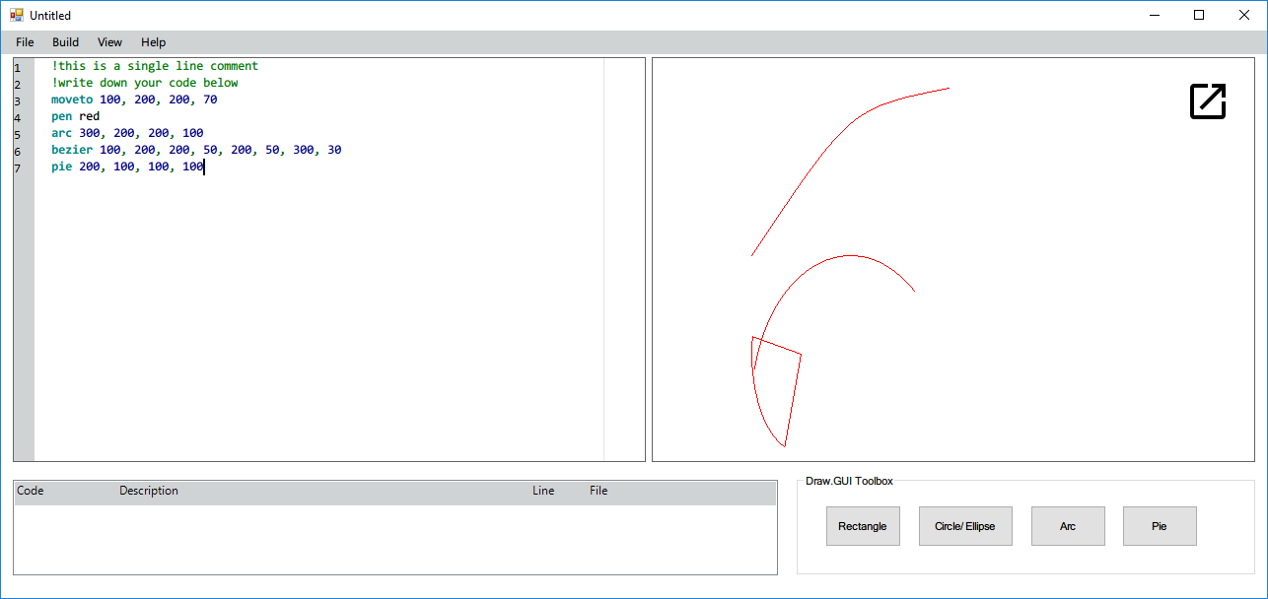

Ability to show output in full screen if the form’s panel is not wide enough

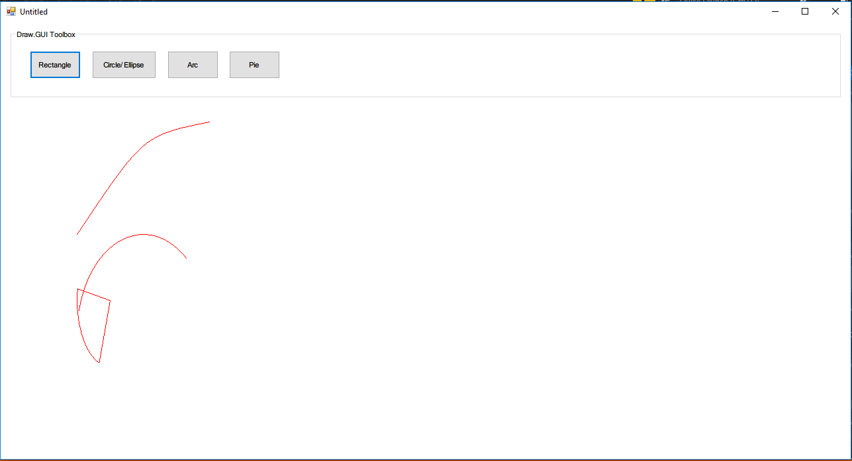

Ability to show grind lines for the drawing shapes

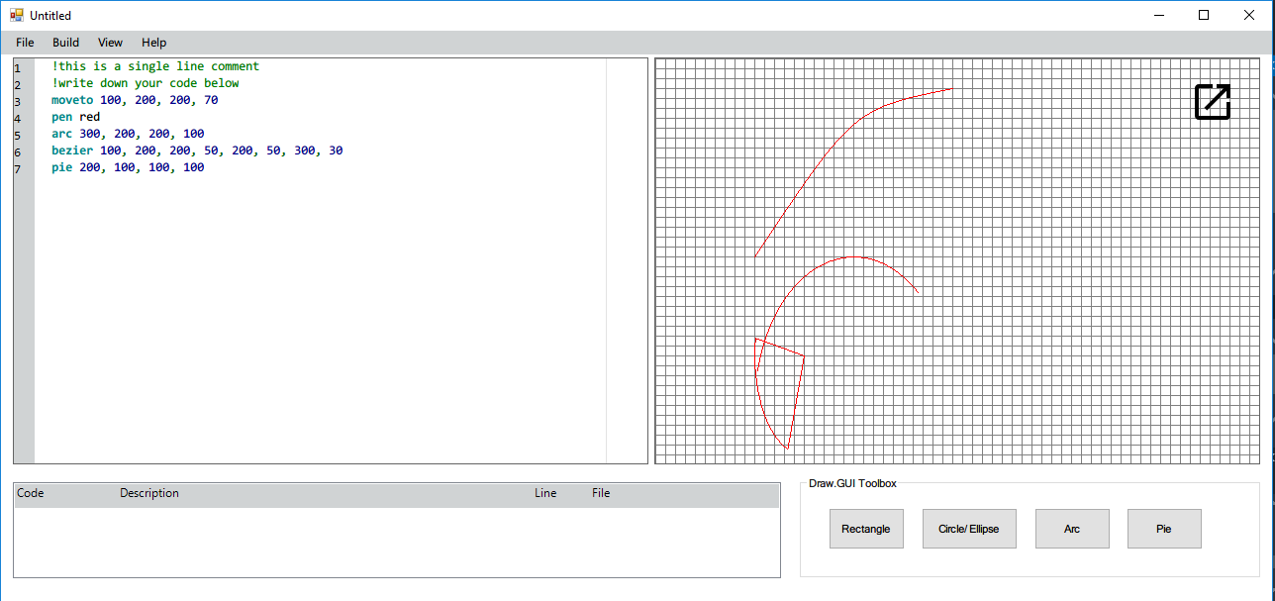

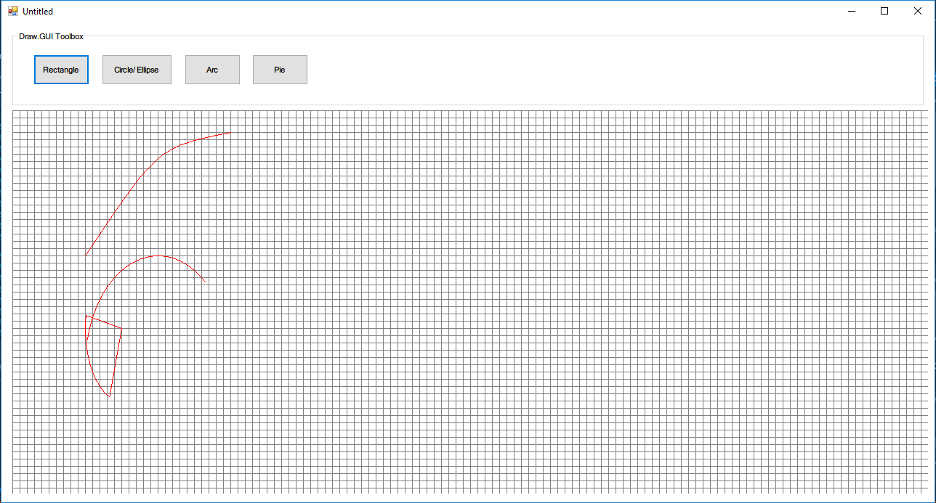

Ability to color fill the drawing objects

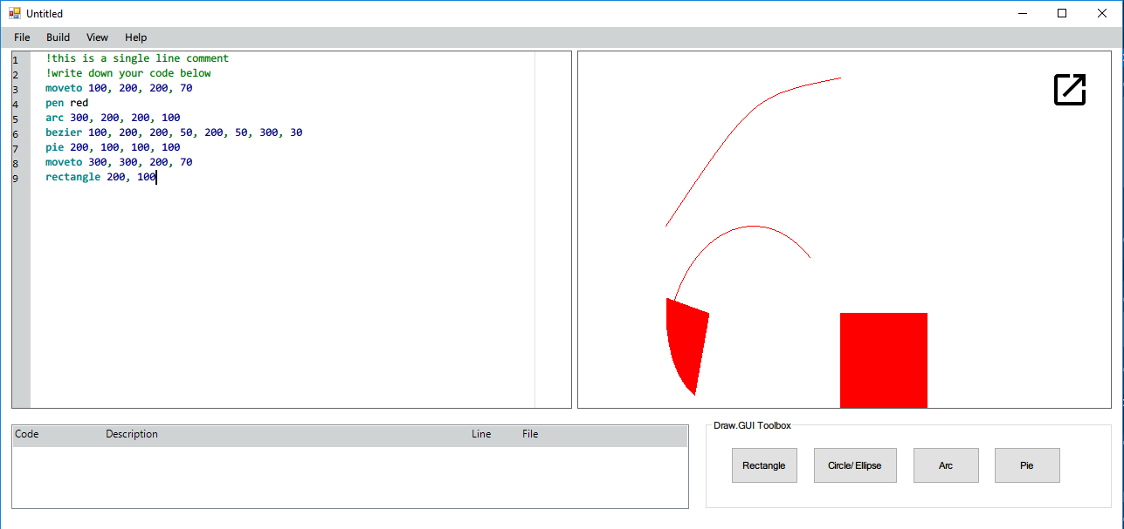

GUI functionality to draw shapes by mouse over the panel

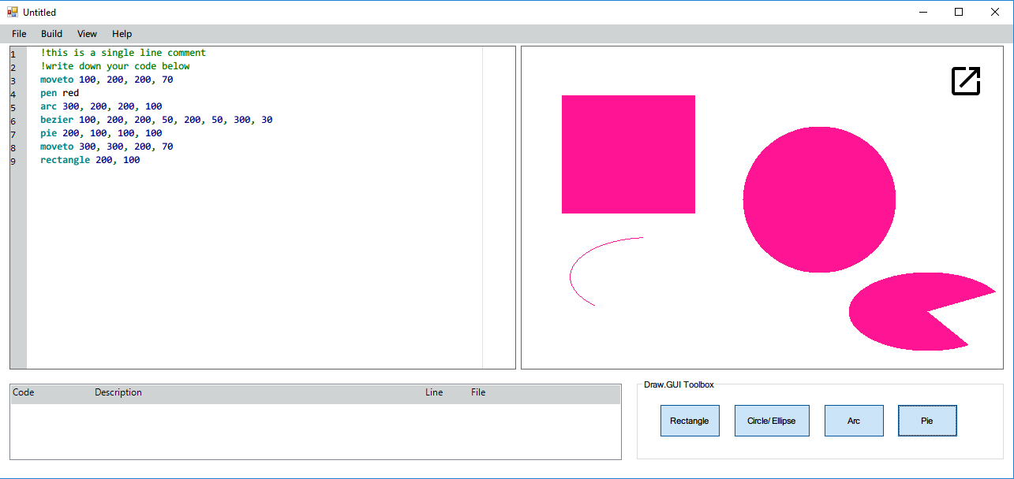

Along with many other features like open and save files for the code,

Show informative error log after each build,

Save image of the canvas locally,

Add workspace folders, etc.