|  |
| --- |
| KOD:  -- ****************** SqlDBM: Microsoft SQL Server ******************  -- ******************************************************************  DROP TABLE [Program];  GO  DROP TABLE [AgeGroups];  GO  DROP TABLE [AgeNumbers];  GO  DROP TABLE [VariableTarget];  GO  DROP TABLE [Title];  GO  DROP TABLE [Channel];  GO  DROP TABLE [DateAndTime];  GO  --************************************** [AgeNumbers]  CREATE TABLE [AgeNumbers]  (  [NumberID] INT NOT NULL ,  [Nuber] FLOAT NOT NULL ,  CONSTRAINT [PK_AgeNumbers] PRIMARY KEY CLUSTERED ([NumberID] ASC)  );  GO  --************************************** [VariableTarget]  CREATE TABLE [VariableTarget]  (  [VariableTargetID] INT NOT NULL ,  [VariableTargetName] VARCHAR(50) NOT NULL ,  CONSTRAINT [PK_VariableTarget] PRIMARY KEY CLUSTERED ([VariableTargetID] ASC)  );  GO  --************************************** [Title]  CREATE TABLE [Title]  (  [TitleID] INT NOT NULL ,  [Description] VARCHAR(50) NOT NULL ,  [2nDescription] VARCHAR(50) NULL ,  CONSTRAINT [PK_Title] PRIMARY KEY CLUSTERED ([TitleID] ASC)  );  GO  --************************************** [Channel]  CREATE TABLE [Channel]  (  [ChannelID] INT NOT NULL ,  [ChannelName] VARCHAR(50) NOT NULL ,  CONSTRAINT [PK_Channel] PRIMARY KEY CLUSTERED ([ChannelID] ASC)  );  GO  --************************************** [DateAndTime]  CREATE TABLE [DateAndTime]  (  [DateAndTimeID] INT NOT NULL ,  [Date] DATE NOT NULL ,  [StartTime] TIME(7) NOT NULL ,  CONSTRAINT [PK_DateAndTime] PRIMARY KEY CLUSTERED ([DateAndTimeID] ASC)  );  GO  --************************************** [AgeGroups]  CREATE TABLE [AgeGroups]  (  [AgeGroupsID] INT NOT NULL ,  [AgeCode] VARCHAR(50) NOT NULL ,  [AgeGroupDescription] VARCHAR(50) NOT NULL ,  [NumberID] INT NOT NULL ,  CONSTRAINT [PK_AgeGroups] PRIMARY KEY CLUSTERED ([AgeGroupsID] ASC),  CONSTRAINT [FK_70] FOREIGN KEY ([NumberID])  REFERENCES [AgeNumbers]([NumberID])  );  GO  --SKIP Index: [fkIdx_70]  --************************************** [Program]  CREATE TABLE [Program]  (  [ProgramID] INT NOT NULL ,  [ChannelID] INT NOT NULL ,  [VariableTargetID] INT NOT NULL ,  [DateAndTimeID] INT NOT NULL ,  [TitleID] INT NOT NULL ,  [AgeGroupsID] INT NOT NULL ,  [Duration] TIME(7) NOT NULL ,  [TotalIndividuals] INT NOT NULL ,  [Subgroup] FLOAT NOT NULL ,  CONSTRAINT [PK_Program] PRIMARY KEY CLUSTERED ([ProgramID] ASC),  CONSTRAINT [FK_54] FOREIGN KEY ([ChannelID])  REFERENCES [Channel]([ChannelID]),  CONSTRAINT [FK_62] FOREIGN KEY ([VariableTargetID])  REFERENCES [VariableTarget]([VariableTargetID]),  CONSTRAINT [FK_66] FOREIGN KEY ([DateAndTimeID])  REFERENCES [DateAndTime]([DateAndTimeID]),  CONSTRAINT [FK_78] FOREIGN KEY ([TitleID])  REFERENCES [Title]([TitleID]),  CONSTRAINT [FK_82] FOREIGN KEY ([AgeGroupsID])  REFERENCES [AgeGroups]([AgeGroupsID])  );  GO  --SKIP Index: [fkIdx_54]  --SKIP Index: [fkIdx_62]  --SKIP Index: [fkIdx_66]  --SKIP Index: [fkIdx_78]  --SKIP Index: [fkIdx_82] |

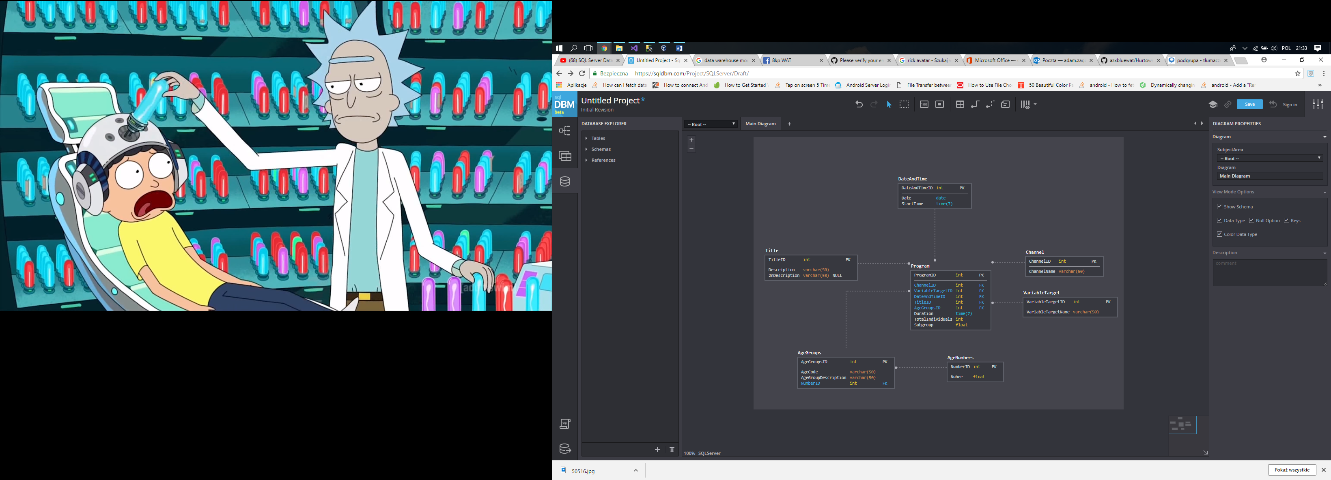

Control flow:

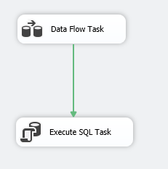

Data Flow:

