Game programming with data structures

Final Project

Azza Elgendy

Section 1

**Game Name: Halloween Run**

Player: Witch

Enemy: Bat, Pumpkin

Score: The Coins

Game time: based on local variable decrement in game update

Description:

The Game start with flying witch as the player trying to collect coins and avoid the bat’s hits.

When the bat hit the witch the hit score increase, when the witch collects coins, coins score increased

At the end of the game it compares the score.

If the hit score more the Coins score the player lose.

If the coins score more than bat ‘s score the player win and go to the next level

Level 2 includes a pumpkin which hit the player and increase the hit score

The score is being saved to a file .

The high score scene display the top 5 score reading from the saved file.

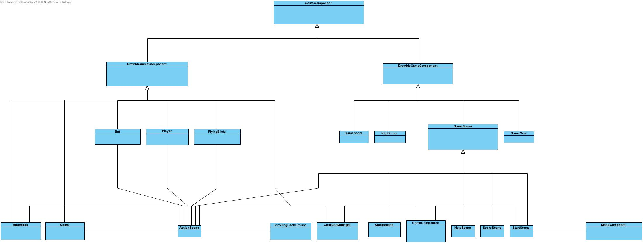

**References:**

*Bat Icon*, Retrieved November 6, 2018, from <http://www.iconarchive.com/show/halloween-icons-by-gcds/bat-icon.html>

*HALLOWEEN BACKGROUND CLIPART #15*, Retrieved November 6, 2018, from <https://techflourish.com/categories/halloween-background-clipart.html#overlayGallery9_post_20520_halloween-background-clipart-5.png>

*Improve your design ,*SitePoint , Retrieved November 6, 2018 from <https://www.sitepoint.com/2d-animation-tutorial-using-spine-mobile-apps/>

Pumpkin Icon, Retrieved November 6, 2018 from <http://www.iconarchive.com/show/halloween-icons-by-yootheme/pumpkin-icon.html>

*Witch*, Retrieved November 25, 2018, from <http://pngimg.com/uploads/witch/witch_PNG105.png>

Music, sound effect

(2018). Retrieved from <http://soundbible.com/tags-bat.html>

(2018). [Image]. Retrieved from <https://findicons.com/icon/128319/bat>