**Download Android Studio from here** <https://developer.android.com/studio>

**The Default installation location:**

C:\Program Files\Android\Android Studio

**Tips**: if your username contains a space for example “first last” be sure to create another user on your developer computer which is one-word username

**The default SDK location:**

C:\Users\username\AppData\Local\Android\Sdk

Find the SDK location

**C:\Users\azza\AppData\Local\Android\Sdk**

**For google phones as physical device**

Install the google **USB** driver

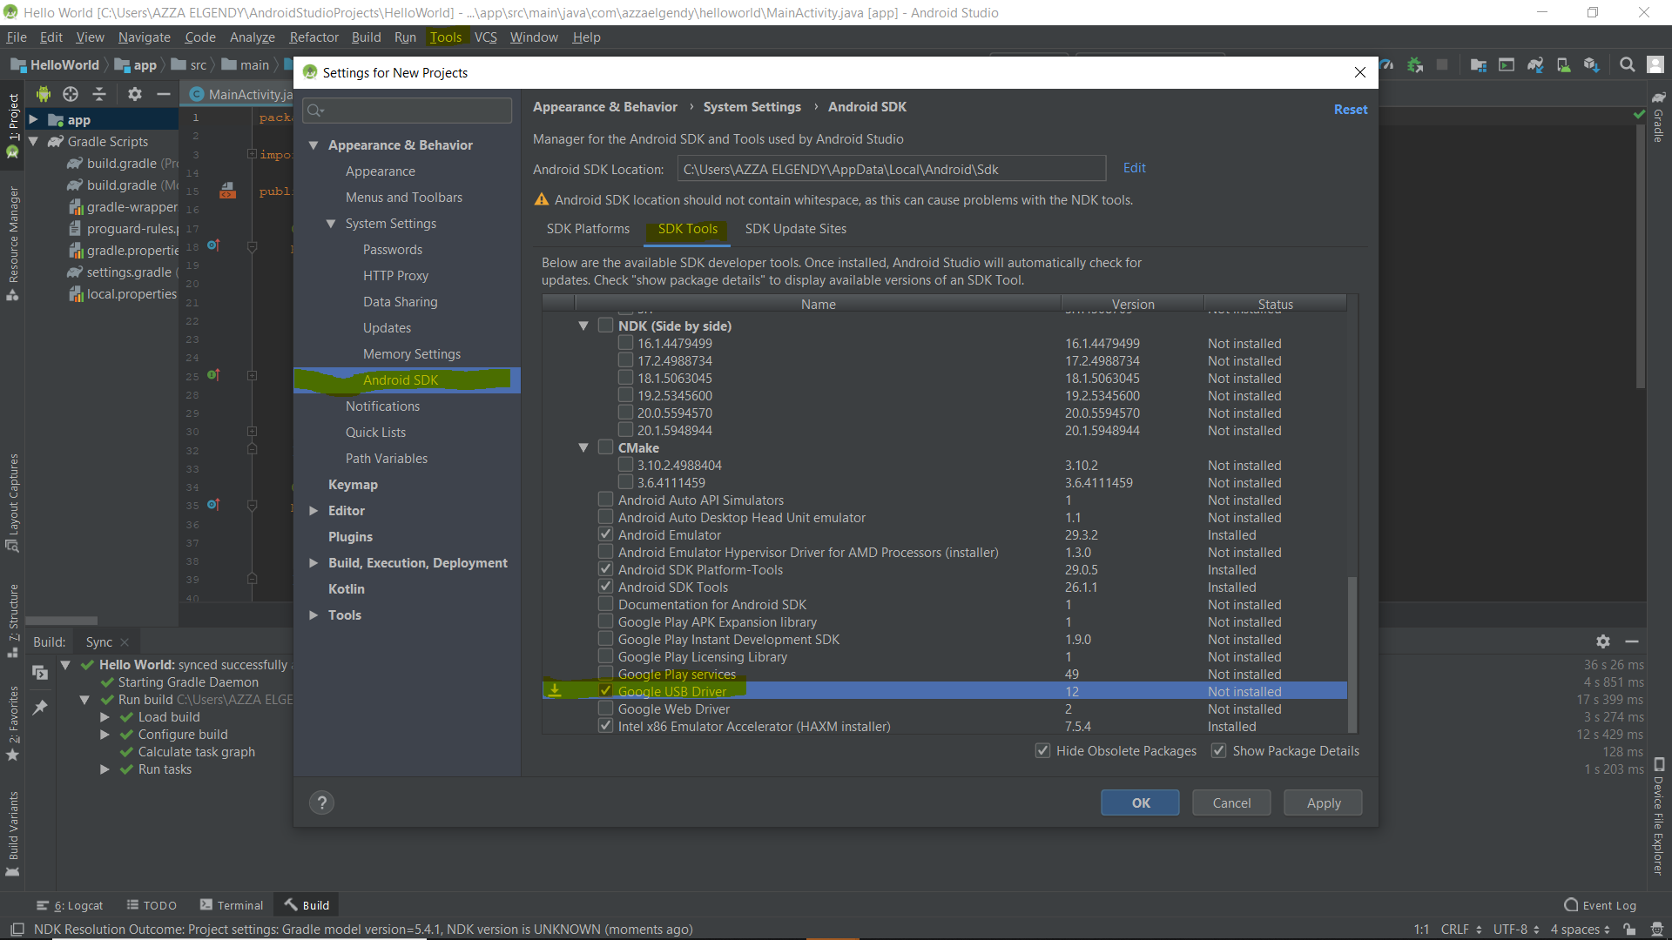

1. Find the google driver location

C:\Users\username\AppData\Local\Android\Sdk\extras\google\usb_driver

1. Go to Device Manager
2. Update the driver of the unknown device from the location specified up there

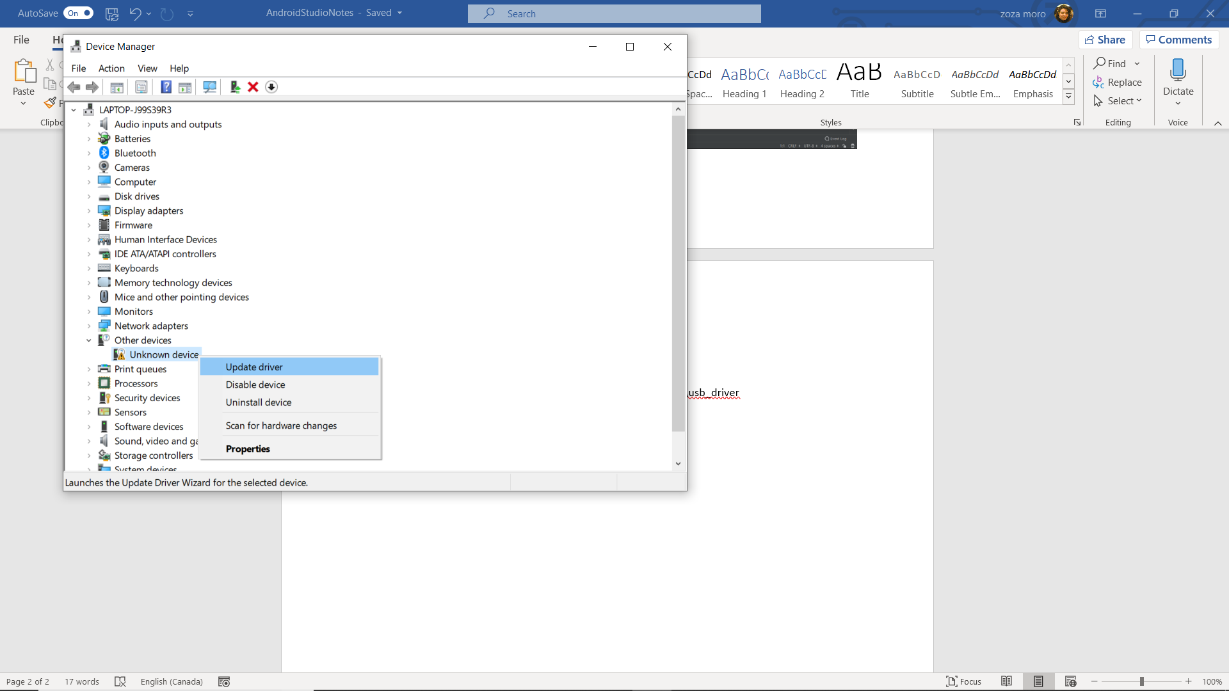

**For other android physical devices**

Enable developer mode on your device

Go to settings find the **about phone tab** press build number7 times this will enable the developer tools

Go to the developer tools and allow USB debagging and keep screen awake

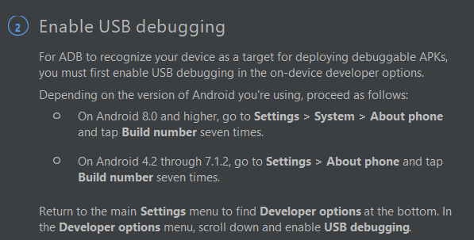

Connect your device to the computer

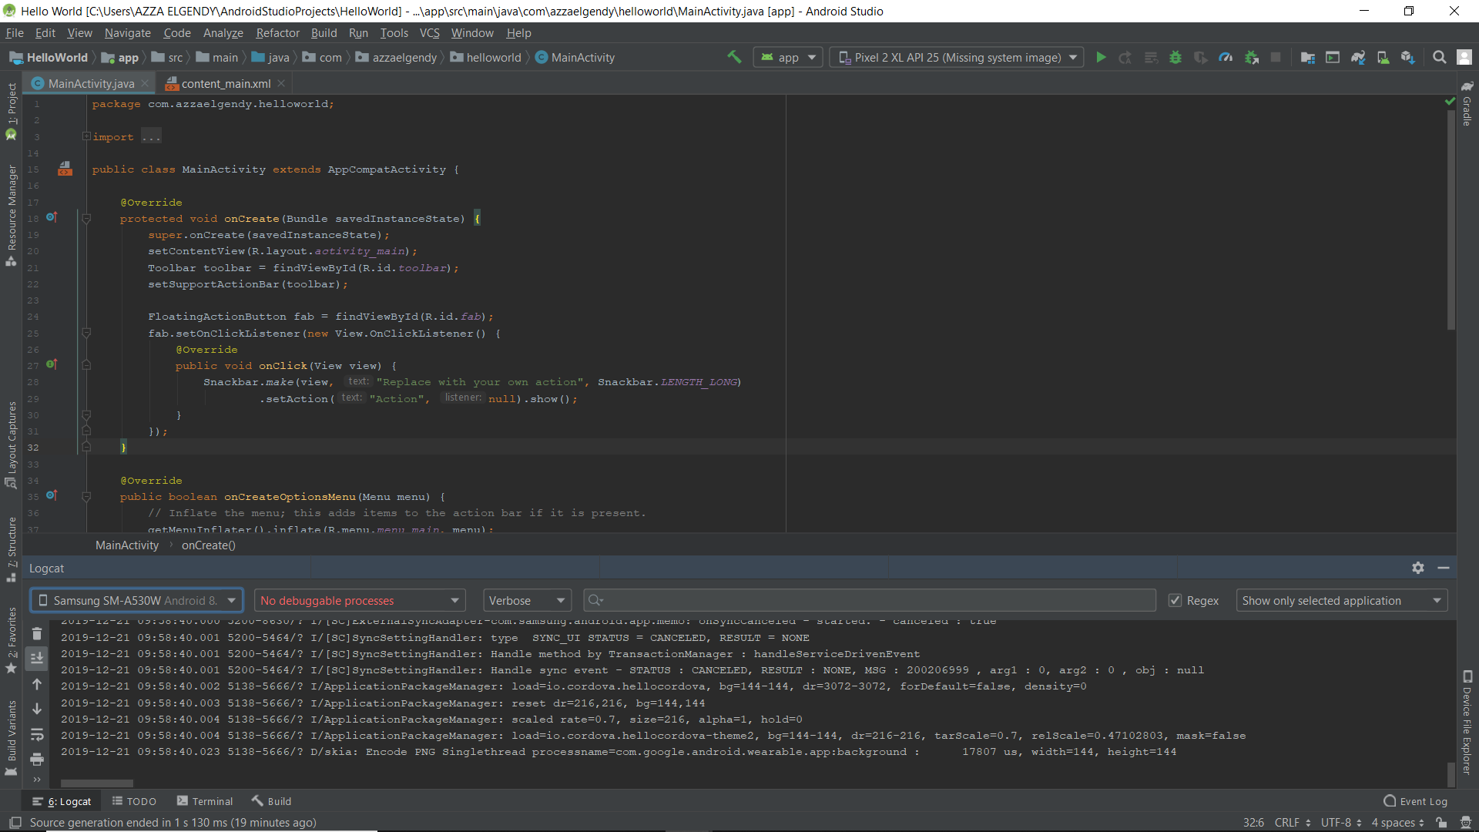Press **logcat** inthe bottom left of your android studio

To use the Emulator

Create a virtual device

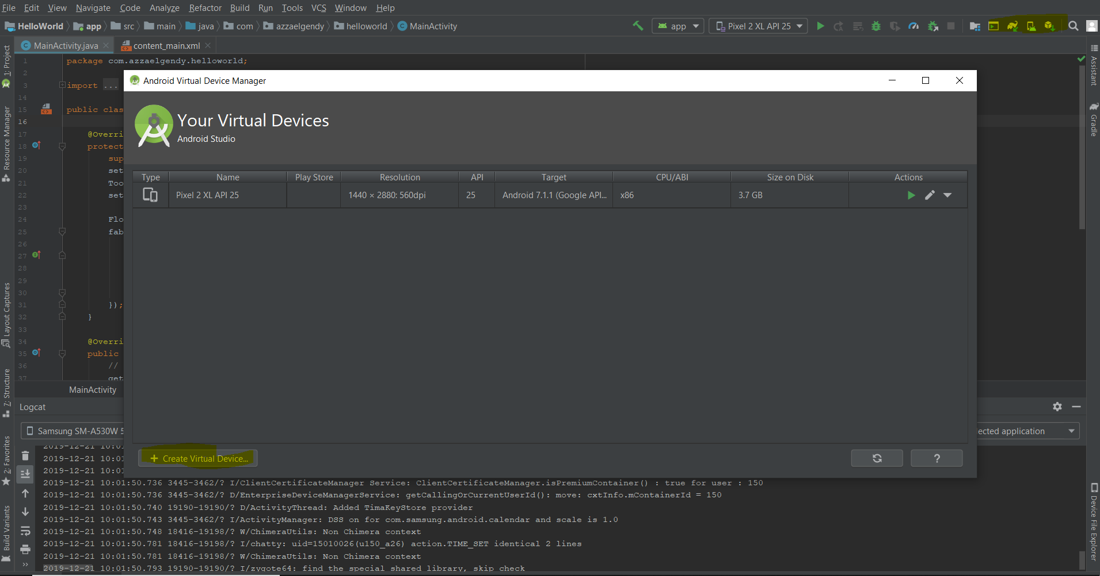

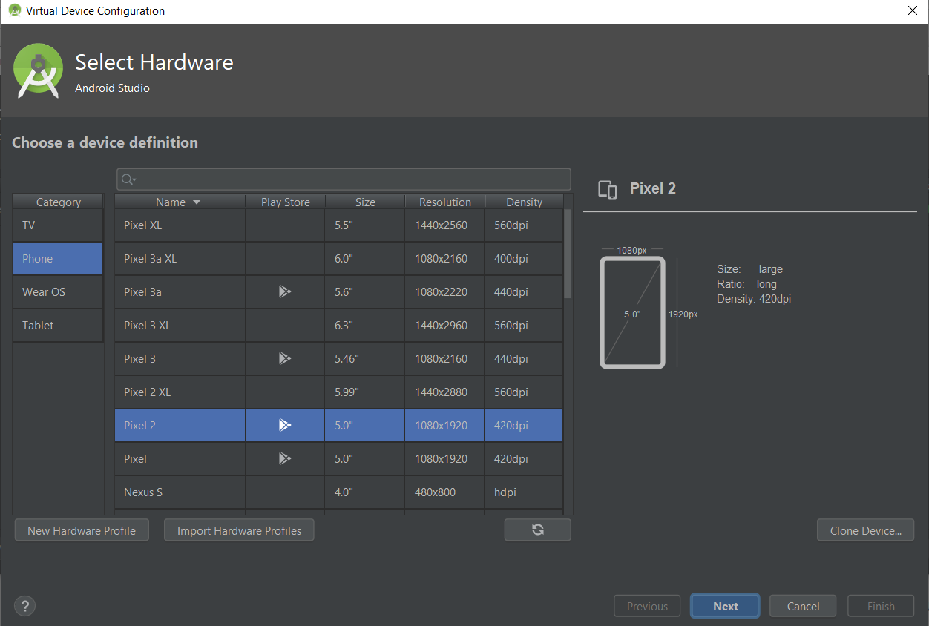Choose and install your virtual device.

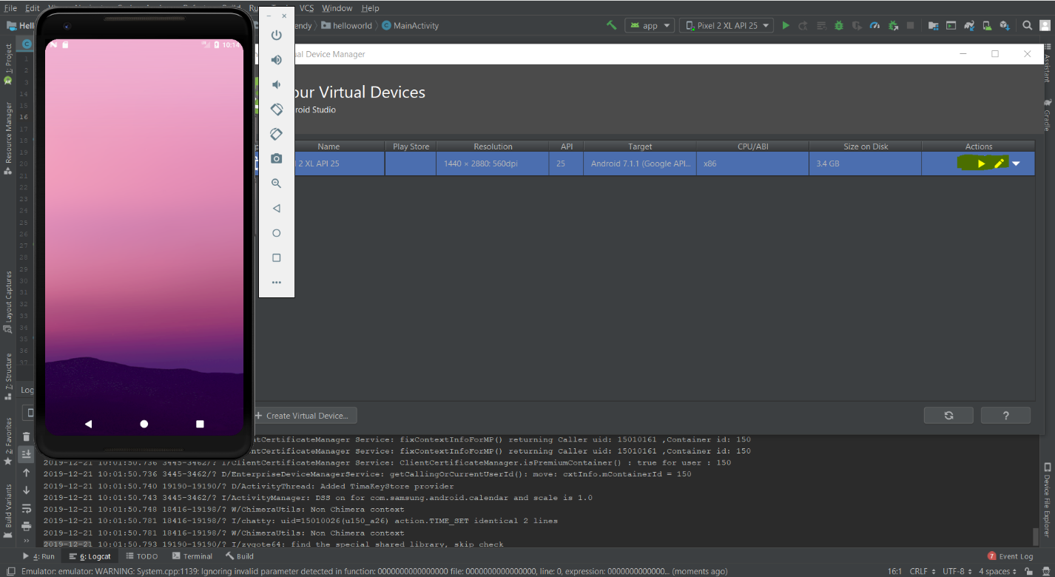Once installed press the green arrow and lunch