**Analysis of the risk to make strokes**

**In this project we look for the factors that increase the risk of strokes.**

**for example: age, hypertension, heart disease, work type, smoking status.**

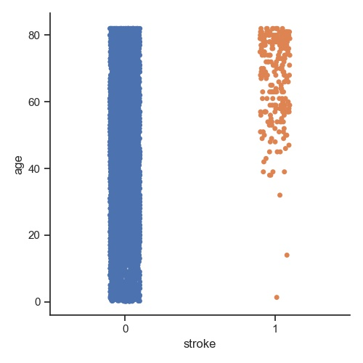

**-The relationship between the incidence of stroke and age is a positive relationship, as the elderly are more susceptible to stroke than young people.**

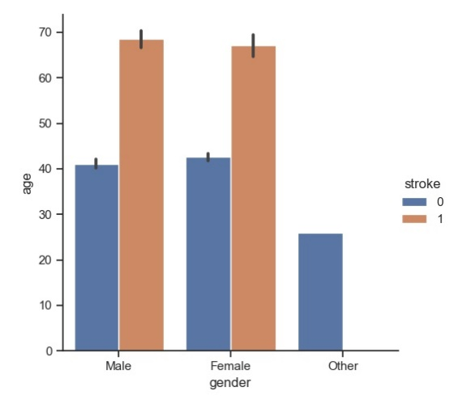

-**The risk of strokes is the same for both sexes.**

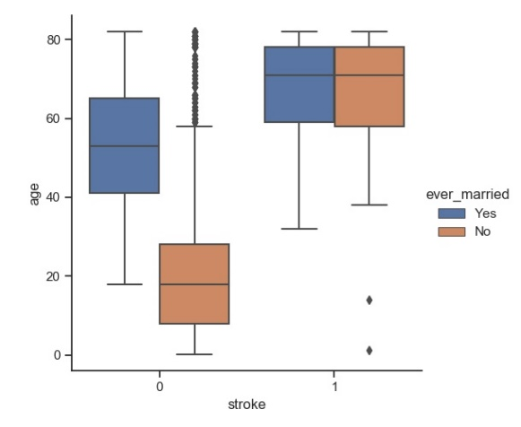

**-The photo shows the relationship between marriage, age, and stroke.**

**\*\*Next step I will use the classification to complete the rest of the project**