|  |  |  |  |  |
| --- | --- | --- | --- | --- |
| |  |  | | --- | --- | | GPE Contractors |  | |  |  | |
| Family run business  Est 1990, we have been in the business long enough that we have mastered it. Every job is insured and all our engineers are NIC and Gas Safe certified. |

# Recent work

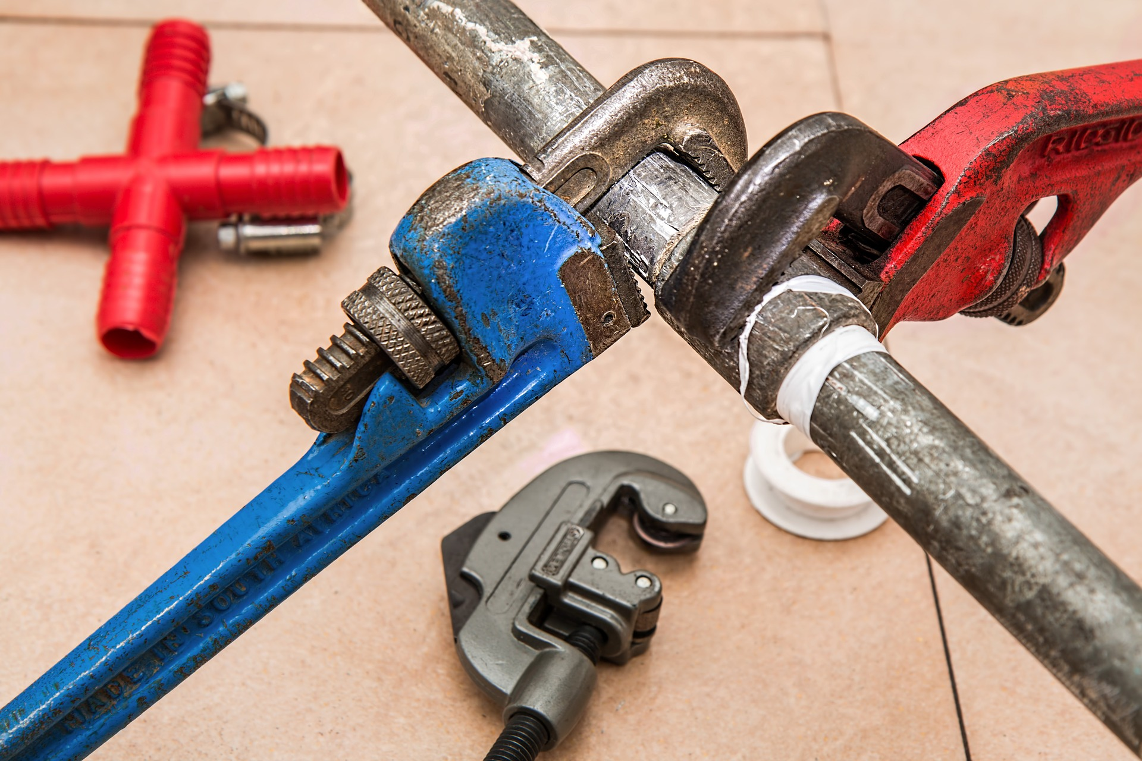

## Job 1

Info on job here…

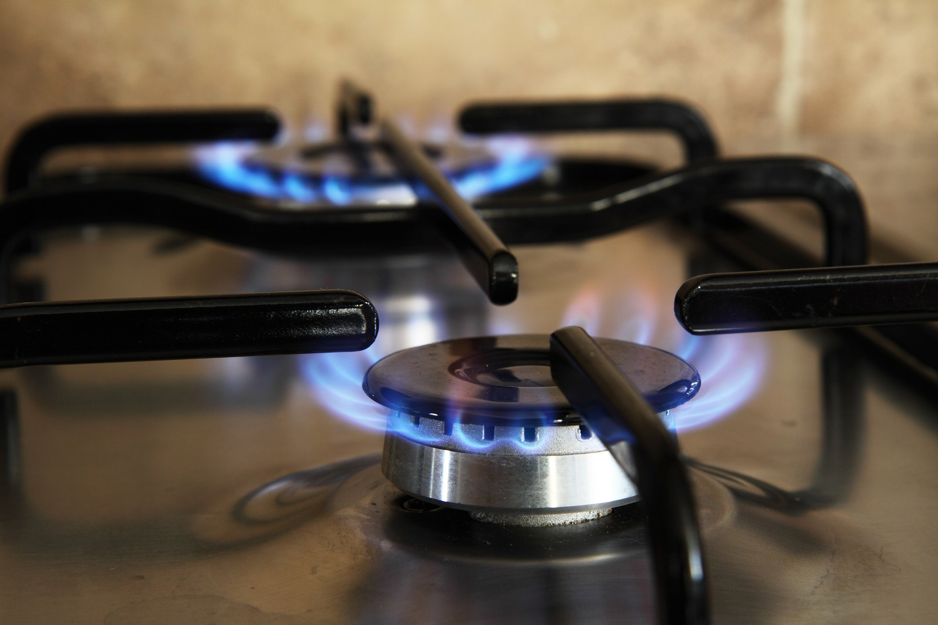

## Job 2

Info on job here…

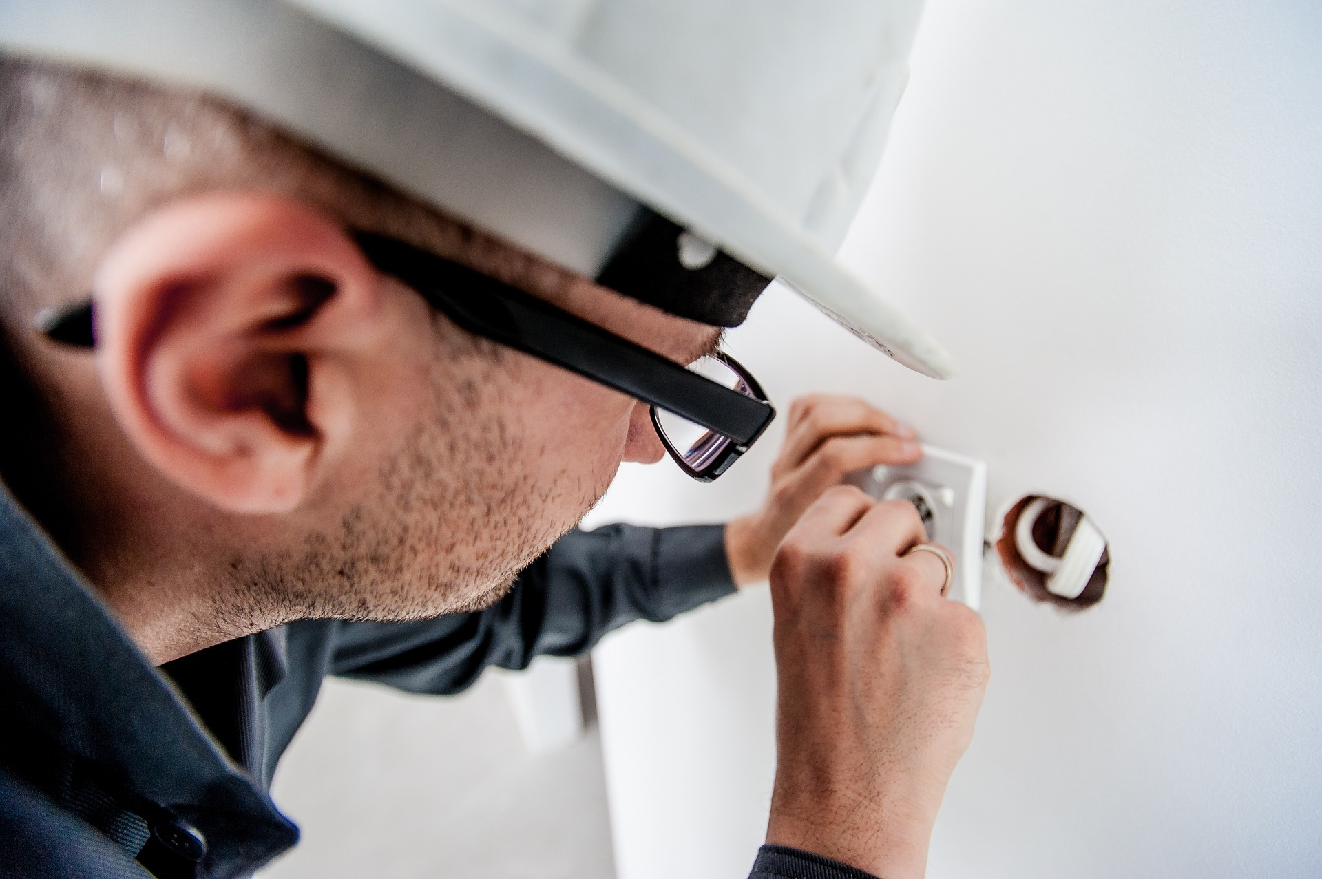

## Job 3

Info on job here…