Assignment-3

**Introduction to Databases**

**Question-1:** Problem Statement: There can be multiple customers, who can place multiple orders on the site. Now a sales person can handle these orders will distribute into multiple sales persons (One order will be assign to one salesperson only). So a sales person can have multiple orders of multiple customers Create Database.

**Soln.**

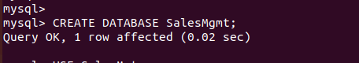

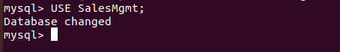

**Question-2**: Design Schema

**Soln.**

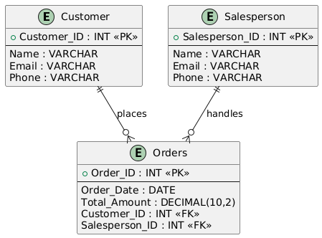

**Question-3: Create tables**

**Soln.**

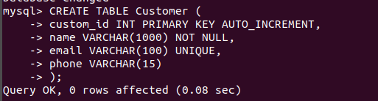

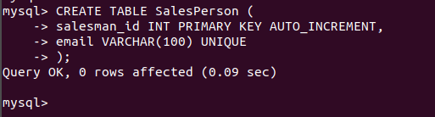

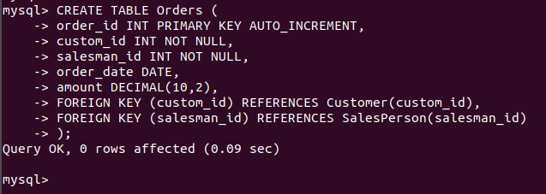

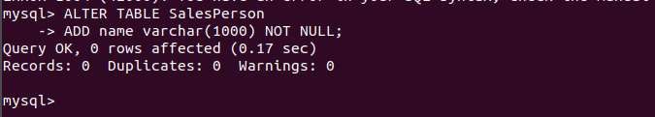

**Question-4: Insert sample data**

**Soln.**

**Customer table**



**SalesPerson Table**



**Orders Table**

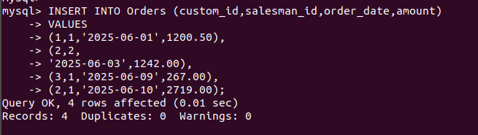

**ALL TABLES**

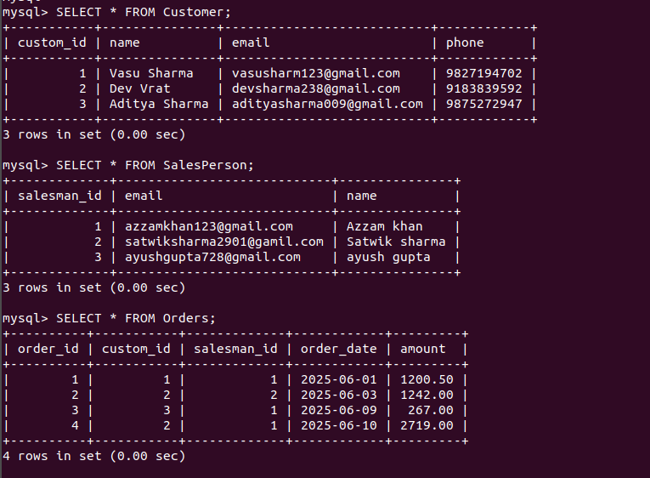

**Question-5: Find the sales person have multiple orders.**

**Soln.**

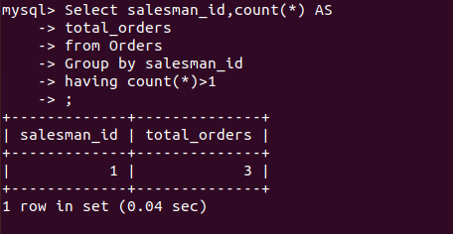

**Question-6: Find the all sales person details along with order details**

**Soln.**

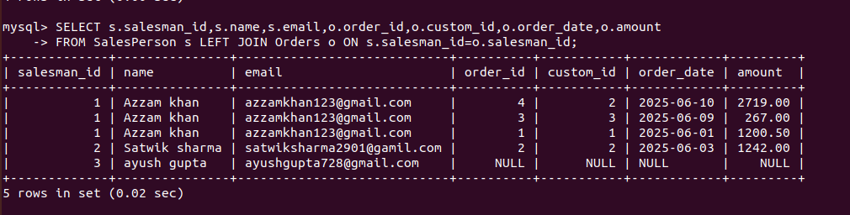

**Question-7: Create index**

**Soln.**

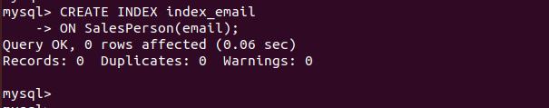

**Question-8: How to show index on a table**

**Soln.**



**Question-9: Find the order number, sale person name, along with the customer to whom that order belongs to**

**Soln.**

