Assignment-2

**Introduction to version control**

Question-1:Git Setup <https://confluence.atlassian.com/bitbucket/set-up-git-744723531.html>

Soln.

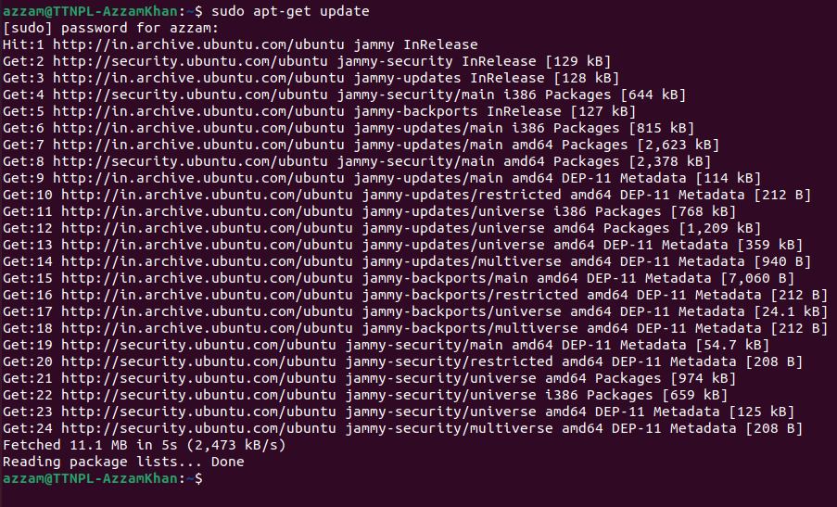

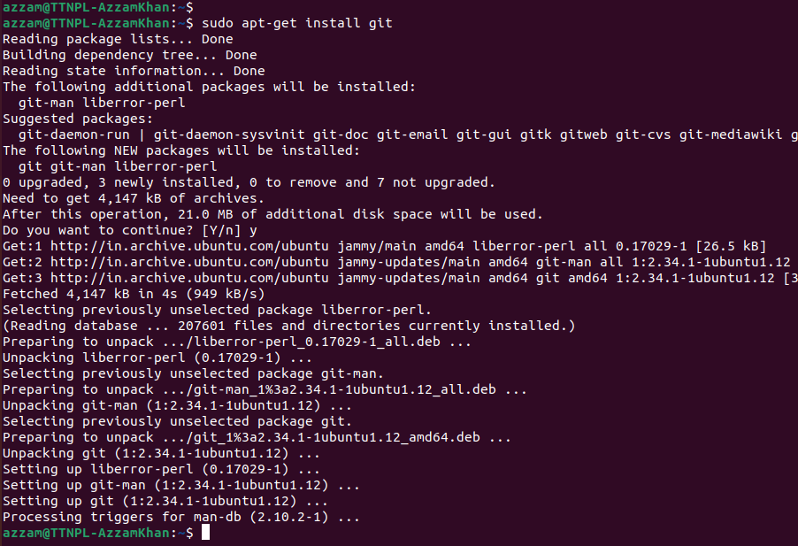

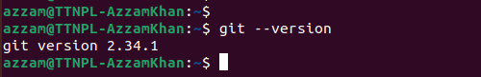



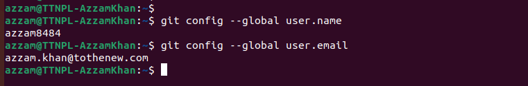

Question-2: Initialize a Git Repository

Soln.

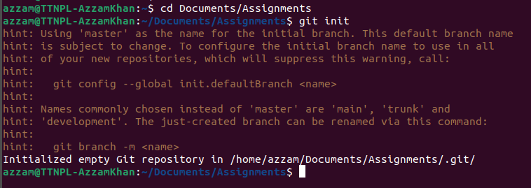

Question-3: Add files to the repository

Soln.

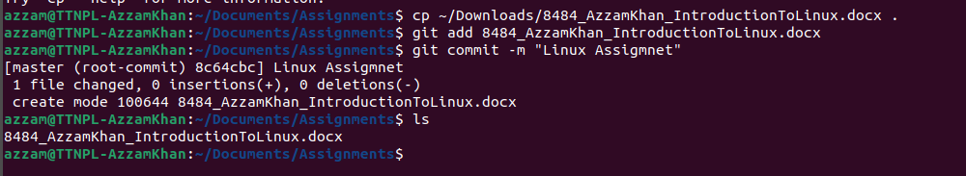

Question-4:Unstage 1 file

Soln.

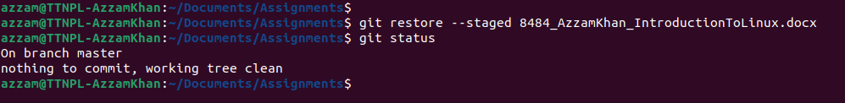

Question-5: Commit the file

Soln.

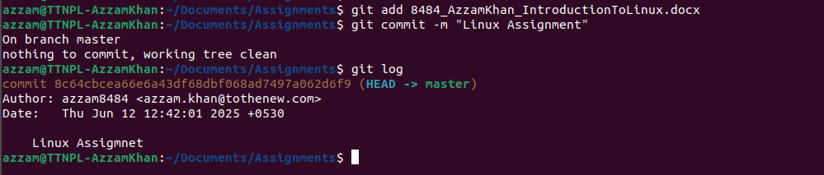

Question-6: Add a remote

Soln.



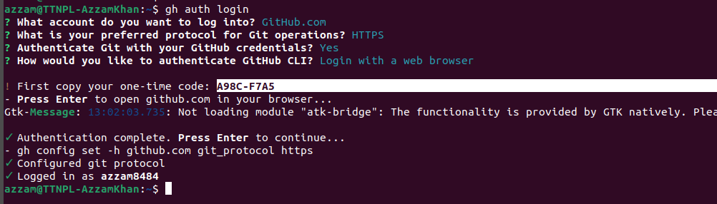



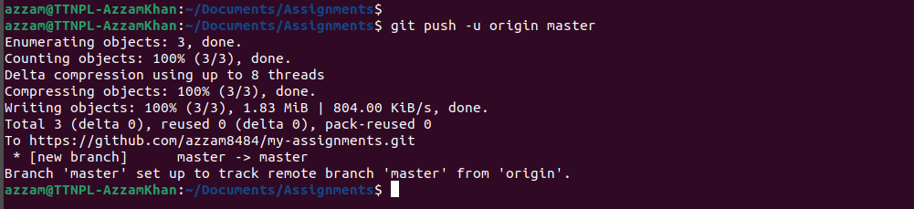

Question-7: Undo changes to a particular file

Soln.

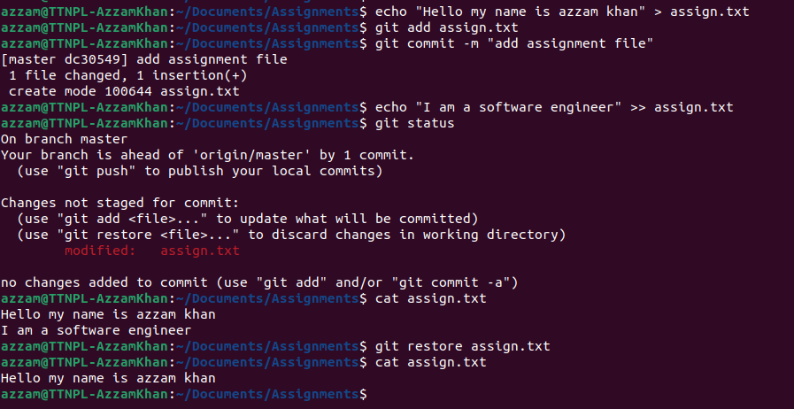

Question-8: Push changes to Github

Soln.

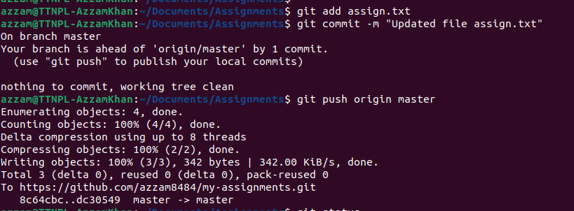

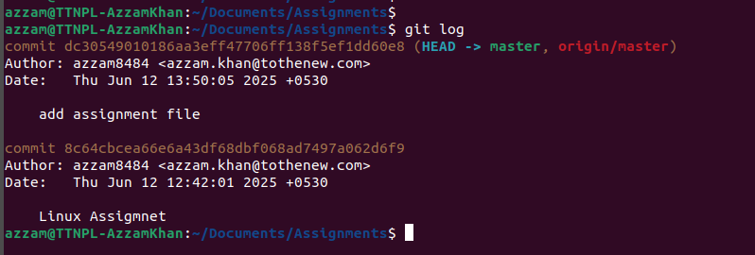

Question-9: Clone the repository

Soln.

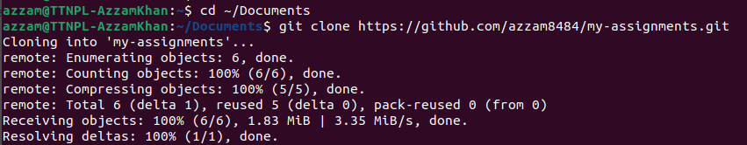

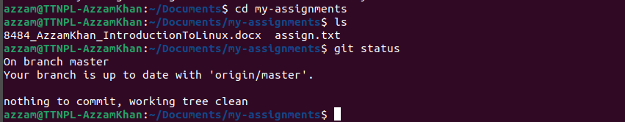

Question-10: Add changes to one of the copies and pull the changes in the other.

Soln.

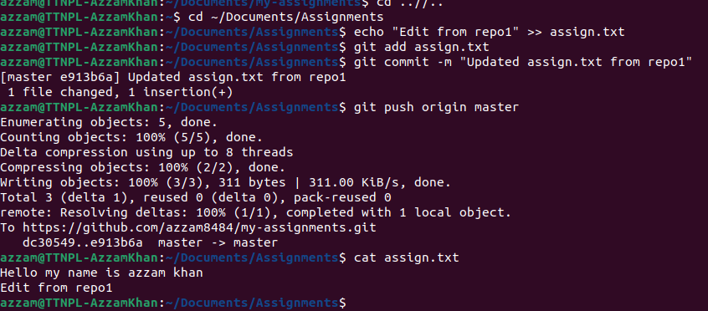

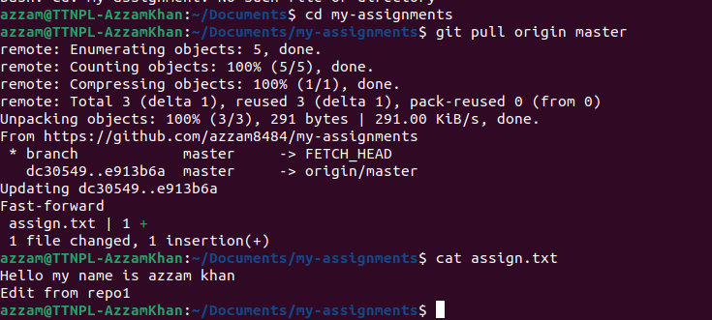

Question-11: Check differences between a file and its staged version

Soln.

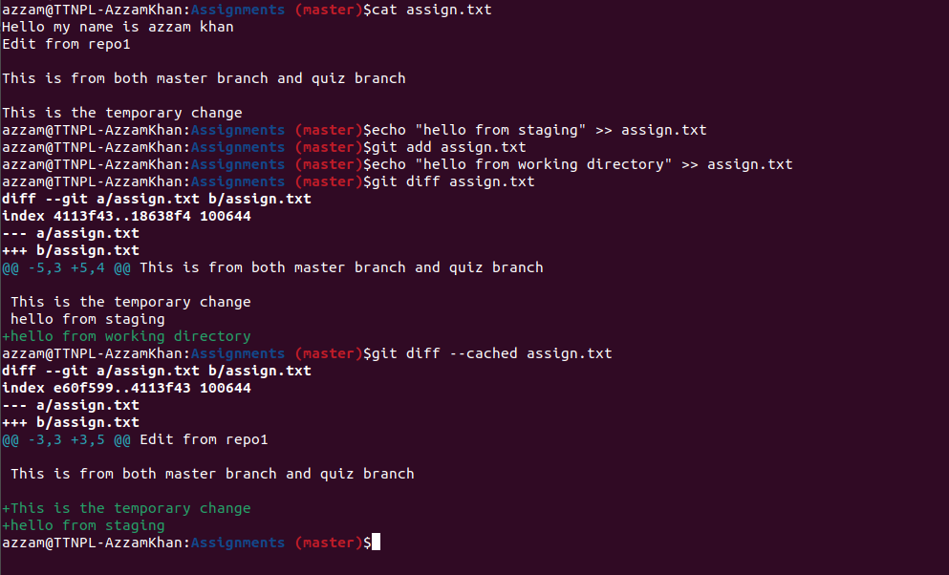

Question-12: Ignore a few files to be checked in

Soln.



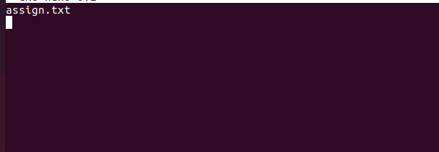

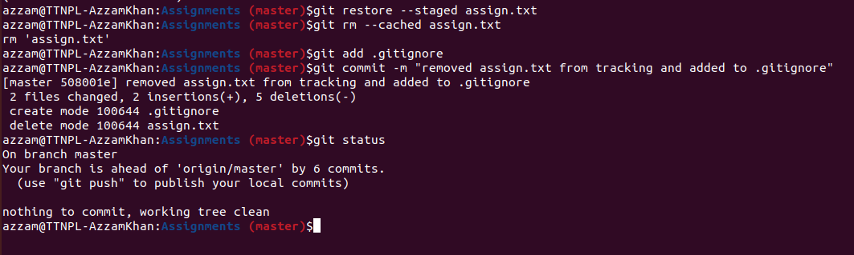

Question-13: Create a new branch

Soln.

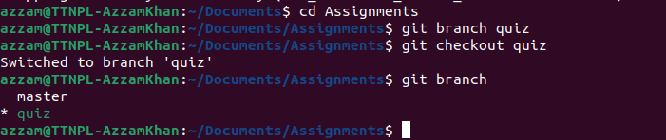

Question-14: Diverge them with commits

Soln.

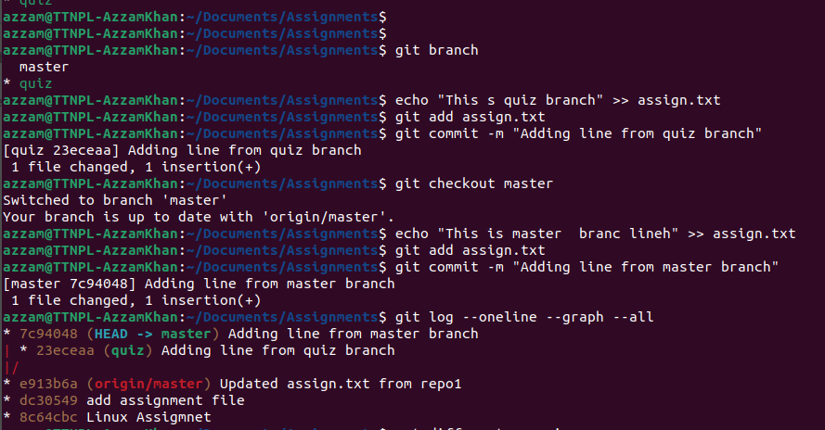

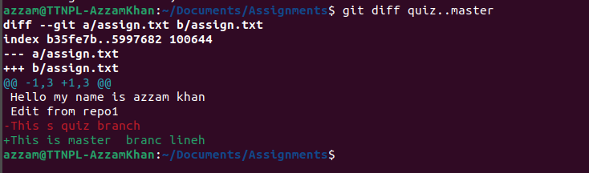

Question-15: Edit the same file at the same line on both branches and commit

Soln.

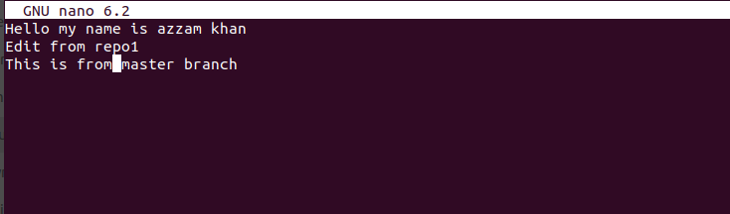

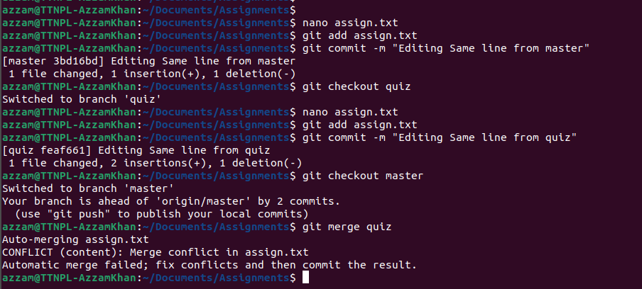

Question-16: Try merging and resolve merge conflicts

Soln.

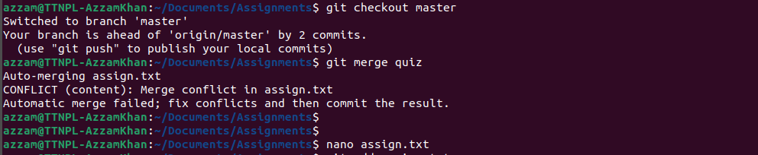

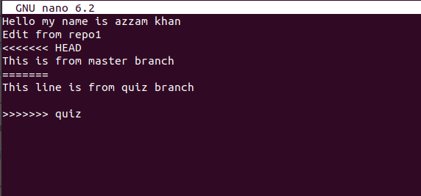

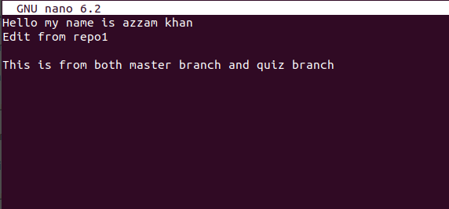

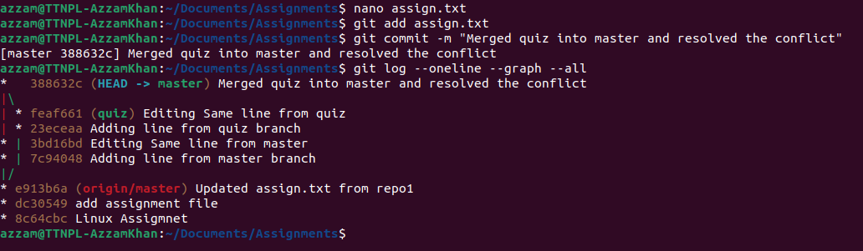

Question-17: Stash the changes and pop them.

Soln.

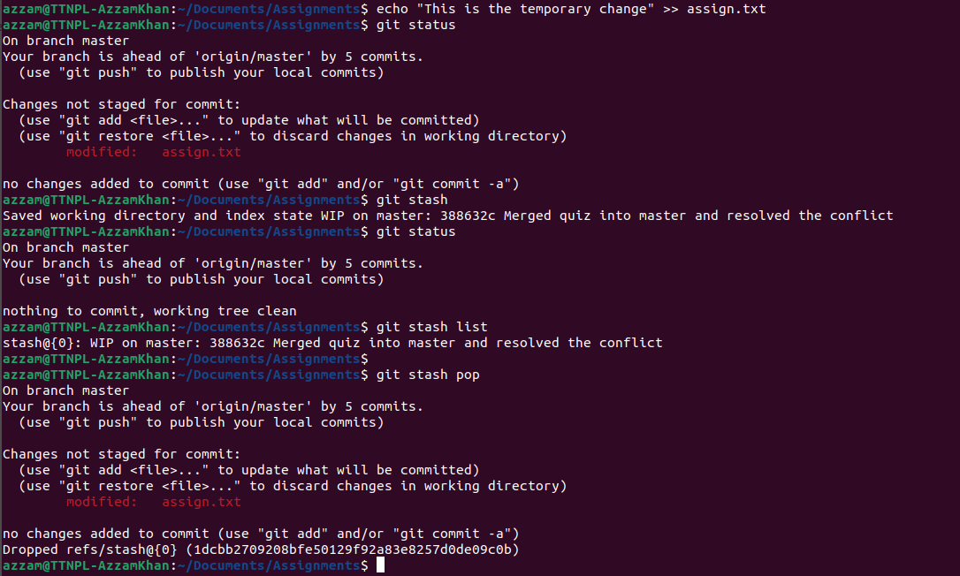

Question-18: Add the following code to your .bashrc file : color_prompt="yes" parse_git_branch() { git branch 2> /dev/null | sed -e '/^[^*]/d' -e 's/* \(.*\)/(\1)/' } if [ "$color_prompt" = yes ]; then PS1='\u@\h\[\033[00m\]:\[\033[01;34m\]\W\[\033[01;31m\] $(parse_git_branch)\[\033[00m\]\$ ' else PS1='\u@\h:\W $(parse_git_branch)\$ ' fi unset color_prompt force_color_prompt

**Soln.**

