ENTITY RELATIONSHIP DIAGRAM
& DATA MODEL SPECIFICATION
Dopamin Cafe Accounting & Inventory System
Logical PostgreSQL ERD • Based on SRS v0.1 and current Google Form/Excel sources

Item | Value
Document ID | ERD-DOPAMIN-ACCINV
Version | 0.1 — Logical Baseline
Target DB | PostgreSQL (Neon initially; provider-portable)
Primary Keys | UUID
Money Type | NUMERIC(18,2)
Quantity Type | NUMERIC(18,3)
Business Timezone | Asia/Jakarta
Operating Hours | 10:00–21:30

Design principle: Google Sheets remains raw operational evidence. PostgreSQL stores normalized effective data, accounting/fund transactions, workflow, inventory, report snapshots, corrections, and audit history.

1. ERD Design Decisions
- One normalized application database: Google Sheets is not treated as the reporting database.
- Raw source is immutable. Corrections are recorded separately and change the effective normalized value without deleting original evidence.
- All balances, totals, variance, and report KPIs are derived/system-generated; users never edit a balance directly.
- Housebank and Cashier Cash are separate internal fund accounts. Company → Housebank is funding, while Housebank → Cashier is an internal transfer.
- Food/Beverage sales remain separate from payment methods. Food + Beverage measures category sales; Cash/QRIS/Transfer measures settlement/payment mix.
- Menu prices are versioned by effective date so historical sales do not change when prices are updated.
- Financial deletion uses VOID/reversal semantics. Audit logs are append-only.
- Daily email runs are immutable snapshots with revisions; previously sent reports are not silently rewritten.
- Physical implementation should use CHECK constraints and service-layer validation rather than PostgreSQL ENUMs, improving migration portability between PostgreSQL providers.

1.1 Main Domains
Domain | Core Tables | Purpose
Access & RBAC | roles, permissions, role_permissions, users | Application authorization for Owner, Director, Manager, Cashier, Kitchen.
Integration | data_sources, raw_submissions, source_field_mappings, sync_runs | Google Form/Sheet ingestion, idempotency, traceability, retries.
Master | chart_of_accounts, payment_methods, expense_categories, menu_items, menu_price_history, fund_accounts | Controlled master/reference data.
Cashier & Sales | cashier_reports, payment_lines, cashier_expense_lines, cash_counts, sales_reports, sales_report_items | Normalized operational sales/cash data.
Finance & Purchase | fund_transactions, purchase_requests/items/actions/receipts, journal_entries/lines | Housebank, operational spending, approval, double-entry-ready accounting.
Inventory | inventory_items, stock_opname_sessions/lines | MVP stock opname and variance.
Reporting | daily_closings, report settings/recipients/runs/deliveries | Completeness, daily KPI snapshot, configurable email.
Governance | data_corrections/items, audit_logs, system_settings | Correction history, detailed changes, settings history.

1.2 SRS Refinement
The SRS concept “daily_metrics” is intentionally not a manually editable base table in this ERD. Daily dashboard metrics should be produced from SQL views/queries; only closing snapshots and sent-report snapshots are persisted. A regenerable cache may be added later if performance requires it.

2. Cashier, Sales, Menu & Payment ERD
This view shows how wide Google Form rows are normalized into payment, expense, cash-count, and menu-item sales lines.
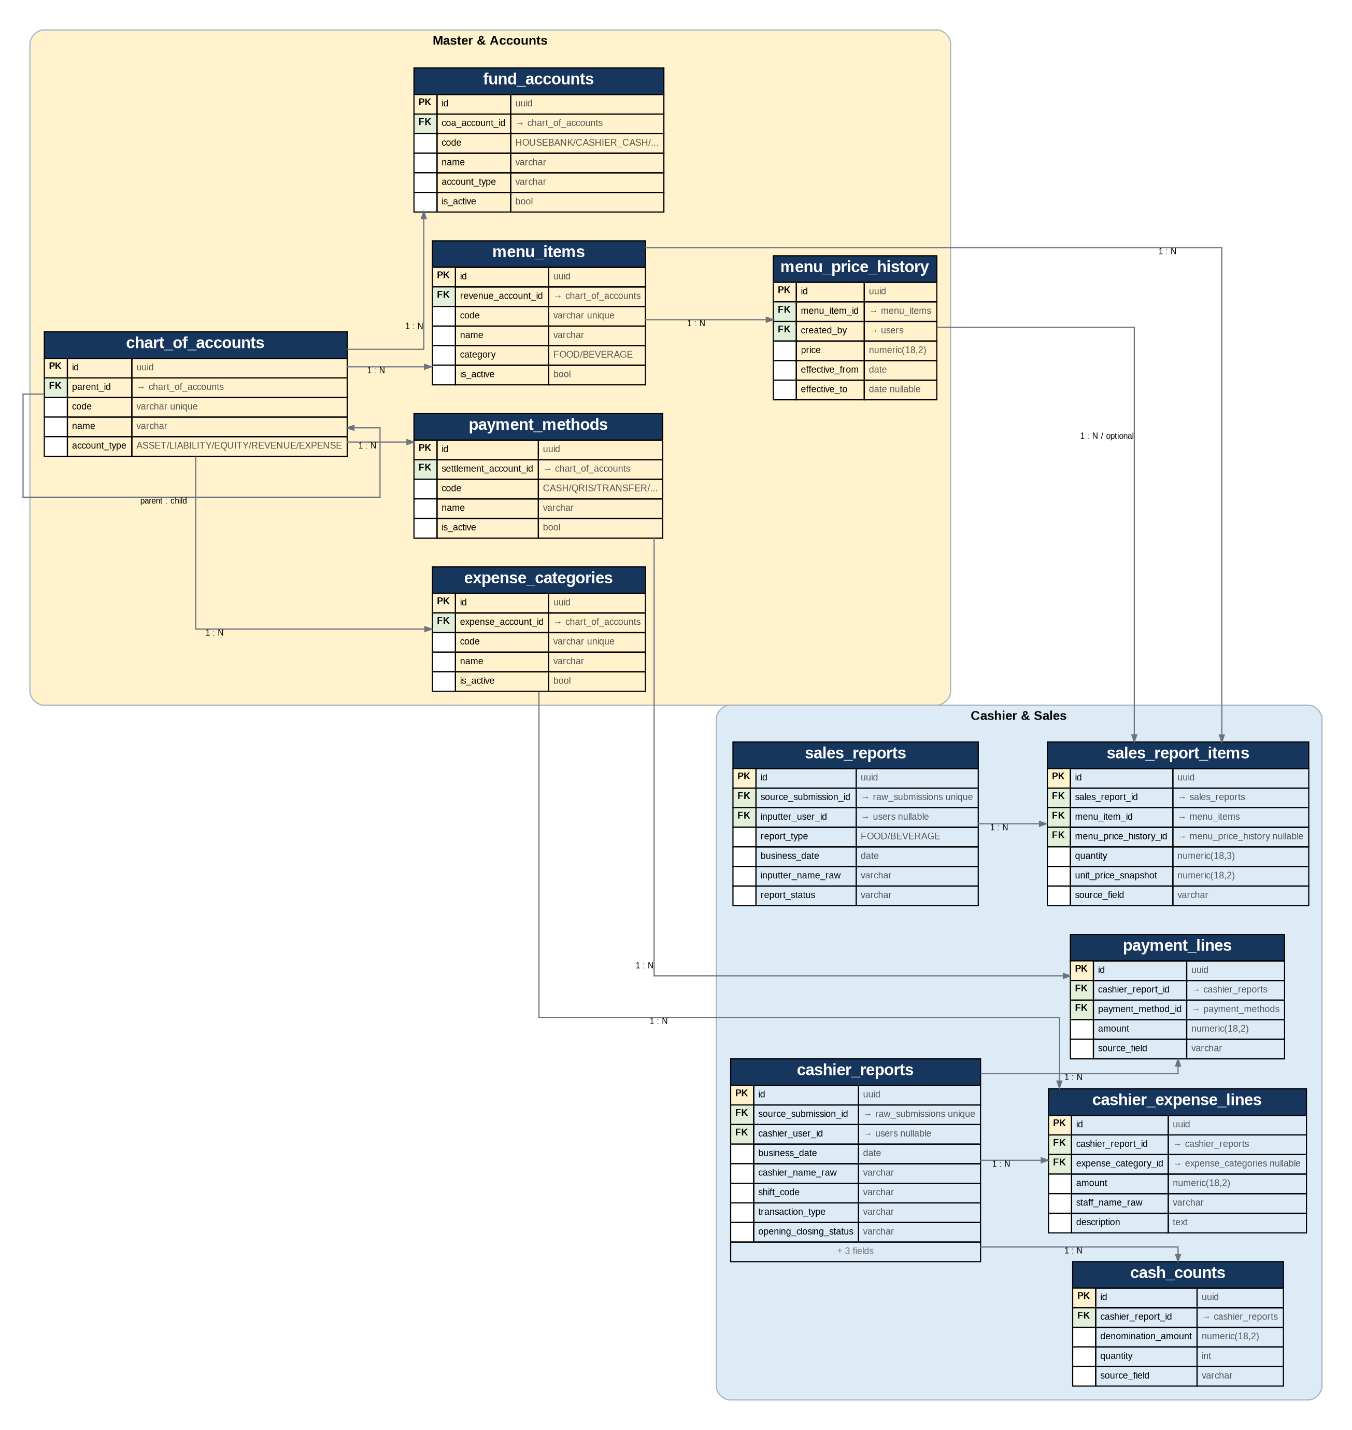

3. Finance, Purchase Request & Accounting ERD
This view separates Housebank/Cashier fund movements from revenue and provides a double-entry-ready journal layer.
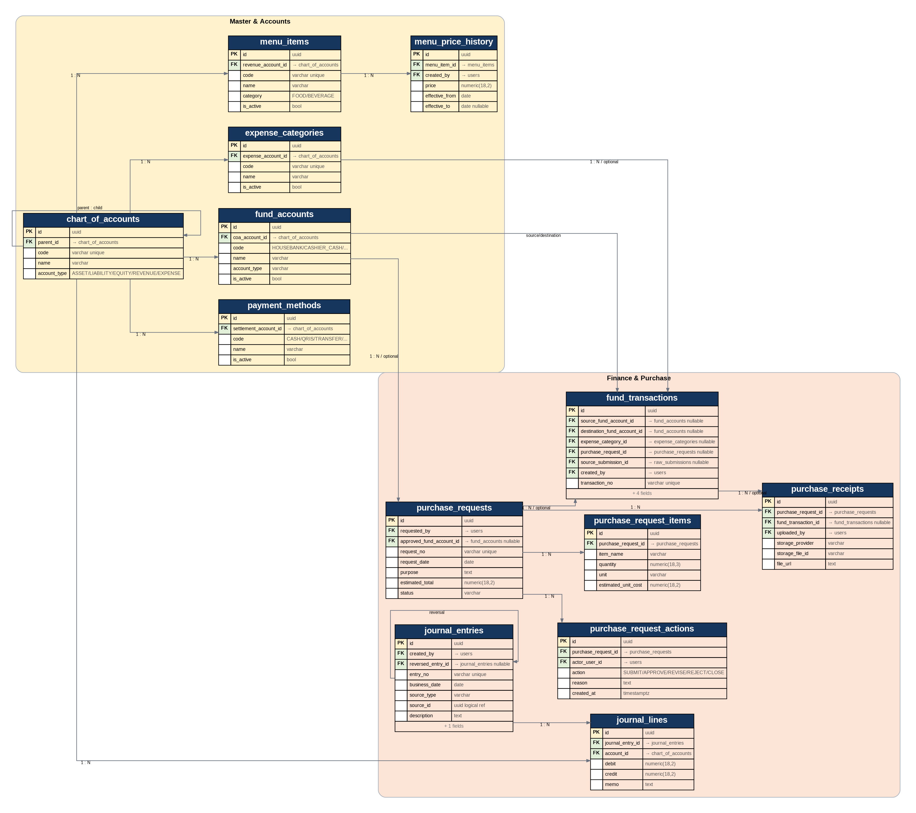

4. Integration, Access, Reporting & Governance ERD
This view covers raw source ingestion, roles, report scheduling, report revisions, corrections, settings, and append-only audit history.
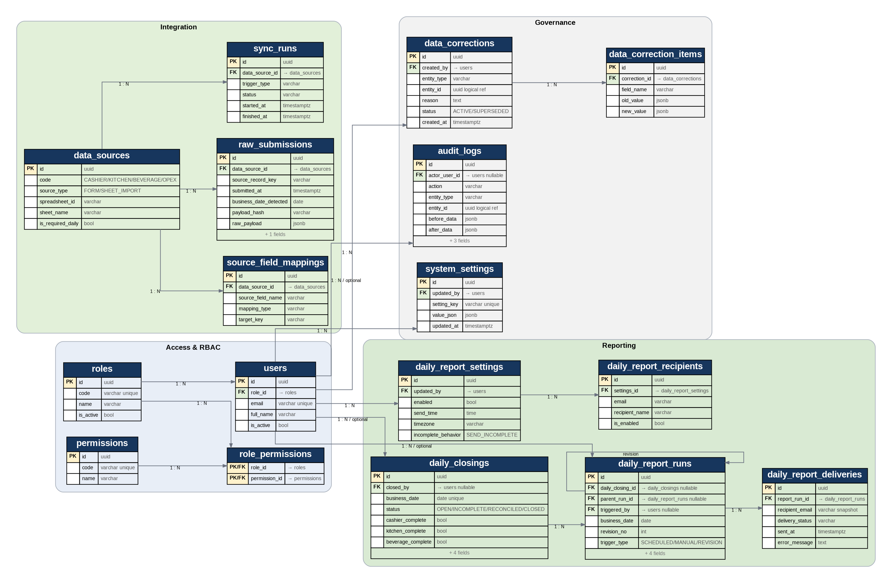

5. Inventory & Daily Reporting ERD
Stock opname is intentionally simple in MVP; recipe/BOM is excluded.
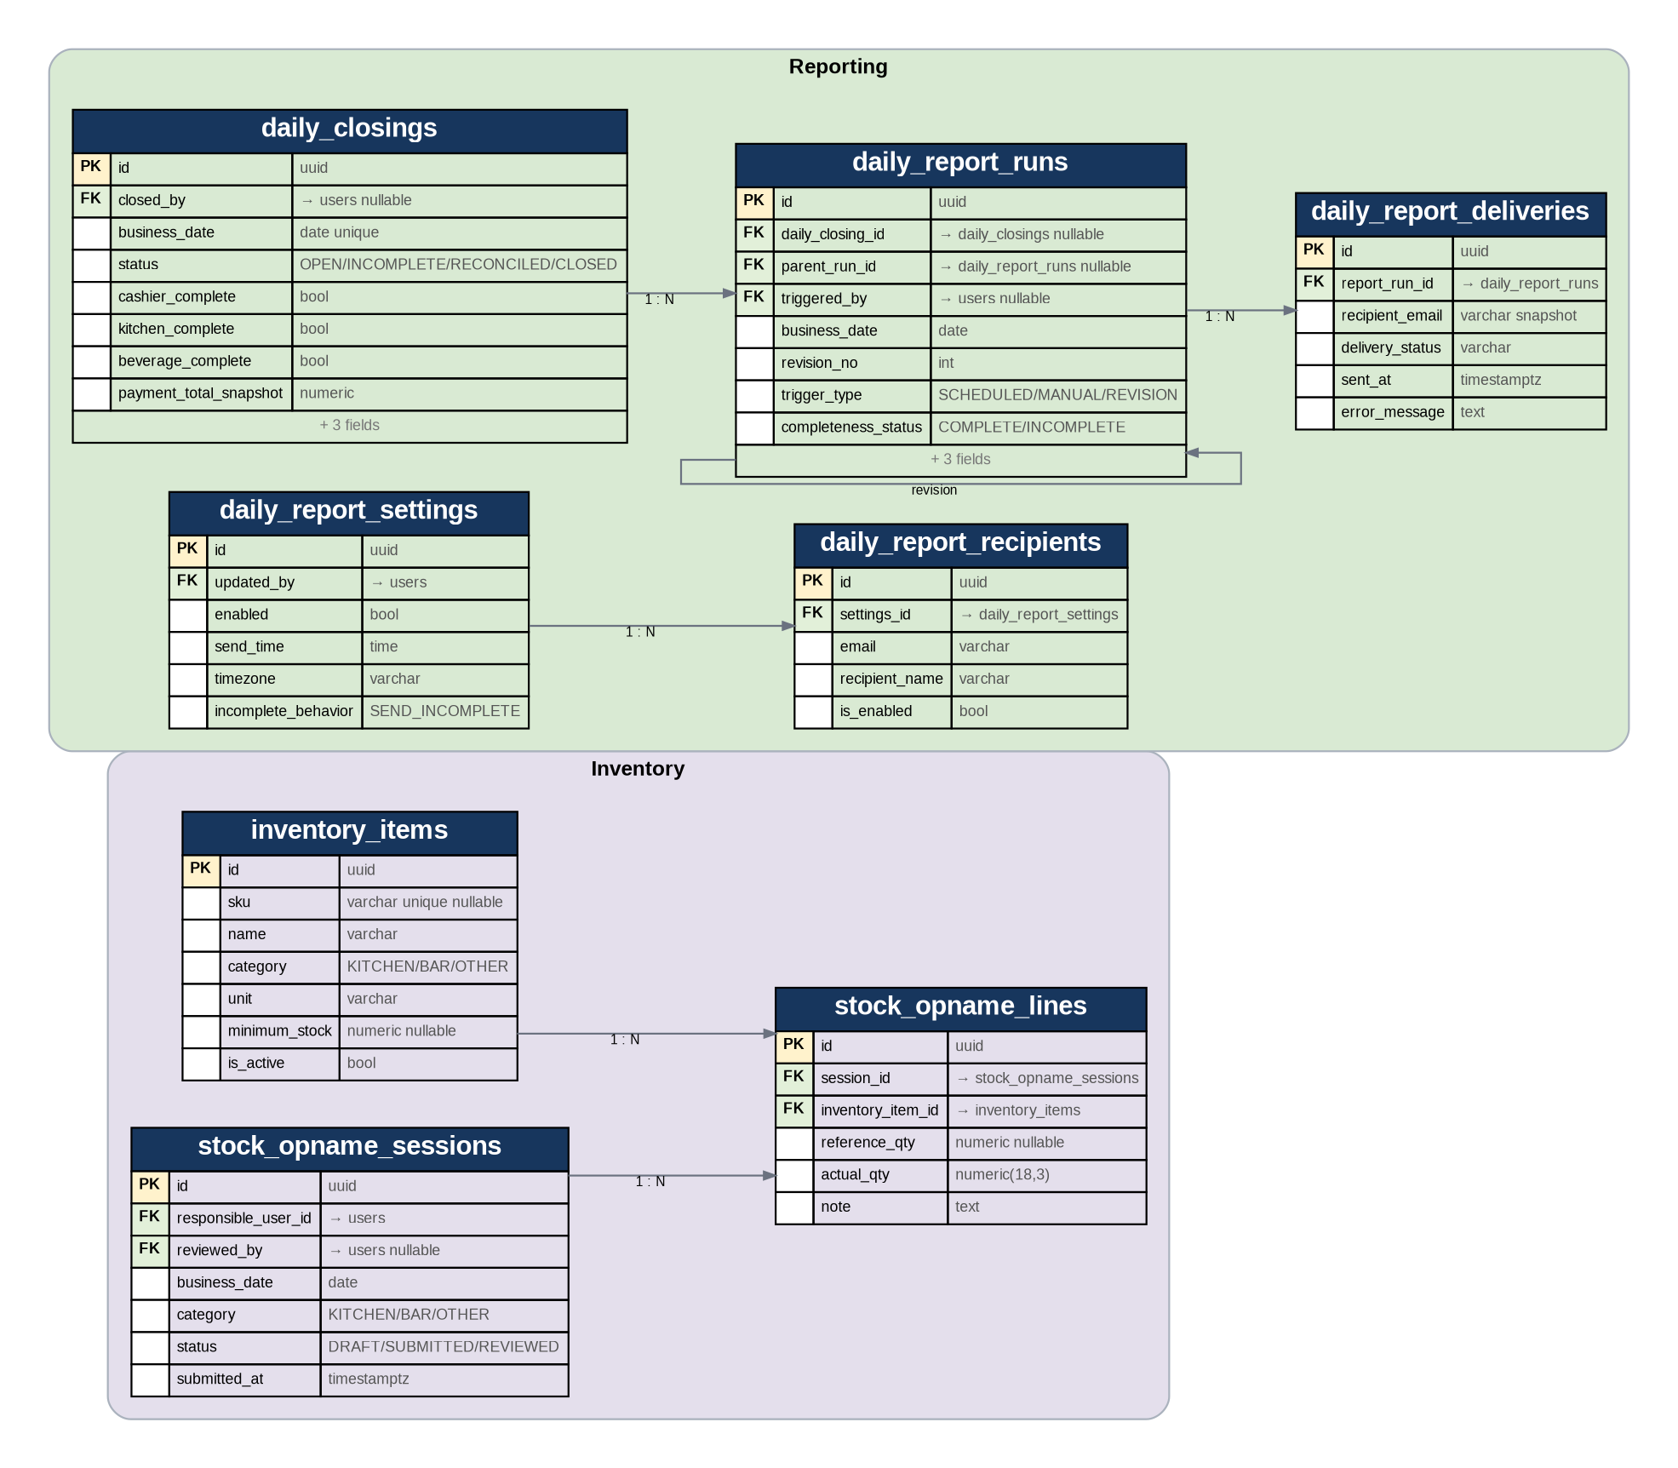

6. Table Dictionary — Access & Integration
Table | Key Fields / Logical Meaning
roles | PK id: uuid; code: varchar unique; name: varchar; is_active: bool
permissions | PK id: uuid; code: varchar unique; name: varchar
role_permissions | PK/FK role_id: → roles; PK/FK permission_id: → permissions
users | PK id: uuid; FK role_id: → roles; email: varchar unique; full_name: varchar; is_active: bool
data_sources | PK id: uuid; code: CASHIER/KITCHEN/BEVERAGE/OPEX; source_type: FORM/SHEET_IMPORT; spreadsheet_id: varchar; sheet_name: varchar; is_required_daily: bool
source_field_mappings | PK id: uuid; FK data_source_id: → data_sources; source_field_name: varchar; mapping_type: varchar; target_key: varchar
raw_submissions | PK id: uuid; FK data_source_id: → data_sources; source_record_key: varchar; submitted_at: timestamptz; business_date_detected: date; payload_hash: varchar; raw_payload: jsonb; processing_status: varchar
sync_runs | PK id: uuid; FK data_source_id: → data_sources; trigger_type: varchar; status: varchar; started_at: timestamptz; finished_at: timestamptz

6.1 Integration Constraints
- UNIQUE(data_source_id, source_record_key) on raw_submissions to prevent duplicate ingestion.
- payload_hash is stored to detect changed source content and safe reprocessing.
- raw_payload is JSONB and must never be destructively overwritten by user corrections.
- source_field_mappings allows Google Form column names such as “Pembayaran Cash 2” to map to a normalized target key without hard-coding every report query.
- Beverage source is considered final only after the form contains explicit Business Date / Tanggal Penjualan.

7. Table Dictionary — Master, Cashier & Sales
Table | Key Fields / Logical Meaning
chart_of_accounts | PK id: uuid; FK parent_id: → chart_of_accounts; code: varchar unique; name: varchar; account_type: ASSET/LIABILITY/EQUITY/REVENUE/EXPENSE
payment_methods | PK id: uuid; FK settlement_account_id: → chart_of_accounts; code: CASH/QRIS/TRANSFER/...; name: varchar; is_active: bool
expense_categories | PK id: uuid; FK expense_account_id: → chart_of_accounts; code: varchar unique; name: varchar; is_active: bool
menu_items | PK id: uuid; FK revenue_account_id: → chart_of_accounts; code: varchar unique; name: varchar; category: FOOD/BEVERAGE; is_active: bool
menu_price_history | PK id: uuid; FK menu_item_id: → menu_items; FK created_by: → users; price: numeric(18,2); effective_from: date; effective_to: date nullable
fund_accounts | PK id: uuid; FK coa_account_id: → chart_of_accounts; code: HOUSEBANK/CASHIER_CASH/...; name: varchar; account_type: varchar; is_active: bool
cashier_reports | PK id: uuid; FK source_submission_id: → raw_submissions unique; FK cashier_user_id: → users nullable; business_date: date; cashier_name_raw: varchar; shift_code: varchar; transaction_type: varchar; opening_closing_status: varchar; petty_cash_amount: numeric; cash_outside_petty_amount: numeric; report_status: varchar
payment_lines | PK id: uuid; FK cashier_report_id: → cashier_reports; FK payment_method_id: → payment_methods; amount: numeric(18,2); source_field: varchar
cashier_expense_lines | PK id: uuid; FK cashier_report_id: → cashier_reports; FK expense_category_id: → expense_categories nullable; amount: numeric(18,2); staff_name_raw: varchar; description: text
cash_counts | PK id: uuid; FK cashier_report_id: → cashier_reports; denomination_amount: numeric(18,2); quantity: int; source_field: varchar
sales_reports | PK id: uuid; FK source_submission_id: → raw_submissions unique; FK inputter_user_id: → users nullable; report_type: FOOD/BEVERAGE; business_date: date; inputter_name_raw: varchar; report_status: varchar
sales_report_items | PK id: uuid; FK sales_report_id: → sales_reports; FK menu_item_id: → menu_items; FK menu_price_history_id: → menu_price_history nullable; quantity: numeric(18,3); unit_price_snapshot: numeric(18,2); source_field: varchar

7.1 Cashier Normalization Rules
- One Google Form row maps to one cashier_reports row; one business date may contain multiple cashier_reports rows.
- Duplicate branch fields (Cash/Cash 2, QRIS/QRIS 2, etc.) become normalized payment_lines. Empty branch columns do not create rows.
- Expense fields become cashier_expense_lines. Source field name is retained for traceability.
- Cash denominations become cash_counts(denomination_amount, quantity); actual cash is calculated from these lines.
- Cashier expected cash and variance are not stored as editable source fields; they are derived in closing/reconciliation logic.
- Kitchen/Beverage wide columns are unpivoted into sales_report_items. unit_price_snapshot is taken from the price history effective on Business Date.

8. Table Dictionary — Finance, Purchase & Accounting
Table | Key Fields / Logical Meaning
fund_transactions | PK id: uuid; FK source_fund_account_id: → fund_accounts nullable; FK destination_fund_account_id: → fund_accounts nullable; FK expense_category_id: → expense_categories nullable; FK purchase_request_id: → purchase_requests nullable; FK source_submission_id: → raw_submissions nullable; FK created_by: → users; transaction_no: varchar unique; business_date: date; transaction_type: FUNDING/TRANSFER/EXPENSE/...; amount: numeric(18,2); status: POSTED/VOID
purchase_requests | PK id: uuid; FK requested_by: → users; FK approved_fund_account_id: → fund_accounts nullable; request_no: varchar unique; request_date: date; purpose: text; estimated_total: numeric(18,2); status: varchar
purchase_request_items | PK id: uuid; FK purchase_request_id: → purchase_requests; item_name: varchar; quantity: numeric(18,3); unit: varchar; estimated_unit_cost: numeric(18,2)
purchase_request_actions | PK id: uuid; FK purchase_request_id: → purchase_requests; FK actor_user_id: → users; action: SUBMIT/APPROVE/REVISE/REJECT/CLOSE; reason: text; created_at: timestamptz
purchase_receipts | PK id: uuid; FK purchase_request_id: → purchase_requests; FK fund_transaction_id: → fund_transactions nullable; FK uploaded_by: → users; storage_provider: varchar; storage_file_id: varchar; file_url: text
journal_entries | PK id: uuid; FK created_by: → users; FK reversed_entry_id: → journal_entries nullable; entry_no: varchar unique; business_date: date; source_type: varchar; source_id: uuid logical ref; description: text; status: POSTED/VOID
journal_lines | PK id: uuid; FK journal_entry_id: → journal_entries; FK account_id: → chart_of_accounts; debit: numeric(18,2); credit: numeric(18,2); memo: text

8.1 Fund Transaction Rules
transaction_type | Required Direction | Accounting Meaning
EXTERNAL_FUNDING | destination = HOUSEBANK; source internal account = NULL | Company cash injected into cafe operational fund; not sales revenue.
INTERNAL_TRANSFER | source + destination internal accounts are both required and different | Example Housebank → Cashier; not revenue and not expense.
EXPENSE | source internal account required; destination NULL; expense category required | Operational cash outflow.
OPENING_BALANCE | destination internal account required | Migration/initialization only; controlled by leadership/admin.
ADJUSTMENT | requires reason + audit and elevated permission | Exceptional correction; use sparingly.

8.2 Journal Layer
- journal_entries + journal_lines form the accounting ledger. Each posted entry must balance total debit = total credit.
- source_type + source_id is a logical polymorphic reference to the originating business event. This avoids many nullable source FKs and keeps the journal extensible.
- Sales auto-posting should be enabled only after daily category sales and payment totals pass reconciliation; until Moka integration exists, discrepancies must remain visible rather than forced into a false balanced sale.
- Voiding a posted journal uses reversal/reversed_entry_id; history is preserved.

9. Table Dictionary — Inventory, Reporting & Governance
Table | Key Fields / Logical Meaning
inventory_items | PK id: uuid; sku: varchar unique nullable; name: varchar; category: KITCHEN/BAR/OTHER; unit: varchar; minimum_stock: numeric nullable; is_active: bool
stock_opname_sessions | PK id: uuid; FK responsible_user_id: → users; FK reviewed_by: → users nullable; business_date: date; category: KITCHEN/BAR/OTHER; status: DRAFT/SUBMITTED/REVIEWED; submitted_at: timestamptz
stock_opname_lines | PK id: uuid; FK session_id: → stock_opname_sessions; FK inventory_item_id: → inventory_items; reference_qty: numeric nullable; actual_qty: numeric(18,3); note: text
daily_closings | PK id: uuid; FK closed_by: → users nullable; business_date: date unique; status: OPEN/INCOMPLETE/RECONCILED/CLOSED; cashier_complete: bool; kitchen_complete: bool; beverage_complete: bool; payment_total_snapshot: numeric; sales_total_snapshot: numeric; sales_payment_difference: numeric; cash_variance_snapshot: numeric
daily_report_settings | PK id: uuid; FK updated_by: → users; enabled: bool; send_time: time; timezone: varchar; incomplete_behavior: SEND_INCOMPLETE
daily_report_recipients | PK id: uuid; FK settings_id: → daily_report_settings; email: varchar; recipient_name: varchar; is_enabled: bool
daily_report_runs | PK id: uuid; FK daily_closing_id: → daily_closings nullable; FK parent_run_id: → daily_report_runs nullable; FK triggered_by: → users nullable; business_date: date; revision_no: int; trigger_type: SCHEDULED/MANUAL/REVISION; completeness_status: COMPLETE/INCOMPLETE; metrics_snapshot: jsonb; missing_sources: jsonb; status: varchar
daily_report_deliveries | PK id: uuid; FK report_run_id: → daily_report_runs; recipient_email: varchar snapshot; delivery_status: varchar; sent_at: timestamptz; error_message: text
data_corrections | PK id: uuid; FK created_by: → users; entity_type: varchar; entity_id: uuid logical ref; reason: text; status: ACTIVE/SUPERSEDED; created_at: timestamptz
data_correction_items | PK id: uuid; FK correction_id: → data_corrections; field_name: varchar; old_value: jsonb; new_value: jsonb
audit_logs | PK id: uuid; FK actor_user_id: → users nullable; action: varchar; entity_type: varchar; entity_id: uuid logical ref; before_data: jsonb; after_data: jsonb; reason: text; source: WEB/SYNC/JOB; created_at: timestamptz
system_settings | PK id: uuid; FK updated_by: → users; setting_key: varchar unique; value_json: jsonb; updated_at: timestamptz

9.1 Report Snapshot Rules
- daily_closings has one row per Business Date and stores system-generated reconciliation/completeness snapshots; snapshot fields are read-only to users.
- daily_report_runs is versioned by (business_date, revision_no). A revised email creates a new run and parent_run_id points to the previous run.
- metrics_snapshot and source snapshot metadata preserve what was sent even if later corrections change effective operational data.
- daily_report_deliveries stores recipient_email as a snapshot so historical delivery remains correct even if settings recipients are later changed.
- data_corrections is the correction action header; data_correction_items captures field-level old/new values. audit_logs separately records the full system action trail.

10. Key Cardinalities & Integrity Rules
Relationship | Cardinality | Rule
roles → users | 1 : N | Each application user has one active role in MVP.
roles ↔ permissions | M : N | Resolved through role_permissions.
data_sources → raw_submissions | 1 : N | One source contains many source rows/submissions.
raw_submissions → cashier_reports | 1 : 0..1 | Only Cashier source rows normalize into a cashier report.
raw_submissions → sales_reports | 1 : 0..1 | Kitchen/Beverage source rows normalize into a sales report.
cashier_reports → payment_lines | 1 : N | One submission can contain multiple payment methods.
cashier_reports → cashier_expense_lines | 1 : N | One submission can contain multiple expense categories.
cashier_reports → cash_counts | 1 : N | Denomination lines for cash closing.
sales_reports → sales_report_items | 1 : N | Wide product columns are unpivoted.
menu_items → menu_price_history | 1 : N | Historical prices are retained.
purchase_requests → purchase_request_actions | 1 : N | Approval/revision/reject history is immutable.
purchase_requests → fund_transactions | 1 : N optional | Actual spend may consist of one or multiple transactions.
stock_opname_sessions → stock_opname_lines | 1 : N | One session contains many inventory item counts.
daily_report_settings → recipients | 1 : N | One schedule can send to multiple emails.
daily_report_runs → deliveries | 1 : N | Delivery result is tracked per recipient snapshot.
data_corrections → correction_items | 1 : N | One correction action can change multiple fields.
journal_entries → journal_lines | 1 : N | At least two lines are normally required for balanced double entry.

10.1 Non-Negotiable Constraints
- All monetary amount columns: amount >= 0; direction comes from transaction type/account side, not negative numbers.
- fund_transactions INTERNAL_TRANSFER requires both source and destination, and they cannot be the same account.
- No hard delete for posted financial transactions, journal entries, purchase approval history, report runs, corrections, or audit logs.
- sales_report_items UNIQUE(sales_report_id, menu_item_id).
- cash_counts UNIQUE(cashier_report_id, denomination_amount).
- stock_opname_lines UNIQUE(session_id, inventory_item_id).
- daily_report_runs UNIQUE(business_date, revision_no).
- menu_price_history must not contain overlapping effective periods for the same menu item.
- A normalized Cashier/Sales report must reference exactly one raw source submission; source_submission_id is unique within each normalized report table.

11. Recommended Indexes & SQL Views

11.1 High-Value Indexes
Table | Index / Unique Key | Reason
raw_submissions | UNIQUE(data_source_id, source_record_key) | Idempotent ingestion.
raw_submissions | INDEX(processing_status, first_seen_at) | Retry/error queue.
cashier_reports | INDEX(business_date, shift_code, report_status) | Daily cashier filtering.
payment_lines | INDEX(payment_method_id, cashier_report_id) | Payment mix aggregation.
sales_reports | INDEX(business_date, report_type, report_status) | Food/Beverage daily aggregation.
sales_report_items | INDEX(menu_item_id, sales_report_id) | Product trend/top seller.
menu_price_history | INDEX(menu_item_id, effective_from DESC) | Resolve effective price quickly.
fund_transactions | INDEX(business_date, status) | Daily Housebank/operational report.
fund_transactions | INDEX(source_fund_account_id, destination_fund_account_id) | Account balance queries.
stock_opname_sessions | INDEX(business_date, category, status) | Stock report filtering.
audit_logs | INDEX(created_at DESC); INDEX(entity_type, entity_id); INDEX(actor_user_id, created_at DESC) | Fast audit investigation.
daily_report_runs | UNIQUE(business_date, revision_no) | Immutable versioned report.

11.2 Recommended Views (Not Source-of-Truth Tables)
View | Purpose
vw_daily_sales_summary | Food, Beverage, quantity, revenue by Business Date.
vw_daily_payment_summary | Cash, QRIS, Transfer, Card, DP, Receivable, Promotion totals.
vw_daily_cashier_expenses | Cashier outflow by category and staff.
vw_housebank_ledger | Housebank inflow/outflow and running balance.
vw_cashier_cash_reconciliation | Expected cash, denomination actual cash, variance.
vw_daily_completeness | Cashier/Kitchen/Beverage availability for report status.
vw_daily_management_report | Unified query consumed by dashboard/email report generation.
If dashboard volume later grows, these views may be backed by a materialized/cache table. That cache remains regenerable and never becomes a manually editable financial source of truth.

12. Existing Spreadsheet → ERD Mapping
Existing Source | Primary ERD Target | Important Mapping Rule
Cashier Report | raw_submissions → cashier_reports → payment_lines / cashier_expense_lines / cash_counts | Tanggal Pelaporan = Business Date; branch payment fields are normalized; helper text is ignored/flagged.
Daily Sales Kitchen | raw_submissions → sales_reports(FOOD) → sales_report_items | Tanggal penjualan = Business Date; menu columns are unpivoted; price resolved by date.
Daily Sales Beverage | raw_submissions → sales_reports(BEVERAGE) → sales_report_items | Add Tanggal Penjualan before production; Barista maps to inputter.
OPEX Report | raw_submissions (historical import) → fund_transactions | Debit company funding → Housebank inflow; Kredit → operational outflow; spreadsheet Balance is validation only, not imported as editable balance.

12.1 Example: Incorrect Cash Input Correction
Step | Entity | Behavior
1 | raw_submissions | Original Google Form payload contains Cash = Rp400,000,000. Raw row stays unchanged.
2 | cashier_reports/payment_lines | Normalized CASH line initially has effective amount Rp400,000,000 and is flagged NEEDS_REVIEW.
3 | data_corrections | Manager/authorized user submits reason “salah input dua angka nol”.
4 | data_correction_items | old_value = 400,000,000; new_value = 4,000,000.
5 | payment_lines | Effective normalized value becomes Rp4,000,000 inside one DB transaction.
6 | audit_logs | Records actor, field, before/after, reason, timestamp, source=WEB.
7 | daily_closings / report views | Totals and variance are recalculated automatically; balance itself was never directly edited.
8 | APP_CORRECTIONS Sheet (integration behavior) | Correction can be mirrored to a dedicated correction sheet; original Form Responses row remains intact.

13. ERD Baseline Decisions to Carry into Physical Schema
- Use UUID PKs. For audit_logs, UUID is acceptable; BIGINT may be used later only if performance justifies it.
- Use NUMERIC(18,2) for IDR money and NUMERIC(18,3) for stock/quantity to support non-integer inventory units.
- Use timestamptz for event times and date for Business Date.
- Use JSONB only for raw payload, snapshots, flexible setting value, and before/after audit/correction data; core financial relationships remain relational columns/FKs.
- Use ON DELETE RESTRICT for transactional FK relationships. Master records are deactivated rather than deleted when already referenced.
- Use database transactions for every correction/void/approval/fund movement that writes more than one table.
- Audit creation must occur in the same transaction as the business mutation wherever practical.
- PostgreSQL schema must not rely on Neon-only functions so migration to another PostgreSQL provider remains feasible.
Next design artifact after this ERD: Physical Database Schema/DDL + seed master data, then Permission Matrix and screen-by-screen specification.

