SOFTWARE DESIGN
DESCRIPTION
Dopamin Cafe Accounting & Inventory System
Architecture • Modules • Integration • Accounting Engine • Reporting • Security • Operations

Document ID | SDD-DOPAMIN-ACCINV
Version | 0.1 - Technical Design Baseline
Parent Documents | SRS v0.1; ERD & Data Model v0.1
Architecture Style | Modular Monolith / Full-stack Next.js
Business Timezone | Asia/Jakarta
Operating Hours | 10:00 - 21:30
Database Baseline | PostgreSQL (initial provider may be Neon; provider-independent core)
Status | Ready for UI/UX, API, Physical Schema, and Implementation Detail

This document describes HOW the approved SRS and ERD are to be implemented. It does not replace the SRS; business behavior remains governed by the SRS and the logical data model remains governed by the ERD.

Document Control
Version | Status | Description
0.1 | Technical Design Baseline | Initial SDD derived from SRS v0.1 and ERD v0.1. Establishes modular-monolith architecture, integration patterns, accounting posting model, scheduler design, security, and deployment baseline.

Design Authority
Artifact | Authority
SRS v0.1 | Business requirements and acceptance behavior.
ERD v0.1 | Logical data entities, relationships, cardinalities, integrity direction.
SDD v0.1 | Technical architecture, component responsibilities, workflows, error handling, runtime and security design.
Upcoming UI/UX Spec | Visual behavior, navigation, screen states, component-level interaction.
Upcoming API & Physical DB Specs | Concrete endpoint contracts and executable PostgreSQL/Drizzle schema.

Contents
- 1. Design Goals and Constraints
- 2. Architecture Overview
- 3. Application Structure and Runtime Boundaries
- 4. Module / Component Design
- 5. Google Forms & Sheets Integration Design
- 6. Business Date and Daily Closing Design
- 7. Cashier and Sales Processing Design
- 8. Finance, Housebank, and Accounting Engine
- 9. Purchase Request Design
- 10. Inventory / Stock Opname Design
- 11. Correction, Void, and Audit Design
- 12. Daily Report and Email Scheduler Design
- 13. Dashboard / Query Architecture
- 14. Authentication and Authorization
- 15. API Design Conventions
- 16. Error Handling, Data Quality, and Observability
- 17. Security Design
- 18. Performance and Scalability
- 19. Backup, Recovery, and Provider Portability
- 20. Deployment and Environment Design
- 21. Source-Code Structure and Engineering Conventions
- 22. Architecture Decision Records
- 23. Traceability and Implementation Handoff
- Appendix A. State Machines
- Appendix B. Initial Accounting Mapping
Core design principle: operational staff keep using Google Forms. Google Sheets remains raw evidence; PostgreSQL becomes the normalized application source for reporting, accounting, approvals, corrections, and audit.

1. Design Goals and Constraints

1.1 Goals
- Keep operational input simple for Cashier and Kitchen by retaining Google Forms.
- Produce reliable, traceable financial and inventory reporting without treating Google Sheets as a relational database.
- Prevent silent corruption: derived totals/balances are never directly editable; corrections operate on source transactions and remain auditable.
- Use one lightweight deployable application instead of separate frontend/backend/microservices.
- Allow later migration between PostgreSQL providers with minimal code changes.
- Support future Moka integration and recipe/BOM without redesigning the entire core model.

1.2 Constraints
Constraint | Design Response
Low-cost / free-tier-first operation | Use modular monolith, serverless-friendly PostgreSQL, no Redis/queue in MVP, Apps Script for Google-native events and scheduling heartbeat.
No Moka integration in MVP | Food/Beverage revenue is analytical quantity × effective price; Cashier payment totals remain a separate reconciliation dimension.
Google Form data may contain errors | Preserve raw submission, validate, flag, correct by overlay/history rather than overwrite evidence.
Configurable daily email time | Use scheduler heartbeat and backend due-check rather than hard-coding 04:00.
Financial audit required | Append-only audit, immutable posted journals/report snapshots, VOID/reversal semantics, mandatory correction reason.
Small team / simple operations | Role set limited to Owner, Director, Manager, Cashier, Kitchen; permissions enforced server-side.

1.3 Explicit Non-Goals of This SDD
- Pixel-perfect UI and wireframes (handled in UI/UX Screen Specification).
- Final REST payload for every endpoint (handled in API & Integration Specification).
- Executable DDL/Drizzle schema (handled in Physical Database Specification).
- Recipe/BOM, Moka API, payroll, tax, or enterprise ERP features.

2. Architecture Overview

2.1 System Context
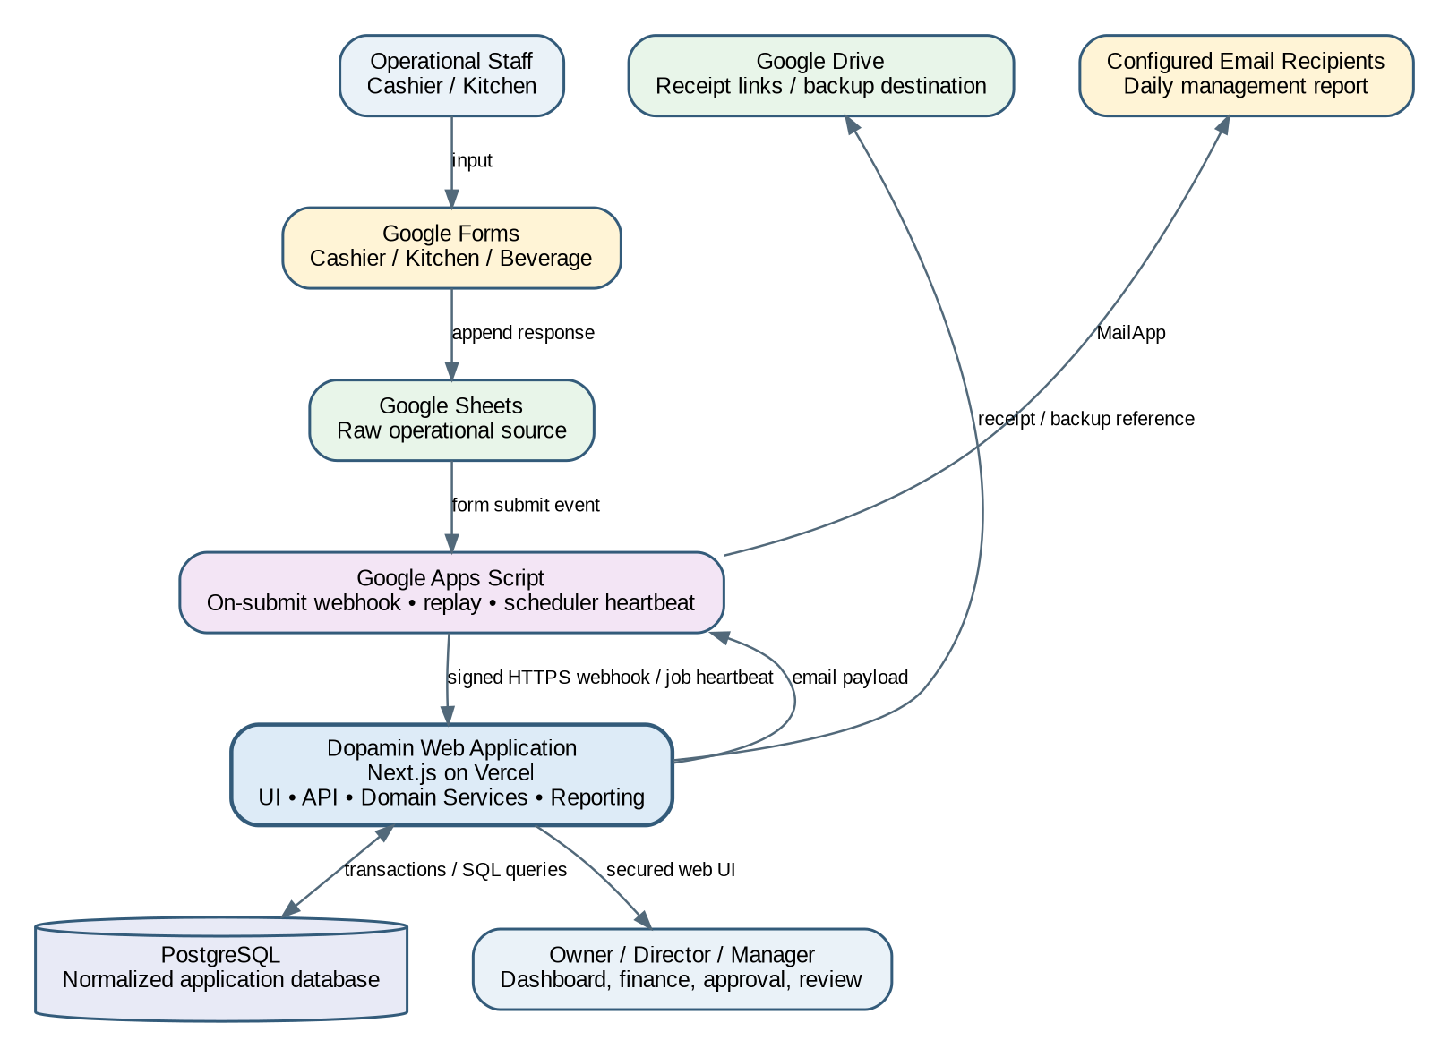
Figure 2-1. System context and external integrations.
The web application is the central computation and governance layer. Google components handle staff input, raw-source persistence, event delivery, and low-cost scheduled heartbeat. PostgreSQL stores normalized domain data and immutable application history.

2.2 Architecture Style
Selected style: MODULAR MONOLITH. One Next.js codebase/deployment contains UI, APIs, domain services, query services, and integrations; the code is separated into modules internally, not into networked microservices.

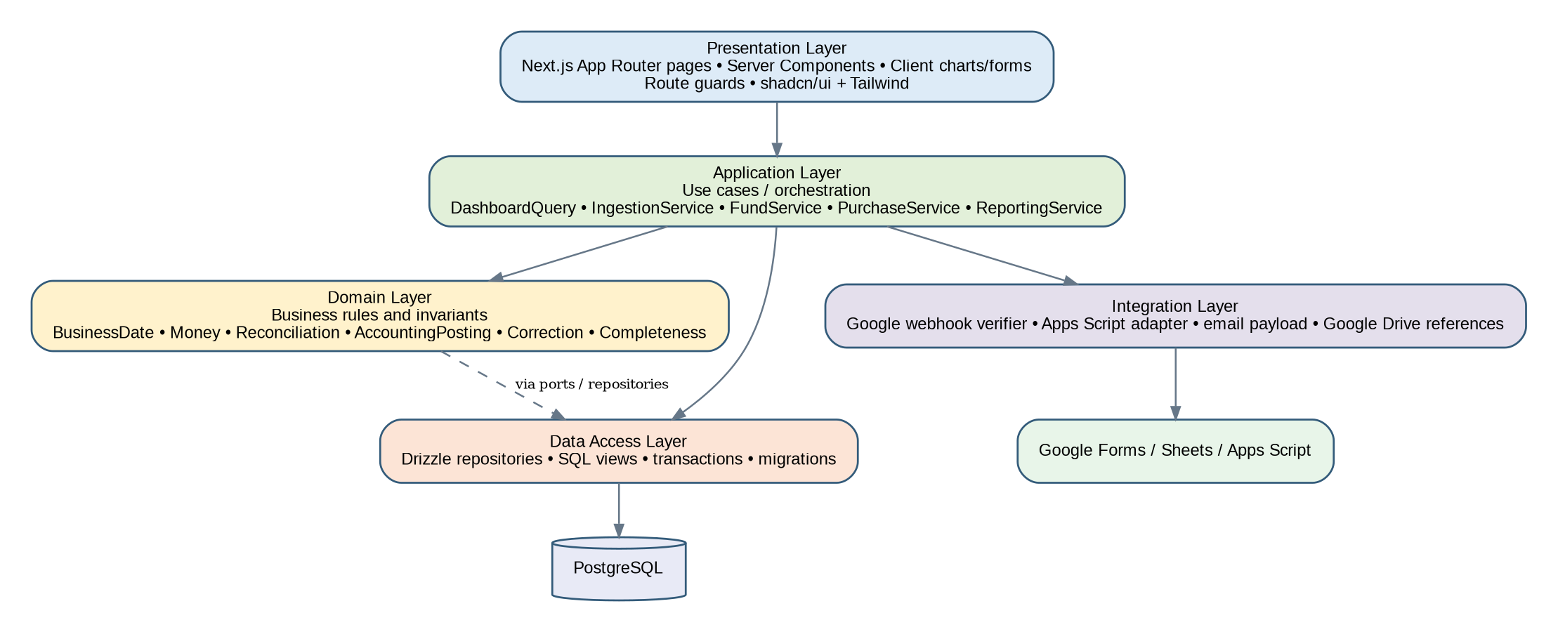
Figure 2-2. Layered modular-monolith design.

2.3 Why Not Microservices
- Current scale is a single cafe operation with low transaction volume.
- Distributed services would add deployment, network, tracing, retry, and consistency complexity without business benefit.
- Accounting/correction/audit writes benefit from local transactional consistency.
- Modules are deliberately isolated in code so they can be extracted later if scale requires it.

2.4 Runtime Boundaries
Runtime | Responsibilities
Browser | Render UI, charts, filters, forms; never trusted for authorization or financial calculations.
Next.js Server | Authentication, authorization, validation, domain orchestration, SQL queries, accounting posting, report generation, audit.
PostgreSQL | Transactional persistence, constraints, joins, aggregation views, immutable history.
Google Apps Script | Form event delivery, reconciliation replay, scheduler heartbeat, MailApp sending.
Google Sheets | Raw response source; not queried directly by dashboard during normal runtime.
Google Drive | Receipt/link storage and optional external backup destination.

3. Application Structure and Runtime Boundaries

3.1 Request Patterns
Pattern | Flow | Use
Read / Query | Server Component or API -> Query Service -> SQL View/Repository -> DTO | Dashboard, tables, reports, detail screens.
Internal Write | UI action -> auth/permission -> Zod validation -> Application Service -> DB transaction -> domain row + journal/audit | Funding, transfers, corrections, approvals, settings.
External Ingestion | Apps Script webhook -> HMAC verify -> raw persistence -> normalize -> validate -> transactional write -> audit/data issue | Google Forms/Sheets.
Scheduled Job | Apps Script heartbeat -> job due-check -> report snapshot -> email payload -> delivery callback | Daily report email.

3.2 Transaction Boundary
A material business mutation must commit atomically whenever it affects multiple domain tables. Example: Company -> Housebank funding writes fund transaction, accounting journal, and audit record in the same PostgreSQL transaction. If posting or audit creation fails, the entire mutation rolls back.
BEGIN
authorize(actor, action)
validate(command)
create_domain_transaction()
post_journal_if_applicable()
write_audit_event()
COMMIT
// failure anywhere => ROLLBACK

3.3 Idempotency
- External ingestion is idempotent by source + source-row key + payload hash.
- Scheduled report creation is idempotent by report type + Business Date + revision/reservation state.
- Mutation endpoints that may be retried can accept an idempotency key where appropriate.
- Journal posting is unique per domain source/event to prevent duplicate debit/credit creation.

3.4 Consistency Model
Area | Consistency
Financial transaction + journal + audit | Strong/transactional within PostgreSQL.
Google Sheet -> application | Eventual; normally immediate via webhook, recovered by replay/reconciliation.
Dashboard after mutation | Read-after-write from DB; cache invalidated/revalidated.
Email delivery | At-least-attempted with run state; exact email transport confirmation may be external. Snapshot itself remains authoritative.

4. Module / Component Design

4.1 Module Catalog
Module | Primary Components | Owns / Coordinates
identity | AuthService, UserService, AuthorizationPolicy | users, roles, session identity, permission checks
integration | WebhookVerifier, RawSubmissionService, NormalizerRegistry, ReconciliationService | sources, raw submissions, processing attempts, mapping/version
cashier | CashierReportService, PaymentNormalizer, ExpenseNormalizer, CashReconciliationService | cashier reports, payments, expenses, counts
sales | SalesReportService, MenuService, PriceResolver | food/beverage sales reports, item quantities, price history
finance | FundService, FundTransferService, ExpenseService | Housebank/Cashier fund transactions and balances
accounting | PostingService, JournalService, AccountMapping | balanced journal entries and journal lines
purchase | PurchaseRequestService, ApprovalService | PR lifecycle, funding source, receipt linkage
inventory | InventoryService, StockOpnameService | inventory master, sessions, line variance
correction | CorrectionService, VoidService | effective-value corrections and reversible financial changes
reporting | DashboardQueryService, ClosingService, DailyReportService | views, completeness, snapshots, exports
audit | AuditService, AuditQueryService | append-only material event history
settings | SettingsService | timezone, operating hours, scheduler/email settings, validation thresholds

4.2 Dependency Direction
- UI may call application/query services; it must not directly write tables.
- Domain modules may depend on shared primitives (Money, BusinessDate, ActorContext), but not on UI.
- Accounting is invoked by finance/cashier/sales domain events through explicit posting functions, not SQL triggers in MVP.
- Audit is a cross-cutting service invoked from application commands; database permissions additionally protect audit rows.
- Integration normalizers produce domain commands; they do not bypass domain validation.

4.3 Shared Domain Primitives
Primitive | Rule
Money | Fixed-precision IDR. DB NUMERIC(18,2); application uses Decimal/string-safe conversion, never JS floating-point arithmetic for financial totals.
BusinessDate | DATE in Asia/Jakarta reporting context; independent from submitted_at.
ActorContext | user_id, role, source (WEB/GOOGLE_SCRIPT/SYSTEM), request/correlation id.
EntityStatus | Controlled state strings/lookup values, never free-form business state.
EffectiveValue | Original source plus latest valid correction overlay for reporting. Derived totals are never stored as freely editable source.

5. Google Forms & Sheets Integration Design

5.1 Ingestion Flow
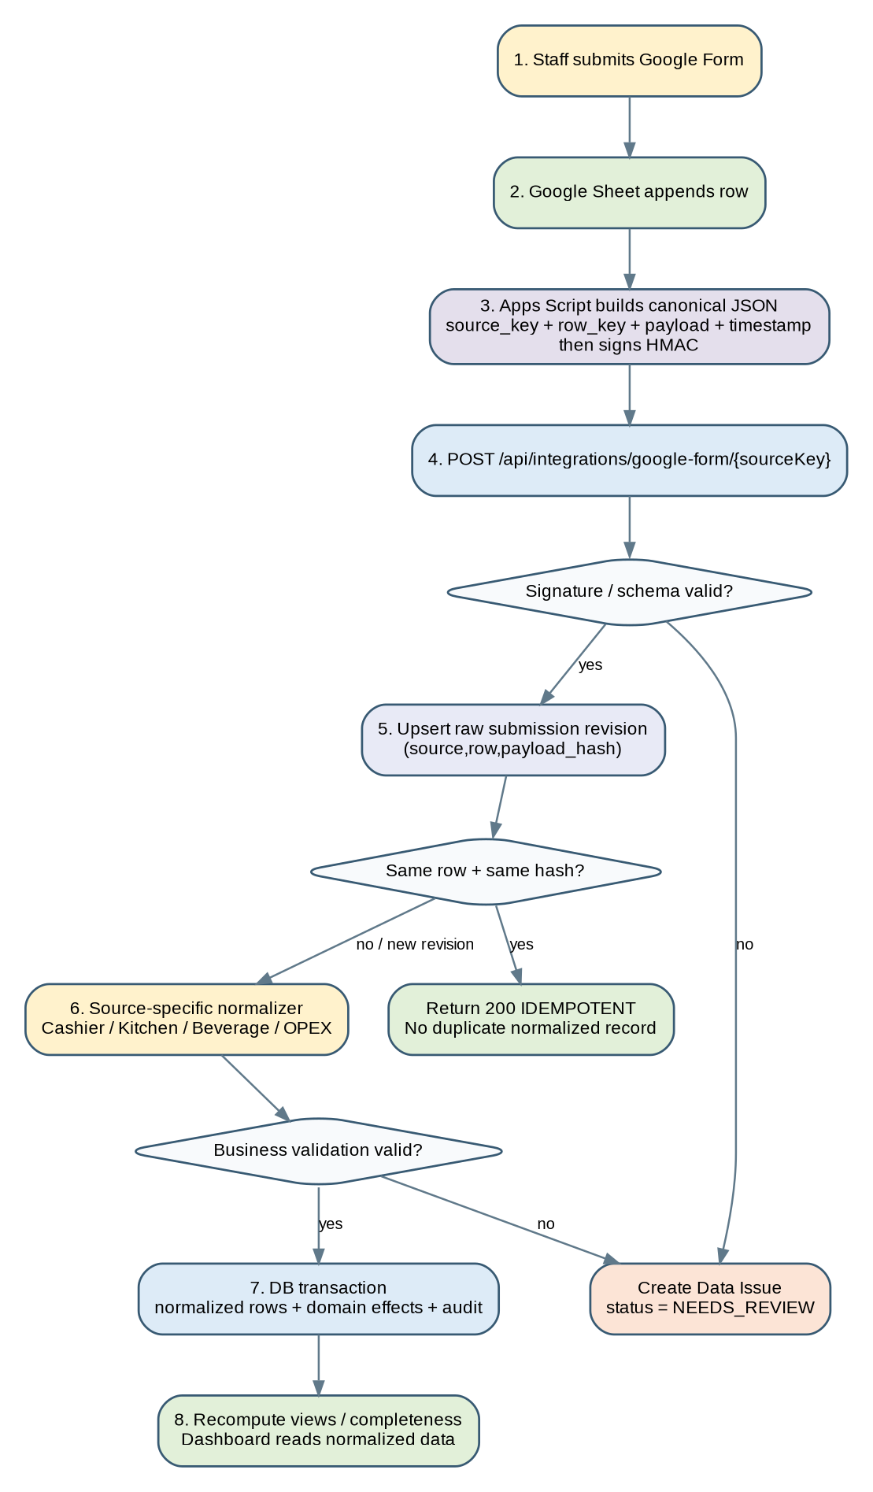
Figure 5-1. Google Form / Sheet ingestion pipeline.

5.2 Apps Script Event Payload
Apps Script converts a submitted row into a canonical envelope. The application still retains the raw field/value map so normalization can evolve without losing evidence.
{
"sourceKey": "cashier_report_v1",
"spreadsheetId": "...",
"sheetName": "Form Responses 1",
"rowKey": "42",
"submittedAt": "2026-09-05T21:41:10+07:00",
"eventCreatedAt": "2026-09-05T21:41:12+07:00",
"payload": {
"Tanggal Pelaporan": "2026-09-05",
"Nama Cashier": "...",
"Pembayaran Cash": "1500000",
"...": "..."
}
}

5.3 Webhook Security
- Apps Script secret is stored in Script Properties, not inside spreadsheet cells.
- Request contains timestamp and HMAC-SHA256 signature over canonical request body.
- Backend rejects invalid signature or timestamp outside the allowed replay window.
- Body size is capped; sourceKey must exist and be enabled.
- Every request gets a correlation_id for logs and audit/data-issue traceability.

5.4 Raw Submission Versioning
A replay of the same sheet row with identical payload hash is a no-op. If the same source row changes in Google Sheets, the new payload hash is recorded as a new raw revision rather than overwriting the previous raw payload. The application flags SOURCE_CHANGED and reprocesses through a controlled path.
Unique identity concept:
source_id + source_row_key + payload_hash
Same row + same hash => IDEMPOTENT
Same row + different hash => NEW RAW REVISION / SOURCE_CHANGED

5.5 Source-Specific Normalizers
Source | Normalizer Responsibility
Cashier | Resolve Business Date, flatten branched payment fields, extract expenses, petty cash, denominations, opening/closing metadata, validate money.
Kitchen | Resolve Business Date from Tanggal penjualan; unpivot food columns into sales item quantities.
Beverage | Require explicit Tanggal Penjualan; unpivot beverage columns; map Barista/Cashier identity.
OPEX historical/import | Map Debit/Credit to Housebank movement for seed/reconciliation; never import Balance as editable truth.

5.6 Reconciliation / Replay
- Apps Script may periodically replay recent rows or a configured row window; backend idempotency makes replay safe.
- Admin/Data Issues page exposes last successful source event and failed processing attempts.
- A “Reprocess” action re-runs normalization against stored raw payload with the current mapping version.
- Mapping changes are versioned so support can identify which rule produced a normalized record.

6. Business Date and Daily Closing Design

6.1 Business Date Resolution
Source | Resolution Rule
Cashier | Use Tanggal Pelaporan. submitted_at is evidence only.
Kitchen | Use Tanggal penjualan.
Beverage | Use required Tanggal Penjualan field to be added to form.
Housebank / App-created finance | User-selected transaction date in Asia/Jakarta, constrained by permission and correction rules.
Scheduled daily report | Previous Business Date relative to configured report schedule, not simply previous UTC date.

6.2 Operating Window
Baseline operating hours: 10:00 - 21:30 Asia/Jakarta. These hours are configuration, not a hard-coded database assumption. Late Google Form submission can still belong to the prior Business Date if the explicit report/sales date says so.

6.3 Completeness Model
The daily closing service evaluates required source groups for a Business Date. MVP required groups are Cashier, Kitchen, and Beverage; inventory is operationally useful but is not required to mark the sales report complete unless configured later.
Source Group | State
Cashier | MISSING / RECEIVED / VALID / NEEDS_REVIEW
Kitchen | MISSING / RECEIVED / VALID / NEEDS_REVIEW
Beverage | MISSING / RECEIVED / VALID / NEEDS_REVIEW
Overall Daily Closing | COMPLETE only when configured required groups are VALID; otherwise INCOMPLETE

6.4 Closing Recalculation
- Closing status is derived from normalized source state; users do not manually type COMPLETE.
- A late submission or approved correction triggers closing status reevaluation.
- A previously sent daily report remains immutable; new completeness can produce a report revision.

7. Cashier and Sales Processing Design

7.1 Cashier Normalization
Raw Pattern | Normalized Result
Pembayaran Cash / Cash 2 | payment_lines(method=CASH) using meaningful non-null branch value(s); duplicate accidental branch values are detected/flagged.
QRIS / Transfer / cards / City Ledger / DP / Promotion | One payment line per controlled method/classification.
Expense blocks | cashier_expense_lines with category, amount, staff, description, source reference.
Petty cash fields | cashier report cash metadata; branch variants consolidated.
Denomination counts | cash_count lines / structured fields used to derive physical cash.
Navigation/helper text | Rejected/ignored by field parser and recorded as data-quality issue if present in business field.

7.2 Sales Normalization
Kitchen/Beverage wide forms are unpivoted to row-based item quantities. Revenue is calculated using the price effective on Business Date. A future price change does not alter historical revenue.
food_revenue(day) = SUM(item_quantity * price_effective_on(day))
beverage_revenue(day) = SUM(item_quantity * price_effective_on(day))

7.3 Reconciliation - Two Dimensions
Food/Beverage answers “what was sold?” Payment methods answer “how was it settled/received?”. These dimensions are compared, not added together.

Dimension | Examples | Purpose
Product sales | Food, Beverage | Category revenue based on item quantities × prices.
Settlement / payment | Cash, QRIS, Transfer, Card, Receivable, DP, Promotion | How the transaction was paid/settled.
Reconciliation | Product sales total vs eligible settlement total | Detect missing form, incorrect amount, delayed submission, receivable/deposit differences.

7.4 Cash Reconciliation Service
The service computes expected and actual cash from source components. Exact petty-cash treatment remains a configuration/business-validation item, but the implementation must not permit a user to override the resulting balance/variance directly.
expected_closing_cash =
opening_cash
+ cash_receipts
+ internal_transfer_in_to_cashier
- cashier_cash_expenses
- internal_transfer_out_from_cashier
- cash_deposit_out
+ approved_cash_adjustments
variance = actual_counted_cash - expected_closing_cash

Physical count and petty-cash formula will be finalized in UI/UAT design using the current cashier form. The architecture already supports the components without storing an editable “balance”.

8. Finance, Housebank, and Accounting Engine

8.1 Fund Account Model
- HOUSEBANK: operational fund receiving company funding and paying operational expenses.
- CASHIER_CASH: operational money held at cashier.
- Clearing/settlement accounts may represent QRIS, transfer bank, card, receivables, customer deposit, etc.
- Fund-account balance is calculated from posted transactions/journals, not maintained as a manually editable balance field.

8.2 Domain Transaction Types
Type | Source | Financial Meaning
COMPANY_FUNDING | Owner/Director app input | External funding into Housebank; not sales revenue.
INTERNAL_TRANSFER | Housebank -> Cashier (or future reverse) | Asset/fund transfer; not revenue/expense.
CASHIER_EXPENSE | Cashier report/app correction | Operational expense paid from Cashier Cash.
HOUSEBANK_EXPENSE | Finance/PR flow | Operational expense paid from Housebank.
SALES_SETTLEMENT | Cashier report | Payment/settlement amount by method.
PRODUCT_SALES_ALLOCATION | Kitchen/Beverage reports | Allocates sales clearing to Food/Beverage revenue for reconciliation/accounting analytics.

8.3 Posting Architecture
Accounting posting is performed by an application PostingService, not direct UI SQL and not hidden database triggers. A domain event/source record carries a stable source reference; the PostingService resolves account mapping and creates a balanced journal entry within the same transaction where applicable.
post(sourceType, sourceId, eventType):
mapping = accountMapping.resolve(eventType, attributes)
lines = mapping.buildJournalLines()
assert(sum(debit) == sum(credit))
assert(noExistingPostedJournal(sourceType, sourceId, eventType))
journalRepository.insert(header, lines)

8.4 Sales Clearing Model
Because product category sales and cashier payments come from independent forms, the accounting layer uses a Sales Clearing concept. This avoids double-counting while exposing mismatches.
Event | Debit | Credit
QRIS receipt 100,000 | QRIS Clearing 100,000 | Sales Clearing 100,000
Cash receipt 50,000 | Cashier Cash 50,000 | Sales Clearing 50,000
Food sales allocation 80,000 | Sales Clearing 80,000 | Food Sales Revenue 80,000
Beverage sales allocation 70,000 | Sales Clearing 70,000 | Beverage Sales Revenue 70,000

If cashier settlement totals and product sales totals are equal, Sales Clearing returns to zero for the Business Date (subject to DP/receivable/promo rules). A residual is a reconciliation signal, not an amount that staff manually edits.

8.5 Core Posting Examples
Business Event | Debit | Credit | P&L Effect
Company -> Housebank | Housebank | Company Funding / Intercompany | None
Housebank -> Cashier | Cashier Cash | Housebank | None
Cashier operational expense | Operational Expense category | Cashier Cash | Expense
Housebank operational expense | Operational Expense category | Housebank | Expense
Receivable sale settlement classification | Accounts Receivable | Sales Clearing | Revenue only when product allocation posts
Customer DP received | Cash/Bank or appropriate asset | Customer Deposit Liability | Not revenue until applied

8.6 Journal Immutability
- Posted journal entries are not edited in place.
- A financial correction that changes a posted amount creates reversal/repost or a correcting journal linked to the correction record.
- Journal source reference is unique enough to prevent duplicate posting.
- Only DRAFT (if used) may be discarded before posting; POSTED uses VOID/REVERSAL semantics.

9. Purchase Request Design

9.1 State Flow
DRAFT -> SUBMITTED -> APPROVED -> FUNDED/READY_TO_SPEND -> PURCHASED -> RECEIPT_RECORDED -> CLOSED
+-- REVISION_REQUESTED -> SUBMITTED
+-- REJECTED

9.2 Responsibilities
Actor | Actions
Manager | Create/edit draft, submit, respond to revision request, record purchase detail/receipt within permission.
Owner / Director | Approve, request revision, reject; choose/confirm funding source according to policy; view all history.
System | Append approval history, enforce valid transitions, create/associate expense transaction when purchase is finalized, audit every material action.

9.3 Funding Source
Approved requests select HOUSEBANK or CASHIER as funding source. Selecting a source does not itself create an expense. The expense is created when the actual spend is recorded/finalized, using actual amount rather than estimated amount.

9.4 Invariants
- Rejected requests cannot be spent.
- Revision-required requests cannot move to purchased until resubmitted and approved.
- Actual spend must be positive and have Business Date/transaction date.
- Receipt reference can be required by policy before CLOSED; missing receipt remains visible in weekly recap.
- PR status history is append-only.

10. Inventory / Stock Opname Design

10.1 MVP Model
- Inventory categories: Kitchen, Beverage/Bar, Other.
- A stock-opname session groups lines for a date/category/responsible user.
- Each line stores item, unit, expected/reference quantity when available, actual quantity, calculated variance, and note.
- Recipe/BOM consumption is not calculated in MVP.

10.2 Permission Mapping
Category | Operational Input | Review
Kitchen | Kitchen role | Manager, Owner, Director
Beverage/Bar | Cashier role | Manager, Owner, Director
Other | Manager | Owner, Director

10.3 Variance
variance_qty = actual_qty - expected_qty
// if expected quantity is not available in MVP for an item:
// preserve actual count; variance remains NULL rather than inventing a value.

10.4 Future Compatibility
The item and session design must remain compatible with future stock movements, purchasing receipts, recipe/BOM, theoretical usage, waste, and COGS. MVP does not fake these values before source data exists.

11. Correction, Void, and Audit Design

11.1 Correction Flow
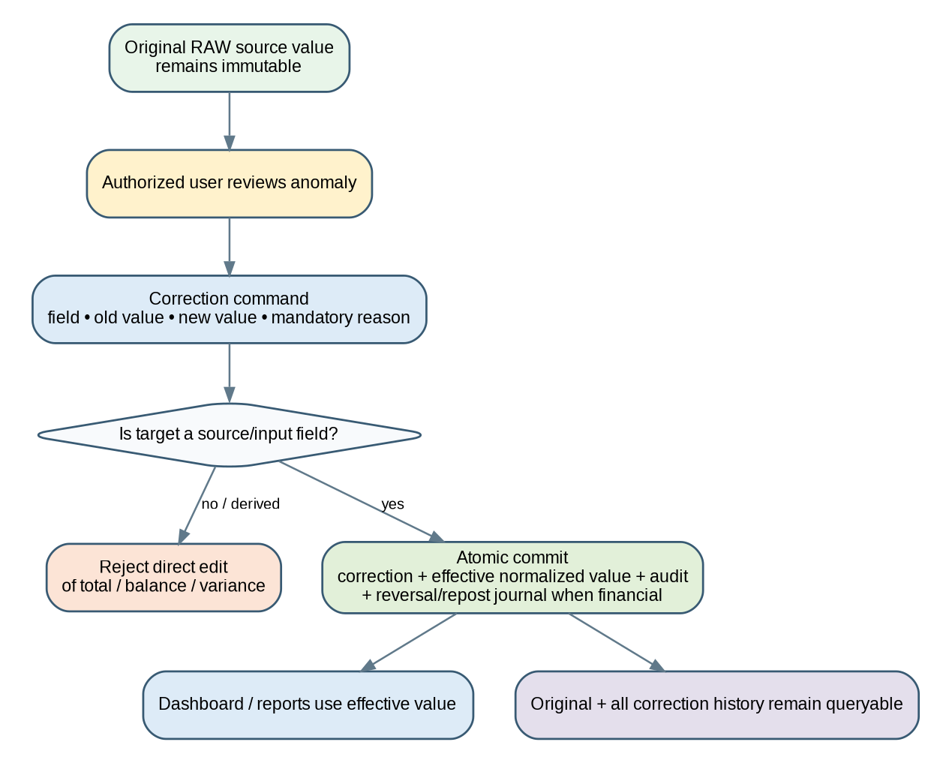
Figure 11-1. Correction and effective-value design.

11.2 Correction Rules
- Only source/input fields are correctable. Derived values (balance, totals, variance) are read-only.
- Correction requires field, old value, new value, reason, actor, timestamp, and source entity reference.
- The original raw Google payload is never overwritten by application correction.
- Dashboard/query layer resolves effective value or uses corrected normalized row produced by controlled correction logic.
- Financial correction triggers correcting/reversal journal if a posted journal was affected.

11.3 VOID versus DELETE
Record Type | Deletion Rule
Raw submissions | Never delete through normal UI; retain evidence.
Financial transactions | No hard delete; VOID/reversal with reason and actor.
Posted journal | Immutable; reverse/correct.
Purchase approvals/history | Append-only.
Report runs | Immutable snapshot; new revision/resend.
Master data e.g. menu/inventory item | Deactivate/soft-delete when no longer used; historical references remain.

11.4 Audit Event Structure
audit_event = {
actor_user_id, actor_role,
action, module, entity_type, entity_id,
before_json, after_json, reason,
source: WEB | GOOGLE_SCRIPT | SYSTEM,
correlation_id, created_at
}

11.5 Required Audit Actions
At minimum: CREATE, UPDATE, CORRECTION, VOID, APPROVE, REJECT, REVISION_REQUEST, COMPANY_FUNDING, FUND_TRANSFER, PRICE_CHANGE, STOCK_CORRECTION, SETTINGS_CHANGE, REPORT_GENERATED, REPORT_SENT, REPORT_RESENT, and important data reprocessing events.

12. Daily Report and Email Scheduler Design

12.1 Scheduler Strategy
Because send time is configurable and the project is cost-sensitive, MVP uses a small Apps Script heartbeat (recommended approximately every 15 minutes). The backend decides whether a report is due. This avoids recreating a clock trigger whenever the user changes send time and keeps business logic in the application.
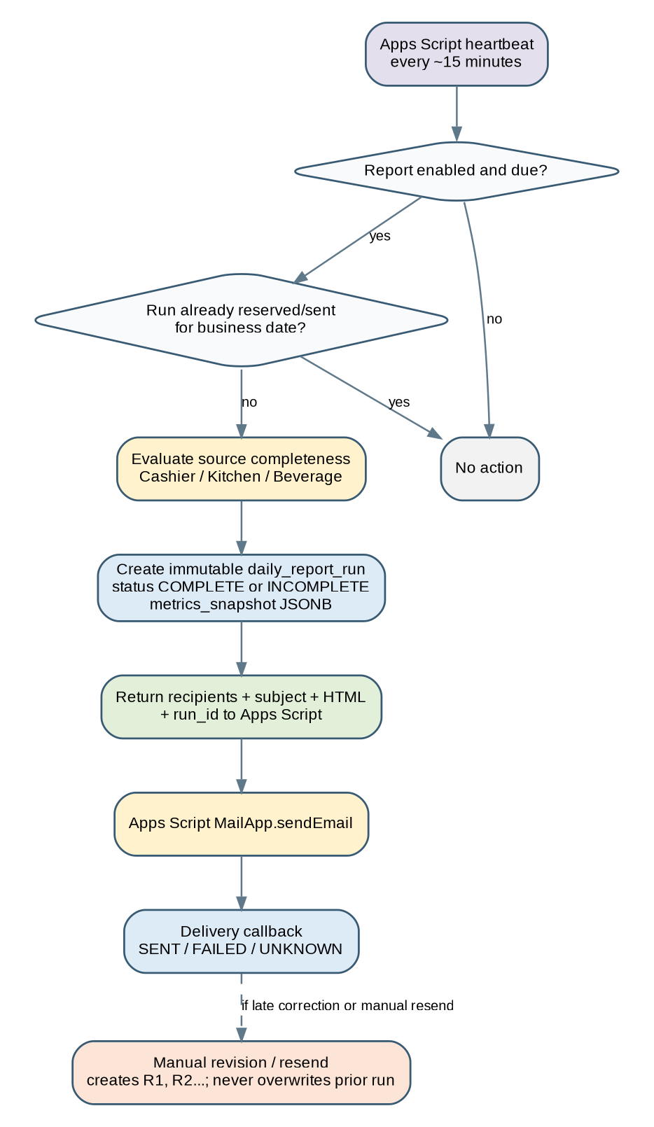
Figure 12-1. Configurable daily report scheduler and delivery flow.

12.2 Due-Check Algorithm
on heartbeat(nowJakarta):
settings = loadDailyReportSettings()
if !settings.enabled: return NOOP
businessDate = previousBusinessDate(nowJakarta)
if now is outside configured due window: return NOOP
if active/sent run already exists for businessDate: return NOOP
completeness = closingService.evaluate(businessDate)
metrics = reportService.snapshotMetrics(businessDate)
run = reserveReportRun(businessDate, completeness, metrics)
return emailPayload(run, recipients)

12.3 Report Run State
State | Meaning
RESERVED | A due run is reserved so repeated heartbeat does not create duplicate sends.
GENERATED | Metrics and email payload snapshot created.
SENT | Apps Script reported successful send.
FAILED | Known send failure; visible to authorized user.
UNKNOWN | Reservation occurred but delivery callback is uncertain; do not auto-spam. Manual review/resend.
REVISION | New immutable run after late submission/correction; references previous run.

12.4 Email Contents
Metric | Source Query
Keuangan masuk kasir total | Eligible payment/settlement lines for Business Date.
Cash | payment_method = CASH
QRIS | payment_method = QRIS
Food | Food item quantities × effective prices
Beverage | Beverage item quantities × effective prices
Keuangan keluar dari kasir | Cashier expenses
Uang masuk Housebank | Company/external funding into Housebank
Keuangan keluar Housebank | Operational Housebank expenses

12.5 Incomplete Data
If required data is missing, report is still generated and sent as BELUM LENGKAP. Missing source groups are explicitly listed. The report does not guess missing values.

12.6 Revisions and Resend
- Original report run and metrics snapshot remain unchanged.
- Late data/correction can create R1, R2, etc., each linked to prior run.
- Manual resend of an unchanged snapshot is distinguished from a recalculated revision.
- Every generation/send/resend action is audited.

13. Dashboard / Query Architecture

13.1 Read Model Strategy
Dashboard queries run against normalized transactional tables and SQL views, not raw submissions. Daily aggregates may be materialized/cached later if needed, but the canonical figures remain derivable from transaction data.

13.2 Recommended Views
View | Purpose
vw_daily_product_sales | Food/Beverage quantity and priced revenue by Business Date.
vw_daily_payments | Settlement totals by payment method.
vw_daily_cashier_expenses | Cashier expense totals and categories.
vw_fund_account_movements | Housebank/Cashier inflow/outflow and running components.
vw_daily_reconciliation | Product sales vs eligible settlement and clearing residual.
vw_cash_reconciliation | Expected/actual cash and variance.
vw_daily_completeness | Required source group state per Business Date.
vw_stock_opname_variance | Stock actual/expected/variance by session/item.

13.3 Query Service
- DashboardQueryService returns UI-ready DTOs with money formatted only at presentation edge.
- Date-range filter uses Business Date, never raw submission timestamp.
- Owner/Director can drill KPI -> grouped detail -> source transaction/raw reference.
- Manager receives permission-limited operational DTOs; Cashier/Kitchen query routes return only authorized scope.

13.4 Route / Screen Skeleton (for UI Spec Handoff)
/dashboard
/sales/food
/sales/beverage
/cashier/reports
/cashier/reconciliation
/finance/housebank
/finance/transactions
/purchase-requests
/inventory
/reports/daily
/system/data-issues
/audit
/settings/users
/settings/menu
/settings/daily-report
/settings/system

These routes are technical navigation candidates only. The next UI/UX document will define information architecture, wireframes, responsive behavior, empty/loading/error states, and exact role navigation.

14. Authentication and Authorization

14.1 Authentication Baseline
Recommended MVP: Auth.js with Google OAuth because the operating environment already uses Google tools. The application database remains the authority for role, active status, and permissions; successful Google authentication alone does not grant access.
- User email must match an active application user/allowlist record.
- Session carries user id and role reference; sensitive actions recheck server-side authorization.
- If Google OAuth is later replaced, domain modules are unaffected because they depend on ActorContext, not provider-specific session objects.

14.2 Role Baseline
Role | Baseline
OWNER | Full access including settings, audit, corrections, financial operations.
DIRECTOR | Equivalent full access; primary company->Housebank funding operator.
MANAGER | Operational review, PR, stock, cashier/sales visibility as allowed; no company funding by default.
CASHIER | Cashier + Beverage operational scope; no Housebank/owner settings.
KITCHEN | Kitchen sales + Kitchen inventory scope only.

14.3 Enforcement Points
- Page/route access guard for UX.
- Application-service action authorization for true security.
- Repository queries scope by user role where sensitive rows differ.
- External integration endpoints use integration identity/HMAC, not user session.
- Audit stores the effective actor for each mutation.

14.4 Permission Vocabulary
The upcoming RBAC matrix should use action-level permissions such as VIEW, CREATE, UPDATE, CORRECT, VOID, APPROVE, EXPORT, MANAGE_SETTINGS, MANAGE_USERS, FUND_HOUSEBANK, and TRANSFER_FUNDS rather than only “can access module”.

15. API Design Conventions

15.1 API Categories
Category | Examples | Authentication
Internal application read/write | /api/finance/..., /api/purchase-requests/... | User session + permission.
External Google ingestion | /api/integrations/google-form/{sourceKey} | HMAC integration signature.
Internal scheduled job | /api/internal/jobs/daily-report/check | HMAC/service secret.
Delivery callback | /api/internal/jobs/daily-report/{runId}/delivery | HMAC/service secret.

15.2 Response Envelope
{
"data": { ... },
"meta": { "requestId": "..." }
}
// error
{
"error": {
"code": "VALIDATION_ERROR",
"message": "Human-safe summary",
"fieldErrors": { ... }
},
"meta": { "requestId": "..." }
}

15.3 API Rules
- Amounts cross API boundary as decimal strings or integer rupiah values defined consistently; never rely on floating JSON arithmetic.
- Dates use ISO 8601; Business Date uses YYYY-MM-DD; timestamps include offset or UTC Z.
- Mutation request validation uses Zod schemas shared with UI where appropriate.
- Client cannot submit calculated balance/total as authoritative value.
- Pagination and filtering are mandatory for large audit/transaction lists.
- Detailed endpoint contracts are deferred to API & Integration Specification.

16. Error Handling, Data Quality, and Observability

16.1 Error Classes
Class | Example | Behavior
VALIDATION | Invalid date, negative amount, non-numeric quantity | Reject/flag with field-level detail; do not create financial effect.
AUTHORIZATION | Cashier tries Company->Housebank funding | 403 / denial; security/audit log if material.
INTEGRATION | Bad HMAC, source mapping missing | Reject request or create processing issue; log correlation id.
DATA_QUALITY | Suspicious huge amount, helper text in business field | Store raw, mark NEEDS_REVIEW, prevent/limit normalized posting based on severity.
CONFLICT | Duplicate journal/source event, invalid PR transition | 409-style domain conflict; no partial write.
SYSTEM | DB/network/unexpected exception | Rollback, log request id, return generic safe error to user.

16.2 Data Issues Queue
A dedicated “Data Issues” read model/page should expose invalid submissions, source changes, suspicious values, mapping failures, and incomplete required fields. Owner/Director/Manager permissions determine who can resolve/reprocess.

16.3 Logging
- Structured server logs include request_id/correlation_id, module, action, actor id when available, source key, and error code.
- Never log database passwords, OAuth tokens, full secrets, or unnecessary personal data.
- Integration processing status is persisted separately from ephemeral runtime logs so support does not depend on provider log retention.

16.4 Health Signals
Signal | Where Visible
Last successful source ingestion | Admin/Data Issues or System status.
Failed raw submissions | Data Issues.
Last scheduler heartbeat / last daily report | Daily Report Settings / System status.
Backup last success | System/operations status when backup automation is implemented.
DB connectivity/version | Internal health endpoint, protected or non-sensitive.

17. Security Design

17.1 Threat-Oriented Controls
Threat | Control
Unauthorized finance action | Server-side RBAC and explicit action permission.
Webhook forgery | HMAC signature + timestamp replay window + source allowlist.
Duplicate/replayed event | Payload hash/idempotency constraints.
Tampering with audit history | Append-only application design; restricted DB role; no edit/delete UI.
Mass assignment / derived value edit | Explicit Zod command schemas; ignore/reject calculated fields.
Secret leakage | Environment secrets / Apps Script Properties; redact logs.
SQL injection | Drizzle parameterization / prepared SQL; no interpolated untrusted SQL.
Cross-site request abuse | Auth.js CSRF/session protections; same-site cookie settings; write actions require authenticated session.
Broken object authorization | Every entity mutation loads entity and checks permission/context server-side.
Backup compromise | Separate storage account/location; restricted access; optional encryption at rest from provider.

17.2 Principle of Least Privilege
- Application runtime DB user gets required DML rights, not database-owner privileges where provider supports separate roles.
- Migration/admin credentials are not exposed to browser/runtime unless necessary.
- Google integration secret is scoped only to webhook/scheduler endpoints.
- Kitchen and Cashier never receive financial configuration data in API responses merely because a hidden page exists.

17.3 Sensitive Data
This system primarily stores operational and financial business data. Personal data should be minimized to staff identity/contact needed for access/audit. Receipt links and financial descriptions should be protected by authorization and not exposed through public URLs when avoidable.

18. Performance and Scalability

18.1 Expected Scale
MVP is designed for one cafe with relatively low daily submission volume. The architecture prioritizes correctness and low cost; it should still remain efficient for several years of daily records without redesign.

18.2 Query Strategy
- Index Business Date on transactional/report tables used for daily/range filters.
- Index foreign keys and common status fields used in PR/audit/data-issue screens.
- Use normalized sales items rather than scanning 35-42 wide spreadsheet columns at dashboard time.
- Use SQL views for common aggregates; add materialized/daily aggregate cache only after measuring need.
- Audit tables require pagination and selective filters; never load full history into browser.

18.3 Serverless Database Considerations
- Use provider-supported pooled/serverless connection string.
- Keep transactions short; do not hold DB transaction open while calling Google APIs or email transport.
- Perform external email send after report snapshot reservation/commit.
- Cold-start latency is acceptable for internal MVP; financial consistency is higher priority than sub-second first response.

18.4 Growth Path
Trigger | Future Action
Dashboard queries become slow | Add indexed aggregate tables/materialized views and scheduled refresh.
Ingestion volume increases | Introduce background job/queue and asynchronous normalization.
Multiple branches | Add branch_id to core entities and branch-scoped authorization; migrate reports to branch-aware views.
Moka integration | Add POS integration adapter feeding same sales/payment domain commands.
Heavy analytics | Replicate/read warehouse later without changing operational transaction model.

19. Backup, Recovery, and Provider Portability

19.1 Data-Copy Strategy
Google Forms/Sheets = raw operational evidence
PostgreSQL = normalized application + accounting + audit source
External DB backup = recovery copy independent of DB provider

19.2 Backup Scope
- All PostgreSQL schemas/tables required for application-native data: users/roles, corrections, Housebank, purchase approvals, journal, report runs, audit, settings, inventory.
- Raw Google Form submissions are additionally recoverable from Sheets, but app raw-submission table is still backed up.
- Receipts may remain referenced in Google Drive; database backup contains file id/URL metadata.

19.3 Restore Procedure - Design Requirement
- Provision replacement PostgreSQL database.
- Run schema migrations to compatible version or restore full logical dump as chosen by runbook.
- Restore data backup.
- Verify row counts / journal balance / critical integrity checks.
- Update DATABASE_URL and provider pool configuration.
- Redeploy/restart application and perform smoke tests.
- Replay Google Sheet rows since last successful backup if required; ingestion idempotency prevents duplicates.

19.4 Provider Independence
- Use standard PostgreSQL types/functions for core business data where possible.
- Provider-specific branching/compute features are not required for correctness.
- DB connection is injected through configuration.
- Migration history is owned by the application repository, not only provider dashboard.

20. Deployment and Environment Design

20.1 Environments
Environment | Purpose | Data Rule
local | Developer execution and unit/integration testing | Synthetic/local data only unless explicitly sanitized.
preview | Pull-request / feature validation | Separate preview DB/schema; never production DB.
staging | UAT against near-production configuration | Controlled test data; can connect to test Google forms.
production | Cafe operational system | Production PostgreSQL, real Google form sources, real scheduled report recipients.

20.2 Deployment Topology
Git repository
└─ Next.js application
├─ Vercel deployment (baseline)
├─ PostgreSQL connection (pooled runtime URL)
└─ Environment secrets
Google Apps Script projects
├─ Form event sender / reconciliation replay
└─ Report scheduler heartbeat + MailApp

20.3 Required Configuration
Variable / Setting | Purpose
DATABASE_URL | Pooled runtime PostgreSQL connection.
DATABASE_MIGRATION_URL | Optional direct/admin connection used only by migrations.
AUTH_SECRET | Auth.js session signing/secret.
GOOGLE_OAUTH_CLIENT_ID / SECRET | Google login baseline.
GOOGLE_INTEGRATION_SECRET | HMAC shared secret for form/replay endpoints.
REPORT_JOB_SECRET | HMAC/service secret for scheduler and delivery callback.
APP_BASE_URL | Canonical application URL.
BUSINESS_TIMEZONE | Asia/Jakarta baseline; application setting is authoritative for reporting.
LOG_LEVEL | Runtime log verbosity.

20.4 Migration Policy
- Schema changes are versioned in repository and applied through migrations.
- Backward-compatible expand/migrate/contract pattern is preferred for production changes.
- Destructive migrations require backup and explicit review.
- Application deploy that depends on new schema must be coordinated with migration execution.

21. Source-Code Structure and Engineering Conventions

21.1 Recommended Repository Structure
src/
app/
(auth)/
(protected)/
dashboard/
sales/
cashier/
finance/
purchase-requests/
inventory/
reports/
audit/
settings/
api/
integrations/
internal/jobs/
modules/
identity/
integration/
cashier/
sales/
finance/
accounting/
purchase/
inventory/
correction/
reporting/
audit/
settings/
db/
schema/
migrations/
views/
lib/
auth/
money/
date/
validation/
logging/
components/
ui/
charts/
tests/
unit/
integration/
e2e/

21.2 Technology Baseline
Concern | Baseline
Language | TypeScript
Web framework | Next.js App Router
UI | Tailwind CSS + shadcn/ui
Charts | Recharts for MVP
Validation | Zod
ORM / SQL | Drizzle ORM + explicit SQL views where useful
Database | PostgreSQL
Authentication | Auth.js + Google OAuth baseline
Money arithmetic | PostgreSQL NUMERIC + decimal-safe application handling
Dates | DATE + TIMESTAMPTZ; Asia/Jakarta business-date service
Testing | Vitest or equivalent unit/integration; Playwright for critical E2E flows

21.3 Coding Rules
- No financial calculation using JavaScript floating point.
- No direct table mutation from page components.
- Every public application command has authorization + validation.
- Every material financial/governance mutation writes audit in same transaction where possible.
- Repository/API names use stable business terms: Housebank, Cashier, BusinessDate, PurchaseRequest, not spreadsheet column names.
- Google column names belong only in integration mapping/normalizer code.

22. Architecture Decision Records
ADR | Decision | Status | Rationale
ADR-001 | Modular monolith | Selected | Lowest complexity while preserving module boundaries and transactional consistency.
ADR-002 | PostgreSQL application database | Selected | Relational integrity, accounting joins/aggregations, provider portability.
ADR-003 | Google Sheets as raw source, not dashboard DB | Selected | Preserves staff workflow while avoiding sheet-as-database limitations.
ADR-004 | Raw submissions immutable/versioned | Selected | Supports audit, reprocessing, and source-change detection.
ADR-005 | Business Date separate from submitted_at | Selected | Late submissions must still report to intended operational date.
ADR-006 | Sales Clearing reconciliation | Selected | Avoids double-counting independent product-sales and payment sources.
ADR-007 | No hard delete for financial records | Selected | Audit/accounting integrity.
ADR-008 | Apps Script heartbeat for configurable email | Selected for MVP | Allows configurable time at low cost; tolerance documented.
ADR-009 | Explicit accounting PostingService | Selected | Transparent, testable posting rules rather than hidden SQL triggers.
ADR-010 | Beverage form gets explicit sales date | Required | Removes ambiguity from late submissions.
ADR-011 | No Redis/queue in MVP | Selected | Volume does not justify infrastructure; can add later behind service boundary.
ADR-012 | Report snapshots immutable | Selected | Sent reports remain historically reproducible; revisions are separate runs.

23. Traceability and Implementation Handoff

23.1 SRS / ERD -> Design Trace
Design ID | SRS / ERD Trace | Design Decision
SDD-INT | SRS FR-INT-*; ERD Integration | Signed/idempotent ingestion, raw versioning, normalizer registry, replay.
SDD-CAS | SRS FR-CAS-*; Cashier ERD | Normalized payment/expense/count lines and reconciliation service.
SDD-SALES | SRS FR-KIT/BEV/MENU-* | Unpivot quantity reports, effective price resolver, sales clearing allocation.
SDD-FIN | SRS FR-FIN-*; Finance ERD | Separate fund accounts, posting service, derived balance.
SDD-PR | SRS FR-PR-* | Explicit state machine, approval history, actual-spend posting.
SDD-INV | SRS FR-INV-* | Session/line stock opname with calculated variance.
SDD-EML | SRS FR-EML-* | Heartbeat due-check, immutable report run, incomplete send, revision.
SDD-COR | SRS FR-COR/AUD-* | Correction overlay, reversal/repost, append-only audit.
SDD-SEC | SRS NFR-SEC-* | Google auth baseline, RBAC, HMAC integration, secret handling.
SDD-BKP | SRS NFR-BKP/PORT-* | External backups and PostgreSQL-provider portability.

23.2 Next Documents
Next Artifact | What It Must Finalize
UI/UX & Screen Specification | Information architecture, role navigation, wireframes, page states, forms, tables, charts, mobile behavior, correction/data-issue UX.
RBAC Matrix | Action-level VIEW/CREATE/UPDATE/CORRECT/VOID/APPROVE/EXPORT permissions for each role/module.
API & Integration Specification | Concrete endpoints, request/response schemas, HMAC canonicalization, Apps Script contract, error codes.
Physical Database Specification | PostgreSQL DDL, exact data types, FK/UNIQUE/CHECK, indexes, SQL views, Drizzle schema, seed records.
Test/UAT Plan | Financial test cases, permission tests, Google ingestion, correction, report scheduling, backup/restore.
Deployment Runbook | Vercel/provider setup, environment secrets, migration, Apps Script deployment, backup/restore procedure.

23.3 Implementation Gate
Frontend implementation should not begin beyond the shell/design-system level until UI/UX + RBAC are approved. Financial write implementation should not begin until the physical schema and posting mappings are finalized. This avoids rework in the highest-risk areas.

Appendix A. State Machines

A.1 Raw Submission Processing
RECEIVED -> VALIDATING -> PROCESSED
+-- NEEDS_REVIEW
+-- REJECTED
NEEDS_REVIEW -> REPROCESSING -> PROCESSED / NEEDS_REVIEW

A.2 Purchase Request
DRAFT -> SUBMITTED -> APPROVED -> PURCHASED -> RECEIPT_RECORDED -> CLOSED
+-- REVISION_REQUESTED -> SUBMITTED
+-- REJECTED

A.3 Financial Transaction
DRAFT (optional app-created) -> POSTED -> VOIDED/REVERSED
POSTED is immutable; correction produces reversal/correcting transaction.

A.4 Daily Report Run
DUE -> RESERVED -> GENERATED -> SENT
+-- FAILED
+-- UNKNOWN
SENT -> REVISION R1 -> SENT
-> RESEND (same snapshot)

A.5 Daily Closing
INCOMPLETE --(all required sources VALID)--> COMPLETE
COMPLETE --(source correction/issues)-------> re-evaluated COMPLETE/INCOMPLETE

Appendix B. Initial Accounting Mapping
This is a design baseline for implementation testing. Final account codes/names will be frozen in the Physical Database / Accounting Mapping specification.
Code (illustrative) | Account | Type
1001 | Cashier Cash | Asset
1002 | Housebank | Asset
1010 | QRIS Clearing | Asset
1011 | Bank Transfer Clearing | Asset
1012 | Card Clearing | Asset
1100 | Accounts Receivable / City Ledger | Asset
2001 | Customer Deposit / DP | Liability
3001 | Company Funding / Intercompany | Equity/Liability - final classification TBD
4000 | Sales Clearing | Clearing
4100 | Food Sales Revenue | Revenue
4200 | Beverage Sales Revenue | Revenue
5000+ | Operational Expense Categories | Expense

B.1 Posting Test Cases
Case | Journal Expectation
Company adds Rp5,000,000 to Housebank | Dr Housebank 5,000,000 / Cr Company Funding 5,000,000; no revenue.
Housebank transfers Rp1,000,000 to Cashier | Dr Cashier Cash 1,000,000 / Cr Housebank 1,000,000; no P&L.
Cashier receives Cash Rp2,000,000 | Dr Cashier Cash 2,000,000 / Cr Sales Clearing 2,000,000.
Product forms calculate Food 1,200,000 + Beverage 800,000 | Dr Sales Clearing 2,000,000 / Cr Food Sales 1,200,000 / Cr Beverage Sales 800,000.
Cashier pays operational expense Rp300,000 | Dr Operational Expense 300,000 / Cr Cashier Cash 300,000.
Incorrect posted expense 300,000 corrected to 200,000 | Create correction/reversal effect of 100,000; original posted event remains historically visible; audit required.

DP, promotion/cooperation, and other ambiguous settlement classes require final accounting mapping before automatic posting is enabled. The system may ingest and report them while marking accounting classification as pending.

END OF SDD v0.1

