SOFTWARE REQUIREMENTS
SPECIFICATION
Dopamin Cafe Accounting & Inventory System
Google Forms / Google Sheets Integration • Financial Reporting • Inventory • Audit Trail

Document ID | SRS-DOPAMIN-ACCINV
Version | 0.1 — Draft Baseline
Status | Requirements Baseline for MVP
Business Timezone | Asia/Jakarta
Operating Hours | 10:00 – 21:30
Prepared From | Stakeholder discussion, 4 spreadsheets, 3 process-flow diagrams

This document defines the functional and non-functional baseline before ERD, API design, UI design, and implementation.

Document Control
Version | Status | Description
0.1 | Draft Baseline | Initial SRS based on agreed business rules and analysis of current forms/spreadsheets.

Approval / Validation
Role | Responsibility | Validation Status
Owner / Director | Business owner and final operational acceptance | Pending formal sign-off
Manager | Operational process validation | Pending UAT
System Analyst / Developer | Translate SRS into ERD, APIs, UI and implementation | Ready for design

Table of Contents
- 1. Introduction
- 2. Existing Process and Source Data
- 3. Product Scope and Objectives
- 4. Stakeholders, Roles, and Permissions
- 5. System Context and Architecture
- 6. Core Business Rules
- 7. Functional Requirements
- 8. Data Requirements and Normalization
- 9. Reports, Dashboard, and KPI Definitions
- 10. Non-Functional Requirements
- 11. Deployment, Backup, and Operations
- 12. MVP Scope, Out-of-Scope, and Future Phase
- 13. Acceptance Criteria / UAT
- 14. Assumptions and Items to Validate
- Appendix A. Current Process Flow References
- Appendix B. Spreadsheet-to-System Mapping
Baseline principle: Google Forms/Sheets remain the operational input and raw-data source. PostgreSQL is the application database for normalized data, accounting logic, inventory, approvals, reporting, corrections, and audit history.

1. Introduction

1.1 Purpose
This SRS defines the requirements for a lightweight accounting, finance, sales, and inventory application for Dopamin Cafe. The application consolidates operational data currently captured through Google Forms and Google Sheets, converts it into normalized and auditable records, and presents detailed dashboards, reports, financial movements, stock opname results, and scheduled daily email summaries.

1.2 Scope
- Cashier reporting: income by payment method, cashier expenses, opening/closing cash, petty cash, and cash denominations.
- Food sales reporting from Kitchen Google Form, using quantity × master-menu price for MVP.
- Beverage sales reporting from Cashier/Barista Google Form, using quantity × master-menu price for MVP.
- Operational-fund / Housebank tracking, including company funding, internal transfer to Cashier, and operational spending.
- Purchase Request workflow based on the supplied operational flow.
- Stock opname for Kitchen, Beverage/Bar, and Other inventory categories.
- Configurable scheduled daily report email with incomplete-data status.
- Detailed dashboard, historical drill-down, charts, filters, exports, corrections, and immutable audit trail.

1.3 Definitions
Term | Definition
Business Date | Operational transaction/reporting date used for cafe reporting, independent from Google Form submission timestamp.
Raw Submission | Original Google Form/Sheet payload preserved without destructive modification.
Effective Value | Value used by the application after applying approved correction(s) to an original source value.
Housebank | Operational cash/fund account funded by the company before money may be moved to Cashier.
Cashier Cash | Cash physically/operationally held at the cashier.
Internal Transfer | Movement between cafe-owned fund accounts; not revenue and not expense.
Closing | Operational state where required data for a business date/shift is considered submitted and reconcilable.
Audit Trail | Append-only history of material system/user changes and financial actions.
MVP | First production-capable scope described in this SRS; excludes Moka integration and recipe/BOM automation.

2. Existing Process and Source Data

2.1 Existing Operational Flows
The supplied process diagrams establish three primary operational flows:
- Guest order/payment: Guest orders menu → Cashier records transaction in Moka POS → Cashier receives payment → payment can be QRIS / Cash / Transfer → Cash Register → Recapitulation.
- Operational spending: Manager → Purchase Request → approval/revision/rejection → choose Housebank or Cashier fund → spend operational funds → record usage → recap receipts → weekly report to leadership.
- Stock opname: Kitchen, Bar, and Other stock are checked by the responsible operational function → recap → Manager compiles Dopamin stock report → report to leadership.

2.2 Source Files Analyzed
Source | Observed Structure | System Interpretation
Cashier Report (Responses) | 57 raw columns; includes reporting date, cashier, shift, expenses, multiple payment-method fields, petty cash, denominations, and opening/closing branches. | Primary source for cashier income/outflow, payment reconciliation, and cash closing.
Daily Sales Kitchen | 35 columns; explicit inputter, sales date, and menu-item quantities. | Primary source for food unit sales in MVP.
Daily Sales Beverage | 42 columns; timestamp, beverage quantities, barista; no explicit business-date field in current file. | Primary source for beverage unit sales in MVP; form must add explicit sales/business date.
OPEX Report | Debit / Credit / Balance ledger-like data, including company funding and operational expenses. | Seed/reference for Housebank and operational-fund model.

2.3 Important Data-Quality Findings
- Cashier data contains duplicated payment columns caused by Google Form branching (e.g., Cash / Cash 2). The application must consolidate non-null values into normalized payment lines.
- Cashier data contains examples of implausible values (e.g., a very large cash amount) and navigation text such as “Submit Form” / “Kembali ke menu utama” in fields. Validation and correction workflows are required.
- Cashier has an explicit “Tanggal Pelaporan”; it must take precedence over Google Form submission timestamp for business reporting.
- Kitchen already has explicit “Tanggal penjualan”.
- Beverage currently lacks “Tanggal penjualan”; this must be added to the Google Form to avoid ambiguous reporting if a submission is late.
- Food/Beverage forms contain quantities, not selling prices. MVP revenue by category therefore requires a menu-price master with price history.
SRS requirement: current Google Form layouts may be adjusted for data quality, but Google Forms remain the staff-facing input mechanism in MVP.

3. Product Scope and Objectives

3.1 Product Objectives
Objective | Expected Outcome
Single operational view | Leadership can see finance, sales, cash, Housebank, expenses, and stock from one application.
Reliable numbers | All totals and balances are derived from source transactions; derived financial values are not manually editable.
Low operational friction | Cashier/Kitchen continue to input data using Google Forms rather than a new complex back-office UI.
Auditability | Original data, corrections, approvals, voids, settings changes, and report runs remain traceable.
Lightweight infrastructure | One full-stack application plus PostgreSQL; avoid unnecessary microservices and infrastructure.
Provider portability | Core data uses standard PostgreSQL/SQL so the application can be migrated away from a specific DB provider.

3.2 Success Indicators
- Daily management report can be generated automatically at a configurable time.
- Owner/Director can drill from a dashboard number down to the supporting transactions.
- Cashier, food, beverage, expense, and Housebank figures are reconcilable and explainable.
- Incorrect source entries can be corrected without deleting the original evidence.
- A database-provider failure does not permanently destroy the only copy of cafe operational data.

4. Stakeholders, Roles, and Permissions

4.1 User Roles
Role | Primary Responsibilities | Access Baseline
Owner | Leadership, governance, full reporting, configuration, override. | Full access to all modules and audit history.
Director | Leadership, operational funding, reporting, approvals. | Full access; primary operator for Company → Housebank funding.
Manager | Day-to-day operational control, purchase requests, stock, monitoring. | Operational modules, inventory, purchase requests, reports; no company-funding entry by default.
Cashier | Cashier reporting, beverage/barista sales input, income/outflow recording. | Cashier and Beverage scope; limited own/history views as configured.
Kitchen | Food production/sales quantities and Kitchen stock input. | Kitchen sales and Kitchen stock scope only.

4.2 Permission Rules
ID | Prioritas | Kebutuhan Fungsional | Kriteria Penerimaan Ringkas
ROLE-01 | Must | Owner and Director shall have access to all dashboards, detail reports, settings, audit trails, correction history, and financial modules. | Both can open every MVP module.
ROLE-02 | Must | Director shall be the primary role that records Company → Housebank funding; Owner may act as superuser. | Manager/Cashier/Kitchen cannot create this transaction.
ROLE-03 | Must | Manager shall manage operational workflow, stock opname, purchase requests, and relevant reports. | Manager can operate assigned modules without access to system-owner settings.
ROLE-04 | Must | Cashier shall include beverage/barista operational responsibility in MVP. | Cashier can view/operate cashier and beverage scope.
ROLE-05 | Must | Kitchen shall be restricted to food/kitchen data and kitchen inventory scope. | Kitchen cannot view financial or Housebank detail.
ROLE-06 | Must | Authorization shall be enforced server-side, not only by hiding UI. | Unauthorized API requests return denial.

5. System Context and Architecture

5.1 Logical Architecture
Google Forms → Google Sheets (raw operational source) → Ingestion / Validation API → PostgreSQL Application DB → Dashboard / Reports / Email
The application is planned as a single full-stack Next.js application. Google Sheets is not the primary reporting database; it is treated as a raw operational source and recovery reference. PostgreSQL stores normalized entities, corrections, approval workflow, financial ledger, stock opname data, report snapshots, settings, and audit records.

5.2 Integration Principles
- Google Form submission should trigger ingestion as soon as practical; periodic reconciliation is also required to detect missed updates.
- Ingestion must be idempotent: the same source row/submission must not create duplicate financial/sales records.
- Raw payload must be preserved alongside normalized records.
- The application must support re-sync/reprocess of a source submission after mapping or validation changes.
- Core implementation must not depend on proprietary database features for essential business data.

6. Core Business Rules
Rule ID | Business Rule
BR-001 | Operating hours are 10:00–21:30 Asia/Jakarta.
BR-002 | Business reporting is based on Business Date, not Google Form submission timestamp.
BR-003 | For Cashier and Kitchen, explicit report/sales date from the form is authoritative.
BR-004 | Beverage Form shall contain an explicit Business/Sales Date field in MVP.
BR-005 | Food revenue in MVP = valid food quantity × price effective on the Business Date.
BR-006 | Beverage revenue in MVP = valid beverage quantity × price effective on the Business Date.
BR-007 | Menu price is initially the same for all order/payment channels.
BR-008 | Food/Beverage category revenue and payment-method totals are different dimensions and must not be summed together as separate revenues.
BR-009 | Company → Housebank funding is a funding transaction, not cafe revenue.
BR-010 | Housebank → Cashier is an internal transfer, not revenue or expense.
BR-011 | Cashier expense and Housebank expense reduce their respective fund accounts and must be linked to a source/reason.
BR-012 | Derived fields such as total, balance, net cash, revenue summary, and variance cannot be manually edited.
BR-013 | Corrections modify the effective value while preserving original values and correction history.
BR-014 | Financial records are never physically deleted through the application; cancellation uses VOID/REVERSAL semantics.
BR-015 | Audit records are append-only and are not editable from the application.
BR-016 | Scheduled daily report time and recipient emails are configurable.
BR-017 | If required data is incomplete at send time, the daily report must still be sent with status BELUM LENGKAP and missing-source indicators.
BR-018 | Each generated daily report is a snapshot. Later corrections create a revision/new report run rather than silently rewriting the sent historical snapshot.
BR-019 | Stock MVP uses stock opname / actual stock and adjustments; recipe/BOM consumption is out of MVP.
BR-020 | Purchase Request follows the supplied flow: request → approve/revise/reject → choose source fund → spend → receipt recap → weekly report.

7. Functional Requirements

7.1 Authentication and User Management
ID | Prioritas | Kebutuhan Fungsional | Kriteria Penerimaan Ringkas
FR-AUTH-01 | Must | System shall authenticate application users before access to protected pages and APIs. | Unauthenticated access is redirected/denied.
FR-AUTH-02 | Must | Each user shall have one active application role in MVP. | Role is visible in profile/admin user list.
FR-AUTH-03 | Should | Owner/Director shall be able to activate/deactivate users. | Deactivated user cannot access protected functions.
FR-AUTH-04 | Must | User identity shall be stored on all material create/update/approval/correction/audit events. | Audit record shows actor.

7.2 Google Forms / Sheets Ingestion
ID | Prioritas | Kebutuhan Fungsional | Kriteria Penerimaan Ringkas
FR-INT-01 | Must | System shall ingest Cashier, Kitchen, Beverage, and operational-fund source data from Google Sheets. | New valid submissions appear in application data.
FR-INT-02 | Must | System shall store source spreadsheet, sheet, source row/submission key, timestamps, raw payload, processing status, and error information. | Raw record can be inspected for every imported item.
FR-INT-03 | Must | Ingestion shall be idempotent. | Re-sending the same source does not duplicate transactions.
FR-INT-04 | Must | System shall validate required fields, numeric ranges, dates, and supported mappings before creating normalized financial data. | Invalid data is quarantined/flagged, not silently accepted.
FR-INT-05 | Must | System shall support reprocessing a raw submission after mapping/correction. | Normalized result is updated consistently.
FR-INT-06 | Should | System shall perform scheduled reconciliation against Google Sheets to detect missed trigger deliveries. | Missed rows can be imported automatically or flagged.
FR-INT-07 | Must | Beverage data shall include explicit Business/Sales Date before being treated as final for reporting. | Beverage report is not silently assigned by ambiguous timestamp when required date is absent.

7.3 Cashier Module
ID | Prioritas | Kebutuhan Fungsional | Kriteria Penerimaan Ringkas
FR-CAS-01 | Must | System shall display cashier reports by Business Date, cashier name, and shift. | User can filter and drill into a report.
FR-CAS-02 | Must | System shall normalize duplicate/branched payment columns into payment lines by method. | Cash/QRIS/Transfer/etc. are shown once per normalized line.
FR-CAS-03 | Must | System shall support payment methods observed in source data: Cash, QRIS, Transfer, Debit Card, Credit Card (Visa/Mastercard), Receivable/City Ledger, DP, and Promotion/Cooperation. | All valid source methods map to controlled payment types.
FR-CAS-04 | Must | System shall normalize cashier expenses into expense lines including category, amount, staff/user, and note/source. | Expense details can be audited.
FR-CAS-05 | Must | System shall calculate actual cash from denomination counts and cash-outside-petty-cash fields where available. | Calculated actual cash is visible.
FR-CAS-06 | Must | System shall calculate expected cash from cashier transactions and compare against actual cash. | Variance is shown and cannot be manually overwritten.
FR-CAS-07 | Should | System shall flag suspicious values and malformed text for review. | Implausible amount or navigation text can be marked for correction.
FR-CAS-08 | Must | System shall preserve opening/closing status and petty-cash information from source data. | Closing detail remains traceable.

7.4 Food / Kitchen Sales
ID | Prioritas | Kebutuhan Fungsional | Kriteria Penerimaan Ringkas
FR-KIT-01 | Must | System shall import Kitchen sales quantities per menu item and Business Date. | Daily item quantities match source.
FR-KIT-02 | Must | System shall calculate food revenue using quantity × price effective on the Business Date. | Historical revenue does not change when a future price changes.
FR-KIT-03 | Must | System shall display food detail by date, product, quantity, inputter, and calculated revenue. | Drill-down available.
FR-KIT-04 | Should | System shall flag negative, non-numeric, or unusually high quantities. | Invalid values require review.

7.5 Beverage / Barista Sales
ID | Prioritas | Kebutuhan Fungsional | Kriteria Penerimaan Ringkas
FR-BEV-01 | Must | System shall import beverage quantities by menu item, Business Date, and barista/cashier identity. | Daily beverage quantities match source.
FR-BEV-02 | Must | System shall calculate beverage revenue using quantity × price effective on the Business Date. | Historical revenue remains stable.
FR-BEV-03 | Must | Beverage form shall be updated to capture explicit Tanggal Penjualan / Business Date. | Late submissions are assigned to the intended date.
FR-BEV-04 | Must | Cashier role shall be permitted to operate/view beverage data in MVP. | Role matches current staffing model.

7.6 Master Menu and Price History
ID | Prioritas | Kebutuhan Fungsional | Kriteria Penerimaan Ringkas
FR-MENU-01 | Must | Owner/Director shall manage active Food and Beverage menu items. | Menu can be activated/deactivated without deleting history.
FR-MENU-02 | Must | Each menu item shall have category Food or Beverage. | Revenue can be grouped correctly.
FR-MENU-03 | Must | Price changes shall be stored with effective-from date; historical price records shall be retained. | Past reports continue using past price.
FR-MENU-04 | Must | System shall prevent overlapping/ambiguous effective price ranges for the same item. | One valid price applies to a business date.

7.7 Housebank and Operational Funds
ID | Prioritas | Kebutuhan Fungsional | Kriteria Penerimaan Ringkas
FR-FIN-01 | Must | System shall maintain at least Housebank and Cashier Cash as separate fund accounts. | Balances are independently visible.
FR-FIN-02 | Must | Director (and Owner as superuser) shall record Company → Housebank funding. | Transaction increases Housebank without increasing sales revenue.
FR-FIN-03 | Must | Authorized users shall record Housebank → Cashier internal transfers. | Both fund balances change; revenue/expense remains zero.
FR-FIN-04 | Must | System shall record operational expenses paid from Housebank or Cashier with amount, date, source account, category, description, staff/vendor, and receipt reference where available. | Expense can be traced to supporting detail.
FR-FIN-05 | Must | System shall derive fund balances from transactions, not editable balance fields. | Balance equals transaction ledger.
FR-FIN-06 | Must | System shall support debit/credit-style historical view compatible with the current OPEX report. | User can reconcile imported historical OPEX.

7.8 Purchase Request Workflow
ID | Prioritas | Kebutuhan Fungsional | Kriteria Penerimaan Ringkas
FR-PR-01 | Must | Manager shall be able to create a Purchase Request containing purpose/items/estimated amount and notes. | Request receives unique ID and status.
FR-PR-02 | Must | Authorized approver in MVP shall be Owner/Director and can Approve, Request Revision, or Reject. | Decision, actor, timestamp, and reason are recorded.
FR-PR-03 | Must | Revision/Reject action shall return the request to Manager with an explanation. | Manager can see requested changes/rejection reason.
FR-PR-04 | Must | Approved request shall select funding source: Housebank or Cashier. | Funding source is mandatory before expense finalization.
FR-PR-05 | Must | Actual spend and receipt/nota reference shall be recorded after purchase. | Request can be reconciled with actual expense.
FR-PR-06 | Must | System shall provide weekly purchase/receipt recap for leadership. | Weekly report lists requests, funding source, actual spend, and receipt status.

7.9 Inventory / Stock Opname
ID | Prioritas | Kebutuhan Fungsional | Kriteria Penerimaan Ringkas
FR-INV-01 | Must | System shall support inventory categories Kitchen, Beverage/Bar, and Other. | Items can be grouped by responsibility.
FR-INV-02 | Must | System shall create stock-opname sessions by Business Date/date and category. | Session contains responsible user and status.
FR-INV-03 | Must | Stock-opname lines shall store item, unit, expected/reference quantity if available, actual quantity, variance, and note. | Variance is calculated, not manually set.
FR-INV-04 | Must | Kitchen can input/view Kitchen stock; Cashier can input/view Beverage/Bar stock; Manager handles Other and consolidated review. | Permissions match operational roles.
FR-INV-05 | Should | System shall highlight stock variances and missing counts. | Manager can identify exceptions.
FR-INV-06 | Must | Recipe/BOM-based theoretical consumption is excluded from MVP. | No automatic ingredient consumption is expected in Phase 1.

7.10 Dashboard and Detail Reporting
ID | Prioritas | Kebutuhan Fungsional | Kriteria Penerimaan Ringkas
FR-DSH-01 | Must | Owner/Director dashboard shall display complete financial and operational KPIs for selected date range. | All primary KPIs are visible and filterable.
FR-DSH-02 | Must | Dashboard shall support at minimum Today, Yesterday, custom date range, week, and month filters. | KPIs recalculate by chosen business-date range.
FR-DSH-03 | Must | Every financial KPI shall support drill-down to underlying records where practical. | User can explain the number.
FR-DSH-04 | Must | System shall display trends/charts for revenue, Food vs Beverage, payment mix, cashier expenses, Housebank movement, and stock variance. | Charts reflect the same filtered data as KPI cards.
FR-DSH-05 | Should | System shall support CSV/XLSX export for selected report/detail views. | Export matches filtered view.

7.11 Scheduled Daily Email Report
ID | Prioritas | Kebutuhan Fungsional | Kriteria Penerimaan Ringkas
FR-EML-01 | Must | Owner/Director shall configure daily report enabled/disabled state, send time, timezone, and one or more recipient email addresses. | Settings persist and are auditable.
FR-EML-02 | Must | Report Business Date shall default to the previous business date relative to send time. | Daily email summarizes the intended prior day.
FR-EML-03 | Must | If required source data is missing, the email shall still send and visibly state BELUM LENGKAP plus missing source(s). | Recipient can identify incompleteness.
FR-EML-04 | Must | Daily email shall include: total cashier inflow, Cash inflow, QRIS inflow, Food revenue, Beverage revenue, cashier outflow, Housebank/operational-fund inflow, and Housebank/operational-fund outflow. | All requested metrics are present.
FR-EML-05 | Should | Daily email shall also include Transfer/other payment methods, cash variance, Housebank ending balance, and inventory exception count when available. | Management context is improved.
FR-EML-06 | Must | Each send attempt shall create a report-run record including status, metrics snapshot, recipients, generation timestamp, and delivery result. | Historical sent report can be reviewed.
FR-EML-07 | Must | Authorized user shall be able to generate/resend a revised report after corrections or late submissions. | Revision does not overwrite original send record.

7.12 Corrections, Void, and Data Integrity
ID | Prioritas | Kebutuhan Fungsional | Kriteria Penerimaan Ringkas
FR-COR-01 | Must | Authorized users shall correct source-derived records without destroying the original raw value. | Original and corrected values remain visible.
FR-COR-02 | Must | Every correction shall require a reason and record actor/timestamp. | Correction cannot save without reason.
FR-COR-03 | Must | Effective values shall drive reports after correction. | Dashboard updates from corrected source while history remains available.
FR-COR-04 | Must | Calculated totals/balances cannot be edited directly. | User must correct the underlying transaction.
FR-COR-05 | Must | Financial records shall use VOID/reversal instead of hard delete. | Voided record remains queryable and auditable.
FR-COR-06 | Should | Application corrections shall be synchronized to a dedicated corrections log/source (e.g., an APP_CORRECTIONS sheet) without altering original Google Form evidence. | Sheet-side audit reference can be reconstructed.

7.13 Audit Trail
ID | Prioritas | Kebutuhan Fungsional | Kriteria Penerimaan Ringkas
FR-AUD-01 | Must | System shall create audit events for CREATE, UPDATE, CORRECTION, VOID, APPROVE, REJECT, REVISION_REQUEST, report send/resend, settings changes, price changes, stock corrections, Housebank funding, and fund transfers. | Material actions appear in audit history.
FR-AUD-02 | Must | Audit event shall capture actor, time, action, entity type/id, before/after values when applicable, reason, and request/source metadata where practical. | Detailed event can be inspected.
FR-AUD-03 | Must | Audit records shall be append-only and not editable/deletable through the application. | Even Owner cannot remove log from UI.
FR-AUD-04 | Must | Owner/Director shall have a searchable/filterable audit-log screen. | Can filter by date, actor, action, module, entity.

7.14 Settings and Administration
ID | Prioritas | Kebutuhan Fungsional | Kriteria Penerimaan Ringkas
FR-SET-01 | Must | System shall store business timezone Asia/Jakarta and operating hours 10:00–21:30 as configurable system settings. | Values can be viewed; changes are auditable.
FR-SET-02 | Must | System shall manage report recipients and daily report time through application settings. | No code change required for recipient/time change.
FR-SET-03 | Should | System shall manage validation thresholds such as suspiciously high amount/quantity warnings. | Threshold changes are auditable.

8. Data Requirements and Normalization

8.1 Core Entities
Domain | Core Entities / Tables (Conceptual) | Purpose
Identity | users, roles | Application user and authorization.
Integration | raw_form_submissions, sync_runs | Raw source retention and ingestion status.
Corrections | data_corrections | Original/effective value history and reasons.
Cashier | cashier_reports, payment_lines, cashier_expense_lines | Normalized cashier report.
Menu/Sales | menu_items, menu_price_history, sales_reports, sales_report_items | Food/Beverage quantities and priced revenue.
Funds | fund_accounts, fund_transactions | Housebank/Cashier funding, transfer, and expenses.
Accounting | journal_entries, journal_lines | Double-entry-ready financial ledger / controlled accounting layer.
Purchase | purchase_requests, purchase_request_items, purchase_approvals | Operational purchase workflow.
Inventory | inventory_items, stock_opname_sessions, stock_opname_lines | Stock opname and variance.
Reporting | daily_metrics, daily_report_settings, daily_report_recipients, daily_report_runs | Aggregates, settings, and immutable report snapshots.
Audit | audit_logs | Append-only system and financial change history.

8.2 Data Integrity Constraints
- Financial amounts use fixed-precision decimal/numeric storage; floating point is not permitted for monetary values.
- Business Date is mandatory for normalized daily sales/cashier data.
- Price history must resolve exactly one effective price per menu item per Business Date.
- A source submission key / payload hash must prevent duplicate ingestion.
- Fund-account balance is computed from ledger transactions.
- A correction references the original entity/field and cannot erase previous correction history.
- Audit-log rows are append-only.

8.3 Source Normalization Rules
Source Pattern | Normalization Rule
Cashier payment columns, including duplicated “... 2” variants | Create normalized payment_lines for non-empty numeric values; ignore navigation/helper text; map to controlled payment_method code.
Cashier expense columns | Create one or more expense_lines with category, amount, staff/user, description, and source column reference.
Cash denominations | Store denomination count lines or structured values and calculate actual cash; do not use manually entered total as the sole source of truth.
Kitchen menu columns | Unpivot wide quantity columns into sales_report_items(menu_item_id, qty).
Beverage menu columns | Unpivot wide quantity columns into sales_report_items(menu_item_id, qty).
OPEX Debit/Credit | Map company funding to Housebank inflow; operational purchase/payment to Housebank outflow/expense; retain source text.

Normalization must preserve source-column/source-row traceability so a dashboard value can be traced back to the exact Google Sheet input.

9. Reports, Dashboard, and KPI Definitions

9.1 Mandatory Daily Email Metrics
Metric | Definition for MVP
Keuangan masuk kasir total | Sum of actual received payment-method amounts for the Business Date; exclude non-cash revenue recognition without received funds unless explicitly classified as received.
Uang masuk Cash | Sum payment_lines where payment_method = CASH.
Uang masuk QRIS | Sum payment_lines where payment_method = QRIS.
Keuangan masuk dari Food | Sum food quantity × effective menu price.
Keuangan masuk dari Beverage | Sum beverage quantity × effective menu price.
Keuangan keluar dari kasir | Sum valid cashier_expense_lines paid from Cashier Cash.
Uang masuk ke kas / Housebank | External/company funding into Housebank; internal Housebank→Cashier transfer is reported separately, not as revenue.
Keuangan keluar dari kas / Housebank | Operational outflow/expense paid from Housebank.

9.2 Reconciliation KPIs
- Sales by category = Food Revenue + Beverage Revenue (+ future other sales if introduced).
- Payment mix = Cash + QRIS + Transfer + Cards + other payment types according to accepted payment records.
- Category sales and payment mix are cross-check dimensions; they must not be added together into one revenue number.
- Cash variance = Actual physical Cash − Expected Cash.
- Housebank ending balance = opening/previous balance + external funding + internal inbound − internal outbound − Housebank expenses.

9.3 Recommended Dashboard Components
Area | Cards / Charts / Details
Executive | Total sales, cashier inflow, cashier outflow, net operational cash movement, Housebank balance, data completeness status.
Sales | Food vs Beverage revenue, quantity trend, top products, day/week/month trend.
Payments | Cash / QRIS / Transfer / Card mix and trend.
Cashier | Opening/closing, petty cash, actual cash, expected cash, variance, expense categories.
Housebank | Funding received, operational expenses, internal transfers, running balance.
Inventory | Stock-opname completion, largest variances, items not counted.
Data Quality | Incomplete sources, rejected/invalid submissions, outstanding corrections.

9.4 Example Daily Report Status
STATUS DATA
Cashier: ✅ Lengkap
Kitchen: ✅ Lengkap
Beverage: ❌ Belum masuk
STATUS REPORT: ⚠ BELUM LENGKAP
The report is still sent at the configured time and may later be regenerated as a revision.

10. Non-Functional Requirements
ID | Category | Requirement
NFR-SEC-01 | Security | All protected actions require authenticated identity and server-side authorization.
NFR-SEC-02 | Security | Secrets such as DB credentials and Google integration credentials must be stored as deployment secrets/environment variables, not in source code.
NFR-DATA-01 | Data Integrity | Monetary values use fixed-precision numeric type; financial totals are derived from source transactions.
NFR-DATA-02 | Auditability | Original source, correction, report-run, and audit history must remain traceable.
NFR-PERF-01 | Performance | Typical dashboard/detail pages should return useful data within approximately 3 seconds under normal cafe-scale load after database wake-up.
NFR-PERF-02 | Performance | Long-period analytics may use precomputed daily aggregates/caching to avoid repeated scans of raw submissions.
NFR-AVL-01 | Availability | MVP is designed for small-business internal use; brief cold starts are acceptable, but data loss is not.
NFR-BKP-01 | Backup | Automated external database backup shall run at least daily; manual backup shall be available before major migrations.
NFR-BKP-02 | Recovery | MVP target RPO ≤ 24 hours for application-native data, with Google Sheets serving as additional raw-data recovery source for form submissions.
NFR-BKP-03 | Recovery | MVP target RTO is best-effort ≤ 4 hours to restore a PostgreSQL backup to a replacement provider and reconfigure the application.
NFR-PORT-01 | Portability | Core data model and SQL shall be PostgreSQL-standard and avoid essential dependence on a single DB provider.
NFR-TIME-01 | Timezone | All business scheduling and UI business dates use Asia/Jakarta unless explicitly displayed otherwise.
NFR-EML-01 | Scheduling | Configurable report-time implementation may have a small tolerance when using free-tier scheduling; intended tolerance should be documented in production setup.
NFR-UX-01 | Usability | Primary dashboard must be usable on desktop and mobile web; detail tables may provide horizontal scrolling on small screens.
NFR-LOG-01 | Observability | Integration failures, scheduled-report failures, and unexpected server errors must be logged with enough context for troubleshooting.

11. Deployment, Backup, and Operations

11.1 Deployment Baseline
Layer | Baseline Choice | Requirement
Application | Next.js full-stack | Frontend and backend APIs in one deployable application.
Hosting | Vercel initially | Deployment target may change without redesigning business logic.
Database | PostgreSQL; Neon is acceptable initial provider | Provider-independent schema; migration/restore must be possible.
Raw Input | Google Forms + Google Sheets | Remain staff input and raw operational evidence.
Scheduler / Integration | Google Apps Script and/or production scheduler | Handles ingestion trigger and scheduled reporting.
File/Receipt | Google Drive/reference links in MVP | Do not store large receipt files directly in PostgreSQL.

11.2 Backup Strategy
- Daily logical backup of PostgreSQL to external storage separate from the database provider.
- Retention target: 30 daily, 12 weekly, and 12 monthly backup points where storage/quota allows.
- Backup restore test must be performed before declaring production readiness.
- Raw Google Form/Sheet data is never destructively rewritten by the application.
- Application-native records not present in Google Sheets (Housebank funding, approval decisions, settings, corrections, audit logs) are included in DB backup.

11.3 Operational Health
- Admin/Owner should be able to see last successful data sync, last daily report run, and integration errors.
- Failed ingestion records must remain visible with retry/reprocess capability.
- Scheduled email run must record delivery outcome per run.

12. MVP Scope, Out-of-Scope, and Future Phase

12.1 MVP In Scope
- Google Form/Sheet ingestion and raw-data retention.
- Cashier income/outflow, payment-method reporting, petty cash and closing reconciliation.
- Kitchen and Beverage quantity-based sales reporting with menu price history.
- Housebank funding, transfer, operational expenses, and running balance.
- Purchase Request workflow and weekly recap.
- Stock opname and variance.
- Owner/Director complete dashboard and detailed drill-down.
- Configurable daily email report with BELUM LENGKAP state.
- Corrections, void semantics, report revision snapshots, and detailed append-only audit trail.
- Daily external DB backup and provider portability.

12.2 Explicitly Out of MVP
- Direct Moka POS API integration.
- Different prices by Dine-In / GoFood / GrabFood / channel.
- Recipe/BOM and automatic theoretical ingredient consumption.
- Automated COGS from recipes and purchase-cost layers.
- Full enterprise accounting suite / taxation / payroll.
- Native mobile applications.

12.3 Likely Phase 2
- Moka integration for transaction-level sales and payment reconciliation.
- Recipe/BOM, theoretical stock, waste, food cost, and COGS analysis.
- More formal general ledger, P&L, cash-flow, and balance-sheet reporting.
- Low-stock alerts and purchase suggestions.
- Multi-branch support if business scope expands.

13. Acceptance Criteria / UAT
ID | Acceptance Scenario
UAT-01 | A valid Cashier Google Form submission is ingested once, appears under correct Business Date, and can be traced to raw source.
UAT-02 | Cash/QRIS/Transfer and other payment fields are normalized without double counting duplicated branch columns.
UAT-03 | A malformed or implausible cashier value is flagged and can be corrected with mandatory reason while original value remains visible.
UAT-04 | Kitchen quantity × effective price produces correct historical Food revenue.
UAT-05 | Beverage report uses explicit Business Date and calculates Beverage revenue using effective price.
UAT-06 | Company → Housebank increases Housebank balance but does not increase cafe revenue.
UAT-07 | Housebank → Cashier changes both account balances but does not create revenue/expense.
UAT-08 | Cashier or Housebank expenses reduce the correct account and appear in daily/period reports.
UAT-09 | A Manager Purchase Request can be approved, revised, or rejected with complete decision history.
UAT-10 | Stock opname calculates variance and restricts input/view by role as specified.
UAT-11 | Daily email time and recipients can be changed from settings without source-code change.
UAT-12 | At send time with missing Beverage data, email still sends as BELUM LENGKAP and identifies Beverage as missing.
UAT-13 | After late data/correction, authorized user can generate a revised daily report without overwriting the original report snapshot.
UAT-14 | Owner/Director can drill from KPI to underlying transactions.
UAT-15 | Audit screen shows before/after values for a financial correction and the actor/reason/timestamp.
UAT-16 | Attempting to edit a derived balance directly is impossible.
UAT-17 | Attempting to physically delete a financial record from UI is impossible; VOID/reversal is used instead.
UAT-18 | A PostgreSQL backup can be restored to a clean replacement database and the application can reconnect by changing configuration.

14. Assumptions and Items to Validate

14.1 Baseline Assumptions Used in This SRS
- Owner and Director have equivalent application-wide access; Director is the primary operational user for Company → Housebank funding.
- Purchase Requests are created by Manager and approval decisions are performed by authorized leadership (Owner/Director) in MVP.
- Cashier includes the beverage/barista operational function.
- Manager owns/consolidates the “Other” stock category in the absence of a separate Captain role.
- Food/Beverage selling price is identical across channels for MVP.
- Google Forms remain the primary operational input for Cashier, Kitchen, and Beverage during MVP.

14.2 Items to Finalize During ERD/UI Design (Non-Blocking)
Item | Decision Needed Before Implementation Detail
Shift model | Whether Cashier uses only Siang/Malam or any additional shift/status rules.
Required-source completeness | Exact set of forms that define LENGKAP for each business date.
Cash reconciliation formula | Confirm opening/petty-cash treatment and exact handling of cash expenses/transfers in expected-cash formula.
Expense taxonomy | Final controlled categories for cashier and Housebank expenses.
Purchase Request fields | Exact item/amount/vendor fields and whether multi-item request is needed in first UI.
Receipt storage | Whether receipts remain Google Drive links or need direct upload later.
Email content branding | Final sender name, subject, layout, and whether attachment (PDF/XLSX) is required.

These items do not block the architecture or data-model direction. They should be closed during the next ERD + screen specification phase.

Appendix A. Current Process Flow References

A.1 Alur Pemesanan dan Pembayaran Tamu
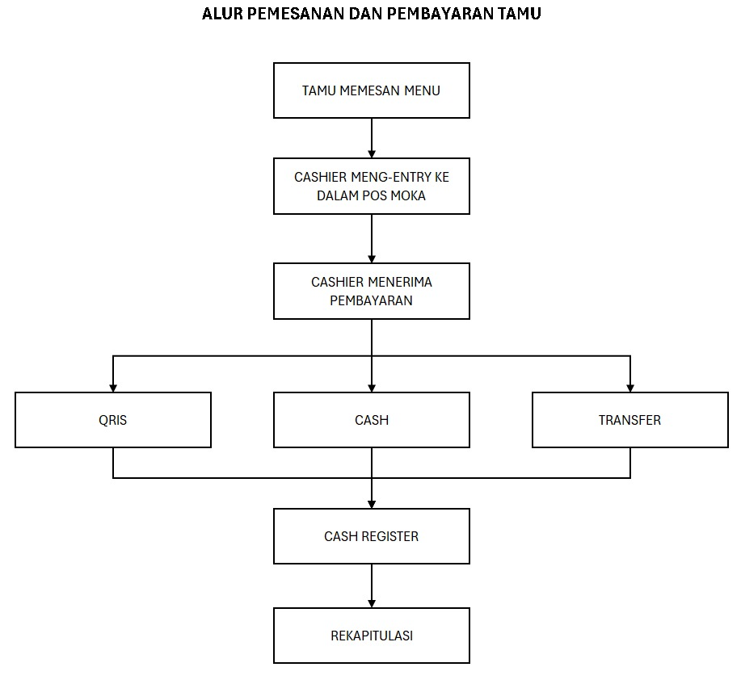
Reference supplied by stakeholder; the SRS translates this flow into system requirements and audit states.

A.2 Alur Pengajuan Dana Belanja / Operasional
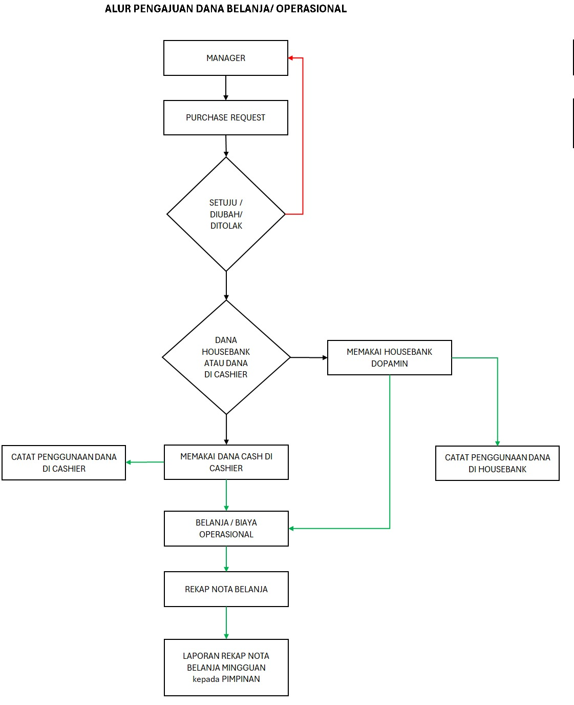
Reference supplied by stakeholder; the SRS translates this flow into system requirements and audit states.

A.3 Stock Opname
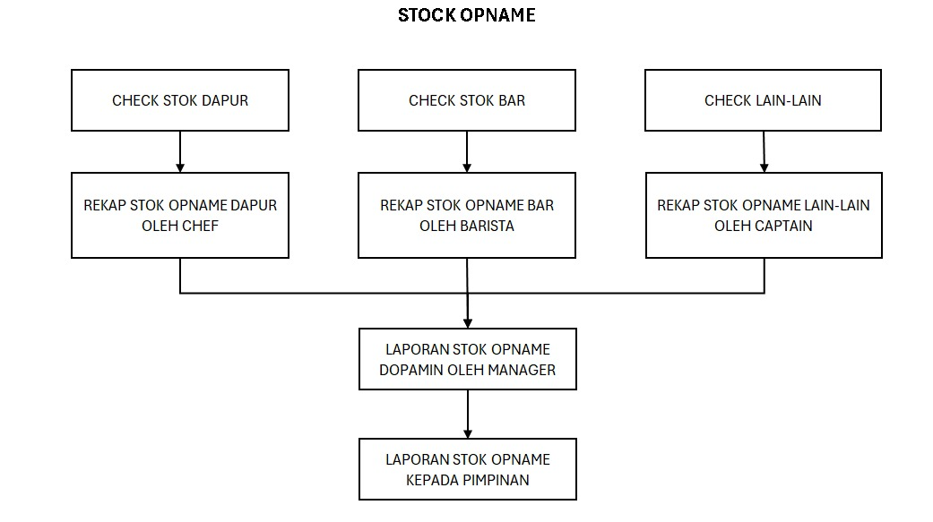
Reference supplied by stakeholder; the SRS translates this flow into system requirements and audit states.

Appendix B. Spreadsheet-to-System Mapping

B.1 Cashier Report (Responses)
Source Column/Group | Target Concept | Rule
Timestamp | raw_form_submissions.submitted_at | Source submission time; not Business Date.
Tanggal Pelaporan | cashier_reports.business_date | Primary business/reporting date.
Nama Cashier | cashier_reports.cashier_user/name | Cashier identity; may require mapping to application user.
Waktu Shift | cashier_reports.shift | Shift label.
Transaksi / Transaksi 2 | cashier_reports / expense classification | Branch/control data; normalize meaningful transaction type.
Jumlah belanja lainnya + staff | cashier_expense_lines | Expense category: Other.
Jumlah makan karyawan + staff | cashier_expense_lines | Expense category: Employee Meal.
Jumlah belanja transportasi + staff | cashier_expense_lines | Expense category: Transport.
Jumlah belanja peralatan/perlengkapan + staff | cashier_expense_lines | Expense category: Equipment/Supplies.
Jumlah belanja bahan baku + staff | cashier_expense_lines | Expense category: Raw Material.
Pembayaran Cash / Cash 2 | payment_lines(CASH) | Consolidate non-null branch values.
Pembayaran QRIS / QRIS 2 | payment_lines(QRIS) | Consolidate non-null branch values.
Pembayaran Transfer / Transfer 2 | payment_lines(TRANSFER) | Consolidate non-null branch values.
Pembayaran Piutang / City Ledger | payment_lines(RECEIVABLE) | Keep distinct code if business requires.
Pembayaran di Muka (DP) | payment_lines(DP) | Do not automatically treat as normal cash sales without accounting rule.
Pembayaran Promosi / Kerjasama Promosi | payment_lines(PROMOTION) | Controlled payment/settlement classification.
Debit / Credit Visa / Mastercard | payment_lines(CARD_*) | Normalize payment method.
Opening & Closing Status | cashier_reports.status | Opening/Closing state.
Jumlah petty cash / petty cash 2 | cashier_reports.petty_cash | Branch variants normalize to one field/history.
Pecahan 100k…500 (+ variants) | cash_denominations | Store denomination counts and calculate actual cash.
Jumlah cash di luar petty cash (+ variant) | cashier_reports.cash_outside_petty | Used in cash reconciliation.

B.2 Daily Sales Kitchen
Source Column/Group | Target Concept | Rule
Timestamp | raw_form_submissions.submitted_at | Submission timestamp.
Nama Inputer | sales_reports.inputter | Kitchen inputter.
Tanggal penjualan | sales_reports.business_date | Authoritative Business Date.
All food menu columns | sales_report_items(menu_item, quantity) | Unpivot wide columns; null = zero/no sale.
Paket Nugas (food) | sales_report_items | Treat as Food menu item.

Observed food-item columns include Ayam Penyet + Nasi, Chicken Cordon Bleu, Chicken Finger, Chicken Mac and Cheese, Dopamin Mix Platter, Dopamin Pizza, ramen, rice-bowl variants, toast variants, and other listed menu items. Exact master-menu seeding will be produced in the ERD/data-seed phase.

B.3 Daily Sales Beverage
Source Column/Group | Target Concept | Rule
Timestamp | raw_form_submissions.submitted_at | Submission timestamp.
[NEW] Tanggal Penjualan | sales_reports.business_date | Must be added to Beverage Form for reliable reporting.
Barista | sales_reports.inputter | Cashier/barista identity.
All beverage menu columns | sales_report_items(menu_item, quantity) | Unpivot wide columns; null = zero/no sale.
Paket Nugas (beverage) | sales_report_items | Treat as Beverage menu item.

Observed beverage-item columns include Americano, Cappucino, Espresso, Kopi Susu Gula Aren, Long Black, teas, squashes, smoothies, cream-cheese beverages, V-60, Vietnam Drip, and other listed items.

B.4 OPEX Report
Source Column | Target Concept | Rule
No | source reference | Historical sequence/reference only.
Tanggal | fund_transactions.business_date/date | Transaction date.
Transaksi | fund_transactions.description / party | Description retained for audit/mapping.
Debit | fund_transactions amount / direction IN | Company funding or other inbound to Housebank.
Kredit | fund_transactions amount / direction OUT | Operational expense/outflow.
Balance | Derived only | Use for import validation/reconciliation; application balance is recomputed from transactions.

B.5 Required Google Form Adjustments
- Add Tanggal Penjualan / Business Date to Beverage Form.
- Prefer controlled numeric validation for monetary and quantity fields.
- Avoid helper/navigation text being captured as business data.
- Maintain stable column/question identifiers or mapping keys when forms are changed.
- Do not remove source history after the application goes live.

