UI/UX & SCREEN
SPECIFICATION
Dopamin Cafe Accounting & Inventory System
Brand direction inspired by Dopamin Coffee & Workspace — Cimahi

Document | Value
Document ID | UIUX-DOPAMIN-ACCINV
Version | 0.1 — Draft Baseline
Depends On | SRS v0.1 • ERD v0.1 • SDD v0.1
Primary Platforms | Desktop Web + Responsive Mobile Web
Business Timezone | Asia/Jakarta
Brand Palette | Derived approximately from stakeholder-supplied cafe/photo reference

Document Control
Version | Status | Description
0.1 | Draft Baseline | Initial UI/UX, navigation, design-system, responsive, and screen specification based on approved SRS/ERD/SDD.

Purpose
This document converts the approved system requirements and technical design into an implementable application experience. It defines information architecture, navigation per role, visual tokens, components, screen inventory, interaction states, responsive behavior, and low-fidelity branded wireframes.
Brand colors are approximated from the stakeholder-supplied Dopamin Cafe photo/logo. If official vector brand assets are supplied later, exact values should replace these sampled colors without changing the UX structure.

Design Principles
- Operational clarity before decoration: financial status, completeness, and exceptions must be visible immediately.
- Do not force staff to learn unnecessary back-office complexity; Google Forms remain the main operational input for Cashier/Kitchen/Beverage in MVP.
- Every important number must be explainable through drill-down to supporting records.
- Dangerous actions (correction, void, approval, funding) must communicate consequence, actor, and audit impact.
- Use Dopamin green as the primary action/brand color, warm cafe neutrals for surfaces, and restrained semantic colors for alerts.
- Owner/Director receive a complete executive view; Manager sees operational exceptions; Cashier and Kitchen see simplified role workspaces.

Contents
- 1. Brand & Visual Direction
- 2. Design System
- 3. Information Architecture
- 4. Role-Based Navigation
- 5. Global Layout & Components
- 6. Screen Inventory
- 7. Detailed Screen Specifications
- 8. Critical User Flows
- 9. Responsive & Mobile Rules
- 10. Accessibility & Content Standards
- 11. UI Acceptance Checklist
- Appendix A. Wireframe Gallery

1. Brand & Visual Direction

1.1 Visual Character
The application should feel operationally professional while still recognizably belonging to Dopamin Coffee & Workspace. The supplied cafe reference combines a dark green logo, warm wood/cafe neutrals, off-white surfaces, and dark charcoal details. The UI uses that character without turning financial screens into decorative marketing pages.
Token | Hex | Usage | Swatch
Dopamin Green | #0F623E | Primary actions, active navigation, key positive emphasis
Deep Green | #0A432C | Headings, dark brand emphasis, selected states
Cafe Olive | #A09062 | Secondary accents, charts, warm visual balance
Warm Sand | #DED7BE | Soft surfaces, headers, inactive accents
Cafe Cream | #F6F3E9 | Application background
Paper White | #FBFAF6 | Cards and main surfaces
Charcoal | #1D271E | Sidebar and primary text
Muted Gray-Green | #68736A | Secondary text and metadata

1.2 Semantic Colors
State | Color | Meaning / Rule
Success / Complete | #2E7D52 | Submission complete, reconciliation within tolerance, successful delivery.
Warning / Incomplete | #B47A1F | Missing submission, variance, pending review; warning does not mean financial loss automatically.
Danger / Invalid | #A94A3F | Rejected data, high-risk correction, void/reversal, destructive confirmation.
Information | #3E6C78 | Neutral system information, sync status, secondary explanation.

Financial sign should not be communicated by color alone. For example, -Rp50.000 must include a minus sign/text label, not only red color.

1.3 Brand Usage Rules
- Primary green is reserved for the main CTA, active navigation, selected filters, and confirmed positive state; do not color every card green.
- Warm neutrals are used for background and hierarchy so dense accounting tables remain readable.
- The photographic cafe image is suitable for login/onboarding or documentation, not as a background behind financial tables.
- If an official vector logo is supplied, use it in the application shell and login screen; until then, do not recreate the monkey/logo mark from the photo.

2. Design System

2.1 Typography
Token | Desktop | Mobile | Usage
Display / Page Title | 28-32 px | 24-28 px | Page/module title; semibold/bold.
Section Heading | 18-22 px | 18-20 px | Card/table section heading.
Body | 14-16 px | 14-16 px | Forms, tables, explanatory copy.
Small / Meta | 12-13 px | 12-13 px | Timestamp, helper, source info.
Financial KPI | 26-34 px | 24-30 px | Primary money values; tabular numerals preferred.

Recommended implementation font: Inter or system UI stack. Monetary figures should use tabular numerals so columns align consistently.

2.2 Spacing, Radius, and Density
Token | Value | Rule
Base spacing | 4 px | Use 4/8/12/16/24/32/48 progression.
Card radius | 12-16 px | Operationally modern, not overly rounded.
Input radius | 8-10 px | Keep forms compact and clear.
Desktop content max width | 1440-1600 px | Allow wide finance tables.
Default table row | 48-56 px | Use 40-44 px only for dense audit/history table mode.
Sidebar | 240-256 px | Collapsible below tablet breakpoint.

2.3 Core Components
Component | Variants / Required States | UX Rule
Button | Primary, Secondary, Ghost, Danger; default/loading/disabled | One primary action per panel whenever possible.
KPI Card | Neutral, Success, Warning, Error | Always show label + value + scope/time context.
Status Badge | Complete, Incomplete, Pending, Rejected, Voided | Badge text is mandatory; color is supplementary.
Data Table | Default, compact, selectable, expandable | Sticky header for long tables; currency right-aligned.
Filter Bar | Date range, module filters, status, user | Applied filters visible; Reset action available.
Money Input | IDR formatting with raw numeric validation | Never silently round significant values.
Confirmation Modal | Normal, high-risk | High-risk corrections/voids require reason and consequence copy.
Drawer / Detail Panel | Read-only transaction detail | Use for fast drill-down without losing table context.
Empty/Error State | No data, no permission, sync error | Explain what happened and next action.

3. Information Architecture
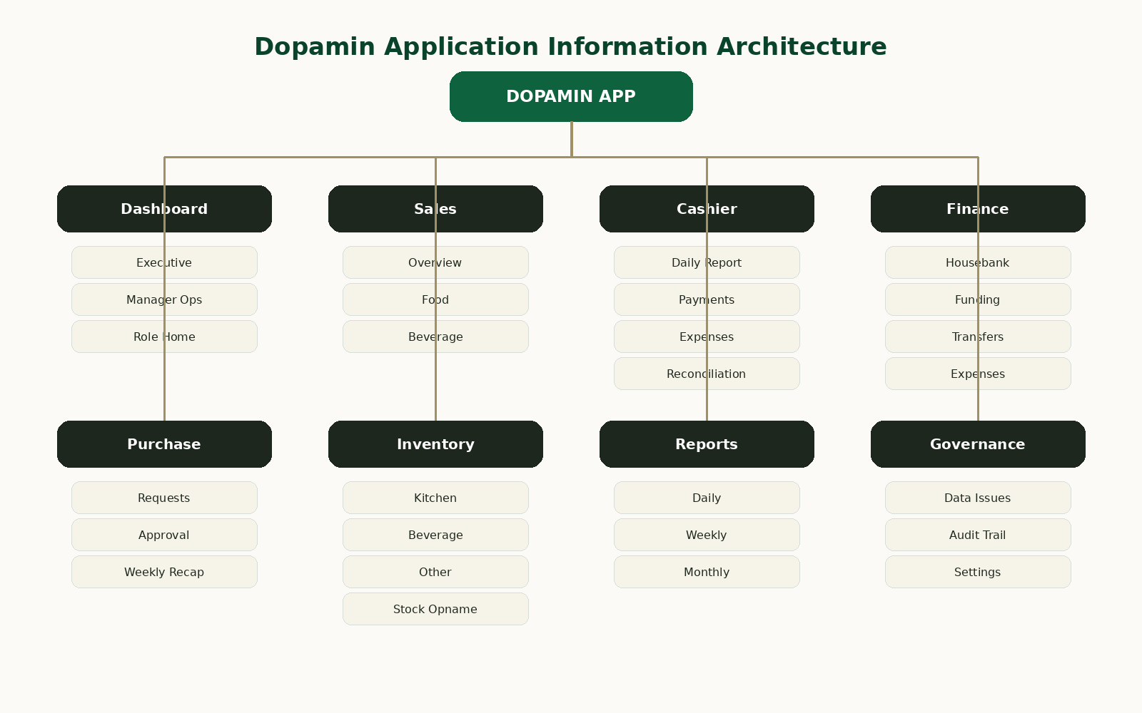
Figure 1 — Proposed information architecture for the MVP application.

3.1 Primary Navigation
- Dashboard — role-specific home and operational summary.
- Sales — Food/Beverage sales quantities and priced revenue.
- Cashier — daily cashier report, payments, expenses, cash reconciliation.
- Finance — Housebank, company funding, internal transfers, operational expenses.
- Purchase — Purchase Requests, approvals, receipt completion, weekly recap.
- Inventory — stock categories and stock-opname sessions.
- Reports — daily/weekly/monthly historical reports and report runs.
- Data Issues — invalid, incomplete, suspicious, or correction-required source data.
- Audit Trail — append-only history for leadership.
- Settings — users, menu/prices, report schedule/recipients, system settings.

3.2 Navigation Behavior
- Desktop: persistent left sidebar; active route highlighted with Dopamin Green.
- Tablet: collapsible sidebar/drawer; preserve route names and status count badges.
- Mobile: bottom navigation for 3-5 role-primary modules plus “More” drawer for secondary pages.
- Role permission changes both navigation visibility and server-side authorization; hidden menu alone is not security.

4. Role-Based Navigation
Module / Action | Owner | Director | Manager | Cashier | Kitchen
Executive Dashboard | Full | Full | Operational | Own scope | Own scope
Sales Overview | Full | Full | Full | Beverage + summary | Food + summary
Cashier Detail | Full | Full | Full | Own/current | No
Housebank / Finance | Full | Full | View/limited | No | No
Company → Housebank | Yes | Yes | No | No | No
Purchase Request | Full | Full | Create/manage | No | No
Approve / Reject PR | Yes | Yes | No | No | No
Inventory | Full | Full | Full | Beverage/Bar | Kitchen
Reports | Full | Full | Operational | Own scope | Own scope
Data Issues | Full | Full | Operational | Own source if allowed | Own source if allowed
Audit Trail | Full | Full | Limited | No | No
Settings | Full | Full | No | No | No

This table defines the UI baseline only. The next RBAC document will specify VIEW / CREATE / UPDATE / CORRECT / VOID / APPROVE / EXPORT at action level.

5. Global Layout & Interaction Patterns

5.1 Desktop Shell
- Left sidebar: Dopamin brand, module navigation, role identity.
- Top header: page title, Business Date/date range context, user menu, optional sync indicator.
- Main area: KPI summary → exception/status area → charts → detail tables in that order for executive pages.
- High-risk financial actions are placed near the relevant account but visually separated from navigation/filter controls.

5.2 Global Date Context
- All dashboard/report pages visibly state Business Date or active date range.
- Quick options: Today, Yesterday, This Week, This Month, Custom.
- Submission timestamp may appear in detail but must never replace Business Date in daily financial context.
- When viewing historical data with a later correction, show “Corrected” indicator and correction timestamp.

5.3 Status & Exception Hierarchy
Level | Examples | UI Treatment
Critical | Invalid financial source, failed posting, permission violation | Red banner / action required; no silent fallback.
Warning | Missing Beverage report, cash variance, stock variance | Amber badge/card; dashboard exception panel.
Informational | Sync pending, report scheduled, no receipt attached yet | Muted blue/neutral inline status.
Complete | Required forms complete, successful report send | Green badge/check; no oversized success banner.

6. Screen Inventory
ID | Screen | Primary Role | Purpose
AUTH-01 | Login | All | Authenticate with permitted account.
DSH-01 | Executive Dashboard | Owner/Director | Complete business performance overview.
DSH-02 | Manager Operations | Manager | Completeness, exceptions, PR and stock status.
DSH-03 | Cashier Home | Cashier | Own daily cashier and beverage status.
DSH-04 | Kitchen Home | Kitchen | Food report and Kitchen stock status.
SAL-01 | Sales Overview | Leadership/Manager | Food vs Beverage trend and totals.
SAL-02 | Food Sales Detail | Leadership/Manager/Kitchen | Menu quantity/revenue detail.
SAL-03 | Beverage Sales Detail | Leadership/Manager/Cashier | Beverage quantity/revenue detail.
MNU-01 | Menu & Price Master | Owner/Director | Menu activation and effective price history.
CAS-01 | Cashier Reports | Leadership/Manager/Cashier | List of cashier reports.
CAS-02 | Cashier Report Detail | Leadership/Manager/Cashier | Payments, expenses, denominations, reconciliation.
CAS-03 | Cash Reconciliation | Leadership/Manager/Cashier | Expected vs actual and variance.
FIN-01 | Housebank | Owner/Director | Balance and fund transaction history.
FIN-02 | Company Funding Form | Owner/Director | Company → Housebank entry.
FIN-03 | Fund Transfer Form | Authorized | Housebank → Cashier internal transfer.
FIN-04 | Operational Expense Form | Authorized | Expense from Housebank/Cashier.
FIN-05 | Fund Transaction Detail | Leadership | Trace source, journal, audit.
PR-01 | Purchase Request List | Leadership/Manager | Status pipeline and filters.
PR-02 | Create/Edit Purchase Request | Manager | Request purpose/items/estimate.
PR-03 | Purchase Request Detail | Leadership/Manager | Approval history, funding, receipt.
PR-04 | Approval Dialog | Owner/Director | Approve / revision / reject.
PR-05 | Weekly Recap | Leadership/Manager | Requests and receipt completion.
INV-01 | Inventory Overview | Leadership/Manager | Category completion and variances.
INV-02 | Stock Opname Session | Role scoped | Input/review actual counts.
INV-03 | Inventory Item History | Leadership/Manager | Historical count and variance.
RPT-01 | Daily Reports | Leadership/Manager | Daily report history and completeness.
RPT-02 | Report Run Detail | Leadership | Original/revision snapshots and delivery.
RPT-03 | Weekly/Monthly Report | Leadership | Aggregated reporting.
ISS-01 | Data Issues | Leadership/Manager | Invalid/incomplete/suspicious source queue.
ISS-02 | Correction Review | Authorized | Before/after + reason + audit consequence.
AUD-01 | Audit Trail | Owner/Director | Searchable append-only event history.
AUD-02 | Audit Event Detail | Owner/Director | Full before/after metadata.
SET-01 | User Management | Owner/Director | Activate/deactivate users and role.
SET-02 | Daily Report Settings | Owner/Director | Schedule and recipients.
SET-03 | System Settings | Owner/Director | Timezone, operating hours, thresholds.
SET-04 | Integration Status | Owner/Director | Google Sheet sync health and reprocess.

7. Detailed Screen Specifications

7.1 Executive Dashboard — DSH-01
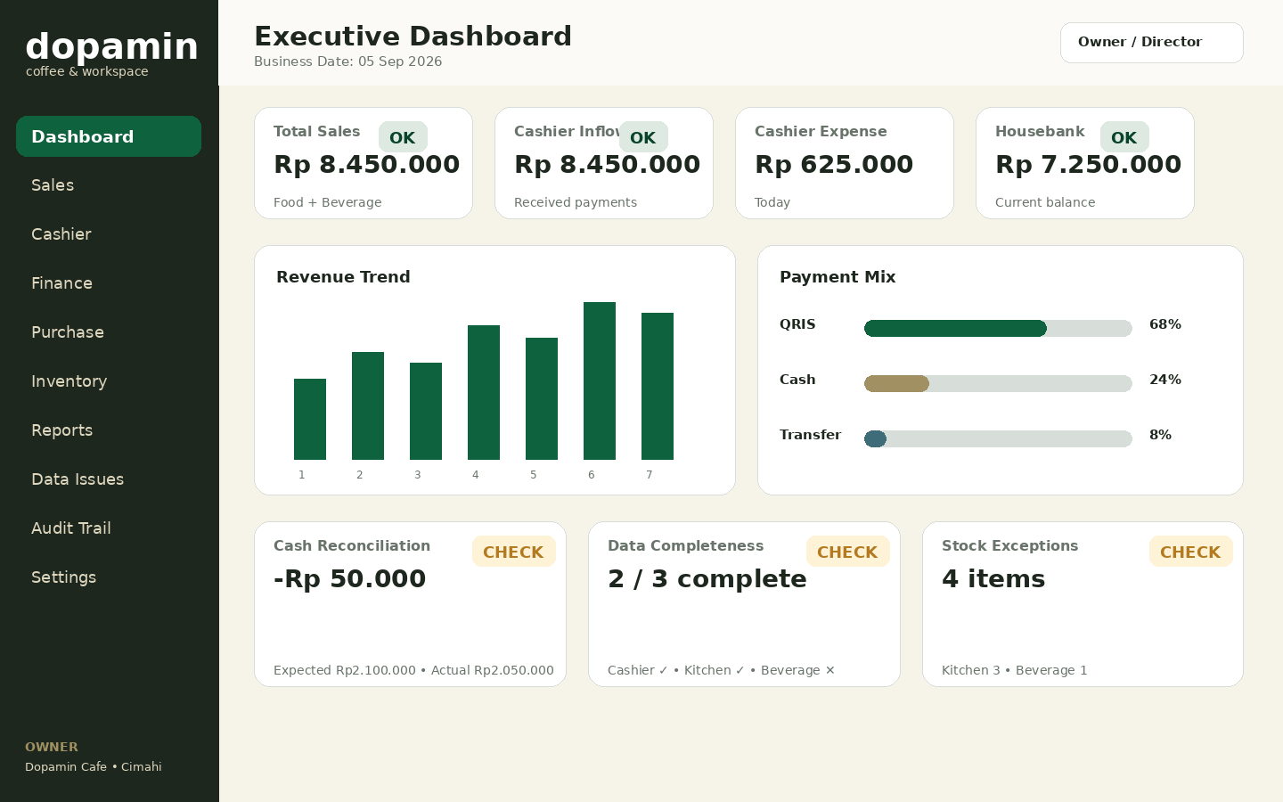
Figure 2 — Executive dashboard wireframe, Dopamin brand direction.
ID | Screen / Rule | Specification | Acceptance
DSH01-A | Header | Business Date/date range, data freshness, user identity. | Date context always visible.
DSH01-B | KPI cards | Total Sales, Cashier Inflow, Cashier Expense, Housebank balance. | Values drill down when clicked.
DSH01-C | Sales trend | Time-series chart; same filter as KPI cards. | No mismatch between chart and cards.
DSH01-D | Payment mix | Cash / QRIS / Transfer / card/other accepted methods. | Percent + nominal accessible in tooltip/detail.
DSH01-E | Cash reconciliation | Expected, Actual, Difference; warning on variance. | Derived value not editable.
DSH01-F | Completeness | Cashier, Kitchen, Beverage state. | Missing source names explicit.
DSH01-G | Inventory exceptions | Count and route to stock issues. | Only relevant exceptions shown.

7.2 Manager Operations — DSH-02
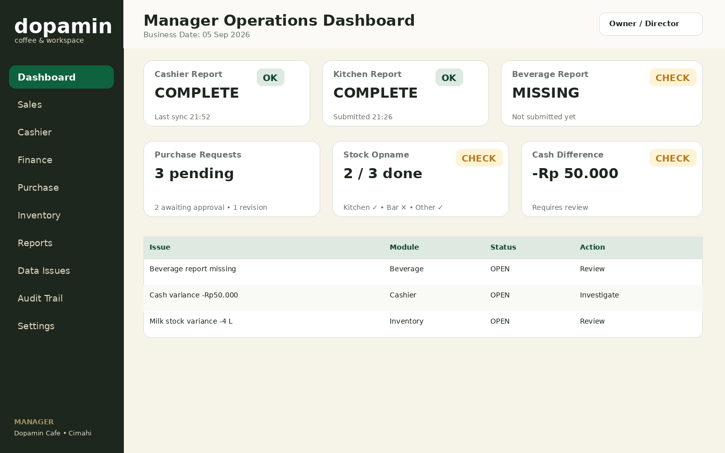
Figure 3 — Manager workspace focuses on operational exceptions.
- Primary objective: answer “what is incomplete or needs action today?” rather than duplicate the executive financial dashboard.
- Issue list must provide direct action to affected report/stock/transaction.
- Purchase Request counts and stock completeness are visible without exposing restricted owner-only settings.

7.3 Cashier & Beverage Workspace — DSH-03
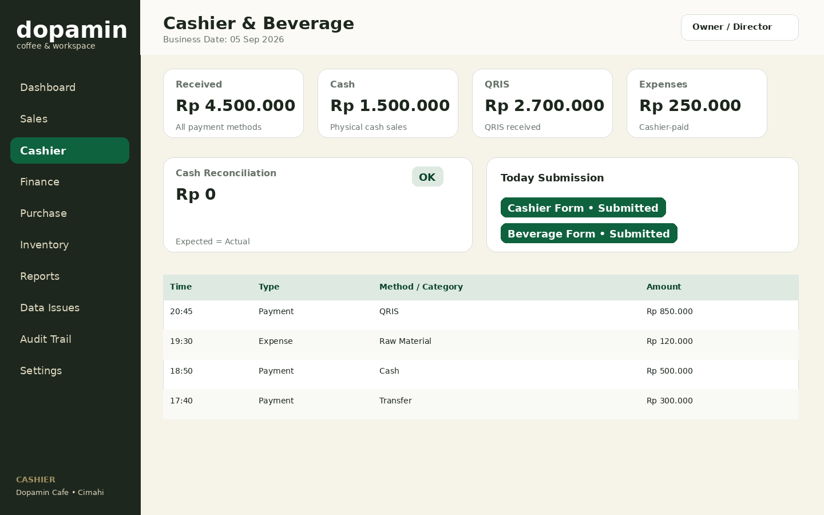
Figure 4 — Simplified Cashier workspace; Google Forms remain primary data entry.
- Show received money by method, cashier expense, reconciliation, and today submission state.
- Offer clear “Open Cashier Form” / “Open Beverage Form” quick links if integration allows configured form URLs.
- Do not expose Housebank company funding or full audit screens.

7.4 Kitchen Workspace — DSH-04
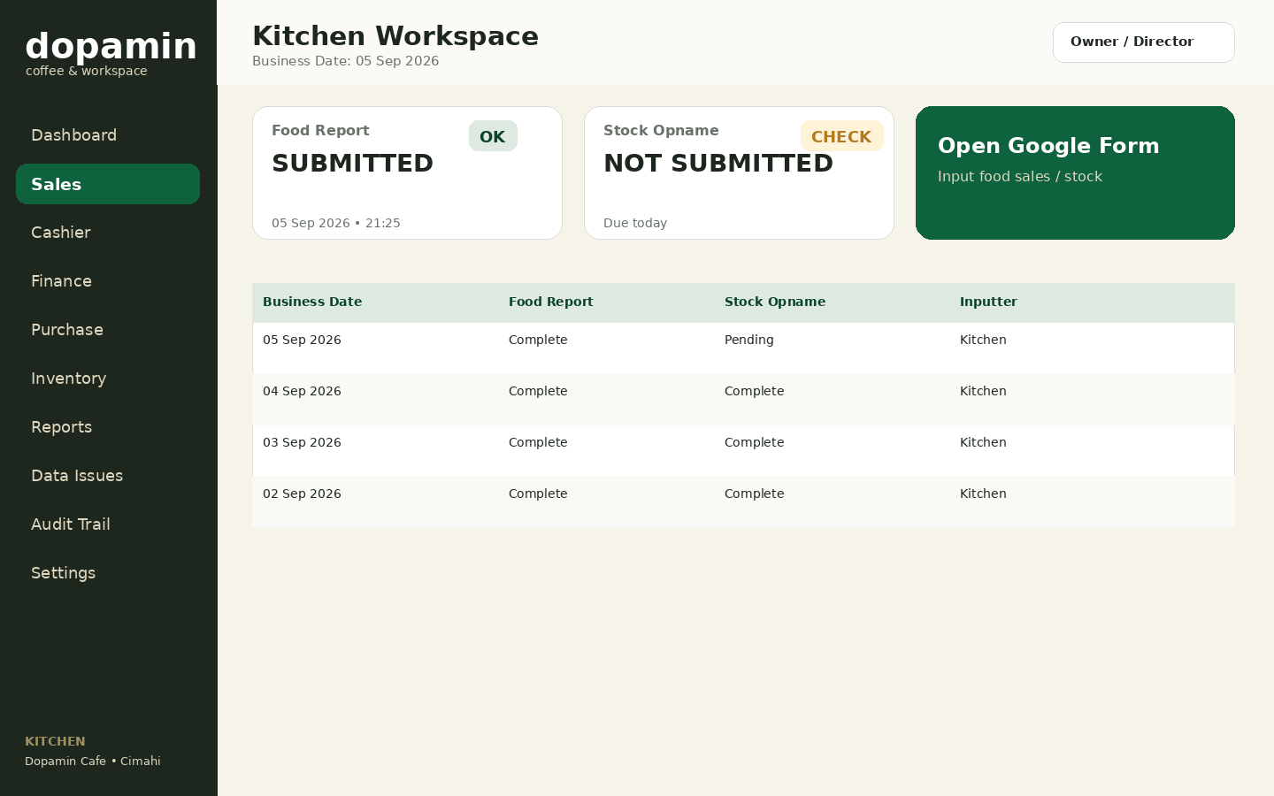
Figure 5 — Kitchen workspace emphasizes submission and Kitchen stock completion.
- Keep interface minimal: Food report status, Stock Opname status, link to Google Form, and recent history.
- No financial account information is exposed.

7.5 Housebank — FIN-01
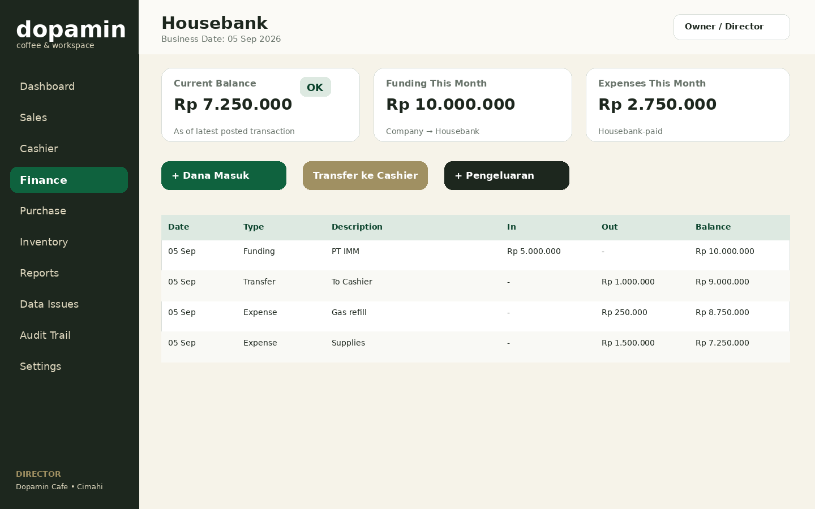
Figure 6 — Housebank account, actions, and running ledger view.
ID | Screen / Rule | Specification | Acceptance
FIN01-A | Balance | Derived current Housebank balance. | Cannot be directly edited.
FIN01-B | Funding | Company → Housebank CTA visible only to permitted roles. | Creates funding transaction, not sales revenue.
FIN01-C | Transfer | Housebank → Cashier internal transfer. | UI labels it “Internal Transfer”.
FIN01-D | Expense | Operational expense from selected fund account. | Requires category + amount + description.
FIN01-E | Ledger table | Date, type, description, in/out, running balance. | Click row opens immutable detail/audit.

7.6 Financial Action Forms — FIN-02/03/04
Form | Required Fields | Validation / Confirmation
Company Funding | Business Date, amount, source/company reference, description, optional document reference | Amount > 0; destination fixed to Housebank; confirm “This is funding, not sales revenue”.
Internal Transfer | Business Date, source Housebank, destination Cashier, amount, note | Source ≠ destination; amount > 0; confirm no revenue/expense is created.
Operational Expense | Business Date, source account, category, amount, description, staff/vendor, receipt reference | Amount > 0; sufficient-policy warning if balance would be abnormal; receipt optional/required per later policy.

7.7 Purchase Request — PR-01..05
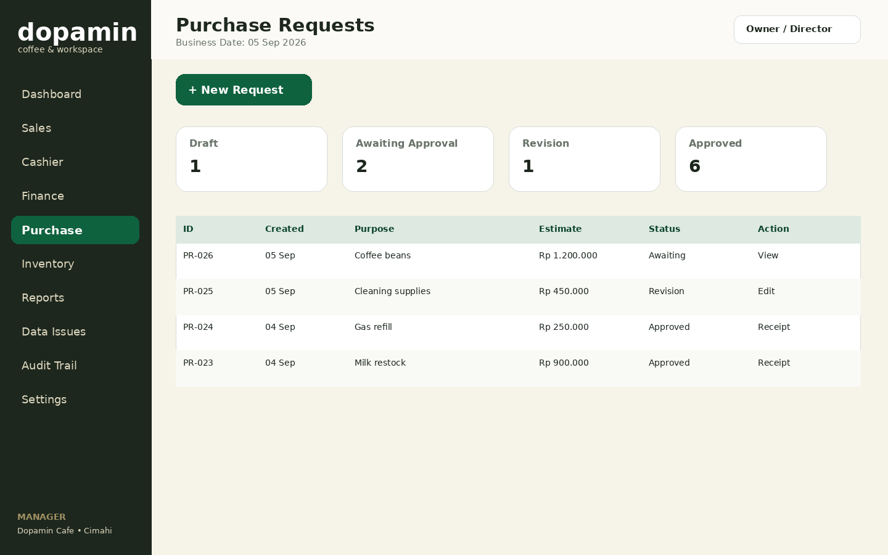
Figure 7 — Purchase Request list and status pipeline.
- Statuses: DRAFT → AWAITING_APPROVAL → REVISION_REQUIRED / REJECTED / APPROVED → PURCHASED / COMPLETED.
- Manager sees edit action only when request state allows modification.
- Owner/Director approval dialog must require a note for Revision or Reject.
- After approval, funding source Housebank or Cashier must be selected before final expense completion.
- Receipt/nota completion is visible in weekly recap.

7.8 Stock Opname — INV-01/02
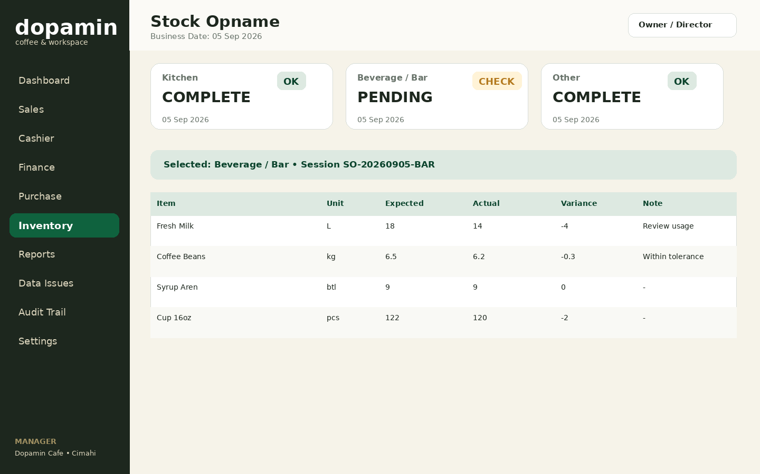
Figure 8 — Stock Opname session and variance review.
- Role scope: Kitchen → Kitchen items; Cashier → Beverage/Bar; Manager → Other + consolidated review.
- Actual quantity is editable only while the session is open; Variance is calculated automatically.
- Negative/large variance is highlighted but not automatically classified as loss without review.
- Completed session becomes read-only; later correction uses an audited correction flow.

7.9 Data Issues & Correction — ISS-01/02
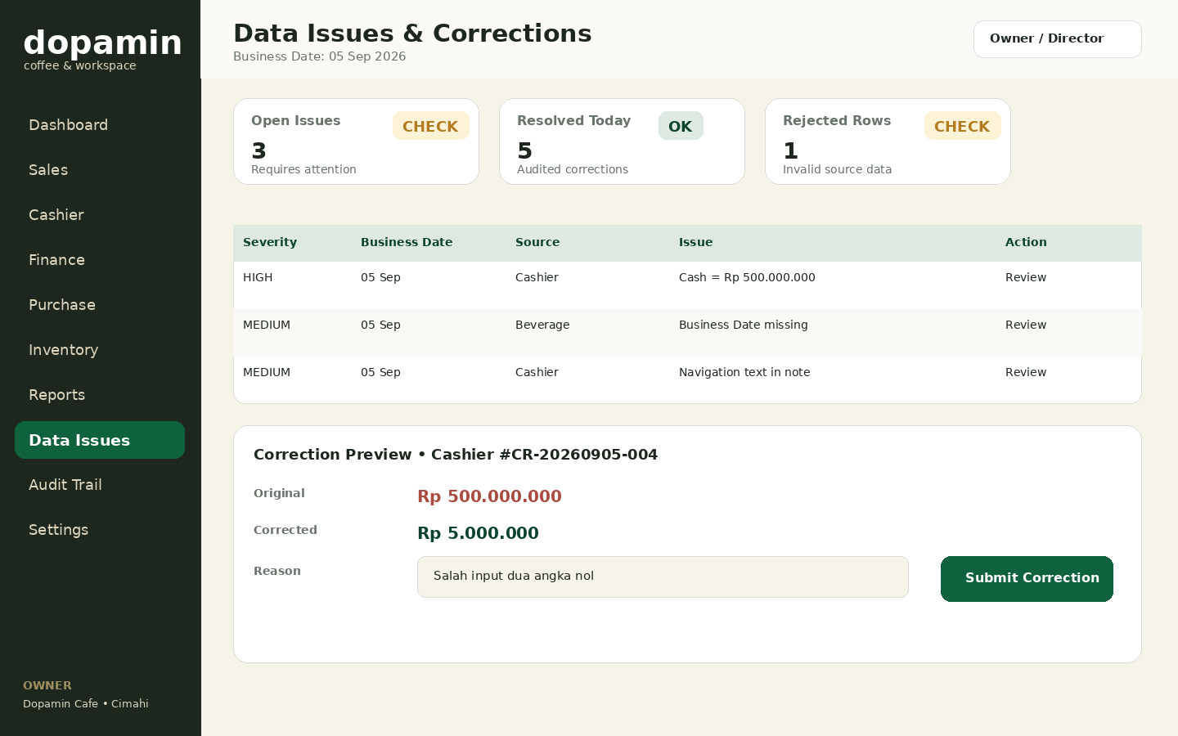
Figure 9 — Data quality queue and audited correction preview.
ID | Screen / Rule | Specification | Acceptance
ISS-A | Issue queue | Severity, Business Date, source, issue summary, action. | Open issues are filterable and traceable to raw submission.
ISS-B | Original value | Display original value read-only. | Never overwritten in UI.
ISS-C | Corrected value | Authorized user enters proposed effective value. | Field-level validation applies.
ISS-D | Reason | Mandatory correction reason. | Save disabled without reason.
ISS-E | Consequence | Explain impacted report/journal/revision where relevant. | High-risk correction requires confirmation.
ISS-F | Audit | Record actor, before/after, reason, timestamp. | Audit event generated on success.

7.10 Audit Trail — AUD-01/02
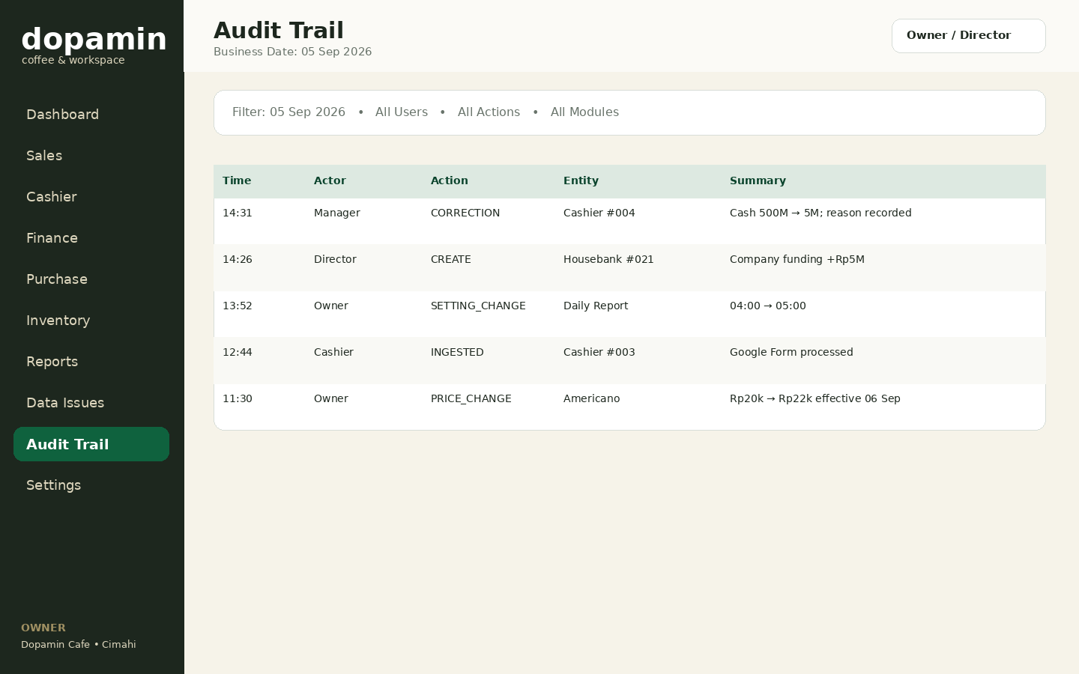
Figure 10 — Searchable audit trail for Owner/Director.
- Filters: date/time, actor, action, module, entity ID.
- Default table summarizes action; detail view shows before/after payload safely formatted.
- No edit/delete control exists for audit events.
- Export may be enabled for Owner/Director in a later RBAC decision.

7.11 Daily Report Settings — SET-02
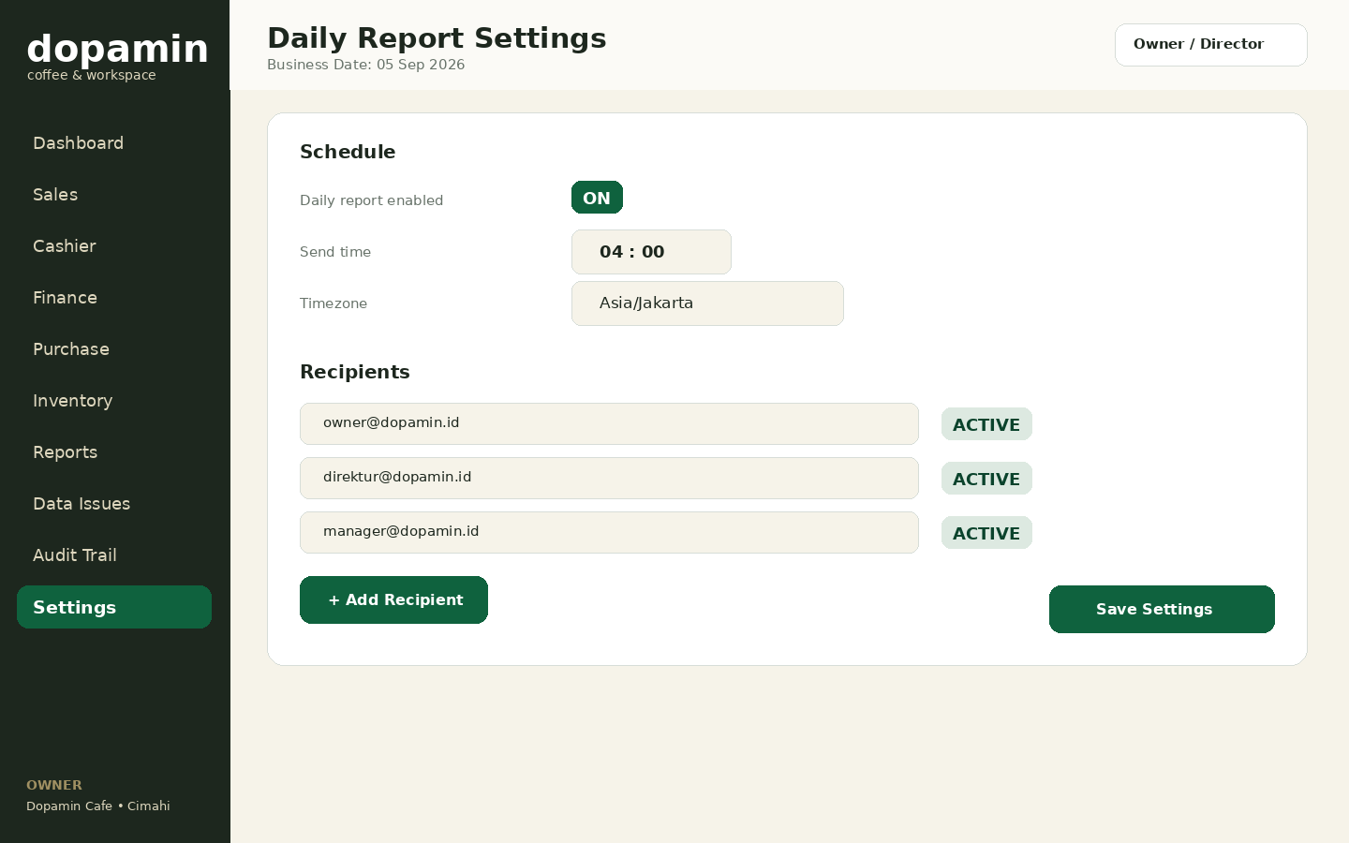
Figure 11 — Daily report schedule and recipient management.
- Enable/disable scheduled report; choose send time and timezone.
- Multiple recipients; email validation and active/inactive state.
- If data is incomplete, baseline behavior remains “send with BELUM LENGKAP”.
- All settings changes create audit events.

7.12 Sales Screens — SAL-01/02/03
Area | Specification
Overview KPI | Food revenue, Beverage revenue, quantity sold, data completeness.
Trend chart | Food vs Beverage revenue over selected Business Date range.
Top products | Item, quantity, effective price, calculated revenue.
Detail table | Business Date, item, category, quantity, effective price, calculated revenue, source/inputter.
Price marker | If price changed during range, each row uses Business-Date effective price; detail exposes price-history reference.
Reconciliation note | Sales category total is not added to payment-method total; the UI presents them as separate dimensions.

7.13 Cashier Report Detail — CAS-02
Section | Content / Actions
Header | Business Date, cashier, shift, source sync state, report status.
Payments | Normalized payment lines by method; source column/row trace in detail.
Expenses | Category, amount, staff, note, source.
Petty Cash | Opening/closing petty cash fields from source.
Cash Count | Denomination counts and calculated physical cash.
Reconciliation | Expected cash, actual cash, variance, explanation/status.
Correction History | Before/after corrections with actor and reason.
Actions | Review issue / correction if permitted; no direct edit of derived totals.

8. Critical User Flows

8.1 Daily Operational Review
- Owner/Director opens Executive Dashboard.
- Selects Business Date / Today / Yesterday.
- Checks completeness and exception cards before interpreting financial totals.
- Clicks any variance/missing source to open detail or Data Issues.
- After review, can open Daily Report snapshot or resend a revised report if data changed.

8.2 Correction Flow
- Open Data Issue or transaction detail.
- System shows original raw/source value and current effective value.
- Authorized user enters corrected value and mandatory reason.
- System previews impacted derived values and indicates whether accounting/report revision may be created.
- User confirms; backend applies correction transactionally.
- Audit event is generated; original value remains preserved; affected report may require R1/R2 revision.

8.3 Purchase Request Flow
- Manager creates request → submits for approval.
- Owner/Director Approves, Requests Revision, or Rejects.
- If Revision, Manager edits permitted fields and resubmits.
- Approved request selects Housebank or Cashier as funding source.
- Purchase occurs; actual amount and receipt are attached/referenced.
- Request becomes completed and appears in weekly recap.

8.4 Daily Email Report Flow
- Scheduler reaches configured send window.
- System evaluates previous Business Date completeness.
- System freezes report snapshot metrics and source-status state.
- If incomplete, subject/body displays BELUM LENGKAP and lists missing sources.
- Delivery result and recipients are recorded.
- Later data/correction may generate a revision snapshot; original send remains unchanged.

8.5 Failed Google Form Ingestion
- Raw submission is stored or detected by reconciliation.
- Validation/mapping fails → issue becomes visible in Data Issues / Integration Status.
- Valid financial records are not fabricated from invalid input.
- Authorized user corrects/reprocesses mapping/data.
- Successful reprocess creates normalized entities and clears/resolves issue with audit trace.

9. Responsive & Mobile Rules
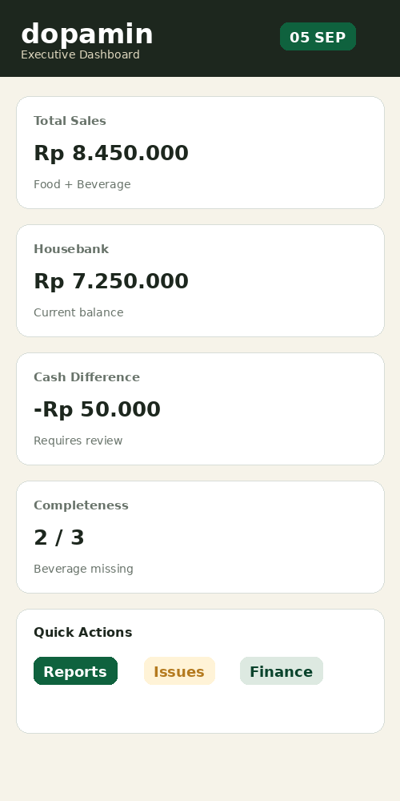
Figure 12 — Mobile dashboard direction; prioritize stacked KPIs and actions.
Breakpoint / Context | Behavior
≥ 1280 px Desktop | Persistent sidebar, 3-4 KPI cards per row, wide tables, side-by-side charts.
768-1279 px Tablet | Collapsible sidebar, 2 KPI cards per row, charts stack as needed.
< 768 px Mobile | Bottom navigation/More drawer; single-column cards; tables become horizontal scroll or card-list for simple histories.
Financial tables | Never hide critical amount/type/status columns merely to fit mobile; horizontal scroll is acceptable.
Modals | High-risk dialogs become full-screen sheet on small devices.
Forms | One-column fields on mobile; money/date controls large enough for touch.
Charts | Show simplified legends/labels; user can open data table alternative.

9.1 Mobile Role Priorities
Role | Bottom / First-Level Navigation
Owner/Director | Dashboard • Finance • Reports • Issues • More
Manager | Dashboard • Purchase • Inventory • Issues • More
Cashier | Home • Cashier • Beverage • History • More
Kitchen | Home • Food • Stock • History

10. Accessibility & Content Standards
- Target WCAG 2.1 AA contrast for body text and interactive controls where practical.
- All form controls have persistent labels; placeholders are not substitutes for labels.
- Keyboard focus must be visible; core desktop workflows should be keyboard operable.
- Status is expressed with text/icon + color, not color alone.
- Charts require accessible text summary or equivalent data table.
- Currency is displayed consistently as Indonesian Rupiah, e.g., Rp 1.250.000; database/API remains numeric.
- Business Date format in Indonesian UI: 05 Sep 2026 or 5 September 2026 depending space; avoid ambiguous 05/09 without context.
- Use direct operational language: “Belum Lengkap”, “Perlu Ditinjau”, “Terkoreksi”, “Dibatalkan (Void)”, not vague labels such as “Error 2”.
- High-risk confirmation copy states consequence: which account/report changes and that the action will be audited.

10.1 Empty / Loading / Error States
State | Required UI
Loading | Skeleton or progress for KPI/table; do not show Rp0 as a temporary loading substitute.
No data | Explain whether there were no transactions or the source report has not been submitted.
No permission | Clear access-denied page/state; do not imply missing data.
Sync delayed | Show last successful sync and retry/reprocess option for authorized roles.
Partial data | Keep available metrics visible but mark overall report incomplete.
Server failure | Friendly error + retry; generate/log incident context server-side.

11. UI Acceptance Checklist
ID | Acceptance Requirement
UI-ACC-01 | Every financial summary visibly states its Business Date/date range.
UI-ACC-02 | Owner/Director can reach supporting transaction detail from major KPI cards.
UI-ACC-03 | Manager dashboard prioritizes missing reports and operational exceptions.
UI-ACC-04 | Cashier and Kitchen screens do not expose restricted financial/settings modules.
UI-ACC-05 | Housebank balance has no direct edit control.
UI-ACC-06 | Company funding UI explicitly identifies destination Housebank and non-sales nature.
UI-ACC-07 | Internal transfer UI explicitly communicates no revenue/expense is created.
UI-ACC-08 | Correction screen always displays original + proposed effective value + mandatory reason.
UI-ACC-09 | Audit screen has no edit/delete action.
UI-ACC-10 | Incomplete daily report is visibly labeled BELUM LENGKAP and identifies missing sources.
UI-ACC-11 | Mobile layout keeps critical financial values readable without hiding meaning.
UI-ACC-12 | Loading state never masquerades as zero financial value.
UI-ACC-13 | Menu price history and effective-date behavior is explainable in relevant detail views.
UI-ACC-14 | All semantic statuses have text labels in addition to color.
UI-ACC-15 | Primary brand green is used consistently for CTA/active states, not as an uncontrolled decorative fill.

Appendix A. Wireframe Gallery
These wireframes define layout intent and information priority. They are not pixel-final visual design. Final implementation may refine spacing/iconography while preserving content hierarchy, permissions, states, and brand tokens.

A.1 Executive Dashboard

A.1 Executive Dashboard

A.2 Manager Operations

A.2 Manager Operations

A.3 Cashier & Beverage

A.3 Cashier & Beverage

A.4 Kitchen Workspace

A.4 Kitchen Workspace

A.5 Housebank

A.5 Housebank

A.6 Purchase Requests

A.6 Purchase Requests

A.7 Stock Opname

A.7 Stock Opname

A.8 Data Issues / Correction

A.8 Data Issues / Correction

A.9 Audit Trail

A.9 Audit Trail

A.10 Daily Report Settings

A.10 Daily Report Settings

Appendix B. Implementation Handoff
Handoff Area | Implementation Direction
Frontend stack | Next.js App Router + Tailwind CSS + shadcn/ui or equivalent accessible component primitives.
Tokens | Implement colors/spacing/radius as CSS variables; do not hard-code brand colors throughout components.
Tables | Server-backed filtering/pagination when data grows; currency right aligned; sticky header where useful.
Charts | Recharts/ECharts acceptable; always derive from same filtered query used by KPI cards.
Forms | Zod/client schema mirrors server validation; server remains authoritative.
Icons | Use one consistent icon library; icons supplement, not replace, text for critical financial actions.
Responsive | Implement mobile behavior from Section 9; do not simply scale desktop table down.
RBAC | Navigation gating + server authorization; next document will finalize action-level matrix.
Next deliverable | Detailed RBAC / Security & Permission Matrix, followed by API & Integration Specification and Physical DB/Drizzle schema.

END OF UI/UX & SCREEN SPECIFICATION v0.1

