1.
ADDITION
#! /bin/bash
echo Enter num1 and num2
read num1 num2

sum=`expr $num1 + $num2`
echo $sum

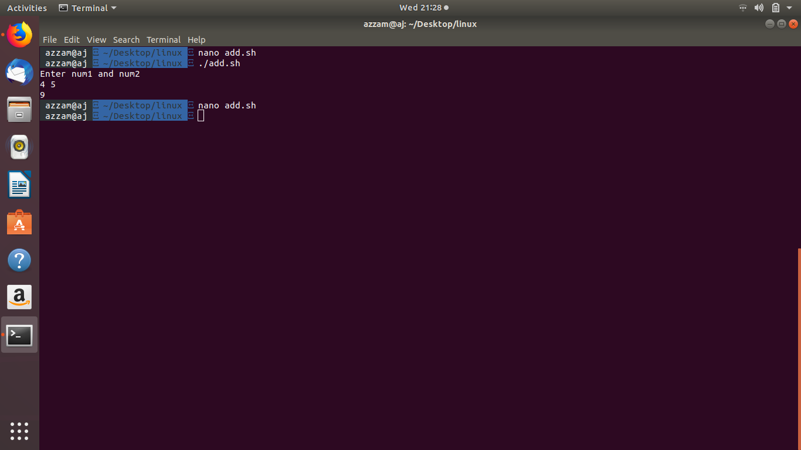

2.
MULTIPLICATION
#! /bin/bash
echo Enter two numbers
read a b
pro=`expr $a \* $b`
echo $pro

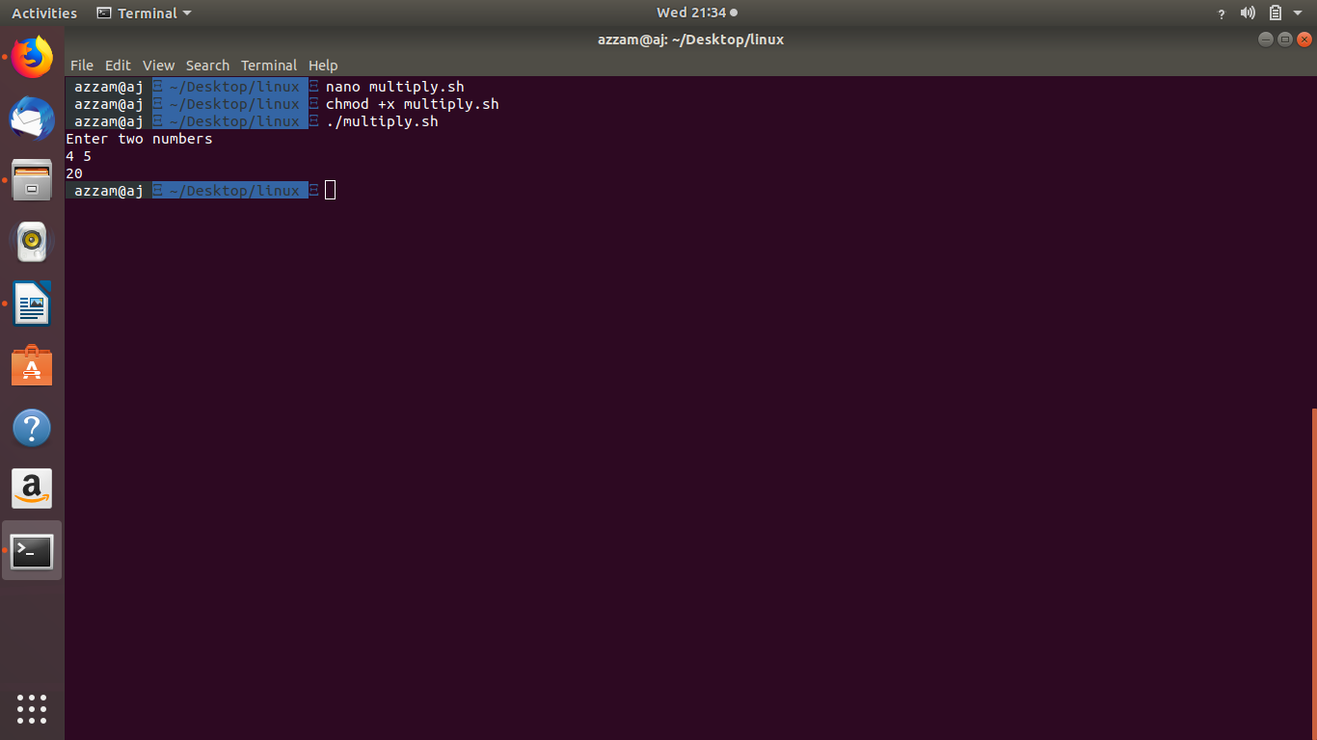

3.
ADDING TWO REAL NO.

#! /bin/bash
echo Enter two real numbers
read a b
c=`echo $a +$b | bc`
echo The sum is = $c

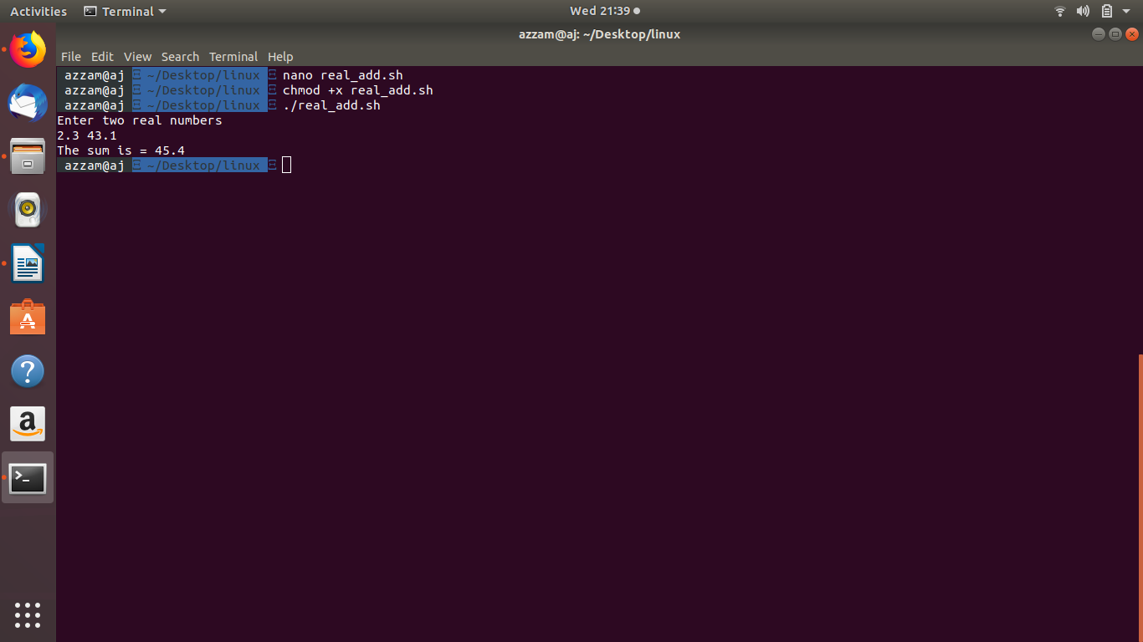

4.
FILE COPY

#! /bin/bash
echo Enter first file
read f1
echo Enter second file
read f2
if cp $f1 $f2
then
echo File copied
else
echo File not copied
fi

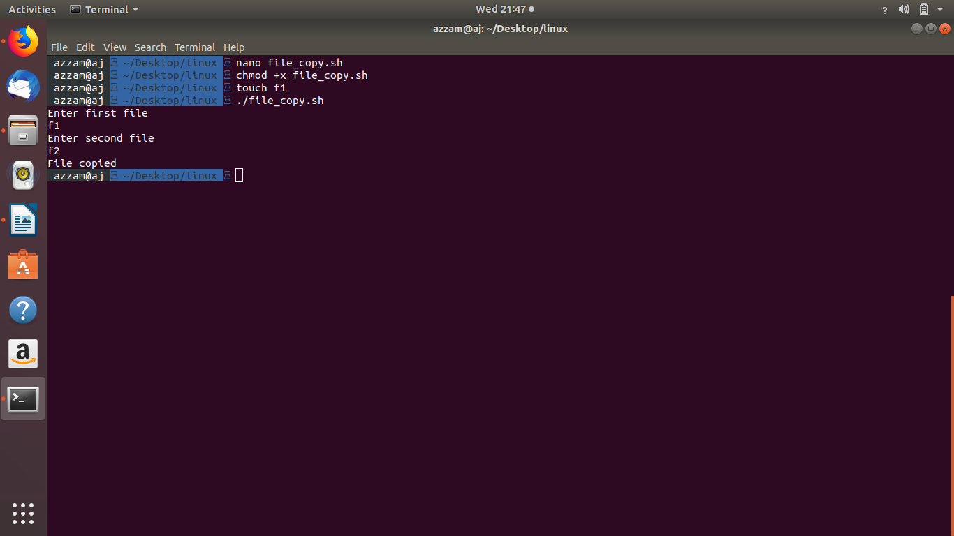

5.
CHECKING READ WRITE PERMISSIONS AND COPYING

#! /bin/bash
echo Enter file 1
read f1
echo enter file 2
read f2
if [ -s -a -r $f1 ]
then
if [ -w $f2 ]
then
cp $f1 $f2
else
echo "No write permissions on second file "
fi

else
echo " No read permissions on first file"
fi

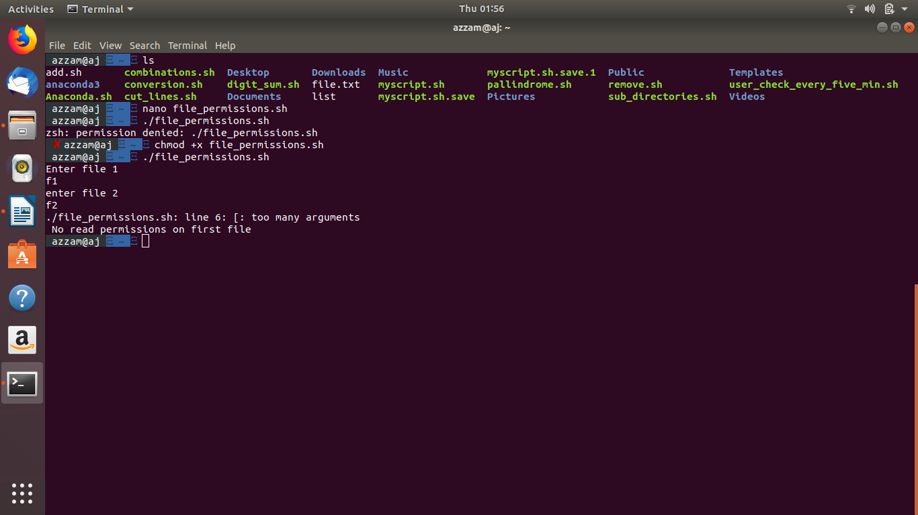

6.
CHECKING USER LOGGED IN OR NOT

#! /bin/bash
echo Enter the username
read uname
who>list
if [ grep $uname list ]
then
echo USER LOGGED IN
else
echo USER NOT LOGGED IN
fi

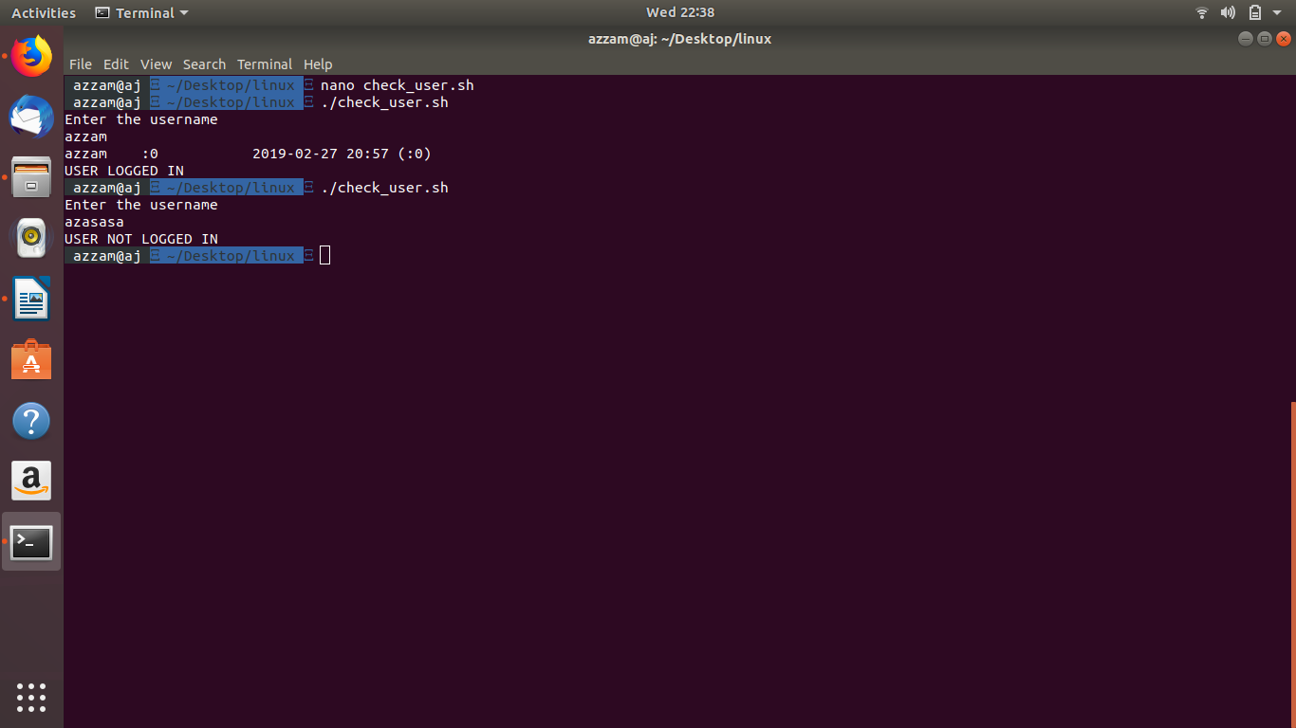

7.
LEAP YEAR

! /bin/bash
echo Enter a year
read year
if [ -z $year ]
then
year=$(date +"%Y")
fi

if [ `expr $year % 4` -eq 0 ]
then
echo LEAP YEAR !
else
echo NOT A LEAP YEAR !
fi

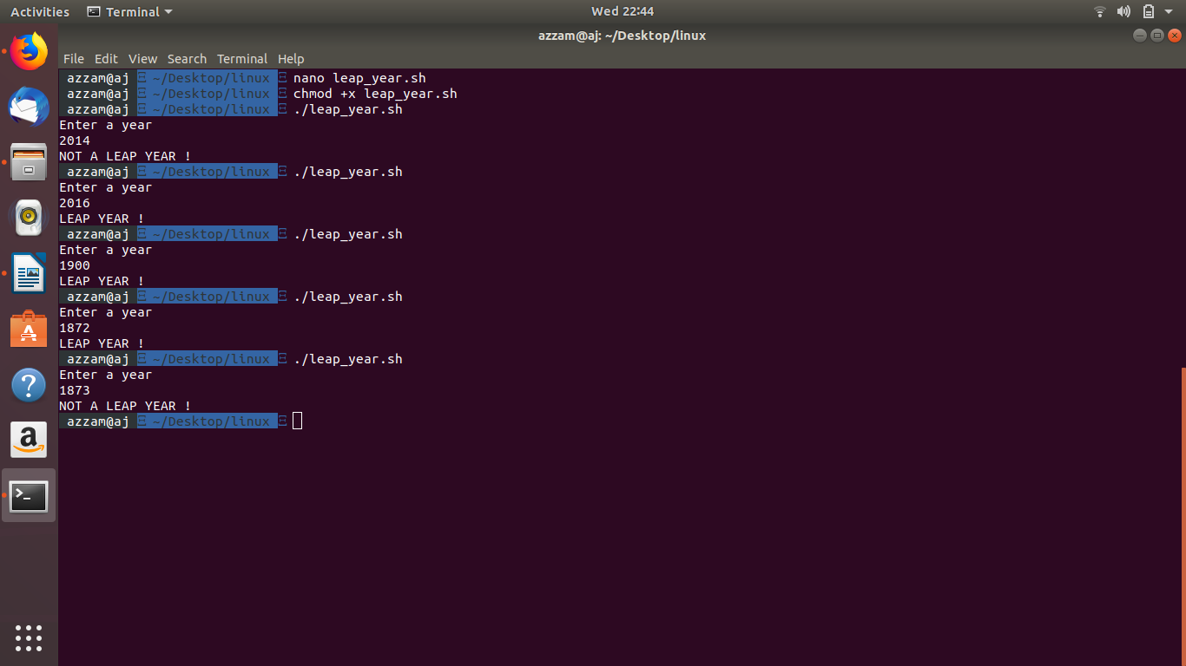

8.
GREETINGS
#! /bin/bash
t=$(date +"%H")
if [ $t -gt 6 -a $t -lt 12 ]
then
echo GOOD MORNING !
elif [ $t -gt 12 -a $t -lt 16 ]
then
echo GOOD AFTERNOON !
elif [ $t -gt 16 -a $t -lt 20 ]
then
echo GOOD EVENING !
else
echo GOOD NIGHT !
fi

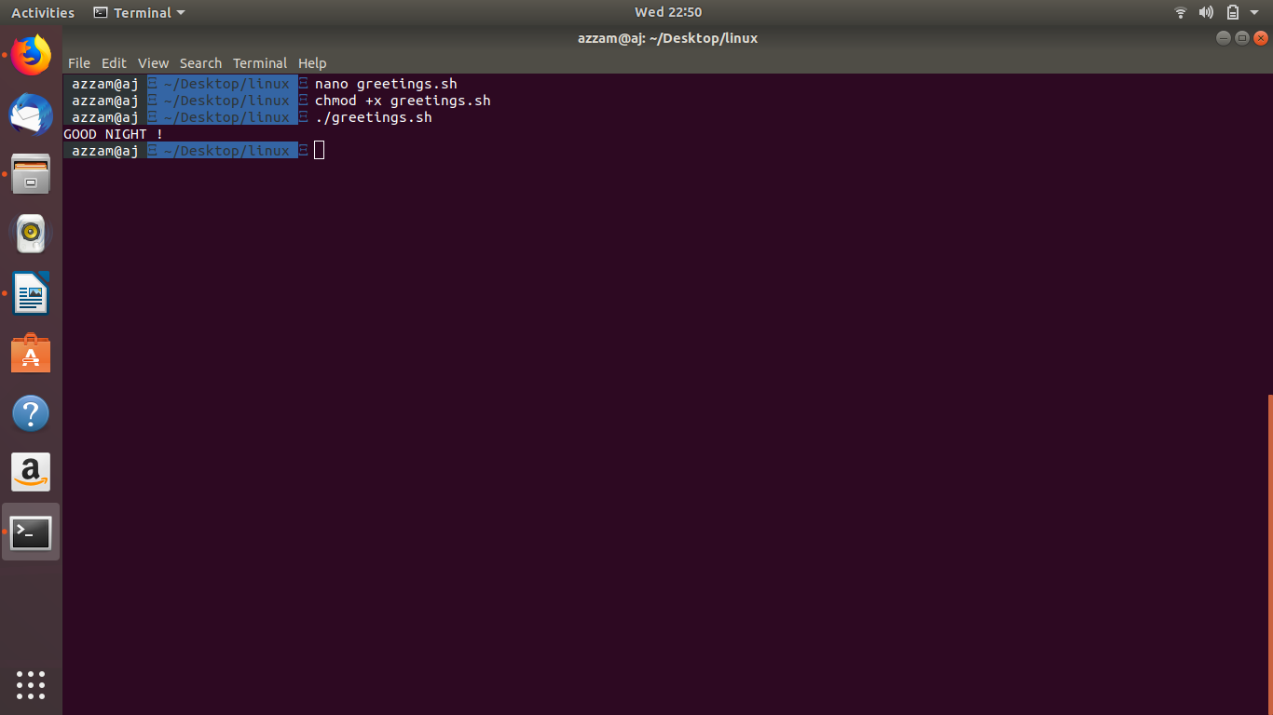

9.
REMOVE LINUX WORD

#! /bin/bash
echo Enter file name
read fname
grep -v -i "linux" $fname > f
mv f $fname

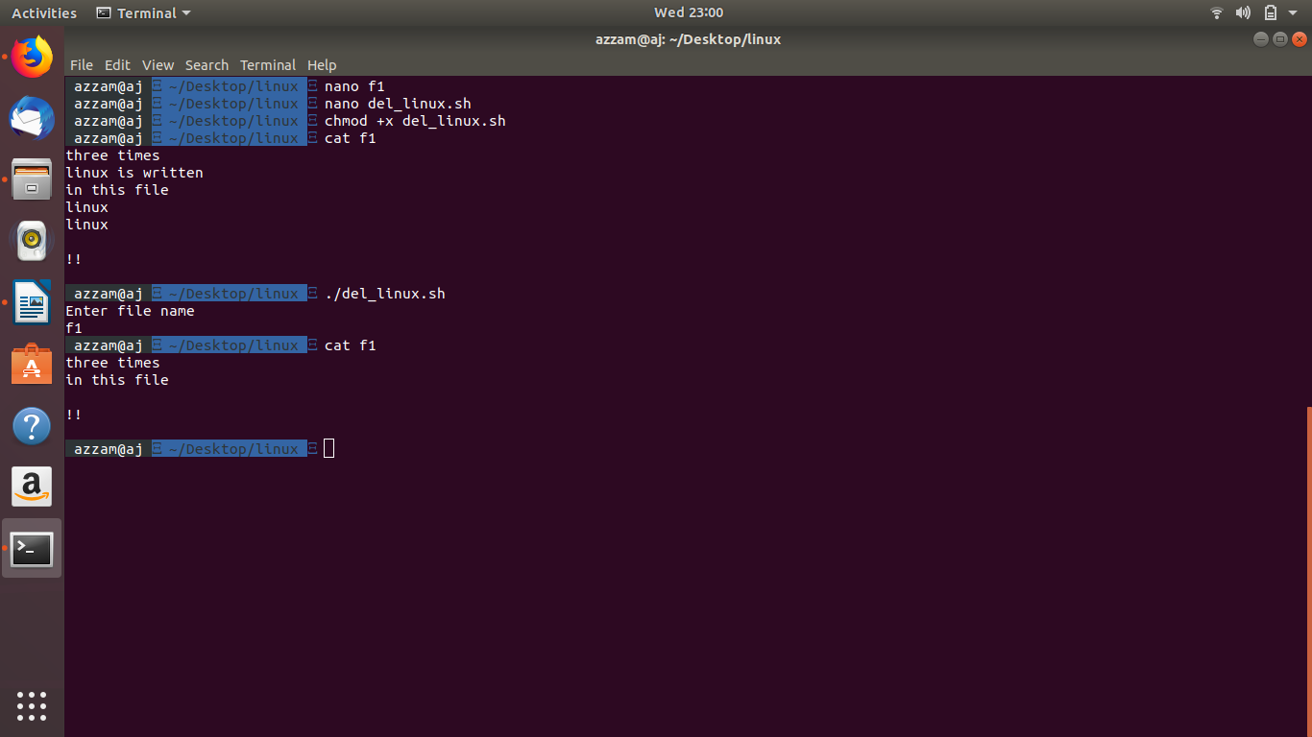

10.
SUM OF DIGITS

#! /bin/bash
echo Enter the number
read n
s=0
while [ $n -gt 0 ]
do
rem=`expr $n % 10`
s=`expr $s + $rem`
n=`expr $n / 10`
done
echo SUM OF DIGITS = $s

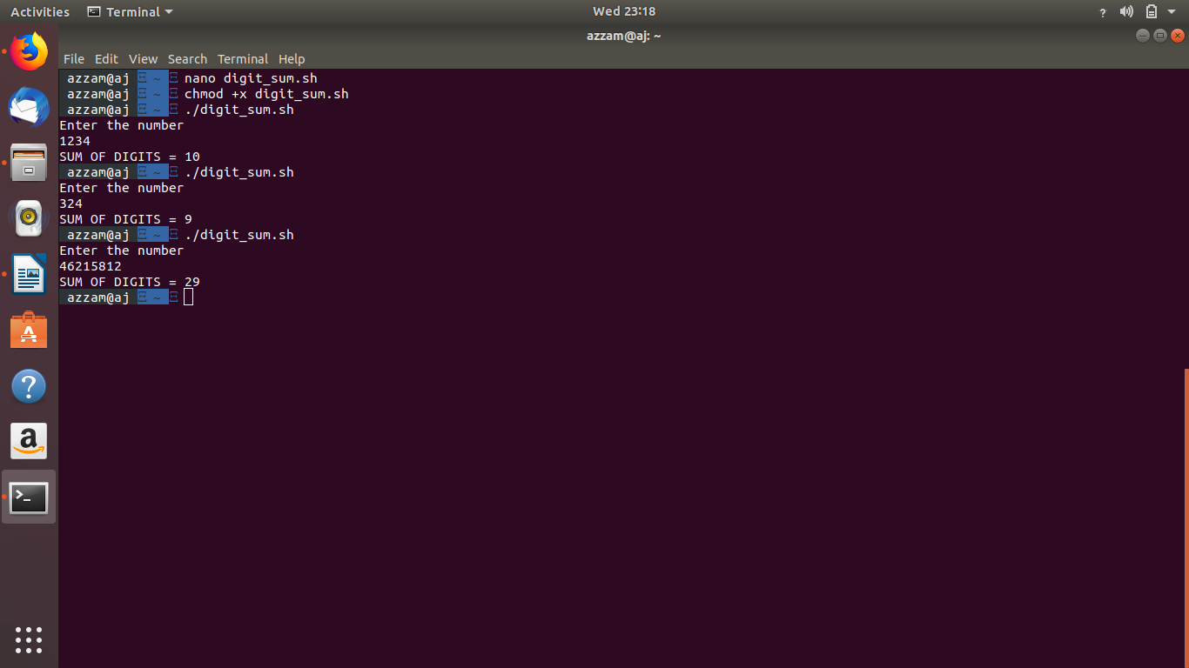

11.
PALLINDROME

#! /bin/bash
echo Enter the number
read n
rev=0
m=$n
while [ $n -gt 0 ]
do
rem=`expr $n % 10`
rev=`expr $rev \* 10 + $rem`
n=`expr $n / 10`
done
if [ $m -eq $rev ]
then
echo Number is pallindrome
else
echo Number is not a pallindrome
fi

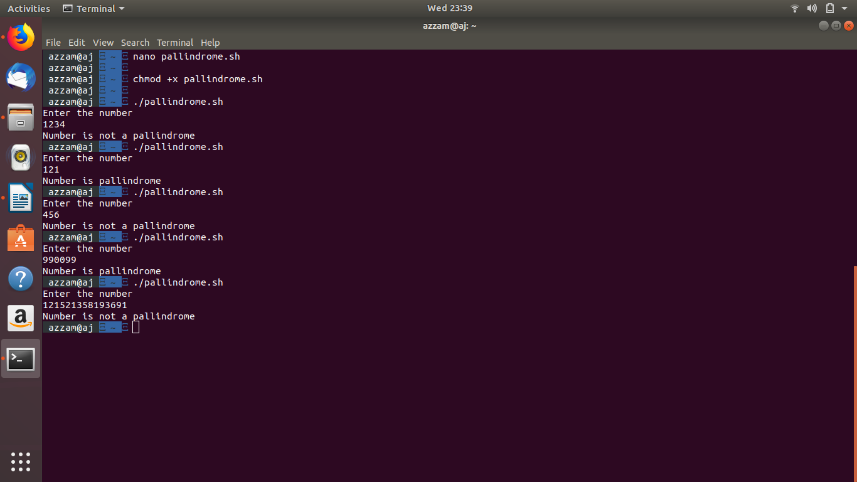

12.
USER LOG IN CHECK EVERY FIVE MINUTE

#! /bin/bash
echo Enter User Name
read uname
i=0
while [ $i -lt 5 ]
do
who>list
if grep $uname list
then
echo USER LOGGED IN
exit
else
echo USER NOT LOGGED IN
fi
i=`expr $i + 1`
sleep 60
done

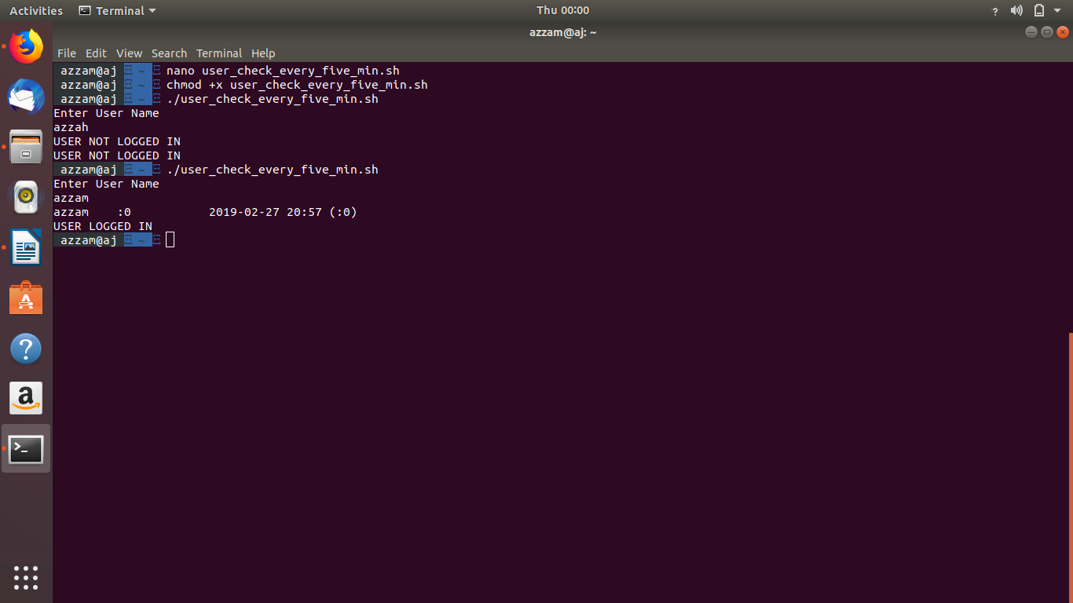

13.
CONVERSIONS

#! /bin/bash
echo Enter the number
read n
c=$(echo "obase=2;$n" | bc)
echo The binary is $c
c=$(echo "obase=16;$n" | bc)
echo The hexa conversion is $c
c=$(echo "obase=8;$n" | bc)
echo The octal conversion is $c

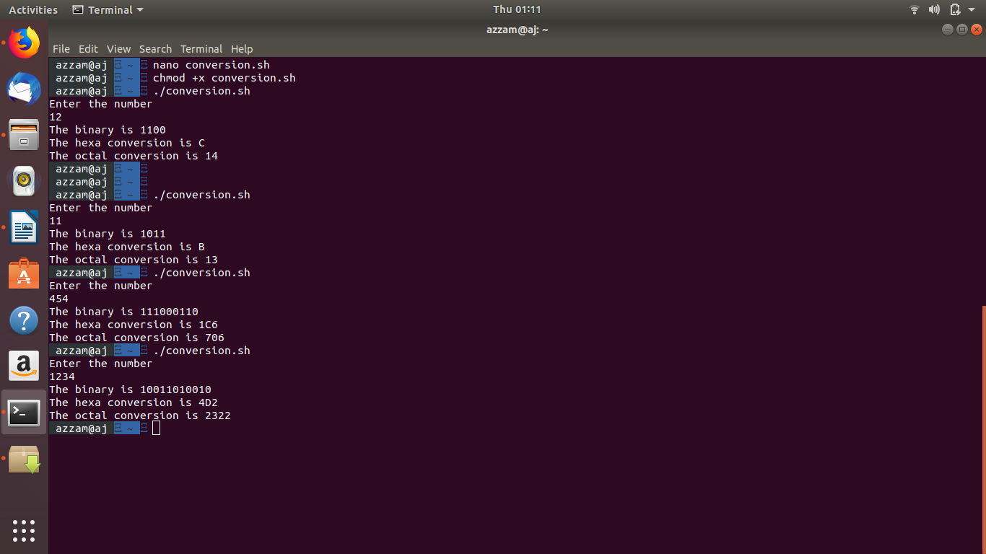

14.
REMOVING ALL TEMPORARY FILES

#! /bin/bash
for a in *.tmp
do
rm $a
done

